**Name: Anish Sharma Div: I-1**

**Roll no: I011 SAP ID: 60003220045**

**Experiment 7**

**Aim**: Implement Sequential File allocation techniques

**Code:**

#include <stdio.h>

#include <stdlib.h>

int flag[100];

void main()

{

int f[50], n, i, st, len, j, c, k, count = 0;

for (i = 0; i < 50; i++)

f[i] = 0;

printf("Enter no. of files:");

scanf("%d", &n);

count = 0;

printf("Enter memory req :");

int mem[n];

for (int i = 0; i < n; i++)

{

scanf("%d", &mem[i]);

}

for (int i = 0; i < n; i++)

{

count = 0;

int index = rand() % 100;

int copy = index;

if (flag[index] == 1)

{

i--;

continue;

}

for (int j = 0; j < mem[i]; j++)

{

flag[index] = 1;

index++;

count++;

}

printf("\nfile:%d,length%d block allocated are:", i + 1, count);

for (int j = index; j < index + count; j++)

printf("%d ", j);

}

}

**Output:**

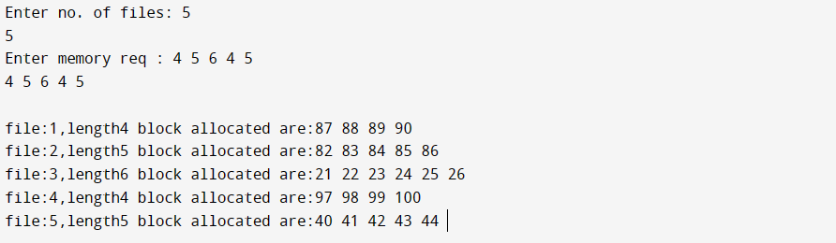

**EXPERIMENT 8**

**Aim:** Implement FCFS, SSTF, SCAN, CSCAN disk scheduling algorithm.(Any 2)

**1)FCFS**

**Code:**

import java.util.*;

public class OS1 {

public static void main(String[] args) {

Scanner sc=new Scanner(System.in);

int queue[]={98, 183, 40, 122, 10, 124, 65};

int head=sc.nextInt();

int temp=head;

int FCFS=0;

int min=Integer.MAX_VALUE;

System.out.println("The order of the pointer movement in FCFS is:");

for(int i=0;i<queue.length;i++){

System.out.print(queue[i]+"-> ");

FCFS=FCFS+Math.abs(temp-queue[i]);

temp=queue[i];

}

System.out.println("\n total seek time with FCFS algorithm is:"+FCFS);

}

}

**Output:**

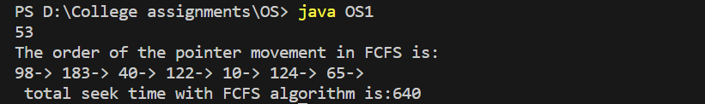

**2) SSTF**

**Code:**

import java.util.*;

public class SSTF {

public static void main(String[] args) {

Scanner sc=new Scanner(System.in);

int head=sc.nextInt();

int temp=head;

int SSTF=0;

int min=Integer.MAX_VALUE;

int minIndex=-1;

System.out.println("input values for SSTF:");

Vector<Integer> v=new Vector<Integer>();

for(int j=0;j<7;j++){

v.add(sc.nextInt());

}

System.out.println("The order of the pointer movement in SSTF is:");

temp=head;

for(int x=0;x<7;x++){

for(int y=0;y<v.size();y++){

if(Math.abs(v.elementAt(y)-temp)<min){

min=Math.abs(v.elementAt(y)-temp);

minIndex=y;

}

}

System.out.print(v.elementAt(minIndex)+"-> ");

SSTF=SSTF+min;

temp=v.elementAt(minIndex);

v.removeElement(v.elementAt(minIndex));

min=Integer.MAX_VALUE;

}

System.out.println("\n total seek time with SSTF algorithm is:"+SSTF);

}

}

**Output:**

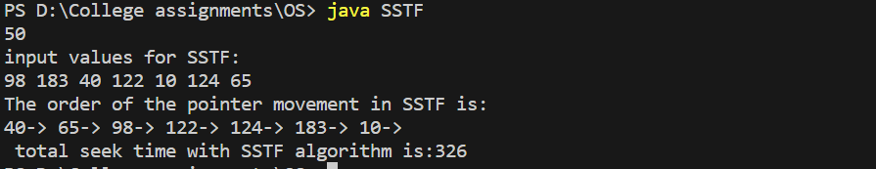

**3) SCAN**

**Code:**

import java.util.*;

public class SCAN {

public static void main(String[] args) {

Scanner sc=new Scanner(System.in);

int queue[]={98, 183, 40, 122, 10, 124, 65};

int head=sc.nextInt();

int temp=-1,temp2=head;

int SCAN=0;

Arrays.sort(queue);

for(int j=0;j<queue.length;j++){

if(queue[j]>head){

temp=j;

break;

}

}

System.out.println("The order of the pointer movement in SCAN is:");

for(int i=temp-1;i>=0;i--){

System.out.print(queue[i]+"-> ");

SCAN=SCAN+(temp2-queue[i]);

temp2=queue[i];

}

SCAN=SCAN+temp2;

temp2=0;

for(int k=temp;k<7;k++){

System.out.print(queue[k]+"-> ");

SCAN=SCAN+(Math.abs(temp2-queue[k]));

temp2=queue[k];

}

System.out.println("\n total seek time with SCAN algorithm is:"+SCAN);

}

}

**Output:**

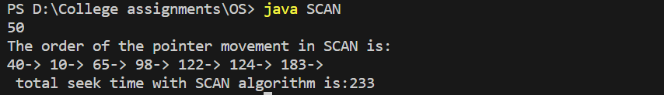

**4) C-SCAN**

**Code:**

import java.util.*;

public class CSCAN {

public static void main(String[] args) {

Scanner sc=new Scanner(System.in);

int queue[]={98, 183, 40, 122, 10, 124, 65};

int head=sc.nextInt();

int temp=-1,temp2=head;

int SCAN=0;

Arrays.sort(queue);

for(int j=0;j<queue.length;j++){

if(queue[j]>head){

temp=j;

break;

}

}

System.out.println("The order of the pointer movement in C-SCAN is:");

for(int i=temp-1;i>=0;i--){

System.out.print(queue[i]+"-> ");

SCAN=SCAN+(temp2-queue[i]);

temp2=queue[i];

}

for(int k=temp;k<7;k++){

System.out.print(queue[k]+"-> ");

SCAN=SCAN+(Math.abs(temp2-queue[k]));

temp2=queue[k];

}

System.out.println("\n total seek time with C-SCAN algorithm is:"+SCAN);

}

}

**Output:**

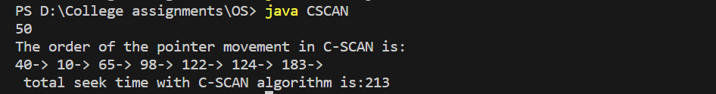

**5) LOOK**

**Code:**

import java.util.*;

public class LOOK {

public static void main(String[] args) {

Scanner sc=new Scanner(System.in);

int queue[]={98, 183, 40, 122, 10, 124, 65};

int head=sc.nextInt();

int temp=-1,temp2=head;

int LOOK=0;

Arrays.sort(queue);

for(int j=0;j<queue.length;j++){

if(queue[j]>head){

temp=j;

break;

}

}

System.out.println("The order of the pointer movement in LOOK is:");

for(int i=temp-1;i>=0;i--){

System.out.print(queue[i]+"-> ");

LOOK=LOOK+(temp2-queue[i]);

temp2=queue[i];

}

System.out.print("0 ->");

LOOK=LOOK+temp2+199;

temp2=199;

System.out.print("199 ->");

for(int k=6;k>=temp;k--){

System.out.print(queue[k]+"-> ");

LOOK=LOOK+(Math.abs(temp2-queue[k]));

temp2=queue[k];

}

System.out.println("\n total seek time with LOOK algorithm is:"+LOOK);

}

}

**Output:**

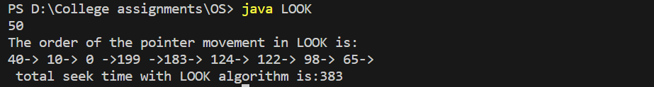

**6) C-LOOK**

**Code:**

import java.util.*;

public class CLOOK {

public static void main(String[] args) {

Scanner sc=new Scanner(System.in);

int queue[]={98, 183, 40, 122, 10, 124, 65};

int head=sc.nextInt();

int temp=-1,temp2=head;

int LOOK=0;

Arrays.sort(queue);

for(int j=0;j<queue.length;j++){

if(queue[j]>head){

temp=j;

break;

}

}

System.out.println("The order of the pointer movement in C-LOOK is:");

for(int i=temp-1;i>=0;i--){

System.out.print(queue[i]+"-> ");

LOOK=LOOK+(temp2-queue[i]);

temp2=queue[i];

}

LOOK=LOOK+queue[6]-temp2;

temp2=199;

for(int k=6;k>=temp;k--){

System.out.print(queue[k]+"-> ");

LOOK=LOOK+(Math.abs(temp2-queue[k]));

temp2=queue[k];

}

System.out.println("\n total seek time with C-LOOK algorithm is:"+LOOK);

}

}

**Output:**

