**EXPERIMENT NO. 02**

**CO/LO:** **Develop web applications.**

**AIM / OBJECTIVE:** **HTML: Style elements of HTML website using CSS.**

**DESCRIPTION OF EXPERIMENT:**

The CSS color property defines the text color to be used.

The CSS font-family property defines the font to be used.

The CSS font-size property defines the text size to be used.

The CSS margin property defines a margin (space) outside the border.

align-items Specifies the alignment for items inside a flexible container

background-color Specifies the background color of an element

background-image Specifies one or more background images for an element

background-size Specifies the size of the background images

display specifies how a certain HTML element should be displayed

flex - A shorthand property for the flex-grow, flex-shrink, and the flex-basis properties

font-size Specifies the font size of text

font-weight Specifies the weight of a font

justify-content Specifies the alignment between the items inside a flexible container when the items do not use all available space

margin Sets all the margin properties in one declaration

padding A shorthand property for all the padding-properties width Sets the width of an element.

**SOURCE CODE:**

<!DOCTYPE html>

<html lang="en">

<head>

    <meta charset="UTF-8">

    <meta name="viewport" content="width=device-width, initial-scale=1.0">

    <title>Coffee Website</title>

    <link rel="stylesheet" href="style.css">

</head>

<body>

    <nav class="navBar">

        <div class="logo">

            <img src="images/logo.png" alt="logo">

        </div>

        <ul class="navList">

            <li><a href="#">Home</a></li>

            <li><a href="#">Menu</a></li>

            <li><a href="#">Services</a></li>

            <li><a href="#">Product</a></li>

            <li><a href="#">Contact</a></li>

            <li class="slider"><a href="#"></a></li>

        </ul>

    </nav>

    <section class="mainBody">

        <div class="left split">

             <div class="content">

                <h1>Coffee Time</h1>

                <p>Rediscover the magic of coffee in an ambiance crafted for wanderers and dreamers</p>

                <button><a href="http://127.0.0.1:5500/order.html" target="_blank">Shop here</a></button>

             </div>

        </div>

        <div class="middle">

            <div class="circle"></div>

            <div class="circle"></div>

            <div class="circle"></div>

        </div>

        <div class="right split">

            <img src="images/coffee split.png" alt="">

        </div>

    </section>

    <!-- <script src="script.js"></script> -->

</body>

</html>

@import url('https://fonts.googleapis.com/css2?family=Lemon&display=swap');

*{

    padding: 0;

    margin: 0;

    box-sizing: border-box;

    font-family: Arial, Helvetica, sans-serif;

}

.logo img{

    height: 4rem;

}

.navBar{

    /* background-color: red; */

    width: 90vw;

    display: flex;

    height: 12vh;

    align-items: center;

    justify-content: space-between;

    position: fixed;

    top: 0;

    left: 50%;

    transform: translateX(-50%);

}

.navList{

    display: flex;

    gap: 2.5rem;

}

.navBar ul{

    list-style: none;

}

.navBar ul a{

    text-decoration: none;

    color: white;

    font-size: 1.2rem;

    letter-spacing: .08rem;

}

.mainBody{

    display: flex;

}

.mainBody .left{

    background-color: #2c1e1e;

    padding-left: 2rem;

}

/* .mainBody .middle{

} */

.mainBody .right{

    background-color: #7c573c;

    justify-content: center;

}

.mainBody .split{

    width: 50vw;

    min-height: 100vh;

    display: flex;

    align-items: center;

}

.navList .slider{

    background-color: rgba(225, 255, 255,0.345);

    width: 6rem;

    height: 5rem;

    position: absolute;

    top: 0;

    right: 430px;

    border-radius: 0 0 2rem 2rem ;

    border-top: 0.3rem solid #2c1e1e;

    backdrop-filter: blur(.5rem);

    z-index: -1;

    transition: 0.5s ease-in-out;

}

.navBar li:nth-child(2):hover ~ .slider{

    right: 335px;

}

.navBar li:nth-child(3):hover ~ .slider{

    right: 225px;

}

.navBar li:nth-child(4):hover ~ .slider{

    right: 105px;

}

.navBar li:nth-child(5):hover ~ .slider{

    right: -10px;

}

.left .content{

    color: white;

}

.content h1{

    font-size: 5rem;

    -webkit-text-fill-color: transparent;

    -webkit-text-stroke: .04rem white;

    letter-spacing: 0.2rem;

    font-family: 'Lemon', cursive;

}

.content p{

    color: rgba(225, 255, 255,0.3);

    font-size: 1.3rem;

    width: 75%;

    line-height: 1.7rem;

    margin: 1.5rem 0;

}

button a{

    text-decoration: none;

    color: white;

    font-size: 1.2rem;

    letter-spacing: .08rem;

}

.content button{

    cursor: pointer;

    background: radial-gradient(at top left,#5a4740,#2c1e1e);

    padding: 1rem 3rem;

    border: 0.2rem solid rgba(225, 255, 255,0.286);

    font-size: 1.3rem;

    color: white;

    letter-spacing: 0.1rem;

    border-radius: 4rem;

}

.content button:hover{

    background: radial-gradient(at bottom right,#5a4740,#2c1e1e);

}

.right img{

    height: 70%;

    padding-left: 3rem;

}

.middle{

    position: absolute;

    top: 50%;

    left: 50%;

    transform: translate(-50%,-50%);

}

.middle .circle{

    height: 10rem;

    width: 10rem;

    border-radius: 8rem;

    background-color: white;

    background-position:center;

    background-size: cover;

    background-repeat: no-repeat;

}

.circle:nth-child(1){

    background-image: url(images/coffee\ powder.jpg);

    background-size: 350%;

}

.circle:nth-child(2){

    margin: 2rem 0;

    background-image: url(images/coffee\ beans.jpg);

}

.circle:nth-child(3){

   background-image: url(images/leaves.jpg);

   background-size: 350%;

}

.menu{

    background-color: #2c1e1e;

    padding: 1rem;

}

.discount marquee{

    text-align:center;

    color: bisque;

}

.menu .heading{

    font-size: 4rem;

    -webkit-text-fill-color: transparent;

    -webkit-text-stroke: .04rem white;

    letter-spacing: 0.2rem;

    height: 12vh;

    padding-bottom: 5rem;

    /* font-weight: bolder;

    color: white; */

    text-align: center;

    /* font-size: 45px; */

    /* letter-spacing: .08rem; */

    font-family: 'Lemon', cursive;

}

.menu .box-container{

    display: grid;

    grid-template-columns:repeat(auto-fit,minmax(30rem,1fr)) ;

    gap: 1rem;

}

.menu .box-container .box{

    height: auto;

    width: auto;

    border: 2px solid rgb(117, 102, 102);

    padding: 2rem;

    text-align: center;

}

.menu .box-container .box img{

    height: 15rem;

}

.menu .box-container .box h3{

    color: white;

    font-size: 1.2rem;

    padding: 1rem,0;

}

.menu .box-container .box .price{

    color: white;

    font-size: 1.5rem;

    padding: 5rem,0;

}

.menu .box-container .box .incDec{

    /* border: 1px solid white; */

    /* width: 10rem; */

    color: white;

    font-size:2rem;

    /* display: flex; */

}

.incDec span{

    /* margin-left: 0.5rem;

    margin-right: 0.5rem;

    padding: 0.2rem; */

    text-align: center;

    border: 2px solid white;

    padding: 0 1rem;

}

.plus ,.minus{

    cursor: pointer;

    width: 1rem;

}

.payment{

    justify-content: center;

    text-align: center;

}

.payment button{

    /* background-color: #2c1e1e;

    font-weight: bolder;

    color: white;

    font-size: 3rem; */

    margin-top: 1rem;

    margin-bottom: 1rem;

    background: radial-gradient(at top left,#5a4740,#2c1e1e);

    padding: 1rem 3rem;

    border: 0.2rem solid rgba(225, 255, 255,0.286);

    font-size: 1.3rem;

    color: white;

    letter-spacing: 0.1rem;

    border-radius: 4rem;

    cursor: pointer;

}

.payment button:hover{

    background: radial-gradient(at bottom right,#5a4740,#2c1e1e);

}

.message{

    height: auto;

    width: 70%;

    margin-left: 15vw;

}

.message p{

    text-align: center;

    color: white;

    font-weight: bolder;

    opacity: 0;

}

.incDec .zero{

    margin: 0 1rem;

}

**OUTPUT:**

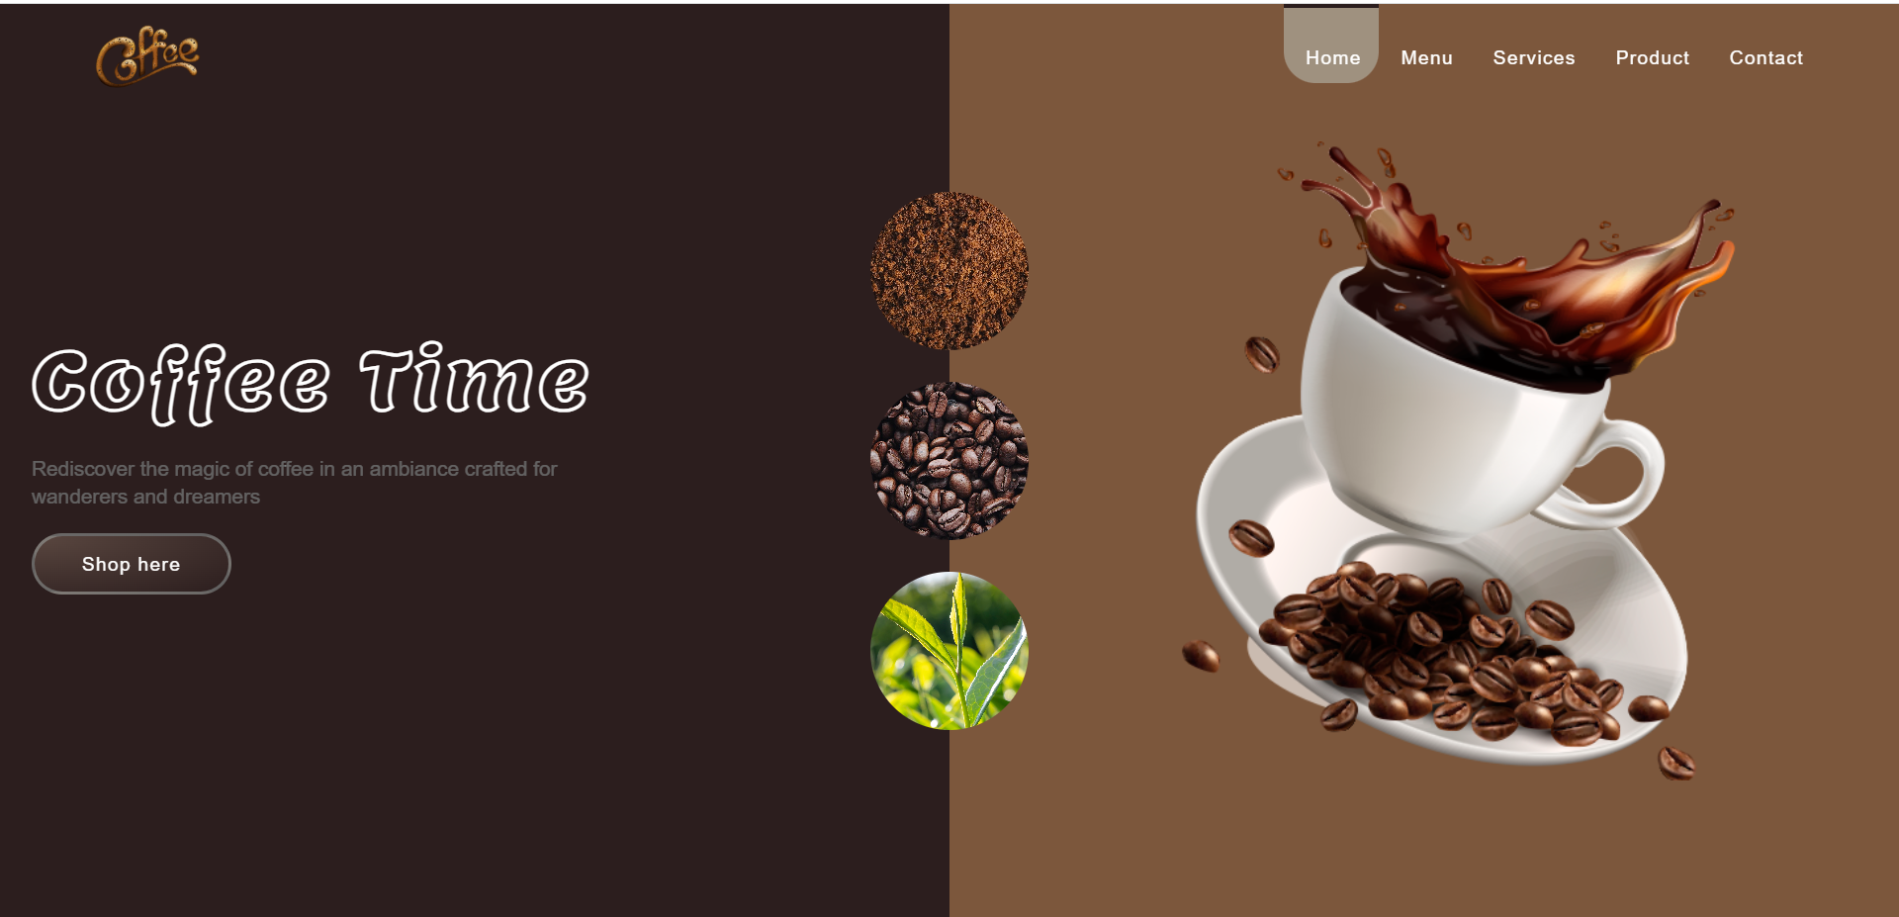

**CONCLUSION:**

With the help of Experiment – 2 , I have understood the application of various tags of HTML And style attributes of CSS.

**REFERENCES:**

[1] MDN reference https://developer.mozilla.org/en-US/docs/Web/CSS/Reference