**EXPERIMENT NO. 01**

**NAME:Anish Sharma**

**SAP ID: 60003220045**

**ROLL_NO: I011**

**CO/LO:** **Develop web applications.**

**AIM / OBJECTIVE:** **HTML: Design a website including basic html tags, list, image, links, table and forms using only HTML.**

**DESCRIPTION OF EXPERIMENT:**

React is a JavaScript library for building user interfaces, primarily focused on creating single-page applications where user interactions are dynamic and frequent. Developed and maintained by Facebook, React has gained widespread adoption in the web development community for its simplicity, flexibility, and efficiency.

1)Component-Based Architecture:

React is based on a component-based architecture, where UIs are broken down into reusable components.

2)Virtual DOM:

React uses a virtual DOM (Document Object Model) to optimize updates and improve performance. Instead of directly manipulating the actual DOM, React updates a virtual representation and then efficiently updates the real DOM only where changes occurred.

3)Declarative Syntax:

React follows a declarative programming paradigm, allowing developers to describe the desired state of the UI, and React takes care of updating the DOM to match that state.

4)Unidirectional Data Flow:

React enforces a unidirectional data flow, which means that data flows in one direction, from parent components to child components.

5)Reusability and Composition:

React promotes the reusability of components. Developers can create modular components and reuse them across different parts of the application, leading to more maintainable and scalable code.

**SOURCE CODE:**

**1)App.js**

import { useState } from "react";

import StartGame from "./components/StartGame";

import GamePlay from "./components/GamePlay";

function App() {

  const [isGameStarted, setIsGameStarted] = useState(false);

  const toggleGamePlay = () => {

    setIsGameStarted((prev) => !prev);

  };

  return (

    <>{isGameStarted ? <GamePlay /> : <StartGame toggle={toggleGamePlay} />}</>

  );

}

export default App;

**COMPONENTS:**

**1.GamePlay.js**

import styled from "styled-components";

import NumberSelector from "./NumberSelector";

import TotalScore from "./TotalScore";

import RoleDice from "./RoleDice";

import { useState } from "react";

import { Button, OutlineButton } from "../styled/Button";

import Rules from "./Rules";

const GamePlay = () => {

  const [score, setScore] = useState(0);

  const [selectedNumber, setSelectedNumber] = useState();

  const [currentDice, setCurrentDice] = useState(1);

  const [error, setError] = useState("");

  const [showRules, setShowRules] = useState(false);

  const generateRandomNumber = (min, max) => {

    return Math.floor(Math.random() * (max - min) + min);

  };

  const roleDice = () => {

    if (!selectedNumber) {

      setError("You have not selected any number");

      return;

    }

    const randomNumber = generateRandomNumber(1, 7);

    setCurrentDice((prev) => randomNumber);

    if (selectedNumber === randomNumber) {

      setScore((prev) => prev + randomNumber);

    } else {

      setScore((prev) => prev - 2);

    }

    setSelectedNumber(undefined);

  };

  const resetScore = () => {

    setScore(0);

  };

  return (

    <MainContainer>

      <div className="top_section">

        <TotalScore score={score} />

        <NumberSelector

          error={error}

          setError={setError}

          selectedNumber={selectedNumber}

          setSelectedNumber={setSelectedNumber}

        />

      </div>

      <RoleDice currentDice={currentDice} roleDice={roleDice} />

      <div className="btns">

        <OutlineButton onClick={resetScore}>Reset Score</OutlineButton>

        <Button onClick={() => setShowRules((prev) => !prev)}>

          {showRules ? "Hide" : "Show"} Rules

        </Button>

      </div>

      {showRules && <Rules />}

    </MainContainer>

  );

};

export default GamePlay;

const MainContainer = styled.main`

  padding-top: 70px;

  .top_section {

    display: flex;

    justify-content: space-around;

    align-items: end;

  }

  .btns {

    margin-top: 40px;

    gap: 10px;

    display: flex;

    flex-direction: column;

    align-items: center;

    justify-content: center;

    gap: 10px;

  }

`;

**2.StartGame.js**

import styled from "styled-components";

import { Button } from "../styled/Button";

const StartGame = ({ toggle }) => {

  return (

    <Container>

      <div>

        <img src="/images/dices.png" />

      </div>

      <div className="content">

        <h1>Dice Game</h1>

        <Button onClick={toggle}>Play Now</Button>

      </div>

    </Container>

  );

};

export default StartGame;

const Container = styled.div`

  max-width: 1180px;

  height: 100vh;

  display: flex;

  margin: 0 auto;

  align-items: center;

  .content {

    h1 {

      font-size: 96px;

      white-space: nowrap;

    }

  }

`;

**3.NumberSelector.js**

import styled from "styled-components";

const NumberSelector = ({

  setError,

  error,

  selectedNumber,

  setSelectedNumber,

}) => {

  const arrNumber = [1, 2, 3, 4, 5, 6];

  const numberSelectorHandler = (value) => {

    setSelectedNumber(value);

    setError("");

  };

  return (

    <NumberSelectorContainer>

      <p className="error">{error}</p>

      <div className="flex">

        {arrNumber.map((value, i) => (

          <Box

            isSelected={value === selectedNumber}

            key={i}

            onClick={() => numberSelectorHandler(value)}

          >

            {value}

          </Box>

        ))}

      </div>

      <p>Select Number</p>

    </NumberSelectorContainer>

  );

};

export default NumberSelector;

const NumberSelectorContainer = styled.div`

  display: flex;

  flex-direction: column;

  align-items: end;

  .flex {

    display: flex;

    gap: 24px;

  }

  p {

    font-size: 24px;

    font-weight: 700px;

  }

  .error {

    color: red;

  }

`;

const Box = styled.div`

  height: 72px;

  width: 72px;

  border: 1px solid black;

  display: grid;

  place-items: center;

  font-size: 24px;

  font-weight: 700;

  background-color: ${(props) => (props.isSelected ? "black" : "white")};

  color: ${(props) => (!props.isSelected ? "black" : "white")};

`;

**4.Rules.js**

import styled from "styled-components";

const Rules = () => {

  return (

    <RulesContainer>

      <h2>How to play dice game</h2>

      <div className="text">

        <p>Select any number</p>

        <p>Click on dice image</p>

        <p>

          after click on dice if selected number is equal to dice number you

          will get same point as dice{" "}

        </p>

        <p>if you get wrong guess then 2 point will be dedcuted </p>

      </div>

    </RulesContainer>

  );

};

export default Rules;

const RulesContainer = styled.div`

  max-width: 800px;

  margin: 0 auto;

  background-color: #fbf1f1;

  padding: 20px;

  margin-top: 40px;

  border-radius: 10px;

  h2 {

    font-size: 24px;

  }

  .text {

    margin-top: 24px;

  }

`;

**5.RollDice.js**

import styled from "styled-components";

const RoleDice = ({ roleDice, currentDice }) => {

  return (

    <DiceContainer>

      <div className="dice" onClick={roleDice}>

        <img src={`/images/dice/dice_${currentDice}.png`} alt="dice 1" />

      </div>

      <p>Click on Dice to roll</p>

    </DiceContainer>

  );

};

export default RoleDice;

const DiceContainer = styled.div`

  margin-top: 48px;

  display: flex;

  flex-direction: column;

  align-items: center;

  .dice {

    cursor: pointer;

  }

  p {

    font-size: 24px;

  }

`;

**OUTPUT:**

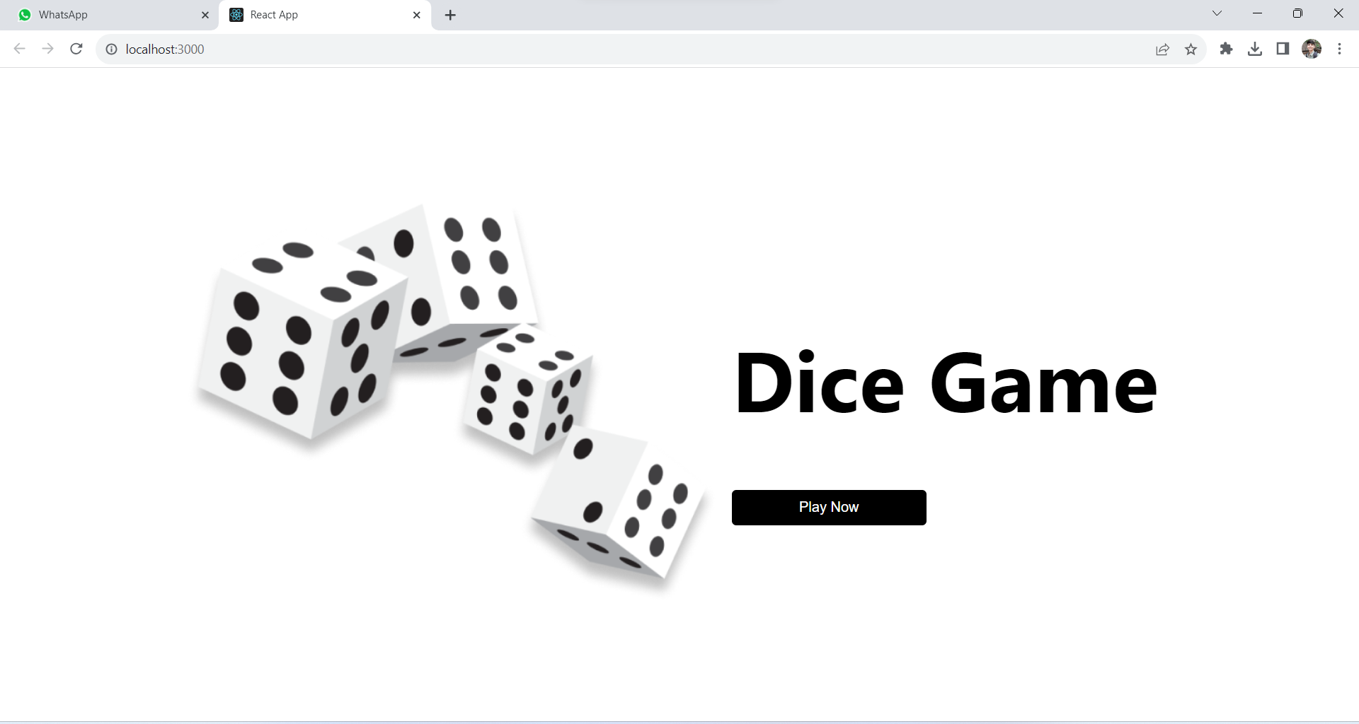

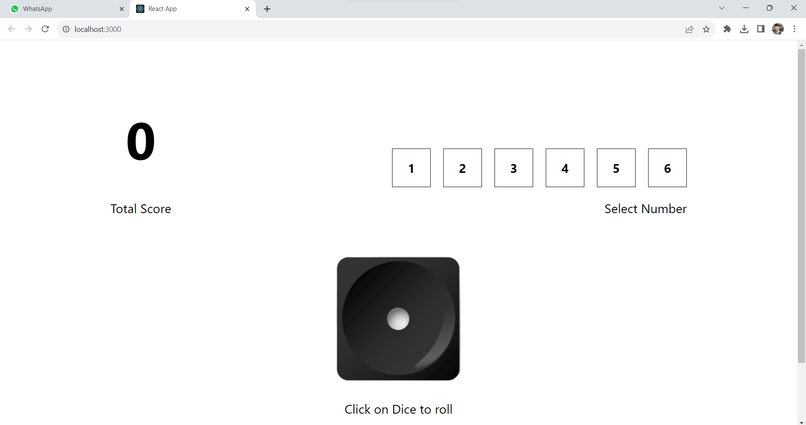

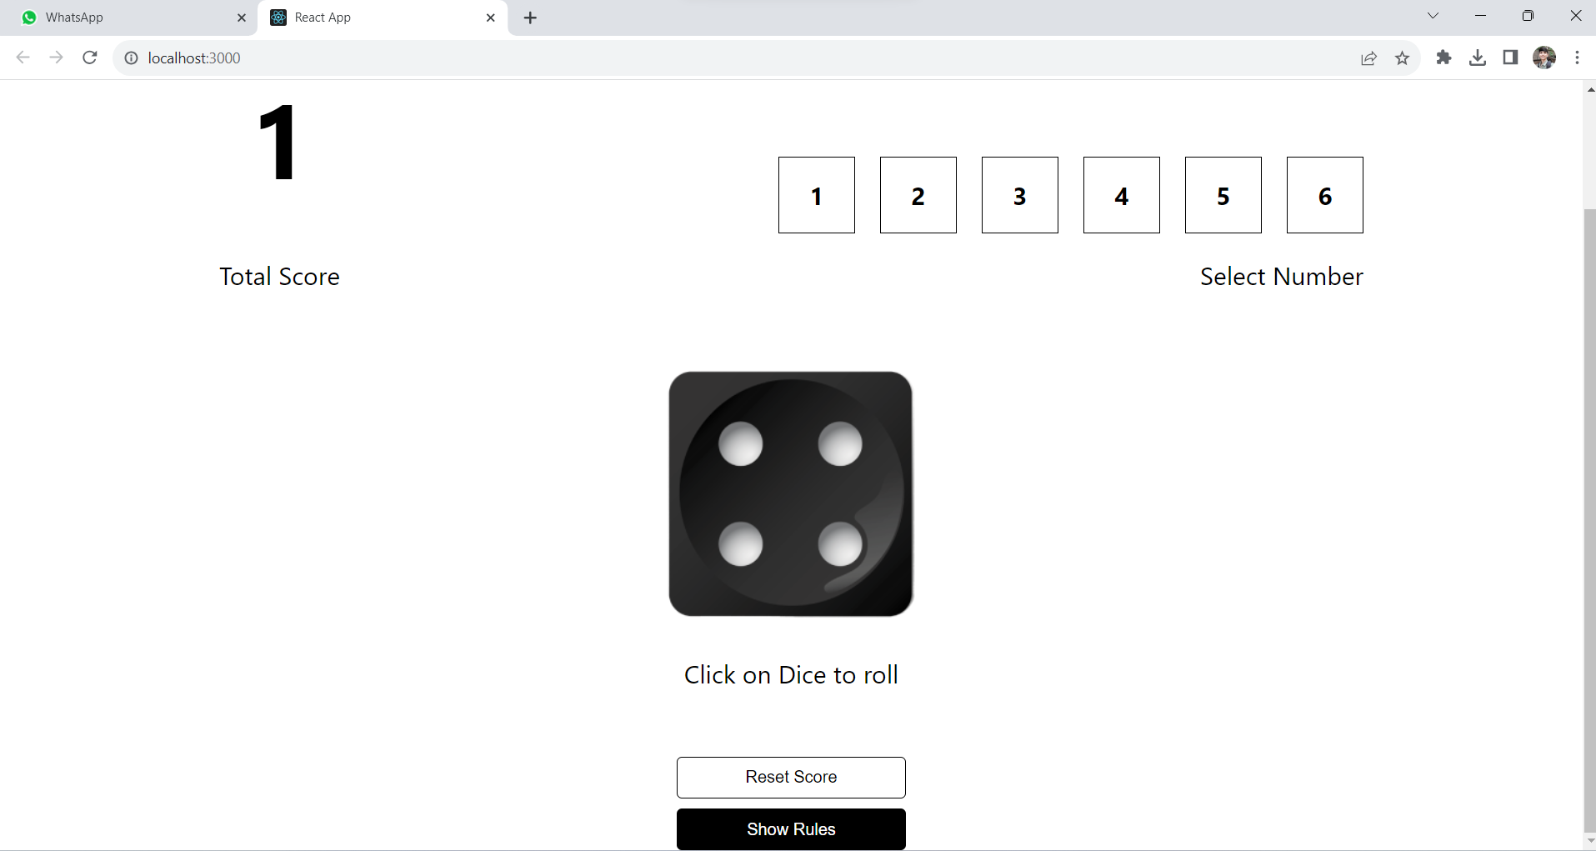

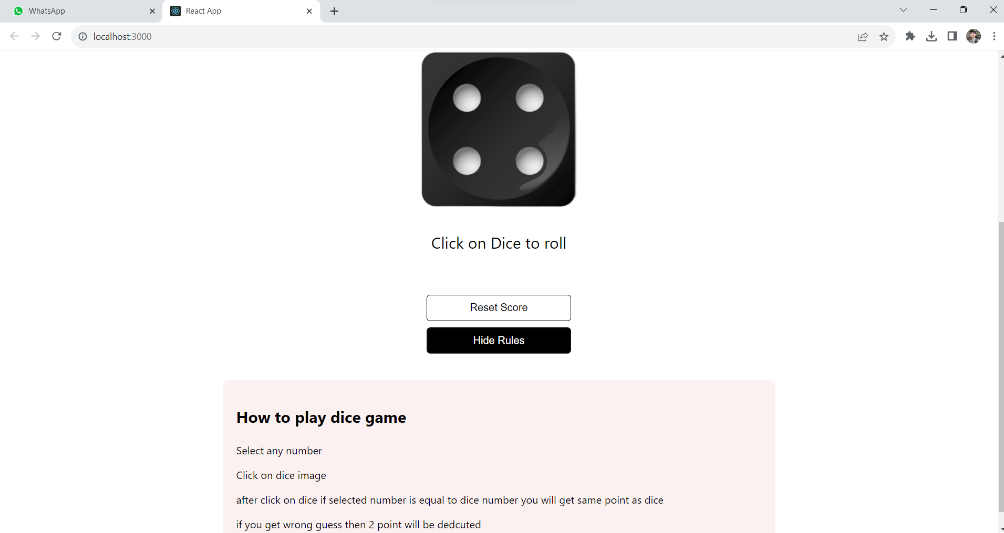

**CONCLUSION:**

We created a dynamic webpage using React.js , we used the functions such as ‘route’ for switching components and providing us with code reusability and ability to see different content without switching webpages.

**REFERENCES:**

**​Website References:​** [React](https://react.dev/) , W3schools