Academic Year 2023-24 SAP ID:60003220045



**DEPARTMENT OF INFORMATION TECHNOLOGY**

COURSE CODE: DJS22ITL307 DATE:6-12-2023

**COURSE NAME: Web Programming Laboratory CLASS:SY. BTech**

EXPERIMENT NO. 11

CO/LO: CO1-Develop web applications.

CO2- Work effectively as a member of a team.

**AIM / OBJECTIVE**: Mini-Project

Team Members Names:

Anish Sharma – 60003220045

Atharva Deshpande – 60003220193

Aryan Patankar - 60003220285

**PROBLEM STATEMENT**:

**Sustainable Product Marketplace –** Make an e-commerce platform/online marketplace to sell sustainable and eco-friendly products. The site should be able to find the carbon footprints of the products and give sustainable product certification and ratings.

SNAPSHOTS OF PROJECT:

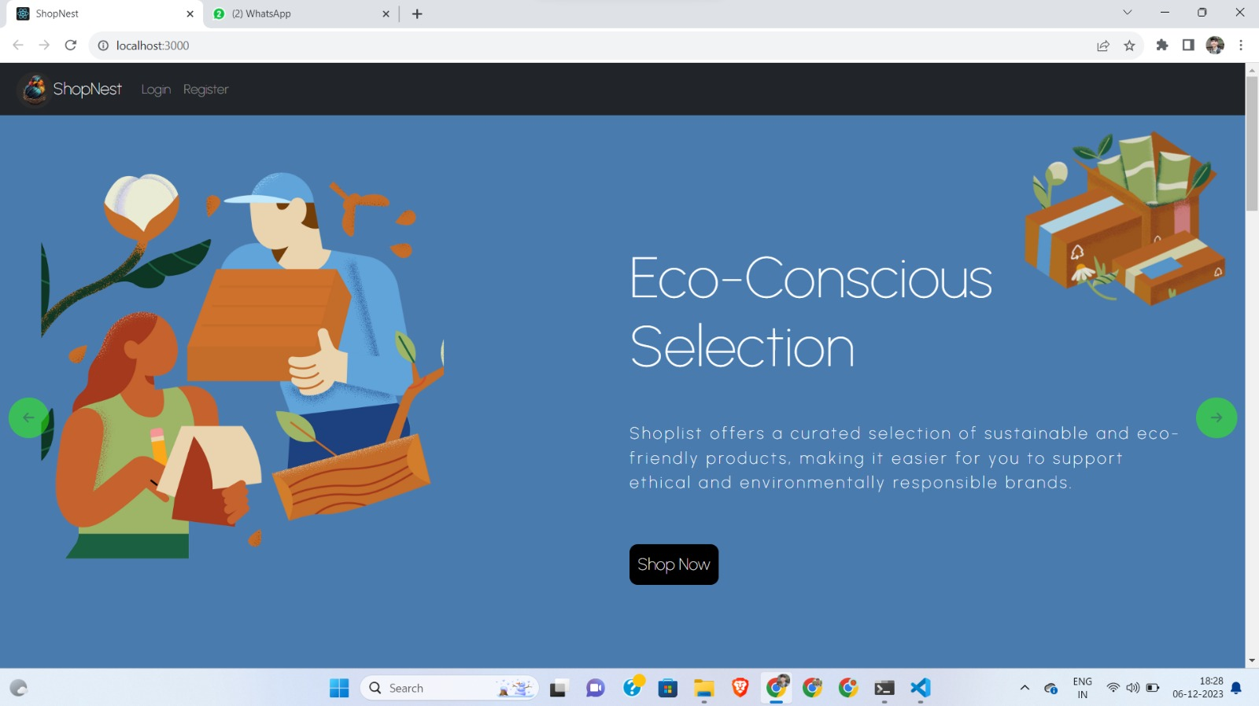

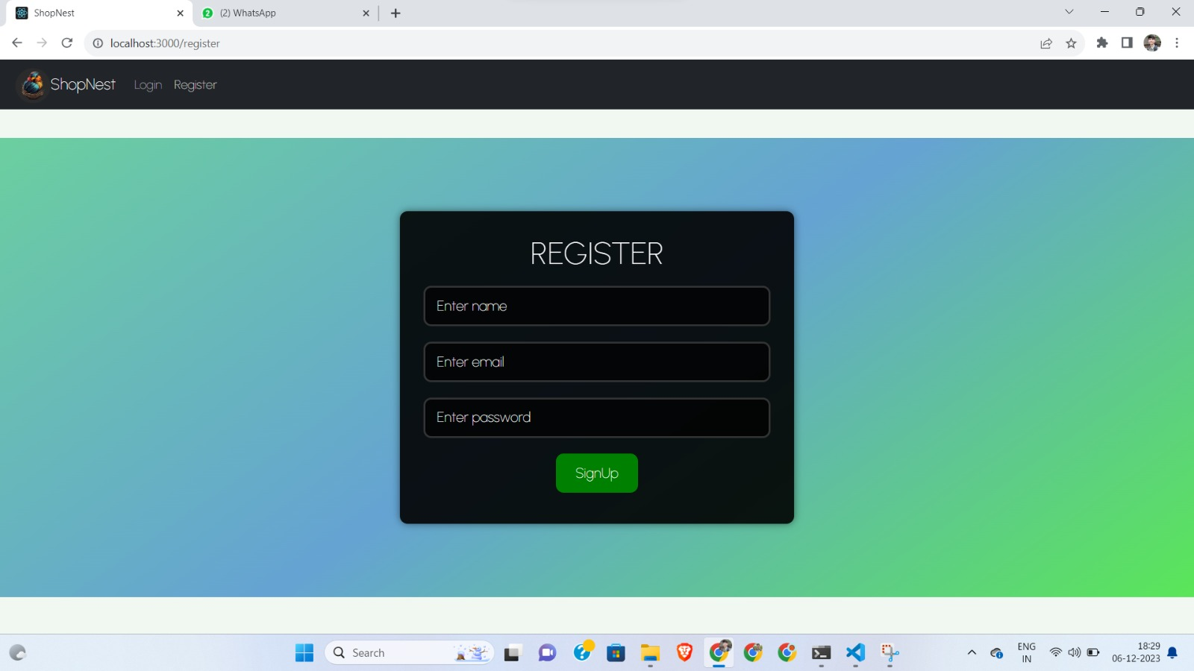

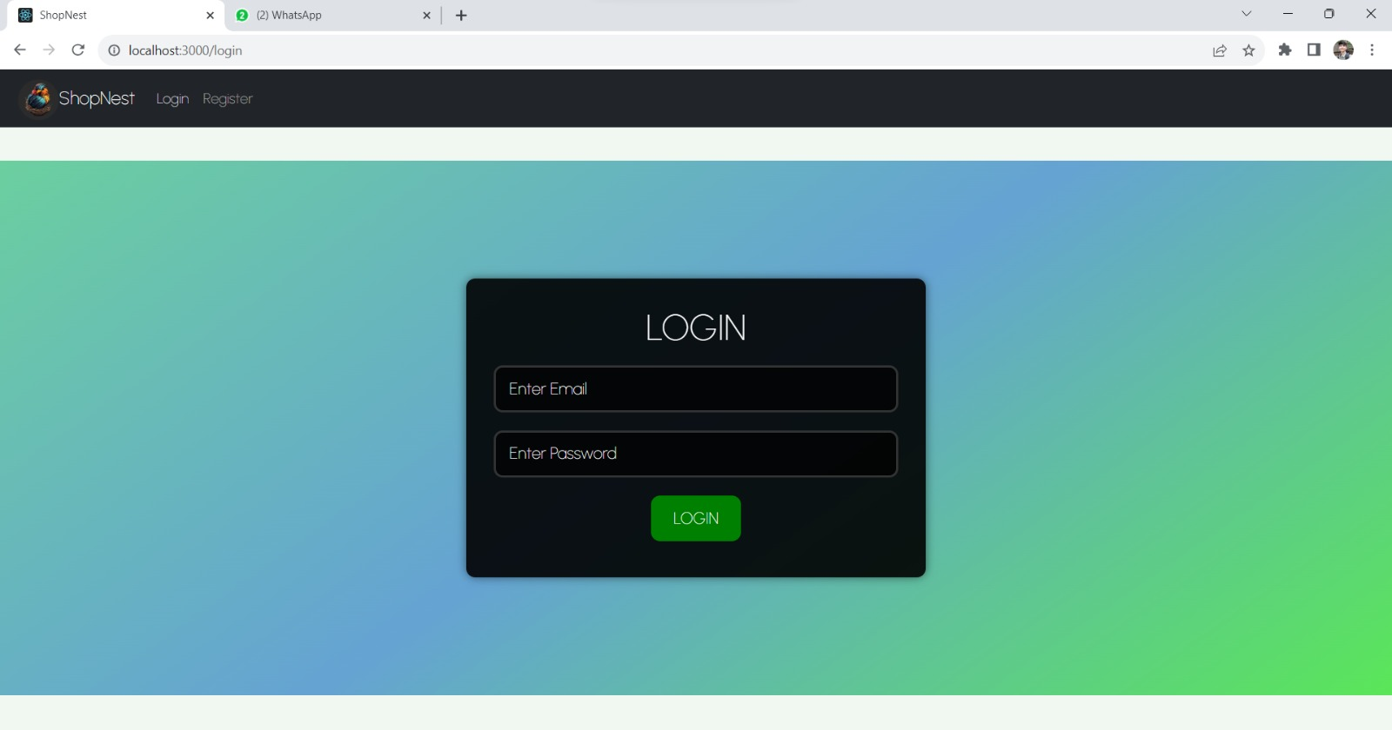  
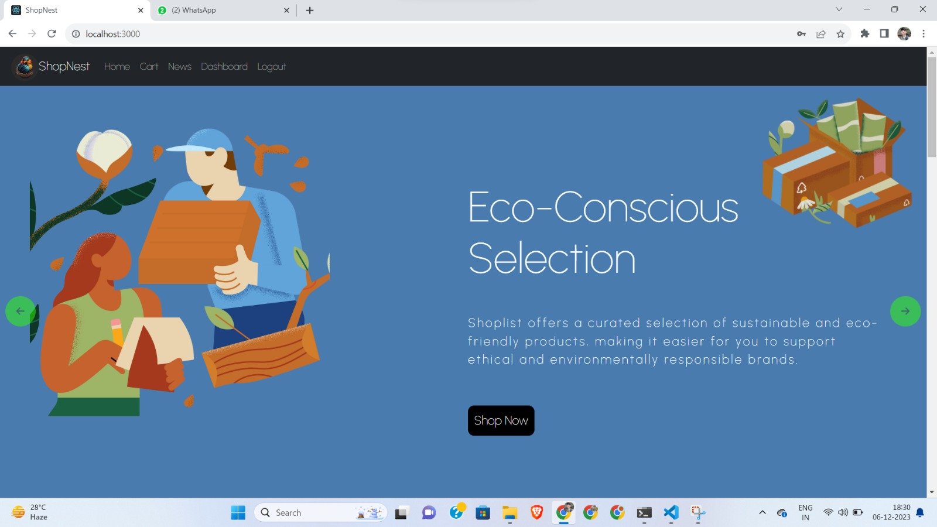

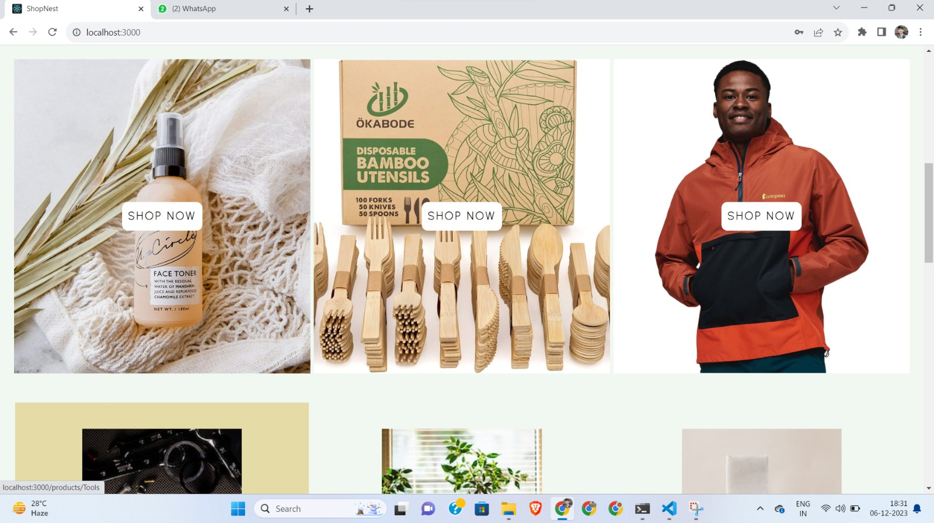

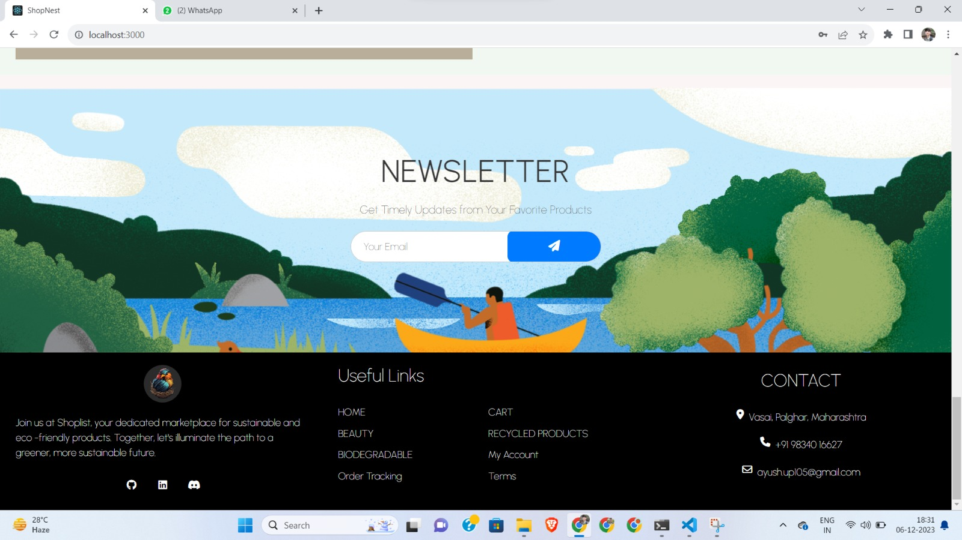

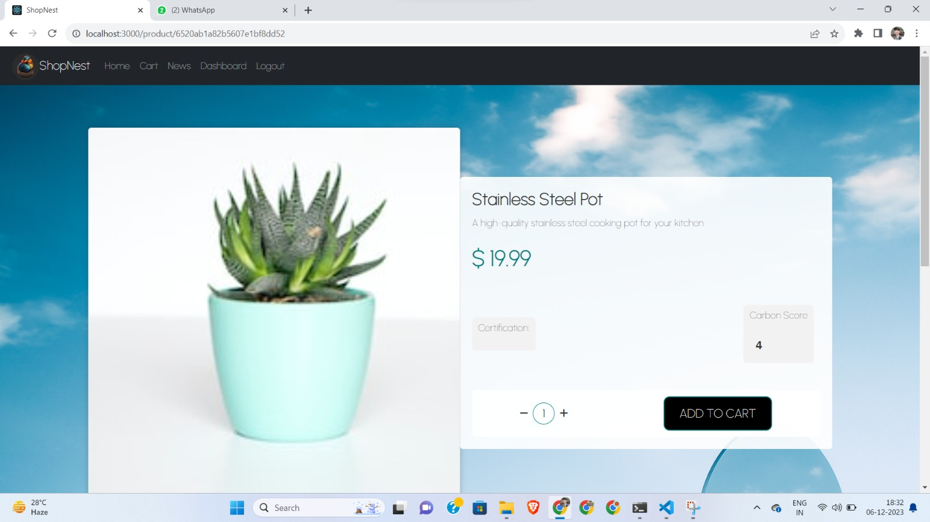

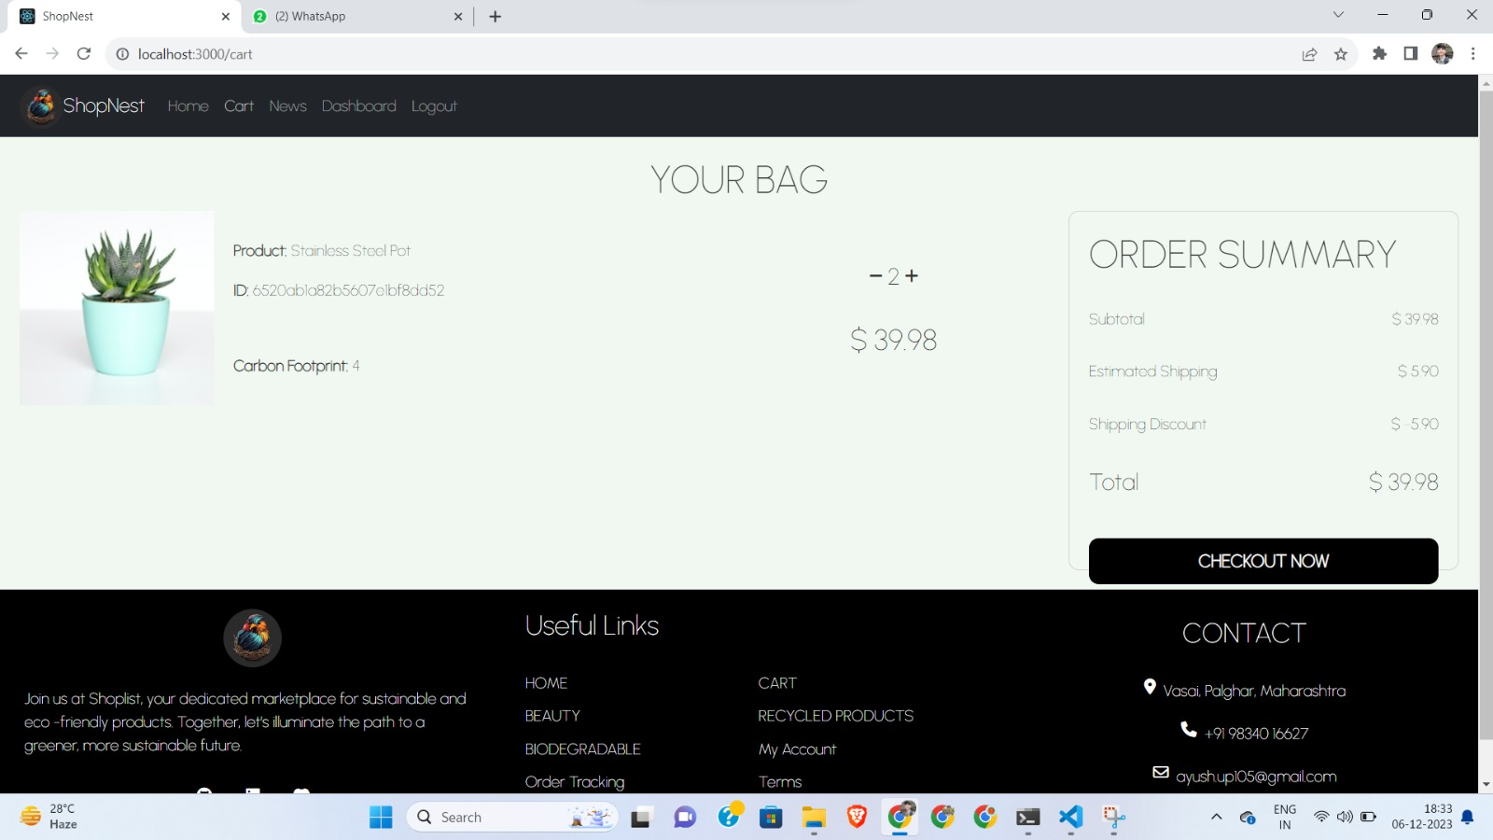

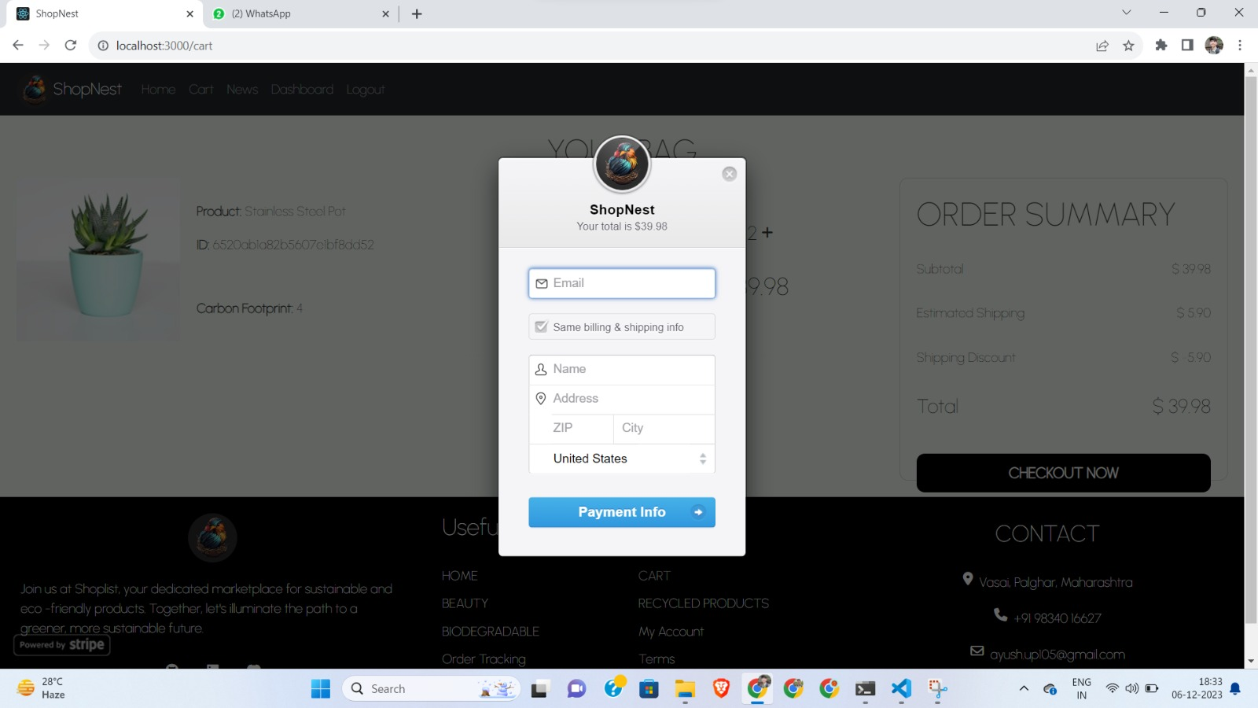

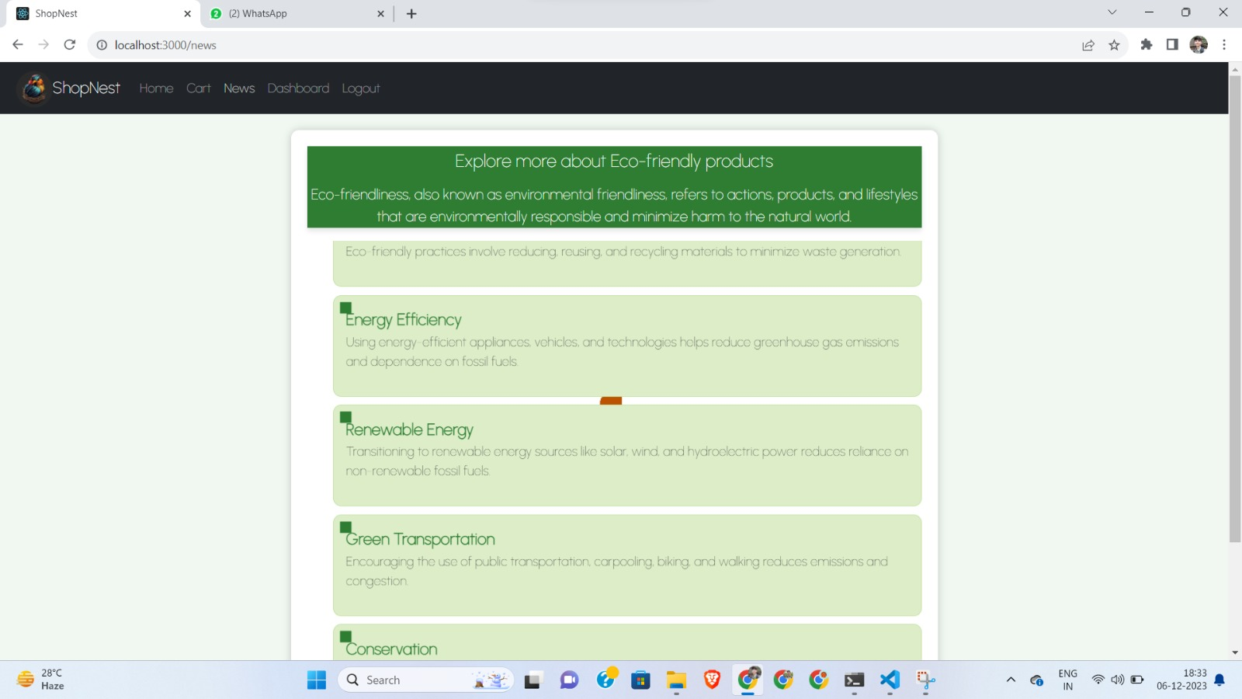

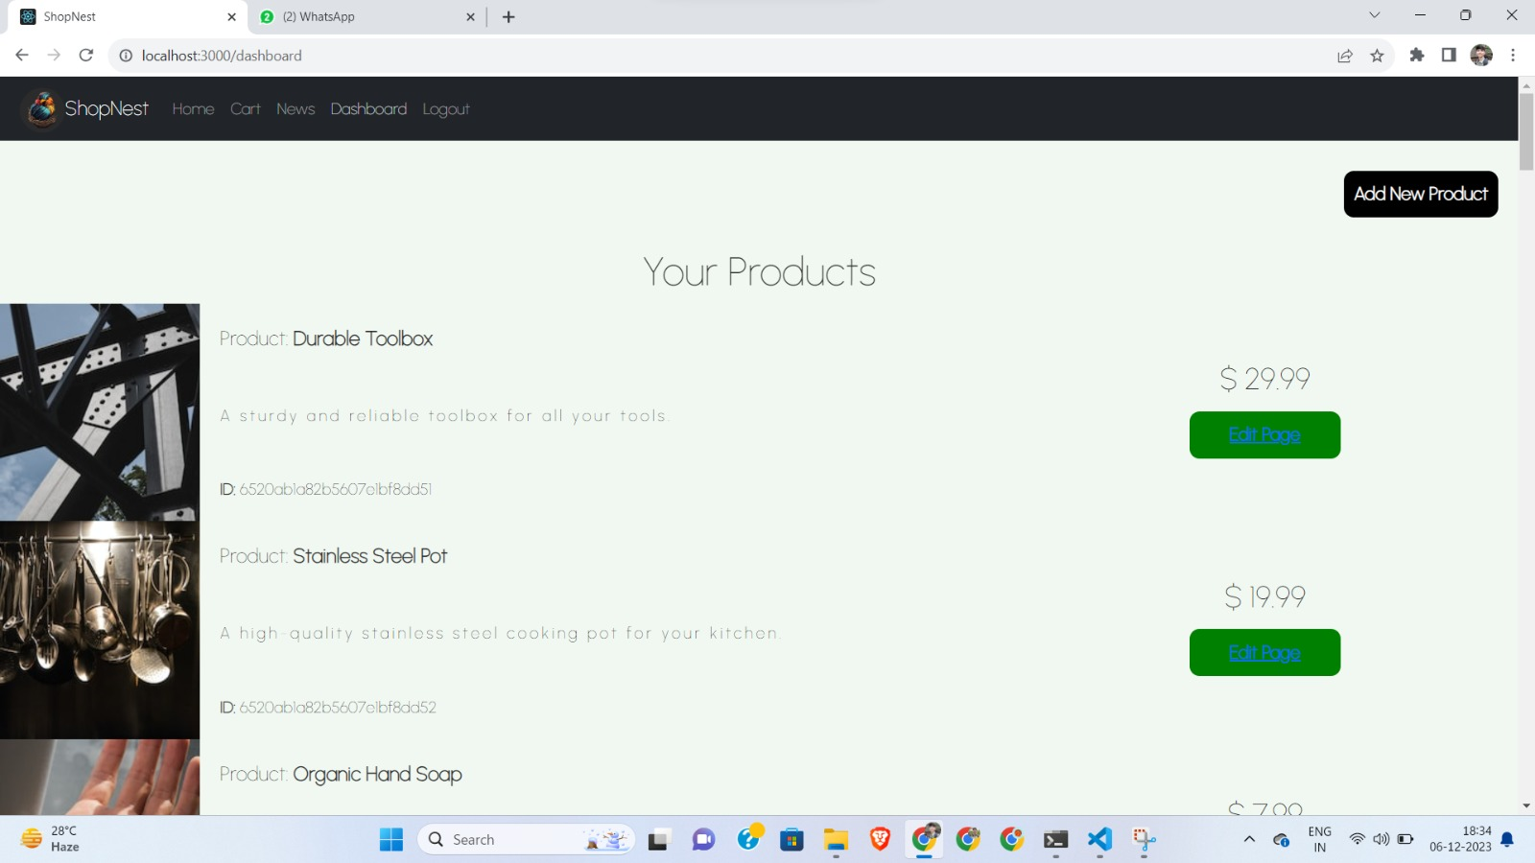

Github Link of the project: https://github.com/SujalChoudhari/DevDynasty