# Class: TY B.etch.-IT, Semester: VI Subject: Big Data Lab

**Experiment – 5: Programming exercises on Hadoop using Hive**

**Name: Anish Sharma Roll no:I011**

**Aim:** To perform programming exercise on Hive.

**Objectives:**

To understand Program applications using tools like Hive.

To implement Hive programming model.

**Outcomes:** After study of this experiment, the student will be able to Perform hands on Hive programming models.

**Prerequisite:** Core Java, Database concepts of SQL, Hadoop File system, and any of Linux operating system flavors.

**Requirements:** PC, Internet and VMWare software, Cloudera. **DDL Commands in Hive**

1. Start Hive hive
2. Create Database

CREATE DATABASE database_name;

1. Show Database Command in Hive

SHOW DATABASES;

1. Describe Database Command in Hive

DESCRIBE DATABASE database_name;

1. Alter Database Command in Hive

ALTER DATABASE database_name SET DBPROPERTIES ('property_name'='value');

1. Use Database Command in Hive

USE database_name;

1. Drop Database in Hive

DROP DATABASE database_name;

(If the database contains tables, use CASCADE to drop them as well)

DROP DATABASE database_name CASCADE;

1. Create Table Command in Hive CREATE TABLE table_name ( id INT, name STRING,

salary FLOAT

)

ROW FORMAT DELIMITED

FIELDS TERMINATED BY ',';

1. Describe Table Command in Hive

DESCRIBE table_name;

1. Drop Table Command in Hive

DROP TABLE table_name;

1. Alter Table Command in Hive

(Add a new column)

ALTER TABLE table_name ADD COLUMNS (department STRING);

1. Show Table Command in Hive

SHOW TABLES;

1. Insert Command in Hive

(For inserting values into a table)

INSERT INTO TABLE table_name VALUES (1, 'John', 50000.0);

1. Select Command in Hive

SELECT * FROM table_name;

1. Update Command in Hive

(Hive does not support UPDATE directly unless ACID properties are enabled. Instead, use

INSERT OVERWRITE to update records.)

INSERT OVERWRITE TABLE table_name SELECT * FROM table_name WHERE id != 1; INSERT INTO table_name VALUES (1, 'John', 55000.0); Output:

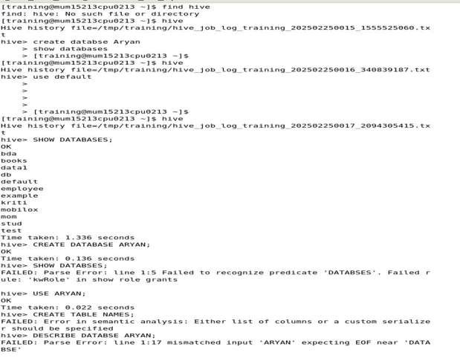

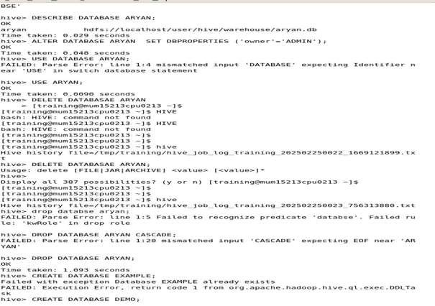

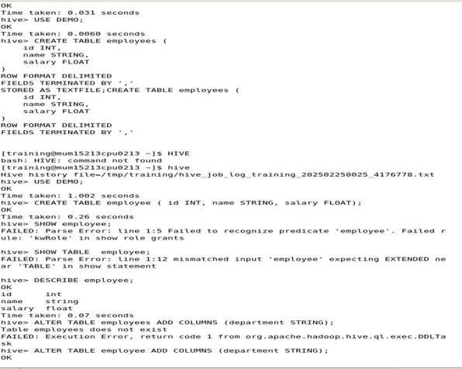

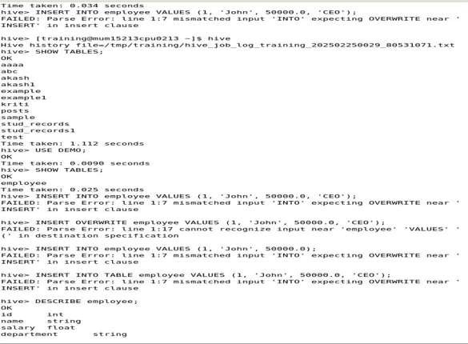

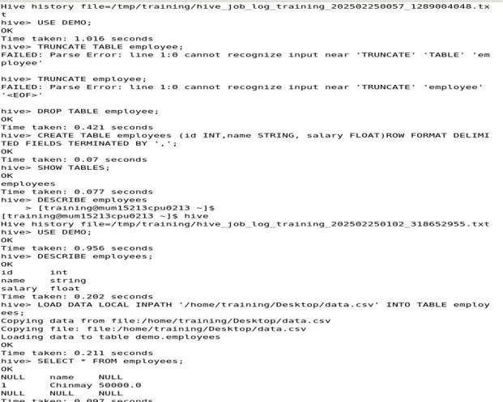

**B. Conclusion:**

In this experiment, various Hive commands were executed to understand database management in Hive. The operations included creating and using databases, creating and modifying tables, inserting and retrieving data, and performing table alterations and deletions. Additionally, challenges related to Hive’s syntax and constraints, such as issues with INSERT INTO, UPDATE, and DROP DATABASE CASCADE, were encountered and analyzed.

**c. References:**

* 1. **Link :-**<https://www.dezyre.com/hadoop-tutorial/hive-commands>
  2. [https://examples.javacodegeeks.com/enterprise-java/apache- hadoop/apache- hadoop-hive-tutorial/](https://examples.javacodegeeks.com/enterprise-java/apache-hadoop/apache-hadoop-hive-tutorial/)
  3. <https://www.javatpoint.com/hive>
  4. <https://www.tutorialspoint.com/hive/hive_introduction.htm>
  5. Alex Holmes “Hadoop in Practice”, Manning Press, Dreamtech Press.
  6. https[://www.dezyre.com/hadoop-tutorial/hive-commands](http://www.dezyre.com/hadoop-tutorial/hive-commands)