# Class: TY-IT, Semester: VI Subject: Big Data Lab

**Experiment – 6: TO STUDY AND IMPLEMENT PIG COMMANDS**

**Name: Anish Sharma Roll no:I011**

1. **Aim:** To study and implement Pig commands.

1. **Requirements:** PC, Internet and VMWare software, Cloudera.
2. **Theory:**

**Students need to write the theory on following points.**

* + Overview of Pig
  + Features of Pig

1. **Procedure**

Open VMWare Workstation > select Cloudera > open virtual machine > in terminals

Perform the Pig commands.

(Minimum 20 commands should be executed)

1.

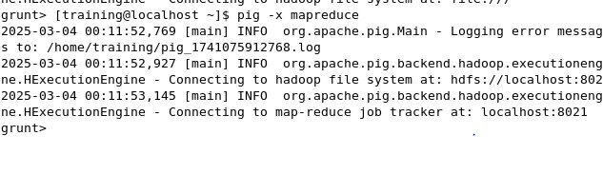

2.students = LOAD 'student_data.txt' USING PigStorage(',') AS (id:int, name:chararray, marks:int);

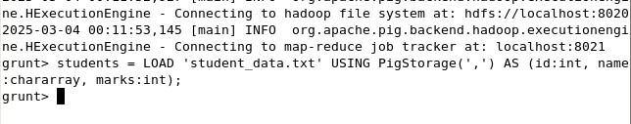

3.dump

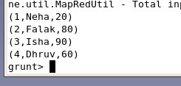

4.high_salary = FILTER data BY salary > 50000;

DUMP high_salary;

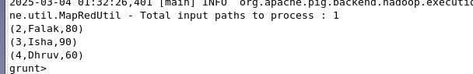

5.name_salary = FOREACH data GENERATE name, salary; DUMP name_salary;

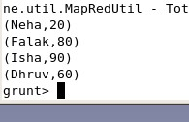

6.max_salary = FOREACH (GROUP data ALL) GENERATE MAX(data.salary); DUMP max_salary;



7.sorted_salaries = ORDER data BY salary DESC;

DUMP sorted_salaries;

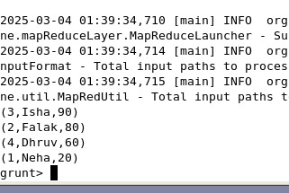

8.avg_salary = FOREACH (GROUP data ALL) GENERATE AVG(data.salary); DUMP avg_salary;

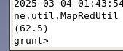

9.min_salary = FOREACH (GROUP data ALL) GENERATE MIN(data.salary); DUMP min_salary;

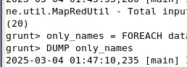

min_salary = FOREACH (GROUP data ALL) GENERATE MIN(data.salary); DUMP min_salary;

10.only_names = FOREACH data GENERATE name;

DUMP only_names;

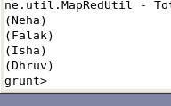

11.low_salary = FILTER data BY salary < 30000;

DUMP low_salary;

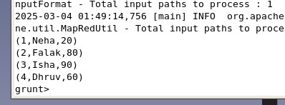

12.i_names = FILTER data BY name MATCHES 'I.*';

DUMP i_names;



13.

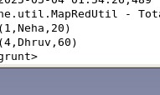

14.

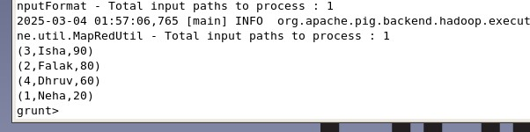

1. **Result/Observation/Program code**

Take the snapshots of each successfully executed commands and with the explanation along with syntax.

1. **Conclusion:**

▪ Write what was performed in the experiment.

▪ Mention few applications of what was studied.

▪ Write the significance of the topic studied in the experiment.

**Resources :**

<https://pig.apache.org/docs/latest/basic.html>

<https://pig.apache.org/docs/latest/start.html><https://www.educba.com/pig-commands/>