Sap id:60003220045



# Department of Information Technology A.Y. 2024-2025

## Class: TY Btech-IT, Semester: VI Subject: Big Data Lab

**Experiment – 7: Programming exercises in NoSQL**

**Name:Anish Sharma Div:IT-1_I011**

1. **Aim:** To perform NoSQL Database Operation.

1. **Objectives:** 
   * To understand NoSQL type of database
   * To implement mongodb and handle unstructured database.

1. **Outcomes:** After study of this experiment, the student will be able to
   * Store and retrieve different types of data in mongodb.
   * Understand the importance of NoSQL.
2. **Prerequisite:** NoSQL, Mongodb.
3. **Requirements:** PC,Internet and MongDB.
4. **Brief Theory:**

**Students need to write the theory of following points.**

* 1. Features of Mongodb
  2. Advantages of MongoDB over RDBMS

1. **Laboratory Exercise**

Execute Minimum 20 commands. Example of which are given below. Also include CRUD commands

* + To see the list of databases in the system:

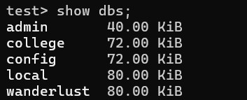

* + To select a database.

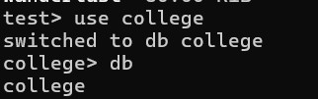

* + To find out the currently selected database:



Sap id:60003220244

* + To delete / drop a database then do this:

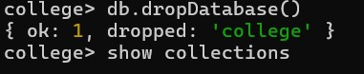

* + To see the collections in a database:



* + Create a new database named "Exam":

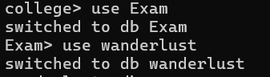

* + To read data from collection

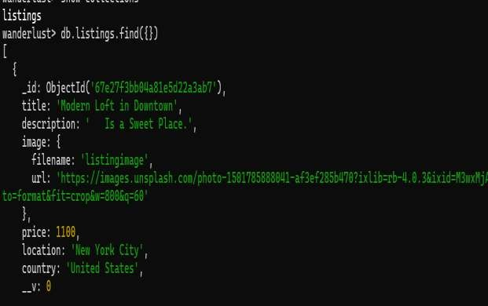

Sap id:60003220244

Remove an entry from the database



* + To get a count of entries in a database



* + Updating a entry
  + To drop a database from the data-set



* + 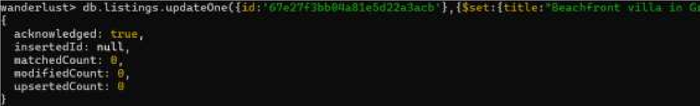Using where condition to find data

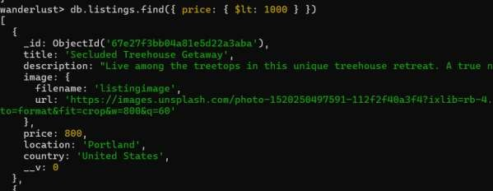

* + Using function findOne()

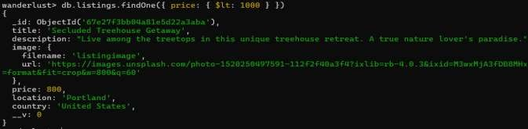

Sap id:60003220244

Equal query

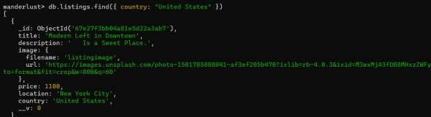

Conclusion:We learnt the implementation of mongosh command.