**DEPARTMENT OF INFORMATION**

**TECHNOLOGY**

**COURSE CODE: DJS22ITHN1L1 DATE: 31-01-2025**

**COURSE NAME: DevOps Laboratory CLASS: TY BTech**

**NAME: Anish Sharma ROLL: I011 DIV: IT1-1**

**EXPERIMENT NO. 1**

**CO/LO: Apply DevOps principles to meet software development requirements.**

**AIM / OBJECTIVE: To understand Version Control System / Source Code Management, install git and create a GitHub account**

**THEORY:**

A Version Control System is a tool you use to track, make, and manage changes to your software code. It's also called source control.

A version control system helps developers store every change they make to a file at different stages so they and their teammates can retrieve those changes at a later time.

There are three types of version control systems, which are:

* Local Version Control Systems • Centralized Version Control Systems
* Distributed Version Control Systems.

**What is a Local Version Control System (LVCS)?**

Version Control Systems (VCS) are essential tools in software development, enabling teams to track changes, collaborate efficiently, and maintain code integrity. There are three primary types of VCS: Local, Centralized, and Distributed.

**Local Version Control System (LVCS):** In an LVCS, developers manage versioning on their individual machines. This involves keeping multiple copies of files in different directories to track changes. While simple, this method is prone to errors and lacks collaboration features, making it less suitable for team environments.

**What is a Centralized Version Control System (CVCS)?**

**Centralized Version Control System (CVCS):** A CVCS uses a central server to store all file versions. Developers commit their changes directly to this central repository. This setup provides a unified view of the project and facilitates collaboration. However, it has a single point of failure; if the server becomes unavailable, developers cannot access the repository or commit changes. Examples of CVCS include Subversion (SVN) and Perforce.

**What is a Distributed Version Control System (DVCS)?**

**Distributed Version Control System (DVCS):** In a DVCS, each developer has a complete copy of the repository, including its full history, on their local machine. This allows for offline work and provides redundancy; if a central server fails, any local repository can restore the system. DVCS supports complex workflows and enhances collaboration through features like branching and merging. Git is a prominent example of a DVCS.

**What is Git?**

**Git:** Git is a distributed version control system that enables developers to track changes, manage branches, and collaborate on projects efficiently. Its distributed nature allows each user to have a full copy of the repository, facilitating offline work and robust version tracking. Git has become the de facto standard for version control in modern software development.

**What is GitHub?**

**GitHub:** GitHub is a web-based platform built upon Git. It provides a user-friendly interface for repository hosting, along with additional features like issue tracking, code reviews, and project management tools. GitHub enhances collaboration by allowing developers to share repositories, contribute to open-source projects, and integrate with various services to streamline the development workflow.

**Git Commands**[**(https://git-scm.com/docs-all**](https://git-scm.com/docs-all) **commands) Observation:**

**Kanban Board:**

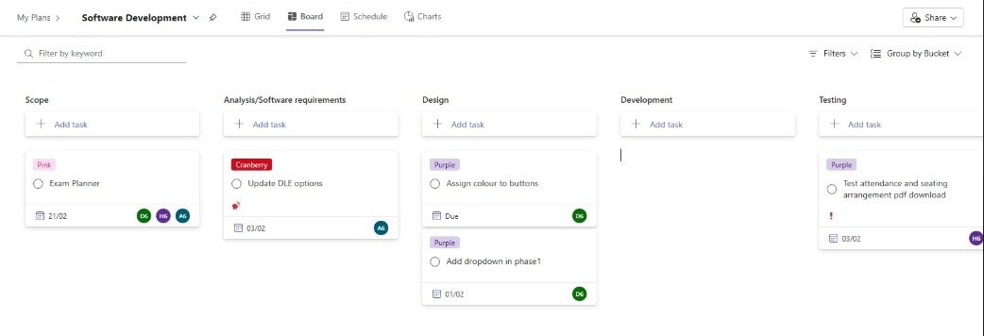

**Git Commands:**

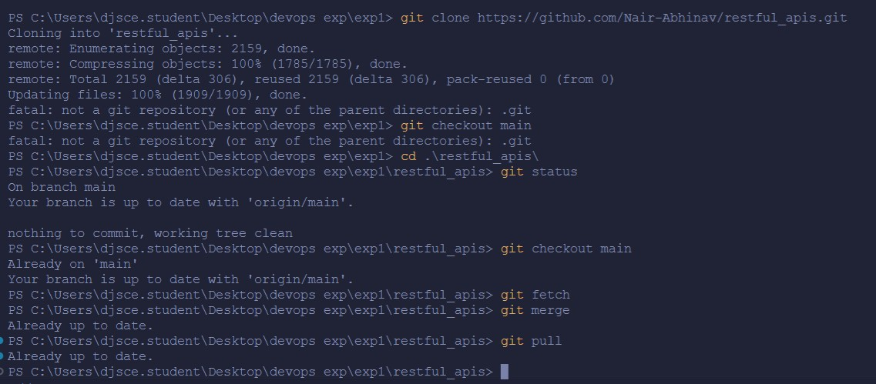

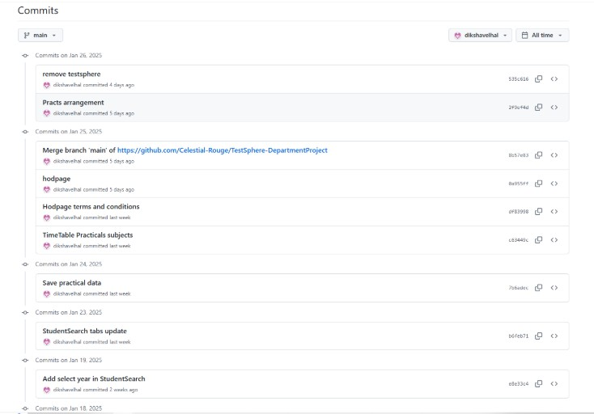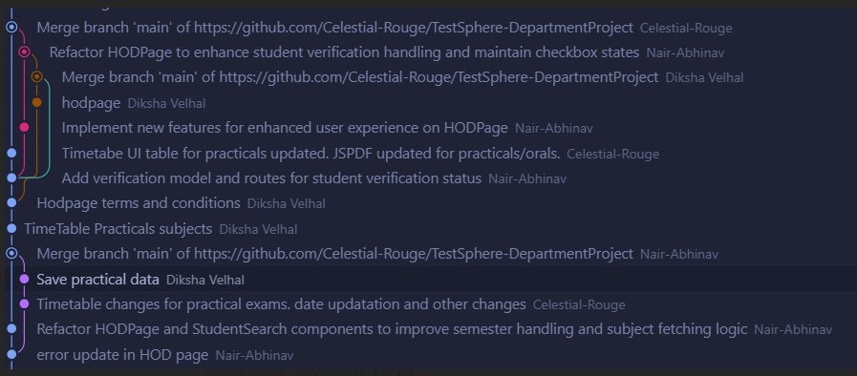

**Conclusion:**

In this experiment, we understood Version Control System / Source Code Management, install git and create a GitHub account.

**References:**

1. [How to Use Git and GitHub – Version Control Basics for Beginners (freecodecamp.org)](https://www.freecodecamp.org/news/git-and-github-the-basics/)
2. [Version Control Systems - GeeksforGeeks](https://www.geeksforgeeks.org/version-control-systems/)
3. [VCS Program Details - Verra](https://verra.org/programs/verified-carbon-standard/vcs-program-details/)