# DEPARTMENT OF INFORMATION TECHNOLOGY

**COURSE CODE: DJS22ITHN1L1 DATE: 31-01-2025**

**COURSE NAME: DevOps Laboratory CLASS: TY BTech**

**NAME: Anish Sharma ROLL: I011 DIV: IT1-1**

# EXPERIMENT NO. 2

**CO/LO: Apply DevOps principles to meet software development requirements.**

**AIM / OBJECTIVE: To perform various GIT operations on local and Remote repositories**

**THEORY:**

**What is Git?**

**Git:** Git is a distributed version control system that enables developers to track changes, manage branches, and collaborate on projects efficiently. Its distributed nature allows each user to have a full copy of the repository, facilitating offline work and robust version tracking. Git has become the de facto standard for version control in modern software development.

**What is GitHub?**

**GitHub:** GitHub is a web-based platform built upon Git. It provides a user-friendly interface for repository hosting, along with additional features like issue tracking, code reviews, and project management tools. GitHub enhances collaboration by allowing developers to share repositories, contribute to open-source projects, and integrate with various services to streamline the development workflow.

**Git Commands**[**(https://git-scm.com/docs-all**](https://git-scm.com/docs-all) **commands) Git Commands:**

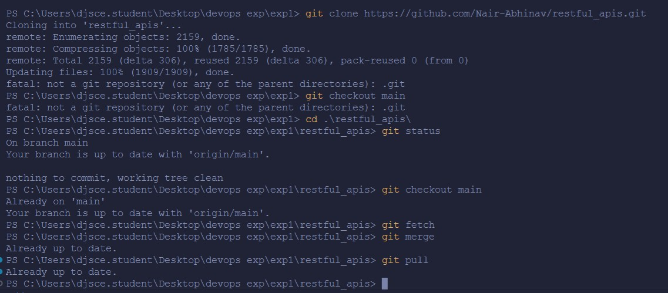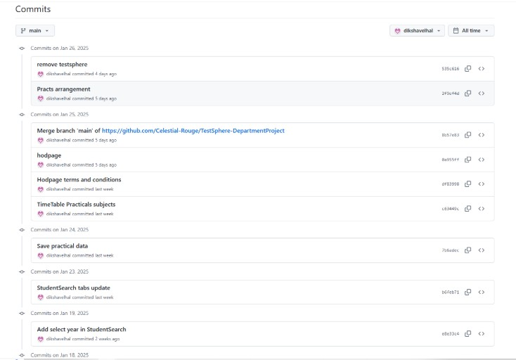

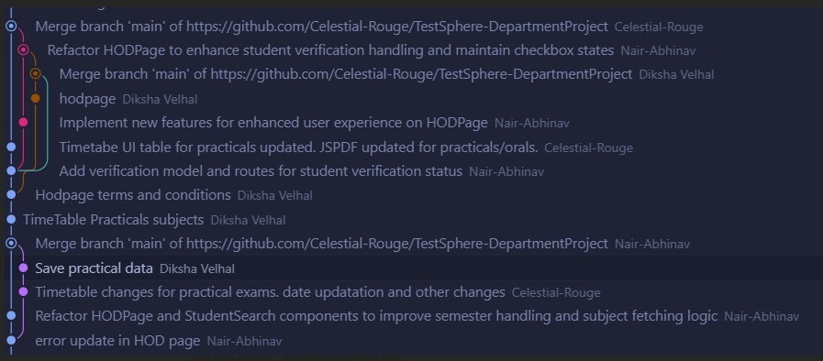

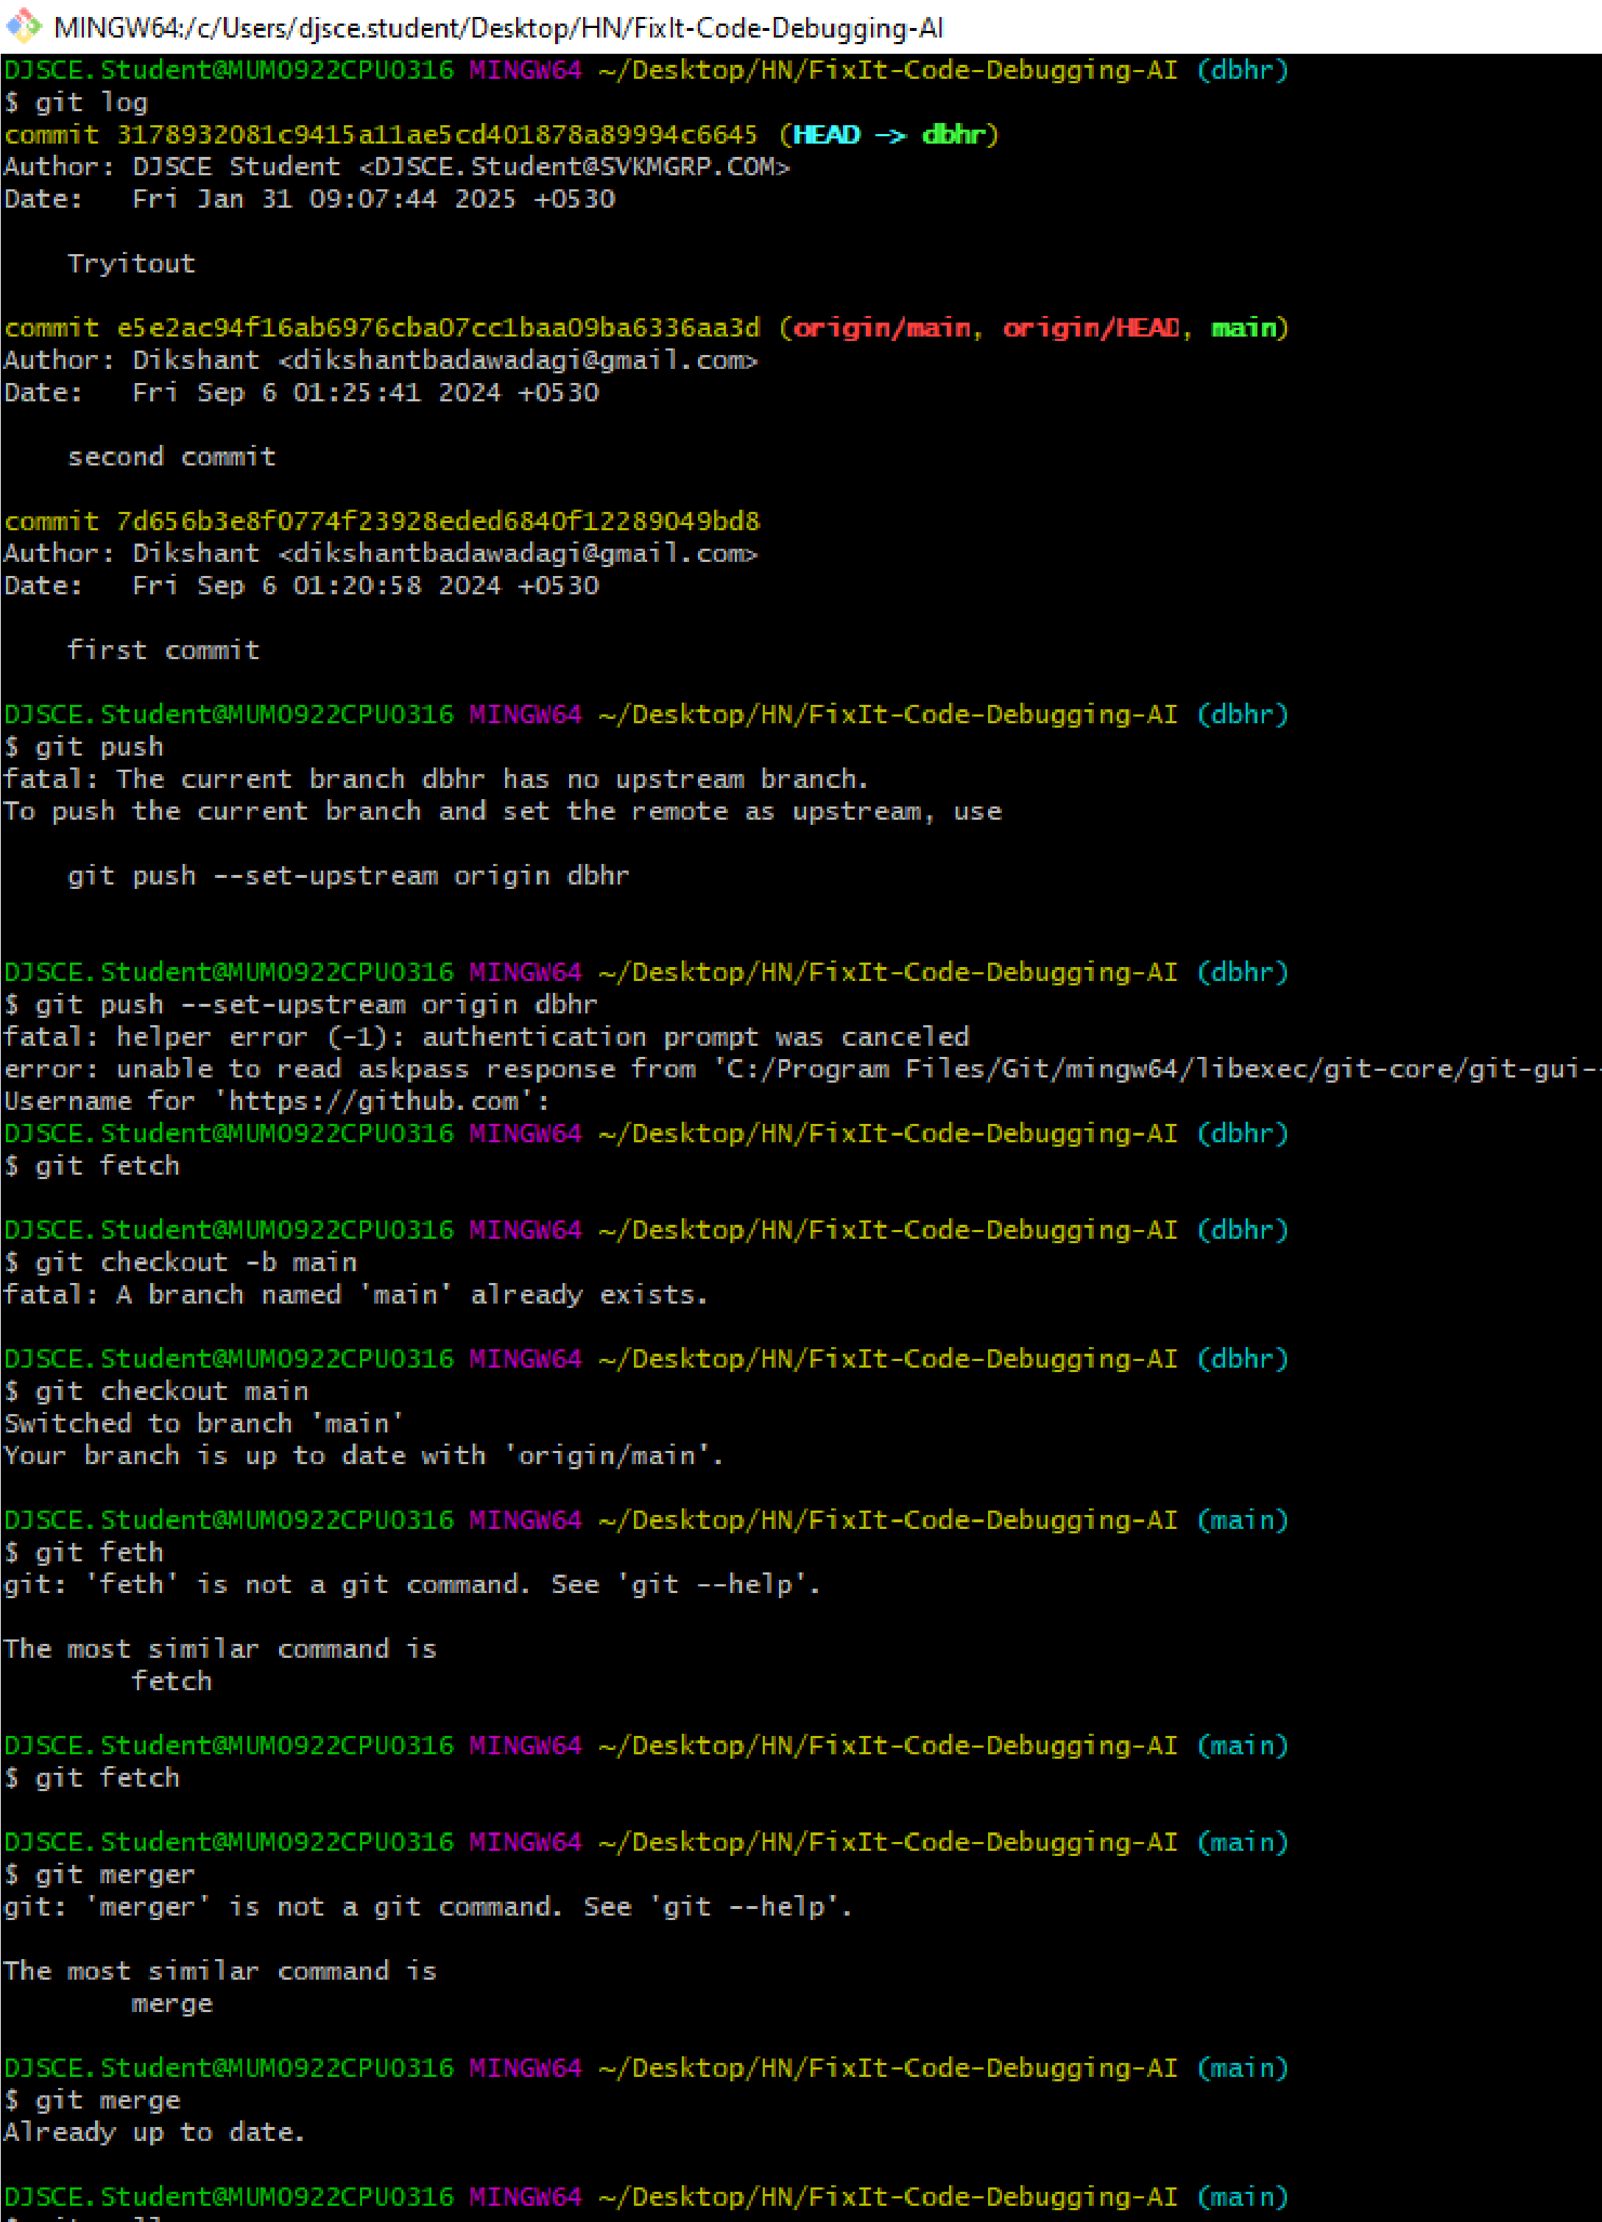

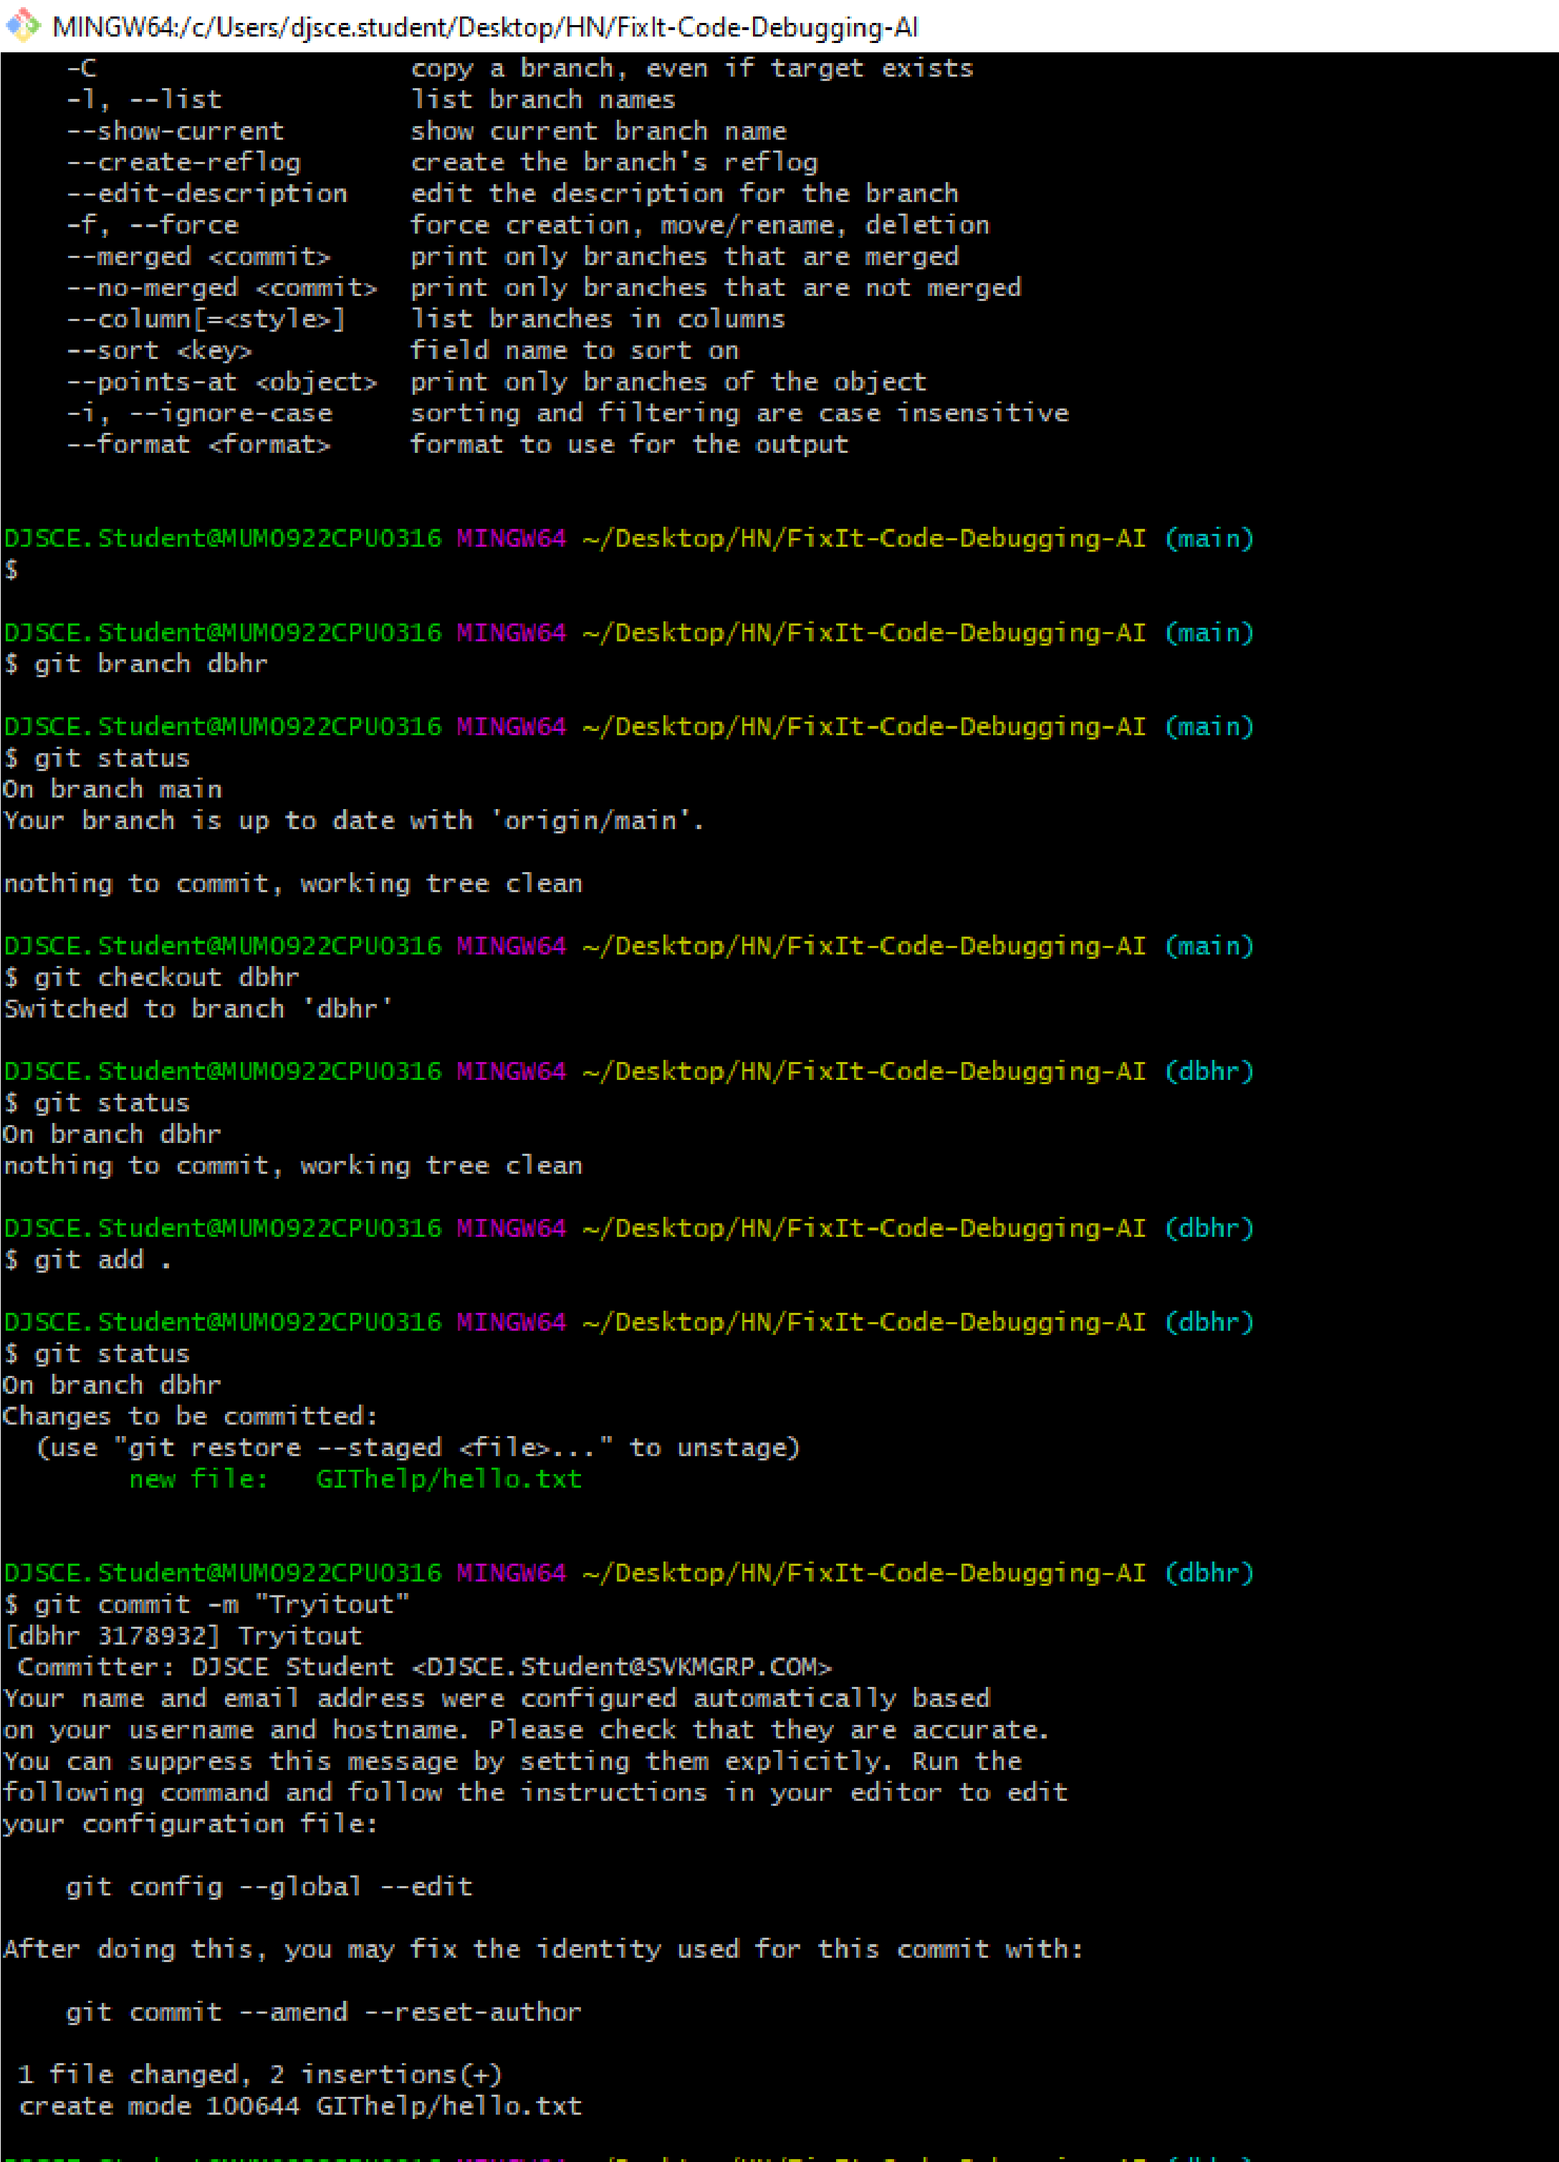

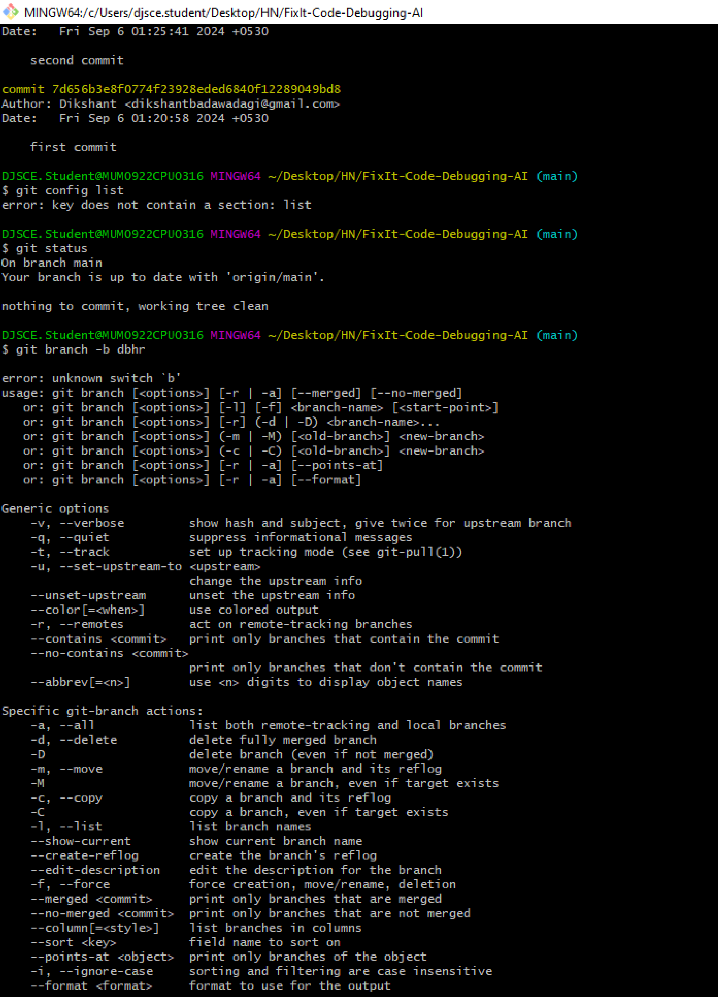

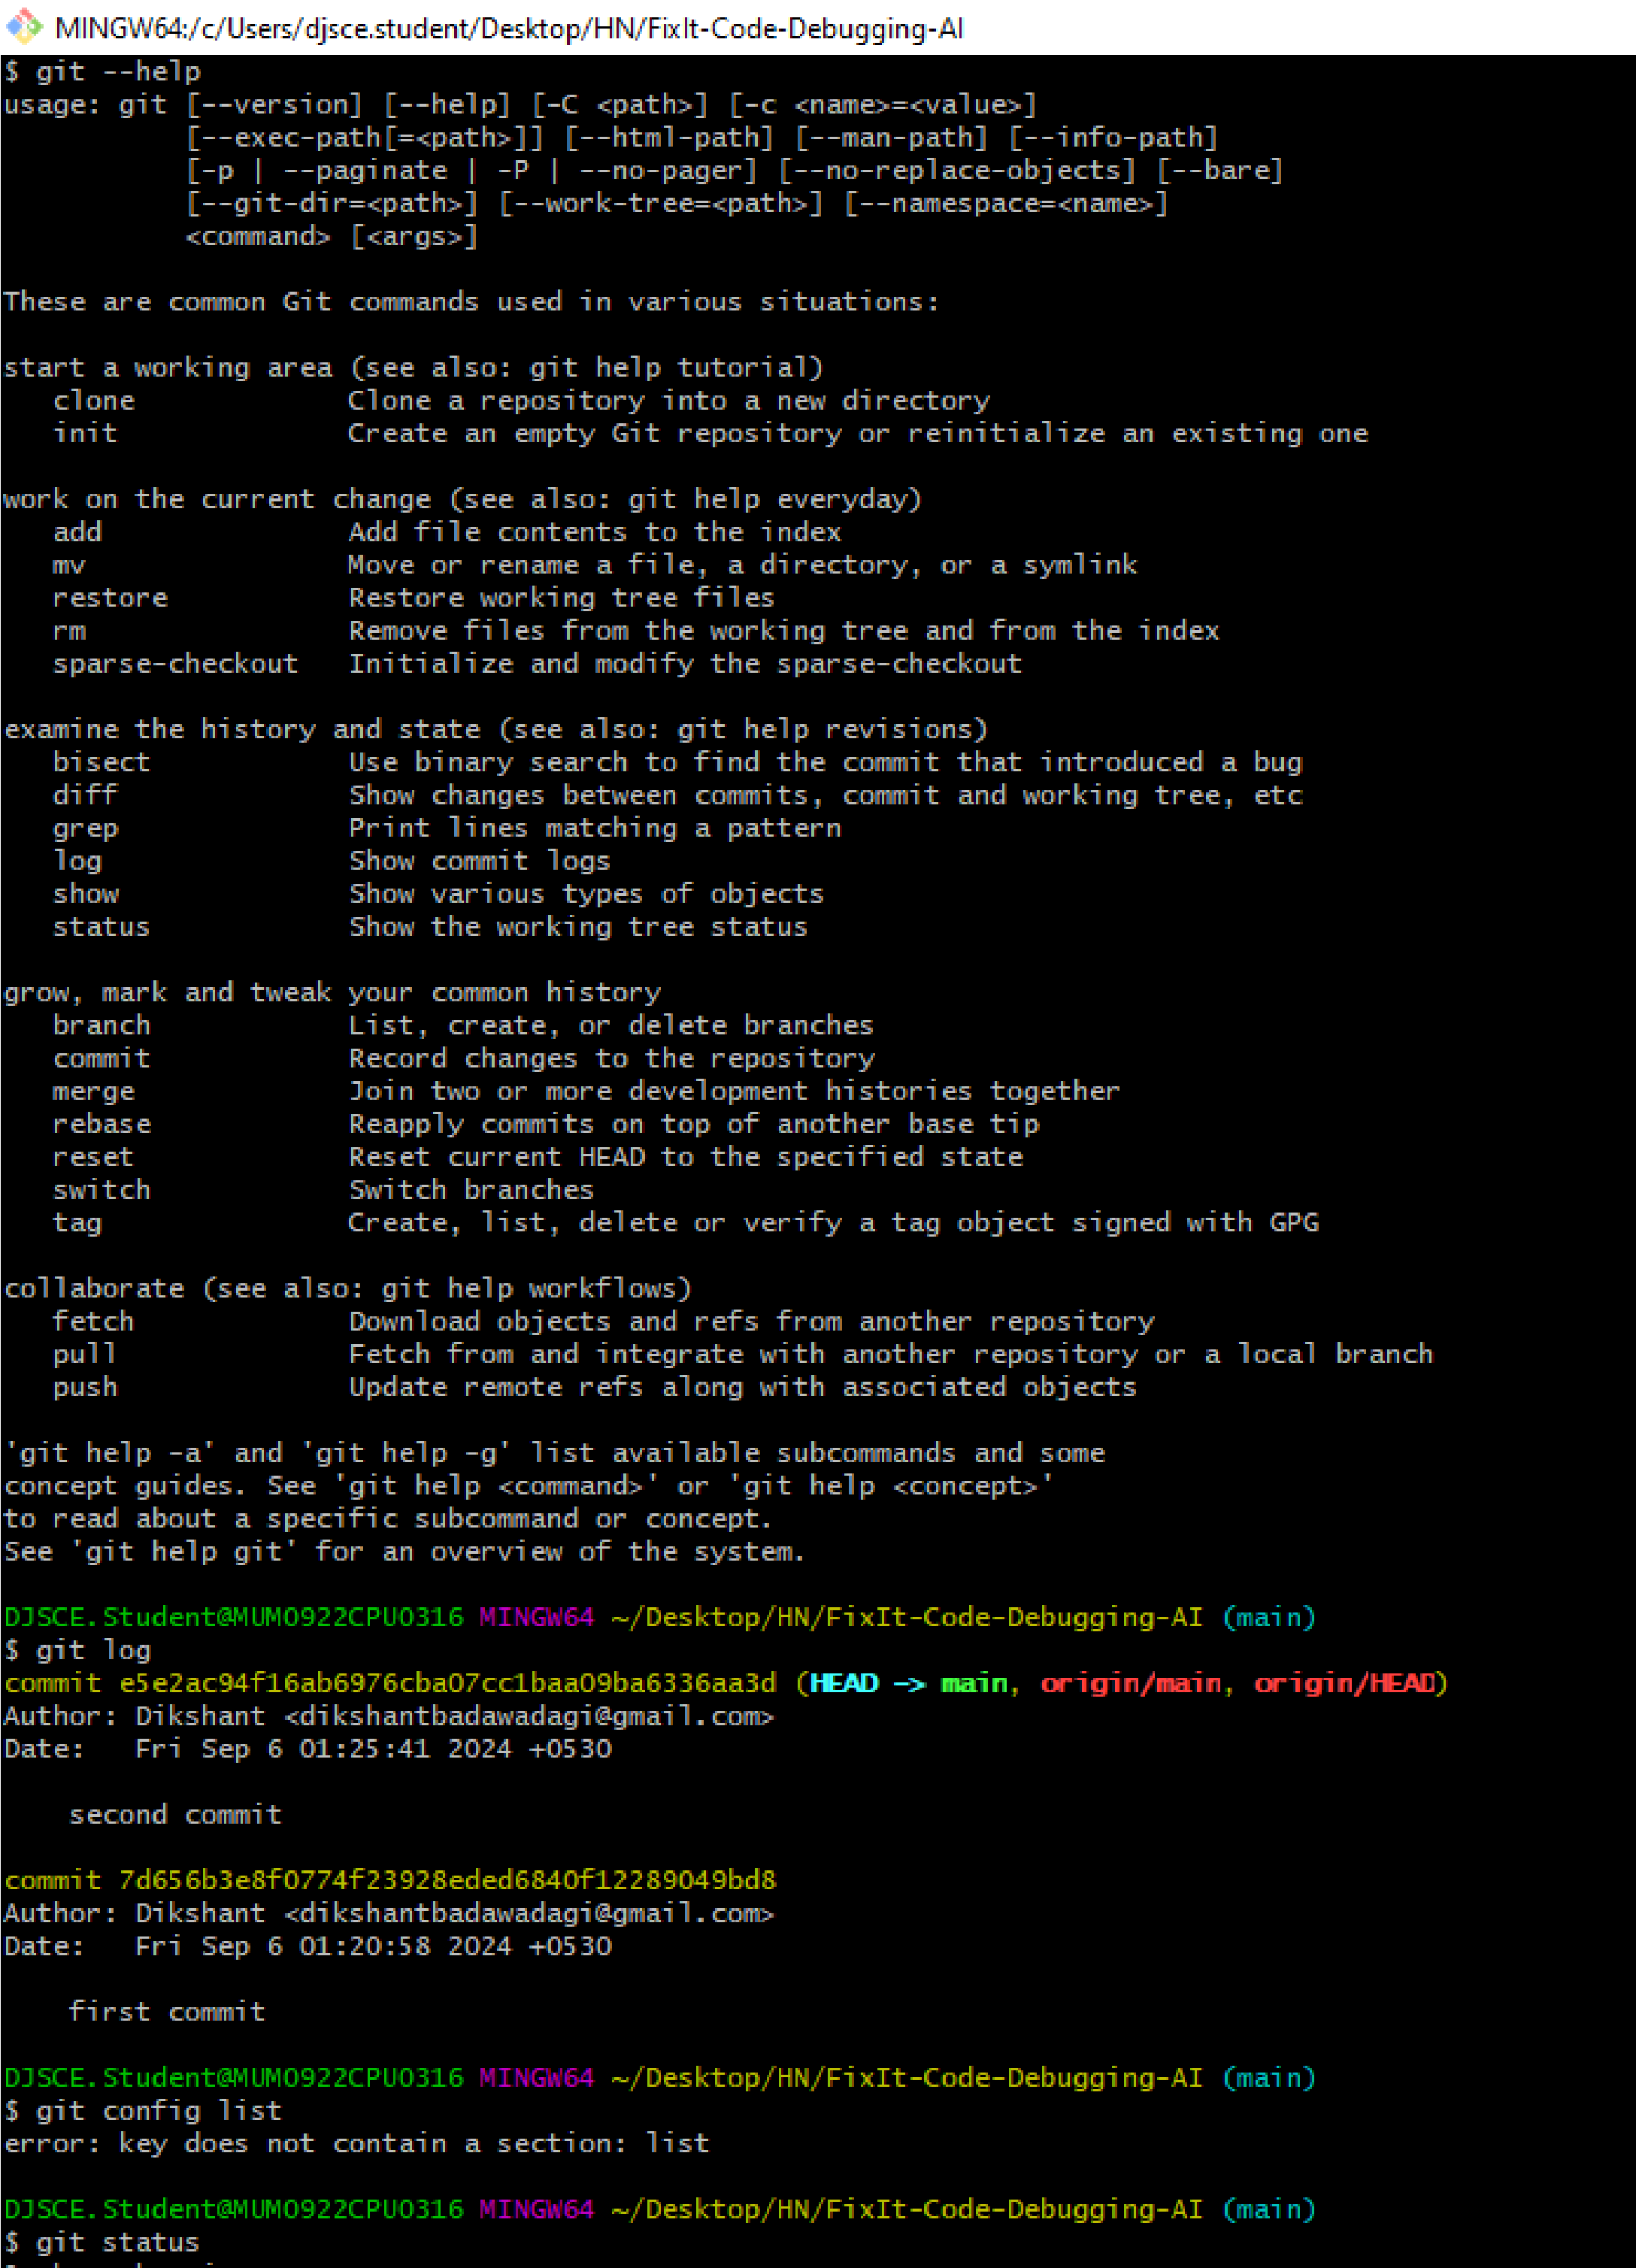

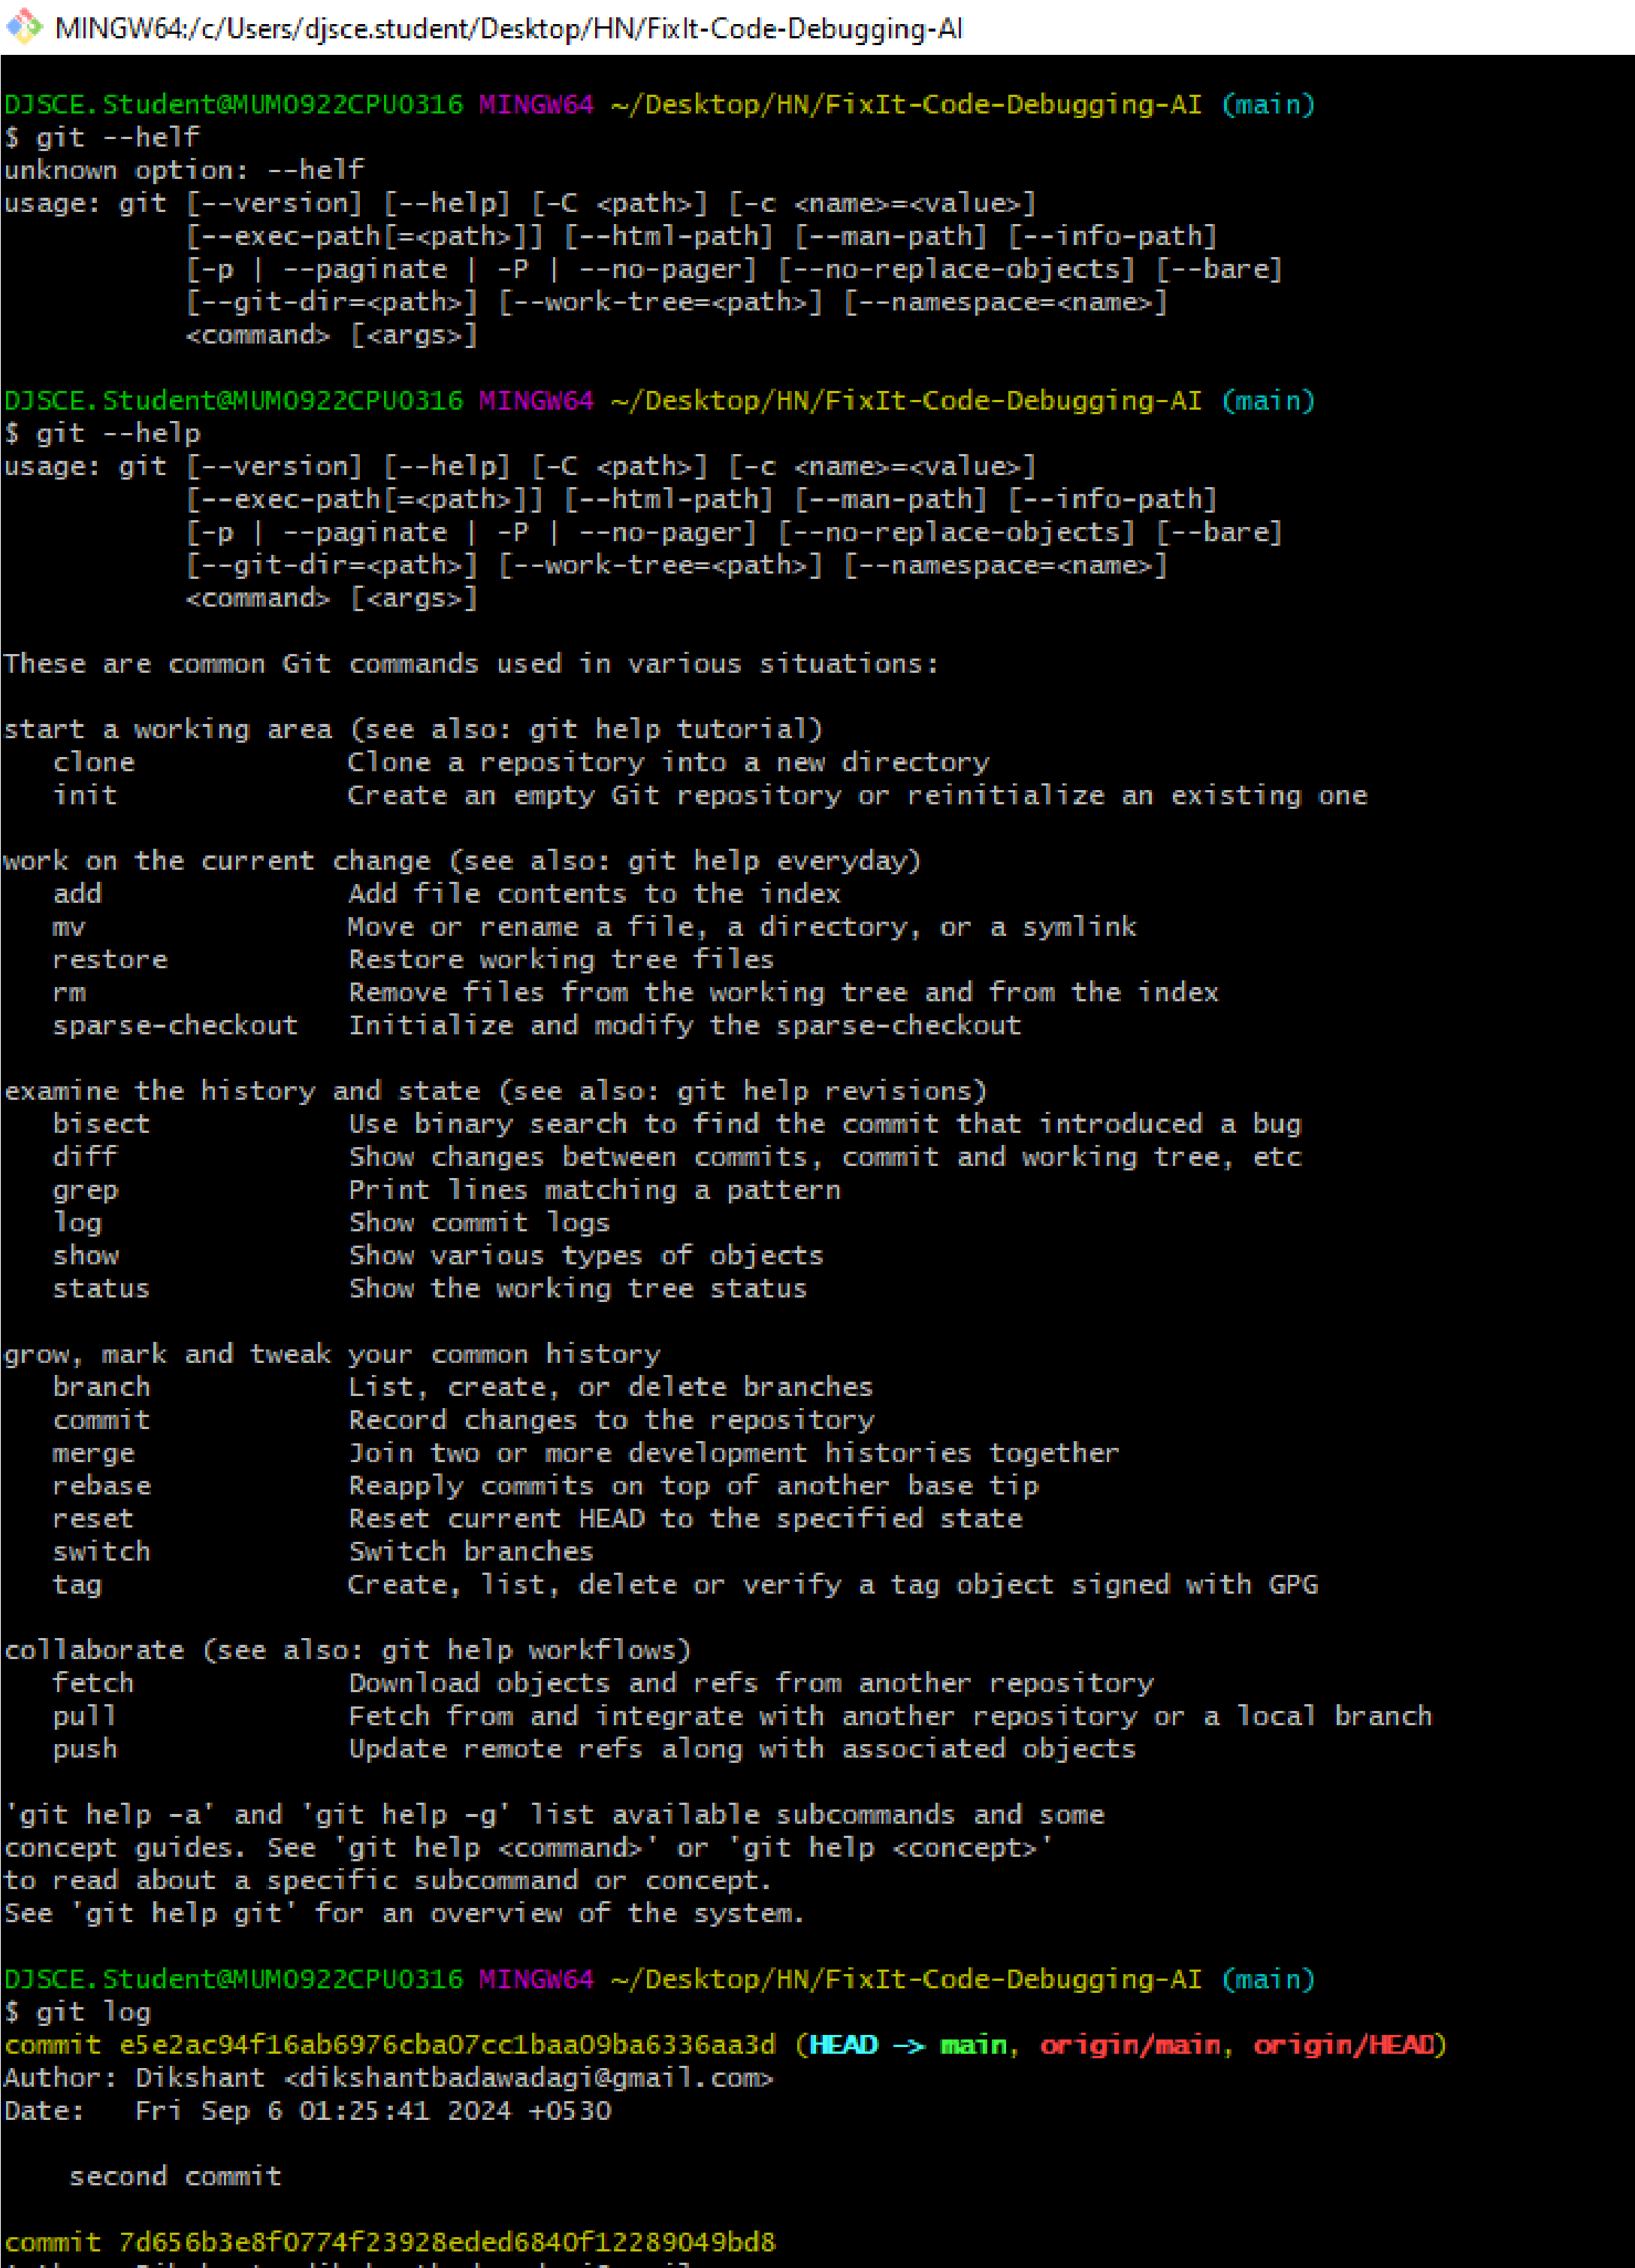

**Conclusion:**

In this experiment, we understood Version Control System / Source Code Management, install git and create a GitHub account.

**References:**

1. [How to Use Git and GitHub – Version Control Basics for Beginners (freecodecamp.org)](https://www.freecodecamp.org/news/git-and-github-the-basics/)
2. [Version Control Systems - GeeksforGeeks](https://www.geeksforgeeks.org/version-control-systems/)
3. [VCS Program Details - Verra](https://verra.org/programs/verified-carbon-standard/vcs-program-details/)