# DEPARTMENT OF INFORMATION TECHNOLOGY

**COURSE CODE: DJS22ITHN1L1 DATE: 06-03-2025**

COURSE NAME: DevOps Laboratory CLASS: TY NAME: Anish Sharma ROLL: I011 DIV: IT1-1

# EXPERIMENT NO. 3

CO/LO: Apply DevOps principles to meet software development requirements.

AIM / OBJECTIVE: To install Jenkins and perform Java and Python Programs.

THEORY:

**Installing Jenkins and Running Java & Python Programs**

**1. Install Jenkins**

* **Prerequisite:** Install Java (JDK).
  + Windows/Linux/macOS: Install OpenJDK (sudo apt install openjdk-11-jdk for Ubuntu).
* **Install Jenkins:**
  + Windows: Download from [Jenkins official site](https://www.jenkins.io/).

**2. Running Java & Python Programs in Jenkins**

* **For Java:** Add a Jenkins job with javac Program.java && java Program
* **For Python:** Use python3 script.py in Jenkins job configuration.

Jenkins automates execution, making CI/CD easier.

OUTPUT:

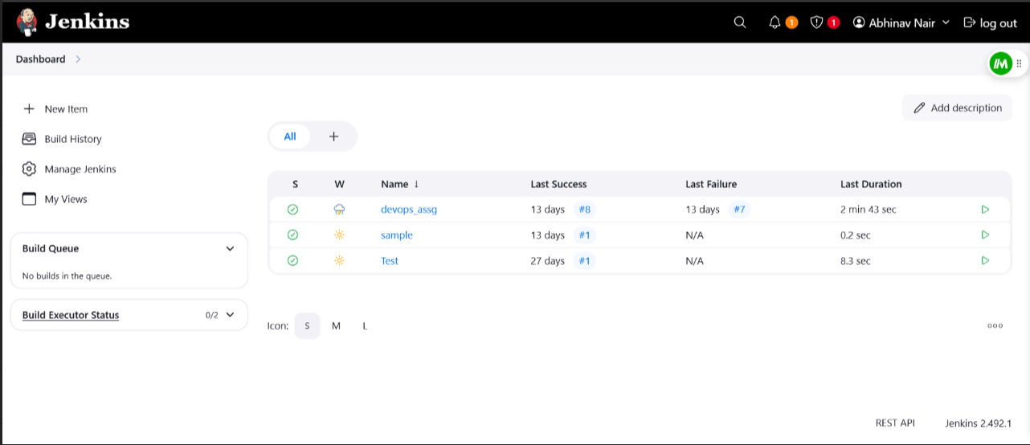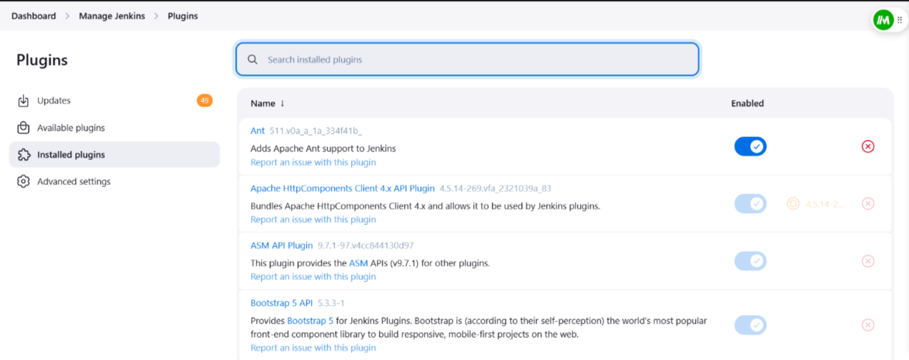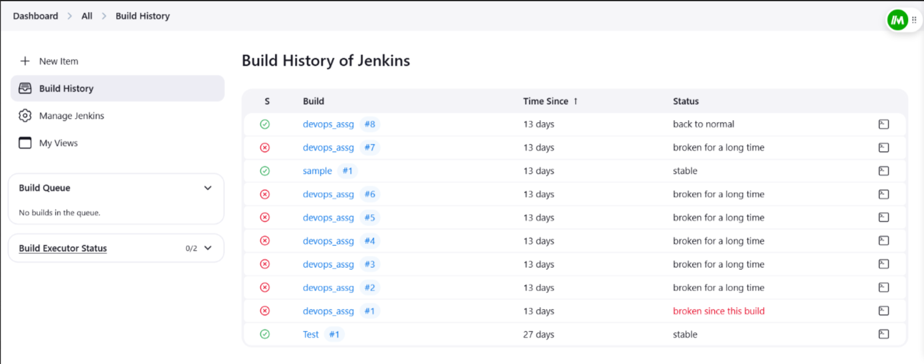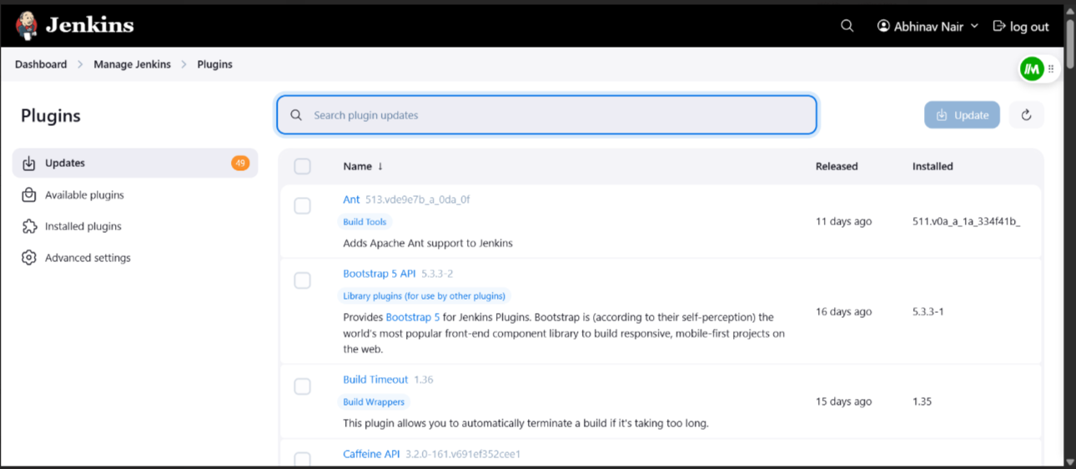

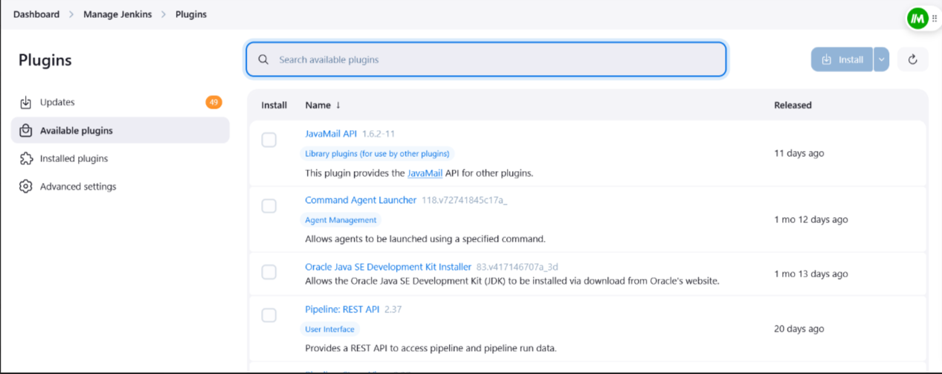

CONCLUSION:

Jenkins is a powerful automation tool that simplifies Continuous Integration and Deployment (CI/CD). By installing Jenkins and configuring it to run Java and Python programs, developers can automate builds, testing, and execution efficiently. This enhances productivity, reduces manual effort, and ensures consistency in software development workflows.