|  |  |
| --- | --- |
| **COURSE CODE: DJS22ITL604** | **DATE: 28-01-2025** |
| **COURSE NAME: Full Stack Web Development Laboratory** | **CLASS: TYBTech** |
| **NAME: ANISH SHARMA ROLL: I011** | **DIV: IT1-1** |

**EXPERIMENT NO. 01**

**CO/LO: CO1-Develop a full stack web application.**

**AIM / OBJECTIVE:** Setting Up MERN Stack Environment Install necessary software/tools and verify basic functionality for each component.

**THEORY**:

The MERN stack is a popular JavaScript-based web development framework used to build full-stack applications. It stands for:

* **M**: MongoDB (Database) A NoSQL database for storing application data in a flexible, JSON- like format.
* **E**: Express.js (Backend Framework) A lightweight web application framework for Node.js, used to build server-side applications.
* **R**: React.js (Frontend Framework) A JavaScript library for building dynamic, responsive user interfaces.
* **N**: Node.js (Runtime Environment) A JavaScript runtime environment for executing server- side code.
* **SQL Databases Vs NoSQL Databases:**

|  |  |
| --- | --- |
| **SQL Databases** | **NoSQL Databases** |
| Relational databases with a structured schema (e.g., MySQL, PostgreSQL). | Non-relational databases designed for flexibility and scalability (e.g., MongoDB, CouchDB) |
| Data is stored in tables with rows and columns | Data is stored in formats like JSON, key- value pairs, or graphs |
| Suitable for applications requiring ACID  (Atomicity, Consistency, Isolation,  Durability) properties | Ideal for applications with unstructured or semi-structured data |

**Basic MongoDB Operations**

* + **Create**: Insert new documents into a collection.
  + **Read**: Retrieve documents from a collection.
  + **Update**: Modify existing documents.
  + **Delete**: Remove documents from a collection.

**Key Components of the MERN Stack**

1. **MongoDB (Database Layer)** 
   * **Purpose**: Stores application data in a flexible, document-oriented, NoSQL format.
   * **Key Features**:
     + - Stores data in JSON-like documents.
       - Scalable and supports distributed databases.
       - Allows for easy integration with Node.js applications via libraries like Mongoose.
   * **Role in MERN**: Acts as the database to persist application data.
2. **Express.js (Backend Framework)** 
   * **Purpose**: A lightweight, flexible web application framework for Node.js.
   * **Key Features**:
     + Simplifies the process of building APIs and managing server logic.
     + Supports middleware to handle HTTP requests, responses, and errors.
     + Integrates seamlessly with MongoDB for database operations.
   * **Role in MERN**: Handles routing, server-side logic, and API endpoints.
3. **React.js (Frontend Framework)** 
   * **Purpose**: A JavaScript library for building user interfaces.
   * **Key Features**:
     + Component-based architecture for reusable UI elements.
     + Virtual DOM for efficient updates and rendering.
     + Strong community support and extensive ecosystem.
   * **Role in MERN**: Builds the dynamic, responsive user interface (frontend).
4. **Node.js (Runtime Environment)** 
   * **Purpose**: Executes JavaScript code on the server side.
   * **Key Features**:
     + Built on Chrome's V8 engine for fast execution.
     + Non-blocking, event-driven architecture for handling concurrent requests.
     + Enables the use of JavaScript for both client and server sides.
   * **Role in MERN**: Provides the runtime environment for running the server-side application.

**How MERN Architecture Works**

1. **Frontend (React)**:

* + - The user interacts with the React.js frontend, which renders components and handles user actions.
    - React communicates with the backend via HTTP requests to perform CRUD operations.

2. **Backend (Express and Node.js)**:

* + - Express.js, running on Node.js, handles incoming requests, processes business logic, and routes the requests to the appropriate endpoints.
    - It also handles communication with the MongoDB database for data storage and retrieval.

3. **Database (MongoDB)**:

* + - MongoDB stores application data in collections as JSON-like documents.
    - The backend uses libraries like Mongoose to perform database operations efficiently.

4. **Data Flow**:

* + - The React frontend sends API requests to the Express.js server.
    - Express processes these requests and interacts with MongoDB for any required data. o The server returns the requested data or status to the frontend, which updates the user interface dynamically.

**Prerequisites**

# • Install Node.js: <https://nodejs.org/>• Install MongoDB:<https://www.mongodb.com/try/download/community>

• Install a code editor (e.g., Visual Studio Code):<https://code.visualstudio.com/>

**DEPARTMENT OF INFORMATION TECHNOLOGY** • Install MongoDB Compass

**Setting Up MongoDB**

1. Download and install MongoDB.

3. Start the MongoDB server: mongod 5. Open the MongoDB shell: mongosh

6. Perform basic operations:

* Insert a document: db.users.insert({name: "John Doe", age: 30})
* Query documents: db.users.find()
* Update a document: db.users.update({name: "John Doe"}, {$set: {age: 31}})
* Delete a document: db.users.remove({name: "John Doe"})

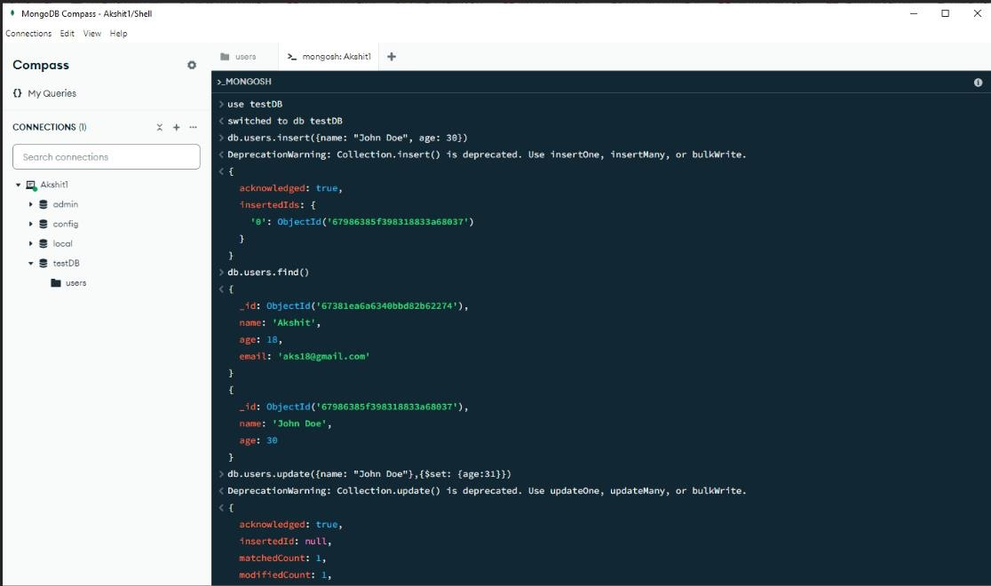

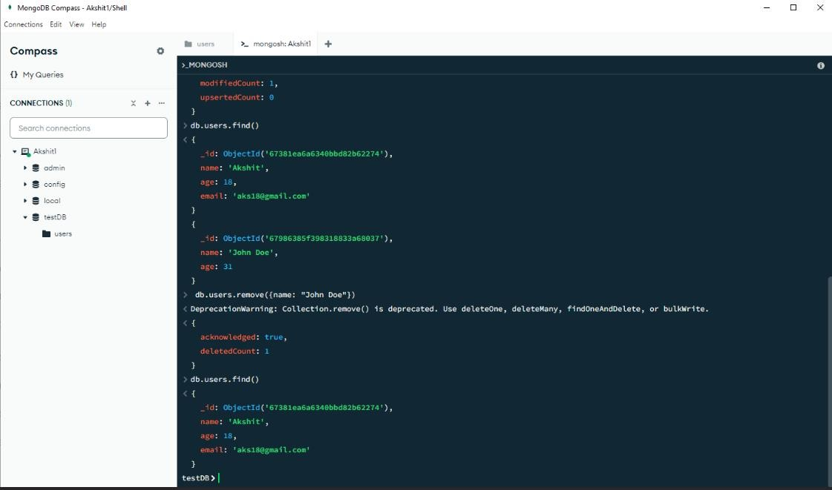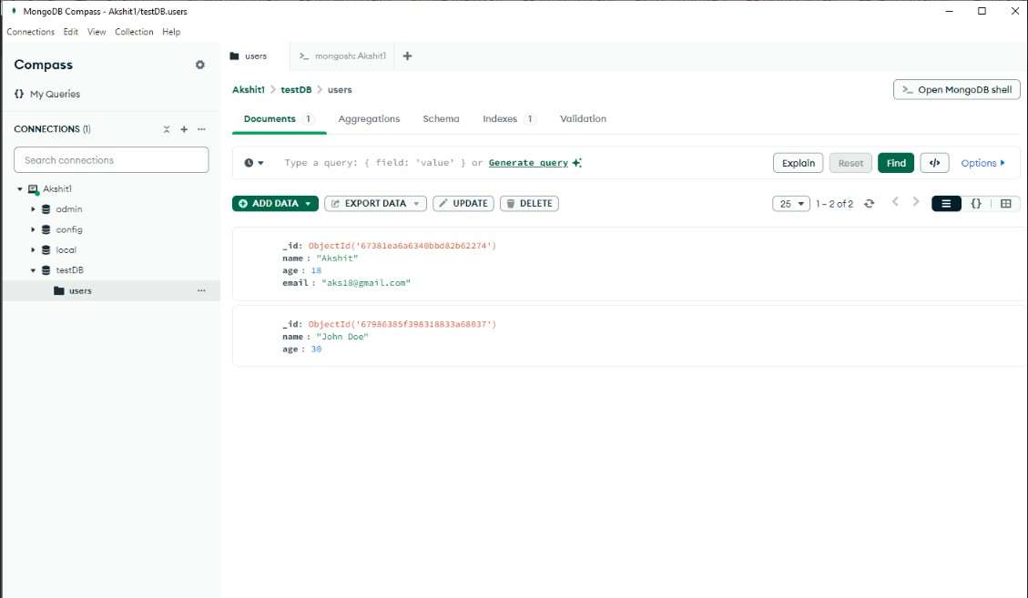

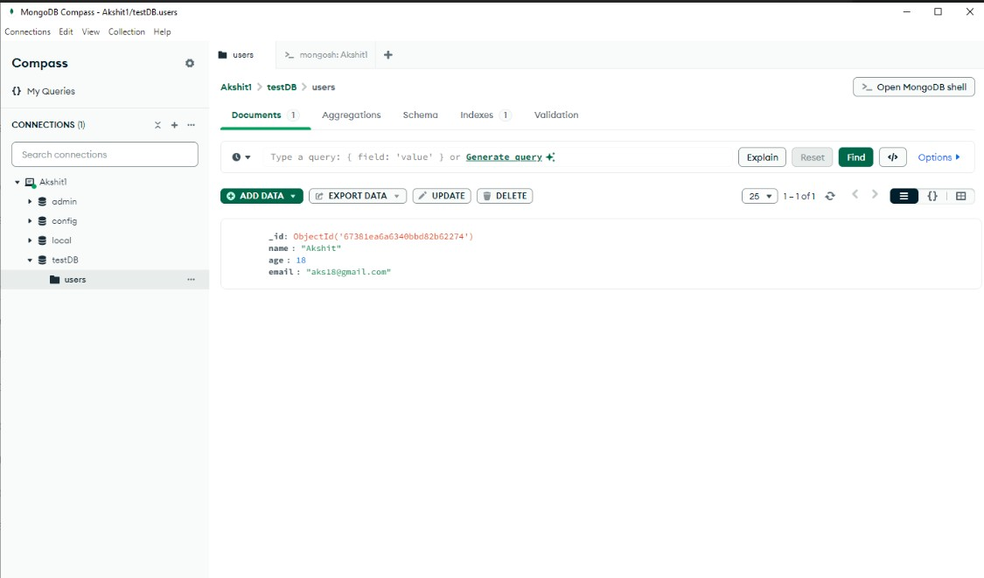

**BOOKS AND WEB RESOURCES:**

1. Installing MongoDB Tutorial Online

Available:https://[www.youtube.com/playlist?list=PL4cUxeGkcC9h77dJ-QJlwGlZlTd4ecZOA](http://www.youtube.com/playlist?list=PL4cUxeGkcC9h77dJ-QJlwGlZlTd4ecZOA)

1. Learning React by Alex Banks and Eve Porcello
2. MongoDB: The Definitive Guide by Kristina Chodorow
3. Node.js Design Patterns by Mario Casciaro
4. Express in Action by Evan Hahn

**Web Resources**

1. MongoDB Documentation: <https://www.mongodb.com/docs/>
2. React Official Documentation:<https://reactjs.org/docs/>
3. Node.js Documentation:<https://nodejs.org/docs/>

# Express.js Guide: <https://expressjs.com/>

**Videos and Blogs**

1. Traversy Media: MERN Stack Tutorial [(YouTube Channel)](https://www.youtube.com/c/TraversyMedia)
2. Academind: MERN Stack Crash Course [(YouTube Channel)](https://www.youtube.com/c/Academind)
3. FreeCodeCamp MERN Tutorial [(FreeCodeCamp Blog)](https://www.freecodecamp.org/news/)