|  |  |
| --- | --- |
| **COURSE CODE: DJS22ITL604** | **DATE: 04-02-2025** |
| **COURSE NAME: Full Stack Web Development Laboratory** | **CLASS: TYBTech** |
| **NAME: Anish Sharma DIV: IT1-1** | **ROLL: I011** |

**DEPARTMENT OF INFORMATION TECHNOLOGY**

# EXPERIMENT NO. 02

**CO/LO:** CO1-Develop a full stack web application.

**AIM / OBJECTIVE:** Building a Simple React Application Create a simple React app with multiple components, manage state, and pass props Connecting React Front-End to Express.js Back-End.

**THEORY**:

React is a JavaScript library for building user interfaces. It allows you to create reusable UI components and manage the application's state efficiently. React follows a component-based architecture, where each UI piece is built as an independent, reusable component.

* **State Management**: React provides useState and useEffect hooks to manage state and lifecycle methods in functional components.
* **Props**: Props (short for properties) allow data to be passed between components.
* **Component Hierarchy**: Breaking UI into smaller components improves maintainability and reusability.

# 1. Building a Simple React Application a) Components in React

React applications are built using **components**, which are reusable pieces of UI. Components can be classified into two main types:

* **Functional Components**: Defined as JavaScript functions that return JSX (JavaScript XML). They are lightweight and mainly used for rendering UI.
* **Class Components**: Defined as JavaScript ES6 classes extending React.Component, allowing the use of lifecycle methods.

Example of a functional component:

function Greeting(props) {

return <h1>Hello, {props.name}!</h1>;

}

# b) Managing State in React

State is an object that stores dynamic data in a component. It is mainly used in **class components** via this.state and updated using setState(), but in functional components, the useState hook is commonly used.

**DEPARTMENT OF INFORMATION TECHNOLOGY**

Example using useState:

import { useState } from "react";

function Counter() {

const [count, setCount] = useState(0);

return (

<div>

<p>Count: {count}</p>

<button onClick={() => setCount(count + 1)}>Increment</button> </div>

); }

# c) Passing Props in React

Props (short for "properties") allow data to be passed from parent to child components. They are read- only and cannot be modified within the child component.

Example of passing props:

function WelcomeMessage({ user }) {

return <h2>Welcome, {user}!</h2>;

}

function App() {

return <WelcomeMessage user="Alice" />;

}

# Express.js Overview

Express.js is a minimal and flexible Node.js web application framework that simplifies backend development. It helps create RESTful APIs for handling data and communicating with the frontend.

* **Routing**: Express allows defining multiple API routes to handle requests.
* **Middleware**: Middleware functions process incoming requests before sending responses.
* **CORS Handling**: Cross-Origin Resource Sharing (CORS) allows the frontend to communicate with the backend hosted on a different domain.

# 2. Connecting React Front-End to Express.js Back-End

React alone handles the front-end, but to fetch and manipulate data, a back-end server is required. Express.js is a minimal and flexible Node.js framework used to build APIs. The communication between React (front-end) and Express.js (back-end) is done via HTTP requests.

**DEPARTMENT OF INFORMATION TECHNOLOGY**

# a) Setting Up Express.js Backend

Express.js is used to create a server that handles requests and sends responses.

**Example of a simple Express server (server.js)**:

const express = require('express'); const cors = require('cors'); const app = express(); app.use(cors()); app.use(express.json()); app.get('/api/message', (req, res) => {

res.json({ message: 'Hello from Express.js backend!' });

});

app.listen(5000, () => {

console.log('Server running on port 5000');

});

# b) Fetching Data from Express API in React

React can fetch data from the Express.js server using the fetch API or libraries like axios.

Example:

import { useEffect, useState } from "react"; function FetchMessage() {

const [message, setMessage] = useState(""); useEffect(() => {

[fetch("http://localhost:5000/api/message")](http://localhost:5000/api/message)

.then(response => response.json())

.then(data => setMessage(data.message));

}, []);

return <h3>{message}</h3>;

}

# PROCEDURE

**Building an Administrator component which handles the database management process.**

# APP

"use client"

*import* { useState } *from* "react";

*import* YearSemesterSelector *from* "./components/YearSemesterSelector"; *import* FileUpload *from* "./components/FileUpload"; *import* CourseTypeSelector *from* "./components/CourseTypeSelector";

*import* SubjectInput *from* "./components/SubjectInput";

|  |
| --- |
| *import* MinorStudentInput *from* "./components/MinorStudentInput"; *import* { Button } *from* "@/components/ui/button";  *export* *default* function *StudentManagementApp*() { const[*year*, *setYear*]= *useState*(""); const[*semester*, *setSemester*]= *useState*(""); const[*courseType*, *setCourseType*]= *useState*(""); const[*subjects*, *setSubjects*]= *useState*([]); const[*minorStudents*, *setMinorStudents*]= *useState*([]); const[*studentData*, *setStudentData*]= *useState*(*null*);  const *handleFileUpload* =(*data*)=>{  *setStudentData*(data);  }; const *clearAll* =()=>{  *setYear*("");  *setSemester*("");  *setCourseType*("");  *setSubjects*([]);  *setMinorStudents*([]);  *setStudentData*(*null*);  };  *return* (  <div *className*="container mx-auto p-4"> <h1 *className*="text-2xl font-bold mb-4">Student Management App</h1>  <YearSemesterSelector *year*={year} *semester*={semester} *onYearChange*={setYear}  *onSemesterChange*={setSemester}  />  {year && semester && <FileUpload *onFileUpload*={handleFileUpload} />}  <CourseTypeSelector *courseType*={courseType} *onCourseTypeChange*={setCourseType}  />  <SubjectInput *subjects*={subjects} |

*onSubjectsChange*={setSubjects}

/>

<MinorStudentInput *minorStudents*={minorStudents}

*onMinorStudentsChange*={setMinorStudents}

/>

<Button *onClick*={clearAll} *className*="mt-4">

Clear All

</Button>

{studentData && (

<div *className*="mt-4">

<h2 *className*="text-xl font-semibold mb-2">Uploaded Student Data:</h2>

<pre *className*="bg-gray-100 p-4 rounded">{JSON*.stringify*(studentData, null,

2)}</pre>

</div>

)}

</div>

); }

**COMPONENTS:**

|  |
| --- |
| *import* { Select, SelectContent, SelectItem, SelectTrigger, SelectValue } *from* "@/components/ui/select";  *export* *default* function *CourseTypeSelector*({ courseType, onCourseTypeChange }) { *return* (  <div *className*="mb-4">  <Select *value*={courseType} *onValueChange*={onCourseTypeChange}>  <SelectTrigger *className*="w-[180px]">  <SelectValue *placeholder*="Select Course Type" /> </SelectTrigger>  <SelectContent>  <SelectItem *value*="Regular">Regular</SelectItem>  <SelectItem *value*="DLE">DLE</SelectItem>  <SelectItem *value*="ILE">ILE</SelectItem>  <SelectItem *value*="ETD">ETD</SelectItem>  </SelectContent>  </Select>  </div>  );  } *import* { useState } *from* "react"; *import* { Button } *from* "@/components/ui/button"; *import* { Input } *from* "@/components/ui/input"; *import* * *as* XLSX *from* "xlsx";  *export* *default* function *FileUpload*({ onFileUpload }) { |

const[*file*, *setFile*]= *useState*(*null*); const *handleFileChange* =(*e*)=>{

if(*e.target.files*){

|  |
| --- |
| *setFile*(*e.target.files*[0]);  }  }; const *handleUpload* = *async* ()=>{ if(!file) *return*;  const *reader* =new *FileReader*();  *reader.onload* =(*e*)=>{ const *data* = *e.target?.result*; const *workbook* = *XLSX.read*(data,{ *type*:"array"}); const *sheetName* = *workbook.SheetNames*[0]; const *worksheet* = *workbook.Sheets*[sheetName]; const *json* = *XLSX.utils.sheet_to_json*(worksheet);  *onFileUpload*(json);  };  *reader.readAsArrayBuffer*(file);  };  *return* (  <div *className*="mb-4">  <Input *type*="file" *accept*=".csv,.xlsx" *onChange*={handleFileChange} *className*="mb2" />  <Button *onClick*={handleUpload} *disabled*={!file}>  Upload  </Button>  </div>  );  } *import* { useState } *from* "react"; *import* { Input } *from* "@/components/ui/input"; *import* { Button } *from* "@/components/ui/button";    *export* *default* function *MinorStudentInput*({ minorStudents, onMinorStudentsChange }) { const[*newMinorStudent*, *setNewMinorStudent*]= *useState*("");  const *handleAddMinorStudent* =()=>{ if(*newMinorStudent.trim*()!==""){  *onMinorStudentsChange*([...minorStudents, *newMinorStudent.trim*()]); |

*setNewMinorStudent*("");

} }; *return* ( <div *className*="mb-4">

|  |
| --- |
| <h3 *className*="text-lg font-semibold mb-2">Minor Students</h3>  <div *className*="flex space-x-2 mb-2">  <Input *type*="text" *value*={newMinorStudent} *onChange*={(e) => *setNewMinorStudent*(*e.target.*value)} *placeholder*="Enter minor student name" *className*="flex-grow"  />  <Button *onClick*={handleAddMinorStudent}>Add Minor Student</Button> </div>  <ul *className*="list-disc pl-5">  {*minorStudents.map*((student, index) => (  <li *key*={index}>{student}</li>  ))}  </ul>  </div>  );  } *import* { useState } *from* "react"; *import* { Input } *from* "@/components/ui/input"; *import* { Button } *from* "@/components/ui/button";  *export* *default* function *SubjectInput*({ subjects, onSubjectsChange }) { const[*newSubject*, *setNewSubject*]= *useState*("");  const *handleAddSubject* =()=>{ if(*newSubject.trim*()!==""){  *onSubjectsChange*([...subjects, *newSubject.trim*()]);  *setNewSubject*("");  }  };  *return* (  <div *className*="mb-4">  <h3 *className*="text-lg font-semibold mb-2">Subjects</h3>  <div *className*="flex space-x-2 mb-2">  <Input *type*="text" *value*={newSubject} *onChange*={(e) => *setNewSubject*(*e.target.*value)} |

*placeholder*="Enter subject"

*className*="flex-grow"

/>

<Button *onClick*={handleAddSubject}>Add Subject</Button>

|  |
| --- |
| </div>  <ul *className*="list-disc pl-5">  {*subjects.map*((subject, index) => (  <li *key*={index}>{subject}</li>  ))}  </ul>  </div>  );  } *import* { Select, SelectContent, SelectItem, SelectTrigger, SelectValue } *from* "@/components/ui/select";  *export* *default* function *YearSemesterSelector*({ year, semester, onYearChange, onSemesterChange,  }) { *return* (  <div *className*="flex space-x-4 mb-4">  <Select *value*={year} *onValueChange*={onYearChange}>  <SelectTrigger *className*="w-[180px]">  <SelectValue *placeholder*="Select Year" />  </SelectTrigger>  <SelectContent>  <SelectItem *value*="SY">SY</SelectItem>  <SelectItem *value*="TY">TY</SelectItem>  <SelectItem *value*="BE">BE</SelectItem>  </SelectContent>  </Select>  {year && (  <Select *value*={semester} *onValueChange*={onSemesterChange}>  <SelectTrigger *className*="w-[180px]">  <SelectValue *placeholder*="Select Semester" />  </SelectTrigger>  <SelectContent>  <SelectItem *value*="Semester 1">Semester 1</SelectItem>  <SelectItem *value*="Semester 2">Semester 2</SelectItem>  </SelectContent> |

</Select>

)}

</div>

);

}

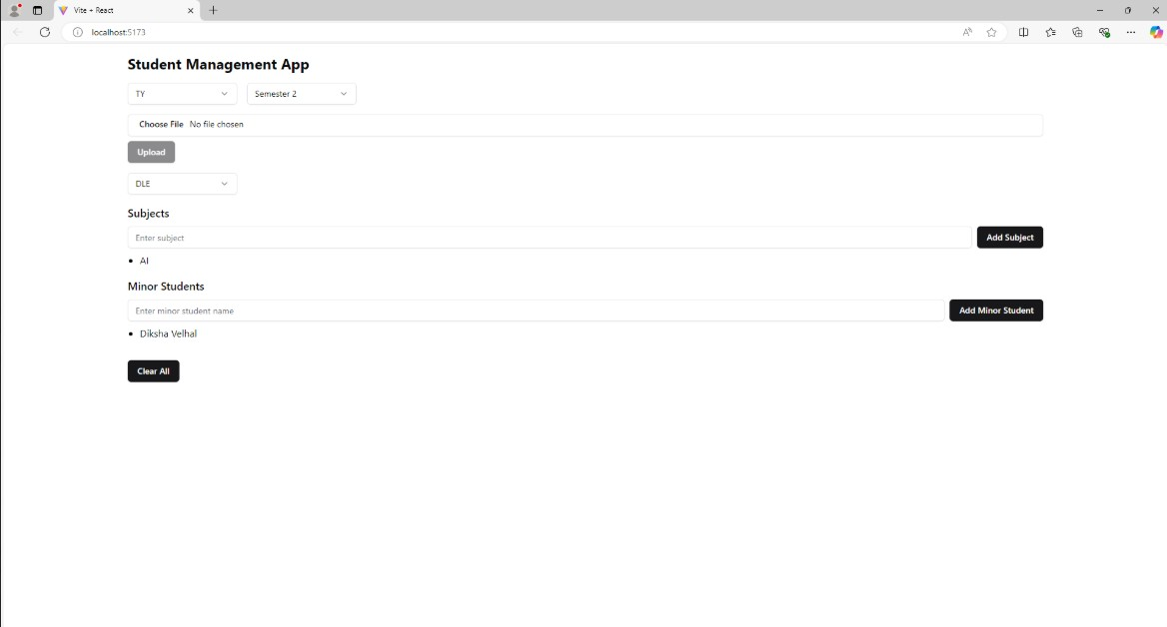

**CONCLUSION:**

In this experiment we builda Simple React Application Create a simple React app with multiple components, manage state, and pass props Connecting React Front-End to Express.js Back-End.

**BOOKS AND WEB RESOURCES:**

1. Fullstackopen, "Full Stack Open," Fullstackopen.com. [Online]. Available: <https://fullstackopen.com/en>
2. freeCodeCamp, "The Complete Guide to Full Stack React Development," freeCodeCamp.org. [Online]. Available: [https://www.freecodecamp.org/news/full-stack-react-application- architecture/](https://www.freecodecamp.org/news/full-stack-react-application-architecture/)

DigitalOcean, "How To Get Started with the MERN Stack," DigitalOcean.com. [Online]. Available: [https://www.digitalocean.com/community/tutorials/getting-started-with-the-mern- stack](https://www.digitalocean.com/community/tutorials/getting-started-with-the-mern-stack)

1. Media, "Express.js Crash Course," *YouTube*. [Online]. Available: [https://www.youtube.com/watch?v=L72fhGm1tfE.](https://www.youtube.com/watch?v=L72fhGm1tfE)
2. The Net Ninja, "Express.js Tutorial for Beginners," *YouTube*. [Online]. Available: https://youtu.be/98BzS5Oz5E4?si=mnOWtp0QHFRn7uf