|  |  |
| --- | --- |
| COURSE CODE: DJS22ITL604 | DATE: 11-02-2025 |
| COURSE NAME: Full Stack Web Development Laboratory | CLASS: TYBTech |
| NAME: Anish Sharma DIV: IT1-1 | ROLL: I011 |

DEPARTMENT OF INFORMATION TECHNOLOGY

# EXPERIMENT NO. 03

CO/LO: CO1-Develop a full stack web application.

AIM / OBJECTIVE: Creating RESTful APIs with Express.js: Create a MongoDB database, design basic schemas, and execute CRUD operations using the MongoDB driver.

THEORY:

Introduction to RESTful APIs

A RESTful API (Representational State Transfer) allows communication between client and server over HTTP using standard methods such as GET, POST, PUT, and DELETE. Express.js, a popular Node.js framework, simplifies the creation of these APIs.

Introduction to MongoDB

MongoDB is a NoSQL database that stores data in JSON-like documents. It is highly scalable and allows flexible schema design.

Key Concepts:

* Express.js: A minimal and flexible web application framework for Node.js.
* MongoDB Driver: A Node.js library that enables database operations.
* Mongoose: An ODM (Object Data Modeling) library for MongoDB that simplifies schema creation.
* CRUD Operations: Create, Read, Update, and Delete functions for managing data.

PROCEDURE

Step 1: Set Up the Project

1. Install Node.js from [https://nodejs.org/.](https://nodejs.org/)
2. Create a new directory and initialize a project:

mkdir restful-api && cd restful-api npm init -y

1. Install dependencies: npm install express mongoose cors body-parser dotenv

Step 2: Configure Express.js Server

1. Create a file server.js and add:

const express = require('express'); const mongoose = require('mongoose'); const cors = require('cors'); const bodyParser = require('body-parser'); require('dotenv').config();

const app = express(); app.use(cors()); app.use(bodyParser.json());

mongoose.connect(process.env.MONGO_URI, {

useNewUrlParser: true, useUnifiedTopology: true

}).then(() => console.log('MongoDB Connected'))

.catch(err => console.log(err));

const PORT = process.env.PORT || 5000;

app.listen(PORT, () => console.log(`Server running on port ${PORT}`));

Step 3: Define MongoDB Schema and Model

1. Create a folder models and add a file User.js:

const mongoose = require('mongoose');

const UserSchema = new mongoose.Schema({ name: String, email: String, age: Number

});

module.exports = mongoose.model('User', UserSchema);

Step 4: Implement CRUD Routes const express = require('express'); const User = require('../models/User'); const router = express.Router();

// Create User

router.post('/users', async (req, res) => { const user = new User(req.body);

await user.save();

res.send(user);

});

// Read Users

router.get('/users', async (req, res) => { const users = await User.find(); res.send(users);

});

// Update User

router.put('/users/:id', async (req, res) => { const user = await User.findByIdAndUpdate(req.params.id, req.body, { new: true }); res.send(user);

});

// Delete User

router.delete('/users/:id', async (req, res) => {

await User.findByIdAndDelete(req.params.id);

res.send({ message: 'User deleted' });

});

module.exports = router;

Step 5: Integrate Routes with Express.js

1. Modify `server.js`:

const userRoutes = require('./routes/userRoutes'); app.use('/api', userRoutes);

Step 6: Start the Server

Run the following command:

node server.js

Your API will be available at [`http://localhost:5000/api/users`.](http://localhost:5000/api/users)

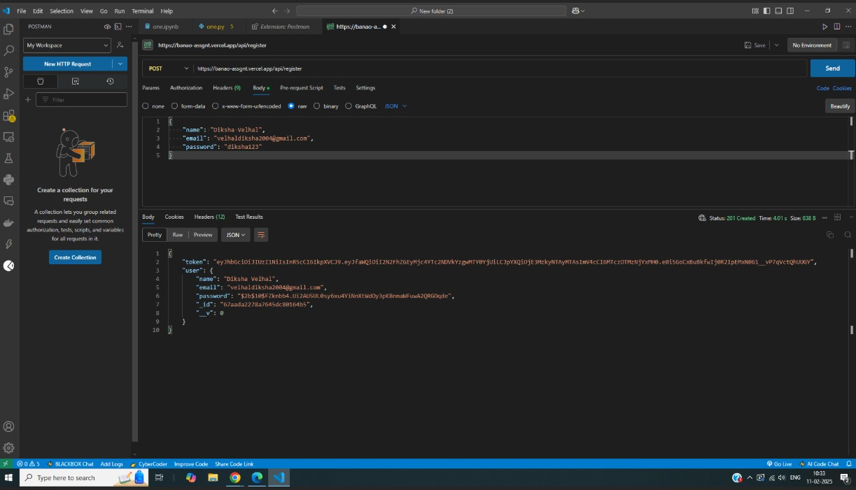

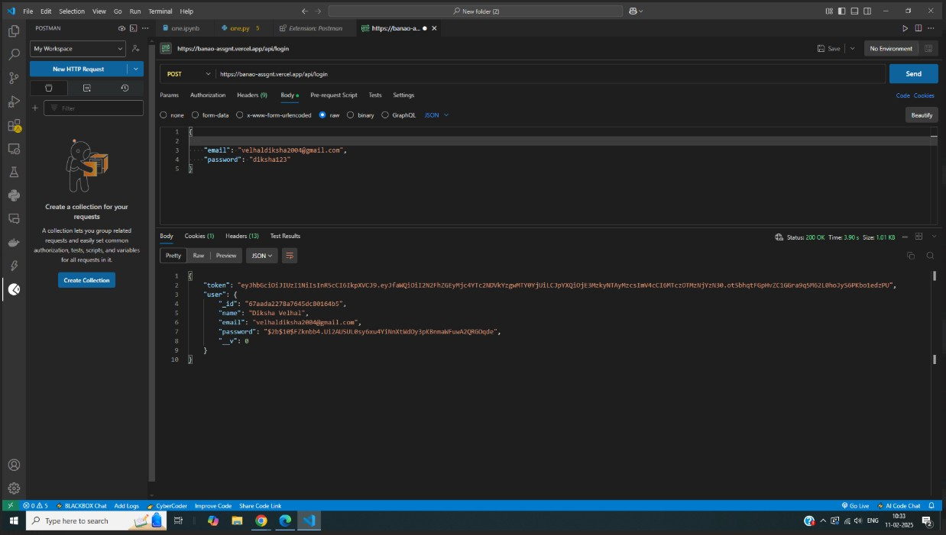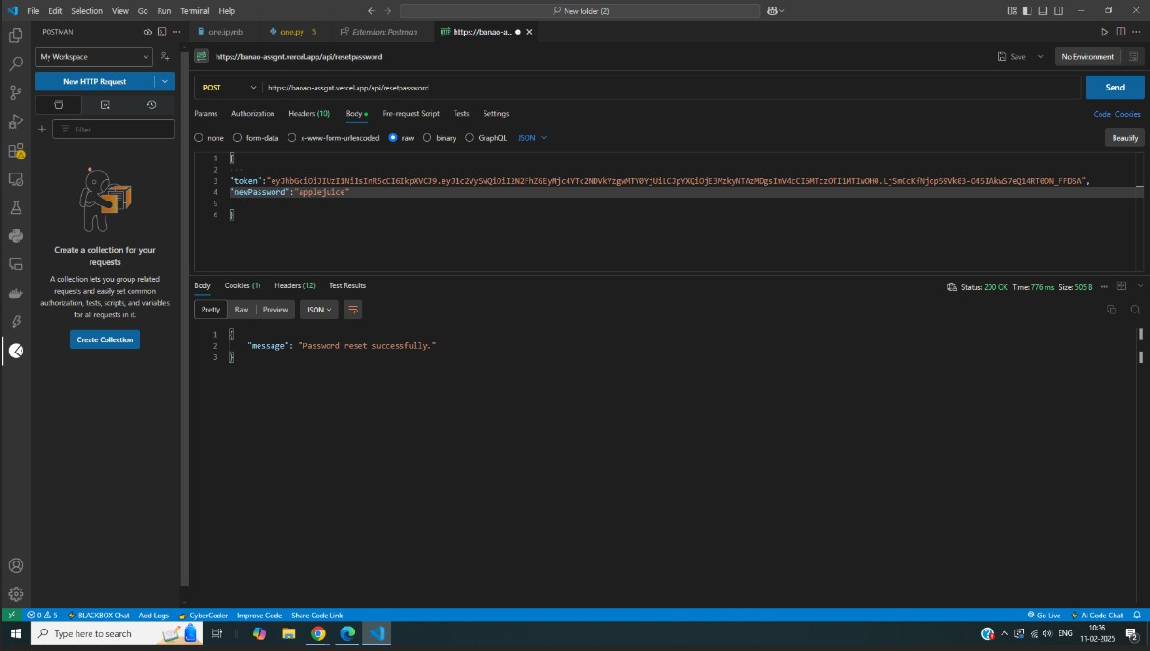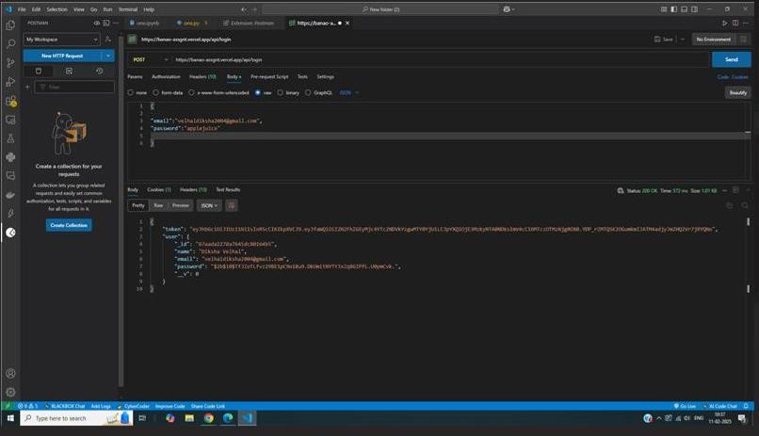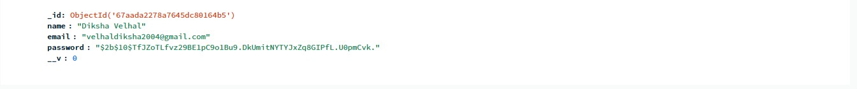

CONCLUSION: In this experiment, we created RESTful APIs with Express.js: Create a MongoDB database, design basic schemas, and execute CRUD operations using the MongoDB driver.

BOOKS AND WEB RESOURCES:

1. MDN Web Docs - [https://developer.mozilla.org/en-US/docs/Learn/Server- side/Express_Nodejs](https://developer.mozilla.org/en-US/docs/Learn/Server-side/Express_Nodejs)
2. MongoDB Documentation -<https://www.mongodb.com/docs/manual/>[3] Express.js Guide -<https://expressjs.com/en/guide/routing.html>