DEPARTMENT OF INFORMATION TECHNOLOGY

**COURSE CODE: DJS22ITL604 DATE:**

|  |  |  |
| --- | --- | --- |
| **COURSE NAME: Full Stack Web Development Laboratory** |  | **CLASS: TYBTech** |
| **Name: Anish Sharma Div:IT-1** |  | **Roll no:I011** |

**EXPERIMENT NO. 06**

**CO/LO:** CO1-Develop a full stack web application.

**AIM / OBJECTIVE:** React Router and Navigation Implement React Router for basic navigation between different components/pages within a React application.

**THEORY**:

**Introduction to React Router**

React Router is a standard library for routing in React applications. It enables navigation between different components/pages without requiring a full page reload. This improves user experience by creating a seamless Single Page Application (SPA).

**Key Concepts:**

1. Routing - Defines how users navigate within the app.
2. BrowserRouter - Wraps the entire application to enable routing.
3. Routes & Route - Specifies different paths and their corresponding components.
4. Link - Used instead of <a> tags for in-app navigation.
5. 404 Page (Not Found) - Displays when an invalid route is accessed.

**Step 1: Set Up the React Project** 1. Create a new React app: npx createreact-app react-router-app cd reactrouter-app 2.

Install React Router: npm install react-router-dom **Step 2: Creating the Main Application File Create src/App.js** import React from "react";

# DEPARTMENT OF INFORMATION TECHNOLOGY

import { BrowserRouter as Router, Routes, Route } from "react-router-dom"; import Navbar from "./components/Navbar"; import Home from

**COURSE CODE: DJS22ITL604 DATE:**

"./pages/Home"; import About from "./pages/About"; import Contact from "./pages/Contact"; **COURSE NAME: Full Stack Web Development Laboratory**  **CLASS: TYBTech**

import NotFound from "./pages/NotFound"; const App = () => { return ( <Router> <Navbar />

<Routes>

<Route path="/" element={<Home />} />

<Route path="/about" element={<About />} />

<Route path="/contact" element={<Contact />} />

<Route path="*" element={<NotFound />} />

</Routes>

</Router>

); };

export default App;

**Step 3: Creating the Navigation Bar Create src/components/Navbar.js** import React from "react"; import { Link } from

"reactrouter-dom"; const Navbar = () => {

return (

<nav style={{ padding: "10px", background: "#f0f0f0" }}>

<Link to="/" style={{ margin: "10px" }}>Home</Link>

<Link to="/about" style={{ margin: "10px" }}>About</Link>

<Link to="/contact" style={{ margin: "10px" }}>Contact</Link> </nav>

); };

export default Navbar;

**Step 4: Creating Page Components with Functionality Create src/pages/Home.js** import React, { useState } from "react";

# DEPARTMENT OF INFORMATION TECHNOLOGY

**COURSE CODE: DJS22ITL604 DATE:**  const Home

= () => {

**COURSE NAME: Full Stack Web Development Laboratory**  **CLASS: TYBTech**

const [count, setCount] = useState(0); return (

<div>

<h2>Welcome to the Home Page</h2>

<p>Click the button to increase the counter.</p>

<button onClick={() => setCount(count + 1)}>Count: {count}</button> </div>

);

}; export default Home; **Create src/pages/About.js** import React from "react"; import aboutImage from "../assets/about.jpg"; const About = () => {

return (

<div>

<h2>About Us</h2>

<p>We are a team dedicated to building web applications.</p>

<img src={aboutImage} alt="About Us" width="300" />

</div>

); };

export default About;

**Create src/pages/Contact.js** import React,

{ useState } from "react"; const Contact = ()

# DEPARTMENT OF INFORMATION TECHNOLOGY

|  |  |
| --- | --- |
| => { const [message, setMessage] = useState(""); const handleSubmit = (e) => {  e.preventDefault(); alert("Message sent: "  + message); setMessage("");  }; |  |
| **COURSE CODE: DJS22ITL604** | **DATE:**  **COURSE** |
| **NAME: Full Stack Web Development Laboratory** | **CLASS: TYBTech**  return ( |

<div>

<h2>Contact Us</h2>

<form onSubmit={handleSubmit}>

<textarea value={message} onChange={(e) => setMessage(e.target.value)} placeholder="Enter your message" rows="4" cols="30"></textarea>

<br />

<button type="submit">Send Message</button>

</form>

</div>

); };

export default Contact;

**Step 5: Implementing a 404 Page (Not Found) Create src/pages/NotFound.js**  import React, { useEffect } from "react"; import { useNavigate } from "react-router-dom"; const NotFound = () => { const navigate =

useNavigate(); useEffect(() => { setTimeout(()

=> { navigate("/"); }, 5000);

}, [navigate]); return (

<div style={{ textAlign: "center" }}>

<h2>❌ 404 - Page Not Found</h2>

<p>You will be redirected to Home in 5 seconds...</p>

<button onClick={() => navigate("/")}>Go Back Home Now</button> </div>

);

};export default NotFound;

**COURSE NAME: Full Stack Web Development Laboratory**  **CLASS: TYBTech**

**TESTING THE APPLICATION**

1. Start the project:

# DEPARTMENT OF INFORMATION TECHNOLOGY

**COURSE CODE: DJS22ITL604 DATE:**  npm start

1. Open http://localhost:3000/ in your browser.
2. Navigate between Home, About, and Contact using the Navbar.
3. Test the 404 Page:

* Enter a random URL like http://localhost:3000/invalid.
* Wait 5 seconds or click 'Go Back Home Now' to be redirected. App.js import {

BrowserRouter as Router, Routes, Route } from 'react-router-dom' import { ToastContainer } from 'react-toastify' import 'react-toastify/dist/ReactToastify.css' import Header from './components/Header' import PrivateRoute from

'./components/PrivateRoute' import Home from './pages/Home' import Login from

'./pages/Login' import Register from './pages/Register' import NewTicket from

'./pages/NewTicket' import Tickets from './pages/Tickets' import Ticket from './pages/Ticket'

// NOTE: Here we have removed the nested routing as the path is the same

function App() {

**COURSE CODE: DJS22ITL604 DATE:**  return (

<>

<Router>

**DEPARTMENT OF INFORMATION TECHNOLOGY**

<div className='container'>

<Header />

<Routes>

<Route path='/' element={<Home />} />

<Route path='/login' element={<Login />} />

<Route path='/register' element={<Register />} />

<Route path='/newticket'

element={

<PrivateRoute>

<NewTicket />

</PrivateRoute>

}

/>

<Route path='/tickets'

element={

<PrivateRoute>

**COURSE CODE: DJS22ITL604 DATE:**

<Tickets />

# DEPARTMENT OF INFORMATION TECHNOLOGY

</PrivateRoute>

}

/>

<Route path='/ticket/:ticketId'

element={

<PrivateRoute>

<Ticket />

</PrivateRoute>

}

/>

</Routes>

</div>

</Router>

<ToastContainer />

</>

)

}

# DEPARTMENT OF INFORMATION TECHNOLOGY

export default App

**COURSE CODE: DJS22ITL604 DATE:**

Regiter.jsx import { useState } from 'react' import { useNavigate } from 'react-router-dom' import { toast } from 'react-toastify' import { FaUser } from 'reacticons/fa' import { useSelector, useDispatch } from 'react-redux' import { register } from

'../features/auth/authSlice' import Spinner from

'../components/Spinner'

function Register() { const [formData, setFormData] = useState({

name: '', email: '', password: '', password2: '',

})

const { name, email, password, password2 } = formData

**DEPARTMENT OF INFORMATION TECHNOLOGY**

const dispatch = useDispatch() const navigate = useNavigate() **COURSE CODE: DJS22ITL604**

**DATE:**

const { isLoading } = useSelector((state) => state.auth)

const onChange = (e) => { setFormData((prevState) => ({

...prevState,

[e.target.name]: e.target.value,

}))

}

// NOTE: no need for useEffect here as we can catch the

// AsyncThunkAction rejection in our onSubmit or redirect them on the // resolution

// Side effects shoulld go in event handlers where possible

# DEPARTMENT OF INFORMATION TECHNOLOGY

// source: - https://beta.reactjs.org/learn/keeping-components-pure#where-you-can-causesideeffects

const onSubmit = (e) => {

e.preventDefault()

if (password !== password2) { toast.error('Passwords do not match') **COURSE**

**CODE: DJS22ITL604**

**DATE:**

} else { const userData = { name, email, password,

}

dispatch(register(userData))

.unwrap()

.then((user) => {

// NOTE: by unwrapping the AsyncThunkAction we can navigate the user after

# DEPARTMENT OF INFORMATION TECHNOLOGY

// getting a good response from our API or catch the AsyncThunkAction

// rejection to show an error message toast.success(`Registered new user - ${user.name}`)

navigate('/')

})

.catch(toast.error)

}

} if (isLoading)

{

**COURSE CODE: DJS22ITL604 DATE:**  return <Spinner

/>

}

return (

<>

<section className='heading'>

<h1>

<FaUser /> Register

</h1>

# DEPARTMENT OF INFORMATION TECHNOLOGY

<p>Please create an account</p>

</section>

<section className='form'>

<form onSubmit={onSubmit}>

<div className='form-group'>

<input type='text'

className='form-

control' id='name' name='name'

value={name} **COURSE**  **CODE: DJS22ITL604**

**DATE:**

onChange={onChange} placeholder='Enter your name'

required

/>

**DEPARTMENT OF INFORMATION TECHNOLOGY**

</div>

<div className='form-group'>

<input type='email' className='form-control' id='email' name='email' value={email} onChange={onChange} placeholder='Enter your email'

required

/>

</div>

<div className='form-group'>

<input type='password' className='formcontrol'

**COURSE CODE:**

**DJS22ITL604**

**DATE:**

**DEPARTMENT OF INFORMATION TECHNOLOGY**

id='password' name='password' value={password} onChange={onChange} placeholder='Enter password'

required

/>

</div>

<div className='form-group'>

<input type='password' className='form-control' id='password2' name='password2' value={password2} onChange={onChange} placeholder='Confirm password'

required

/>

</div>

**DEPARTMENT OF INFORMATION TECHNOLOGY**

<div className='form-group'>

**COURSE CODE: DJS22ITL604 DATE:**

<button className='btn btn-block'>Submit</button>

</div>

</form>

</section>

</>

)

}

export default Register

Login.jsx import { useState } from 'react' import { toast } from 'react-toastify' import { useNavigate } from 'react-router-dom' import { FaSignInAlt } from 'react-icons/fa' import { useSelector, useDispatch } from 'react-redux' import { login } from

'../features/auth/authSlice' import Spinner from

'../components/Spinner'

**DEPARTMENT OF INFORMATION TECHNOLOGY**

function Login() { const [formData, setFormData] = useState({ **COURSE**

**CODE: DJS22ITL604**

**DATE:**

email: '', password: '',

})

const { email, password } = formData

const dispatch = useDispatch() const navigate = useNavigate()

const { isLoading } = useSelector((state) => state.auth)

const onChange = (e) => { setFormData((prevState) => ({ ...prevState,

[e.target.name]: e.target.value,

# DEPARTMENT OF INFORMATION TECHNOLOGY

}))

}

// NOTE: no need for useEffect here as we can catch the

// AsyncThunkAction rejection in our onSubmit or redirect them on the

// resolution

**COURSE CODE: DJS22ITL604 DATE:**

// Side effects shoulld go in event handlers where possible

// source: - https://beta.reactjs.org/learn/keeping-components-pure#where-you-can-causesideeffects

const onSubmit = (e) => {

e.preventDefault()

const userData = { email, password,

}

dispatch(login(userData))

.unwrap()

# DEPARTMENT OF INFORMATION TECHNOLOGY

.then((user) => {

// NOTE: by unwrapping the AsyncThunkAction we can navigate the user after

// getting a good response from our API or catch the AsyncThunkAction

// rejection to show an error message toast.success(`Logged in as ${user.name}`)

navigate('/')

})

.catch(toast.error)

**COURSE CODE: DJS22ITL604 DATE:**

}

if (isLoading) { return <Spinner />

}

return (

<>

<section className='heading'>

<h1>

<FaSignInAlt /> Login

**DEPARTMENT OF INFORMATION TECHNOLOGY**

</h1>

<p>Please log in to get support</p>

</section>

<section className='form'>

<form onSubmit={onSubmit}>

<div className='form-group'>

<input type='email'

className='form-control'

**COURSE CODE:**

**DJS22ITL604**

**DATE:**

id='email' name='email' value={email} onChange={onChange} placeholder='Enter your email'

required

/>

**DEPARTMENT OF INFORMATION TECHNOLOGY**

</div>

<div className='form-group'>

<input type='password' className='form-control' id='password' name='password' value={password} onChange={onChange} placeholder='Enter password' required

/>

</div>

<div className='form-group'>

**COURSE CODE: DJS22ITL604 DATE:**

<button className='btn btn-block'>Submit</button>

</div>

</form>

</section>

</>

# DEPARTMENT OF INFORMATION TECHNOLOGY

)

}

export default Login

NewTicket.jsx import { useState } from 'react' import { useSelector, useDispatch } from 'react-redux' import { useNavigate } from 'react-router-dom' import { toast } from 'react-toastify' import { createTicket } from

'../features/tickets/ticketSlice' import BackButton from

'../components/BackButton'

function NewTicket() { const { user } = useSelector((state) => state.auth) **COURSE**

**CODE: DJS22ITL604**

**DATE:**  const [name] =

useState(user.name) const [email] = useState(user.email) const [product, setProduct]

**DEPARTMENT OF INFORMATION TECHNOLOGY**

= useState('iPhone') const [description, setDescription]

= useState('')

const dispatch = useDispatch() const navigate = useNavigate()

const onSubmit = (e) => {

e.preventDefault() dispatch(createTicket({ product, description }))

.unwrap()

.then(() => {

// We got a good response so navigate the user navigate('/tickets') toast.success('New ticket created!')

})

.catch(toast.error)

} return (

# DEPARTMENT OF INFORMATION TECHNOLOGY

**COURSE CODE: DJS22ITL604 DATE:**  <>

<BackButton />

<section className='heading'>

<h1>Create New Ticket</h1>

<p>Please fill out the form below</p>

</section>

<section className='form'>

<div className='form-group'>

<label htmlFor='name'>Customer Name</label>

<input type='text' className='form-control' value={name} disabled />

</div>

<div className='form-group'>

<label htmlFor='email'>Customer Email</label>

<input type='text' className='form-control' value={email} disabled />

</div>

<form onSubmit={onSubmit}>

<div className='form-group'>

<label htmlFor='product'>Product</label>

**DEPARTMENT OF INFORMATION TECHNOLOGY**

<select

name='product' **COURSE**

**CODE: DJS22ITL604**

**DATE:**

id='product' value={product}

onChange={(e) => setProduct(e.target.value)}

>

<option value='iPhone'>iPhone</option>

<option value='Macbook Pro'>Macbook Pro</option>

<option value='iMac'>iMac</option>

<option value='iPad'>iPad</option>

</select>

</div>

<div className='form-group'>

<label htmlFor='description'>Description of the issue</label>

<textarea name='description' id='description' className='form-control'

# DEPARTMENT OF INFORMATION TECHNOLOGY

placeholder='Description' value={description} onChange={(e) => setDescription(e.target.value)}

></textarea>

</div>

**COURSE CODE: DJS22ITL604 DATE:**

<div className='form-group'>

<button className='btn btn-block'>Submit</button>

</div>

</form>

</section>

</>

)

}

export default NewTicket

Ticket.jsx import { useEffect, useState } from 'react' import { toast

} from 'react-toastify' import Modal from 'react-modal' import { FaPlus } from 'react-icons/fa' import { useSelector, useDispatch } from 'react-redux' import { getTicket, closeTicket } from

**DEPARTMENT OF INFORMATION TECHNOLOGY**

'../features/tickets/ticketSlice' import { getNotes, createNote } from

'../features/notes/noteSlice' import { useParams, useNavigate } from

'react-router-dom' import BackButton from

'../components/BackButton'

**COURSE CODE: DJS22ITL604 DATE:**  import Spinner from '../components/Spinner' import NoteItem from

'../components/NoteItem'

const customStyles = { content: { width: '600px', top: '50%', left: '50%', right: 'auto', bottom: 'auto', marginRight: '-50%', transform: 'translate(-50%, -50%)', position:

'relative',

},

}

Modal.setAppElement('#root')

# DEPARTMENT OF INFORMATION TECHNOLOGY

function Ticket() { const [modalIsOpen, setModalIsOpen] = useState(false) const [noteText, setNoteText] = useState('')

**COURSE CODE: DJS22ITL604 DATE:**  const { ticket } = useSelector((state) => state.tickets)

const { notes } = useSelector((state) => state.notes)

// NOTE: no need for two useParams // const params = useParams() const navigate = useNavigate() const dispatch = useDispatch() const { ticketId } = useParams()

useEffect(() => { dispatch(getTicket(ticketId)).unwrap().catch(toast.error) dispatch(getNotes(ticketId)).unwrap().catch(toast.error)

}, [ticketId, dispatch])

# DEPARTMENT OF INFORMATION TECHNOLOGY

// Close ticket const onTicketClose = () => {

// NOTE: we can unwrap our AsyncThunkACtion here so no need for isError and

// isSuccess state dispatch(closeTicket(ticketId))

.unwrap()

**COURSE CODE: DJS22ITL604 DATE:**

.then(() => { toast.success('Ticket Closed') navigate('/tickets')

})

.catch(toast.error)

}

// Create note submit const onNoteSubmit = (e) => {

// NOTE: we can unwrap our AsyncThunkACtion here so no need for isError and

// isSuccess state

e.preventDefault() dispatch(createNote({ noteText, ticketId }))

# DEPARTMENT OF INFORMATION TECHNOLOGY

.unwrap() .then(() => { setNoteText('') closeModal()

})

.catch(toast.error)

}

**COURSE CODE: DJS22ITL604 DATE:**

// Open/close modal const openModal = () => setModalIsOpen(true) const closeModal = () => setModalIsOpen(false)

if (!ticket)

{

return <Spinner />

}

return (

<div className='ticket-page'>

<header className='ticket-header'>

<BackButton />

# DEPARTMENT OF INFORMATION TECHNOLOGY

<h2>

Ticket ID: {ticket._id}

<span className={`status status-${ticket.status}`}>

{ticket.status}

</span>

</h2>

<h3>

Date Submitted: {new Date(ticket.createdAt).toLocaleString('en-US')}

</h3>

**COURSE CODE: DJS22ITL604 DATE:**

<h3>Product: {ticket.product}</h3>

<hr />

<div className='ticket-desc'>

<h3>Description of Issue</h3>

<p>{ticket.description}</p>

</div>

<h2>Notes</h2>

</header>

{ticket.status !== 'closed' && (

# DEPARTMENT OF INFORMATION TECHNOLOGY

<button onClick={openModal} className='btn'>

<FaPlus /> Add Note

</button>

)}

<Modal

isOpen={modalIsOpen} onRequestClose={closeModal} style={customStyles} contentLabel='Add Note'

>

**COURSE CODE: DJS22ITL604 DATE:**

<h2>Add Note</h2>

<button className='btn-close' onClick={closeModal}>

X

</button>

<form onSubmit={onNoteSubmit}>

<div className='form-group'>

<textarea name='noteText' id='noteText' className='form-control'

# DEPARTMENT OF INFORMATION TECHNOLOGY

placeholder='Note text' value={noteText} onChange={(e) => setNoteText(e.target.value)}

></textarea>

</div>

<div className='form-group'>

<button className='btn' type='submit'>

Submit

</button>

</div>

</form>

**COURSE CODE: DJS22ITL604 DATE:**

</Modal>

{notes ? ( notes.map((note) => <NoteItem key={note._id} note={note} />)

) : (

<Spinner />

)}

{ticket.status !== 'closed' && (

**DEPARTMENT OF INFORMATION TECHNOLOGY**

<button onClick={onTicketClose} className='btn btn-block btn-danger'>

Close Ticket

</button>

)}

</div>

)

}

export default Ticket

Tickets.jsx import { useEffect } from 'react' **COURSE CODE:**

**DJS22ITL604**

**DATE:**

import { useSelector, useDispatch } from 'react-redux' import { getTickets } from '../features/tickets/ticketSlice' import Spinner from '../components/Spinner' import

**DEPARTMENT OF INFORMATION TECHNOLOGY**

BackButton from '../components/BackButton' import

TicketItem from '../components/TicketItem'

function Tickets() { const { tickets } = useSelector((state) => state.tickets)

const dispatch = useDispatch()

// NOTE: only need one useEffect here

useEffect(() => { dispatch(getTickets()) }, [dispatch])

// NOTE: no need for loading state, we can check for absence of tickets

// If we don't have tickets we are loading, if we do have tickets we just

// need to update the tickets with latest tickets in the background if

(!tickets) {

# DEPARTMENT OF INFORMATION TECHNOLOGY

**COURSE CODE: DJS22ITL604 DATE:**  return <Spinner

/>

}

return (

<>

<BackButton />

<h1>Tickets</h1>

<div className='tickets'>

<div className='ticket-headings'>

<div>Date</div>

<div>Product</div>

<div>Status</div>

<div></div>

</div>

{tickets.map((ticket) => (

<TicketItem key={ticket._id} ticket={ticket} />

))}

</div>

</>

# DEPARTMENT OF INFORMATION TECHNOLOGY

) }

**COURSE CODE: DJS22ITL604 DATE:**

export default Tickets

Home.jsx import { Link } from 'react-router-dom' import {

FaQuestionCircle, FaTicketAlt } from 'react-icons/fa'

function Home() {

return (

<>

<section className='heading'>

<h1>What do you need help with?</h1>

<p>Please choose from an option below</p>

</section>

<Link to='/new-ticket' className='btn btn-reverse btn-block'>

<FaQuestionCircle /> Create New Ticket </Link>

# DEPARTMENT OF INFORMATION TECHNOLOGY

<Link to='/tickets' className='btn btn-block'>

<FaTicketAlt /> View My Tickets

# DEPARTMENT OF INFORMATION TECHNOLOGY

**COURSE CODE: DJS22ITL604 DATE:**

</Link>

</>

)

}

export default Home

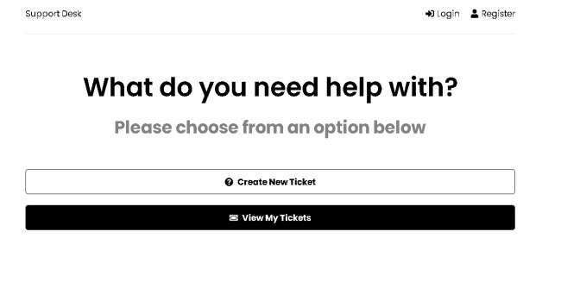

# DEPARTMENT OF INFORMATION TECHNOLOGY

**COURSE CODE: DJS22ITL604 DATE:**

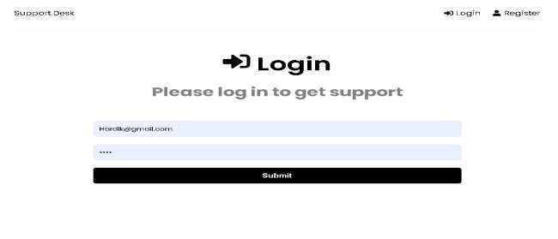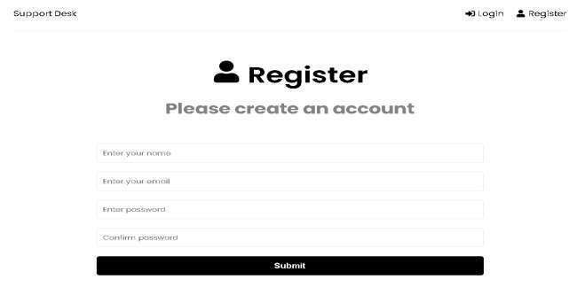

# DEPARTMENT OF INFORMATION TECHNOLOGY

**COURSE CODE: DJS22ITL604 DATE:**

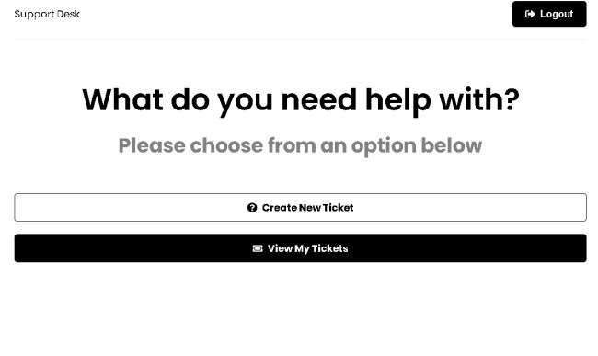

# DEPARTMENT OF INFORMATION TECHNOLOGY

**COURSE CODE: DJS22ITL604 DATE:**

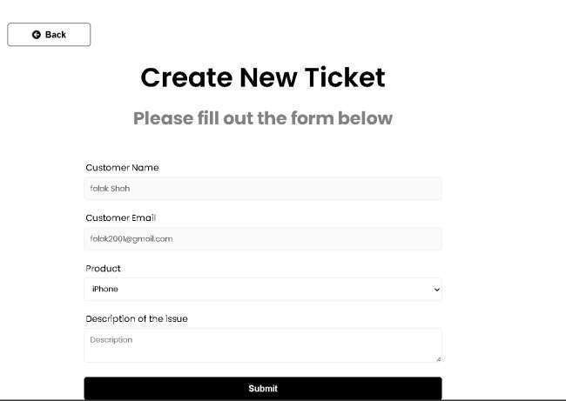

# DEPARTMENT OF INFORMATION TECHNOLOGY

**COURSE CODE: DJS22ITL604 DATE:**

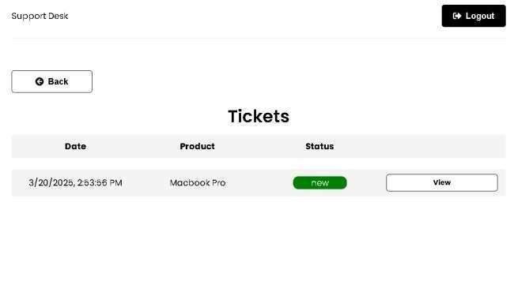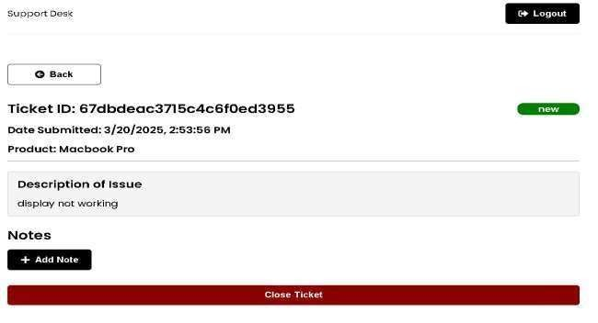

# DEPARTMENT OF INFORMATION TECHNOLOGY

**COURSE CODE: DJS22ITL604 DATE:**

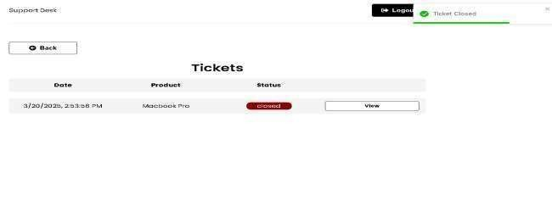

Conclusion:We learnt react router and navigations.

**BOOKS AND WEB RESOURCES:**

1. React Router Official Docs: https://reactrouter.com/
2. MDN Web Docs - SPA Routing: https://developer.mozilla.org/en-US/docs/Web/API/History_API
3. React Official Docs: https://react.dev/