**DEPARTMENT OF INFORMATION TECHNOLOGY**

**COURSE CODE:** DJS22ITL6015 **DATE:**

**COURSE NAME:** ISIG Laboratory  **CLASS: T. Y. B.Tech**

**SAP ID:** 60003320045

**Experiment No. 2**

**CO/LO:** Describe the types of support that an information system can provide to each functional area of the organization.

**AIM / OBJECTIVE:** To create a Tableau dashboard that visualizes the characteristics and usage of Decision Support Systems (DSS) in different organizational scenarios.

**THEORY:**

A decision support system (DSS) is a computer program used to improve a company's decision-making capabilities. It analyzes large amounts of data and presents an organization with the best possible options available.

DSS brings together data and knowledge from different areas and sources to provide users with information beyond the usual reports and summaries. This is intended to help organizations make informed decisions.

A decision support application might gather and present the following typical information:

* Comparative sales figures between one week and the next.
* Projected revenue figures based on new product sales assumptions.
* The consequences of different decisions.

A DSS is an *informational*application as opposed to an *operational* application. Informational applications provide users with relevant information based on a variety of data sources to support better-informed decision-making. Operational applications, by contrast, record the details of business transactions, including the data required for the decision-support needs of a business.

A DSS is an information system commonly used by middle and upper management levels of an organization, typically in operations or planning teams.

**What is the purpose of a DSS?**

The purpose of a DSS is to gather, analyze and synthesize data to produce comprehensive information reports that an organization can use to assist in its decision-making process. Unlike tools that are limited to just data collection, DSS also processes that data to create detailed reports and projections.

DSS are an adaptable tool meant to meet the specific needs of the organization using it. Finance, healthcare and supply chain management industries, for example, all use DSS to help in their decision-making processes. A DSS report can provide insights on topics like sales trends, revenue, budgeting, project management, inventory management, supply chain optimization and healthcare management.

All of this is meant to provide decision-makers with comprehensive information that can be used to make quicker and more accurate decisions.

**Decision support system components**

A typical DSS consists of three parts: a knowledge database, software and a user interface.

**Knowledge base**

A knowledge base is an integral part of a decision support system database, containing information from both internal and external sources. It's a library of information related to particular subjects and is the part of a DSS that stores information used by the system's reasoning engine to determine a course of action.

**Software system**

The software system is composed of model management systems. A [model is a simulation](https://www.techtarget.com/whatis/definition/modeling-and-simulation-MS) of a real-world system with the goal of understanding how the system works and how it can be improved. Organizations use models to predict how outcomes will change with different adjustments to the system.

For example, models can be helpful for understanding systems that are too complicated, expensive or dangerous to fully explore in real life. That's the idea behind computer simulations used for scientific research, engineering tests, weather forecasting and many other applications.

Models can also be used to represent and explore systems that don't yet exist, like a proposed new technology, a planned factory or a business supply chain. Businesses also use models to predict the outcomes of different changes to a system -- such as policies, risks and regulations -- to help make business decisions.

**User interface**

The user interface enables easy system navigation. The primary goal of the DSS's user interface is to make it easy for the user to manipulate the data that's stored on it. Businesses can use the interface to evaluate the effectiveness of DSS transactions for end users. DSS interfaces include simple windows, complex menu-driven interfaces and command-line interfaces.

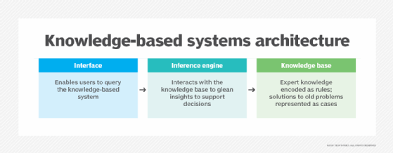A knowledge base is an integral part of a knowledge-based decision support system.

**What are the advantages of a DSS?**

DSS offer several advantages, including the following:

* **Enable informed decision-making.**By taking multiple different data sources into account, DSS can facilitate better, up-to-date and informed decisions.
* **Consider different outcomes.** DSS consider different business outcomes, as possible decisions are based on current and historical company data.
* **Increase efficiency.** DSS automate the analysis of large data sets.
* **Provide better collaboration.** DSS tools might also include communication and collaboration features.
* **Enable flexibility.** DSS can be used by many different industries.
* **Handle complexity.** DSS can handle complex problems that have multiple interdependencies and variables.

**What are the disadvantages of a DSS?**

While DSS offer several potential benefits, they also have notable downsides, including the following:

* **Cost.** Expenses for developing, implementing and maintaining DSS can be high, which can limit their use by smaller organizations.
* **Dependence.** Developing an over-reliance on a DSS eventually takes away from the subjectivity involved in decision-making.
* **Complexity.** DSS must consider all aspects of a given problem, which requires a lot of data. They can also be complex to design and implement.
* **Security.** Data that DSS use might involve sensitive or critical data, meaning that an increased focus on security is required.
* **Employee resistance.** Some employees might be resistant to any workflow change based on the recommendations of a machine.

**OBSERVATION**

**CONCLUSION**

**REFERENCES**:

1. Turban, E., McLean, E., and Wetherbe, J., “Information Technology for Management,” John Wiley and Sons, 2nd Edition, 2000.
2. D.P. Goyal, “Management Information Systems-Managerial Perspectives,” Macmillan, New Delhi, 2006.

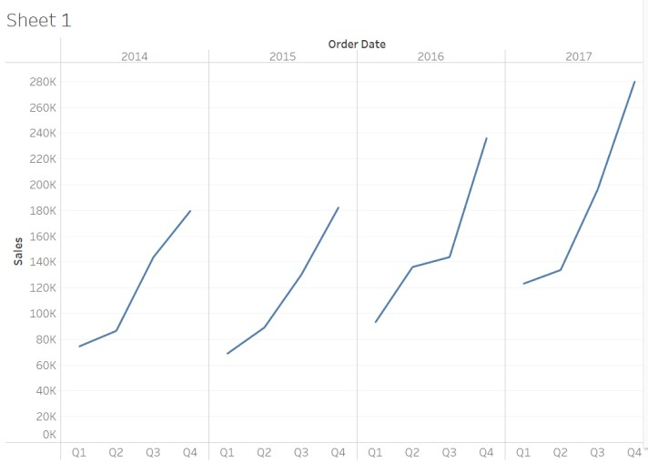

1. Display Sales in different Time period (Quarter, Month, Day)

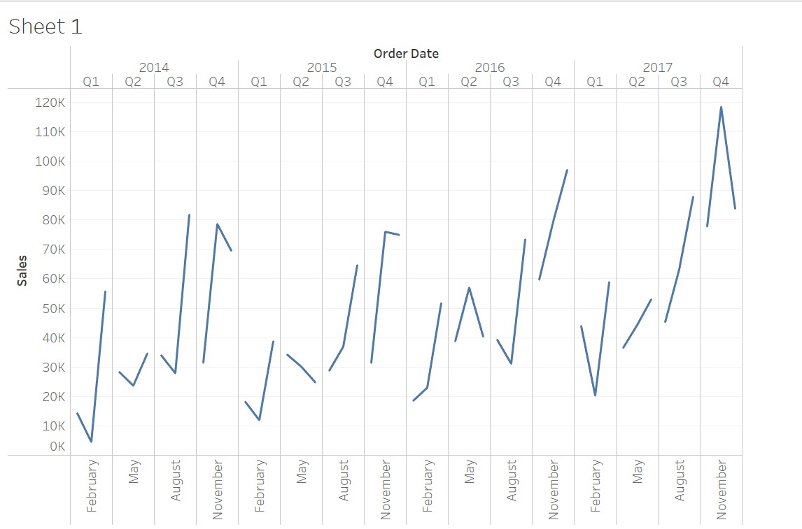

1. Find out more insights regarding which products drive more sales.
   1. Show marked labels
   2. Sort sum of sales descending/ascending within category
   3. Swap the orientation of the chart

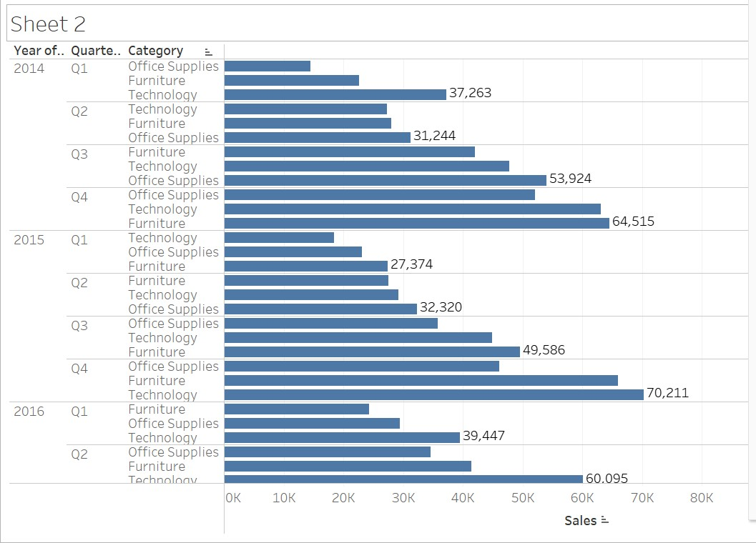

1. Look at products by Sub-category to see which items are the big sellers.

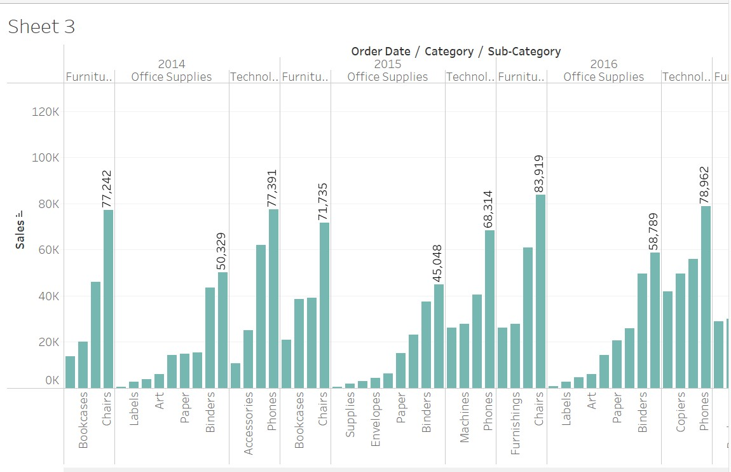

1. Apply filter to order date for category and sub category.

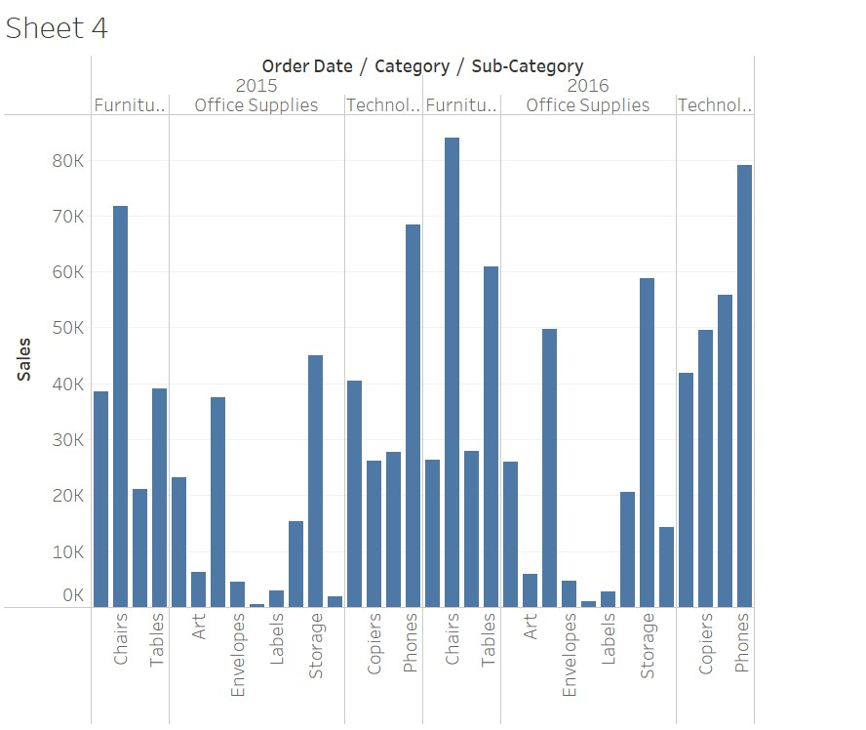

1. Visualize the profit using the colors.

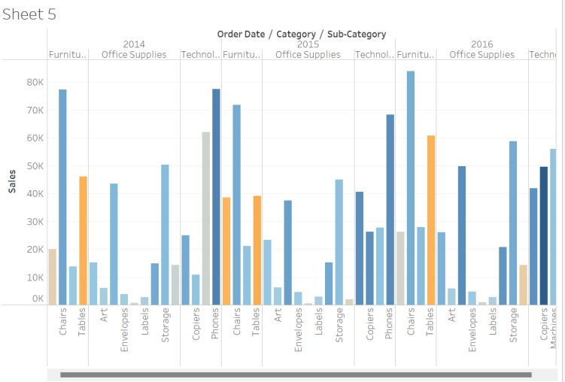

1. Drag Region to the Rows shelf and place it to the left of the Sum(Sales).
2. At the bottom-left of the workspace, double-click Sheet 1 and type Sales by Product and Region sheet and select Duplicate and rename the duplicated sheet to Sales-South.
3. In the new worksheet, from Dimensions, drag Region to the Filters shelf to add it as a filter in the view.
4. In the Filter Region dialogue box, clear all check boxes except South and then click OK.

Now we can focus on sales and profit in the South.

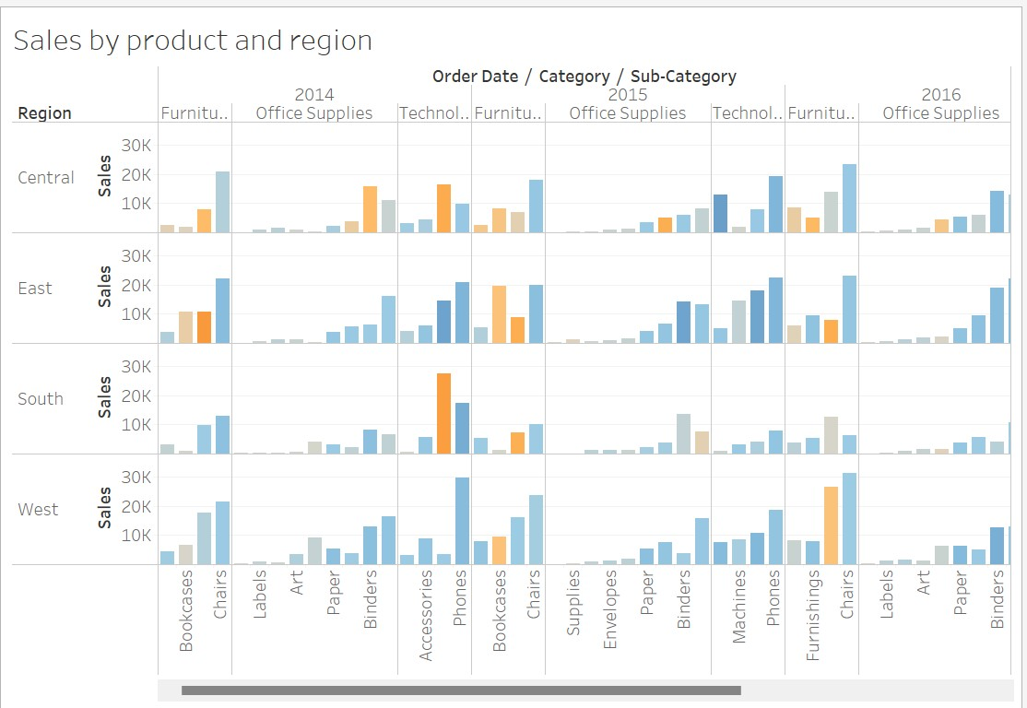

Creating a Map View

* 1. Create a new worksheet.
  2. Add State and Country under Data pane to Detail on the Marks card. We obtain the map view.
  3. Drag Region to the Filters shelf, and then filter down to South only. The map view now zooms in to the South region only, and a mark represents each state.
  4. Drag the Sales measure to the Color tab on the Marks card. We obtain a filled map with the colors showing the range of sales in each state.
  5. We can change the color scheme by clicking Color on the Marks card and selecting Edit Colors.

Write Observations for Florida Sales:

* 1. Display the performance by Profit.
  2. Drag Profit to Color on the Marks card. Rename the sheet as Profit Map.

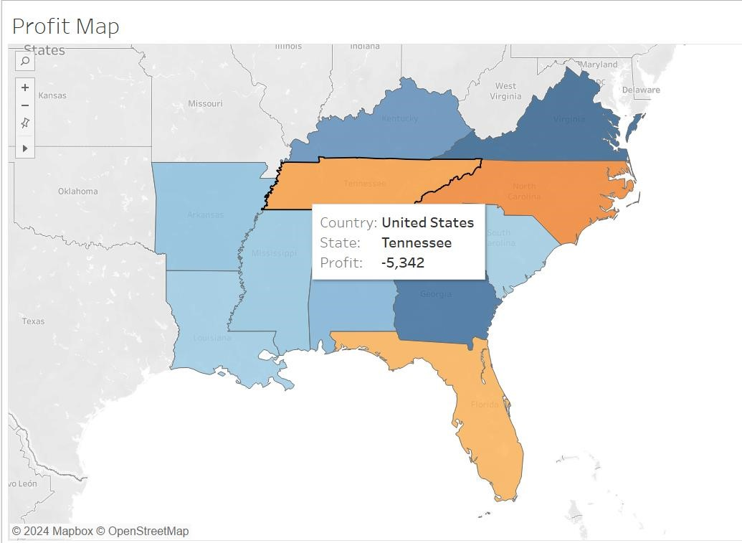

Write Observations for Florida Profit:

* 1. Duplicate the Profit Map worksheet and name it Negative Profit Bar Chart.
  2. Click Show Me on the Negative Profit Bar Chart worksheet. Show Me presents the number of ways in which a graph can be plotted between items mentioned in the worksheet. From Show Me select the horizontal bar option and the view updates to horizontal from vertical bars instantly.

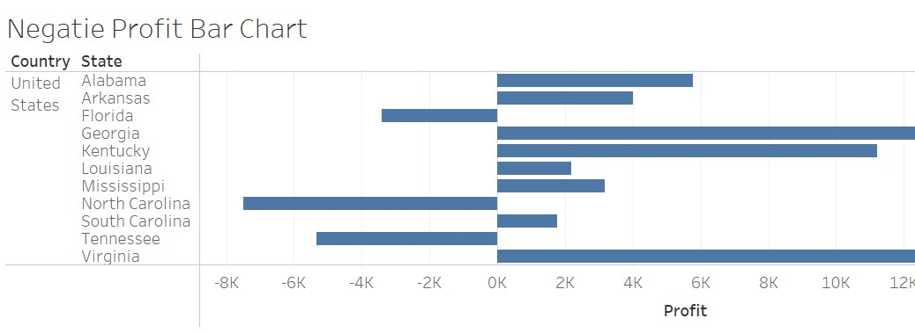

Creating Hierarchies

Hierarchies come in handy when we want to group similar fields so that we can quickly drill down between levels in the viz.

* 1. In the Data pane, drag a field and drop it directly on top of another field or right-click the field and select
  2. Drag any additional fields into the hierarchy. Fields can also be re-ordered in the hierarchy by simply dragging them to a new position. Create the following hierarchies: Location, Order, and Product.

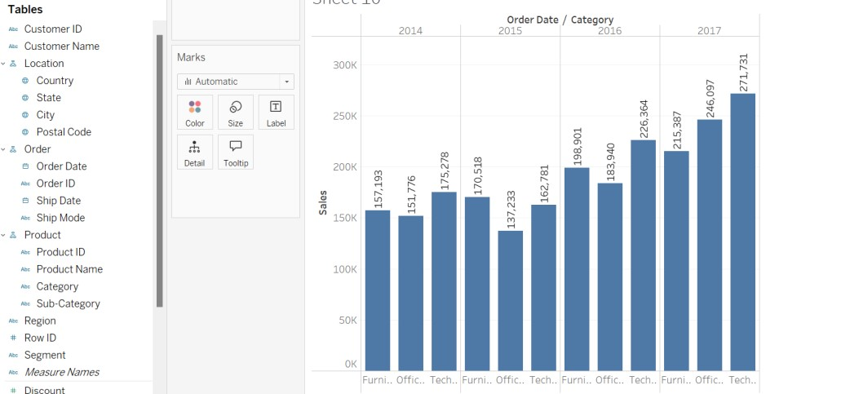

Creating a Dashboard

* 1. Click the New dashboard button.
  2. Drag Sales in the South to the empty dashboard
  3. Drag Profit Map to the dashboard and drop it on top of the Sales in the South view. Both views can be seen at once. To be able to present data in a manner so that others can understand it we can arrange the dashboard to our liking.
  4. Start with the Profit Map. On clicking the map, a Use as filter icon appears in the upper right. Click on it. If we select any map, Sales corresponding to that state will be highlighted in the Sales-South map.
  5. For the Year of Order Date, click on the drop-down option and go to Apply to Worksheets > Selected Worksheets. A dialog box opens up. Select the All option followed by OK. What does this option do? It applies filters to all the worksheets having the same data source.
  6. Explore and experiment. In the visualization below, we can filter the Sales South map to view products that are being sold in North Carolina only. We can then easily explore the profits yearly.
  7. Rename the Dashboard to Regional Sales and Profit.

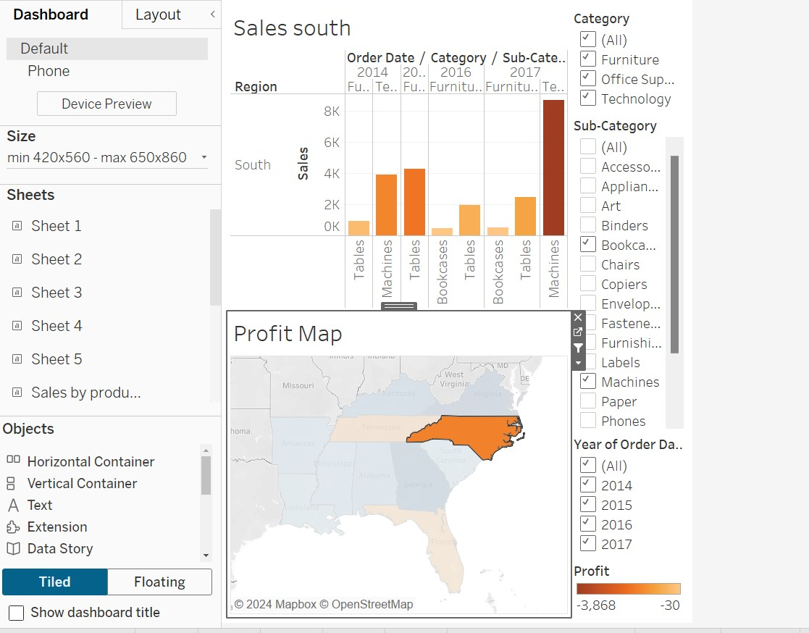

Create a story

* 1. Click the New story button.
  2. From the Story pane on the left, drag the Sales in the South worksheet (created earlier) onto the view.
  3. Edit the text in the gray box above the worksheet. This is the caption. Name it as Sales and profit by year.
  4. Stories are quite specific. Here we will tell a story about selling machines in North Carolina. In the Story pane, click on Duplicate to duplicate the first caption, or you may even create a new one.
  5. In the Sub-Category, filter select only Machines. This helps to gauge sales and profit of machines by year.
  6. Rename the caption to Machine sales and profit by year.

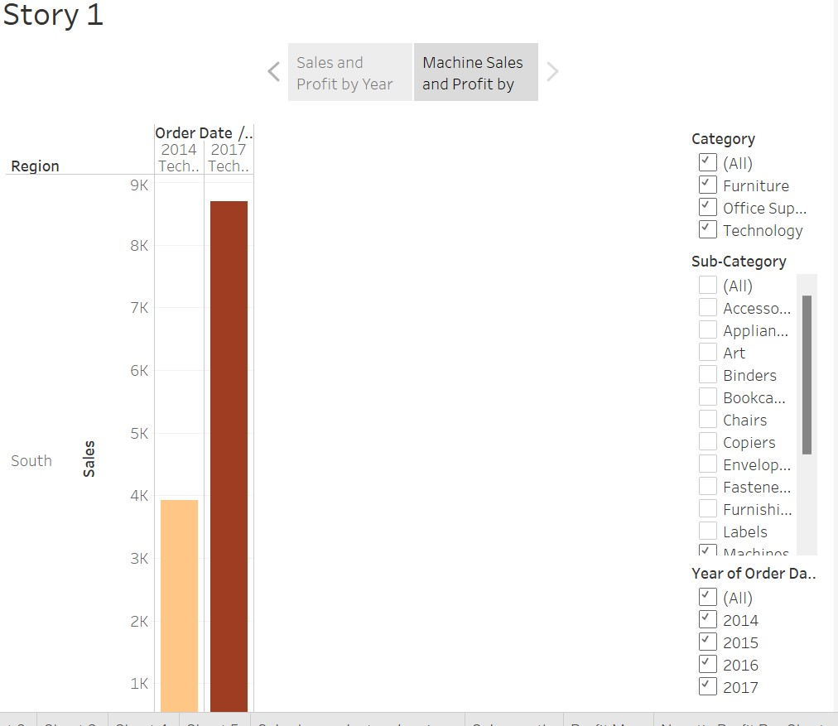

**CONCLUSION:**

In conclusion, this experiment emphasizes the importance of data visualization using Tableau, enabling users to create insightful business intelligence reports.

**REFERENCES:**

1. Ponniah P., “Data Warehousing: Fundamentals for IT Professionals”, 2nd Edition, Wiley India, 2013.
2. Ageed, Z. S., Zeebaree, S. R., Sadeeq, M. M., Kak, S. F., Yahia, H. S., Mahmood, M. R., & Ibrahim, I. M. (2021), “Comprehensive survey of big data mining approaches in cloud systems”, Qubahan Academic Journal, 1(2), 29-38.

**Website References:**

Mota, R. (2021, May 31). Data visualization in Tableau. DataCamp. Retrieved August 4, 2024, from https://www.datacamp.com/tutorial/data-visualisation-tableau