**COURSE CODE:** DJS22ITL6015 **DATE:**

**COURSE NAME:** ISIG Laboratory  **CLASS: T. Y. B.Tech**

**Name:Anish Sharma Div-IT-1-1 Roll no:I011**

**Experiment No.5**

**CO/LO:** Describe the types of support that an information system can provide to each functional area of the organization.

**AIM / OBJECTIVE:** To calculate the Net Present Value (NPV) and Internal Rate of Return (IRR) for a capital investment project using case study data.

**THEORY:**

**Cash Flow**

Cash flow refers to the net amount of cash moving in and out of a business during a specific period. In capital budgeting, cash flows typically consist of:

* **Inflows:** Revenues, cost savings, and residual value at the end of the investment period.
* **Outflows:** Operating expenses, maintenance costs, and taxes.

Cash flows are crucial in NPV and IRR calculations as they provide the basis for evaluating the profitability of an investment.

**Initial Cost**

Initial cost is the upfront expenditure required to start an investment project. It includes:

* **Purchase Cost:** The cost of acquiring equipment, software, or infrastructure.
* **Installation and Setup Costs:** Expenses related to implementing the investment.
* **Other Capital Costs:** Any additional expenses necessary to get the project operational.

In the context of the Excel example, initial costs are listed in the 'Initial Costs' sheet and involve investments in workstations, software, and infrastructure.

**Net Present Value (NPV)**

NPV is a method used to determine the value of an investment by calculating the present value of its expected future cash flows. It considers the time value of money by discounting the cash flows at a predetermined rate (Cost of Capital). The formula for NPV is:

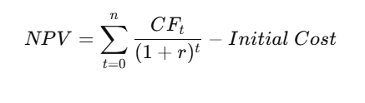

Where:

* CFt = Cash flow at time t
* r = Discount rate (Cost of Capital)
* t = Time period

A positive NPV indicates that the investment would add value to the firm, whereas a negative NPV suggests it would decrease value.

**Internal Rate of Return (IRR)**

IRR is the discount rate at which the NPV of an investment becomes zero. It represents the expected rate of return of the project. IRR is calculated using the following equation:



A project is considered favourable if its IRR exceeds the required rate of return or cost of capital.

**STEPS**

1. Students should select a case study for an investment project. They should make realistic assumptions regarding:
   * Initial Costs
   * Cash Inflows and Outflows over the investment period
   * Cost of Capital
   * Duration of the investment (in years)
2. Using Excel, students should:
   * Identify the relevant cost components from the 'Initial Costs' sheet.
   * Estimate yearly cash flows from potential cost savings and revenue increases as described in the 'Cash Flows' sheet.
   * Apply the Cost of Capital (7% as per assumptions) to discount the cash flows.
3. Calculate the NPV and IRR using Excel functions:
   * **NPV Function**: =NPV(rate, value1, [value2], ...)
   * **IRR Function**: =IRR(values, [guess])
4. Record the calculations and intermediate steps in the observation table.

**OBSERVATION**

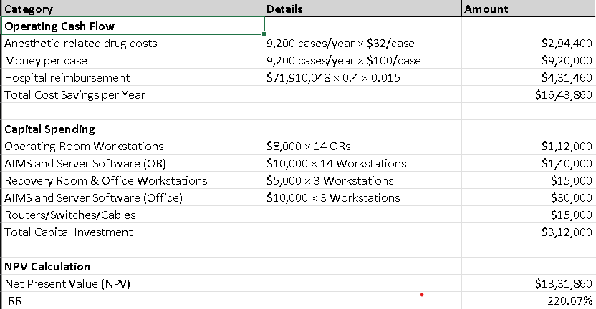

**CONCLUSION:**

The Net Present Value (NPV) and Internal Rate of Return (IRR) calculations indicate that investing in the AIMS system is financially viable for the Memorial Healthcare System. The key findings are:

1. Positive NPV: The NPV of the AIMS investment is positive, meaning the project is expected to generate more value than its cost. This suggests that the investment would add financial benefits to the hospital over time.
2. High IRR: The calculated IRR exceeds the assumed cost of capital (7%), indicating that the project will generate a return higher than the hospital’s required rate of return.
3. Significant Cost Savings: The system is expected to save $1,643,860 annually through reductions in anesthetic drug costs, per-case savings, and increased hospital reimbursements.
4. Justified Capital Spending: Although the initial investment is $312,000, the projected financial benefits outweigh the costs, making the investment worthwhile.

Final Decision: Based on these calculations, adopting the AIMS system is a profitable and strategic decision that aligns with long-term financial goals.

**REFERENCES**:

1. [Net Present Value vs. Internal Rate of Return](https://www.afponline.org/training-resources/resources/articles/Details/net-present-value-vs.-internal-rate-of-return)