# Department of Information Technology

**COURSE CODE:** DJS22ITL6015 **DATE:30-03-2025**

**COURSE NAME:** ISIG Laboratory  **CLASS: T. Y. B.Tech**

**NAME:** Anish Sharma

**Experiment No.6**

**CO/LO:** Describe the types of support that an information system can provide to each functional area of the organization.

**AIM / OBJECTIVE:** To simulate and compare how evolutionary and revolutionary changes affect user adoption over time using Python.

**THEORY:**

**User Resistance:**U ser resistance refers to the opposition or reluctance of users to adopt a new system, process, or technology. It is one of the most common barriers to successful system implementation.

**Causes of User Resistance:**

|  |  |
| --- | --- |
| **Reason** | **Example** |
| Fear of the unknown | Users unsure of the new system’s purpose or operation |
| Loss of control | Automation reduces users' influence or decision-making power |
| Increased workload  initially | Learning a new system feels harder than sticking to the old |
| Lack of trust | Users don’t believe the system will improve their work |
| Poor communication | Change not explained properly |
| Misalignment with user needs | New system does not solve the user’s real problems |

**Impacts on Project:**

# Department of Information Technology

* Delays in project success
* Reduced system utilization
* Workarounds or refusal to use the system
* Increased cost due to re-training and support

**Different Models of User Adoption**

1. **Rogers' Diffusion of Innovation Model:**

|  |  |  |
| --- | --- | --- |
| **Group** | **% of Population** | **Characteristics** |
| Innovators | 2.5% | Eager, tech enthusiasts |
| Early Adopters | 13.5% | Visionaries, influence others |
| Early Majority | 34% | Deliberate, adopt before average |
| Late Majority | 34% | Skeptical, adopt after majority |
| Laggards | 16% | Highly resistant to change |

1. **Technology Acceptance Model (TAM):**

Adoption depends on:

* + **Perceived Usefulness (PU):** "Will this help me?"
  + **Perceived Ease of Use (PEOU):** "Is it easy to use?" Higher PU and PEOU increase the chance of adoption.

1. **Unified Theory of Acceptance and Use of Technology (UTAUT):**

Factors affecting adoption:

* + Performance expectancy
  + Effort expectancy
  + Social influence

# Department of Information Technology

• Facilitating conditions

**3. Different Levers for Affecting User Adoption**

These are **tools, strategies, or interventions** designed to **reduce resistance** and **increase adoption**:

|  |  |  |
| --- | --- | --- |
| **Lever** | **Description** | **Example** |
| **Training** | Educates users to reduce fear | Workshops, hands-on practice |
| **Incentives** | Rewards for early or successful adoption | Bonuses, recognition |
| **Usability**  **Improvements** | Makes the system intuitive and userfriendly | User-friendly UI, help guides |
| **Communication** | Clear, transparent messaging about changes | Regular updates, newsletters |
| **User Involvement** | Involve users in the design process | Surveys, feedback sessions |
| **Support System** | Ongoing help and troubleshooting | Helpdesks, super-users |
| **Change Champions** | Influential people encouraging adoption | Department heads promoting change |

**1. Evolutionary Change (Incremental Change / Continuous Improvement)**

Evolutionary change refers to a gradual, step-by-step process where improvements or changes are introduced slowly over time. It focuses on refining existing systems, processes, or tools without causing major disruptions to daily operations. Organizations typically adopt evolutionary change when they aim for continuous improvement and prefer minimizing risks. This approach allows users to adapt progressively, reducing resistance because they have time to understand, learn, and adjust to the new changes.

An example of evolutionary change is when a company gradually updates its software modules— starting with one department and moving on to others once the new system stabilizes. Another

# Department of Information Technology

example is adding new features to a mobile application one update at a time, allowing users to familiarize themselves with each change.

The benefit of evolutionary change is that it provides a safer way to implement changes. It allows for feedback collection at every step, making it possible to fix problems as they arise. It also lowers the chance of failure because the system isn’t drastically altered overnight. However, the drawback is that change might feel slow, and the organization may take longer to realize the full benefits of the new system.

**Examples:**  • Updating features in an existing software application version by version.

* Gradually migrating users from an old system to a new system module-by-module.
* Improving customer service by tweaking processes rather than a full overhaul.
* Introducing one new yoga pose every week in a health app rather than changing the full routine. **Benefits:**
* Reduces the risk of failure.
* Easier for employees/users to accept and adapt.
* Helps sustain long-term change.
* Allows testing and corrections after every step.

**Challenges:**

* May be too slow for fast-changing industries.
* Benefits might not be immediately visible.
* Continuous change might create change fatigue over time.

**2. Revolutionary Change (Transformational / Radical Change)**

Revolutionary change, on the other hand, involves sudden, large-scale, and often disruptive transformations. It completely alters the existing system or process in a short period of time. This

# Department of Information Technology

type of change is typically driven by external factors such as competition, market demands, technological advancements, or internal factors like leadership decisions aiming for rapid innovation.

Revolutionary change often comes with high risks because it forces users to shift suddenly from their familiar ways of working to something completely new. This can lead to significant resistance as users feel overwhelmed, uncertain, or threatened. However, if managed properly, revolutionary change can bring massive benefits, helping organizations leap forward and gain a competitive edge.

For example, replacing an entire manual workflow system with a fully automated software overnight is revolutionary. It forces everyone in the organization to adapt quickly, changing how they perform their tasks entirely. Another example is when companies, due to a crisis like a pandemic, switch from office-based work to 100% remote operations in just a few days.

While revolutionary change can lead to rapid gains and show bold leadership, it requires strong planning, effective communication, intensive user training, and support to overcome resistance. The consequences of failure are high because reversing such changes is difficult once the process has started.

**Examples:**

* Replacing an entire legacy ERP system with a new cloud-based platform overnight.
* Sudden mergers or acquisitions changing entire organizational structures.
* A company switching overnight from office work to full remote work (as in the COVID19 pandemic). • Implementing AI-driven decision systems that replace human judgment.

**Benefits:**

* Faster implementation of new strategies.
* Potentially greater competitive advantage if executed well.
* Demonstrates strong leadership and innovation.

**Department of Information Technology** **Challenges:**

* High resistance from users due to fear of unknown.
* Risk of system failure or adoption failure.
* Requires significant training and change management effort.

**OBSERVATION:**

CompareEvolutionary change across all user groups compared to revolutionary change import matplotlib.pyplot as plt

# Data time_periods = range(20) adoption_evolutionary = [min(100, 5 * t) for t in time_periods] adoption_revolutionary = [0 if t < 10 else 100 for t in time_periods]

# Plotting plt.plot(time_periods, adoption_evolutionary, color='b', linestyle='--', marker='o') plt.plot(time_periods, adoption_revolutionary, color='r', linestyle='-', marker='x')

# Graph Labels plt.title("User Adoption Over Time: Evolutionary vs Revolutionary Change") plt.xlabel("Time Period") plt.ylabel("Adoption Percentage") plt.legend(["Evolutionary Change", "Revolutionary Change"]) # Using legend for labels plt.grid(True) plt.show()

# Department of Information Technology

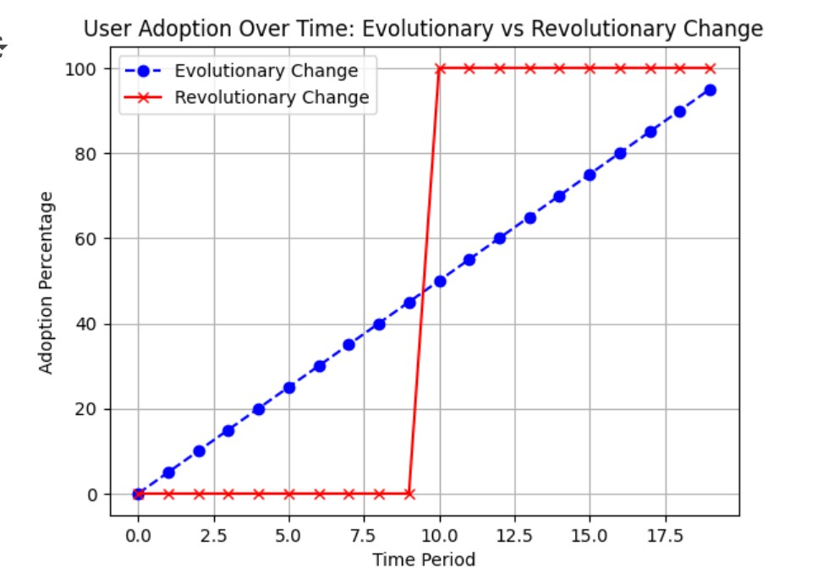

**CONCLUSION QUESTIONS:**

1. Explain how user resistance affects system adoption.

**REFERENCES**:

1. changinghighered.com