**COURSE CODE:** DJS22ITL6015 **DATE:06-05-2025**

**COURSE NAME:** ISIG Laboratory  **CLASS: T. Y. B.Tech**

**Name: Anish Sharma Roll: I011**

**Experiment No.8**

**CO/LO:** Describe the types of support that an information system can provide to each functional area of the organization.

**AIM / OBJECTIVE:** To analyze the organization's IT investment portfolio by classifying IT assets into four key categories—Firm-Wide Infrastructure, Transactional Systems, Informational Systems, and Strategic Systems—and to evaluate each category’s contribution to organizational value, thereby guiding informed and optimal IT investment decisions.

**PROCEDURE:**

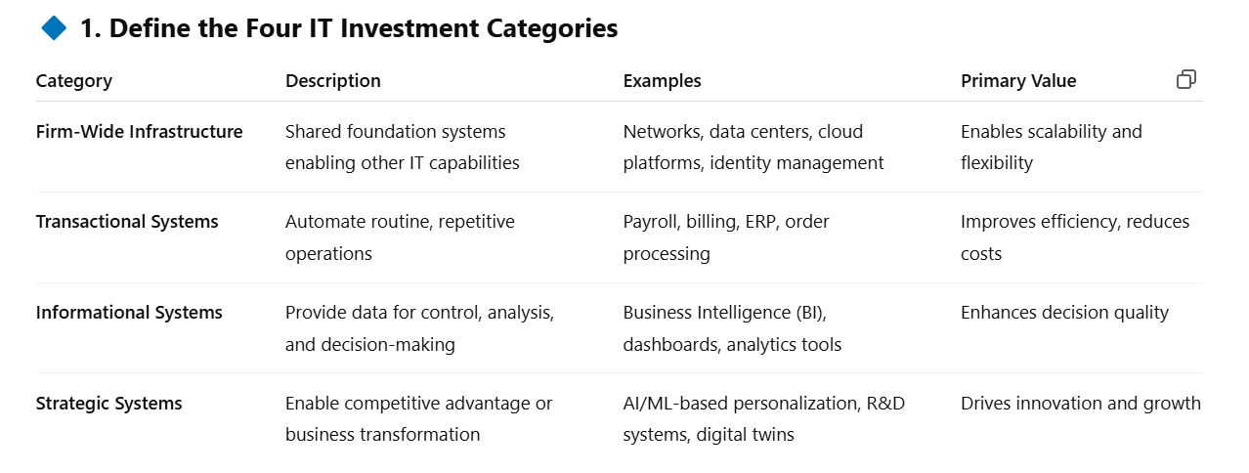

**2. Inventory and Classify IT Assets**

* **Step 1:** Create a list of all IT assets and systems in the organization.
* **Step 2:** For each asset, identify:
  + Purpose/functionality
  + Primary users
  + Dependencies and integrations
  + Classification into one of the four categories above

**3. Evaluate Value Contribution**

Use a **multi-criteria evaluation**, such as:

| **Evaluation Criteria** | **Description** |
| --- | --- |
| **Cost Savings** | Operational cost reductions |
| **Revenue Enablement** | Contribution to sales or service delivery |
| **Strategic Fit** | Alignment with long-term business goals |
| **User Impact** | Productivity or experience enhancement |
| **Risk Reduction** | Security, compliance, or continuity benefits |

**4. Create a Portfolio Map**

Visualize assets in a **2x2 matrix** for **value vs. cost** or **value vs. risk**. Another option is the **McFarlan Strategic Grid**:

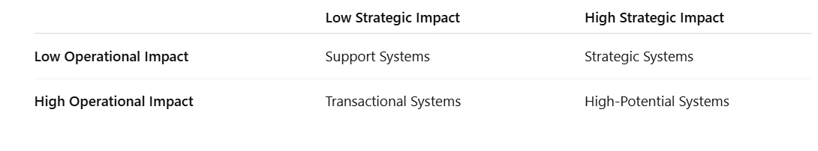

**5. Guide Investment Decisions**

Based on the classification and evaluation:

* **Increase Investment** in high-value Strategic and Informational systems.
* **Optimize** or **automate** Transactional systems to reduce costs.
* **Maintain and modernize** Infrastructure for flexibility and support.
* **Reallocate resources** from low-value or redundant systems.

**OUTPUT**To classify RetailNova's IT assets into four categories—Firm-Wide Infrastructure, Transactional, Informational, and Strategic Systems—and evaluate their contribution to organizational value to guide optimal investment decisions.

**Step 1:** List of IT Assets at RetailNova

| **IT Asset** | **Description** |
| --- | --- |
| Cloud Storage & Network | Centralized cloud infrastructure for all departments |
| POS System | Used for billing at stores and inventory updates |
| CRM System | Customer relationship management platform |
| Sales Dashboard | Provides real-time and historical sales analytics |
| Personalized E-Commerce Engine | AI-based system recommending products to online shoppers |

**Step 2:** Classification into 4 Categories

| **IT Asset** | **Category** |
| --- | --- |
| Cloud Storage & Network | Firm-Wide Infrastructure |
| POS System | Transactional System |
| CRM System | Informational System |
| Sales Dashboard | Informational System |
| E-Commerce Personalization Engine | Strategic System |

**Step 3:** Value Evaluation (Scored out of 5)

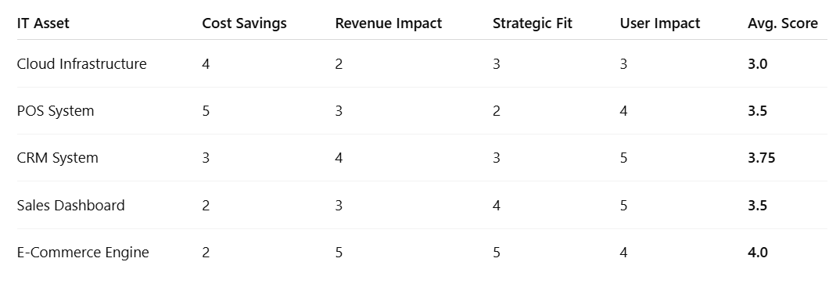

**Step 4:** Portfolio Map

You can visualize this on a 2x2 matrix:

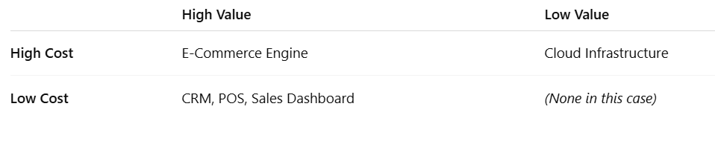

**Step 5:** Recommendations

* **Invest more** in the **E-Commerce Personalization Engine**: It offers high strategic value and revenue growth potential.
* **Maintain and optimize** CRM and POS systems as they offer consistent value with lower costs.
* **Modernize or outsource** cloud infrastructure to improve ROI.
* **Use dashboards** more widely across departments to enhance decision-making.

**CONCLUSION**

Through this experiment, RetailNova gained clear insights into the strategic and operational value of its IT assets. Categorizing and evaluating systems helped in identifying which tools drive growth, which support daily operations, and where to allocate future investments. This methodology enables smarter budgeting and technology upgrades aligned with business goals.

**QUESTIONS:**

**REFERENCES**: