# Summary

**Analyze real world problem using software engineering principles. Draw a Use Case diagram , Activity diagram and sequence Diagram for the chosen problem statement. Compare and interpret your results with expected behavior. Explain unexpected behavior, if any. Base all conclusions on your actual results; describe the meaning of the experiment and the implications of the results.**

**COURSE CODE: DJS22ITL601**   **DATE:**

**COURSE NAME: Software Engineering Laboratory**  **CLASS: T.Y.BTech**

**NAME: Anish Sharma**

**EXPERIMENT NO.3**

**CO/LO** Analyze real world problem using software engineering principles.

**AIM** / **OBJECTIVE**: Model the behavioral aspects for the chosen problem statement and draw the following diagrams

1. Use Case diagram
2. Activity diagram
3. Sequence Diagram

**DESCRIPTION OF EXPERIMENT:**

For Every diagram state

1. Definition of the diagram
2. Symbols used
3. Purpose of the diagram
4. Application of the diagram

**QUESTIONS**

1. Explain elements of Use Case diagram, Activity diagram and Sequence diagram

**OBSERVATIONS / DISCUSSION OF RESULT:**

This section should interpret the outcome of the experiment. The observations can be visually represented using images, tables, graphs, etc. This section should answer the question "What do the result tell us?" Compare and interpret your results with expected behavior. Explain unexpected behavior, if any.

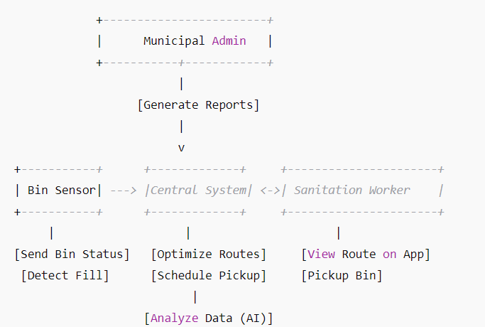

**CONCLUSION:**

Base all conclusions on your actual results; describe the meaning of the experiment and the implications of your results.

QUESTION:

In modern cities, inefficient waste collection leads to overflowing bins, environmental pollution, and increased operational costs. Traditional collection methods follow fixed schedules, often resulting in unnecessary pickups of empty bins while full bins remain unattended. To address this issue, a **Smart Waste Management System** utilizing **IoT sensors and AI-driven route optimization** is proposed. Smart bins equipped with sensors detect waste levels in real time and send updates to a central system. Once a bin reaches a predefined threshold, the system automatically schedules its collection. AI algorithms analyze bin fill levels, traffic conditions, and available resources to optimize garbage truck routes, ensuring efficient waste disposal. Sanitation workers receive dynamically updated routes via a mobile app, minimizing fuel consumption, labor costs, and collection delays. This system aims to enhance urban cleanliness, reduce environmental hazards, and improve municipal waste management efficiency. However, challenges such as **sensor reliability, data security, initial infrastructure costs, and system scalability** must be addressed to ensure its successful implementation in a metropolitan city.

Prepare Use Case diagram, Activity Diagram and Sequence Diagram for the given CASE STUDY

**REFERENCES:**

**Website References:**

1. [The UML 2 class diagram - IBM Developer](https://developer.ibm.com/articles/the-class-diagram/)