**Exercise**

1. Write a program that generates the following output by using setw, left, right and endl manipulators.

Code

#include <iostream<  
#include<iomanip>  
using namespace std;  
int main()  
{  
 cout<<left<<setw(10)<<"Programming"<<endl;  
 cout<<right<<setw(19)<<"Fundamental"<<endl;  
 cout<<right<<setw(19)<<"C++";

return 0;  
}

cout

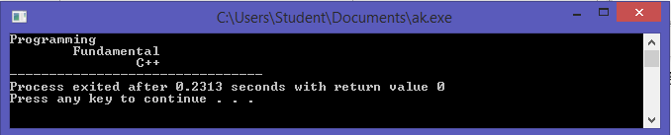

2. Write a program to print the following shapes using the setw and endl manipulator only (Do not use and escape sequence or spaces).

p-1

code

#include <iostream>  
#include <iomanip>  
using namespace std;  
int main(){  
cout<<setw(2)<<"#"<<setw(2)<<"#"<<setw(2)<<"#"<<setw(2)<<"#"<<setw(2)<<"#"<<setw(2)<<"#"<<endl;  
cout<<setw(2)<<setw(2)<<"#"<<setw(2)<<"#"<<setw(2)<<"#"<<setw(2)<<"#"<<setw(2)<<"#"<<endl;

cout<<setw(2)<<"#"<<setw(2)<<"#"<<setw(2)<<"#"<<setw(2)<<"#"<<endl;  
cout<<setw(2)<<"#"<<setw(2)<<"#"<<setw(2)<<setw(2)<<"#"<<endl;  
cout<<setw(2)<<"#"<<setw(2)<<"#"<<endl;  
cout<<setw(2)<<"#"<<endl;

return 0;  
}

cout

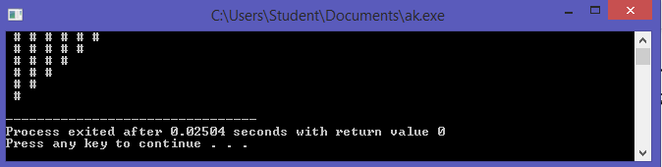

p-2

code

#include <iomanip>  
#include <iomanip>  
using namespace std;  
int main()  
{  
cout<<setw(2)<<"#"<<endl;  
cout<<setw(2)<<"#"<<setw(2)<<"#"<<endl;  
cout<<setw(2)<<"#"<<setw(2)<<"#"<<setw(2)<<"#"<<endl;  
cout<<setw(2)<<"#"<<setw(2)<<"#"<<setw(2)<<"#"<<setw(2)<<"#"<<endl;  
cout<<setw(2)<<"#"<<setw(2)<<"#"<<setw(2)<<"#"<<setw(2)<<"#"<<setw(2)<<setw(2)<<"#"<<endl;  
cout<<setw(2)<<"#"<<setw(2)<<"#"<<setw(2)<<"#"<<setw(2)<<"#"<<endl;  
cout<<setw(2)<<"#"<<setw(2)<<"#"<<setw(2)<<"#"<<endl;  
cout<<setw(2)<<"#"<<setw(2)<<"#"<<endl;  
cout<<setw(2)<<"#"<<endl;

return 0;  
}

cout

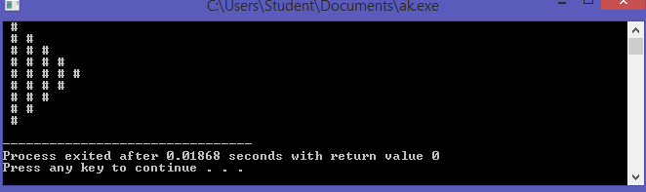

p-3

code

#include <iostream>  
#include <iomanip>

using namespace std;  
int main(){  
cout<<setw(2)<<"#"<<endl;  
cout<<setw(2)<<"#"<<setw(2)<<"#"<<endl;  
cout<<setw(2)<<"#"<<setw(2)<<"#"<<setw(2)<<"#"<<endl;  
cout<<setw(2)<<"#"<<setw(2)<<"#"<<setw(2)<<"#"<<setw(2)<<"#"<<endl;  
cout<<setw(2)<<"#"<<setw(2)<<"#"<<setw(2)<<"#"<<setw(2)<<"#"<<setw(2)<<setw(2)<<"#"<<endl;  
cout<<setw(2)<<"#"<<setw(2)<<"#"<<setw(2)<<"#"<<setw(2)<<"#"<<endl;  
cout<<setw(2)<<"#"<<setw(2)<<"#"<<setw(2)<<"#"<<endl;  
cout<<setw(2)<<"#"<<setw(2)<<"#"<<endl;  
cout<<setw(2)<<"#"<<endl;

return 0;  
}

cout

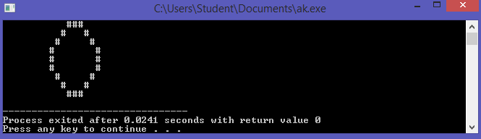

p-4

code

#include <iostream>  
#include <iomanip>  
using namespace std;  
int main()  
{  
cout<<setw(14)<<"#\n";  
cout<<setw(12)<<"#"<<setw(3)<<"#\n";  
cout<<setw(11)<<"#"<<setw(5)<<"#\n";  
cout<<setw(10)<<"#"<<setw(7)<<"#\n";  
cout<<setw(9)<<"#"<<setw(9)<<"#\n";  
cout<<setw(10)<<"#"<<setw(7)<<"#\n";  
cout<<setw(11)<<"#"<<setw(5)<<"#\n";  
cout<<setw(12)<<"#"<<setw(3)<<"#\n";  
cout<<setw(14)<<"#\n";

return 0;  
}

cout

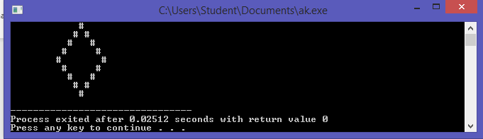

3. Write a program that asks the user to input two numbers i.e., num1 and num2; And the output should be formatted according to these numbers. The larger number will print the larger gap on the screen (use setw and right align).  
Code

#include <iostream>  
#include <iomanip>  
using namespace std;  
int main()  
{  
 int num1,num2;  
 cout<<left<<setw(10)<<"Enter first Value : ";  
 cin>>num1;  
 cout<<left<<setw(10)<<"Enter second Value : ";  
 cin>>num2;  
 cout<<right<<setw(14)<<num1<<" "<<"slots" <<endl;  
 cout<<right<<setw(20)<<num2<<" "<<"slots"; return 0;}

Cout

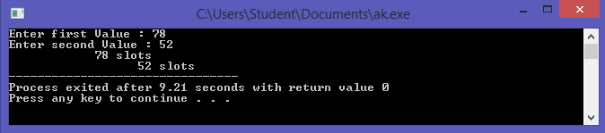

4. Generate the below-mentioned output using the Manipulators only (setw(n), endl, fixed, left, etc.)

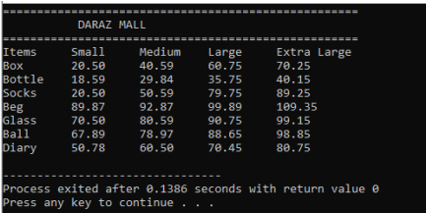

Code

#include <iostream>  
#include <iomanip>  
using namespace std;  
int main(){

cout<<setfill('=');  
cout<<left<<setw(50)<<'='<<endl;  
cout<<"\t\t Mini-Mart "<<endl;  
cout<<setfill('=');  
cout<<left<<setw(50)<<'='<<endl;  
cout<<"Items Small Medium Large Extra-Large \n";  
cout<<"Box 21.0 25.25 54.5 54.9 "<<endl;  
cout<<"Bottle 15.5 21.54 45.25 50.00"<<endl;  
cout<<"Socks 16.5 45.25 56.2 57.25"<<endl;  
cout<<"Beg 23.25 28.25 41.25 50.25"<<endl;

return 0;}

cout

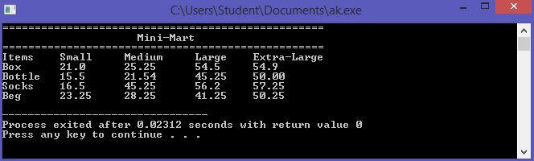

5. Write a program in which you create three float variables to set the price of 240.99999 for a joystick, 180.88888 for Mouse, and 570.77777 for keyboard. Your task is to print the prices of the above-mentioned items in the following format.

Code

#include <iostream>  
#include <iomanip>  
using namespace std;  
int main(){

float vagitables,books,pens;

vagitables=245.2899;  
 books=500.7777;  
 pens=750.7555;  
cout<<setfill('=');  
cout<<left<<setw(50)<<'='<<endl;  
cout<<"\t\t UK-Mart "<<endl;  
cout<<setfill('=');  
cout<<left<<setw(50)<<'='<<endl;  
cout<<"vagitables : "<<setprecision(5)<<vagitables<<endl;  
cout<<"Books : "<<setprecision(5)<<books<<endl;  
cout<<"Pens : "<<setprecision(5)<<pens;

return 0;}

cout

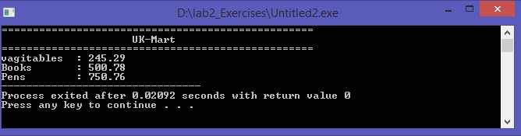

6. Write a program asking the user to enter the total amount, you have to answer how much INTEREST is to be paid on that amount. INTEREST is 14.5% of the total amount.

Code

#include <iostream>  
#include <iomanip>  
using namespace std;

int main(){  
float amount,interest, amount_of_intrest;  
cout<<"Enter the amount : "<<endl;  
cin>>amount;   
interest=(14.5/100)*amount;  
cout<<"Amount of Interest will be : "<<interest;

return 0;}

cout

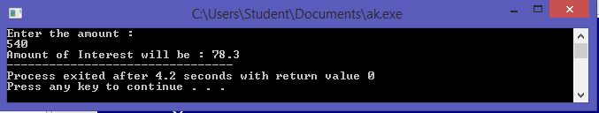

7. Write a program for the marksheet, where the user can enter the marks for five subjects. Then, your program should tell him/her his/her obtained marks, average marks, and percentage.

Code

#include <iostream>  
#include <iomanip>  
using namespace std;

int main(){  
float FP,OOP,Maths,English,ICT,total,average,percentage,obt_Marks;  
string name,CMS;

cout<<"Enter the marks of FP : ";  
cin>>FP;  
cout<<"Enter the marks of ICT : ";  
cin>>ICT;  
cout<<"Enter the marks of OOP : ";  
cin>>OOP;  
cout<<"Enter the marks of Maths : ";  
cin>>Maths;  
cout<<"Enter the marks of English : ";  
cin>>English;  
cout<<setfill('=');  
cout<<left<<setw(50)<<'='<<endl;  
cout<<"\t\t MARKSHEET "<<endl;  
cout<<setfill('=');  
cout<<left<<setw(50)<<'=';  
cout<<"\n Student Name : ";  
cin>>name;  
cout<<"CMS ID : ";  
cin>>CMS;  
cout<<setfill('=')<<setw(50)<<'='<<endl;  
cout<<left<<"SUBJECT \t "<<" MARKS"<<endl;  
cout<<setfill('=')<<setw(50)<<'='<<endl;  
cout<<"FP \t\t "<<setprecision(4)<<FP<<endl;  
cout<<"OOP \t\t "<<setprecision(4)<<OOP<<endl;  
cout<<"Maths \t\t "<<setprecision(4)<<Maths<<endl;  
cout<<"English\t\t "<<setprecision(4)<<English<<endl;  
cout<<"ICT \t"<<setprecision(4)<<ICT<<endl;  
cout<<setfill('=')<<setw(50)<<'='<<endl;  
total=100;  
obt_Marks=FP+OOP+Maths+English+ICT;  
cout<<"Obtianed Marks "<<setprecision(4)<<obt_Marks<<endl;  
percentage=(obt_Marks/5);  
cout<<"Percentage "<<percentage<<fixed<<endl;  
average=obt_Marks/5;  
cout<<"Average "<<average<<endl;  
cout<<setfill('=')<<setw(50)<<'='<<endl;   
return 0;}

cout

