

lAB-4

By-Arun Lal



Sec-E

BSCS(1)

1. Length and breadth of a rectangle are 6 and 8 respectively. Write a program to calculate the area and perimeter of the rectangle.

**code**

#include <iostream>

using namespace std;

int main(){

float Length,Breadth,Area;

cout<<"Enter the Breadth : ";

cin>>Breadth;

cout<<"Enter the Length : ";

cin>>Length;

Area=Length*Breadth;

cout<<"Area will be : "<<Area<<" Square Units";

return 0;}

cout

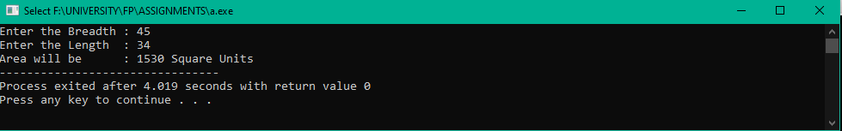

2. Write a program that inputs a six-digit integer, separates the integer into its individual digits

and prints the digits vertically using modulus operator. For example, if the user types 953647,

the program should print:

code

#include <iostream>

using namespace std;

int main(){

int A;

cout<<"Enter the 6 digit number : ";

cin>>A;

cout<<A%10<<endl<<A/10%10<<endl<<A/100%10<<endl

<<A/1000%10<<endl<<A/10000%10<<endl<<A/100000%10<<endl;

return 0;}

cout

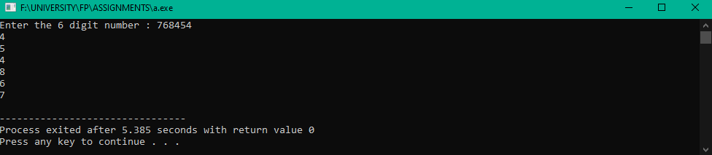

3. Write a program to convert Fahrenheit into Celsius.

𝑪 =𝟓\𝟗( 𝑭 − 𝟑𝟐)

code

#include <iostream>

using namespace std;

int main(){

float C,F;

cout<<"Enter the Celsius : ";

cin>>C;

//formula of Fahrenhiet is

F=((9*C)/5)+32;

cout<<"The Fahrenhiet will be : "<<F;

return 0;}

cout

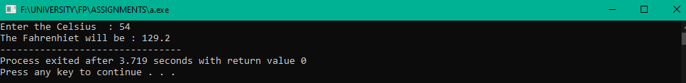

4. Write a program that finds the value of X by using given formula. Take value of ‘a’ and ‘b’ from

user.

X = 6ab ( a + b ) – 4ab

code

#include <iostream>

using namespace std;

int main(){

float a,b,X;

cout<<"Enter the Value of a :";

cin>>a;

cout<<"Enter the Value of b :";

cin>>b;

//the formula for finding the value of X will be

X=6*a*b*(a+b)-4*a*b;

cout<<"The value of X will be :"<<X;

return 0;

}

Cout

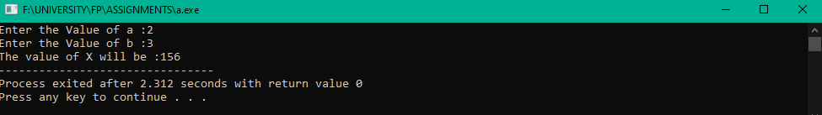

5. Write a program that takes two numbers from user and checks if the two numbers are equal or not by returning 1 or 0 respectively.

code

#include <iostream>

using namespace std;

int main(){

float a,b;

bool X;

cout<<"Enter the Value of a : ";

cin>>a;

cout<<"Enter the Value of b : ";

cin>>b;

X=(a==b);

cout<<"For Equal assign 1 :\n"<<"For unequal assign 0 : \n"<<"Result is : "<<X;

return 0;}

cout

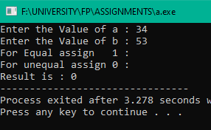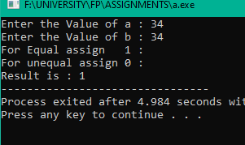

6. Write a program to enter the values of two variables 'num1' and 'num2' from user and then

check if both the conditions 'num1 < 100' and 'num1 < num2' are true

code

#include <iostream>

using namespace std;

int main(){

float num1,num2;

bool b;

cout<<"Enter the Value of num1 : ";

cin>>num1;

cout<<"Enter the Value of num2 : ";

cin>>num2;

b=((num1<100)||(num1<num2));

cout<<b;

return 0;}

Code

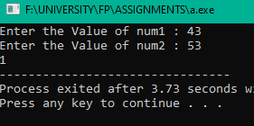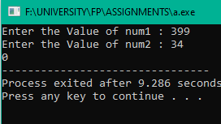

7. Write a program to enter the values of two variables 'num1' and 'num2' from user and then

check if atleast one of the conditions 'num1 < 100' and 'num1 < num2' is true

code

#include <iostream>

using namespace std;

int main(){

float num1,num2;

bool b;

cout<<"Enter the Value of num1 : ";

cin>>num1;

cout<<"Enter the Value of num2 : ";

cin>>num2;

b=((num1<100)&&(num1<num2));

cout<<b;

return 0;

}

Cout

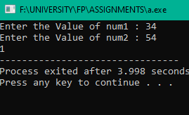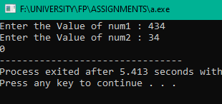

8. Implement a program that calculates the square of a number entered by the user (using

assignment operator).

code

#include <iostream>

using namespace std;

int main(){

float m,n;

cout<<"Enter the Number : ";

cin>>m;

n=m*m;

cout<<"Square of that number will be : "<<n;

return 0;

}

Cout

