

LAB-6

By-Arun Lal



Sec-E

BSCS(1)

CMS-ID=023-24-0120

Exercise

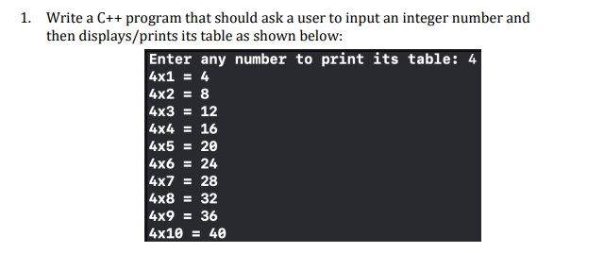

Code

#include <iostream>

using namespace std;

int main()

{

int a,b;

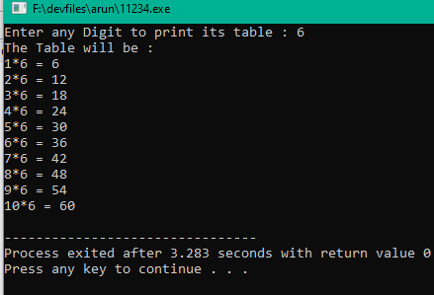cout<<"Enter any Digit to print its table : ";

cin>>a;

cout<<"The Table will be : "<<endl;

for(int i=1; i<=10; i++)

cout<<i<<"\*"<<a<<" = "<<a\*i<<endl;

return 0;

}

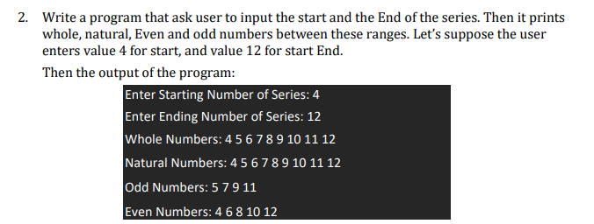

Code

#include <iostream>

using namespace std;

int main()

{

int a,b;

cout<<"Enter the Starting Number of Series: ";

cin>>a;

cout<<"Enter the Ending Number of Series : ";

cin>>b;

cout<<"Whole Number Will Be: ";

for(int i=a; i<=b; i++){

cout<<" "<<i;

}

cout<<endl;

cout<<"Natural Number Will Be: ";

for(int i=a; i<=b; i++){

if(a!=0)

cout<<" "<<i;

}

cout<<endl;

cout<<"Odd Number Will Be :";

for(int i=a; i<=b; i++){

if(i%2 != 0)

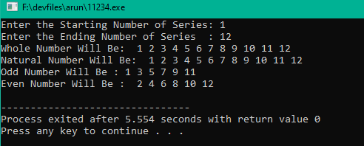cout<<" "<<i;

}

cout<<endl;

cout<<"Even Number Will Be : ";

for(int i=a; i<=b; i++){

if(i%2==0)

cout<<" "<<i;

}

cout<<endl;

return 0;

}

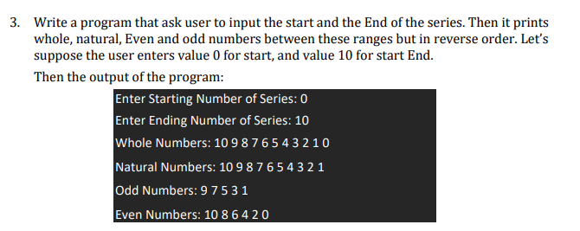

Code

#include <iostream>

using namespace std;

int i;

int main()

{

int a,b;

cout<<"Enter the starting number of the series : ";

cin>>a;

cout<<"Enter the ending number of the series : ";

cin>>b;

cout<<"Whole Numbers : ";

for( i=10; i>=0; i--)

{

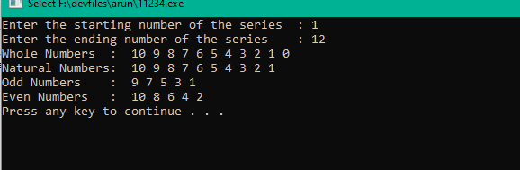 cout<<" "<<i;

}

cout<<endl;

cout<<"Natural Numbers: ";

for(i=10; i>=1; i--)

{

cout<<" "<<i;

}

cout<<endl;

cout<<"Odd Numbers : ";

for(i=10; i>=1; i--)

{

if(i%2!=0)

cout<<" "<<i;

}

cout<<endl;

cout<<"Even Numbers : ";

for(i=10; i>=1; i--)

if(i%2==0)

cout<<" "<<i;

}

cout<<endl;

system("PAUSE");

return 0;

}

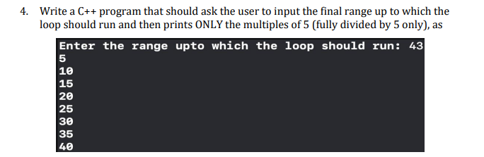

Code

#include <iostream>

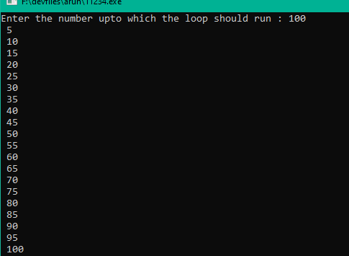using namespace std;

int i;

int main()

{

int a;

cout<<"Enter the number upto which the loop should run : ";

cin>>a;

for(i=1; i<=a; i++)

{

if(i%5==0)

cout<<" "<<i<<endl;

}

system("PAUSE");

return 0;

}

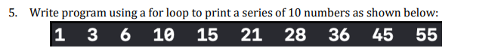

Code

#include <iostream>

using namespace std;

int main()

{

int i, a=0, b=1, c;

cout << "The Fibonacci series will be : " << endl;

cout << a<<" "<<b<<" " ;

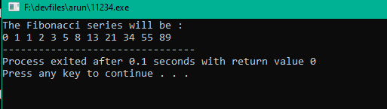for(i=1; i<=10; i++)

{

c=a+b;

cout<<c<<" " ;

a=b;

b=c;

}

return 0;

}

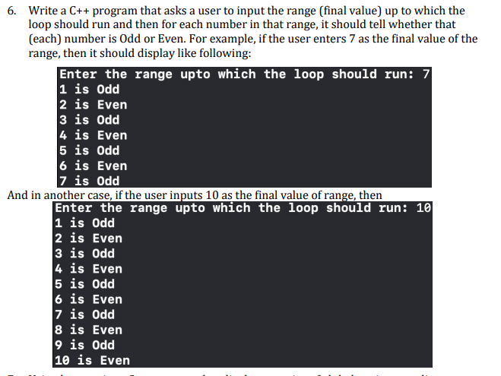

Code

#include <iostream>

using namespace std;

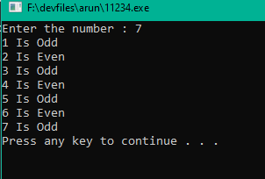

int i;

int main()

{

int a;

cout<<"Enter the number : ";

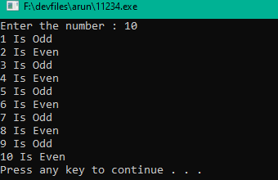cin>>a;

for(i=1; i<=a; i++)

{

if(i%2==0)

cout<<i<<" Is Even"<<endl;

if(i%2!=0)

cout<<i<<" Is Odd"<<endl;

}

system("PAUSE");

return 0;

}



Ascending order

Code

#include <iostream>

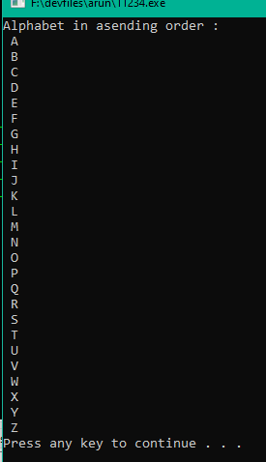using namespace std;

int main()

{

cout<<"Alphabet in asending order : "<<endl;

for(char i='A'; i<='Z'; i++)

cout<<" "<<i<<" "<<endl;

system("PAUSE");

return 0;

}

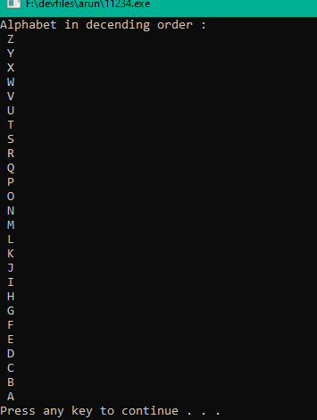

Decending order

Code

#include <iostream>

using namespace std;

int main()

{

cout<<"Alphabet in asending order : "<<endl;

for(char i ='Z'; i>='A'; i--)

cout<<" "<<i<<" "<<endl;

system("PAUSE");

return 0;

}



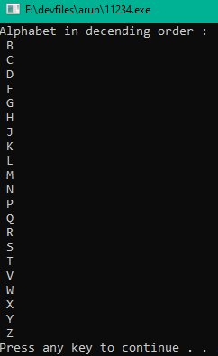Code

#include <iostream>

using namespace std;

int main()

{

cout<<"Alphabet in decending order : "<<endl;

for(char i ='A'; i<='Z'; i++)

if((i != 'A')&&(i != 'E')&&(i != 'I')&&(i != 'O')&&(i != 'U') )

cout<<" "<<i<<" "<<endl;

system("PAUSE");

return 0;

}

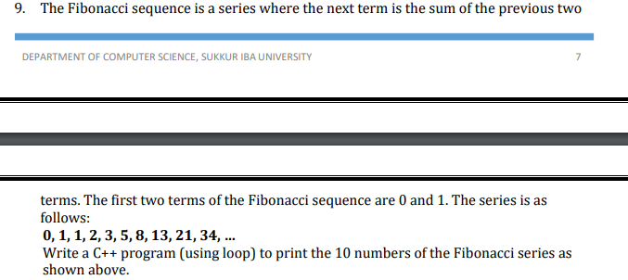

Code

#include <iostream>

using namespace std;

int main(){

int i, a=0, b=1, c;

cout << "The Fibonacci series will be : " << endl;

cout << a<<" "<<b<<" " ;

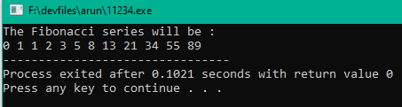for(i=1; i<=10; i++)

{

c=a+b;

cout<<c<<" " ;

a=b;

b=c;

}

return 0;

}

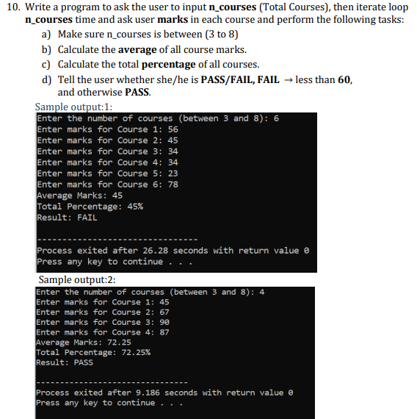

Code

#include <iostream>

using namespace std;

int main()

{

int i,n, a;

float c , d, b=0 ;

cout<<" Enter the Number of courses between(3 and 8) ";

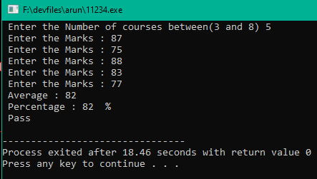cin >> n;

for(i=1; i<=n; i++)

{

if((n<9)&&(n>2))

cout<<" Enter the Marks : ";

cin >> a;

(b+=a);

}

c=(b/n);

cout<<" Average : " << c<< endl;

cout <<" Percentage : " << c<<" %"<<endl;

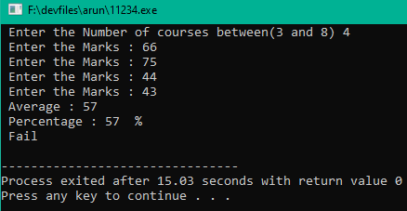if(c>=60)

{

cout << " Pass" << endl;

}

else

cout << " Fail" << endl;

return 0;

}

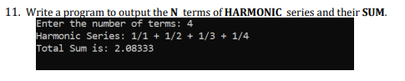

Code

#include <iostream>

using namespace std;

int main() {

int n;

double sum = 0;

cout << "Enter the number of terms: ";

cin >> n;

cout << "Harmonic Series: ";

for (int i = 1; i <= n; i++) {

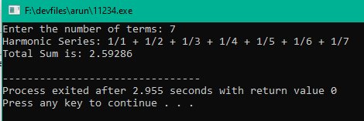 cout << "1/" << i;

if (i != n) {

cout << " + ";

}

sum += 1.0 / i;

}

cout<<endl;

cout << "Total Sum is: " << sum << endl;

return 0;

}