

LAB-8

By-Arun Lal



Sec-E

BSCS(1)

CMS-ID=023-24-0120

Exercise of LAB-8

1. Maximum of Two Numbers Create a program that prompts the user to enter three numbers and uses the ternary operator to find and display the maximum of these three numbers.

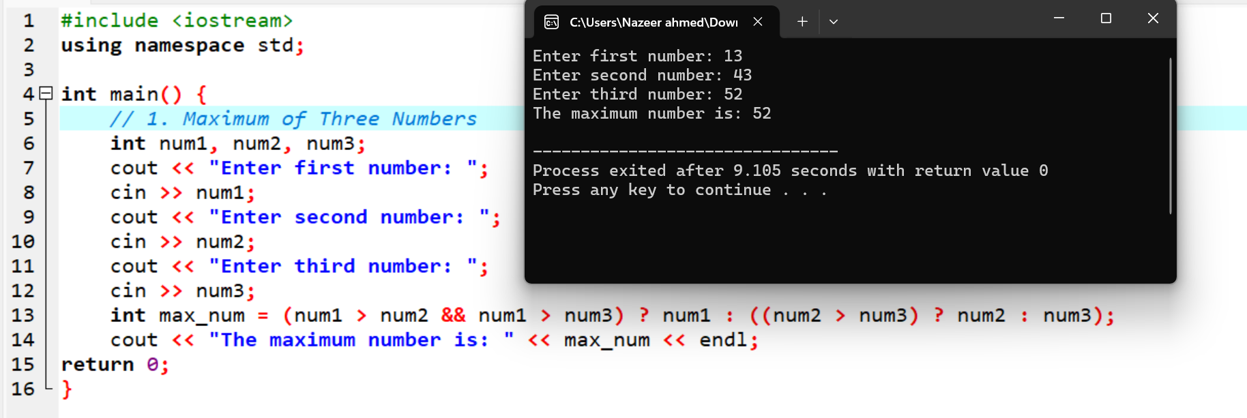

2. Voting Eligibility Create a program that takes a person's age as input and uses the ternary operator to determine and display whether they are eligible to vote in an election. In most countries, the voting age is 18 or older.

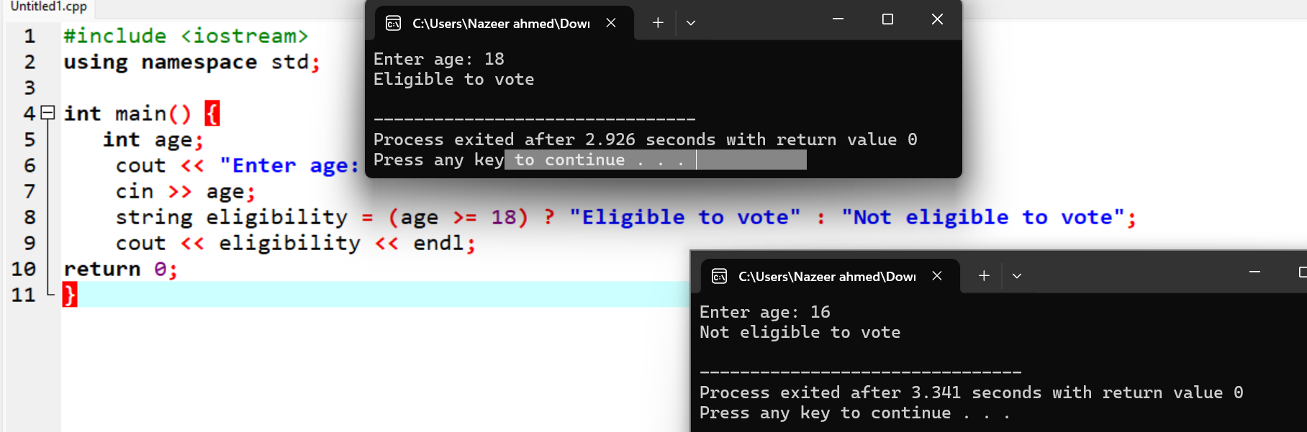

3. Absolute Value Calculator Develop a program that asks the user to enter a number and uses the ternary operator to calculate and display its absolute value (i.e., if the number is negative, negate it).

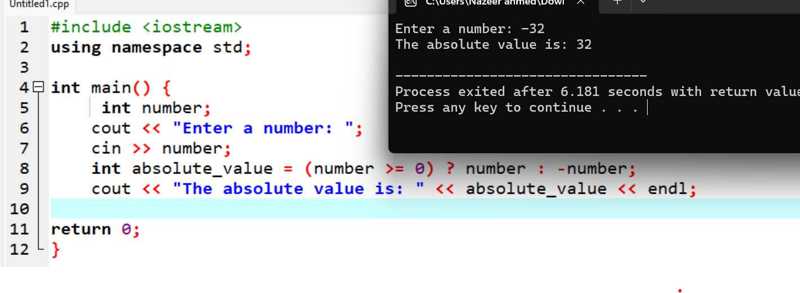

4. Leap Year Checker Write a program that prompts user to input the year. Use Boolean expression with ternary operator to check whether the year is a leap year. Hint: A leap year is divisible by 4.

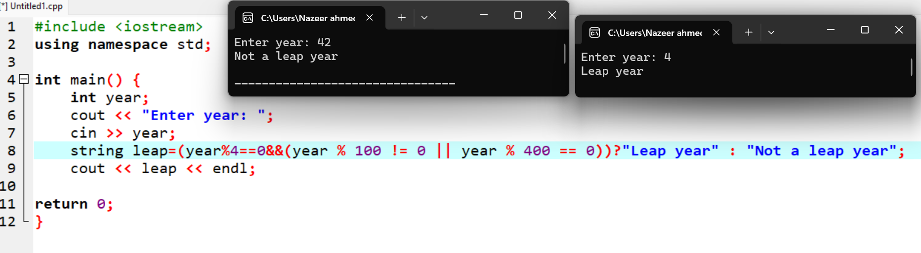

5. Discount Calculator Create a program that asks the user to enter the price of an item and uses the ternary operator to calculate and display the final price with a 10% discount applied if the price is greater than $100.

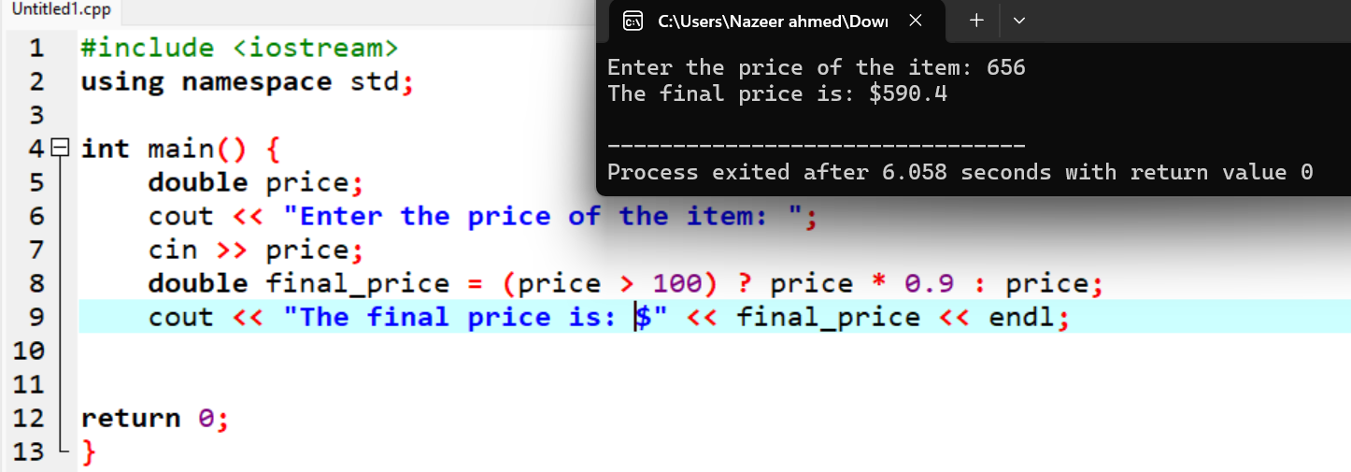

6. Grade Checker Write a program that takes a student's score as input and uses the ternary operator to determine and display their letter grade (A, B, C, D, or F) based on the following grading scale:

- A: 90-100

- B: 80-89

- C: 70-79

- D: 60-69

- F: Below 60

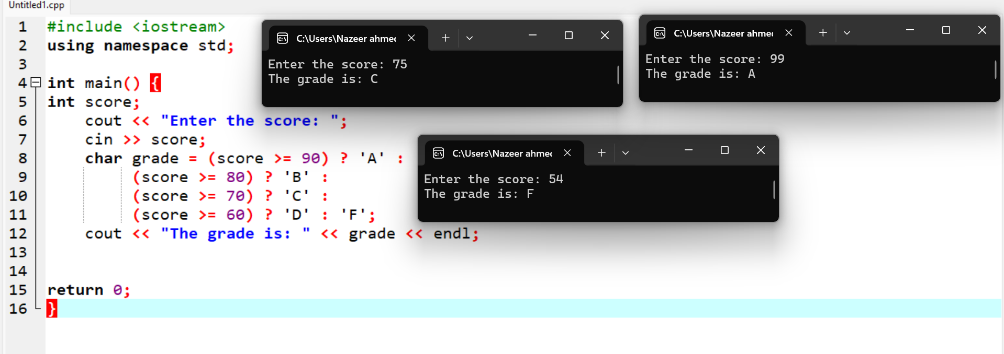

7. Discount Levels Develop a program that prompts the user for the total purchase amount and uses the ternary operator to determine and display the discount percentage based on the following criteria:

- 10% discount for purchases between $100 and $199.

- 20% discount for purchases between $200 or

- No discount for purchases below $100.

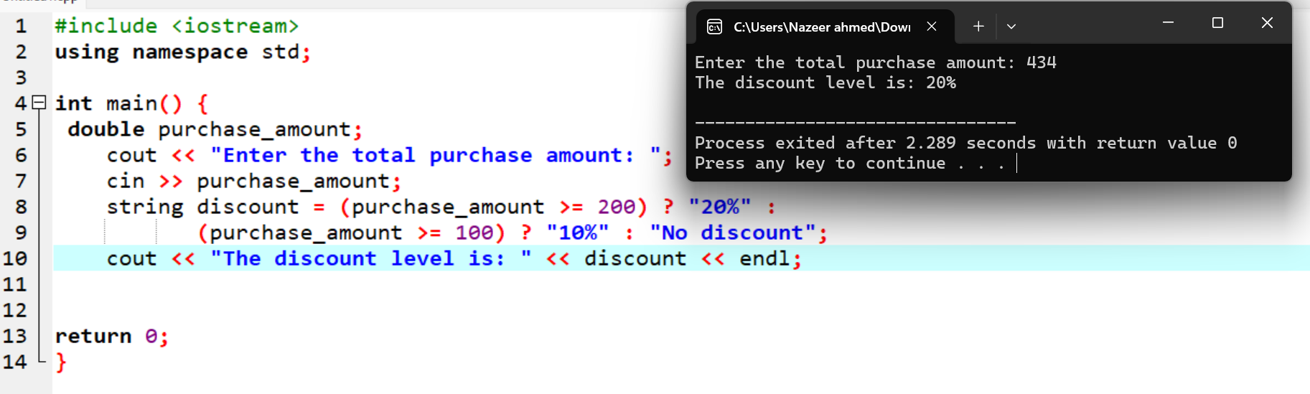

8. Age Group Determiner Develop a program that asks the user to enter their age and uses the ternary operator to categorize them into one of three groups: "Child" (0-12 years old), "Teen" (13-19 years old), or "Adult" (20 or older).

