

LAB-9

By-Arun Lal



Sec-E

BSCS(1)

CMS-ID=023-24-0120

Exercises of LAB-9

1. Calculator Operations (+,-,\*,/,%) Just like the sample program discussed in the class that was performing the addition of two numbers, create five (05) separate functions, each of which gets two integer values as parameters and returns the addition, subtraction, multiplication, division, and modulus (remainder) of those two values, respectively. Then call these functions in the main () function and print the values returned by them. Note: Each user-defined function should only return a value after performing the respective arithmetic operation. The remaining logic, which prints the results, should be put in the main () function.

*code*

#include <iostream>

using namespace std;

double add(double a1, double b1){

cout<<"Addition Will be : ";

return a1+b1;

}

double Sub(double a2, double b2){

cout<<"Subtraction Will be : ";

return a2-b2;

}

double Mul(double a3, double b3){

cout<<"Multiplication Will be : ";

return a3\*b3;

}

double div(double a4, double b4){

cout<<"Division Will be : ";

return a4/b4;

}

int Mod(int a, int b){

cout<<"Mod Will be : ";

return a%b;

}

int main(){

double num1,num2;

cout<<"Enter the 1st Number : ";

cin>>num1;

cout<<"Enter the 2nd Number : ";

cin>>num2;

char opt;

cout<<"Enter the Operation (+,-,\*,/,%)";

cin>>opt;

switch(opt){

case '+':

cout << add( num1, num2);

break;

case '-':

cout << Sub( num1, num2);

break;

case '\*':

cout << Mul( num1, num2);

break;

case '/':

cout << div( num1, num2);

break;

case '%':

cout <<(int)Mod( num1, num2);

break;

default:

cout << "Enter correct operator " << endl;

return 0;

}

return 0;

}

Cout

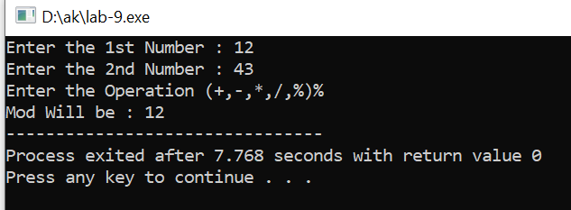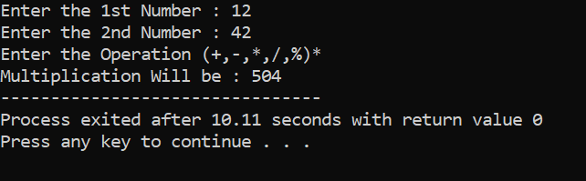

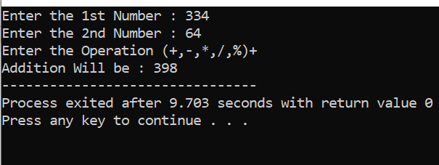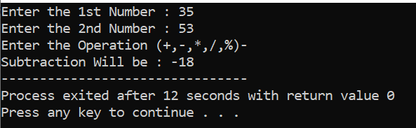

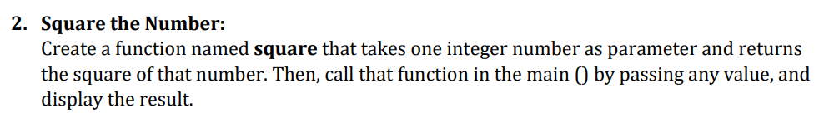

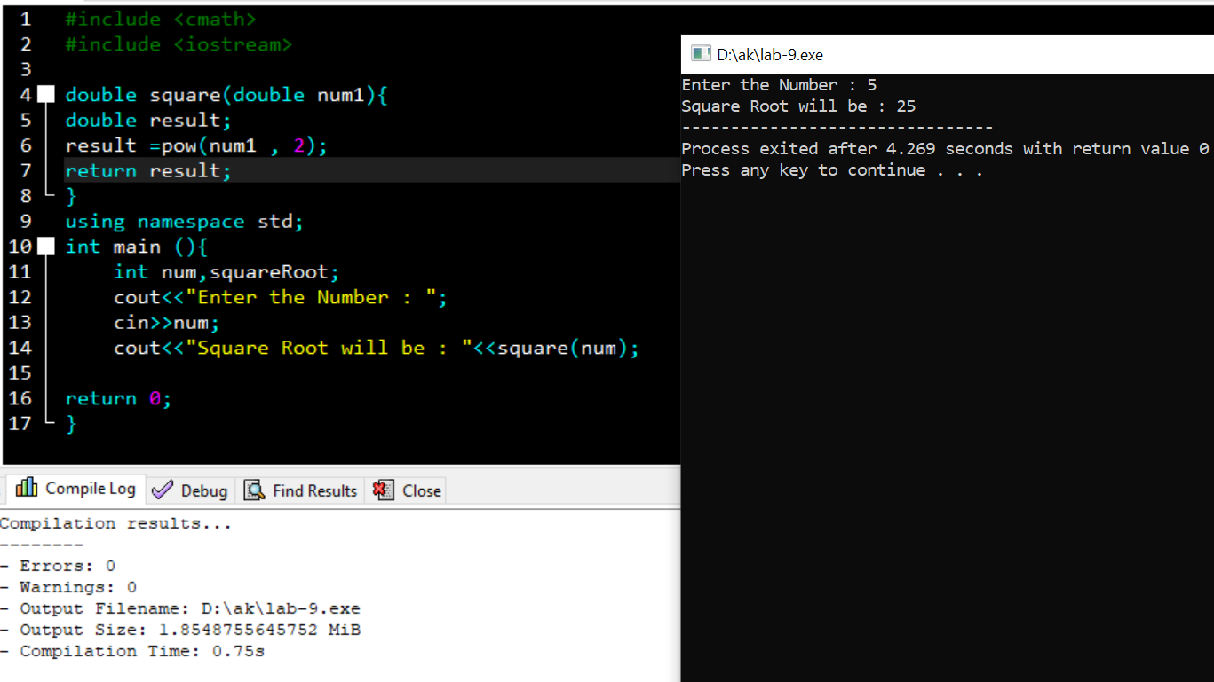

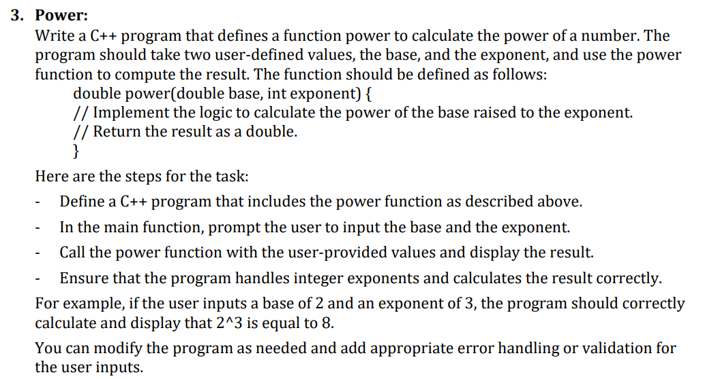

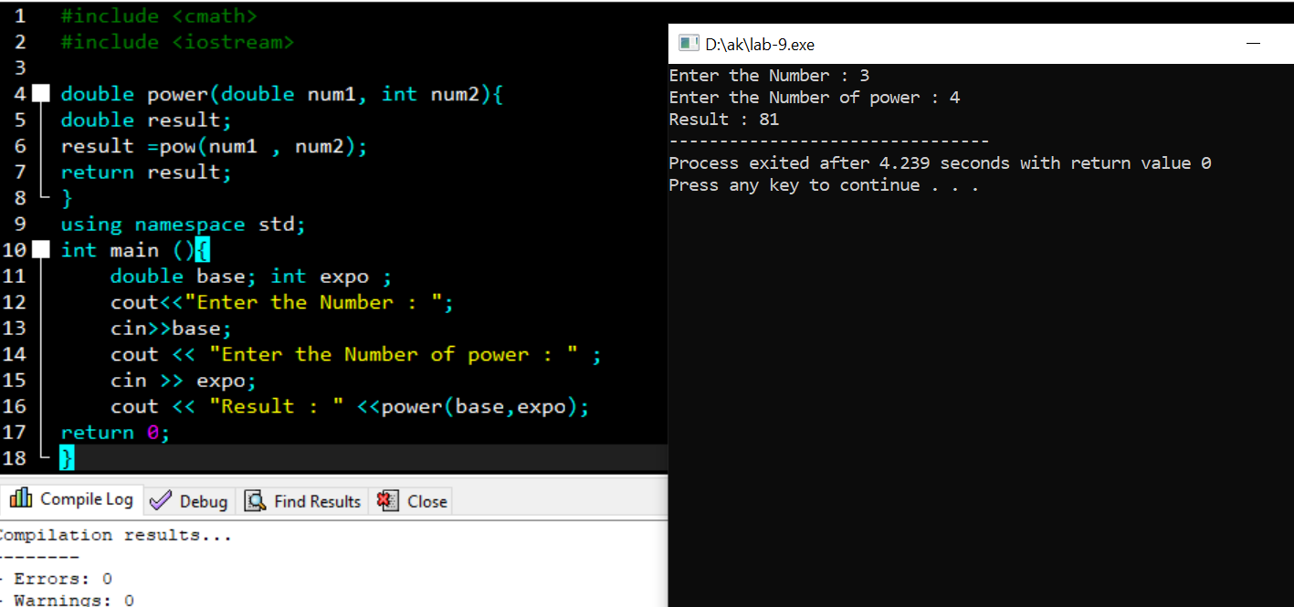

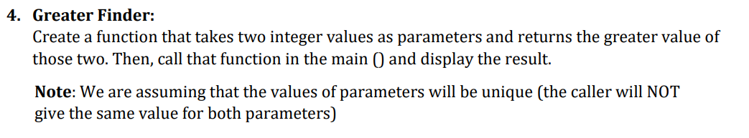

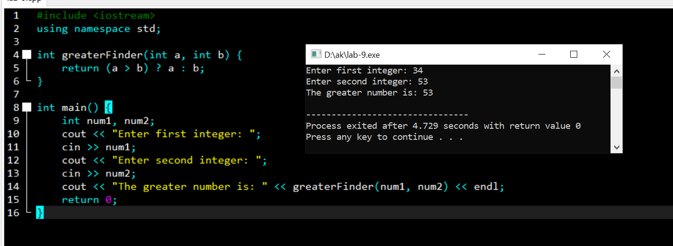

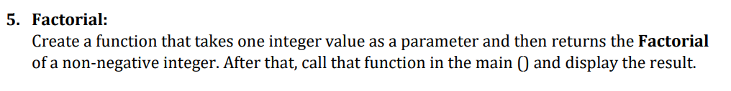

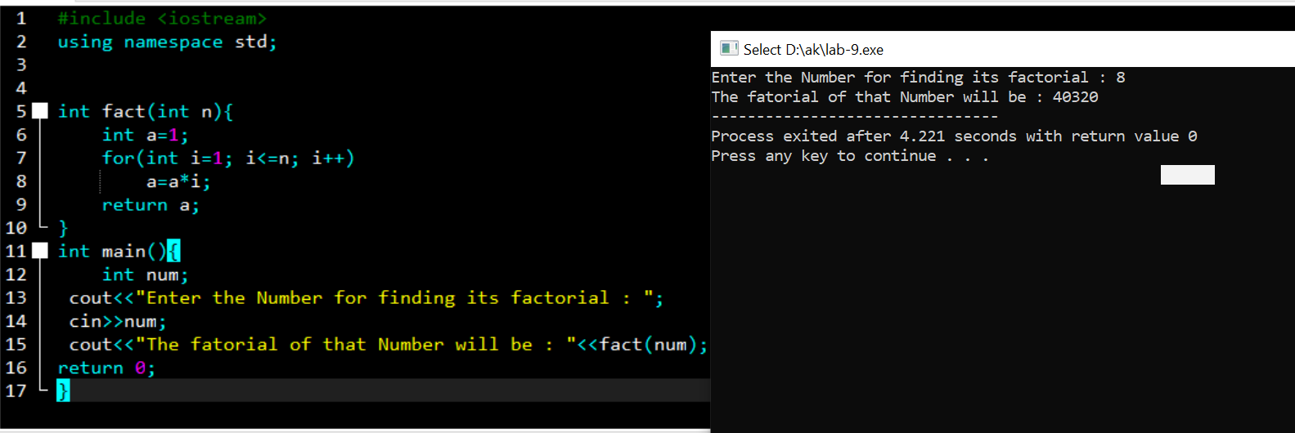

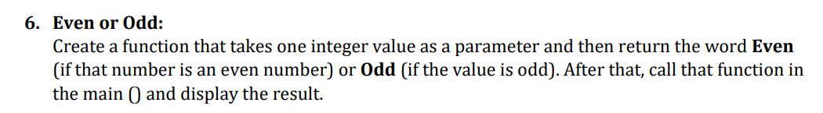

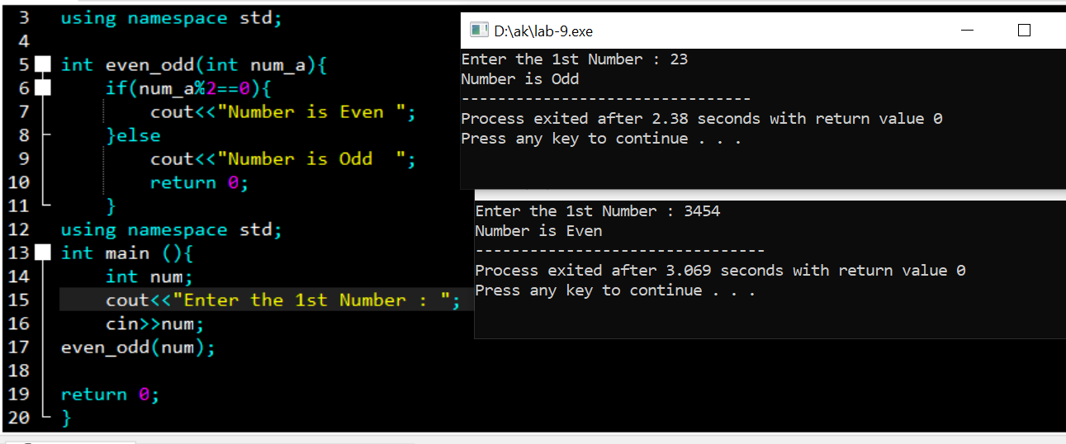

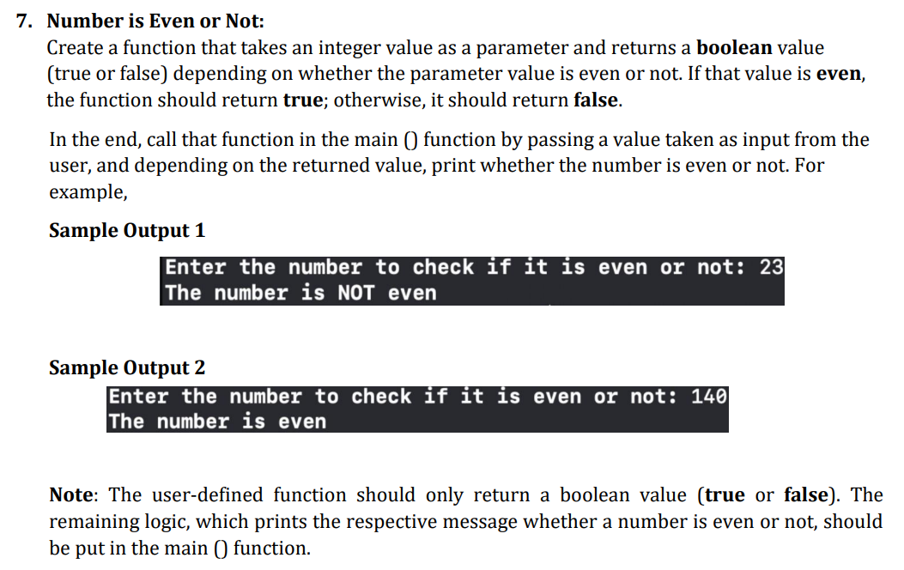

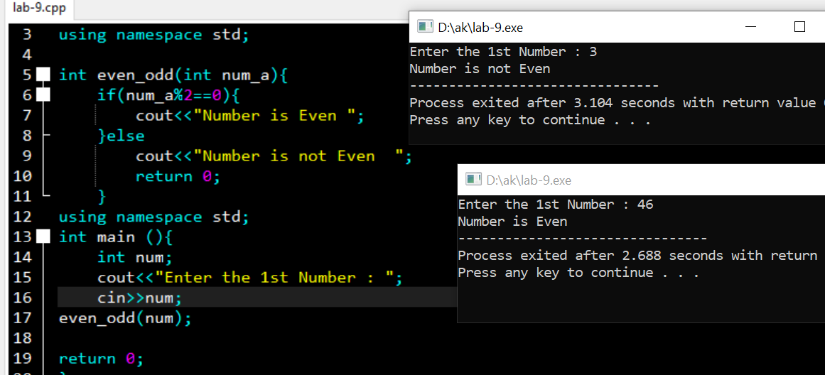

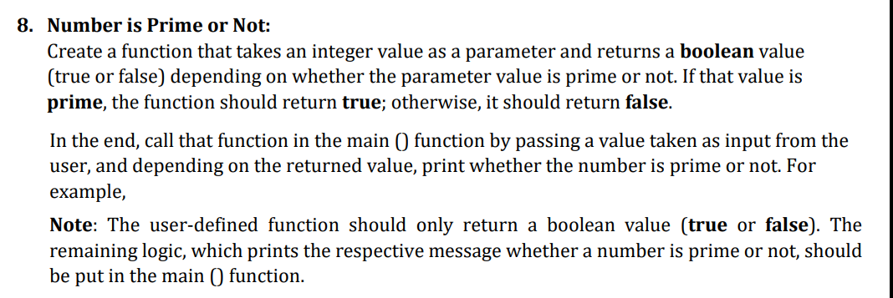

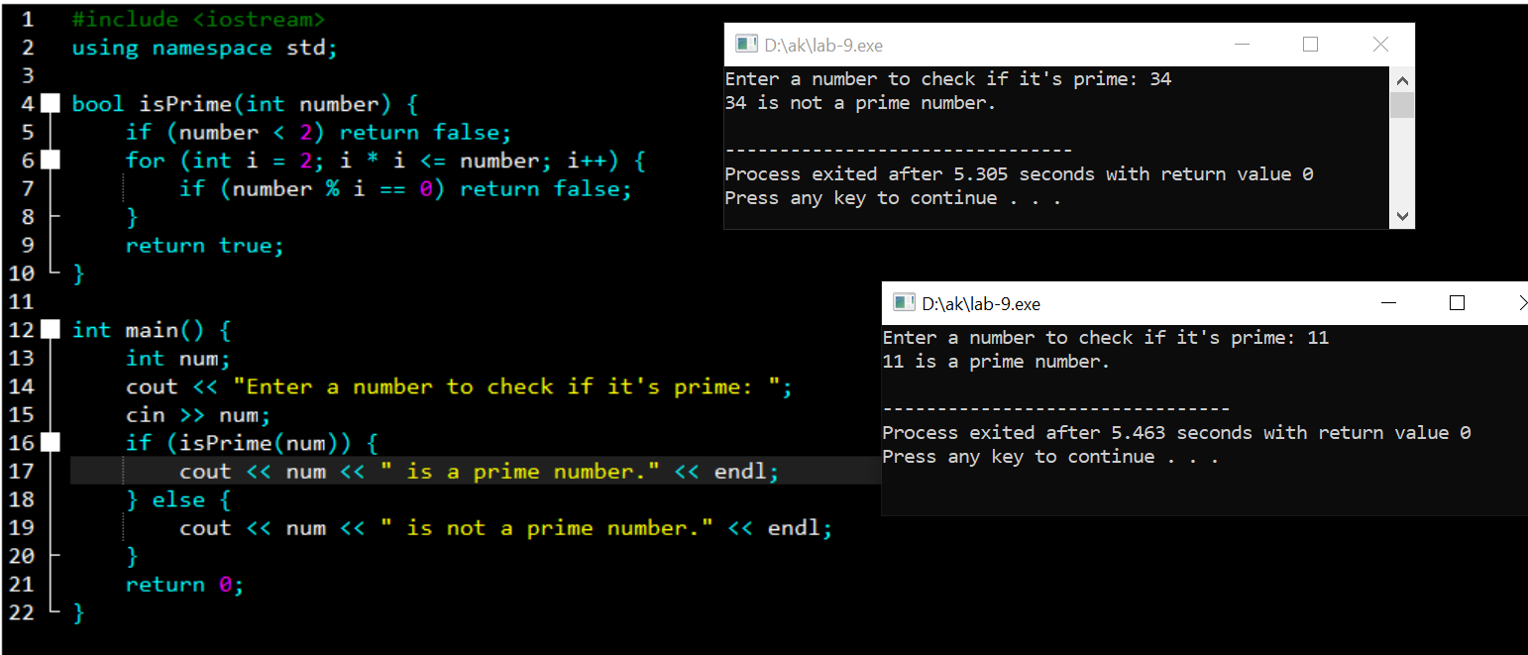

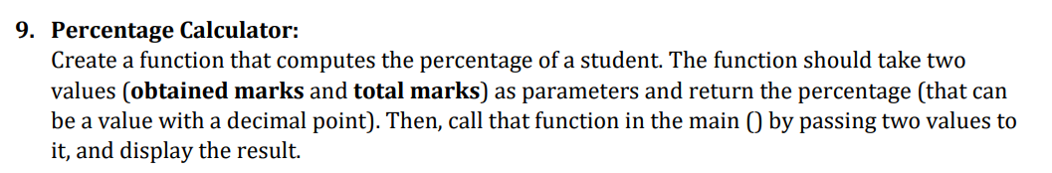

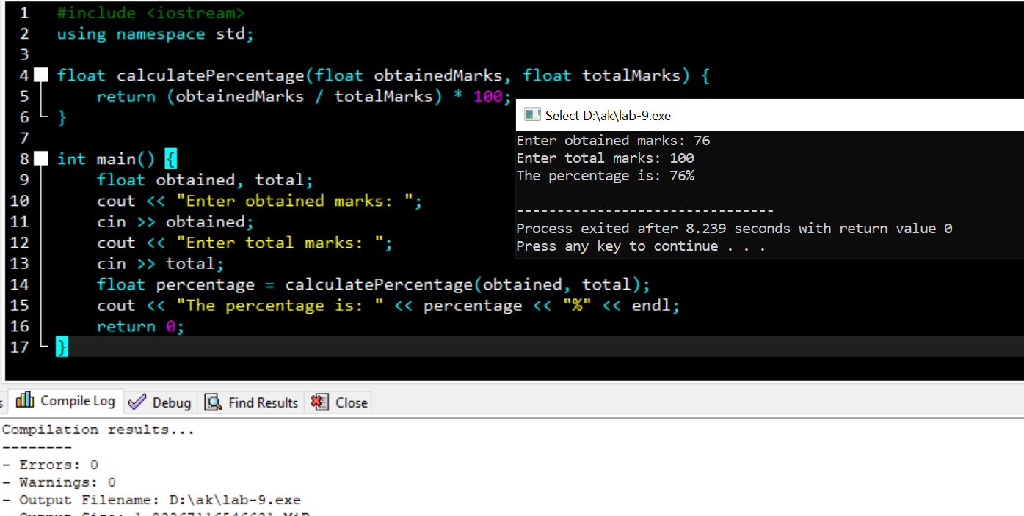

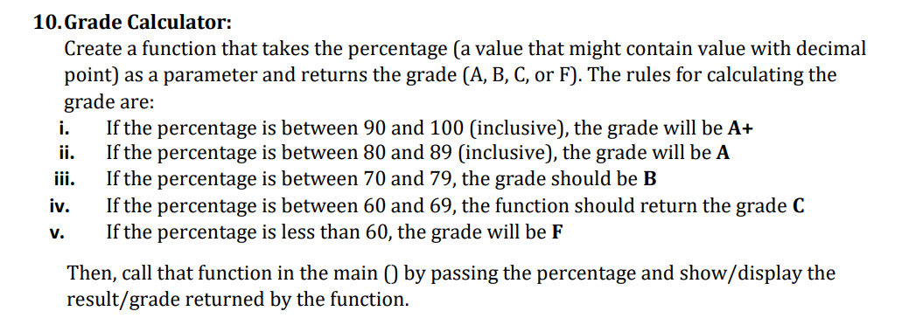

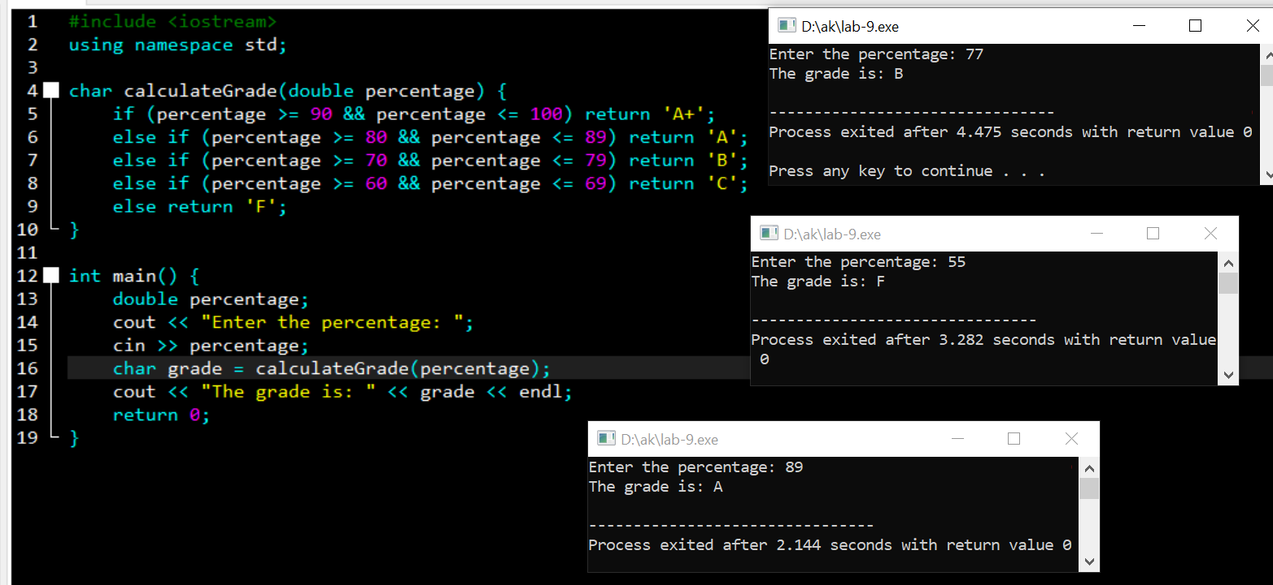

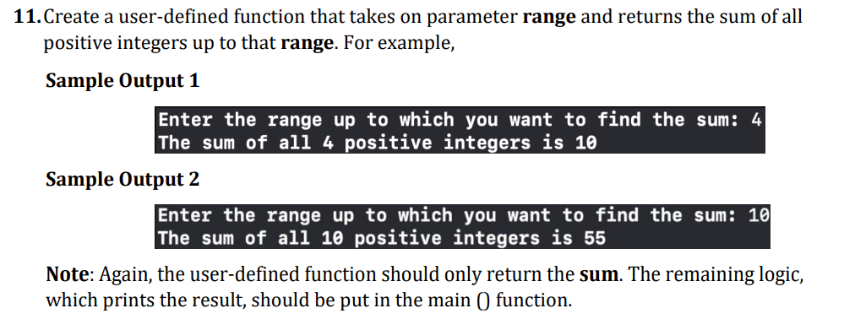

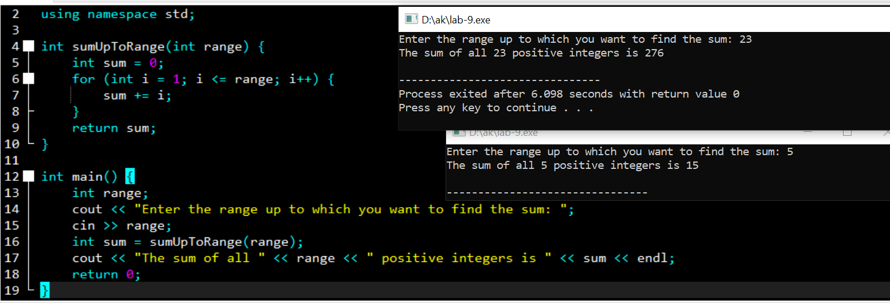

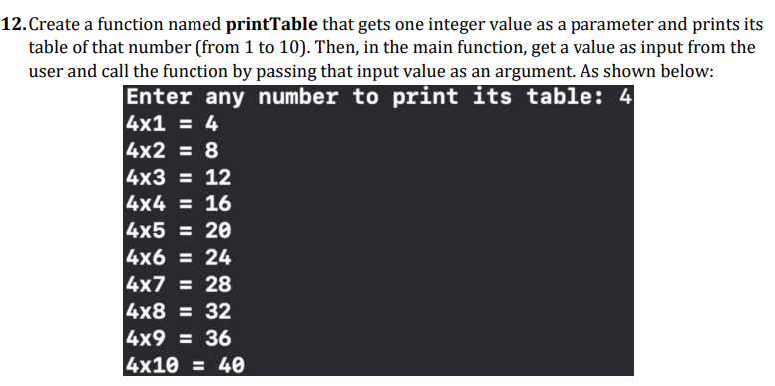

a-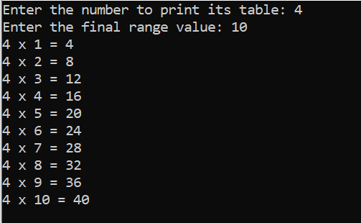

and

