Q-1:

Write a program that takes 5 values from user. Two values of integer and two values of float and one value of char data type. Print each result on a separate line .

**Code**

#include <iostream>

using namespace std;

int main() {

int a,b;

a=10,b=4;

float c,d;

c=5.67,d=40.78;

char e;

e='@';

cout<<"The Integer Values are :"<<" "<<a<<" "<<b;

cout<<"\nfloat Values are :"<<" "<<c<<" "<<d;

cout<<"\nchar data type is :"<<" "<<e;

return 0;

}

**Cout**

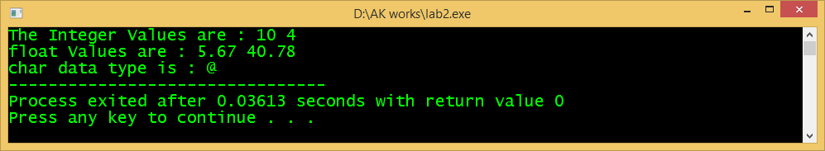

2. Write a program that takes voltage and current from user, saves them in respective data types (I and R as float or double and V as int), and calculates Resistance as per the following formula:

𝑹𝒆𝒔𝒊𝒔𝒕𝒂𝒏𝒄𝒆 (𝑹) $) \frac{ = Voltage(V}{Current(I)}$

Code

#include <iostream>

using namespace std;

int main()

{

double voltage,current,Resistence;

cout<<"Enter the amount Voltages:\n";

cin>>voltage;

cout<<"Enter the amount of Current:\n";

cin>>current;

//Formula of Current

Resistence=voltage/current;

cout<<"Resistence :"<< " "<<Resistence<<"Units"<<endl;

return 0;

}

**cout**

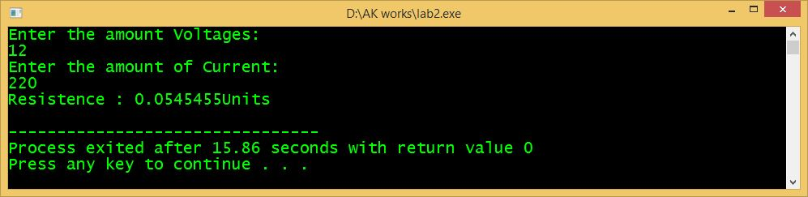

3. Write a program, in which you create three variables to set the marks (out of 100) for ICT, Math and English subjects for Ayaz. Afterwards, your program should calculate his obtained marks in all three subjects. The sample output is shown below.

**Code**

**#include <iostream>**

**using namespace std;**

**int main()**

**{**

**double English,Mathematics,ICT,Name,ObtainedMarks;**

**cout<<"===================================================== \n"<< " \t\t \b\b MARKSHEET \n"<<**

**"===================================================== \n ";**

**// cout<<":\n";?**

**cout<<"Arun obtained Marks In English out of 100 : ";**

**cin>>English;**

**cout<<"\n Arun obtained Marks In Mathematics out of 100 : ";**

**cin>>Mathematics;**

**cout<<"\n Arun obtained Marks In ICT out of 100 : ";**

**cin>>ICT;**

**ObtainedMarks=English+Mathematics+ICT;**

**cout<<"\n Obtained Marks out of 300 : "<<ObtainedMarks;**

**return 0;**

**}**

**Cout**

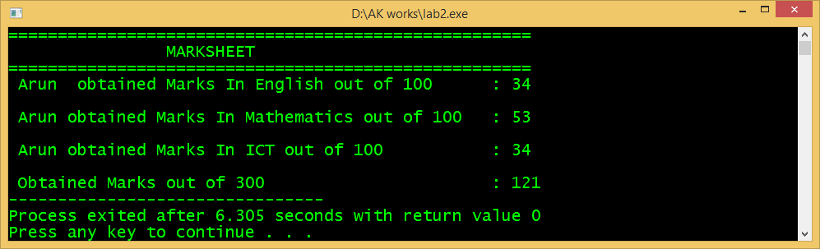

4. Write a program that asks the user to type the first character of their name then the program will generate its ASCII value. The sample output is shown below:  **Code**

#include <iostream>

using namespace std;

int main() {

int asci;

char name;

cout << "Enter the First Charactor of Your name:\n";

cin>>name;

asci=name;

cout<<"Your asci code is:"<<asci;

return 0;

}

**cout**

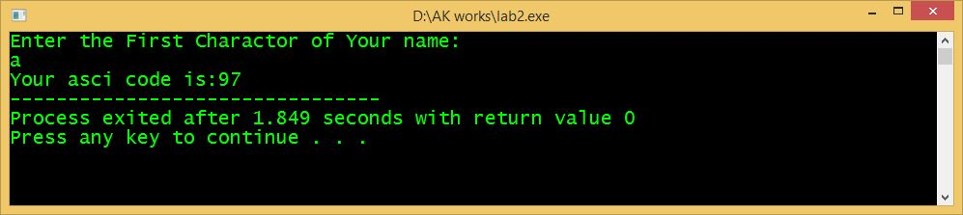

5. Write a program that asks the user to type lowercase (small) alphabet character (first character of your name) then the program will generate its uppercase (capital) alphabet character. The sample output is shown below: 5. Write a program that asks the user to type lowercase (small) alphabet character (first character of your name) then the program will generate its uppercase (capital) alphabet character. The sample output is shown below:

**code**

#include <iostream>

using namespace std;

int main() {

int asci;

char name;

cout << "Enter the Lowercase Charactor of Your name:\n";

cin>>name;

name=name-32;

cout<<"Uppercase of that charactor:"<<name;

return 0;

}

**Cout**

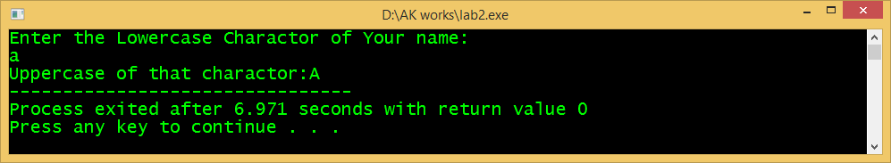

6. Write a program that asks the user to type uppercase (capital) alphabet character (first character of your name) then the program will generate its lowercase (small) alphabet character. The sample output is shown below:

**code**

#include <iostream>

using namespace std;

int main() {

int asci;

char name;

cout << "Enter the Uppercase Charactor of Your name:\n";

cin>>name;

name=name+32;

cout<<"Lowercase of that charactor:"<<name;

return 0;

}

**Cout**

