

LAB-5

By-Arun Lal



Sec-E

BSCS(1)

CMS-ID=023-24-0120

Exercise

If/Else and Nested If/else Tasks

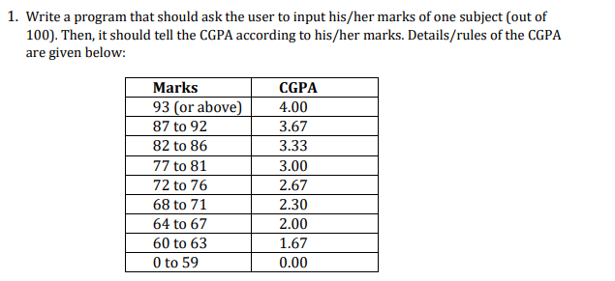

Code

#include <iostream>

using namespace std;

int main()

{

int M;

cout<<"Enter the Marks : ";

cin>>M;

if((M >= 93) && (M<=100)){

cout<<"Your GPA is :"<<"\t4"<<endl;

}

else if(( M < 93)&&(M>=87))

cout<<"Your GPA is :"<<"\t3.67"<<endl;

else if(( M >82)&&(M<=87))

cout<<"Your GPA is :"<<"\t3.33"<<endl;

else if(( M >=82)&&(M<=86))

cout<<"Your GPA is :"<<"\t3.00"<<endl;

else if(( M >=72 )&&(M<=81))

cout<<"Your GPA is :"<<"\t2.67"<<endl;

else if(( M >= 68)&&(M<=71))

cout<<"Your GPA is :"<<"\t2.30"<<endl;

else if(( M >= 64)&&(M<=67))

cout<<"Your GPA is :"<<"\t2.00"<<endl;

else if(( M >= 60)&&(M<=63))

cout<<"Your GPA is :"<<"\t1.67"<<endl;

else

cout<<"Your GPA is :"<<"\t0.00"<<endl;

return 0;

}

Cout

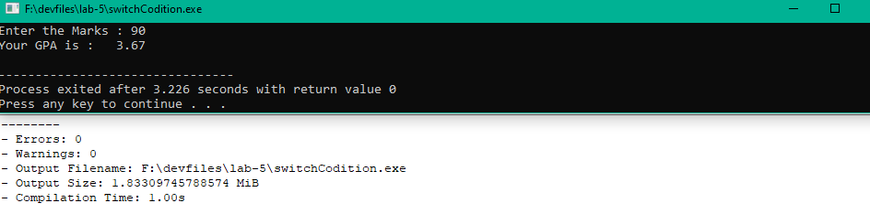-------------------------------------------------------------------------------------------

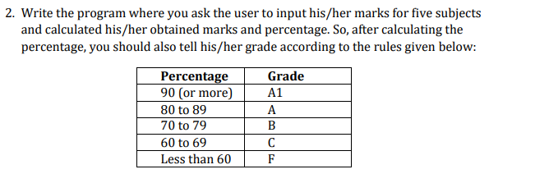

Code

#include <iostream>

using namespace std;

int main()

{

float a,b,c,d,e,T,P,O;

cout<<"Enter the Marks of C++ Programming : ";

cin>>a;

cout<<"Enter the Marks of Discrete Mathematics: ";

cin>>b;

cout<<"Enter the Marks of English \t : ";

cin>>c;

cout<<"Enter the Marks of ICT \t: ";

cin>>d;

cout<<"Enter the Marks of Ethics \t: ";

cin>>e;

T=500;

O=(a+b+c+d+e);

P=(O/500)\*100;

if(P>=90){

cout<<"Your Grade is"<<"\tA-1"<<endl;

}

else if((P>=80)&&(P<=89))

cout<<"Your Grade is"<<"\tA"<<endl;

else if((P>=70)&&(P<=79))

cout<<"Your Grade is"<<"\tB"<<endl;

else if((P>=60)&&(P<=69))

cout<<"Your Grade is"<<"\tC"<<endl;

else if (P<60)

cout<<"Your Grade is"<<"\tF"<<endl;

return 0;

}

Cout

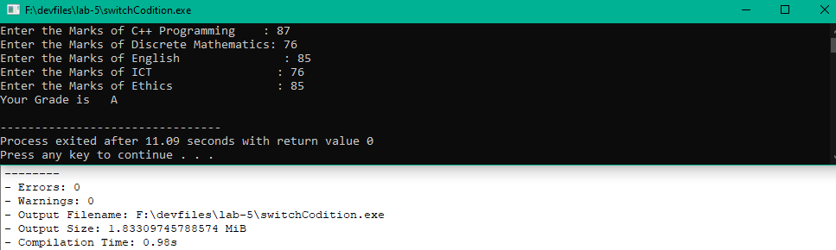

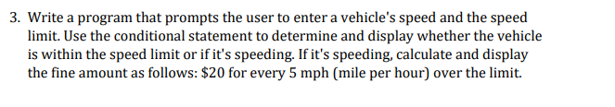

Code

#include <iostream>

using namespace std;

int main()

{

float a,b,f,N;

cout<<"Enter the Speed of the Vehicle : ";

cin>>a;

cout<<"Enter the Speed limit \t : ";

cin>>b;

if(a<=b)

cout<<"You are going Normally"<<endl;

else

cout<<"Your are Exceeding the Limit :"<<endl;

N=a-b;

f=(N/5)\*20;

cout<<"Fine will be :"<<f<<" $"<<endl;

return 0;

}

Cout

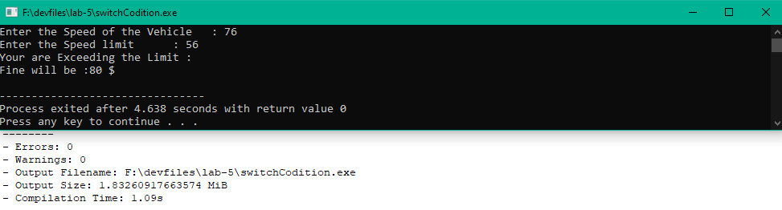

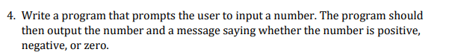

Code

#include <iostream>

using namespace std;

int main()

{

int a;

cout<<"Enter The Number : ";

cin>>a;

if(a%2 == 0)

cout<<"The number is Even :";

else

cout<<"The number is ODD :";

return 0;

}

Cout

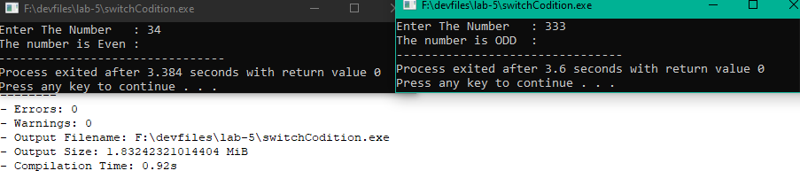

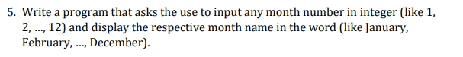

Code

#include <iostream>

using namespace std;

int main()

{

int a;

cout<<"Enter The Number of the Month : ";

cin>>a;

if(a==1)

{

cout<<"Janurary";

}

else if(a==2)

cout<<"Feburary";

else if(a==3)

cout<<"March";

else if(a==4)

cout<<"April";

else if(a==5)

cout<<"May";

else if(a==6)

cout<<"June";

else if(a==7)

cout<<"July";

else if(a==8)

cout<<"August";

else if(a==9)

cout<<"Sepetember";

else if(a==10)

cout<<"October";

else if(a==11)

cout<<"November";

else if(a==12)

cout<<"December";

return 0;

}

Cout

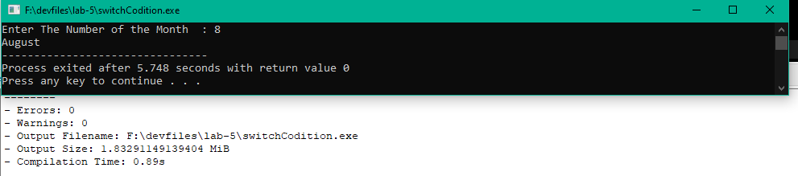

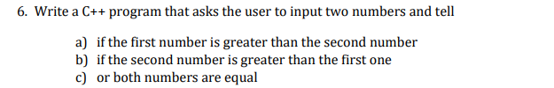

Code

#include <iostream>

using namespace std;

int main()

{

int a,b;

cout<<"Enter The 1st Number : ";

cin>>a;

cout<<"Enter The 2st Number : ";

cin>>b;

if(a>b)

{

cout<<"Here 1st number is greater than 2nd ";

}

else if(a<b)

cout<<"Here 2nd Number is greater than 1st";

else if(a==b)

cout<<"Both are Equal ";

return 0;

}

Cout

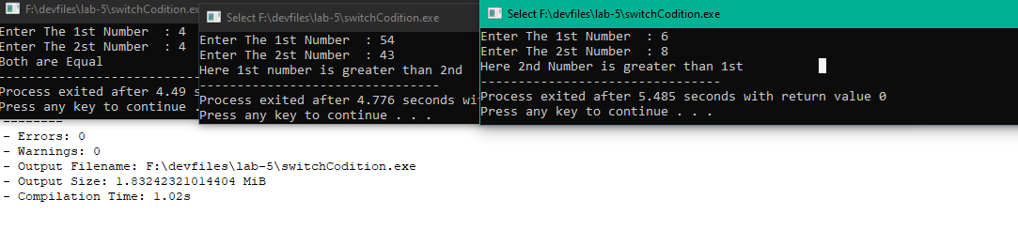

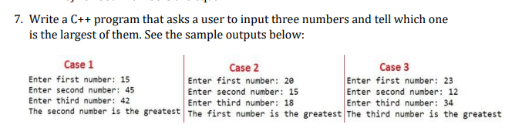

Code

#include <iostream>

using namespace std;

int main()

{

int a,b,c;

cout<<"Enter the 1st Number : ";

cin>>a;

cout<<"Enter the 2st Number : ";

cin>>b;

cout<<"Enter the 3st Number : ";

cin>>c;

if((a>b)&&(b>c)&&(a>c))

{

cout<<" 1st number is greatest";

}

else if((b>a)&&(a<c)&&(b>c))

cout<<" 2nd number is greatest";

else if((c>a)&&(b>a)&&(c>b))

cout<<" 3rd number is greatest ";

return 0;

}

Cout

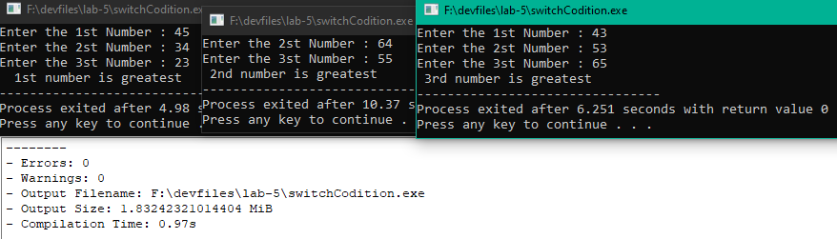

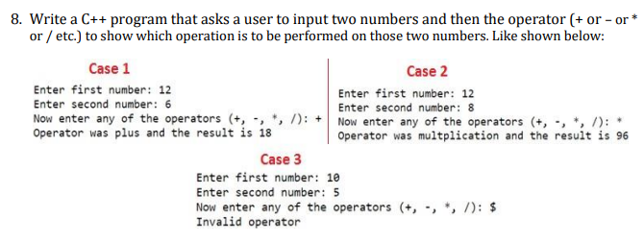

Code

#include <iostream>

using namespace std;

int main()

{

int a,b,d,e,f;

char c;

cout<<" Enter the 1st Number : ";

cin>>a;

cout<<" Enter the 2nd Number : ";

cin>>b;

cout<<" Enter the Operator (-,+,%,/) : ";

cin>>c;

d=(a+b);

e=(a-b);

f=(a/b);

if(c == '-')

{

cout<<" Operator is minus and result is : "<<e;

}

else if(c == '+')

cout<<" Operator is plus and result is : "<<d;

else if(c == '/')

cout<<" Operator is devide and result is : "<<f;

else if(c == '%')

cout<<" in-Valid operator ";

return 0;

cout

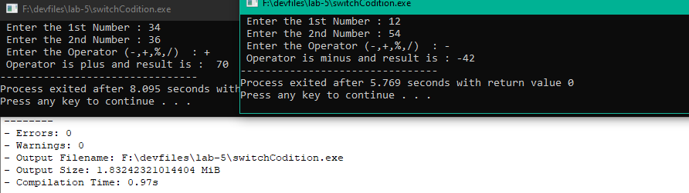

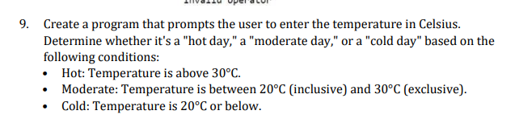

Code

#include <iostream>

using namespace std;

int main()

{

int a;

cout<<"Enter the Temperature in Celcius scale : ";

cin>>a;

if(a>30)

{

cout<<" It is Hot! today";

}

else if((a<30)&&(a>=20))

cout<<" It is Moderate Today";

else if(a<20)

cout<<" It is Cold! Today ";

return 0;

}

Cout

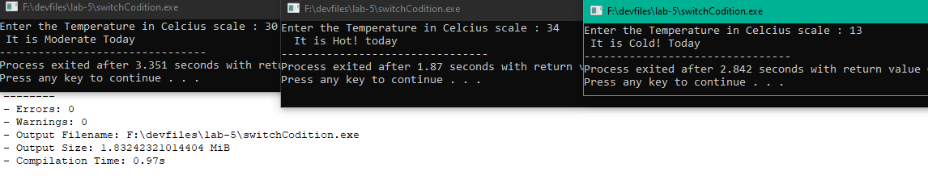

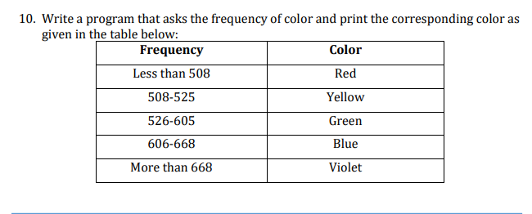

Code

#include <iostream>

using namespace std;

int main()

{

int a;

cout<<"Enter The Frequency : ";

cin>>a;

if(a<508)

{

cout<<"RED";

}

else if((a>508)&&(a<=525))

cout<<"Yellow";

else if((a<526)&&(a<=605))

cout<<"Green";

else if((a>606)&&(a<=668))

cout<<"Blue";

else if(a>668)

cout<<"Violet";

return 0;

}

Cout

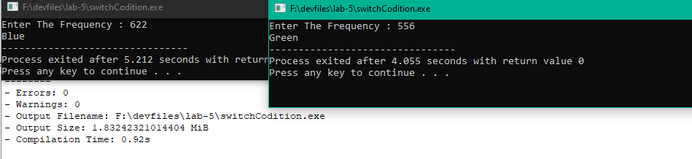

Switch Statement Tasks

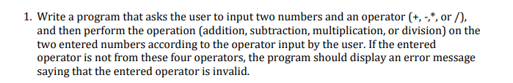

Code

#include <iostream>

using namespace std;

int main()

{

int a,b;

char c;

cout<<"Enter the first charactor : ";

cin>>a;

cout<<"Enter the first charactor : ";

cin>>b;

cout<<"Enter the Operator(-,+,/,\*) : ";

cin>>c;

switch(c){

case '+':

cout<<" Operator is addition(+) and result is : "<<a+b;

break;

case '-':

cout<<" Operator is subtraction(-) and result is : "<<a-b;

break;

case'/':

cout<<" Operator is devision(/) and result is : "<<a/b;

break;

case'\*':

cout<<" Operator is multiplication(\*) and result is : "<<a\*b;

break;

default:

cout<<" Error! \n invalid operator ";

}

return 0;

}

Cout

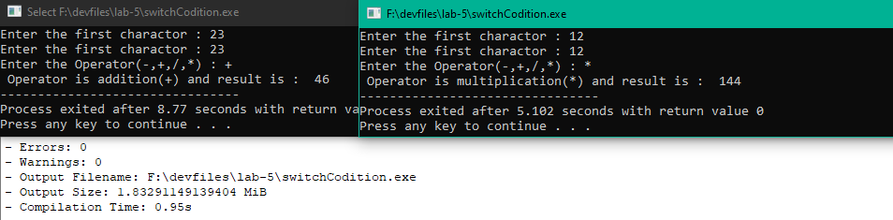

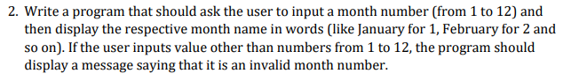

Code

#include <iostream>

using namespace std;

int main()

{

int a;

cout<<"Enter the month number : ";

cin>>a;

switch(a){

case 1:

cout<<" Month is : January ";

break;

case 2:

cout<<" Month is : February";

break;

case 3:

cout<<" Month is : March";

break;

case 4:

cout<<" Month is : April";

break;

case 5:

cout<<" Month is : May";

break;

case 6:

cout<<" Month is : June";

break;

case 7:

cout<<" Month is : July";

break;

case 8:

cout<<" Month is : August";

break;

case 9:

cout<<" Month is : September";

break;

case 10:

cout<<" Month is : October ";

break;

case 11:

cout<<" Month is : November ";

break;

case 12:

cout<<" Month is : December : ";

break;

default:

cout<<" It is a invalid number ";

}

return 0;

}

Cout

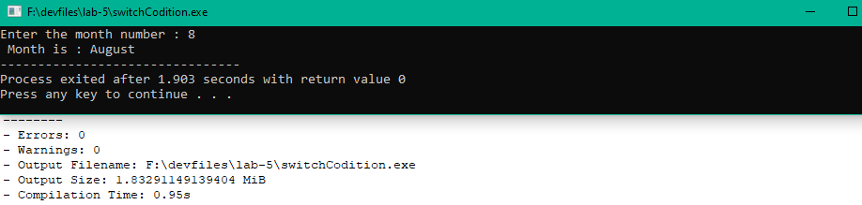

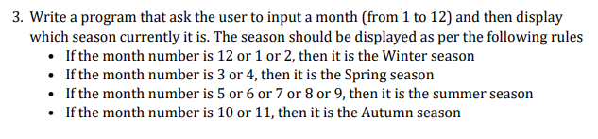

Code

#include<iostream>

using namespace std;

int main()

{

int a;

cout<<"Enter the month number : ";

cin>>a;

switch(a){

case 1:

case 2:

case 12:

cout<<" It is the Winter season ";

break;

case 3:

case 4:

cout<<" It is Spring season ";

break;

case 5:

case 6:

case 7:

case 8:

case 9:

cout<<" It is Summer season ";

break;

case 10:

case 11:

cout<<" It is Automn season ";

break;

default:

cout<<" It is a invalid number of Months ";

}

return 0;

}

Cout

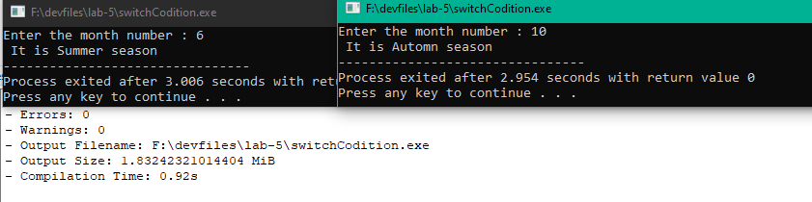

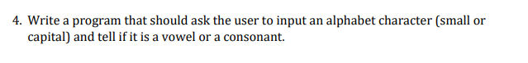

Code

#include<iostream>

using namespace std;

int main()

{ // asci code 97, 101, 105, 111, and 117

char a; //or 65, 69, 73, 79, and 85

cout<<"Enter the month number : ";

cin>>a;

switch(a){

case 'a':

case 'e':

case 'i':

case 'o':

case 'u':

case 'A':

case 'E':

case 'I':

case 'O':

case 'U':

cout<<" It is Vowel ";

break;

default:

cout<<" It a Consonant ";

}

return 0;

}

Cout

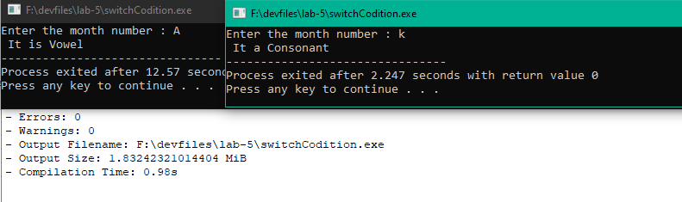

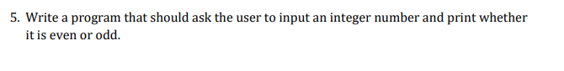

Code

#include<iostream>

using namespace std;

int main()

{

int a;

cout<<"Enter the Number : ";

cin>>a;

switch(a%2){

case (0):

cout<<" It is an Even Number ";

break;

default:

cout<<" It is an Odd Number ";

}

return 0;

}

Cout

