|  |  |  |
| --- | --- | --- |
|  | **EE520 HW1** | |
|  |  |

|  |
| --- |
| **NAME SURNAME : fURKAN SÖNMEZ**  **sTUDENT ID: 205105134**  **Department: ee** |
|  |



## Q1.1

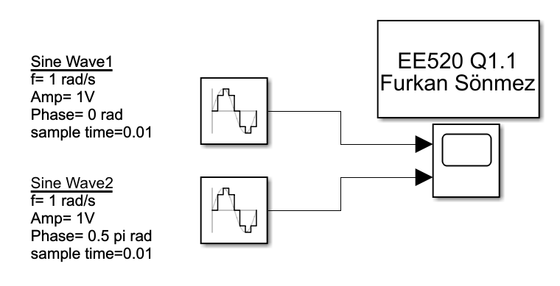

Figure –Simulink Model of 2 Sine Waves which have 0.5 pi phase difference

In this example, I have created two different sine wave simulink blocks as seen in above figure instead of one block which has 2 signal and demux 2 of them to scope.

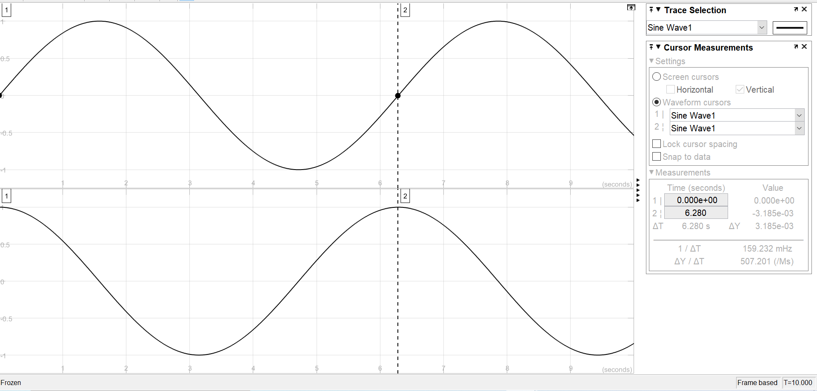

Figure - Scope Measurement for Periode of the first sine wave

## Q1.2

### a.)

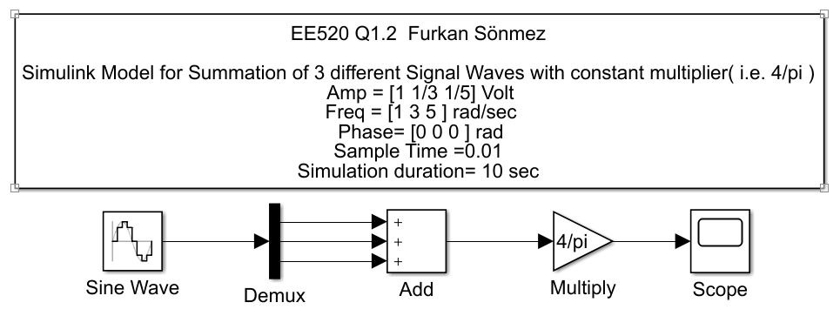

Figure Simulink Model of x(t) for 10 Seconds

### b.)

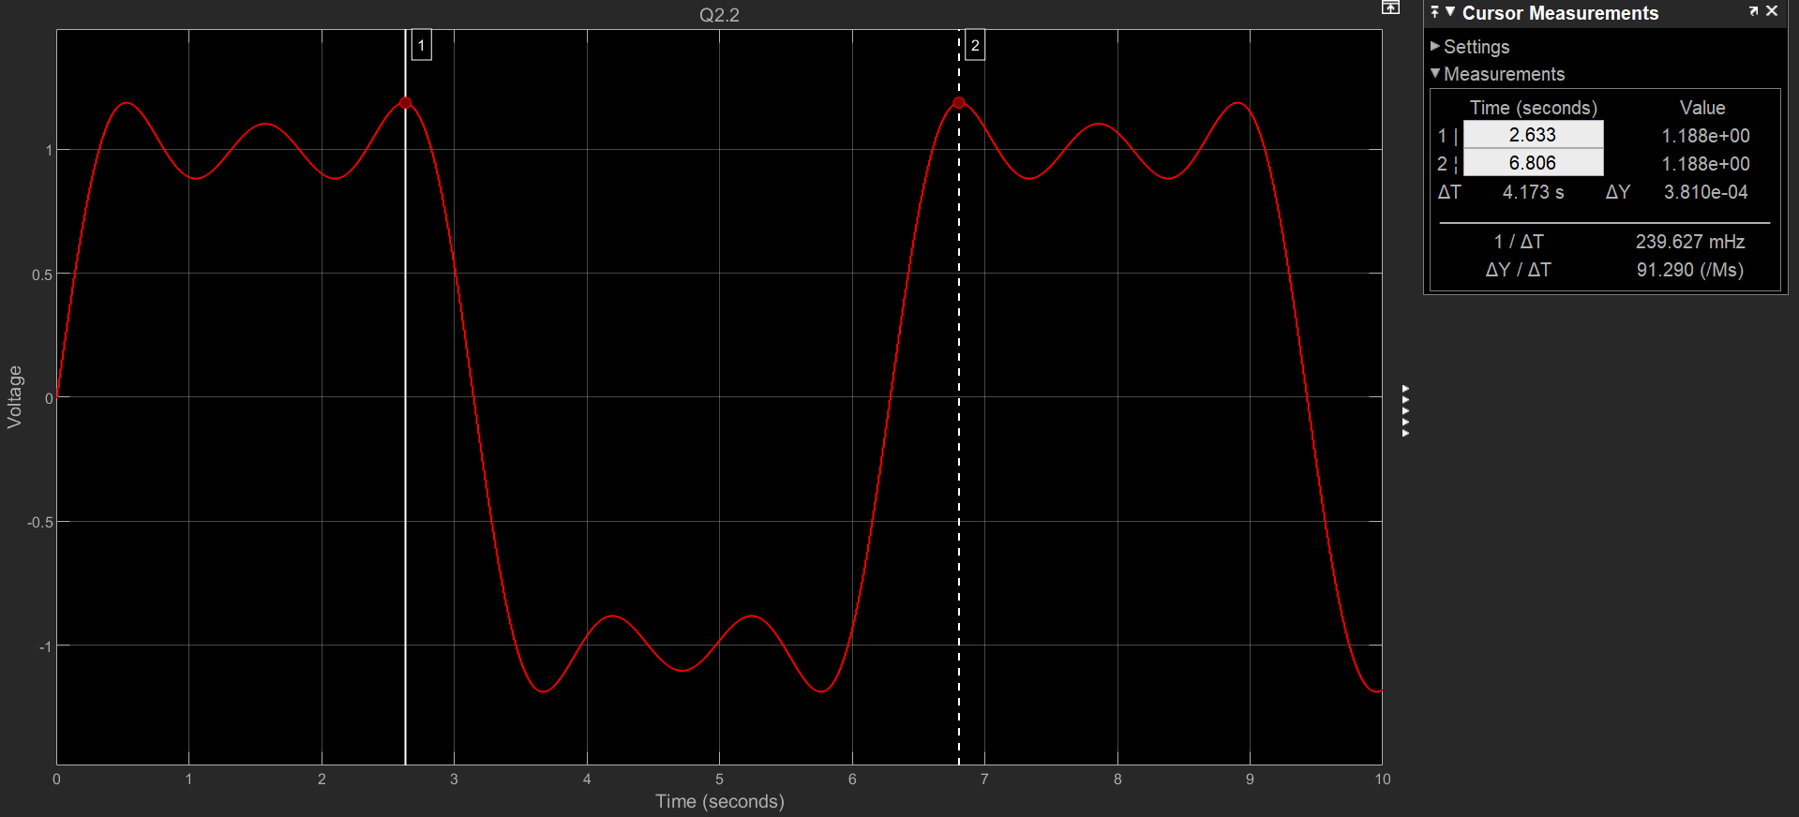

Figure - Scope Analysis of x(t) for 10 Seconds with periode measurements

### c.)

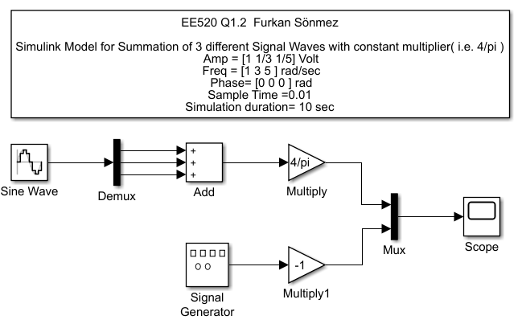

Figure - Simulink Model of x(t) for 10 Seconds with square wave

### d.)

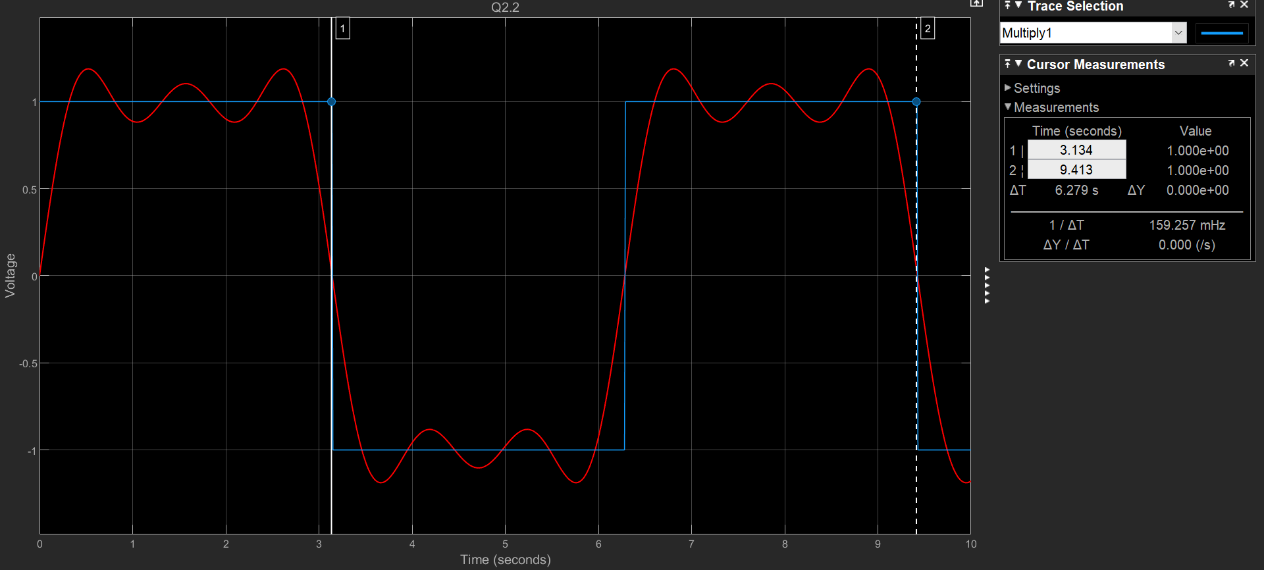

Figure - Scope Analysis of x(t) for 10 Seconds with periode measurements over square wave

## Q1.3

### a.)

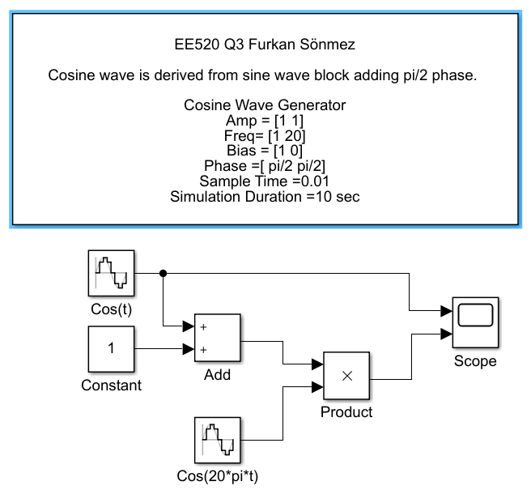

Figure - Simulink Model for (1+cos(t))cos(20t)

### b.)

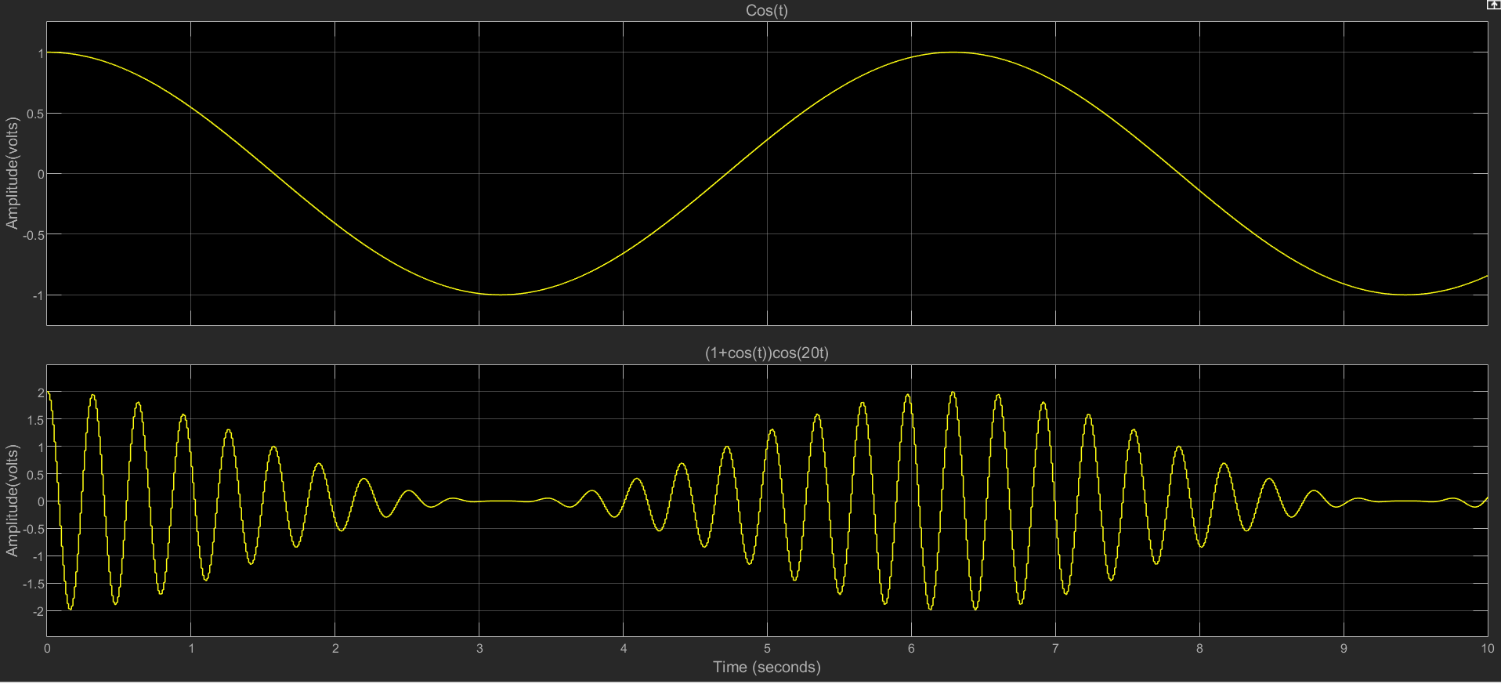

Figure - Scope Analysis of cos(t) and (1+cos(t))cos(20t)

### c.)

Unfortunately, I couldnot find pre-built library for AM Modulation in my Matlab Archive. However, to clarify how the the simulink model is supposed to be according to the example in the book, I made up block which named as “Fake AM Modulator”. Please considering before reading following 2 figures.

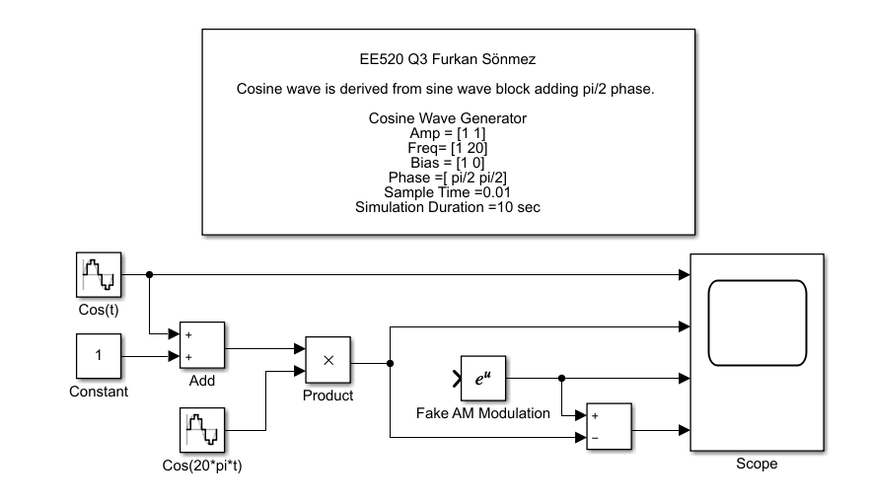

Figure Simulink Model for 4 signals

### d.)

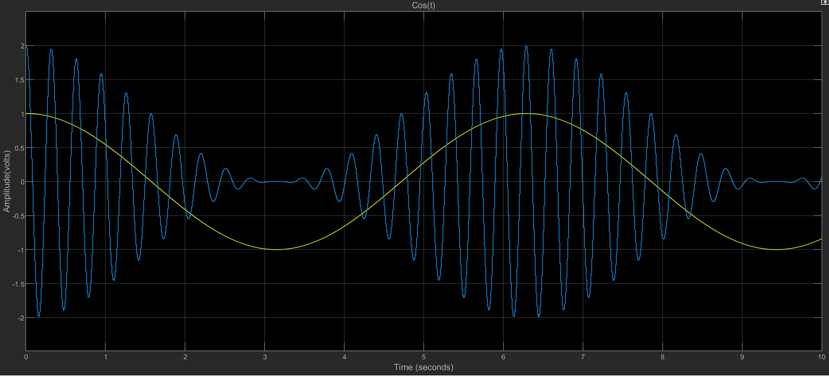

Figure - Scope analysis of Cos(x) and AM modulation (unfortunately pre-build blok output and difference signals are missing above figure)

## 

## 