WellnessBot
Installation & User Guide
Version: v2.0
Application: WellnessBot — Rehabilitation Decision Support
Document Type: Appendix — Installation & User Guide

Contents
1. System Overview 3
2. Prerequisites 4
3. Installation 5
3.1 Extract the Zip Archive 5
3.2 Create a Virtual Environment 6
3.3 Install Dependencies 6
3.4 Configure Environment Variables 7
4. Running the Application 8
4.1 Windows (PowerShell) 8
4.2 macOS / Linux 8
Accessing the Application 8
5. User Guide 9
5.1 Launching the App 9
5.2 Creating a User Profile 9
5.3 Starting a Conversation 10
5.4 Slot-Filling Dialogue Flow 11
5.5 System Responses 12
5.6 Providing Feedback 13
5.7 Knowledge Loop Analysis 14
6. Environment Variables Reference 15
7. Troubleshooting 16
7.1 Script not found / CommandNotFoundException 16
7.2 PowerShell script execution blocked 16
7.3 Application does not start 16
7.4 ModuleNotFoundError: No module named 'SystemCode' 16
7.5 openai.AuthenticationError or 401 Unauthorized 16
7.6 Profile not saving 16
7.7 Logs not being written 16

1. System Overview
WellnessBot is a neuro-symbolic hybrid AI chatbot that provides patients with contextually appropriate, evidence-grounded exercise recommendations during arthroscopic knee rehabilitation. It adapts dynamically to each user's surgery type, recovery phase, reported symptoms, available equipment, and exercise history.
Pipeline Architecture
User Input
→ [1] NLU Extraction (OpenAI GPT-4o-mini)
→ [2] Dialog Merge (Slot filling into ConversationState)
→ [3] CLARIFY Check (Missing slots trigger question loop)
→ [4] User State Inference (Derives phase_id, risk_flags)
→ [5] Rule Engine (RECOMMEND / CLARIFY / FORBID / ESCALATE)
→ [6] Intervention Planner (Exercise selection — RECOMMEND path only)
→ [7] RAG Retrieval (BM25 evidence chunk lookup)
→ [8] LLM Response Generation (Patient-facing validated output)
→ User Output (Streamlit chat UI)

2. Prerequisites
Before installing WellnessBot, ensure the following are available on your machine:
Requirement | Minimum Version | Notes
Python | 3.10+ | Check with python --version
pip | Latest | Bundled with Python
OpenAI API Key | — | OpenAI API Key is required for full system functionality
Internet connection | — | Internet connection is required for OpenAI API calls
Note: WellnessBot has been tested on Windows 11. It is compatible with macOS and Linux, with minor command differences noted where applicable.

3. Installation

3.1 Extract the Zip Archive
The submission is delivered as a zip file. Extract it to a location of your choice.
After extraction, the folder layout will look like this:
WellnessBot_v2/
├── ProjectReport/
│ └── Installation_and_User_Guide ← this document
└── SystemCode/ ← all runnable code lives here
├── .env.example
├── requirements.txt
├── run_streamlit.ps1
├── run_tests.ps1
├── data/
├── logs/
└── wellnessbot/
Important: All terminal commands in this guide must be run from inside the SystemCode/ folder unless otherwise stated.
Open a terminal (PowerShell on Windows, or Terminal on macOS/Linux) and navigate there:
Windows (PowerShell):
cd path\to\WellnessBot_v2\SystemCode
macOS / Linux:
cd path/to/WellnessBot_v2/SystemCode

3.2 Create a Virtual Environment
It is strongly recommended to use a virtual environment to isolate dependencies. Run the following from inside SystemCode/:
Windows:
python -m venv .venv
.venv\Scripts\activate
macOS / Linux:
python -m venv .venv
source .venv/bin/activate
You should see (.venv) prepended to your terminal prompt once the environment is active.

3.3 Install Dependencies
With the virtual environment active, install all required packages:
pip install -r requirements.txt
This installs the following packages:
Package | Version | Purpose
streamlit | ≥ 1.36.0 | Web UI framework
openai | ≥ 1.40.0 | LLM API client (GPT-4o-mini)
pydantic | ≥ 2.7.0 | Data validation and schema enforcement
python-dotenv | ≥ 1.0.1 | Environment variable loading from .env
pyyaml | ≥ 6.0.1 | YAML configuration parsing
pytest | ≥ 8.2.0 | Test suite runner
ruff | ≥ 0.6.0 | Code linter

3.4 Configure Environment Variables
The .env file must be created inside SystemCode/ (alongside requirements.txt). Create it by copying the provided example:
Windows (PowerShell):
Copy-Item .env.example .env
macOS / Linux:
cp .env.example .env
Open SystemCode/.env in a text editor and set the required values:
APP_VERSION=v2.0
LOGGING_ENABLED=1
LOG_DIR=./logs
OPENAI_API_KEY=sk-proj-xxxxxxxxxxxxxxxxxxxxxxxxxxxxxxxxxxxxxxxxxxxxxxxxxxxxx
OPENAI_MODEL=gpt-4o-mini
Security: Please do not share your OPENAI Key

4. Running the Application
Note: All commands below assume your terminal is inside SystemCode/ with the virtual environment active.

4.1 Windows (PowerShell)
A convenience script is provided that automatically sets PYTHONPATH and launches Streamlit. Run it from inside SystemCode/:
.\run_streamlit.ps1

4.2 macOS / Linux
From inside SystemCode/, with the virtual environment active:
PYTHONPATH=.. streamlit run wellnessbot/Wellnessbot.py

Accessing the Application
Once started, open your web browser and navigate to:
http://localhost:8501
Streamlit will also print the URL to the terminal. The application loads immediately — no build step is required.

5. User Guide

5.1 Launching the App
After running the start command (see section 4), open http://localhost:8501 in your browser. You will see the WellnessBot chat interface with a sidebar on the left.

5.2 Creating a User Profile
Before starting a conversation, you must select or create a user profile. The profile stores your surgery details and equipment list, so they persist across sessions.
Steps:
- In the left sidebar, look for the Profile section.
- If no profiles exist, click 'Create'.
- Fill in the required fields: Display Name, Surgery Date, and Equipment Available.
- Click 'Confirm create profile' to create the profile.
- To switch profiles, select a different profile from the dropdown in the sidebar.

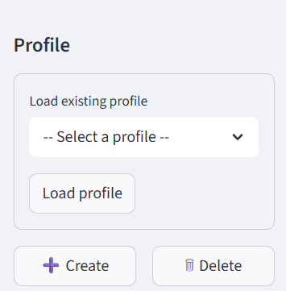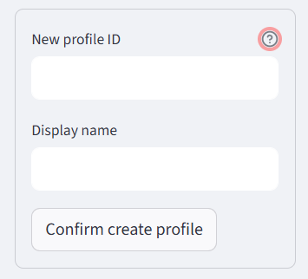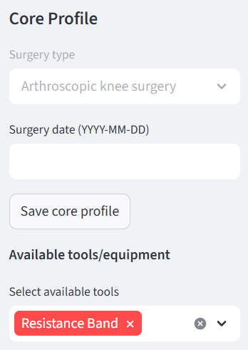
Profile data is stored locally in SystemCode/data/profiles/<profile_id>.json. It is not transmitted anywhere other than the OpenAI API for NLU processing.

5.3 Starting a Conversation
With a profile selected, type your message in the chat input box at the bottom of the screen and press Enter or click Send.
Example opening messages:
- “None”
- “I am having slight fever and no bleeding”
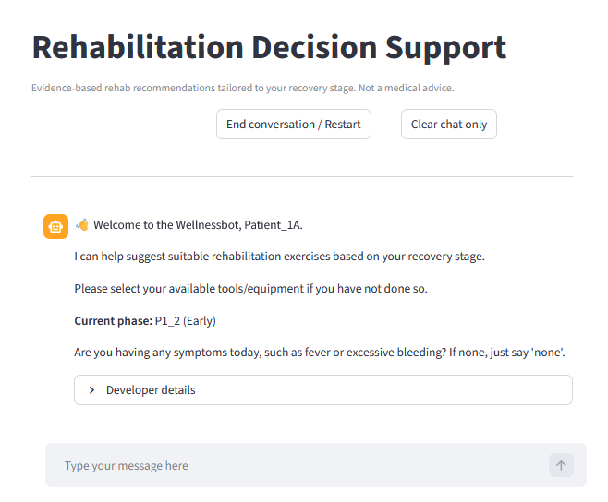
The bot will respond based on the information it has collected so far. If information is missing, it will ask follow-up questions.

5.4 Slot-Filling Dialogue Flow
WellnessBot collects the following information before generating an exercise recommendation. If any slot is missing, it will ask a targeted follow-up question.
Slot | What the Bot Asks | Example Answer
Surgery date / weeks | "When was your surgery or injury? Please tell me the date (YYYY-MM-DD) " | "2025-12-01"
Symptoms | "Are you having any symptoms today, such as fever or excessive bleeding? If none, just say “none”." | "I am having fever" / "None"
Pain score | "How would you rate the pain from 0 to 3?" | "1"
Swelling score | "How would you rate the swelling from 0 to 3? " | "0"
Tips:
- You can provide multiple pieces of information in a single message.
- If you have already set your surgery type and date in your profile, the bot may skip those questions.
- The bot remembers your answers within a session and will not re-ask completed slots.

5.5 System Responses
Once sufficient information is collected, WellnessBot generates one of four responses:
RECOMMEND — Exercise Recommendation
The most common response. The bot provides:
- Self Care (if applicable) — ice/elevation advice based on your symptoms
- Recommended Exercise — exercise name, position, equipment needed, and caution notes
- How To Perform — one grounded instruction line from the clinical evidence database
- References — source citations with links

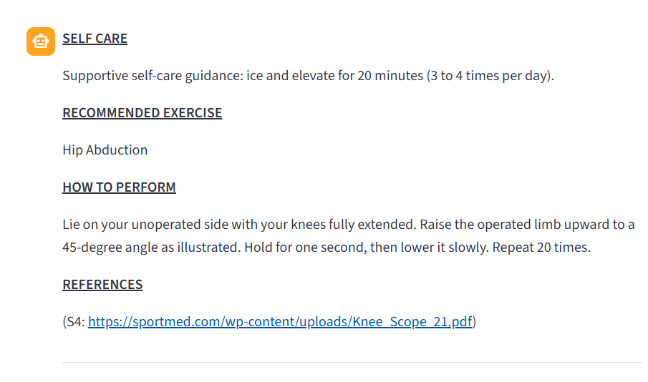
CLARIFY — Follow-up Question (Internal Step)
The bot asks for one missing piece of information before it can make a recommendation. A list of possible exercises may also be shown.

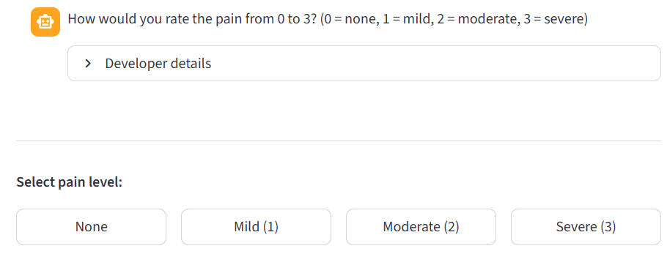

FORBID — Exercise Blocked
The bot explains why an exercise cannot be recommended at this time (e.g., your swelling score is too high). No exercise is provided.

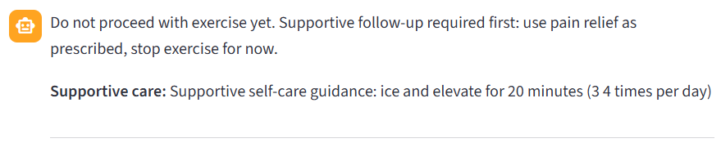

ESCALATE — Seek Clinical Help
If red-flag symptoms are detected (e.g., fever, active bleeding, extreme swelling), the bot advises you to contact your healthcare provider immediately. No exercise is recommended.

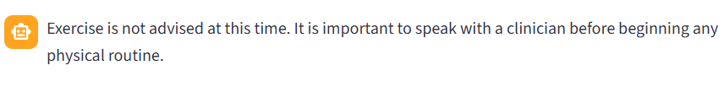

5.6 Providing Feedback
After each final response (RECOMMEND, FORBID, or ESCALATE), a thumbs-up / thumbs-down feedback prompt appears. Click Thumbs Up if the response was helpful, or Thumbs Down if it was not. Feedback is logged to the audit trail and used to monitor system quality.

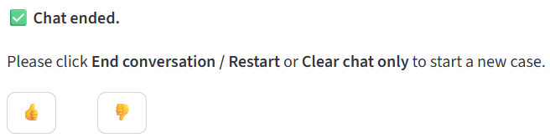

5.7 Knowledge Loop Analysis
The Knowledge Loop Analysis page is used to evaluate system behaviour using interaction logs and user feedback.
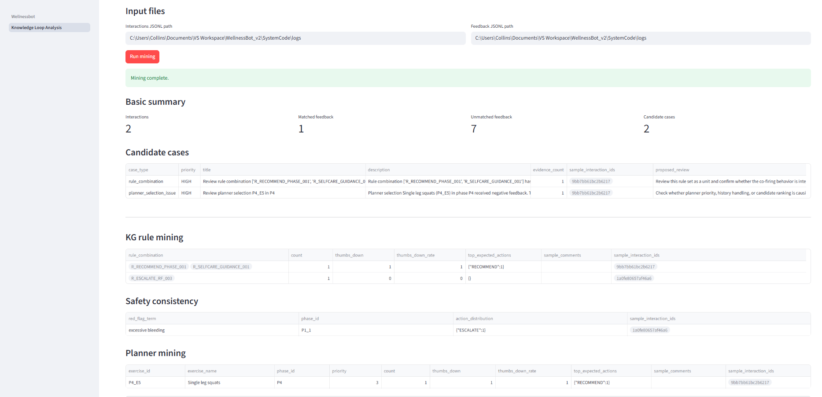
Steps:
- Select Input Files
Ensure the interaction logs and feedback logs are correctly loaded.
- Run Mining
Click “Run Mining” to process logs and generate results.
- Review Basic Summary
View key metrics: total interactions, feedback coverage, and refinement candidates.
- Analyse Refinement Candidates
Review flagged cases with issue summaries, interaction IDs, and suggested actions.
These highlight potential problems such as rule conflicts, negative feedback patterns, or suboptimal planner decisions.
- Deep Dive into Mining Views
  - KG Rule Mining: Identify problematic rule combinations
  - Safety Consistency: Check if red-flag conditions trigger correct actions
  - Planner Mining: Evaluate exercise selection behaviour

This workflow supports systematic identification of system weaknesses and guides manual, developer-driven refinement of the knowledge graph, rules, and planner, without affecting runtime logic.

6. Environment Variables Reference
Variable | Required | Default | Description
OPENAI_API_KEY | Yes | — | OpenAI API key for NLU and LLM response generation
OPENAI_MODEL | No | gpt-4o-mini | OpenAI model for NLU extraction
LOGGING_ENABLED | No | 1 | Set to 0 to disable interaction logging
LOG_DIR | No | ./logs | Directory for daily JSONL interaction log files
APP_VERSION | No | v2 | Version tag written into audit log entries

7. Troubleshooting

7.1 Script not found / CommandNotFoundException
Ensure you are running the command from inside SystemCode/, not from the repo root or elsewhere:
cd path\to\WellnessBot_v2\SystemCode .\run_streamlit.ps1

7.2 PowerShell script execution blocked
Run this once to allow local scripts, then retry:
Set-ExecutionPolicy -ExecutionPolicy RemoteSigned -Scope CurrentUser

7.3 Application does not start
- Ensure your virtual environment is active ((.venv) in your terminal prompt).
- Ensure all dependencies are installed: pip install -r requirements.txt.
- Ensure you are running the command from inside SystemCode/.

7.4 ModuleNotFoundError: No module named 'SystemCode'
- PYTHONPATH must point to the parent of SystemCode/ (i.e., WellnessBot_v2/).
- On macOS/Linux, use PYTHONPATH=.. when running commands manually.
- On Windows, run_streamlit.ps1 sets this automatically — use the script rather than running streamlit directly.

7.5 openai.AuthenticationError or 401 Unauthorized
- Your OPENAI_API_KEY in SystemCode/.env is missing or incorrect.
- Verify the key at platform.openai.com.

7.6 Profile not saving
- Ensure the SystemCode/data/profiles/ directory exists. It is created automatically on first run.
- Check write permissions on the SystemCode/data/ directory.

7.7 Logs not being written
- Ensure LOGGING_ENABLED=1 in SystemCode/.env.
- Ensure the SystemCode/logs/ directory exists and is writable.

