

# MASENO UNIVERSITY

# SCHOOL OF COMPUTING AND INFORMATICS

# DEPARTMENT OF COMPUTER SCIENCE

**CCS 306: SOFTWARE ENGINEERING**

**Project**

# Software Requirement Specification for Pera 1.0

**By**

**Name: DENNIS MAYEKU**

**Reg: CI/03002/014**

**Date: 22 May 2017**

**Sign: ………….**

**Lecturer: Mr. Kevin Mugoye**

Table of Contents

1. Project Proposal Document 5

1.0 Introduction 5

1.1 Justification of the project 5

1.2 Feasibility study 5

2. Requirements document 6

2.0 Preface 6

2.1 Introduction 6

2.2 Glossary 7

2.3 User requirements introduction 8

2.4 System architecture 9

2.5 System requirement specification 9

2.5.1 Software interface requirements 11

2.5.2 Communication interface requirements 12

2.5.3 Hardware interface requirements 12

2.6 System models 13

2.7 System evolution 13

3. Project design document 15

3.0 Preface 15

3.1 Introduction 15

3.2 Glossary 16

3.3 Context diagram 18

3.4 Use cases 19

3.4.1 Use case diagram for customer 19

3.4.2 Use case diagram for operator 19

3.5 State diagrams 21

3.5.1 State diagram for customer validate PIN 21

3.5.2 State diagram for customer withdraw funds 21

3.6 Sequence diagrams 22

3.6.1 Sequence diagram for customer validate PIN - 1 22

3.6.2 Sequence diagram for customer validate PIN - 2 22

3.6.3 Sequence diagram for customer validate PIN - 3 23

2. Overall Description Error! Bookmark not defined.

2.1 Product Perspective **Error! Bookmark not defined.**

2.2 Product Functions **Error! Bookmark not defined.**

2.3 User Classes and Characteristics **Error! Bookmark not defined.**

2.4 Operating Environment **Error! Bookmark not defined.**

2.5 Design and Implementation Constraints **Error! Bookmark not defined.**

2.6 User Documentation **Error! Bookmark not defined.**

2.7 Assumptions and Dependencies **Error! Bookmark not defined.**

3. External Interface Requirements Error! Bookmark not defined.

3.1 User Interfaces **Error! Bookmark not defined.**

3.2 Hardware Interfaces **Error! Bookmark not defined.**

3.3 Software Interfaces **Error! Bookmark not defined.**

3.4 Communications Interfaces **Error! Bookmark not defined.**

4. Domain Model Error! Bookmark not defined.

5. System Features (Use Cases) Error! Bookmark not defined.

5.1 Use Case 1 **Error! Bookmark not defined.**

5.1.1 Name: **Error! Bookmark not defined.**

5.1.2 Goal: **Error! Bookmark not defined.**

5.1.3 Input: **Error! Bookmark not defined.**

5.1.4 Output: **Error! Bookmark not defined.**

5.1.5 Main Scenario: **Error! Bookmark not defined.**

5.1.6 Pre-condition: **Error! Bookmark not defined.**

5.1.7 Steps: **Error! Bookmark not defined.**

5.1.8 Post-condition **Error! Bookmark not defined.**

5.1.9 Exceptional Scenario 1 **Error! Bookmark not defined.**

5.1.10 Example **Error! Bookmark not defined.**

5.2 Use Case 2 (and so on) **Error! Bookmark not defined.**

6. Other Nonfunctional Requirements Error! Bookmark not defined.

6.1 Performance Requirements **Error! Bookmark not defined.**

6.2 Safety Requirements **Error! Bookmark not defined.**

6.3 Security Requirements **Error! Bookmark not defined.**

6.4 Software Quality Attributes **Error! Bookmark not defined.**

7. Other Requirements Error! Bookmark not defined.

Appendix A: Glossary Error! Bookmark not defined.

Appendix B: Analysis Models Error! Bookmark not defined.

Appendix C: To Be Determined List Error! Bookmark not defined.

# Intentionally left blank.

# PROJECT PROPOSAL DOCUMENT

**1.0 Introduction**

Pera 1.0 software is to be developed for Automated Teller Machines (ATM). An automated teller machine (ATM) is a computerized telecommunications device that provides a financial institution's customers a secure method of performing financial transactions, in a public space without the need for a human teller. Through ATM, customers interact with a user-friendly interface that enables them to access their bank accounts and perform various transactions.

This SRS defines External Interface, Performance and Software System Attributes requirements for Pera 1.0. This document is intended for the following group of people:

* Developers for the purpose of maintenance and new releases of the software
* Management of the bank
* Documentation writers
* Testers

**1.1 Justification of the project:**

Pera 1.0 software facilitates the user to perform various transactions in their account in a time saving and convenient way. This software offers benefits such cash withdrawals, balance transfers, deposits, inquiries, credit card advances and other banking related operations for customers. It also allows the bank administrator to fix the tariffs and rules as and when required.

**1.2 Feasibility study**

Pera 1.0 software is built on top of the existing banking infrastructure. The system integrates into to the bank’s core software and services. These interfaces are accessible through API calls that are provided inside Pera 1.0 and authenticated by the parent system.

# REQUIREMENTS DOCUMENT

**2.0 Preface**

This document, Software Requirements Specification (SRS), is created to document the software requirements for Pera 1.0 banking system.

This document was created on the request of the ‘Pera Bank.’ – the ‘Client’. The creator of this document is ‘Indigo Stream Software’ – ‘Vendor’. The ‘Client’ has asked the ‘Vendor’ to develop an SRS for the Banking System. The ‘Vendor’ will also be responsible for the development of the software based on this SRS.

This is the first version of the SRS.

**2.1 Introduction**

A bank has several automated teller machines (ATMs), which are geographically distributed and connected via a wide area network to a central server. Each ATM machine has a card reader, a cash dispenser, a keyboard/display, and a receipt printer. By using the ATM machine, a customer can withdraw cash from either checking or savings account, query the balance of an account, or transfer funds from one account to another.

A transaction is initiated when a customer inserts an ATM card into the card reader. Encoded on the magnetic strip on the back of the ATM card are the card number, the start date, and the expiration date.

Assuming the card is recognized, the system validates the ATM card to determine that the expiration date has not passed, that the user-entered PIN (personal identification number) matches the PIN maintained by the system, and that the card is not lost or stolen.

The customer is allowed three attempts to enter the correct PIN; the card is confiscated if the third attempt fails. Cards that have been reported lost or stolen are also confiscated.

If the PIN is validated satisfactorily, the customer is prompted for a withdrawal, query, or transfer transaction. Before withdrawal transaction can be approved, the system determines that sufficient funds exist in the requested account, that the maximum daily limit will not be exceeded, and that there are sufficient funds available at the local cash dispenser.

If the transaction is approved, the requested amount of cash is dispensed, a receipt is printed containing information about the transaction, and the card is ejected.

Before a transfer transaction can be approved, the system determines that the customer has at least two accounts and that there are sufficient funds in the account to be debited. For approved query and transfer requests, a receipt is printed and card ejected.

A customer may cancel a transaction at any time; the transaction is terminated and the card is ejected. Customer records, account records, and debit card records are all maintained at the server.

An ATM operator may start up and close down the ATM to replenish the ATM cash dispenser and for routine maintenance. It is assumed that functionality to open and close accounts and to create, update, and delete customer and debit card records is provided by an existing system and is not part of this problem.

**2.2 Glossary**

PIN: Personal Identification Number. Is a numeric password shared between a user and a system that can be used to authenticate the user to the system.

Account: A single account in a bank against which transactions can be applied. Accounts maybe of various types with at least checking and savings. A customer can hold more than one account.

ATM: An electronic telecommunications device that enables the customers of a financial institution to perform financial transactions without the need for a human cashier, clerk or bank teller.

Bank: A financial institution that holds accounts for customers and that issues account numbers and passwords authorizing access to accounts over the ATM network.

Customer: The holder of one or more accounts in a bank. A customer can consist of one or more

Persons or corporations the correspondence is not relevant to this problem. The same person holding an account at a different bank is considered a different customer.

Transaction: A single integral request for operations on the accounts of a single customer. We only specified that ATMs must dispense cash, accept cash deposits, view balance and print receipts.

**2.3 User requirements introduction**

The major functions that Pera 1.0 performs are described as follows:

Language Selection

At the welcome screen, the display provides a user with a list of languages from which they can select one.

User Account

*Account Type*: The user has the freedom to select an account type to which all the transactions are made, i.e. whether the account is current account or savings account.

*Withdrawal/Deposit*: The software allows the user to select the kind of operation to be performed i.e. whether they want to withdraw or deposit the money. The amount to be withdrawn or deposited is then input by the user.

*Denominations*: The user is also provided with the choice to select a denomination. Once they enter their requirements the machine determines whether the request can be honored. If yes, the amount is given to the user otherwise other possible alternatives are displayed.

*Depositing cash*: Shall be done with an envelope. After typing the amount to be deposited and verification of the same, the customer must insert an envelope into the receiver.

*Balance transfer*: Shall be facilitated between any two accounts linked to the card for example saving and checking account.

*Balance enquiry*: Balance enquiry for any account linked to the card shall be facilitated.

*Billing:* Any transaction shall be recorded in the form of a receipt and the same would be dispensed to the customer. The billing procedures are handled by the billing module giving the user an option to choose whether they want a printed statement of the transaction.

*Cancelation:* The customer shall abort a transaction with the press of a Cancel key. In addition the user can also cancel the entire session by pressing the abort key and can start a fresh session all over again.

**2.4 System architecture**

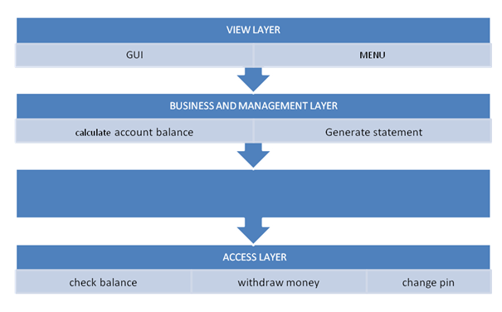

The ATM is a single functional unit consisting of various subcomponents. Pera 1.0 software allows the user to access their bank accounts remotely through an ATM without any aid of human teller. The hardware component includes memory, drives, dispensers for receipts and cash, a card reader, printer, switches, a console, a telephone dialer port, a networking port and disks. The ATM communicates with the bank’s central server through a dial-up communication link.

**2.5 System requirement specification**

* Pera Banks can have many automated teller machines (ATMs), and the new software system shall provide functionality on all ATMs. The system shall enable the customers of Pera Bank, who have valid ATM cards, to perform three types of transactions;
  + Withdrawal of funds
  + Query of account balance
  + Transfer of funds from one bank account to another account in the same bank.
* An ATM card shall be considered valid if it meets the following conditions:
* The card was issued by an authorized bank.
* The card is used after the start date, i.e., the date when the card was issued.
* The card is used before the expiration date, i.e., the date when the card expires.
* The card has not been reported lost or stolen by the customer, who had been issued that card.
* The customer provides correct personal identification number (PIN), which matches the PIN maintained by the system.

The system shall confiscate the ATM card if it detects that a lost or stolen card has been inserted by a customer. The system shall also display an apology to the customer.

* The system shall allow the customer to enter the correct PIN in no more three attempts. The failure to provide correct PIN in three attempts shall result in the confiscation of the ATM card.
* The system shall ask for the transaction type after satisfactory validation of the customer PIN.
* The customer shall be given three options: withdrawal transaction, or query transaction, or transfer transaction.
* If a customer selects withdrawal transaction, the system shall prompt the customer to enter account number and amount to be dispensed. For a withdrawal transaction, the system shall determine that sufficient funds exist in the requested account, that the maximum daily limit has not be exceeded, and that there are sufficient funds available at the local cash dispenser.

If a withdrawal transaction is approved, the requested amount of cash shall be dispensed, a receipt shall be printed containing information about the transaction, and the card shall be ejected. The information printed on the receipt includes transaction number, transaction type, amount withdrawn, and account balance.

* If a customer selects query transaction, the system shall prompt the customer to enter account number. If a query transaction is approved, the system shall print a receipt and eject the card. The information contained on the receipt includes transaction number, transaction type, and account balance.
* If a customer selects transfer transaction, the system shall prompt the customer to enter from account number, to account number, and amount to be transferred. The system shall check if there are enough funds available in the from account, which are being requested for transfer to the to account. If the transfer transaction is approved, a receipt shall be printed and card shall be ejected. The information printed on the receipt includes transaction number, transaction type, amount transferred, and account balance.
* The system shall cancel any transaction if it has not been completed if the customer presses the Cancel button.
* The customer records, account records, and debit card records will all be maintained at the server and shall not be the responsibility of the system.
* The system shall enable an ATM operator to shutdown or start up an ATM for routine maintenance. The system shall enable an ATM operator to add cash to the cash dispenser.
* The system shall not be responsible for opening or closing of accounts, and to create, update, and delete customer and debit card records. These tasks are performed elsewhere by a bank.
* The system shall be linked with the bank server through communication systems, which are beyond the scope of the current system. It is assumed that this facility is always available.

**2.5.1 Software Interface Requirements**

* The transaction management software used to keep track of resources and account activity shall be BMS version 2.0.
* The card management software used to verify PINs and logins shall be CMS version 3.0.
* The database used to keep record of user accounts shall be Oracle version7.0.

**2.5.2 Communication Interface Requirements**

* The system will employ dial-up POS with the central server for low cost communication.
* The communication protocol used shall be TCP/IP.
* Protocol used for data transfer shall be File Transfer Protocol (FTP).

**2.5.3 Hardware Interface Requirements**

* The ATM power supply shall have a 100 - 220V AC manual switch.
* The ATM card should have the following physical dimensions:
  + Width: 85.47 - 85.72 mm
  + Height: 53.92 – 54.03 mm
  + Thickness: 0.76 +- 0.08 mm
* The card reader shall be a magnetic stripe reader.
* The card reader shall have Smart card option.
* The slot for a card in the card reader may include an extra indentation for the embossed area of the card. In effect it acts as a polarization key and may be used to aid the correct insertion orientation of the card. This is an additional characteristic to the magnetic field sensor which operates off the magnetic stripe and is used to open a mechanical gate on devices such as ATMs.
* There shall be a 40 column dot matrix receipt printer.
* There shall be a 40 column dot matrix statement printer.
* The receipt dispenser shall be a maximum of 4" width and 0.5" thickness.
* The statement dispenser shall be a maximum of 5" width and 0.5" thickness.
* The envelope receiver shall be a maximum of 4.5" width, 10" length and 0.5" thickness.
* Screen resolution of at least 800 x 600 required for proper and complete viewing of screens. Higher resolutions would not be a problem.
* The display screen shall be of 10" VGA color type.
* The display screen shall have 256 color resolution.
* The display screen shall also support touch screen facility.
* The speakers shall support Yamaha codecs.
* The keypad shall consist of 16 tactile keys.
* There shall be 8 tactile function keys.
* The keyboard will be weather resistant.

**2.6 System models**

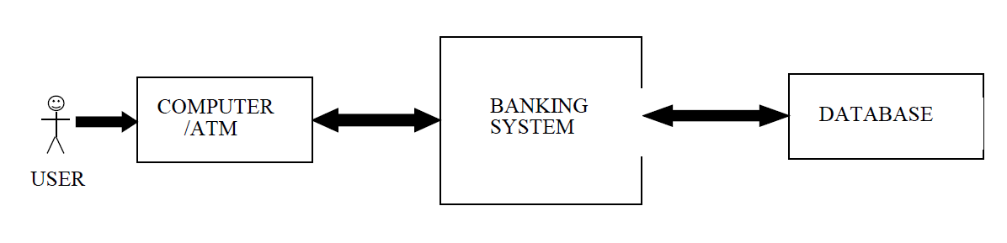

**2.7 System evolution**

The expected evolutions and software changes to Pera 1.0 software are:

* The deposit transaction by a user should be automatically done. That is the ATM’s software should count the cash deposited by a customer automatically with the help of special hardware, without the need for the ATM operator manually counting the cash.
* The cash loaded in the ATM machine for withdrawal purposes should be counted automatically.
* Update the customer’s database automatically once he/she makes a valid deposit transaction.
* Update the customer’s database when he/she makes a valid deposit transaction.
* The software must run and operate on the ATM’s hardware effectively and efficiently.
* The software must properly interface with the existing banking system and the existing banking database system.
* The ATM should produce transaction script after exit from the system.
* The graphic user interface should be more user friendly and accommodate changes that will come as more functionality and services will be added and made to the software as user and system requirements change.

More security and limiting features like:

* Accommodating only 3 wrong password or account number attempts made by user on the ATM.
* Limit daily cash withdrawals of a customer.
* Deposited cash from customer is the same and exact amount he/she stated when making the deposit transaction.
* Updating and validating a customer’s deposit transaction if and only the posited cash from customer is the same exact figure as the amount he/she stated upon initiating the deposit transaction.

# 

# PROJECT DESIGN DOCUMENT

**3.0 Preface**

This document, Software Requirements Specification (SRS), is created to document the software project design for Pera 1.0 banking system.

This document was created on the request of the ‘Pera Bank.’ – the ‘Client’. The creator of this document is ‘Indigo Stream Software’ – ‘Vendor’. The ‘Client’ has asked the ‘Vendor’ to develop an SRS for the Banking System. The ‘Vendor’ will also be responsible for the development of the software based on this SRS.

This is the first version of the SRS.

**3.1 Introduction**

A bank has several automated teller machines (ATMs), which are geographically distributed and connected via a wide area network to a central server. Each ATM machine has a card reader, a cash dispenser, a keyboard/display, and a receipt printer. By using the ATM machine, a customer can withdraw cash from either checking or savings account, query the balance of an account, or transfer funds from one account to another.

A transaction is initiated when a customer inserts an ATM card into the card reader. Encoded on the magnetic strip on the back of the ATM card are the card number, the start date, and the expiration date.

Assuming the card is recognized, the system validates the ATM card to determine that the expiration date has not passed, that the user-entered PIN (personal identification number) matches the PIN maintained by the system, and that the card is not lost or stolen.

The customer is allowed three attempts to enter the correct PIN; the card is confiscated if the third attempt fails. Cards that have been reported lost or stolen are also confiscated.

If the PIN is validated satisfactorily, the customer is prompted for a withdrawal, query, or transfer transaction. Before withdrawal transaction can be approved, the system determines that sufficient funds exist in the requested account, that the maximum daily limit will not be exceeded, and that there are sufficient funds available at the local cash dispenser.

If the transaction is approved, the requested amount of cash is dispensed, a receipt is printed containing information about the transaction, and the card is ejected.

Before a transfer transaction can be approved, the system determines that the customer has at least two accounts and that there are sufficient funds in the account to be debited. For approved query and transfer requests, a receipt is printed and card ejected.

A customer may cancel a transaction at any time; the transaction is terminated and the card is ejected. Customer records, account records, and debit card records are all maintained at the server.

An ATM operator may start up and close down the ATM to replenish the ATM cash dispenser and for routine maintenance. It is assumed that functionality to open and close accounts and to create, update, and delete customer and debit card records is provided by an existing system and is not part of this problem.

**3.2 Glossary**

PIN: Personal Identification Number. Is a numeric password shared between a user and a system that can be used to authenticate the user to the system.

Account: A single account in a bank against which transactions can be applied. Accounts maybe of various types with at least checking and savings. A customer can hold more than one account.

ATM: An electronic telecommunications device that enables the customers of a financial institution to perform financial transactions without the need for a human cashier, clerk or bank teller.

Bank: A financial institution that holds accounts for customers and that issues account numbers and passwords authorizing access to accounts over the ATM network.

Customer: The holder of one or more accounts in a bank. A customer can consist of one or more

Persons or corporations the correspondence is not relevant to this problem. The same person holding an account at a different bank is considered a different customer.

Transaction: A single integral request for operations on the accounts of a single customer. We only specified that ATMs must dispense cash, accept cash deposits, view balance and print receipts.

**3.3 Context diagram**

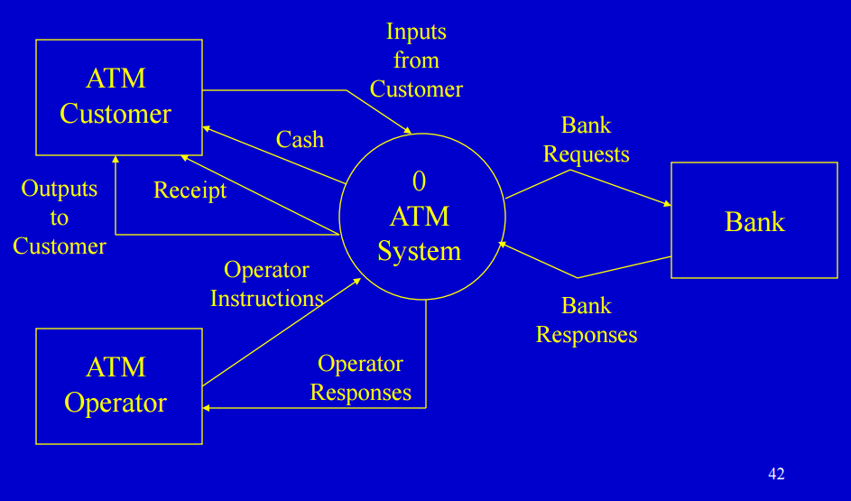

**3.4 Use cases**

**3.4.1 Use case diagram for customer**

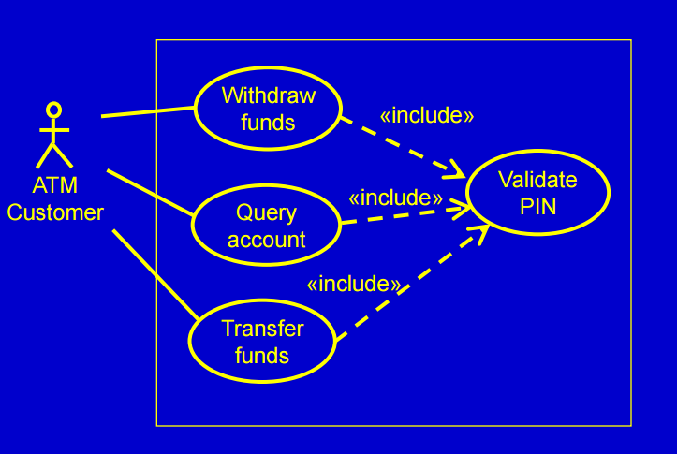

**3.4.2 Use case diagram for operator**

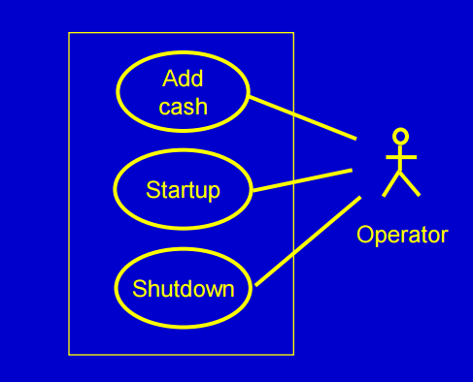

**3.4.3 Use case diagram for ATM**

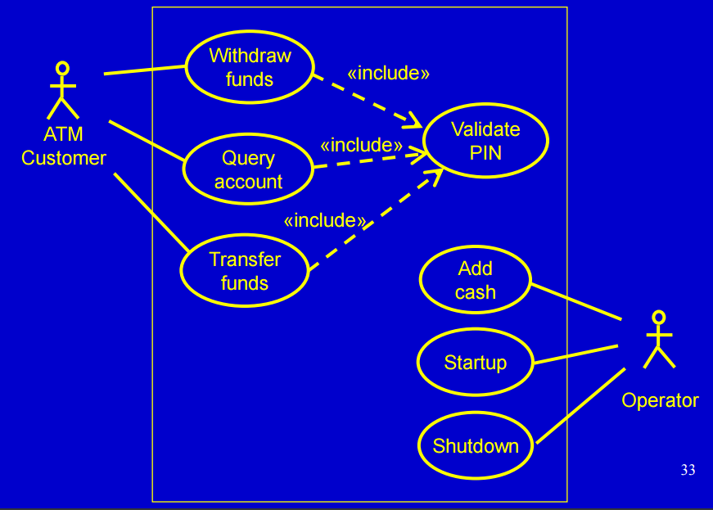

**3.5 State diagrams**

**3.5.1 State diagram for customer validate PIN**

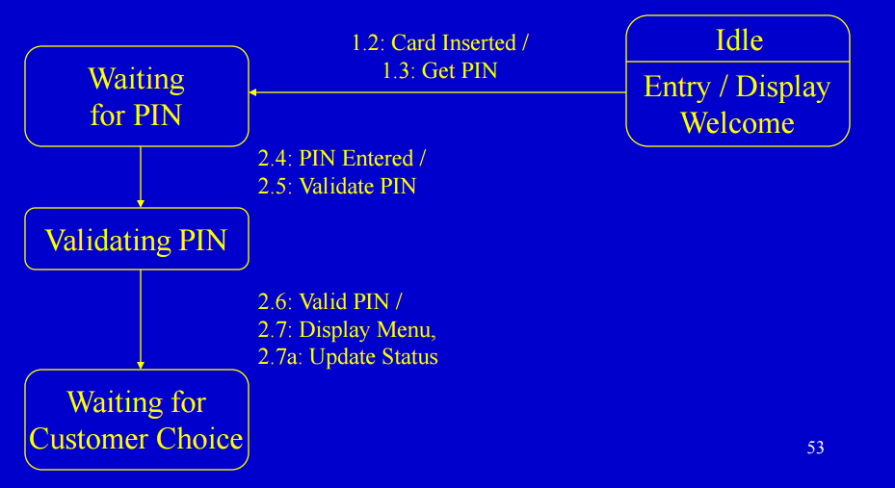

**3.5.2 State diagram for customer withdraw funds**

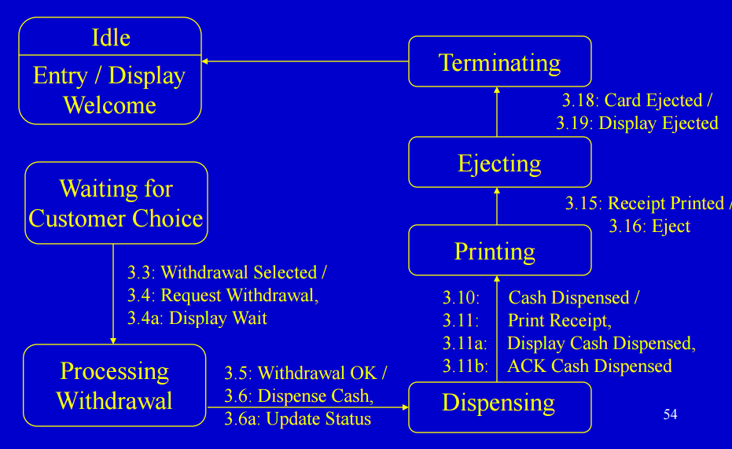

**3.6 Sequence diagrams**

**3.6.1 Sequence diagram for customer validate PIN - 1**

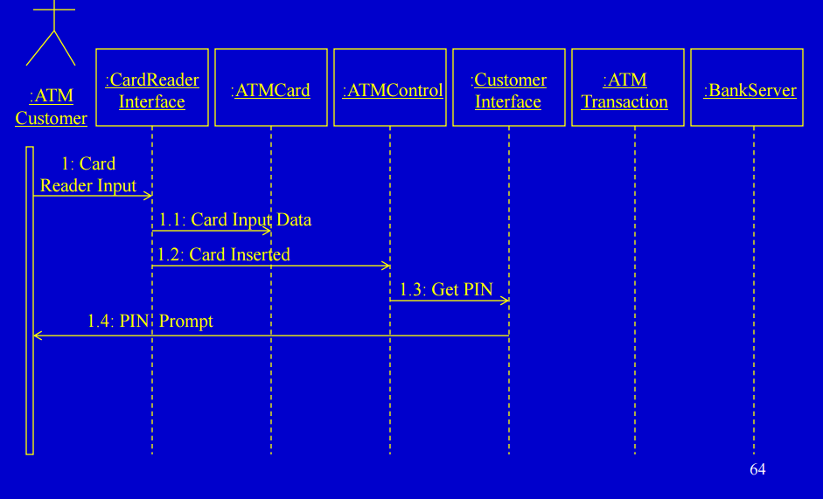

**3.6.2 Sequence diagram for customer validate PIN – 2**

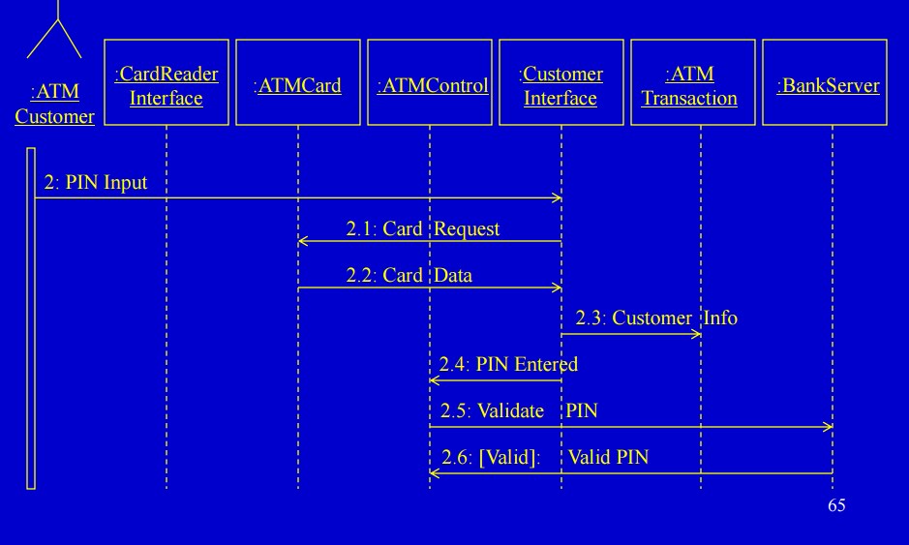

**3.6.3 Sequence diagram for customer validate PIN – 3**

