
School of Science, Engineering and Technology

Assessment Instrument Coversheet

Module Code: CE0902A

Module Title: Group Project

Unit of Assessment: 1

Learning Outcomes 1-3
Assessed (In addition, see module descriptor)

Lecturer: Dr Andrea Szymkowiak

Submission Date: 20 May 2014, 4 pm

Feedback Return Date: Week 38

Feedback Type: Written
(eg verbal, written)

Grading Criteria Refer to Page 2

Submission Requirements:

Hard copy A hard copy of your work should be submitted to the Courework box beside the Science, Engineering and Technology School Reception (Level 4) by
4.00 pm on the date specified with the standard cover sheet attached. In the event of late submission the authorisation for this must be indicated on the cover sheet. If late submission is due to mitigating circumstances, a completed and signed ’Late Submission of Coursework’ (CEX) form must be submitted to your Home School Office, with a medical certificate or other documentary evidence as appropriate.
x
Electronic copy An electronic submission via Blackboard is required for the purpose of checking for plagiarism. The maximum file size which can be submitted is 20MB so you may need to reduce the size of any image files within your document.
Guidance on submitting via Blackboard is available at: http://submit.ac.uk/en_gb/training/student-training/submitting-a-paper, but please contact the Helpdesk on 01382 308888 if you have any problems with this.

Failure to submit any of the required items (hard copy and/or electronic copy) will be deemed as non-submission. Submission of any of the required items after the submission date deadline will be deemed as late submission.
Unit Grading Criteria (please contextualise)

Grade |  | Description of the Grade | Honours  Equivalent | ECTS
A+ | Excellent | Outstanding performance – an excellent grasp of the subject matter. | First | A
A
A–
B + | Very Good | A very good grasp of the subject matter. | Upper Second | B
B
B–
C + | Good | Generally sound grasp of the subject matter, exceeds the threshold standard. | Lower Second | C
C
C–
D + | Satisfactory | A satisfactory performance overall, but limited grasp of some areas of the subject matter. Has achieved the threshold level. | Third | D
D
D–
E + | Marginal Fail | Performance just below the threshold standard. A reasonable expectation that a pass is achievable by reassessment without the need to repeat the module. |  | FX
E
E–
F + | Fail | Performance well below the threshold level. Some limited evidence of achievement of the outcomes. |  | F
F
F–
NS | No submission | No assessments submitted. |  | F
IN | Incomplete | Assessment incomplete due to valid mitigating circumstances.

SNaPP Project Management

<Design Document for Dementia Sufferer’s GetMeHome Mobile Phone Application.

SNaPP Group Project
Gael Fontenelle, Martin Naismith, John Joseph Pikadili, Samuel Okide, Neil Paton, Greg Stewart.

May 2014

Contents

Introduction 4
Finalised Requirements 5
Administrator Requirements (Web Site) 6
Carer Requirements 7
Dementia Sufferer Requirements 8
Non Functional Requirements 9
Use Case Diagrams 11
Registration to Website Use Case 12
Carer Options for setup of Patient Phone Use Case 13
Carer Options for Carer Phone Use Case 14
Patient Options for Patient Phone Use Case 15
Design – Navigational Maps 17
Patient Phone – Diagram 1 18
Patient Phone – Diagram 2 19
Carer Phone – Diagram 1 20
Design - Database Diagram 22
Report on Project Outcome 24
Initial Development and Design 25
Design, Implementation and Testing 25
Individual Input 25
Greg Stewart 25
Gaël Fontenelle 26
Neil Paton 28
Samuel Okide 29
Martin Naismith 30
John Joseph Pikadili 31
Project Progress 31
Group Product Results 32
Final Recommendations 33
Appendix 1 – Diary Notes 35
Appendix 2 – GUI Standards 38
Appendix 3 – Supporting Customer 42
App Introduction 43
App requirements 43
App Structure Image Layout 44
General Installation 46
Quick Start Guide GoGetMe 47
Step 1 Register 47
Step 2 Add Location 48
Step 3 Select Location 48
Step 4 Delete Location 48
Step 5 Help Menu 49
Appendix 4 – Testing 50
Main Navigation Buttons Test 51
Register User Test 54
Index/ References 55

Introduction

This project is the following development design and impementation from the work carried out last term by this group. The proposal is to use the assumptions and planning projections to provide the finished product within the target timescale. However as with all live projects we must be aware of changes which will develop during the course of development.

The project was split up into three main areas;
- The patient phone functions
- The carer phone functions
- The remote database functions

Greg, Neil and John were predominantly working on the patient phone functions, while Martin and Sammie were working on the carer functions while Gael developed the web services database. This was based on the estimated workload for each part of the system.

The main risks to the project identified in the planning stage to production being incomplete, were time overruns and the technical inabilities of the team at the time of the design process.

Finalised Requirements

Dementia Sufferer’s GetMeHome
Mobile Phone Application

SNaPP Group Project

Administrator Requirements (Web Site)

A1 - As an administrator I want to register a carers phone securely to allow access to the recorded web data of patient users locations.
e.g. A new GoGetMe/ComeGetMe phone set-up is provided for a patient, their carer’s and family, the phone numbers and the ‘imei’ number are recorded on the web site login database to ensure only the registered users phones can access the location data stored from that specific patients phone.

A2 – As an administrator I want to register a patient user’s phone securely to record positional data to the web site.
e.g. A new phone setup requires the phone number and the phone ‘imei’ number to be recorded on the web site login database to ensure the locational data is recorded in the correct storage area for access by the patients carers. Data logging starts with the phone being set into user mode on the GoGetMe/ComeGetMe app.

A3 – As an administrator I want to access the web site to monitor activities and for general administration tasks.
e.g. Monitoring the patient logging data could help in identifying when the patient is becoming more dependent on the phone app. This could indicate the patients’ condition is deteriorating to a point where the patient should not be allowed out on their own without a carer.
.

Carer Requirements

C1 – As a carer I would like to setup the phone and tailor it for our needs.
e.g. The carer has a separate area when they login, allowing for stored destination location’s to be updated etc., as every individual installation will need to setup this feature.

C2 – As a carer I would like to be able to record a destination on the Phone, with a picture so that my partner can get assistance to find the location, they wish to go to.
e.g. The carer can move to a location and take a picture, upload it to the app, and the user can click the image, the phone providing assistance to aid the user in locating the destination.

C3 – As a carer I would like to be able to lock my partner’s phone so that
only the GoGetMe application is available to them.
e.g. To separate the user from more complex functions of the phone.

C4 – As a Carer I would like to be able to check on the location of my
partner on my mobile phone, so that I can go and get them.
e.g. This will be done through the GPS location stored on the web server.

C5 – As a carer I would like to be able to set a ‘safe zone’ for the location
of the phone so that an emergency call is sent when the phone
leaves this safe zone.
e.g. Patient leaves the area, giving alerts by SMS to carer’s phone.

C6 – Usage statistics (date, time, function used, location selected)
of certain functions of the application to be stored on phone for
analysis of usage to determine how often the app is required by the
patient (More detailed information on the web site, allowing for analysis there)
e.g. Using the phone and the web site to monitor the usage of the application, and using the information to determine whether the user is becoming worse, making the application a possible danger due to the patients deteriorating condition.

Dementia Sufferer Requirements

D1 – As a dementia sufferer I want to be able to select a destination to visit.
e.g. Select ‘Bettys house’ from a menu of stored locations.

D2 – As a dementia sufferer I want help to get back home by the touch of a button.
e.g. Press a ‘Take Me Home’ button to take me home.

D3 – As a dementia sufferer I want to be able to call for help so that I can get home.
e.g. A button to allow a call to specified contacts and sms broadcast to registered carers of that patient.

D4 – As a dementia sufferer I want to be told which way to walk so that I can get to my destination.
e.g. Voice and screen navigational directions to reach the destination.

D5 – As a dementia sufferer I want to be able to select my favourite destinations so that I can get to that destination.
e.g. To have a favourite destination list to access.

Non Functional Requirements

- The mobile applications will run on an android mobile phone system.
- The patients’ application will be fully implemented within the android sdk.
- The carers’ application will be a hybrid of android sdk and web portal to access the web based data.
- The design and implementation will have to cater to all types of users!
e.g. old/ young, technically able/not able.
- There may be more than one carer phone registered to the web system for a particular patients’ phone.
- The application will be designed to be safety critical i.e. patients with memory loss will be using it, so malfunctions can a danger to the user. This may require additional layers of checking the users’ position with relation to the tailored safe area constraint.
- The database is secured on the server, only allowing access to registered users and devices.
- The application for the user must be responsive and not appear to be locked or hanging, a message should always be given to the user that something is happening.
- The application should be able to operate in difficult situations where gps and phone signals are poor or intermittent, caching data to be saved to the web site once a good signal is received.

- The application should deal with errors cleanly and not display any alarming messages to the user.

Use Case Diagrams

Dementia Sufferer’s GetMeHome
Mobile Phone Application

SNaPP Group Project

Registration to Website Use Case

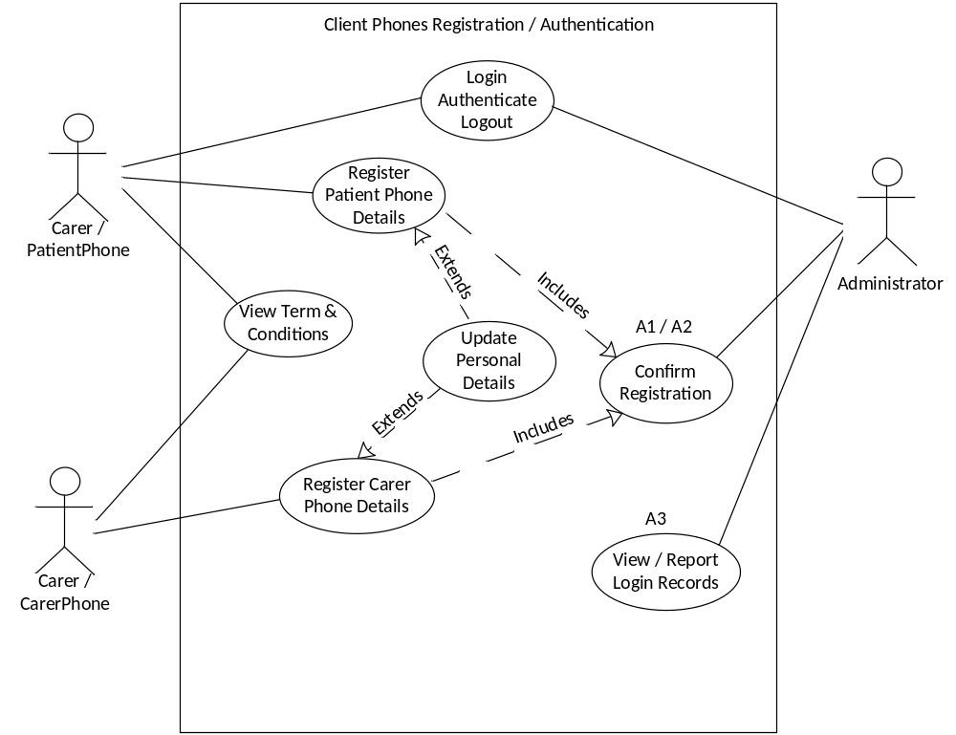

Carer Options for setup of Patient Phone Use Case

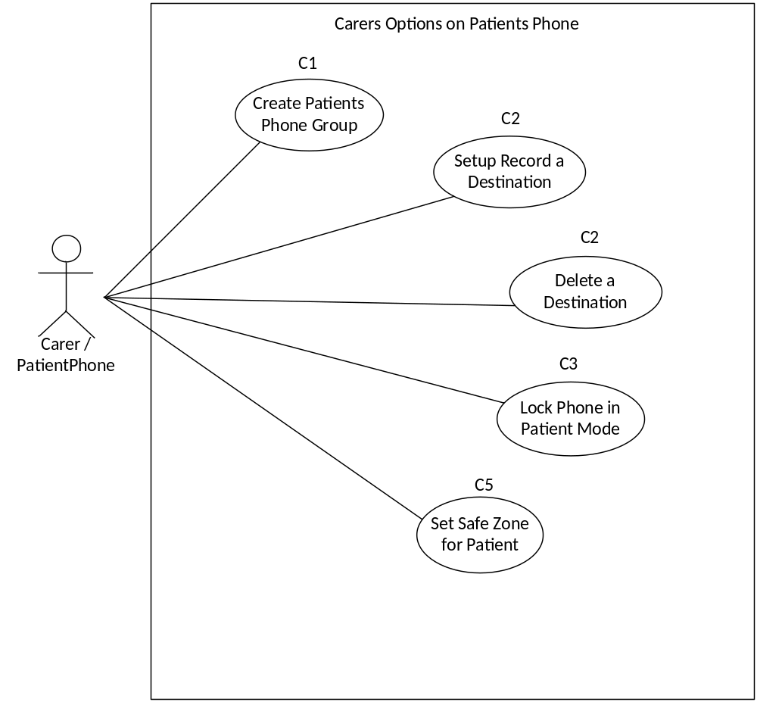

Carer Options for Carer Phone Use Case

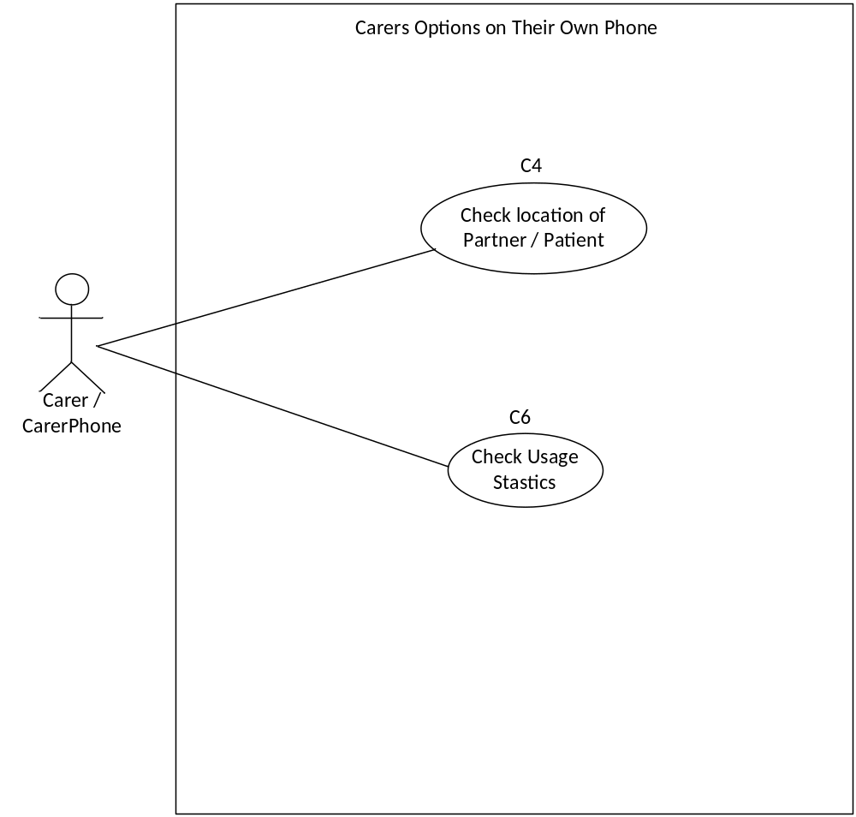

Patient Options for Patient Phone Use Case

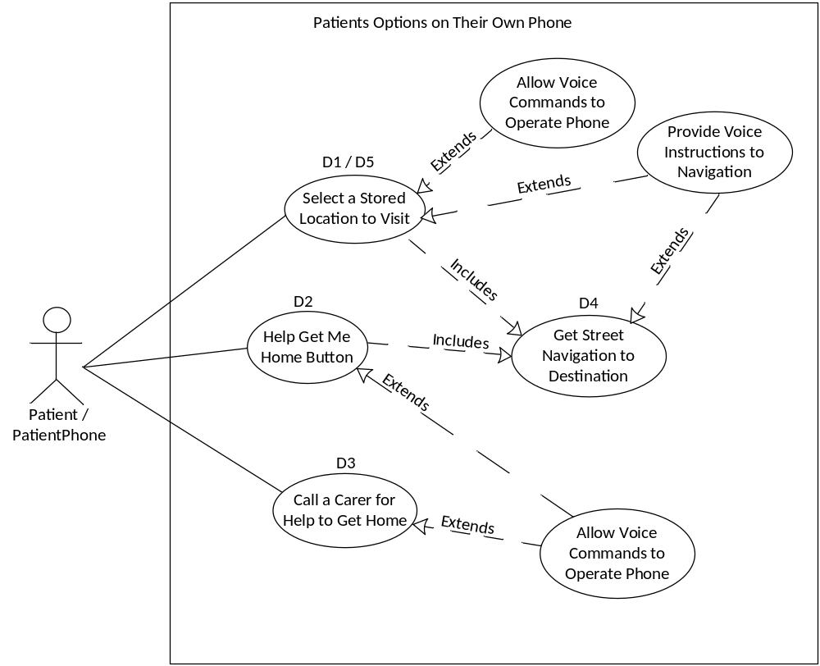

Design – Navigational Maps

Dementia Sufferer’s GetMeHome
Mobile Phone Application

SNaPP Group Project

Patient Phone – Diagram 1

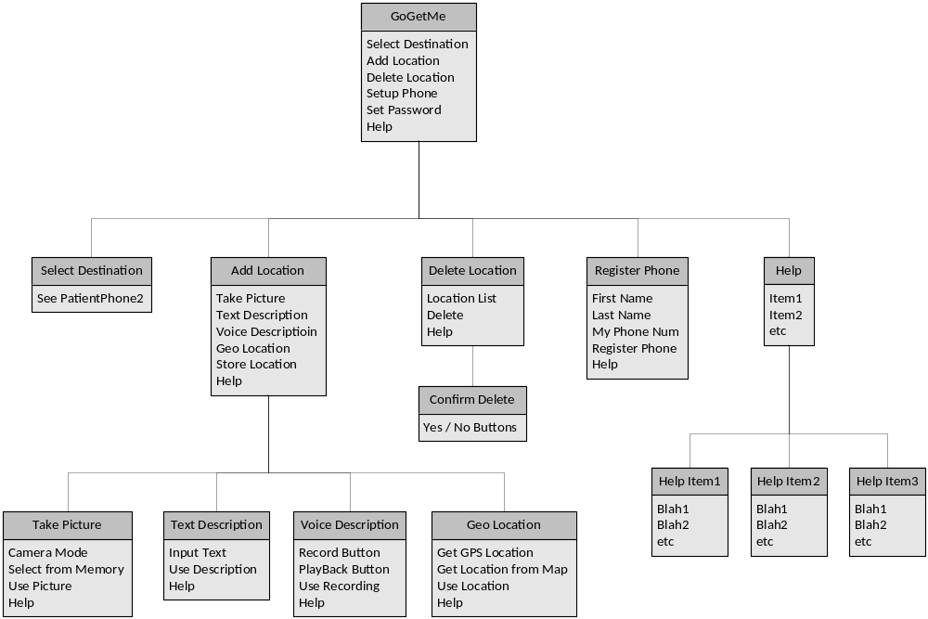

Diagram Missing from Submission

Patient Phone – Diagram 2

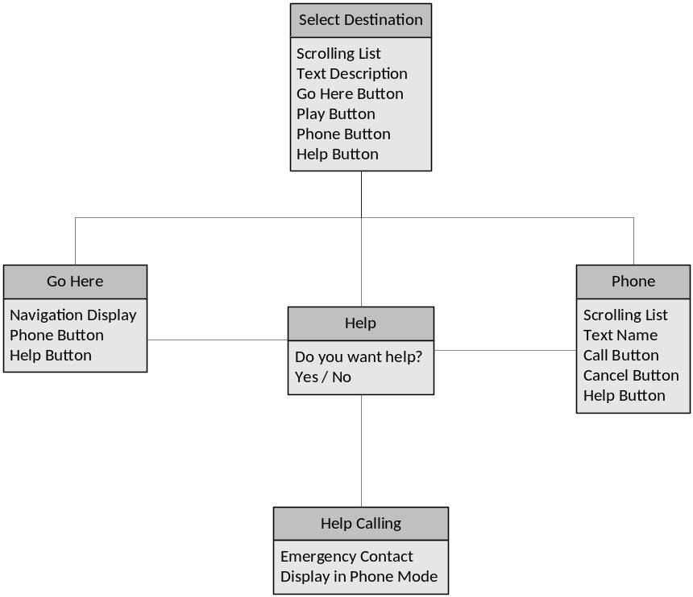

Diagram Missing from Submission

Carer Phone – Diagram 1

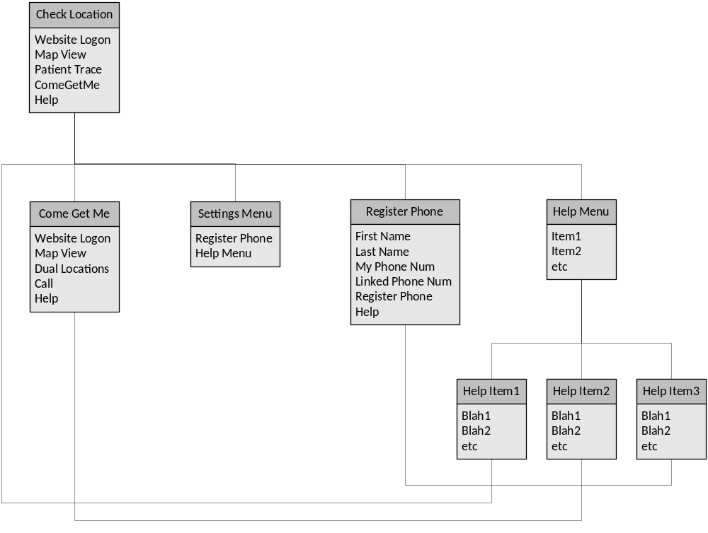

Design - Database Diagram

Dementia Sufferer’s GetMeHome
Mobile Phone Application

SNaPP Group Project
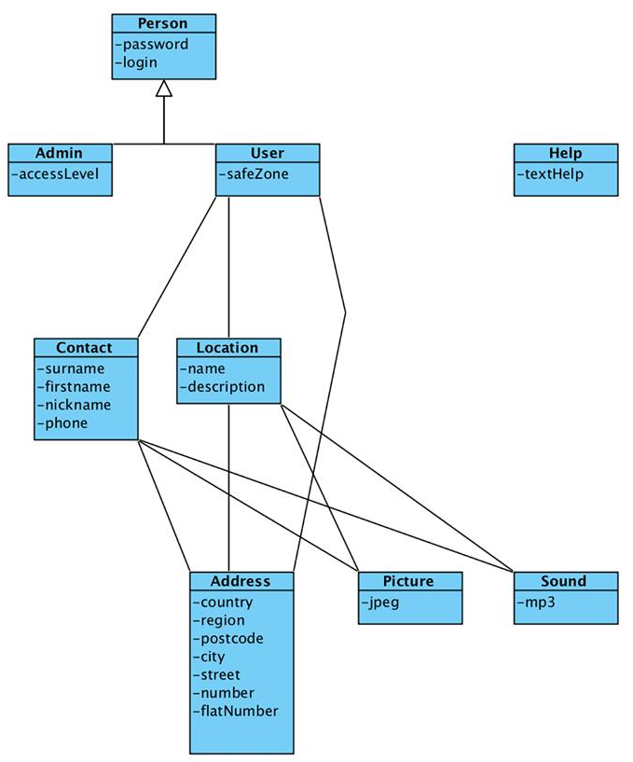

Diagram Missing from Submission

Report on Project Outcome

Dementia Sufferer’s GetMeHome
Mobile Phone Application

SNaPP Group Project

Initial Development and Design

The design and development were appearing to be progressing reasonably well however we were making many assumptions about our ability to implement the required functionality into the product. It was identified to the group that we were taking too long in this phase, as this was to be developed using a RAID framework we should be coding and adjust as we go.

Design, Implementation and Testing

The development then moved on to adjusting the requirements as it was evident there would not be enough time to implement the requirements in the available time. Some of the tools and functionality we required to implement in the application had not been provided in our course work at that time, again we made assumptions which some would catch us out.

Individual Input

Greg Stewart
was instrumental in providing the following;

- Initial implementation of app screen design, Add location, delete location, Select Location, and helped with map layout design
- Implemented code for all the screens above to do their specific jobs
- Created the Location model so that user can add locations and all the locations added are in the same place
- Added polylines to patient map so patient can see line from current position to the destination they selected
- Helped link up carer side to patient side so carer can track patients location

How it works;
- Each screen has their own design, built with an xml layout file to display the various widgets on the screen, map layout has a MapFragment to aid displaying the map view to the screen
- Add Location: Displays a screen for the user to input data about a location, they then take a picture of the location and put that in with it, when user presses add location button the location is saved to the location list
- Delete Location: Displays all current locations stored in the location list and allows the user to select one from a pop up menu then press delete to delete the location
- Select Location: A picture of the location is shown and allows user to flick through all the locations they have, when they have found the one they want, they press the go button which takes them to the map screen with a marker for the destination they picked and a route shown on map from their location
- Map Layout : Displays a map fragment for the user with markers set up to the location they have selected.
- Location Model stores locations into a list that is added to and removed from as the user does so
- Polylines: polylines draw a line from patient to their destination, the mode is set to walking so that the line will take routes such as footpaths and cycle paths to get to its destination where possible.

Possible Improvements;
- Make add location automatic fill in, eg when they start typing address, comes up with suggested addresses
- Polylines get shorter as the patient gets closer to their destination

Current Work Issues;
- The maps won’t work until location has been added
- Polylines don’t work until good enough connection, eg in Uni building don’t work because of the uni building roof block signal

Gaël Fontenelle
was instrumental in providing the following;

- Web services php and java Database Connection on phone
- Linking up the Registration Screen

How it works;
- I create a DatabaseConnection Class, this class receive argument like user ID and catch JSONObject containing the data of the database. I create thread for each different queries and I use a handler to send a message containing the data to the running activity.
- I create the registration screen. You can choose to register as a patient or as a carer by clicking on a check box. If you want to register as a carer you need to fill an additional field with the phone number of the phone you want to follow. This field only appear if you click on the check box to register as a carer. If not the field is invisible.
  - Thread Send Location
Send the user ID, the latitude and the longitude to the database to update the position of the patient when he click on the GoGetMe button.
  - Thread RegisterNewUser
Send the user first name, last name, phone number and the phone IMEI to the database. Add the new user into the database.
  - Thread Connection
Send the phone IMEI and catch the user ID of the user if the user exists.
  - Thread Register Carer
Send the user first name, last name, phone number, the linked phone number (the phone number of the phone the carer want to follow) and the phone IMEI to the database. Add the new user into the database.
  - Thread Location Carer
Send the user ID of the carer and catch the position of the followed phone.

Possible Improvements;
- We can use the database to store more information than user and location information. And synchronize more important information between the carer and the patient.

Neil Paton
was instrumental in providing the following;

- Image gallery activity. Building up the design layouts. The code which allows for image’s to be saved to the SD.
- Map activity. Building up the framework to allow the map to be rendered. Allow for current location to be displayed and updated. The layout mark for the current location.

How it works;
- Image gallery is part of the take picture activity from the add location screen. Here a gallery screen awaits the new images, which will be taken from the camera. With-in the select location screen. These images will be from gallery to use with picking a location to go to.
- The map view will be displayed to a map activity once a location is selected from the select location screen. The screen with display the mark for the user, and their current location. There will also be other mark, which is the location chosen from the select location. The map view will display the polyline between these two points, and will be updated, so the user’s current location follows this line.

Possible Improvements;
- Give the user a choice of location to save images to. This can be other folder on their SD card. A choice to pull image’s from the web. This can save back into the folder of their choice. This will in turn show in the applications gallery.
- The map view currently doesn’t have any buttons that could allow for different pre-set views, such as close up, or from max view. These can be done by pressing customised buttons, to allow for zoom functions.

Current Work Issues;
- The application will not work, unless the select folder is inside the SD card. The path must match. There is no current function to allow for this. This is specified with in the code only. This will addressed with-in code, so that it will create a default folder for them.
- The map view doesn’t have user choice, such as Wi-Fi over data. The GPS limited to outside, indoors will cause any issue. This will need loss of connection message, to will the user that it has occurred.

Samuel Okide
was instrumental in providing the following;

- The help page. Individual help page to every screen, with information on how the user can navigate the application and what they are to do on every page/screen they are currently on.
- The user guide and reference manual. This is a simple guide to enable the user use the mobile application efficiently. Mainly describing steps on how to use the Application. This includes the application description, general installation and steps on how to navigate through the application.

How it works;
- The help button is present on every page/screen of the application. When clicked it takes the user to another page with basic help tips on how the page works. This help activity is stored in a simple text document. This doesn’t go into much detail as there will be a contact us link, to help users with more complicated issues considering this is a health related application.
- Every application hardware or software requires a User guide to help first time users on how the application works. The user guide is simple with pictures to aid users fully understand the workings of the application.

Possible Improvements;
- A help screen that will be more dynamic with a link on every help page that takes the user to a more detailed help page. Since is it a medically inclined app, more research will have to be done to give the user health tips on the detailed page, but this page should still maintain a simple layout so as to not confuse the user. Taking into account that the user of the application are patients with early stages of dementia, too much clumsy information will tend to confuse them and this might be counterproductive.
- The user guide could be given a better layout in the future with more signs like arrows showing the user the paths they need to take to use various aspects of the application.

Current Work Issues;
- The help screens seem to be working fine as each screen has a help screen to assist users understand the workings of every page. The help screen is laid out with a simple layout and it gives the user enough information on how to operate the screen.

Martin Naismith
was instrumental in providing the following;

- Providing the carer side of the application and trying to assist others in the project where things needed additional manpower to progress the development.
- Providing the framework for the options menu and the help system on the phone.
- Creating the registration screen of the carer to register a linked phone.
- Monitoring the ongoing progress of the project.

How it works;
- The carer application is to monitor the location of a patient in their care, the phone of the patent needs to be registered first before the carer phone can be registered to allow access the patient positional data. In the map of the carer phone, a trace of the patients recent movements are displayed as the stored locations are accessed from the website. The carer can move to a new map which shows the last known location and their own location on the map overlay, allowing the carer to navigate to the patient. There is also a call button on this screen which calls the patients phone.
- The options menu is a standard framework for selecting registration screen and the Help Menu. There registration screen was linked to Gael’s database by Gael. The help menu is linked to raw text files which are read in by the text file, stream reader functions of java.

Possible Improvements;
- As the product development was eventually a bit of a rush, there are a number of issues that a prototype product typically has in evidence, specifically the navigation and general look and feel.

Current Work Issues;
- The system is incomplete so work around issues are numerous.

John Joseph Pikadili
was instrumental in providing the following;

- A voice recorder eclipse model was sent at an early stage in the development.

How it works;
- Using the media api from android.

Current Work Issues;
- The recorder is not implemented in the current version of the application.

Project Progress

The overall progress was poor as we did not monitor our time well the group had intended to use a scrum for the three main jobs but this never came into practice as time constraints did not permit this. It was difficult to progress with the limited knowledge we had continually trying to find remedies to problems. Android and eclipse throw up special problems of their own that you only find out about after much frustration.

Group Product Results

Finished Product

The application that has been completed now has a basic framework to meet the requirements of the user. The user can now access the app, once registered. Once registered, they will have the GoGetMe application’s features of Add Location, Delete Location, Select Location, Register and Help Menu.

The application will allow a user to add a location, and have it saved to the device, where it will be displayed on the select location activity. The user can choose where they wish to go, by selecting the image location. The user can then see where there desired location is, by viewing it on the displayed map.

The device will be tracked, once the register details of that device are uploaded to the database. The database will refresh the coordinates of the user as they move.

Personal Satisfaction

They group dynamics where not on the right page, in terms of communication. This lead to large delays, along with set back’s. The development of the application meeting its deadlines where not achieved. The application was set back six weeks. As are result of this issue, the group had to work right up in till the last day, to finish the development documentation.

Improvements

The planning document should be followed, if the group is to follow tight deadlines. The Communication aspect with individual contributions must be communicated better, to ensure no days are wasted.

Final Recommendations

The system is not easily navigated at present as the button names and the overall look and feel are not as we would expect for a professionally produced product. The group had no opportunity to develop the skills required to build this product as we were learning the required skills on the go. The learning of new tools only caught up with us towards the end of the term when we received the course work.

Appendix 1 – Diary Notes

Dementia Sufferer’s GetMeHome
Mobile Phone Application

SNaPP Group Project
Diary Notes

Date | Remarks | Present
Week 1  w/c - 20th Jan | Revised and compiled non-functional requirements.  Reviewed and discussed the functional requirements to take project to completion. | GF, MN, SO, NP, GS
Week 2  w/c - 27th Jan | Compiled finalised Functional and Non-functional Requirements.  Passed by email to client for approval.  Discussed layouts, GUI and planned code, sharing, GitHub.  Ideas – Risk, Data consumption WiFi & GPS connections, Ways to improve apps, WiFi and data issues.  Review interaction and start UML models. | GF, MN, NP
Week 3  w/c - 03rd Feb | Compile Discussion Notes for Group Meeting.  Navigation Maps Designed - Discussed & Finalised.  Discuss screen designs, layout issues & security issues, phone state.  Draw up standards for GUI Designs  Start data dictionary document  Currently about 2 weeks behind schedule. | GF, MN, NP, GS
Week 4  w/c - 10th Feb | GF to work on database and initial phone connection.  GS adding and deleting locations.  NP adding/saving gallery images from camera or SD card.  SO to develop help framework with MN.  MN on mapview and revising the patient and carer functional requirements after discussion with client. | GF, MN, SO, JP, NP, GS
Week 5  w/c - 17th Feb | Early piecing of frameworks and initial testing.  Issue with JP asking for job, asked to provide a voice recorder.  Remove security locking from patients phone app.  Gael to finish connection NP & GF review. | GF, MN, JP, NP
Week 6  w/c - 24th Feb | Discuss scrum current position, ToDo planner, requirements for group documentation. Build API GoGetMe (patient). | MN, SO, NP
Week 7  w/c - 03rd Mar | Continue development of apps.  ? ? ? | GF, MN, SO, JP, NP, GS ?
Week 8  w/c - 10th Mar | Combine development by Neil and Greg on GoGetMe.  Compared development by Gael and Martin on ComeGetMe, Martin combined files and sent to Gael for help on bug fixing. Sammy to start help item planning. | GF, MN, SO, NP, GS
Week 9  w/c - 17th Mar | Currently about 6 weeks behind schedule. Continue combining files and removing bugs. | GF, MN, SO, NP, GS
Week 10  w/c - 24th Mar | Continue combining files and removing bugs. Rewrite the ComeGetMe app. Start help items planning. | GF, MN, SO, NP, GS
Week 11  w/c - 31st Mar | Redo database connections still trying to get combined job files to work. | GF, MN, SO, NP, GS
Diary Notes - Continued

Date | Remarks | Present
Week 12  w/c - 07th Apr | Revision Week
Week 13  w/c - 14th Apr | Revision Week / Exam Week
Week 14  w/c - 21st Apr | Revision Week / Exam Week
Week 15  w/c - 28th Apr | Start developing the mapping, UI etc. | GF, SO, NP, GS
Week 16  w/c - 05th May | Continue development of apps specifically the maps UI | GF, MN, SO, NP, GS
Week 17  w/c - 12th May | Concentrate on other course work submissions
Week 18  w/c - 19th May | Continue Development and Documentation of application, consider combining both apps into one. Submission of Documentation | GF, MN, SO, NP, GS

Appendix 2 – GUI Standards

Dementia Sufferer’s GetMeHome
Mobile Phone Application

SNaPP Group Project
GoGetMe / ComeGetMe - GUI Standards

Android Scheme - Holo Dark => Higher Contrast

Functional Display Actions

- Hold the display of the phone in portrait mode for all patient user functions.
- No action bar to be displayed on patient user screens.
- Lock-out pull down menu on patient screens.
- Touch actions to be acted on registering multiple types of touch gesturing for the same select function. i.e. touch / long press / doubletouch.
- Touch Feedback – a visual indication is required from buttons or swipes.

Minimum Button Size – 48x48dp
Minimum Spacing between items and edges – 8dp

Target API’s
API numbers 10 – 18 cover 90% of devices.
i.e. from 2.33 Gingerbread to 4.3 Jellybean.

Screen sizes Normal covers 78% of devices,
small and large add another 16% of devices.
MDPI – XXHDPI cover 91% of devices
MDPI alone is 23% of devices.

Display Sizes to be targeted

Screen Size | MDPI | HDPI | XHDPI | XXHDPI
Resolution | 160DPI | 240DPI | 320DPI | 480DPI
Launcher Icon | 48x48px | 72x72px | 96x96px | 144x144px

Text style and sizes to be used
Large – Roboto Bold @ 24sp
Medium – Roboto medium @ 18sp

Colours to be used
Android reds, yellows and greens for the buttons i.e. the traffic light colours.

Function | Colour Code for | Colour Code for | Colour Code for | Colour Code for

Help Plan
??

Appendix 3 – Supporting Customer
Documentation
&
Quick Start Guide

Dementia Sufferer’s GetMeHome
Mobile Phone Application

SNaPP Group Project

App Introduction

This section discusses the application specifics and what is required to run a fully functional app on a mobile phone without hitches. This app is not designed to solve problems as regard dementia but will serve solely as assistance to patients suffering from the early stages of dementia. The application is made up of a simple interface to enable easy navigation and accessibility as the proposed user is expected to have a certain degree of memory loss and a complex interface only defeats the aim of designing a fully functional app for the patients

App requirements
- An Android Mobile phone
It is recommended that a mobile phone with an android OS of 4.2 or above is available for the use of this App. The mobile phone should also have a working camera so as to enable the users take pictures of place or events and store them on the phone storage system, to be recalled when they need to access information regarding those places or events.
- Internet connection
A steady internet connection 3G or 4G should also be enabled on the phone to give access to online tools such as google maps for the user to be able to find their way round the setup parameters initially.
- GPS Enabled
The mobile device should be GPS enabled to allow access to tools such as google map for the user to access location details.
- SD card
An SD card is needed for storage purposes. Because the application might be needed on another phone, it is best to store the application on an SD card as this makes it easy to transfer to another device and it deals with the potential issue of low phone internal memory

App Structure Image Layout

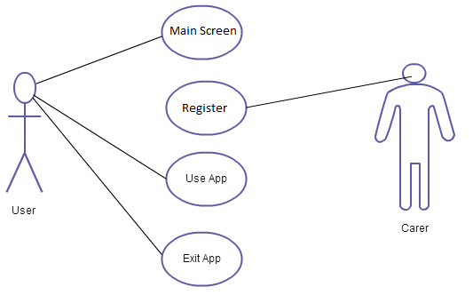

User Case Diagram illustrating the User and Carers role

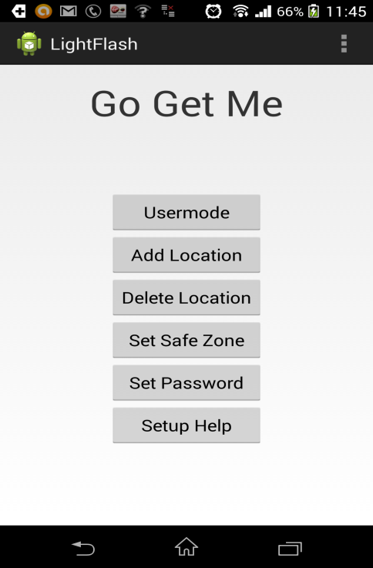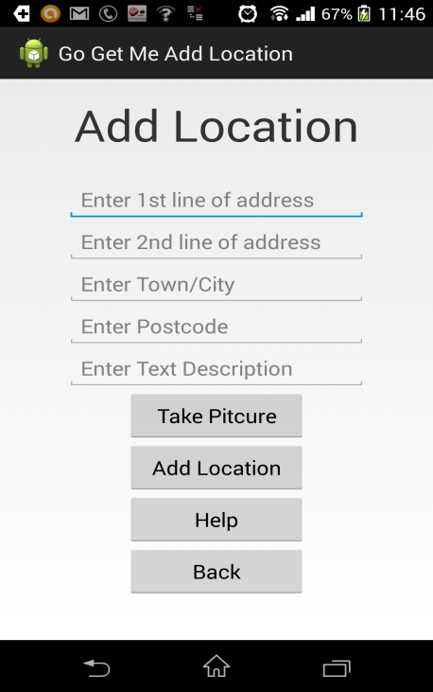

Main Screen Add Location Screen

Select Location Delete Location

Map/directions Screen

General Installation

To install, run and access the GoGetMe mobile application executable;

- GoGetMe mobile application is to be installed manually at this stage because it is still a development application
- To install a non-Market application (development version), in most cases an .apk file. You need a tool to browse the SD card, and pick the .apk file. This tool is called the APK installer.
- First download the APK installer from the Google play store
- Have a specific file format for Android smartphones that is used to install application on it and it is called an APK file (because it has the extension of .apk)
- First download the .apk file unto your mobile device, more preferably in a directory on your SD card
- Copy the executable file into your desired location. Preferably an SD card so it can be accessed on different mobile devices
- Click on the APK installer and scroll to the directory
- Open up the directory and click on the .apk file to install the application on your mobile device

Quick Start Guide GoGetMe

This is a quick start guide for GoGetMe Android mobile application is to allow the user to navigate through the application quickly. The app is designed to help patients with memory issues move from place to place within a given neighbourhood more easily. The app is to help patients solve basic needs, such seeing an image, and remembering what it is.. The app is not supposed to be a corrective measure, such as training the mind. The app is just a user friendly assisted app with features that stores location and events to help patients move on their own more independently. The app also has an added safety measure of tracking their location. The app consists of the user and carer versions. Both apps connected to a database where all information will be stored. The carer can use the site to track the user’s location, as this will store the user’s data as-well. GoGetMe will be designed with simple mobile interface templates such as simple list of large buttons, and large text on them. The use of images will be presented to help pick locations.
The first step to take will be to install the application on a mobile phone, more preferably the Android 4.2 or higher. The following steps are designed to guide users through the use of the application from the start up page all through the app.

Step 1 Register

Click on the Register button which is the second button on the list of buttons and execute the following.
Main Menu: Register Button
Click on the app icon and open the start screen of the application>> this leads to a list of button menus namely; Select Location, Add location, Delete location, Settings and Help.

Recommended start:
- Register button
- Fill in details
- Click on carer icon, if you wish to register phone as carer details, or leave un-checked if you are registering as user.
- Add Location
- Select Location
The section for registering is to help with tracking. As the users phone IMEI number will be stored. The IMEI will help Google maps locate the user’s device and track it, so the carer can see it in the map.

Step 2 Add Location

Click on the Add location button which is the second button on the list of buttons and execute the following.

Main Menu: Add Location Button

This is the screen in the application where users are required to add details of the current location they wish to store in the phone’s select location screen. There are four dialog boxes in which the user adds a new location in a form. Once done filling in the form, click the take picture button. The take picture button will allow for an image of the current location to be store, you can pick your new image you have taken from the camera in the gallery. Once selected your image, press load. You will be taken back to the form page, once happy with details press load again. Ensure the location has a title, supplied at bottom of form. This is then stored in on the SD card and can be recalled when the user needs to access the location, by using the select location activity.

Step 3 Select Location

Click on the Select Location button which is the first button on the list of buttons and execute the following.

Main Menu: Select Location Button

This screen in the application is where the user will be able to select any saved locations. The user will be presented with the images of different locations, in the style of a flick through menu. Press next or prev to scroll the different locations. The locations will be in the form of the locations image, and title. The user must scroll to pick their required location, and then press go at the top right corner. Once the user presses go button, they will be presented with a map view. The map view will display their current location mark, along with the destination mark. The two marks will have a red polyline, showing the user where to go.

Step 4 Delete Location

Click on the “Delete Location” button from the lists of buttons and execute the following action

Main Menu: Delete Location Button

The delete location button takes the user to another screen where they are presented with a dropdown dialog box. Press the dialog box to pull down all locations that are currently saved on the phone. Select by touching the location name, from the pull down menu. This will present it, along with a delete button. If you are happy with the selected location, press delete. The location will be removed the SD card, and no longer available on the app’s select location activity.

Step 5 Help Menu

Click on the app icon and open the start screen of the application>> this leads to a list of button menus namely; User mode, Add location, Delete location and Setup help. Click on the Setup Help button and execute the following.

Main Menu: Help Button

This screen is essential at every stage of the application. On every screen throughout the application there is a help button which when clicked gives the user some basic information about the app and specifically the screen they are currently on. This basis help information contains a link to a more detailed screen with a full description on the page and how to get access and use tools available on the screen.

Appendix 4 – Testing

Dementia Sufferer’s GetMeHome
Mobile Phone Application

SNaPP Group Project

Main Navigation Buttons Test

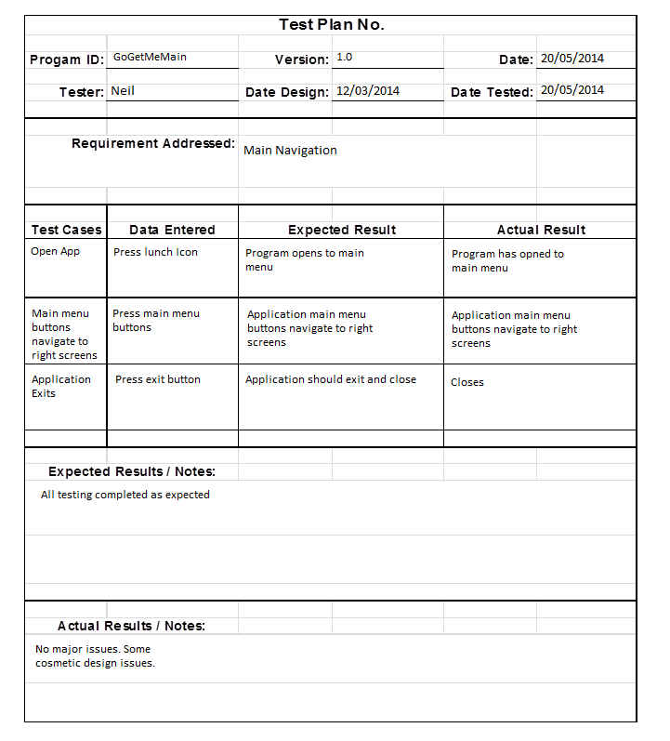

Add Location Test

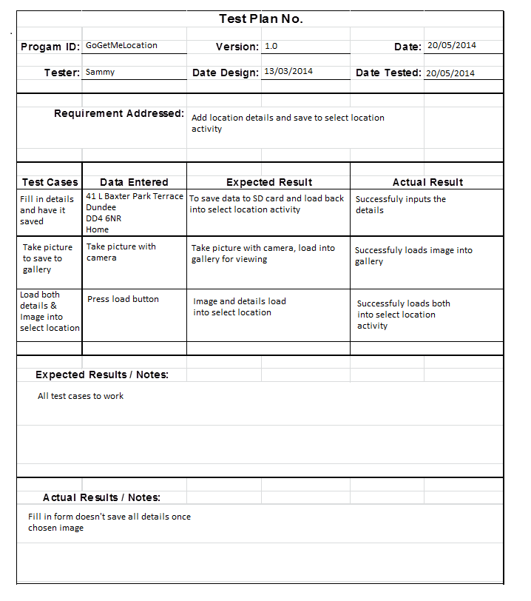

Select Location Test

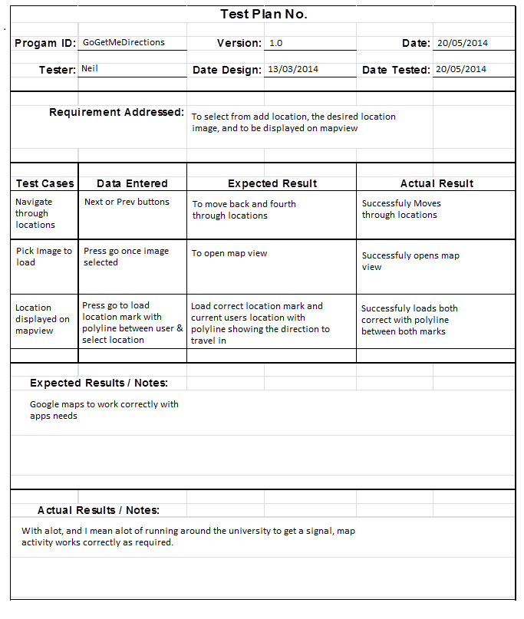

Register User Test

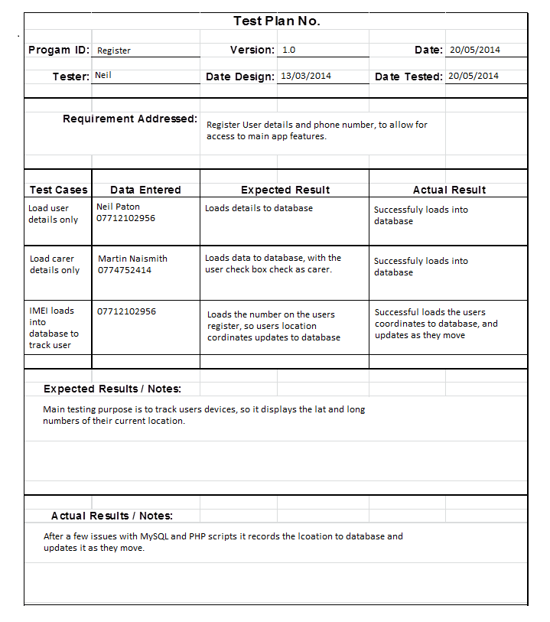

Index/ References

Guiding tech. [online]. Available from http://www.guidingtech.com/10352/what-are-android-apk-files-how-to-install-them/ [Accessed 19th May, 2014]
APK installer. [Online] Available from https://play.google.com/store/apps/details?id=com.graphilos.apkinst [Accessed 26th April, 2014]

