

NN for AI
By Ghulam Sarwar

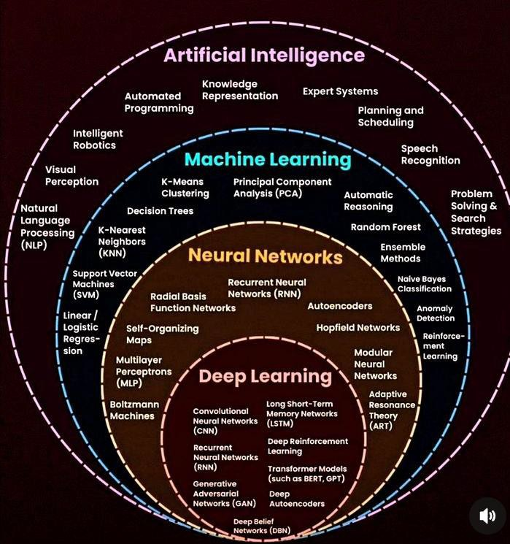

Deep Learning

- Before we launch straight into neural networks, we need to understand the individual components first, such as a single “neuron”.

Deep Learning

- Artificial Neural Networks (ANN) actually have a basis in biology!
- Let’s see how we can attempt to mimic
biological neurons with an artificial neuron, known as a perceptron!


- The biological neuron:

Dendrites
Body
Axon

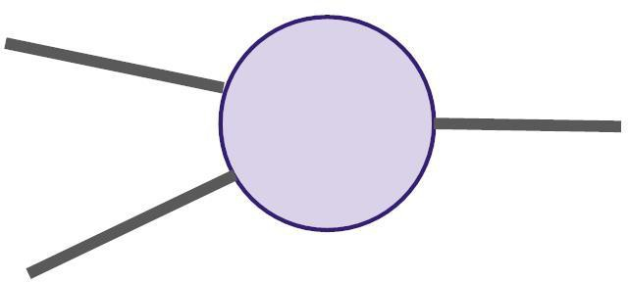

- The artificial neuron also has inputs and
outputs!
Input 0

Output

- This simple model is known as a
perceptron.
Input 0

Output

- Simple example of how it can work.

Input 0

Output

- We have two inputs and an output

Input 0

Output

- Inputs will be values of features

12
Input 0

Output

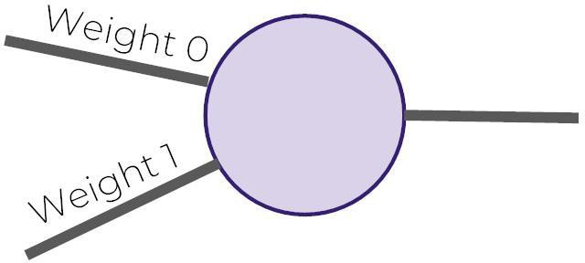

- Inputs are multiplied by a weight

12
Input 0

Output

- Weights initially start off as random

12
Input 0

Output

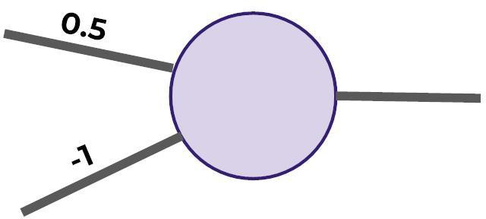

- Weights initially start off as random

12
Input 0

Output

- Inputs are now multiplied by weights

12
Input 0

Output

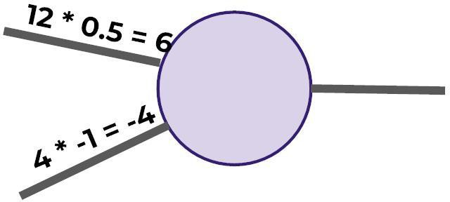

- Inputs are now multiplied by weights

Input 0

Output

Activation
Function

- Then these results are passed to an
activation function.

Input 0

Output

Activation
Function

- Many activation functions to choose
from, we’ll cover this in more detail later!

Input 0

Output

Activation
Function

- For now our activation function will be
very simple...

Input 0
Output

Activation
Function

- If sum of inputs is positive return 1, if sum
is negative output 0.

Input 0

Output

- In this case 6-4=2 so the activation
function returns 1.

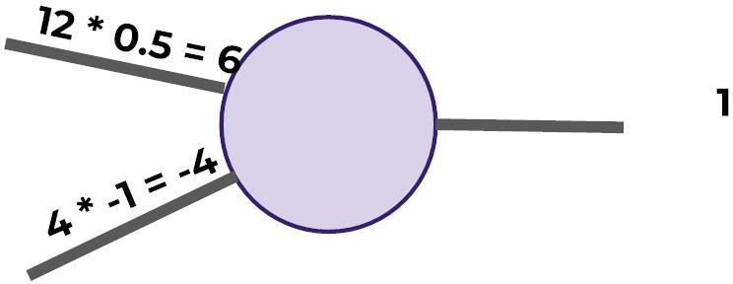
Input 0

Activation
Function Output

- There is a possible issue. What if the
original inputs started off as zero?

Input 0

Activation
Function Output

- Then any weight multiplied by the input
would still result in zero!

Input 0

Activation
Function Output

- We fix this by adding in a bias term, in
this case we choose 1.

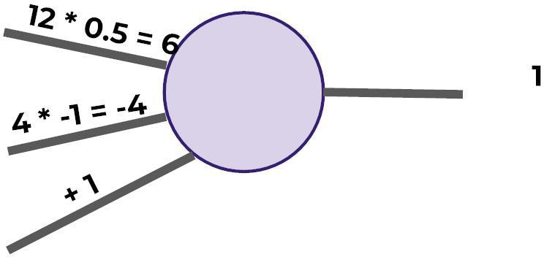
Input 0

Input 1

Activation
Function Output

- So what does this look like
mathematically?

Input 0

Input 1

Activation
Function Output

- Let’s quickly think about how we can
represent this perceptron model mathematically:

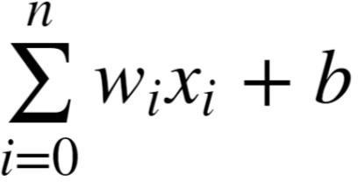

- Once we have many perceptrons in a
network we’ll see how we can easily
extend this to a matrix form!

Deep Learning

- Review
  - Biological Neuron
  - Perceptron Model
  - Mathematical Representation

Deep Learning

- We’ve seen how a single perceptron behaves, now let’s expand this concept to the idea of a neural network!
- Let’s see how to connect many perceptrons together and then how to represent this mathematically!

- Multiple Perceptrons Network
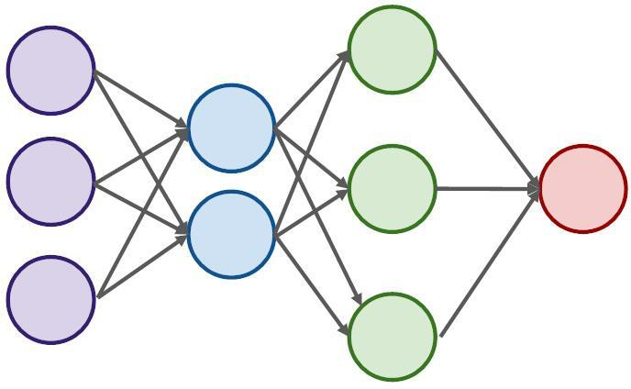

- Input Layer. 2 hidden layers. Output Layer

Deep Learning

- Input Layers
  - Real values from the data
- Hidden Layers
  - Layers in between input and output
  - 3 or more layers is “deep network”
- Output Layer
  - Final estimate of the output

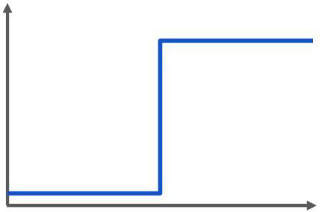

- Previously our activation function was
just a simple function that output 0 or 1.

1
Output

- This is a pretty dramatic function, since
small changes aren’t reflected.

1
Output

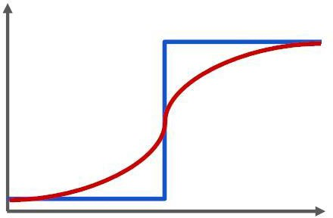

- It would be nice if we could have a more
dynamic function, for example the red line!

1
Output

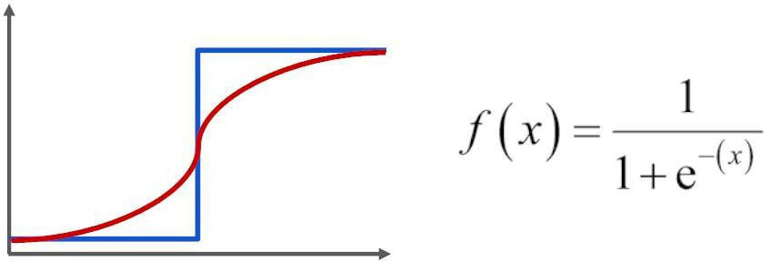

- Lucky for us, this is the sigmoid function!

1
Output

- Changing the activation function used can
be beneficial depending on the task!

1
Output

Example!!


