**DEPARTMENT OF COMPUTER ENGINEERING**

**HCE/HSE/HHE114: Database Systems**

**ASSIGNMENT 2**

1. A university is facing challenges in managing student records and course registrations. How can the University leverage database systems for student management?  **[10]**
2. In the realm of database design, how does the process of normalization contribute in minimizing redundancy and optimizing data integrity?  **[3]**
3. Draw an entity relation diagram for the below table **[10]**

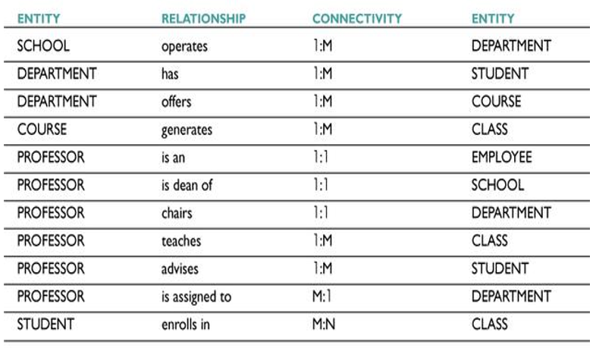

1. What is the difference between a conceptual schema and a physical schema in the context of ER modeling? **[2]**

**Due Date : 02 June 2025**