Adapted Nail Trimmer V2




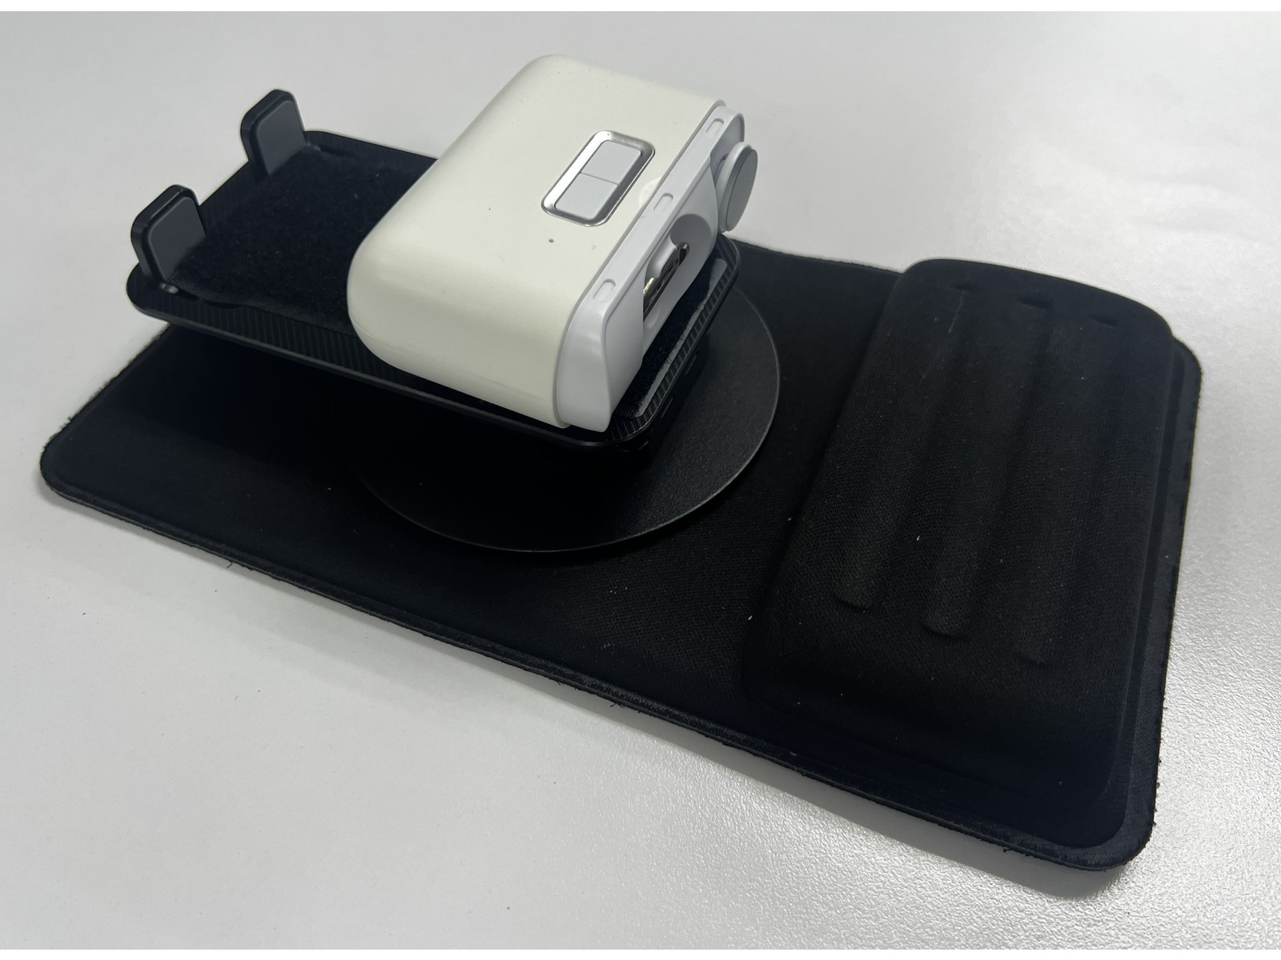

Revision: 1.0
Date: 10-Oct-2026

Table of Contents

Table of Contents 1
1. Introduction 2
1.1 About the Community Partner 2
1.2 Product Description 3
WHY? 3
WHO? 3
WHAT? 3
HOW? 3
1.3 Product Overview and Features 4
1.4 Bill of Materials (BOM) 5
2. User Guide: Instructions for Use 6
2.1 Set Up Instructions 7
2.2 Maintenance 9
2.3 Troubleshooting 10
3. Maker Guide: Assembly Instructions 11
3.1 Assembly Guide 11
4. Credit and Open Hardware License 12
4.1 License Statement and Source Availability 12
4.2 CERN Open Hardware Licence Version 2 12

1. Introduction

1.1 About the Community Partner

Founded in 2015, Stroke Support Station (S3) is Singapore's first and only community-based agency focused solely on stroke recovery and wellness.

S3 supports stroke survivors and caregivers after hospital discharge through technology-enabled and conventional therapy, wellness programmes, care and support services, and community initiatives. Its mission is to help stroke survivors Re-learn and Enjoy Active Living (R.E.A.L.), rebuilding confidence and independence. S3 also operates an Innovation Lab that works with social innovators, clinicians, and caregivers to co-create solutions that improve quality of life for stroke survivors.



1.2 Product Description

This table clarifies the intended purpose and scope of the product:

WHY? | Reduced strength, dexterity, coordination, or control in one hand can make it difficult to hold and operate a conventional nail clipper safely. The product stabilises an electric nail trimmer so it can be positioned for easier one-handed use.
WHO? | Intended for stroke survivors and other people with reduced strength, dexterity, coordination, or control in one hand who can understand and follow the operating steps. A caregiver or therapist should assess suitability and determine whether supervision or physical assistance is required. This product is for fingernail grooming only.
WHAT? | An assistive nail-grooming station made from a mouse pad, an adjustable phone stand, an electric nail clipper and velcro (hook-and-loop fasteners).
HOW? | The mouse pad provides a broad, non-slip base and a padded area for the user's wrist. The phone stand is secured to the mouse pad with velcro. The electric nail clipper is secured to the stand with velcro and positioned so its nail opening and controls are accessible. The user rests the affected hand on the pad and operates the trimmer with the other hand. Long-press the left button to switch on at normal speed, press it once for faster speed, and press it again to switch off.

1.3 Product Overview and Features

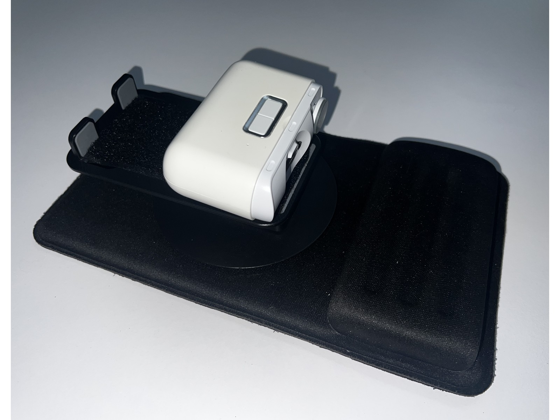
The product creates a stable, adjustable nail-trimming station that can support one-handed use. The components are joined with velcro, so they can be repositioned, separated for cleaning, or replaced.
- Non-slip mouse pad base with a padded wrist rest for comfort and stability.
- Adjustable stand helps position the trimmer at a comfortable angle.
- Compact and modular design made from readily available components.

1.4 Bill of Materials (BOM)

Item | Product Link | Supplier | Price | Quantity
Mouse pad | ELECOM MP-095BK (135 × 220 mm) | WAFUU Japan | S$12.00 | 1
Phone stand | Valore HL-002 | Challenger SG | S$14.90 | 1
Nail clipper | Xiaomi Seemagic SMPH-ZJD05C exact model | Gadget All Time  Shopee SG | S$34.24 | 1
Velcro Fasteners | Required sizes: 65 × 25 mm; 105 × 50 mm; two Ø60 mm circles  50 mm adhesive tape  60 mm adhesive circles | Hardware City  Shopee SG | From S$7.30 | As required

2. User Guide: Instructions for Use

2.1 Set Up Instructions

Set up the product on a stable, flat surface. If the user has reduced sensation, vision, cognition, or hand control, a caregiver or therapist should assess whether assistance or supervision is required.

Set-up step
1. Place the mouse pad on a clean, dry, flat surface with the padded wrist rest closest to the user. | 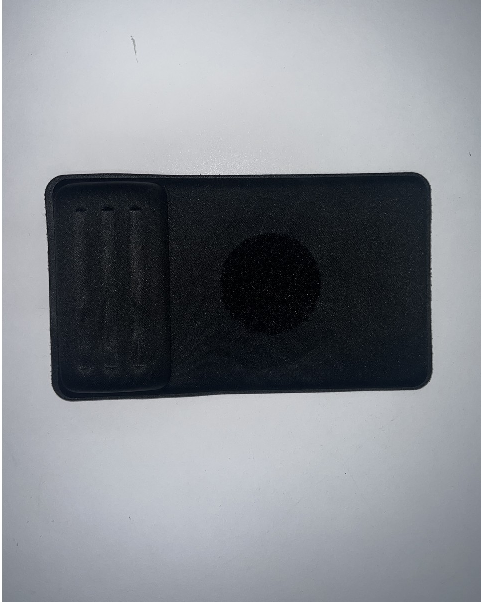
2. Centre the phone stand on the velcro patch and press it firmly onto the mouse pad. Adjust the stand to a comfortable height and angle. | 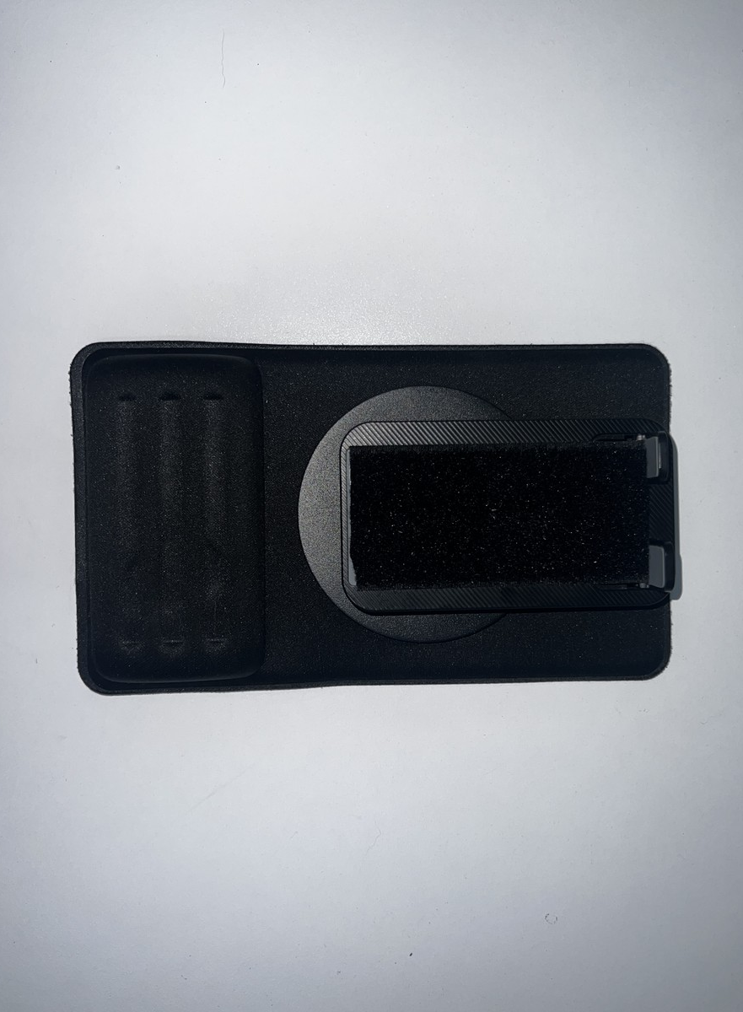
3. Centre the trimmer on the stand's velcro strip with the nail opening and controls facing the user. Press it down firmly. | 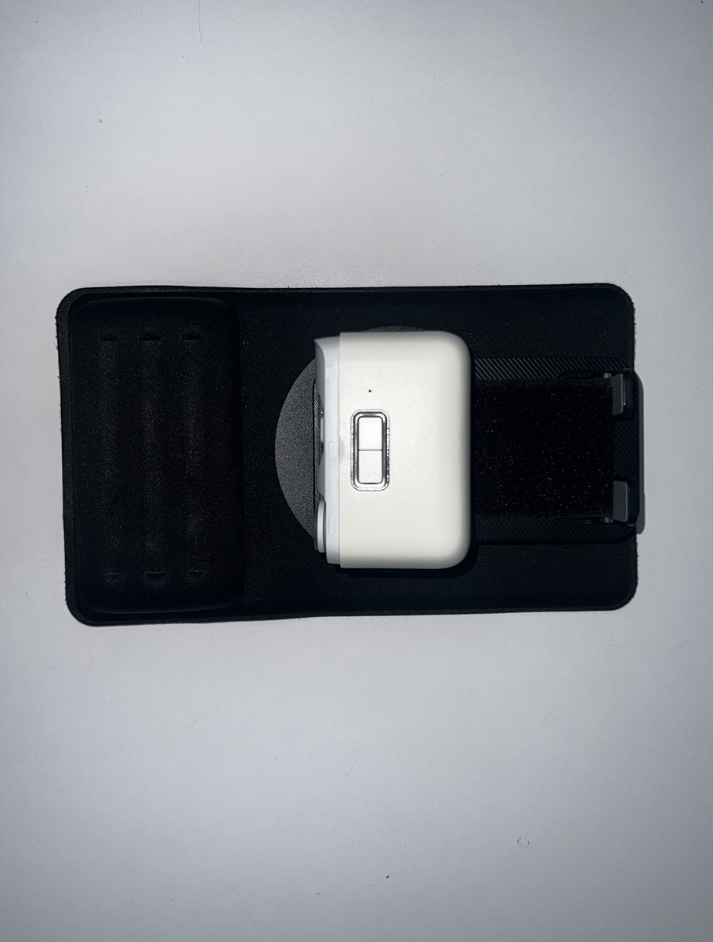
4. Gently test the assembly. The mouse pad should remain flat, the stand should hold its angle, and the trimmer should not move when lightly pressed. | 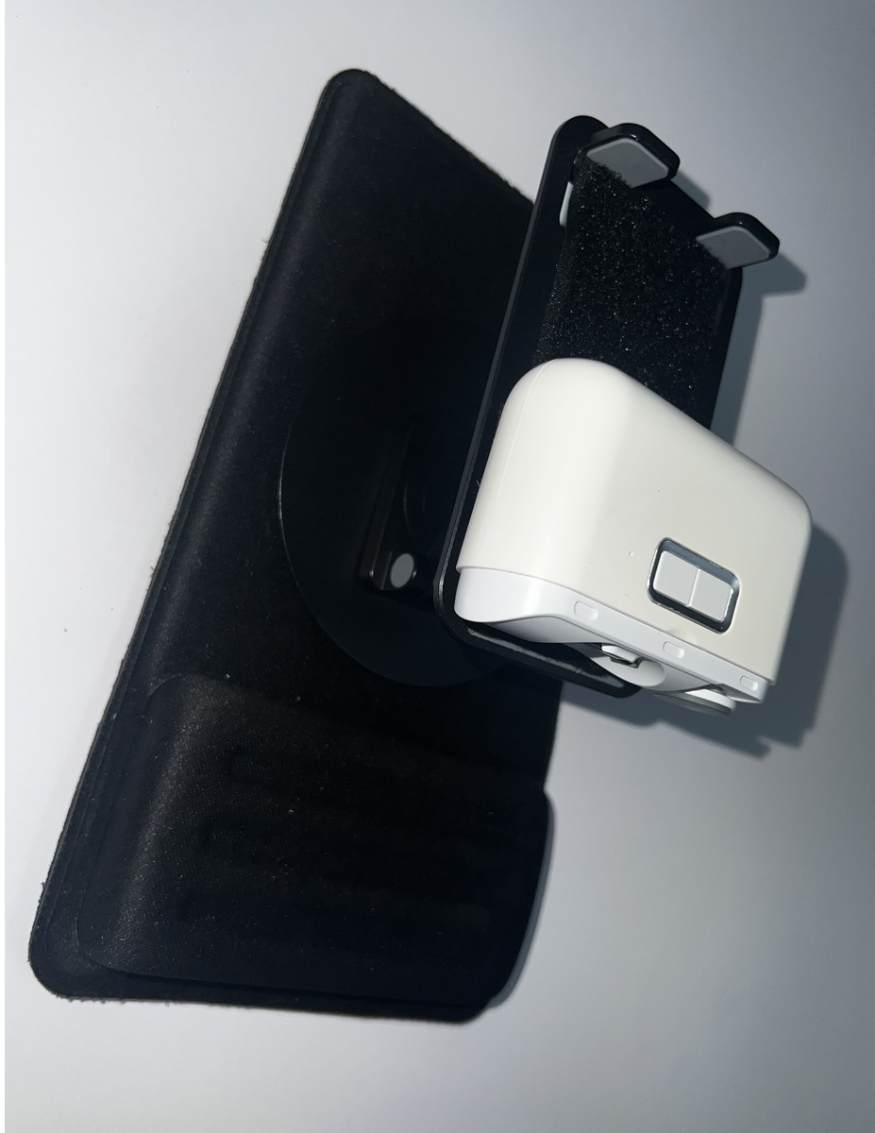
5. Ensure the electric nail clipper is charged and that the opening and cutting area are clean and undamaged.
Control sequence: long-press the left button to switch on at normal speed; press once for faster speed; press once more to switch off.
6. Rest the hand on the padded area. Start at normal speed and use the faster speed only if comfortable. Position one fingernail at a time at the opening and guide it gently with the other hand. Keep skin away from the opening and stop immediately if there is discomfort. | 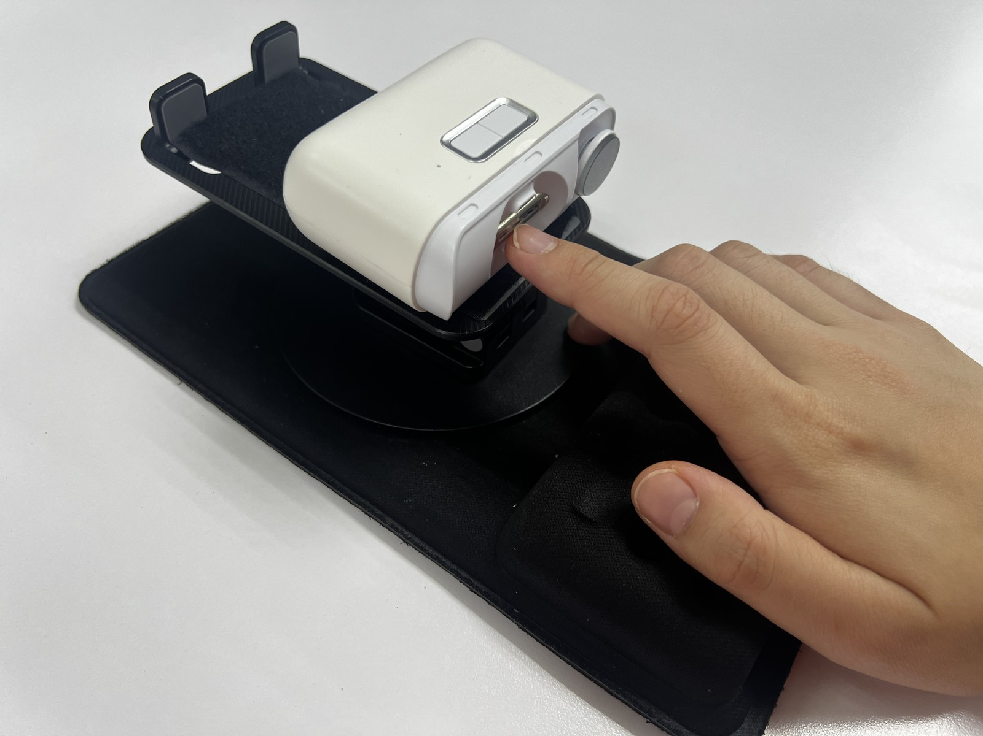
7. After use, complete the control sequence until the trimmer is off. Remove it from the stand, open the nail-debris compartment, and brush out clippings with the supplied cleaning brush. Close the compartment and store the product in a clean, dry place. | 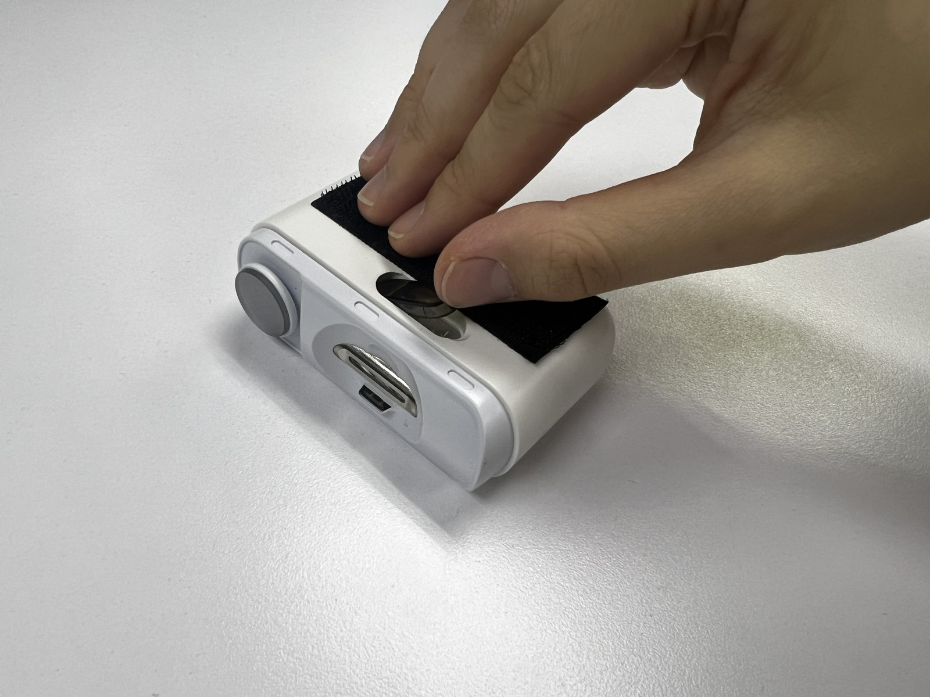

2.2 Maintenance

Inspect the product before each use. Stop using it if the trimmer, stand, mouse pad, velcro fasteners, charging cable, or adhesive is damaged or loose.
- After each use, switch off and remove the trimmer from the stand. Open the nail-debris compartment and use the supplied cleaning brush to remove clippings from the compartment and cutting area. Do not immerse or rinse the trimmer unless the manufacturer's instructions explicitly state that it is washable.
- Wipe the mouse pad, stand, and velcro fasteners with a lightly damp cloth, then allow them to dry completely before reassembly.
- Store the product in a clean, dry place. Keep it away from children when not in use and protect the trimmer from impact.

2.3 Troubleshooting

Problem | Possible Cause | What You Can Try
Trimmer shifts on the stand | Velcro strips are dirty, misaligned, or worn. | Clean and dry the velcro fasteners, align them fully, and press firmly. Replace worn velcro.
Parts detach during use | Velcro strips or adhesive are worn, dirty, or poorly aligned. | Clean and dry the surfaces, then refit or replace the velcro before use.
Base or complete assembly moves during use | The work surface is dusty, wet, uneven, or too smooth, or the velcro is loose. | Move to a clean, dry, flat surface, re-centre the stand, and press the velcro firmly together.
Stand changes angle or wobbles | The hinge is not tightened, or the stand is overloaded or damaged. | Readjust and lock the stand if applicable, and check for damage. Replace the stand if it cannot hold its position.
Trimmer does not switch on or cuts poorly | The battery is flat, nail debris is obstructing the cutting area, the cutting head is worn, or the nail is positioned incorrectly. | Clean the trimmer, recharge it with the correct charger, and follow the manufacturer's instructions. Do not dismantle the trimmer.
Unusual noise, heat, smell, pain, or bleeding | There may be a trimmer fault, obstruction, incorrect nail position, or contact with skin. | Do not continue until the cause is identified; seek appropriate assistance for any injury.

3. Maker Guide: Assembly Instructions
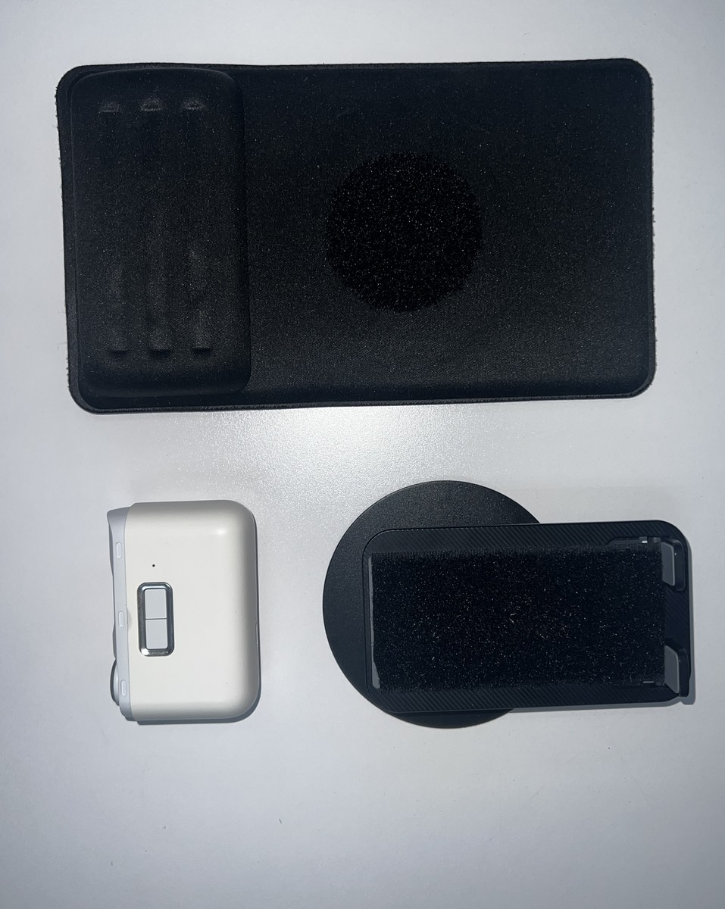

3.1 Assembly Guide

Steps | Images
1. Clean and dry all contact surfaces. Glue one Ø60 mm circular velcro piece to the underside of the phone stand and the matching Ø60 mm circle to the centre of the mouse pad. Allow the adhesive to cure according to its instructions. | 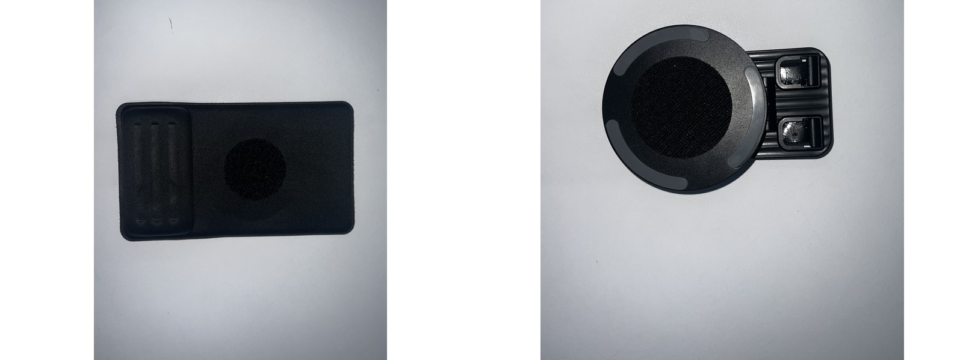
2. Glue the 105 × 50 mm velcro piece to the stand platform and the matching 65 x 25 mm piece to the underside of the electric nail clipper. Centre the pieces for firm contact, while keeping the trimmer's opening, controls, USB-C port, and vents unobstructed. | 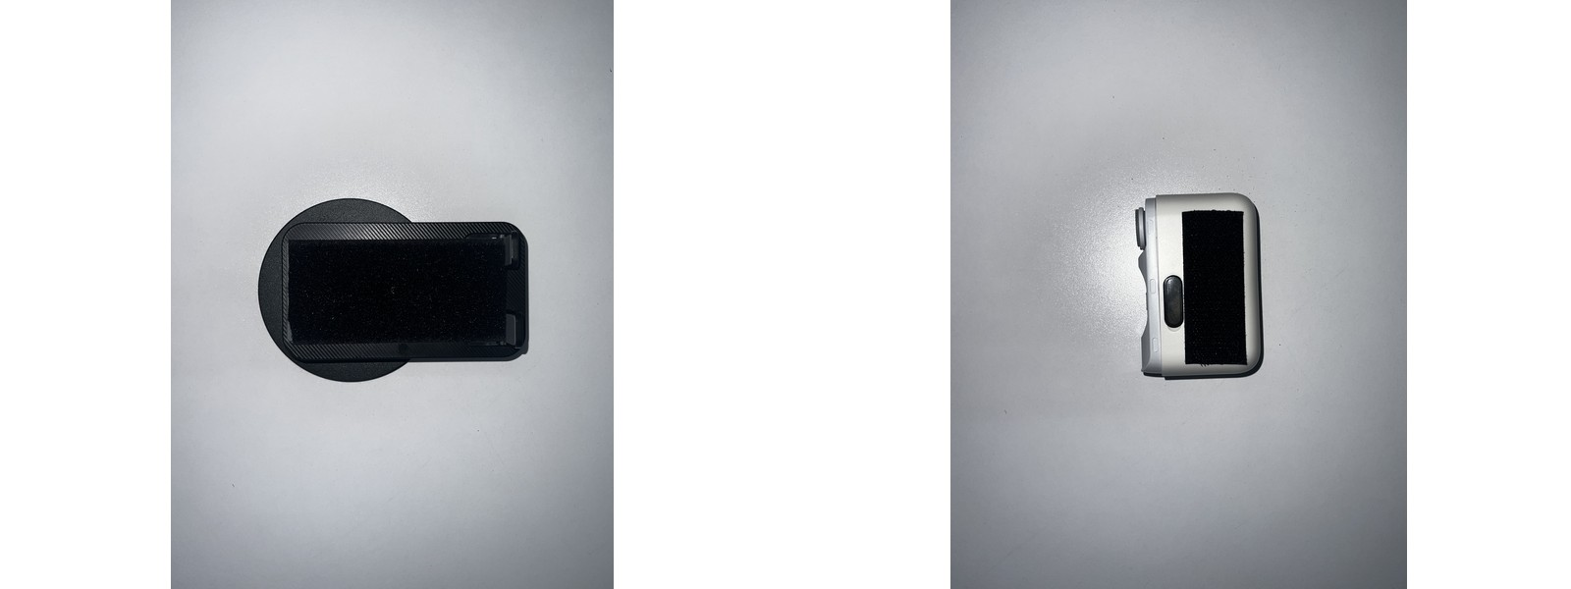
3. Press the components firmly together, orient the trimmer opening and controls toward the user, adjust the stand, and perform a stability check before use.

4. Credit and Open Hardware License
This section provides the required legal notices and attribution for the open hardware design used to create this product.

4.1 License Statement and Source Availability
The hardware design used in this product is licensed under the CERN Open Hardware Licence Version 2 – Weakly Reciprocal (CERN-OHL-W 2.0) or later.
By distributing this product, we are obligated to make the complete design source available to you.
- Complete Source Availability: The complete design files (Source), including schematics, assembly instructions, and any modifications made by Engineering Good, are available free of charge at a permanent online location: https://github.com/Engineering-Good/Adapted-Nail-Trimmer-V2
- Modification Notice: This version of the Adapted Nail Trimmer V2 design was modified by Engineering Good to include the 3.5mm mono audio jack functionality for triggering other toys. The full, modified source is available at the URL listed above.
- Full License Text: The complete legal text of the CERN Open Hardware Licence Version 2 – Weakly Reciprocal** follows this section.

4.2 CERN Open Hardware Licence Version 2

The full text of the license is available here: CERN-OHL-W 2.0 Full Text

