Product Manual Template: [PRODUCT NAME]




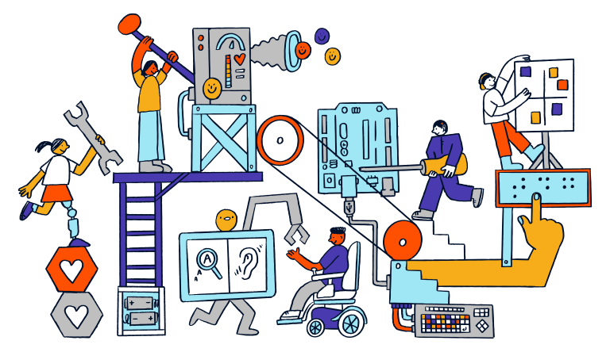

Revision: 1.0
Date: 01-Dec-2025

Table of Contents

Table of Contents 1
1. Introduction 2
1.1 About the Community Partner 2
1.2 Product Description 3
WHY? 3
WHO? 3
WHAT? 3
HOW? 3
1.3 Product Overview and Features 4
1.4 Bill of Materials (BOM) 5
2. User Guide: Instructions for Use 6
2.1 Set Up Instructions 7
2.2 Maintenance 8
2.3 Troubleshooting 9
3. Maker Guide: Assembly Instructions 10
3.1 Assembly Guide 10
4. Credit and Open Hardware Licence 11
4.1. Open Hardware Attribution (if we use MMC) 11
4.2. License Statement and Source Availability 12
4.3 CERN Open Hardware Licence Version 2 12

1. Introduction

1.1 About the Community Partner

Our journey began in 1970 with the will of Mrs Shakuntala Bhatia. Under the banner of the Asian Women’s Welfare Association, Mrs Bhatia and her peers, like Mrs Tambyah and Mrs Kula, identified gaps in the community to help the underserved.

The Association incorporated AWWA Ltd on 7 January 2015, a Singapore company limited by guarantee. In April of the same year, AWWA Ltd took over the operations and activities previously managed by the Association. In 2022, the Association was dissolved, and AWWA continues to address social service gaps as they arise, by being guided by our mission and strategic vision.

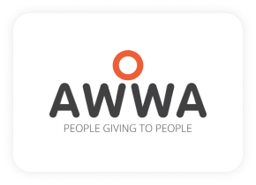

1.2 Product Description

This table clarifies the intended purpose and scope of the product:

WHY? | Special needs students are often excluded from using toys and/or face lack of appropriate ways to express themselves.
WHO? | For special needs students who are learning to understand cause-and-effect and have fun.
WHAT? | A Product and the function(E.g. Button with audio recording and playback function). Adapted with an additional 3.5mm female/male mono audio cable to trigger the power of/by other devices(E.g. Switches or Toys).
HOW? | This product transforms an off-the-shelf product name into a durable and responsive device ( E.g. function that records, plays back audio, while enabling it to trigger the power of other devices). It allows students to experience and understand the cause-and-effect.

1.3 Product Overview and Features

[image]
[Some feature and function]
- Bullet point 1
- Bullet point 2
- Bullet point 3

1.4 Bill of Materials (BOM)

Item | Supplier/Product Link | Price | Quantity

2. User Guide: Instructions for Use
Add image

2.1 Set Up Instructions

Use the following table for a step-by-step guide to setting up the product:

Setting up

2.2 Maintenance

[Insert text regarding cleaning, storage, or checking for wear and tear.]
- Bullet point 1
- Bullet point 2
- Bullet point 3

2.3 Troubleshooting

Problem | Possible Cause | What You Can Try

3. Maker Guide: Assembly Instructions
image

3.1 Assembly Guide

Steps | Images

4. Credit and Open Hardware Licence
This section provides the required legal notices and attribution for the open hardware design used to create this product.

4.1. Open Hardware Attribution (if we use MMC)
The core design for this Adapted Recorder Button is based on the Playback Switch, an open-source assistive technology project.
- Original Designer: Makers Making Change (a program of Neil Squire).
- Original Copyright: Copyright (c) Neil Squire / Makers Making Change.
- Original Source Location: The original project source files are available online at: maker making changes url

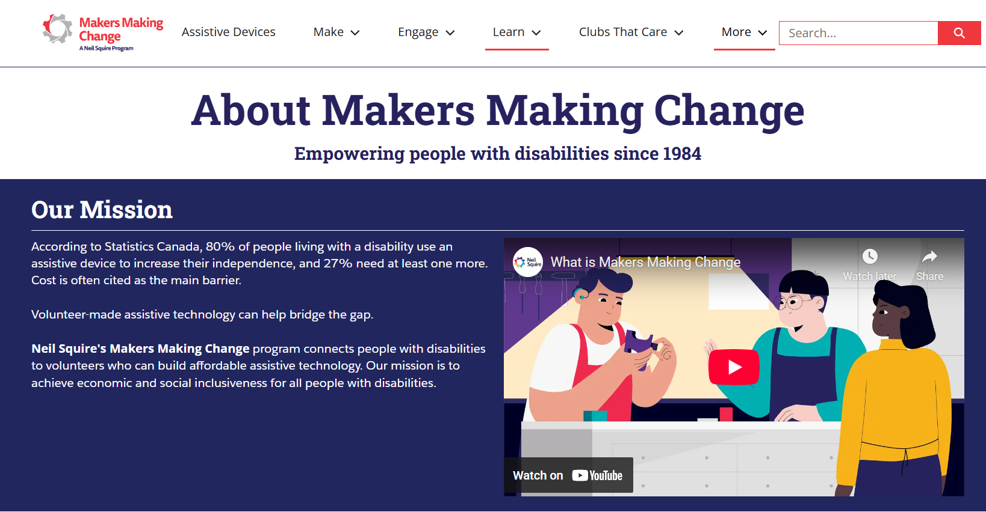

4.2. License Statement and Source Availability

The hardware design used in this product is licensed under the CERN Open Hardware Licence Version 2 – Weakly Reciprocal (CERN-OHL-W 2.0) or later.
By distributing this product, we are obligated to make the complete design source available to you.
- Complete Source Availability: The complete design files (Source), including schematics, assembly instructions, and any modifications made by Engineering Good, are available free of charge at a permanent online location: github url
- Modification Notice: This version of the product name design was modified by Engineering Good to include the 3.5mm mono audio jack functionality for triggering other toys. The full, modified source is available at the URL listed above.
- Full License Text: The complete legal text of the CERN Open Hardware Licence Version 2 – Weakly Reciprocal** follows this section.

4.3 CERN Open Hardware Licence Version 2

The full text of the license is available here: CERN-OHL-W 2.0 Full Text

