Product Manual: Adapted Projector Lamp Toy

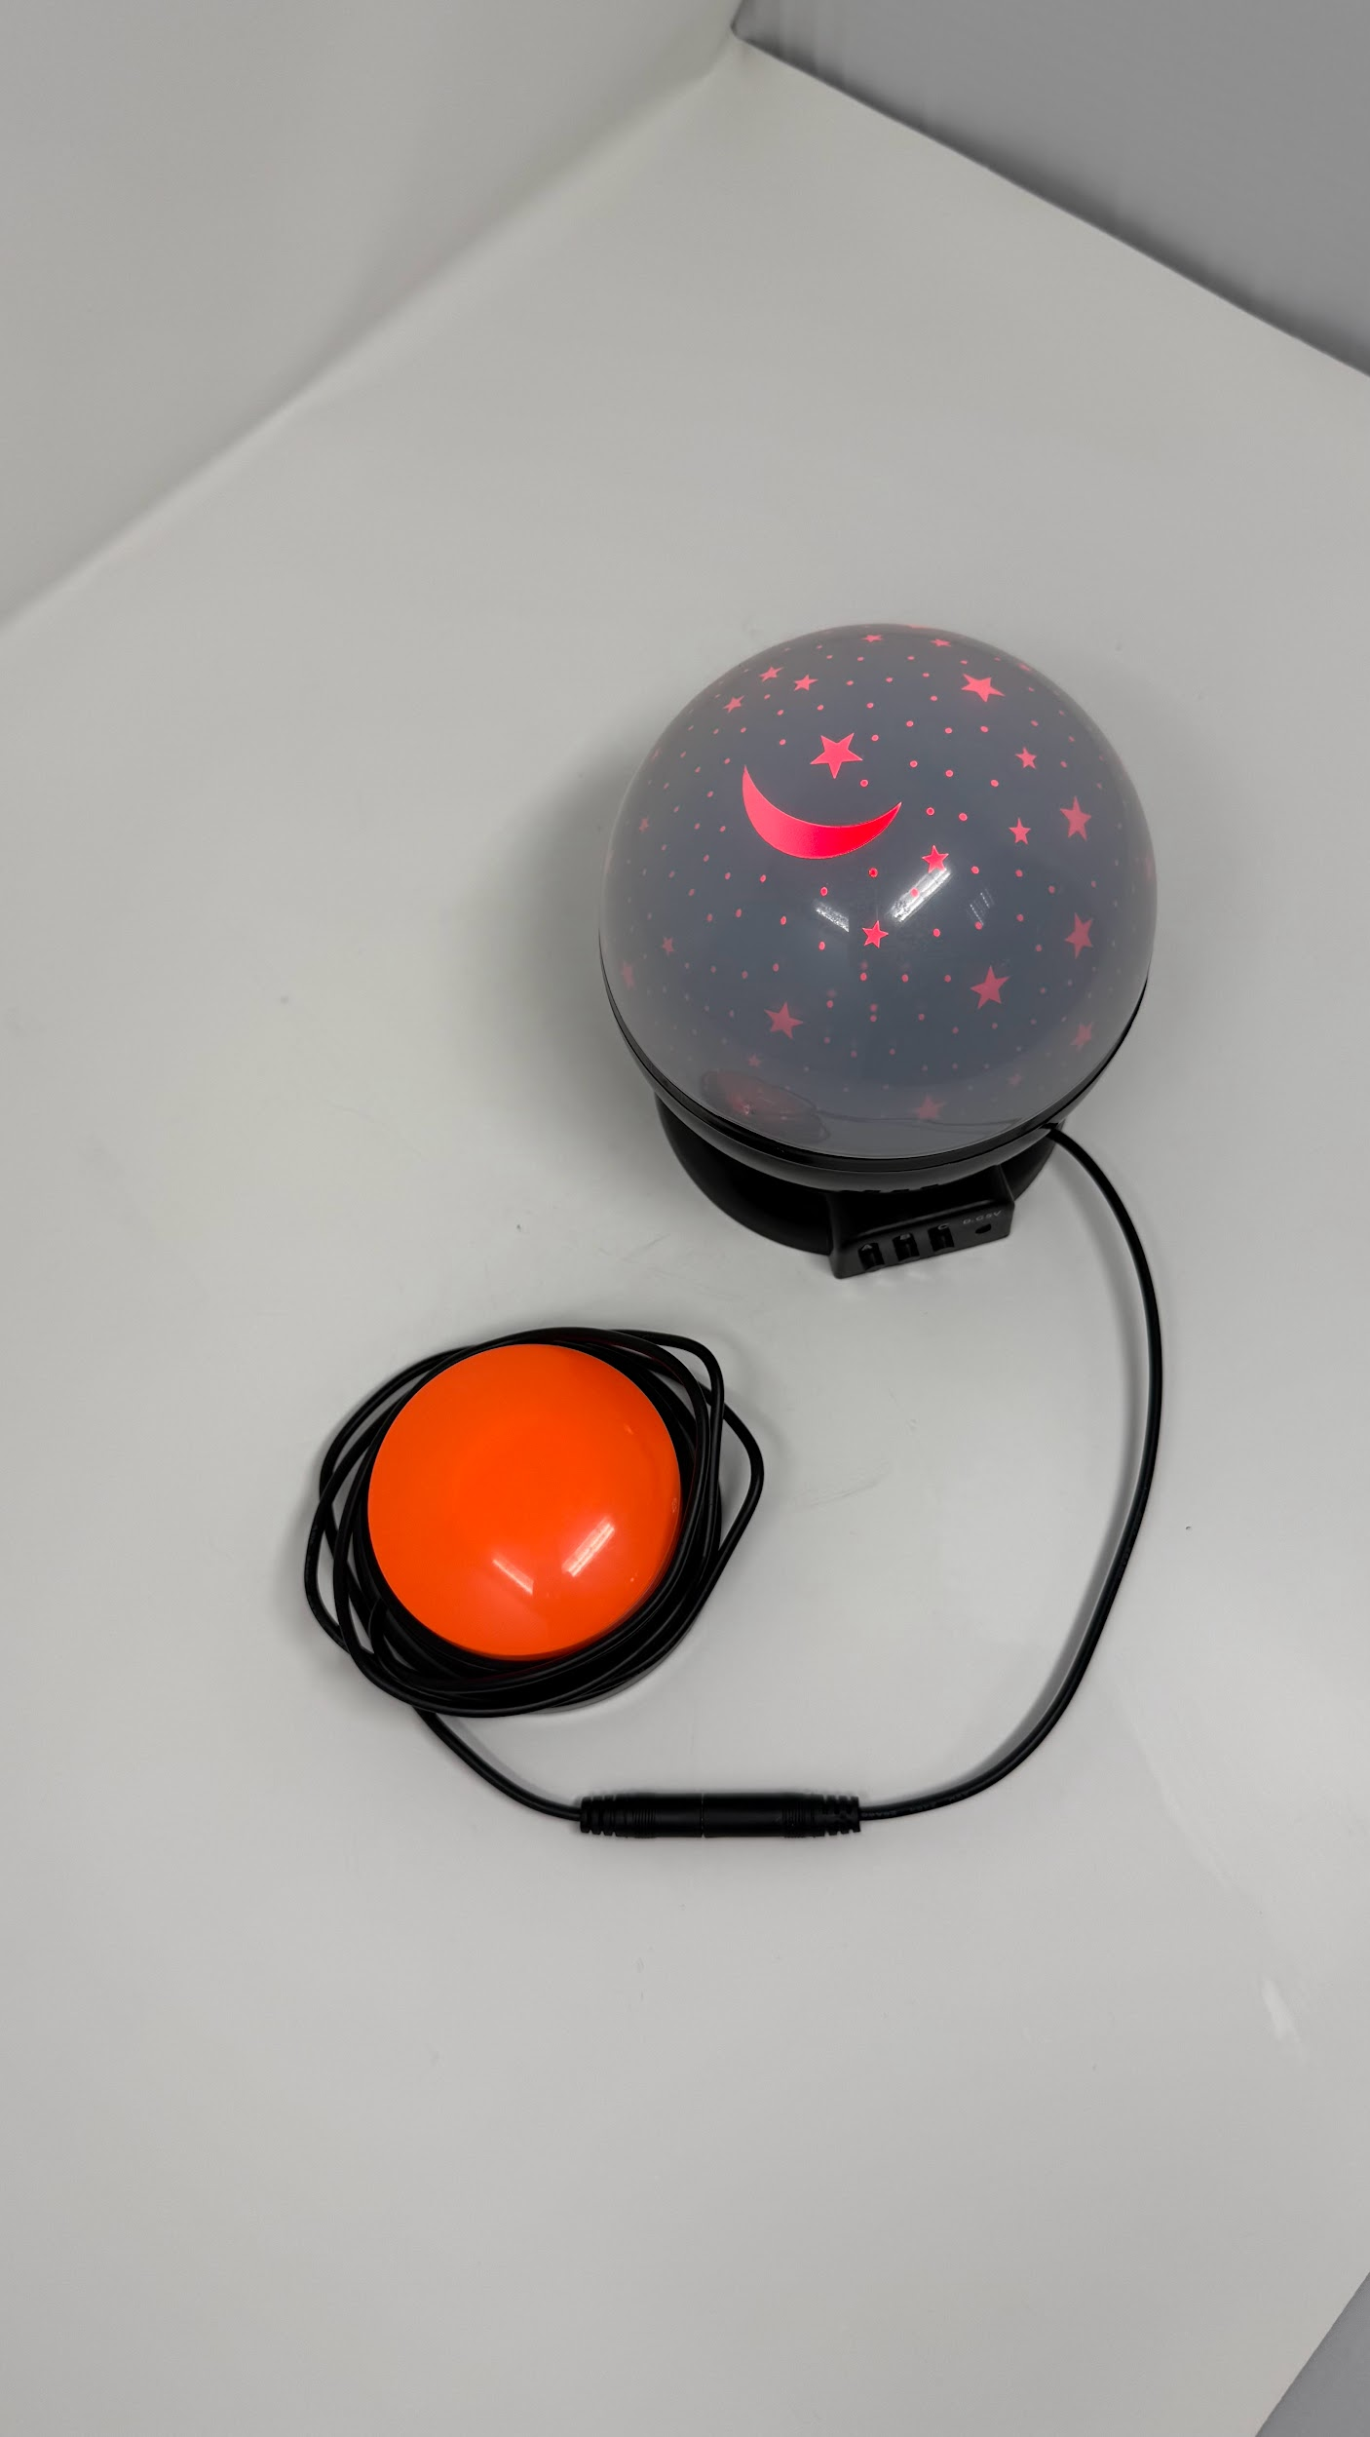





Revision: 1.0
Date: 01-Dec-2025

Table of Contents

Table of Contents 1
1. Introduction 2
1.1 About the Community Partner 2
1.2 Product Description 3
WHY? 3
WHO? 3
WHAT? 3
HOW? 3
1.3 Product Overview and Features 4
1.4 Bill of Materials (BOM) 5
2. User Guide: Instructions for Use 6
2.1 Set Up Instructions 7
2.2 Maintenance 9
2.3 Troubleshooting 9
3. Maker Guide: Assembly Instructions 10
3.1 Assembly Guide 11
4. Credit and Open Hardware Licence 16
4.1. Open Hardware Attribution 16
4.2. License Statement and Source Availability 17
4.3 CERN Open Hardware Licence 17

1. Introduction

1.1 About the Community Partner

Our journey began in 1970 with the will of Mrs Shakuntala Bhatia. Under the banner of the Asian Women’s Welfare Association, Mrs Bhatia and her peers, like Mrs Tambyah and Mrs Kula, identified gaps in the community to help the underserved.

The Association incorporated AWWA Ltd on 7 January 2015, a Singapore company limited by guarantee. In April of the same year, AWWA Ltd took over the operations and activities previously managed by the Association. In 2022, the Association was dissolved, and AWWA continues to address social service gaps as they arise, by being guided by our mission and strategic vision.

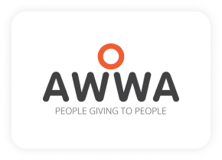

1.2 Product Description

This table clarifies the intended purpose and scope of the product:

WHY? | Special needs students are often excluded from using toys and/or face lack of appropriate ways to express themselves.
WHO? | For special needs students who are learning to understand cause-and-effect and have fun.
WHAT? | A toy lamp with colourful light and projector star and moon onto the wall and ceiling. Adapted with an additional 3.5mm female mono audio cable to trigger power on/off by other switches.
HOW? | This product transforms an off-the-shelf projection lamp into a durable and responsive toy with a 3.5mm female audio jack so it can be triggered by another adapted switch or button. . It allows students to experience and understand the cause-and-effect.

1.3 Product Overview and Features

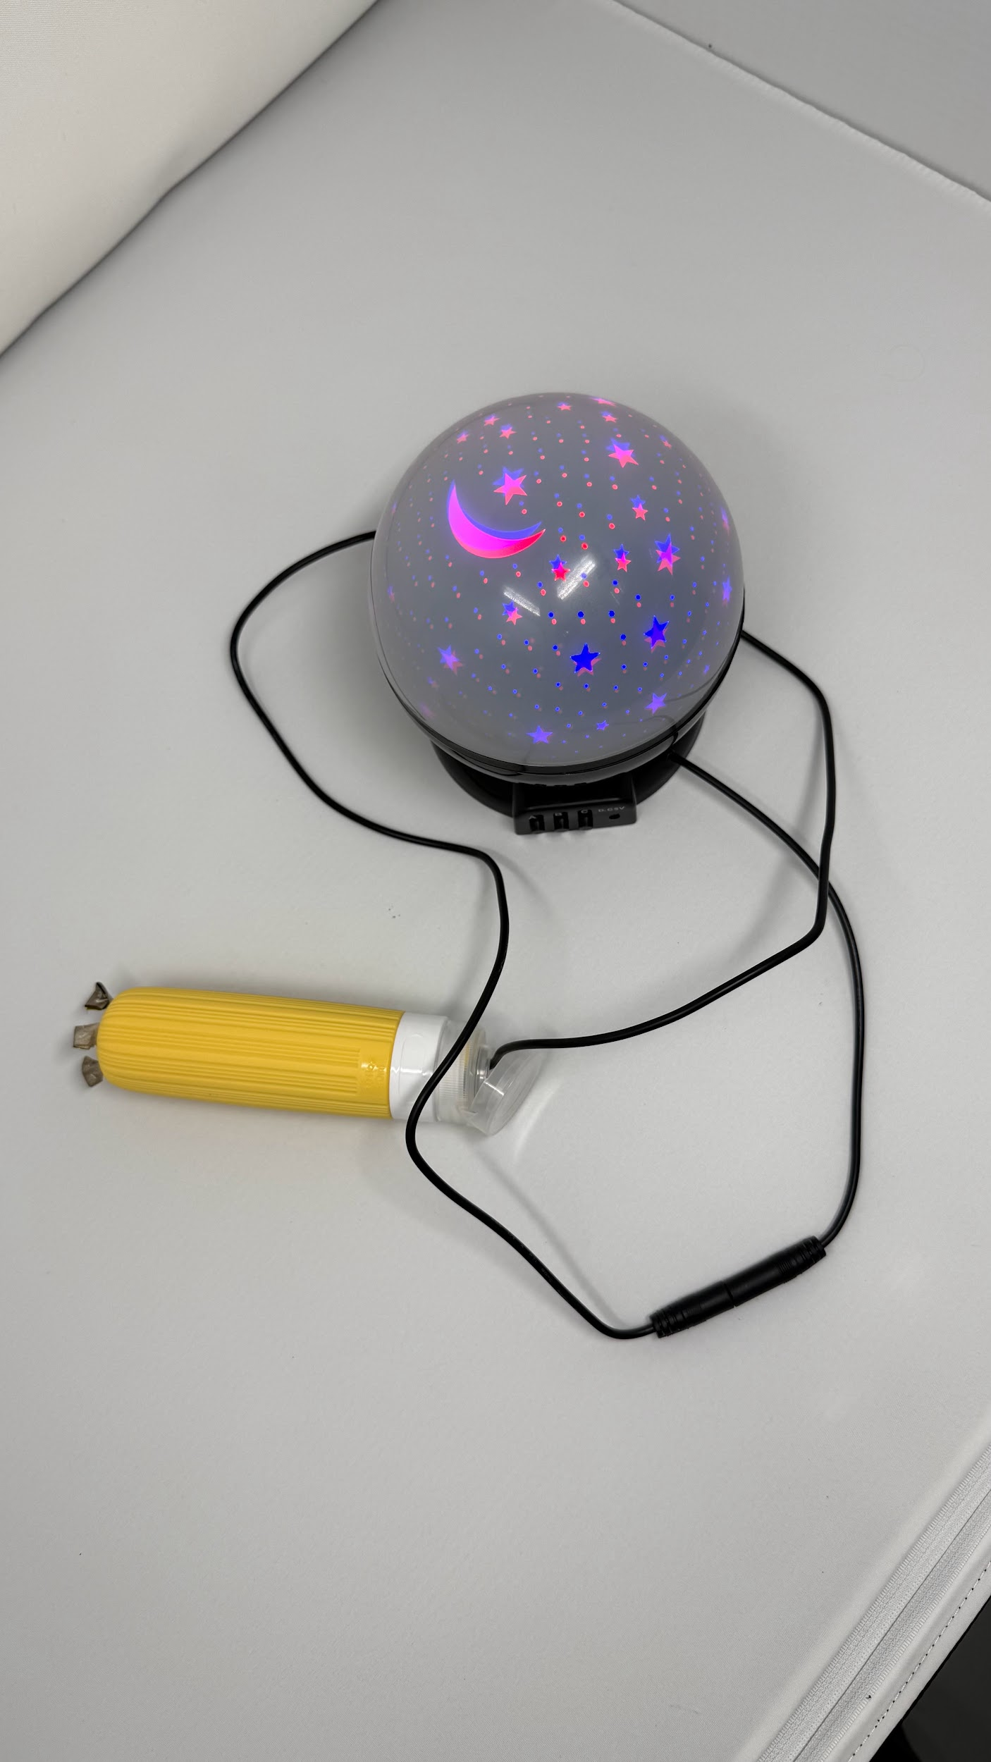
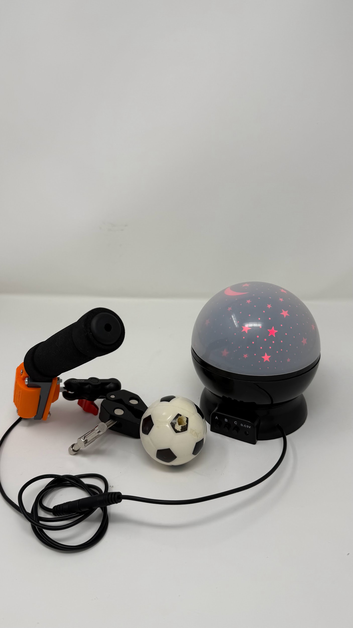
- Adapted Projector Lamp Toy can be connected to an adapted recorder button and turn on/off with audio playback.
- Adapted Projector Lamp Toy can be connected to an adapted limit switch and turn on/off.
- Adapted Projector Lamp Toy can be connected to a squeeze or grip switch and turn on/off.

1.4 Bill of Materials (BOM)

Item | Supplier/Product Link | Price | Quantity
Projection Lamp | Click Here -Link too long | 6.62 SDG/pcs | 1
3.5mm female mono audio jack cable | Click Here - Link too long | 2.10 SGD/pcs | 1
Cable Tie 3x100mm | Click Here - Link too long | 1.62 SGD/100pcs | 1

2. User Guide: Instructions for Use

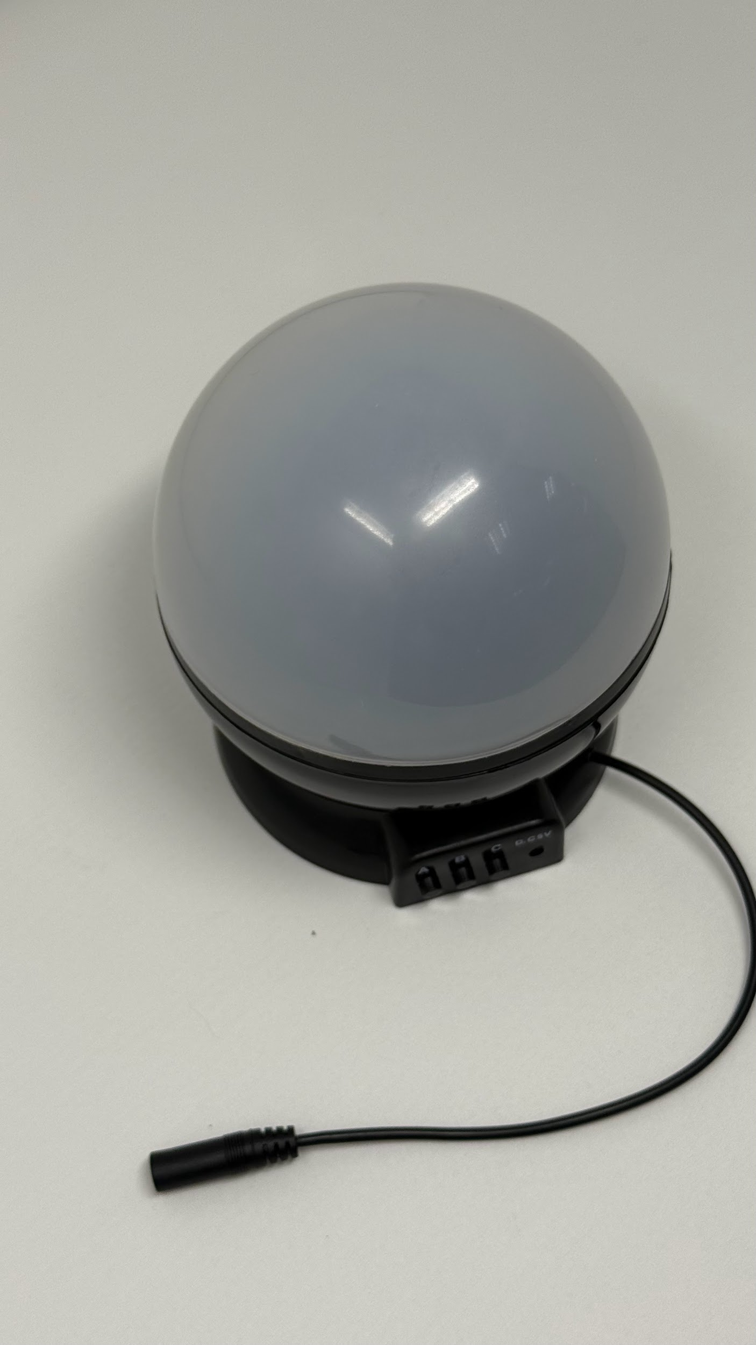

2.1 Set Up Instructions

Use the following table for a step-by-step guide to setting up the product:

Setting up
Open the battery cover and install 3 AA or 4 AAA batteries. Different models of the toy using different batteries. | 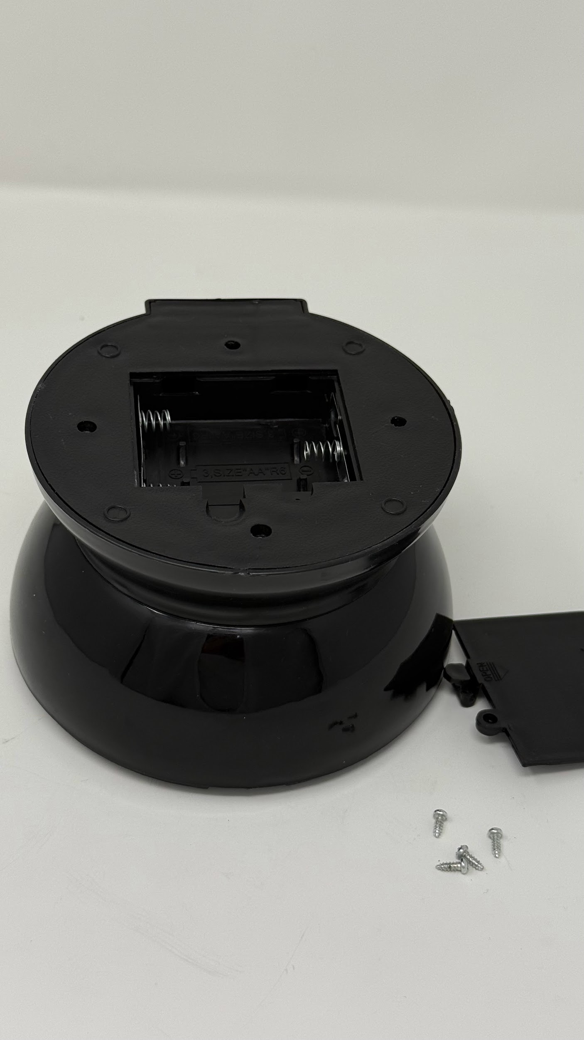
Connect it to an adapted button or switch to turn on/off it. | 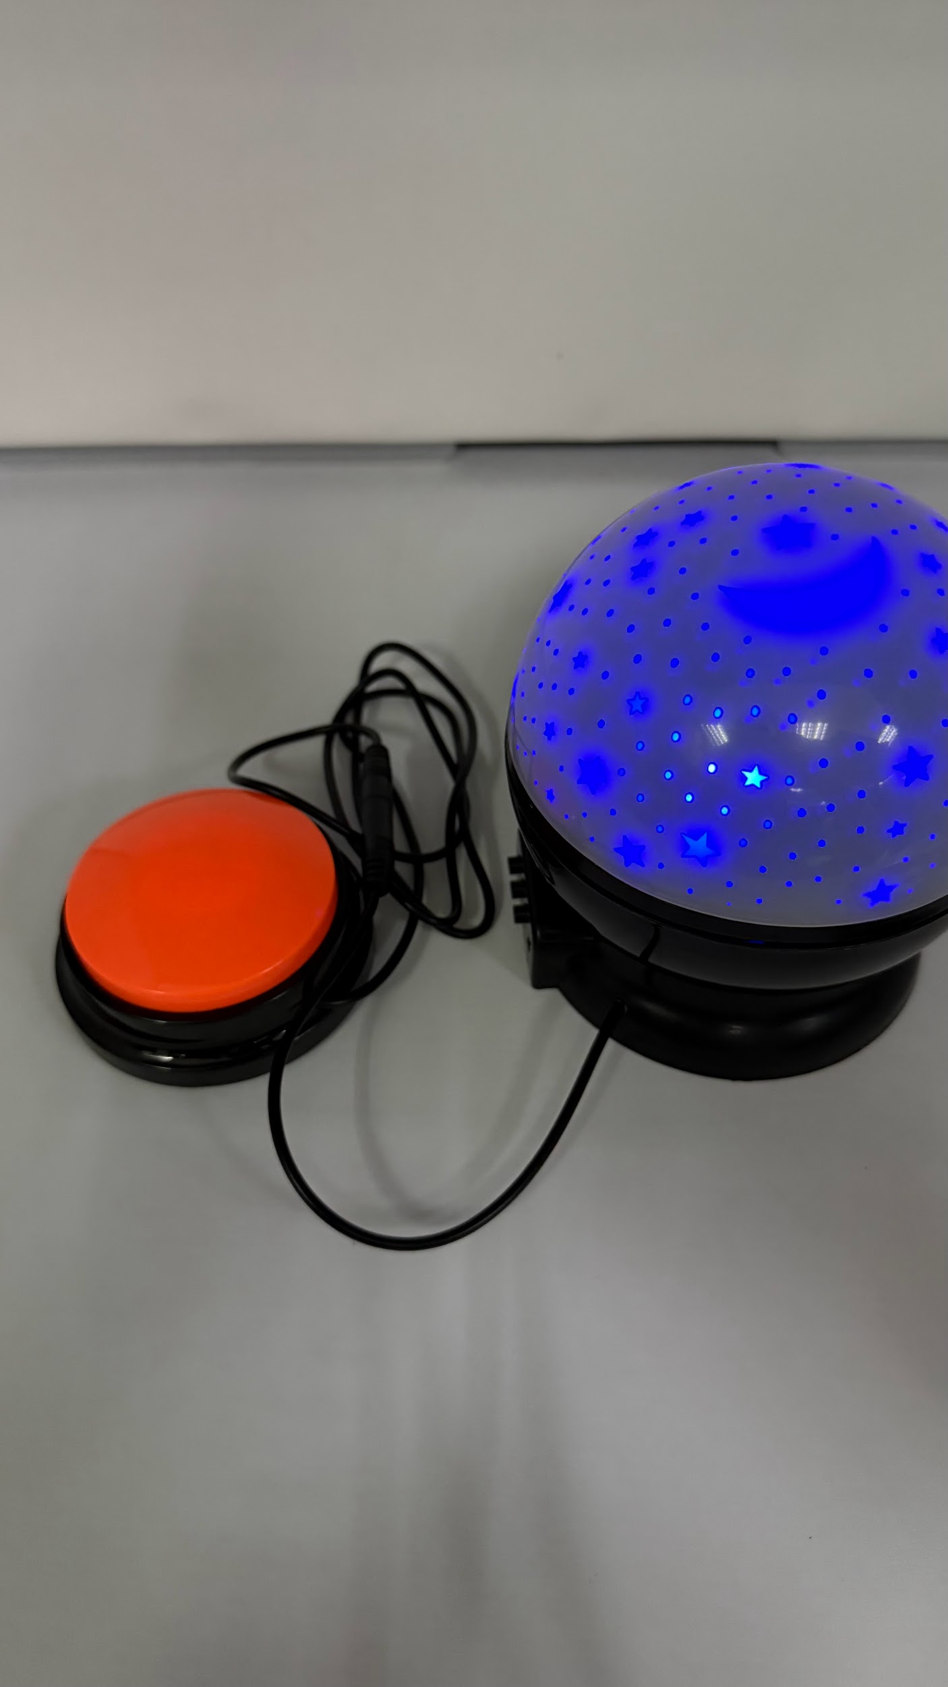
Remove the white cover to let it project to the wall and ceiling. | 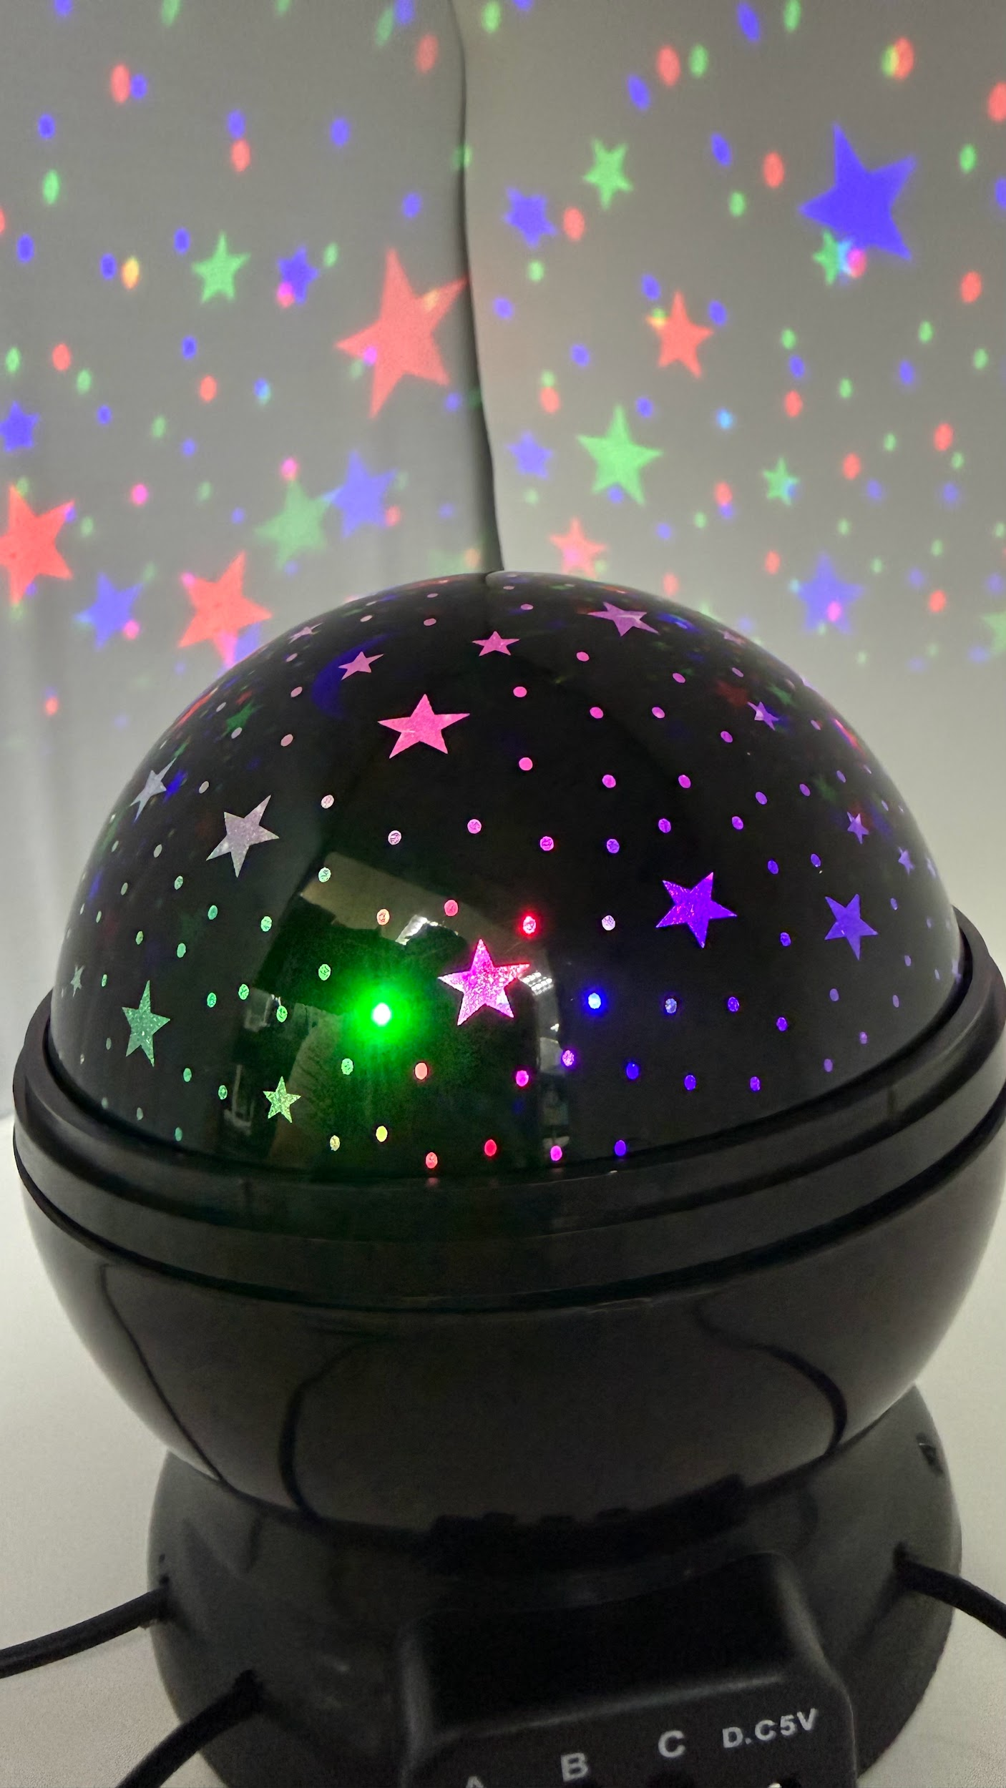
There are 3 modes on the projector lamp toy. Current adaptation only support Mode B  Mode A - Light up white LED and off  Mode B - Light up RED, BLUE, GREEN,  RED BLUE, GREEN BLUE, RED GREEN, RED BLUE GREEN, pulse 3 LEDs and cycle through all 3 LEDs and off between it  Mode C - Rotation on and off | 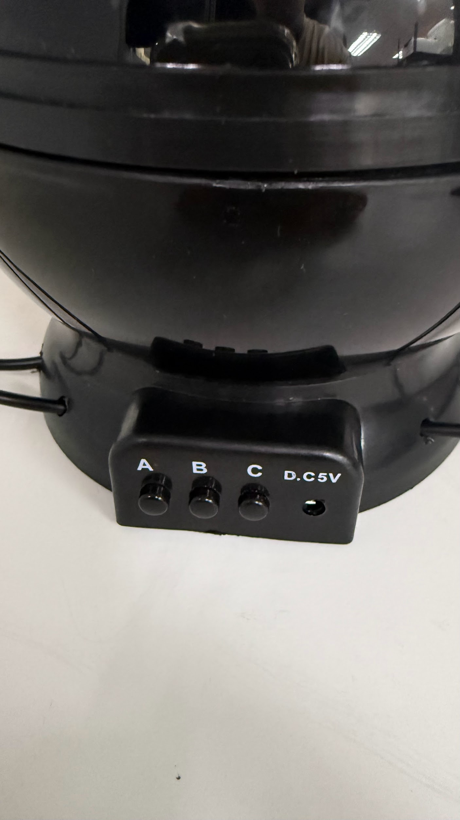

2.2 Maintenance

- Remove AA batteries if the Adapted Projector Lamp Toy is not in use to prevent battery leak and corrosion.
- If AA battery leaks, please change it
- The device can be wiped clean with a damp cloth. Do not wash or submerge in water.

2.3 Troubleshooting

Problem | Possible Cause | What You Can Try
Projector Lamp toy not working | Battery drain | Change the battery to see if it works
 | Battery spoilt because of leakage | Change the battery to see if it works
 | Button is malfunctioning because battery leakage has caused the contact points to corrode | Check how bad the corrosion is? 1. If is very bad that it leak to the PCB, please replace the button,  2. If not try to clean up and replace the battery
 | Projector Lamp toy faulty because of the solder broken | Open with the assembly instruction and try to check on it or contact EG for support.

3. Maker Guide: Assembly Instructions

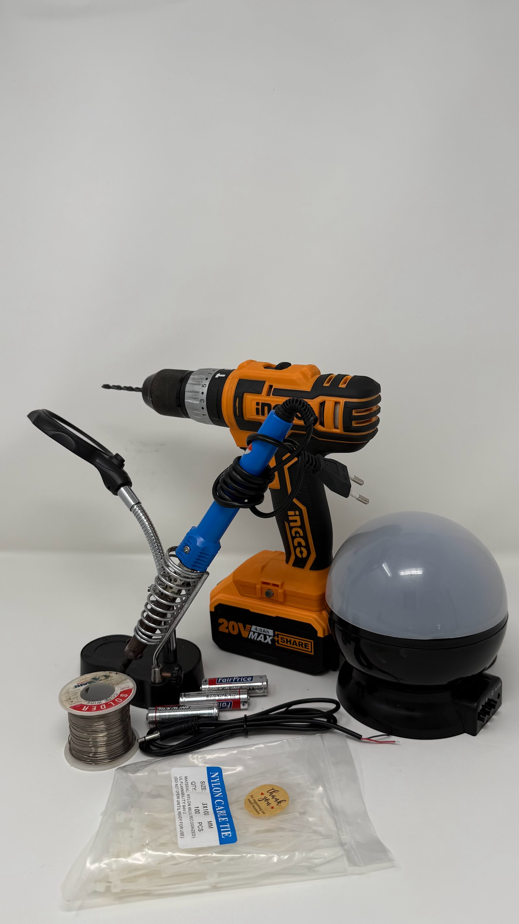

3.1 Assembly Guide

Steps | Images
Remove the top white and black cover. | 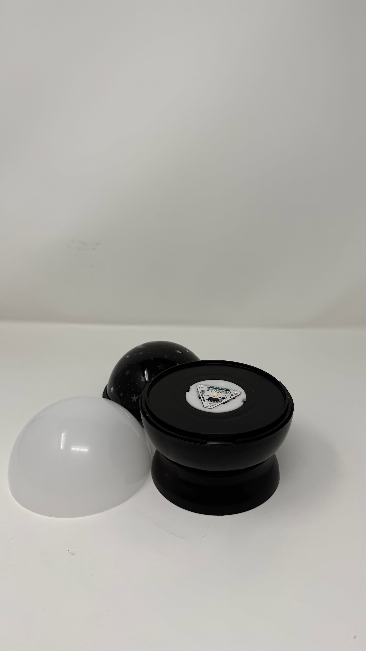
Remove the battery cover. | 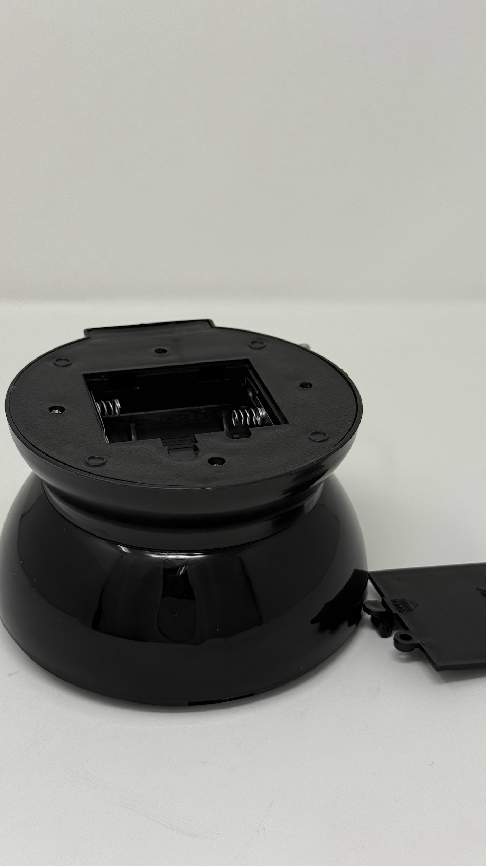
Remove the battery if there is and unscrew the 4 screws. | 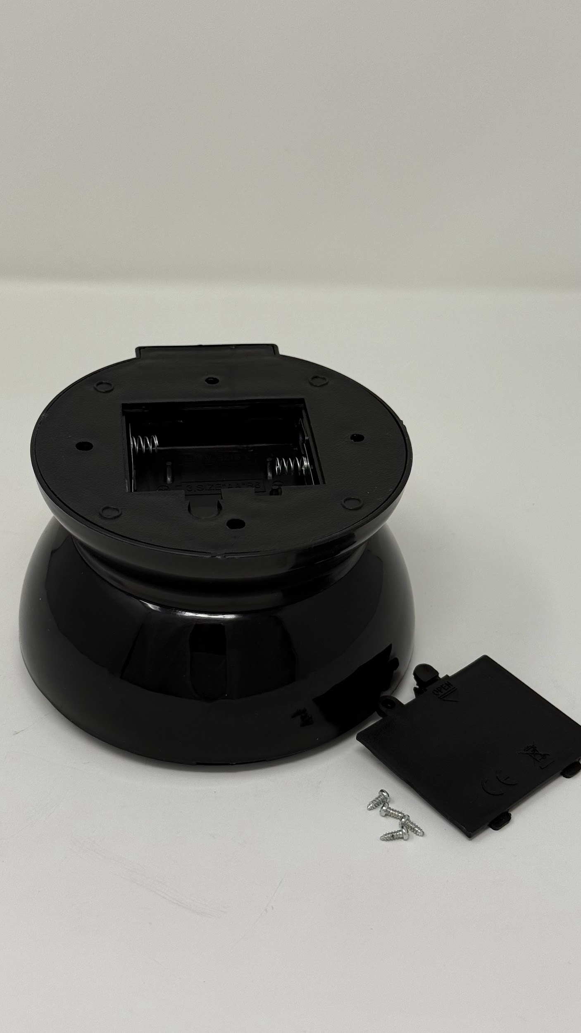
Open up the bottom cover. | 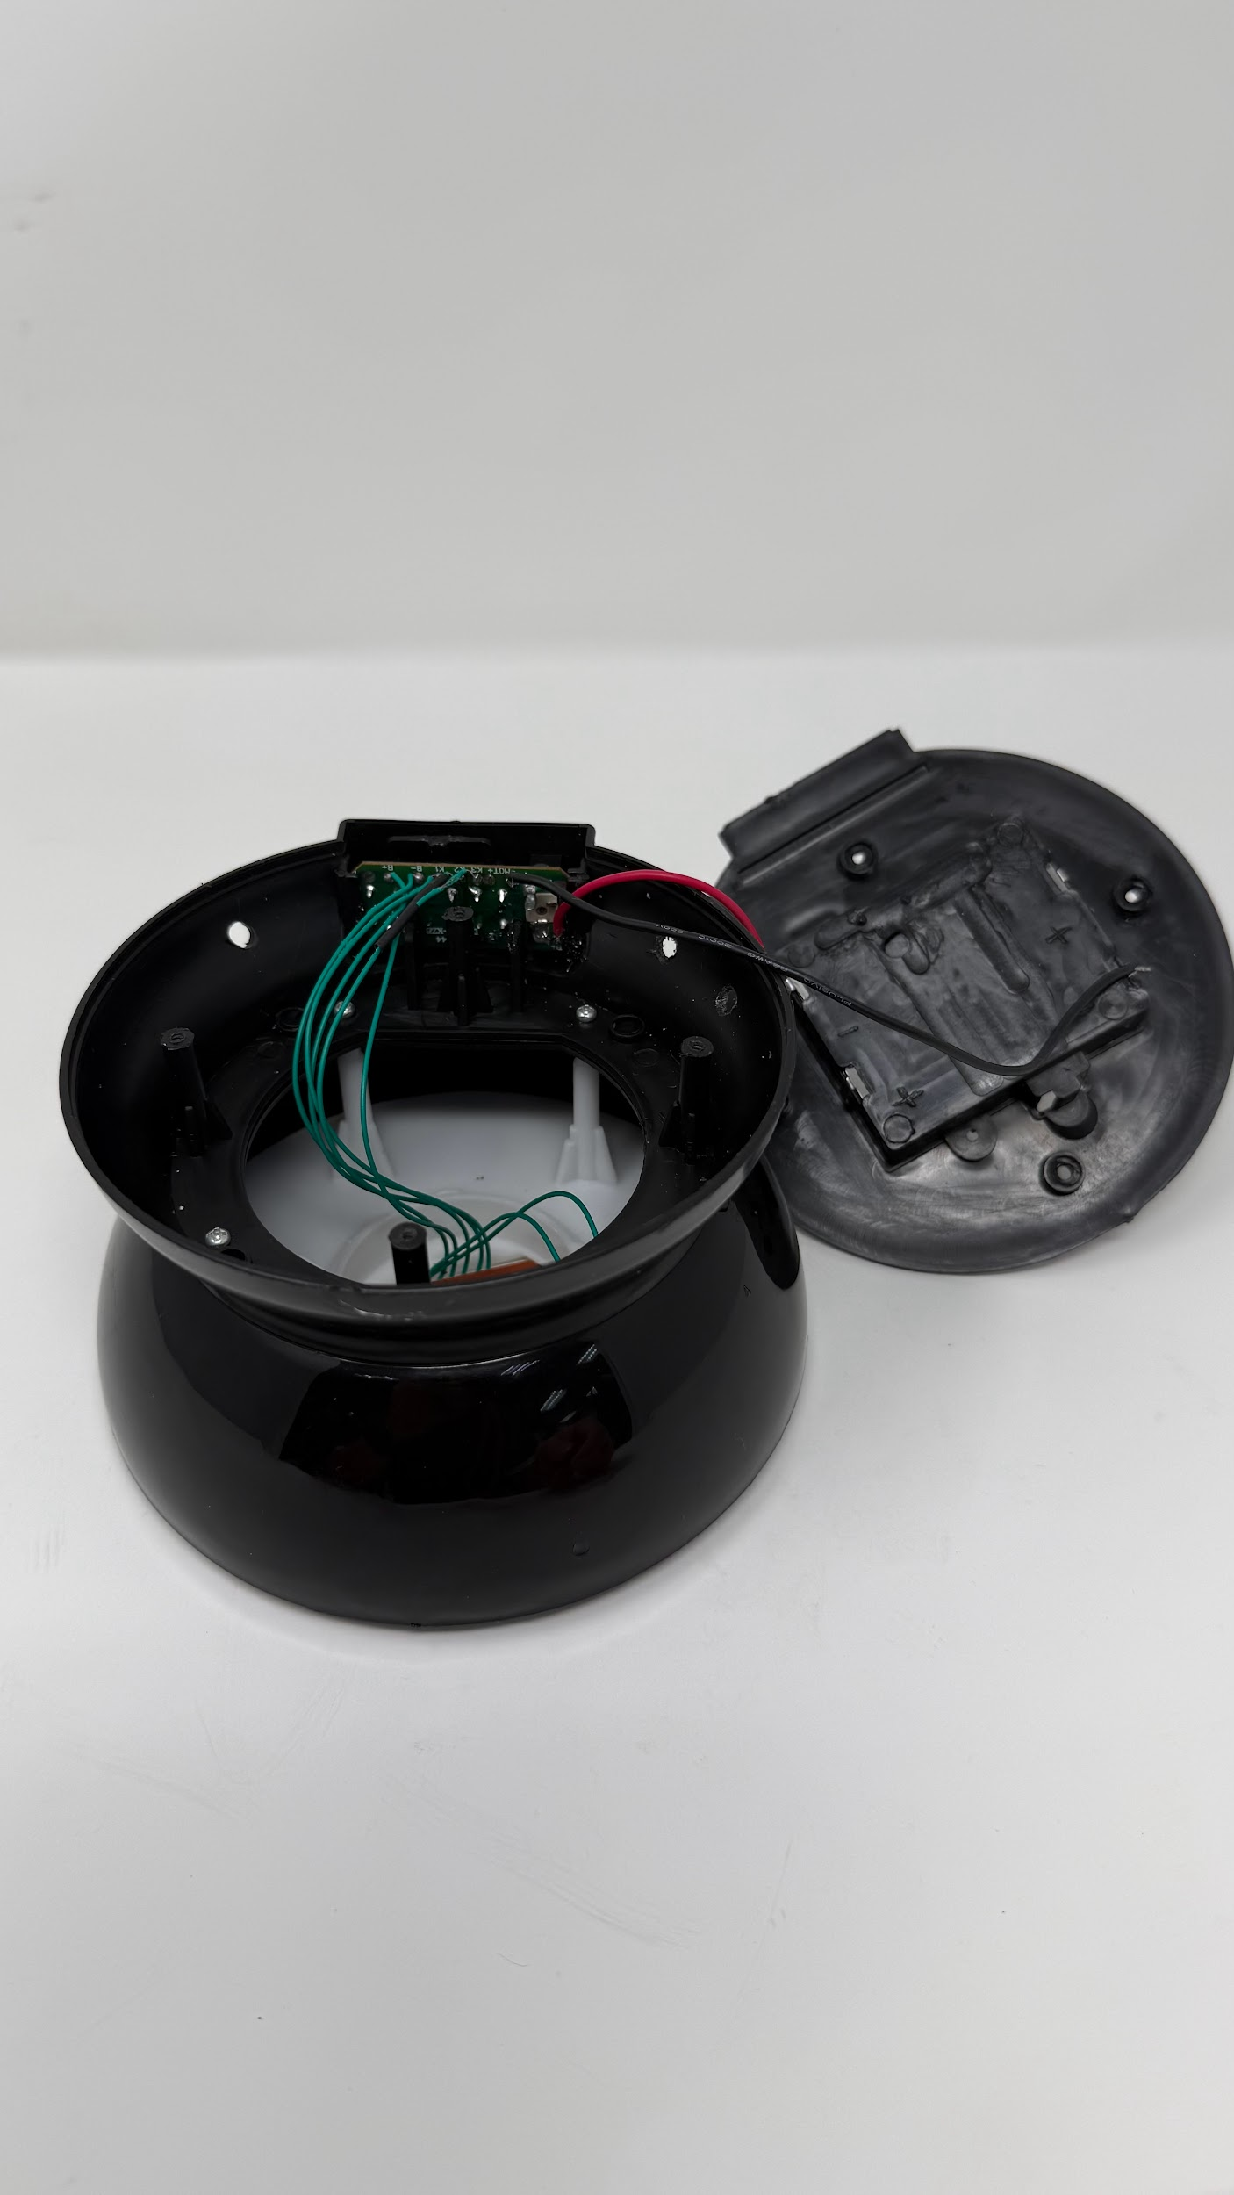
Drill a hole of 4-4.5mm depending on the size of your 3.5mm audio jack cable. | 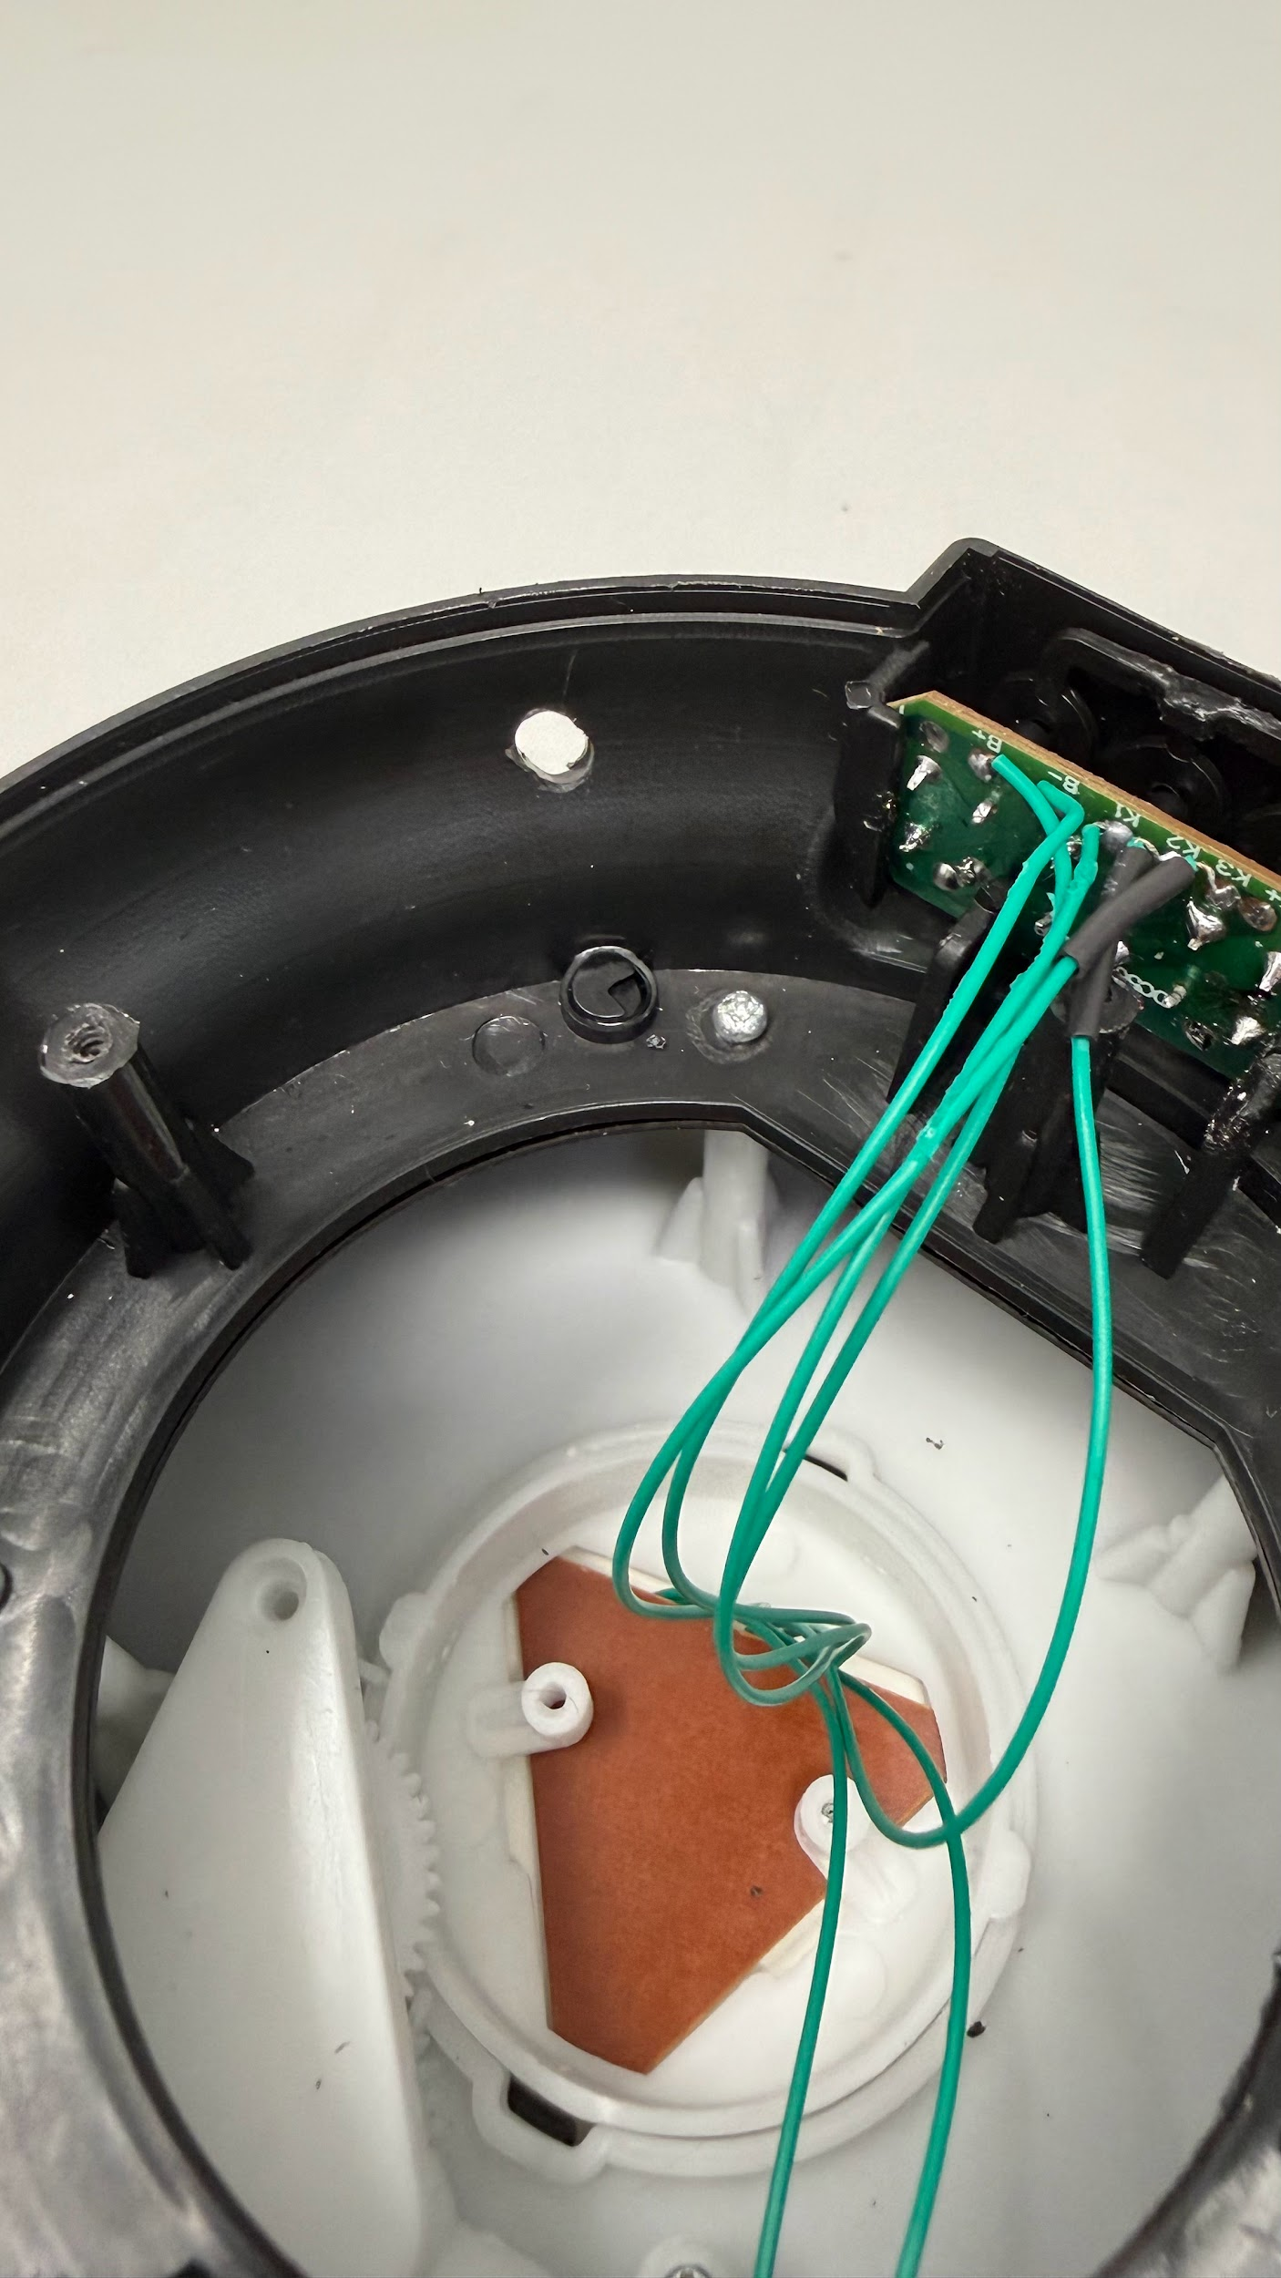
Loop through the 3.5mm female audio jack cable and put a cable tie to it. | 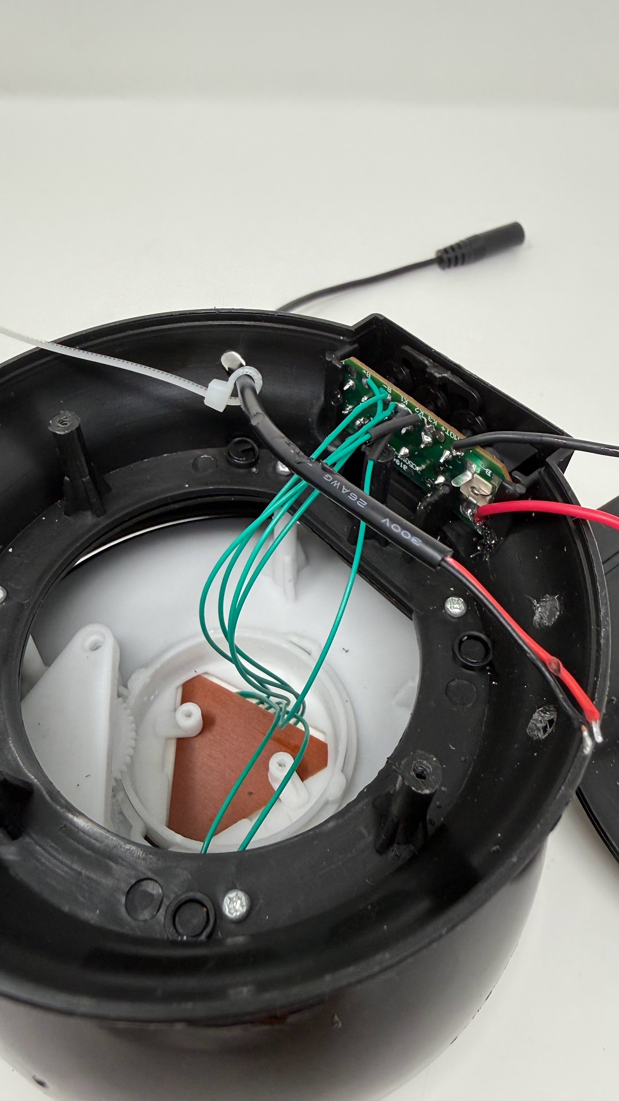
Remove the PCB from the slot. | 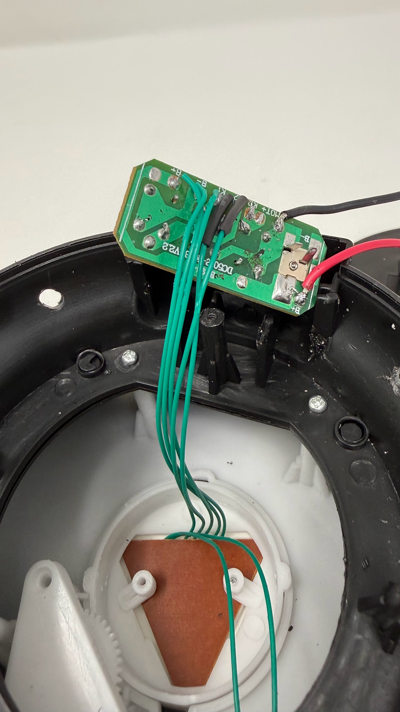
Solder the 2 wires from the 3.5mm female audio jack to the pcb middle button.  You can solder all the 3 buttons too. | 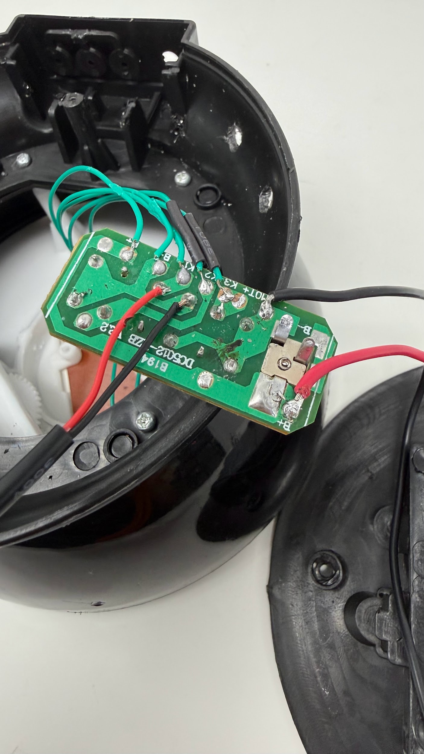
Place back the PCB to the slot properly and don’t break the solder. | 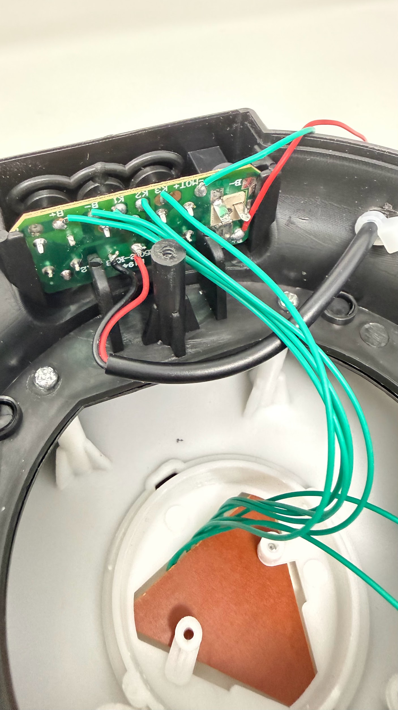
Screw back the 4 screws | 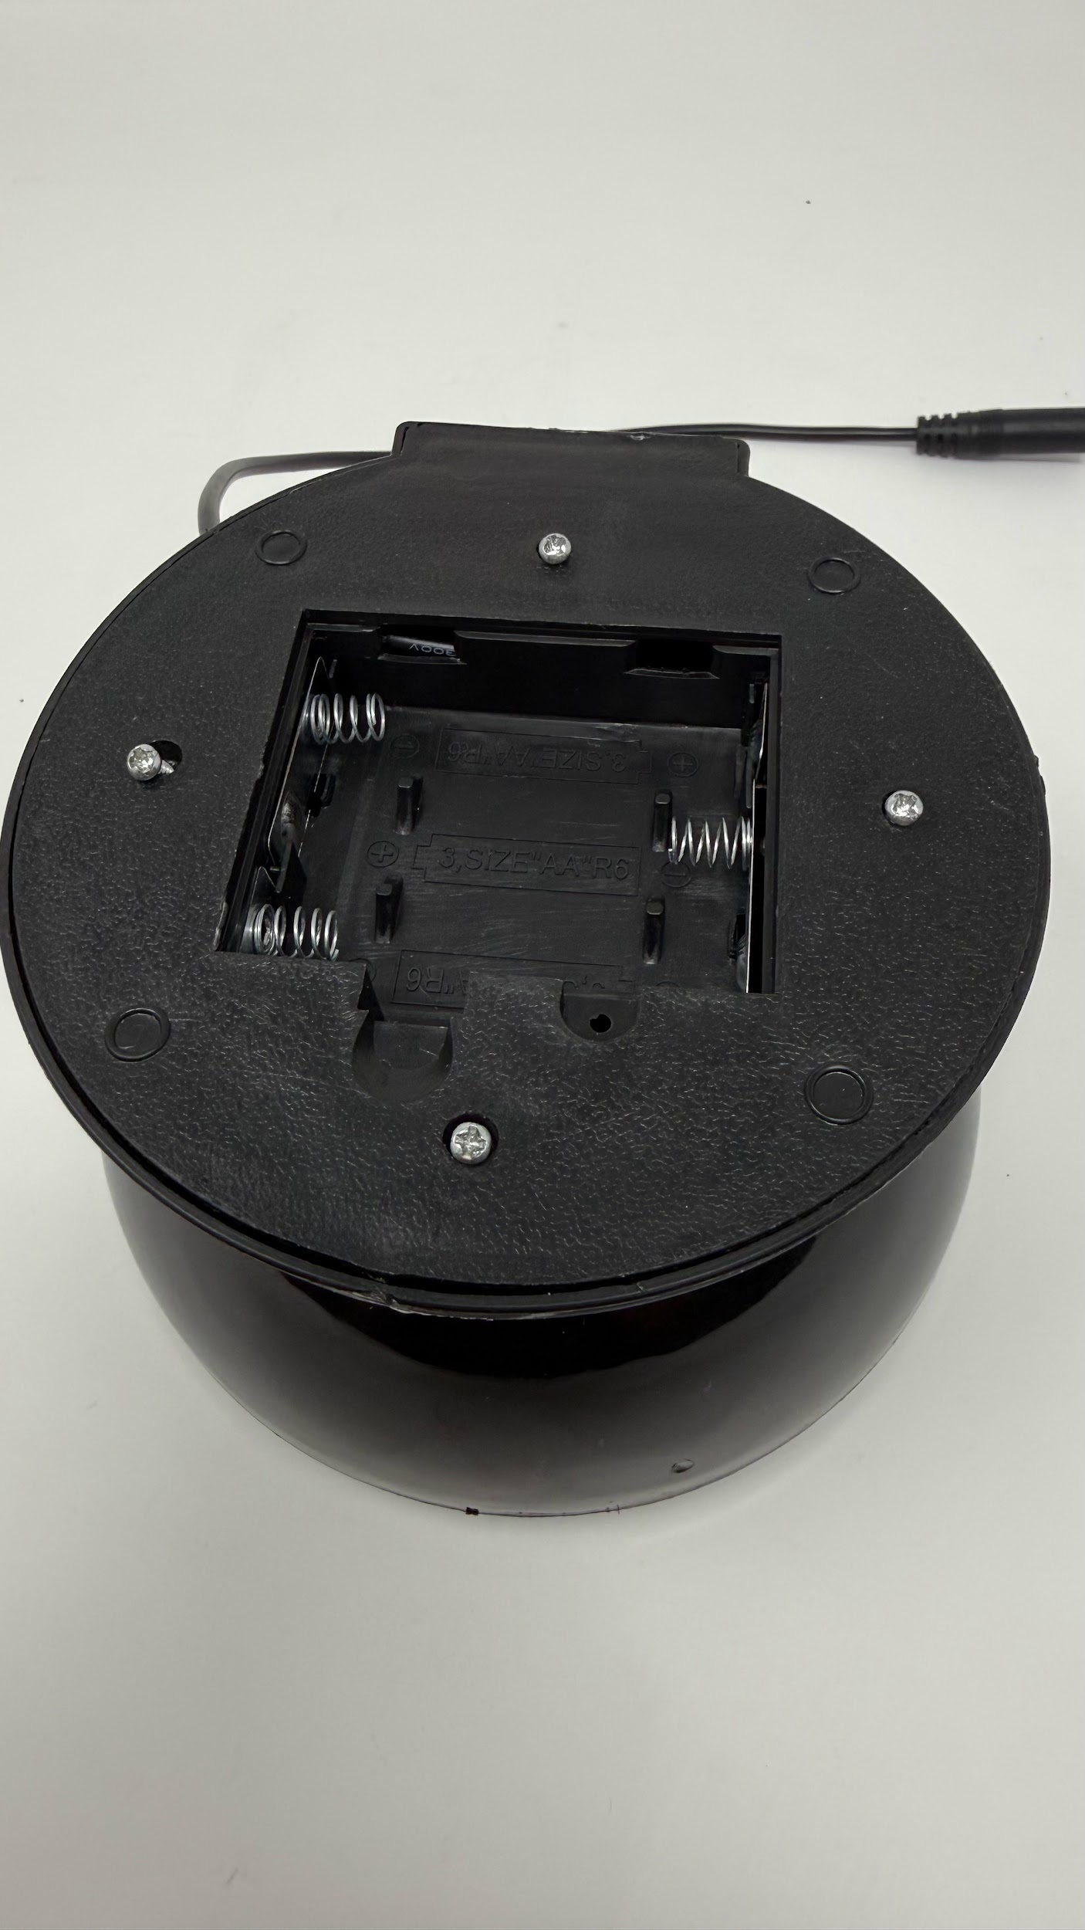
Install 3 AA batteries and test it with a switch or button. | 

4. Credit and Open Hardware Licence

This section provides the required legal notices and attribution for the open hardware design used to create this product.

4.1. Open Hardware Attribution

The core design for this Adapted Protector Lamp Toy is based on the Switch Adapted Moon and Star Projector, an open-source assistive technology project.
- Original Designer: Makers Making Change (a program of Neil Squire).
- Original Copyright: Copyright (c) Neil Squire / Makers Making Change.
- Original Source Location: The original project source files are available online at: https://www.makersmakingchange.com/product/switch-adapted-moon-and-star-projector/01tJR000000694HYAQ

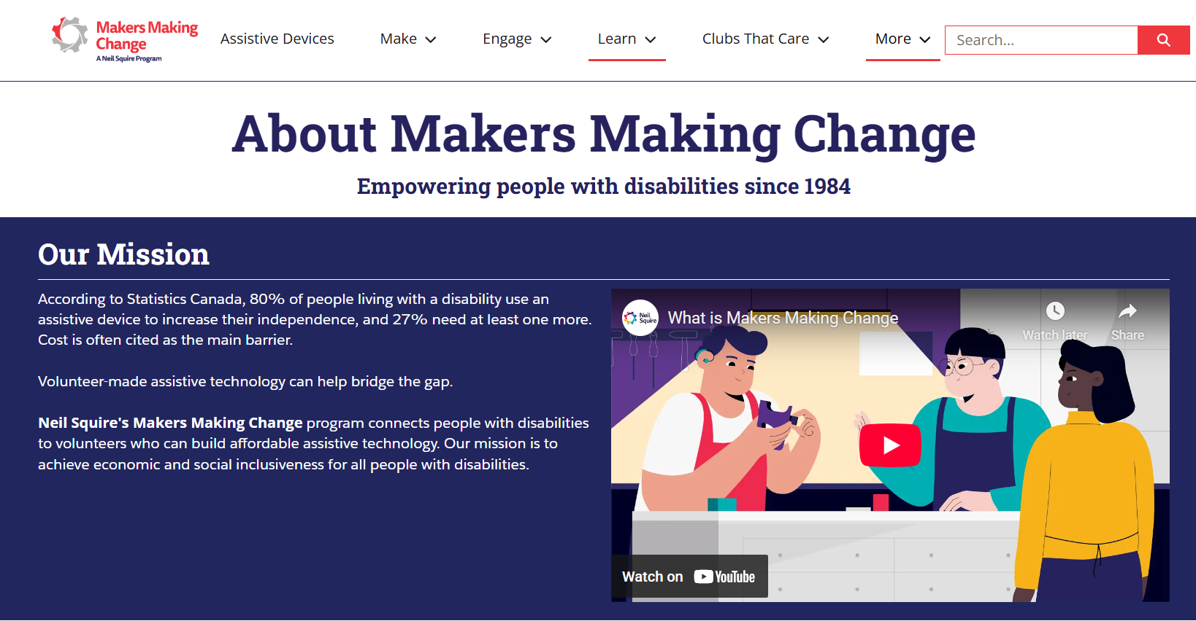

4.2. License Statement and Source Availability

The hardware design used in this product is licensed under the CERN Open Hardware Licence Version 2 – Weakly Reciprocal (CERN-OHL-W 2.0) or later.
By distributing this product, we are obligated to make the complete design source available to you.
- Complete Source Availability: The complete design files (Source), including schematics, assembly instructions, and any modifications made by Engineering Good, are available free of charge at a permanent online location: https://github.com/Engineering-Good/T4G-Adapted-Projector-Lamp-Toy
- Modification Notice: This version of the Adapted Projector Lamp Toy design was modified by Engineering Good to include the 3.5mm mono audio jack functionality for connecting to other switches. The full, modified source is available at the URL listed above.
- Full License Text: The complete legal text of the CERN Open Hardware Licence Version 2 – Weakly Reciprocal** follows this section.

4.3 CERN Open Hardware Licence

The full text of the license is available here: CERN-OHL-W 2.0 Full Text

