Product Manual Template: [Step Switch]

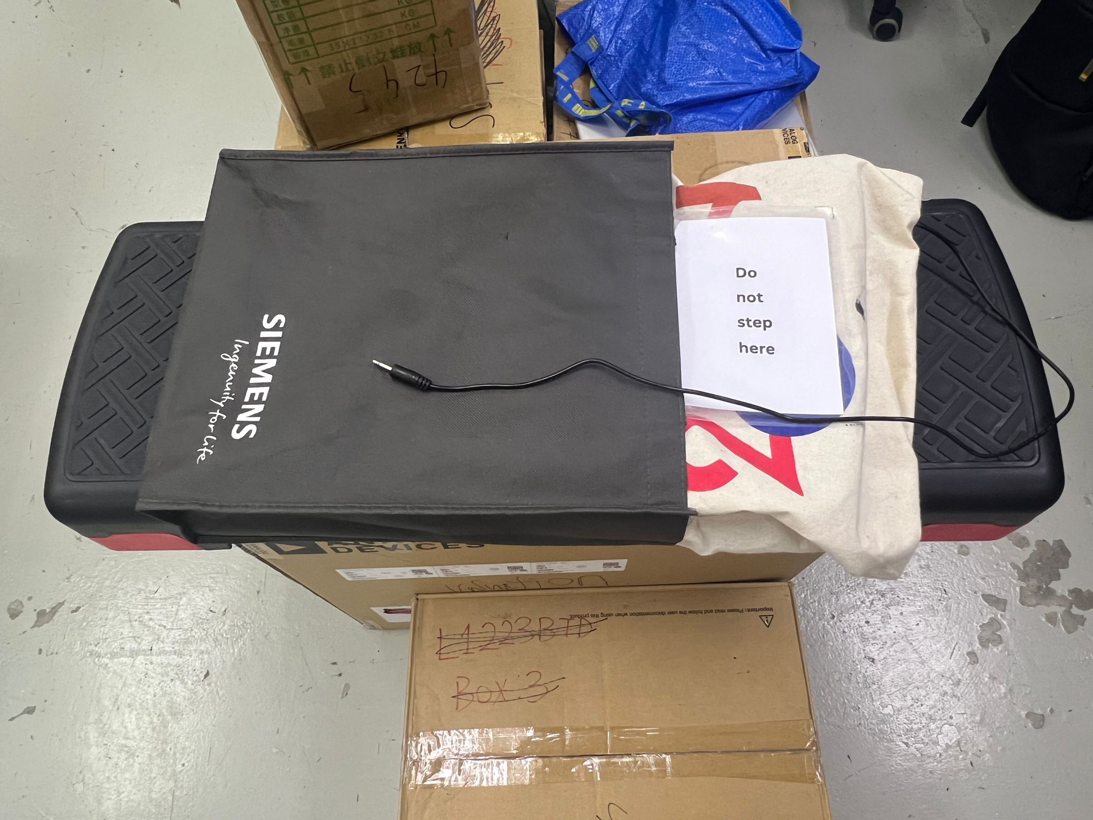




Revision: 1.0
Date: 13-Mar-2026

Table of Contents

Table of Contents 1
1. Introduction 2
1.1 About the Community Partner 2
1.2 Product Description 3
WHY? 3
WHO? 3
WHAT? 3
HOW? 3
1.3 Product Overview and Features 4
1.4 Bill of Materials (BOM) 5
2. User Guide: Instructions for Use 6
2.1 Set Up Instructions 7
2.2 Maintenance 8
2.3 Troubleshooting 9
3. Maker Guide: Assembly Instructions 10
3.1 Assembly Guide 10
4. Credit and Open Hardware Licence 11
4.1. Open Hardware Attribution (if we use MMC) 11
4.2. License Statement and Source Availability 12
4.3 CERN Open Hardware Licence Version 2 12

1. Introduction

1.1 About the Community Partner

Our journey began in 1970 with the will of Mrs Shakuntala Bhatia. Under the banner of the Asian Women’s Welfare Association, Mrs Bhatia and her peers, like Mrs Tambyah and Mrs Kula, identified gaps in the community to help the underserved.

The Association incorporated AWWA Ltd on 7 January 2015, a Singapore company limited by guarantee. In April of the same year, AWWA Ltd took over the operations and activities previously managed by the Association. In 2022, the Association was dissolved, and AWWA continues to address social service gaps as they arise, by being guided by our mission and strategic vision.



1.2 Product Description

This table clarifies the intended purpose and scope of the product:

WHY? | Special needs students are often excluded from using toys and/or face lack of appropriate ways to express themselves.
WHO? | For special needs students who are learning to understand cause-and-effect and have fun.
WHAT? | A Product and the function(E.g. Button with audio recording and playback function). Adapted with an additional 3.5mm female/male mono audio cable to trigger the power of/by other devices(E.g. Switches or Toys).
HOW? | This product transforms an off-the-shelf product name into a durable and responsive device ( E.g. function that records, plays back audio, while enabling it to trigger the power of other devices). It allows students to experience and understand the cause-and-effect.

1.3 Product Overview and Features

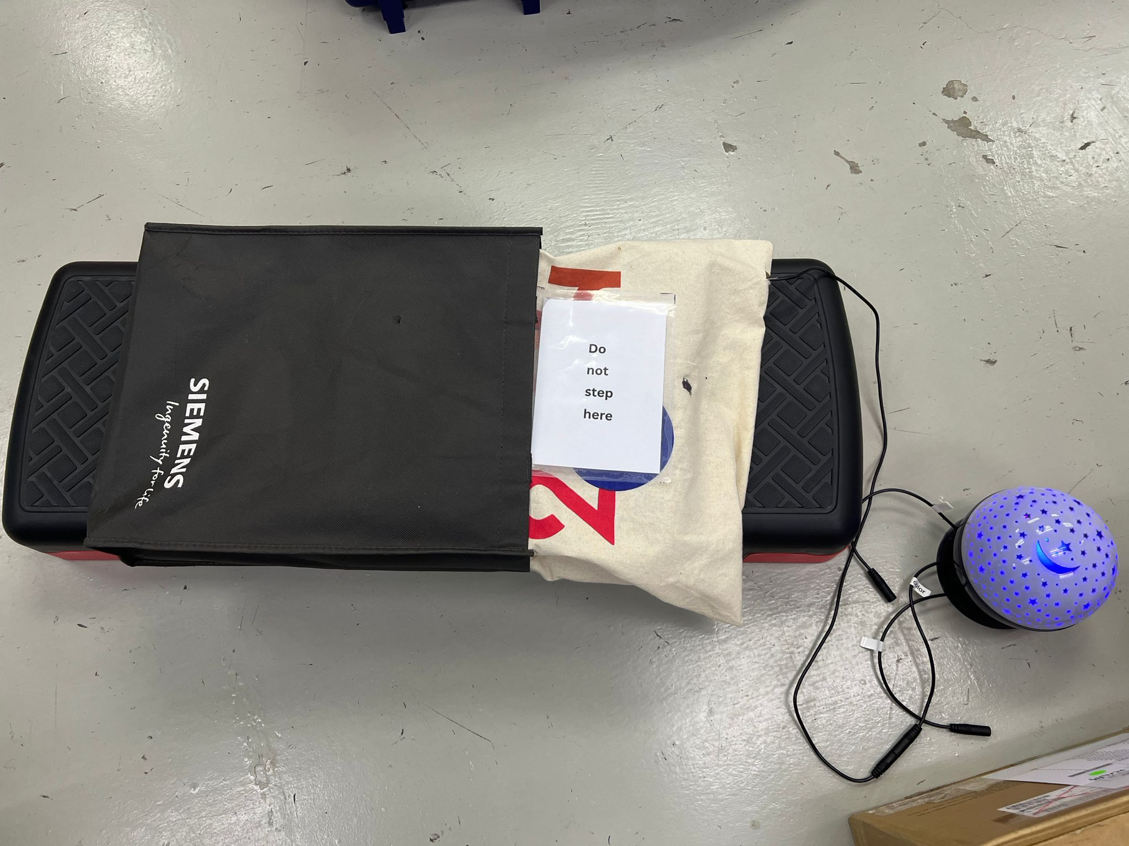

- Step switch can record audio
- Step switch can playback audio
- Step switch can trigger other toys to power on/off via the 3/5mm male mono audio jack and both trigger and playback audio.

1.4 Bill of Materials (BOM)

Item | Supplier/Product Link | Price | Quantity
Adjustable Aerobic Step Up Board (81cm) | https://shorturl.at/ciIlK | $29.90 / set | 1
Yoga mat | Decathlon | $19.90/ 1 mat | 1
Faraday Fabric 2 x 1.1m | https://shorturl.at/5SEfo | $18.52/pcs | 1
1/2/3PCS Black Removable Foam Inserts (for separation of the top and bottom layers of conductive fabric) | https://shorturl.at/XJUju | $6.18/ pcs | 1
Masking tape | Overjoyed | $1.83/pcs | 1
Tote bag | https://shorturl.at/fs8nO | $1.60/pcs | 2
Copper tape | https://shorturl.at/A4xp9 | $20.01/pcs | 1
Pet button | https://shorturl.at/9F40l | $6.40/pcs | 1
Silicone glue | https://shorturl.at/ZrrVy | $2.90/pcs | 1
EPE foam (for covering the PCB board) 10x10cm | https://shorturl.at/Nldem | $1.44/pcs | 1
3.5mm mono audio jack | https://rb.gy/08fa5q | $4.91/pcs | 1
Battery holder | https://shorturl.at/8UTqS | $1.76/pcs | 1

2. User Guide: Instructions for Use

2.1 Set Up Instructions

Use the following table for a step-by-step guide to setting up the product:

Insert batteries inside the step switch: | 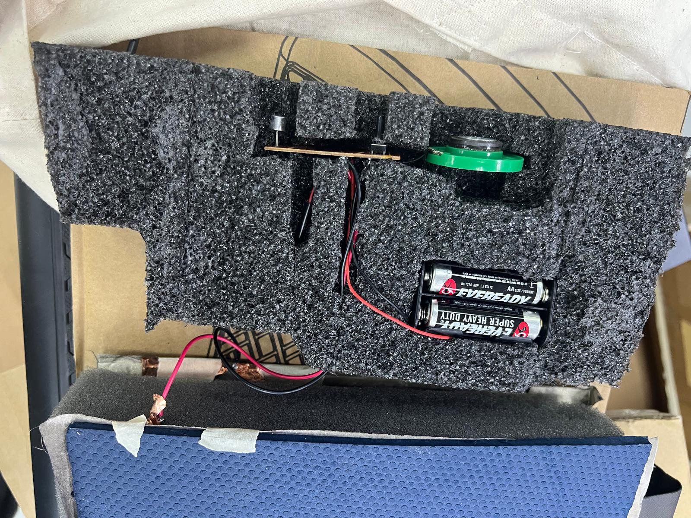
Wrap up switch with the outer tote bag cloth and stick them together with Velcro: | 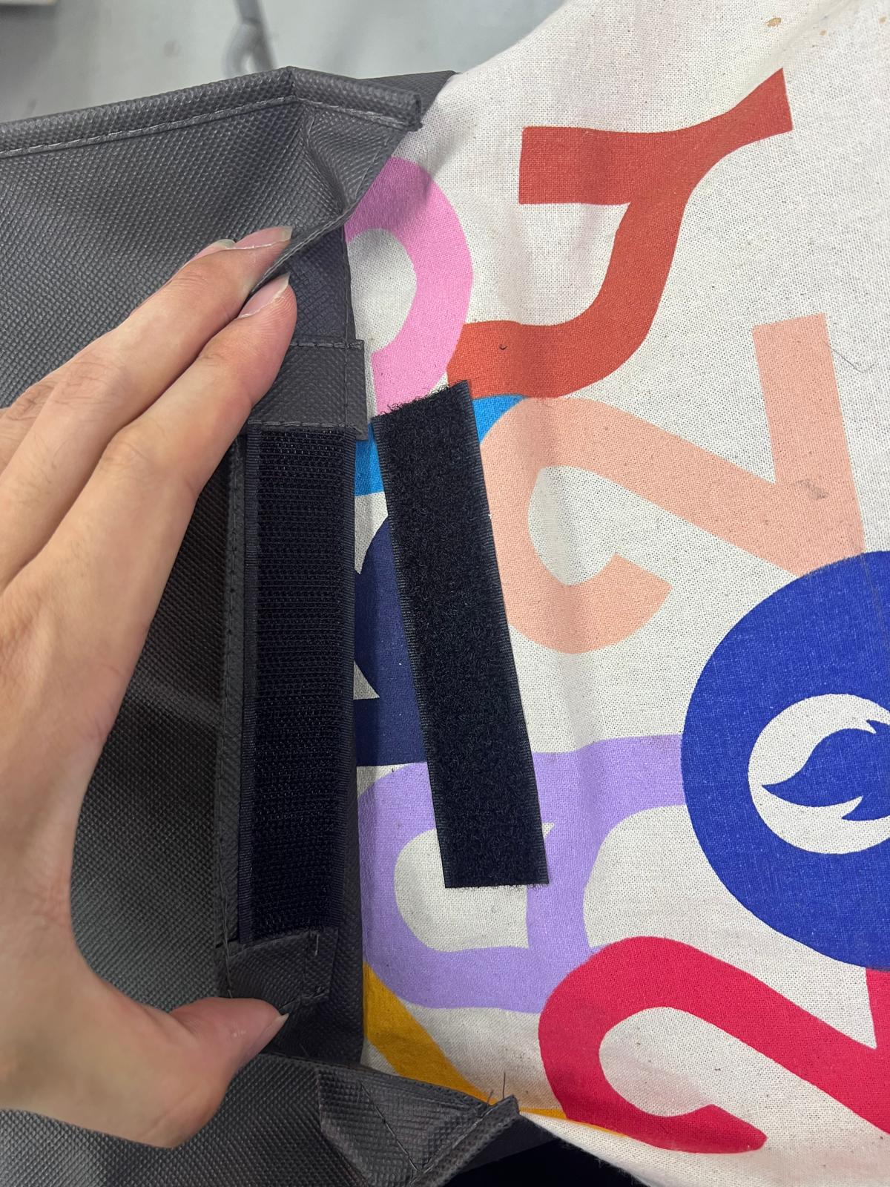
Record audio by pressing and holding the black dot at the side of the switch: | 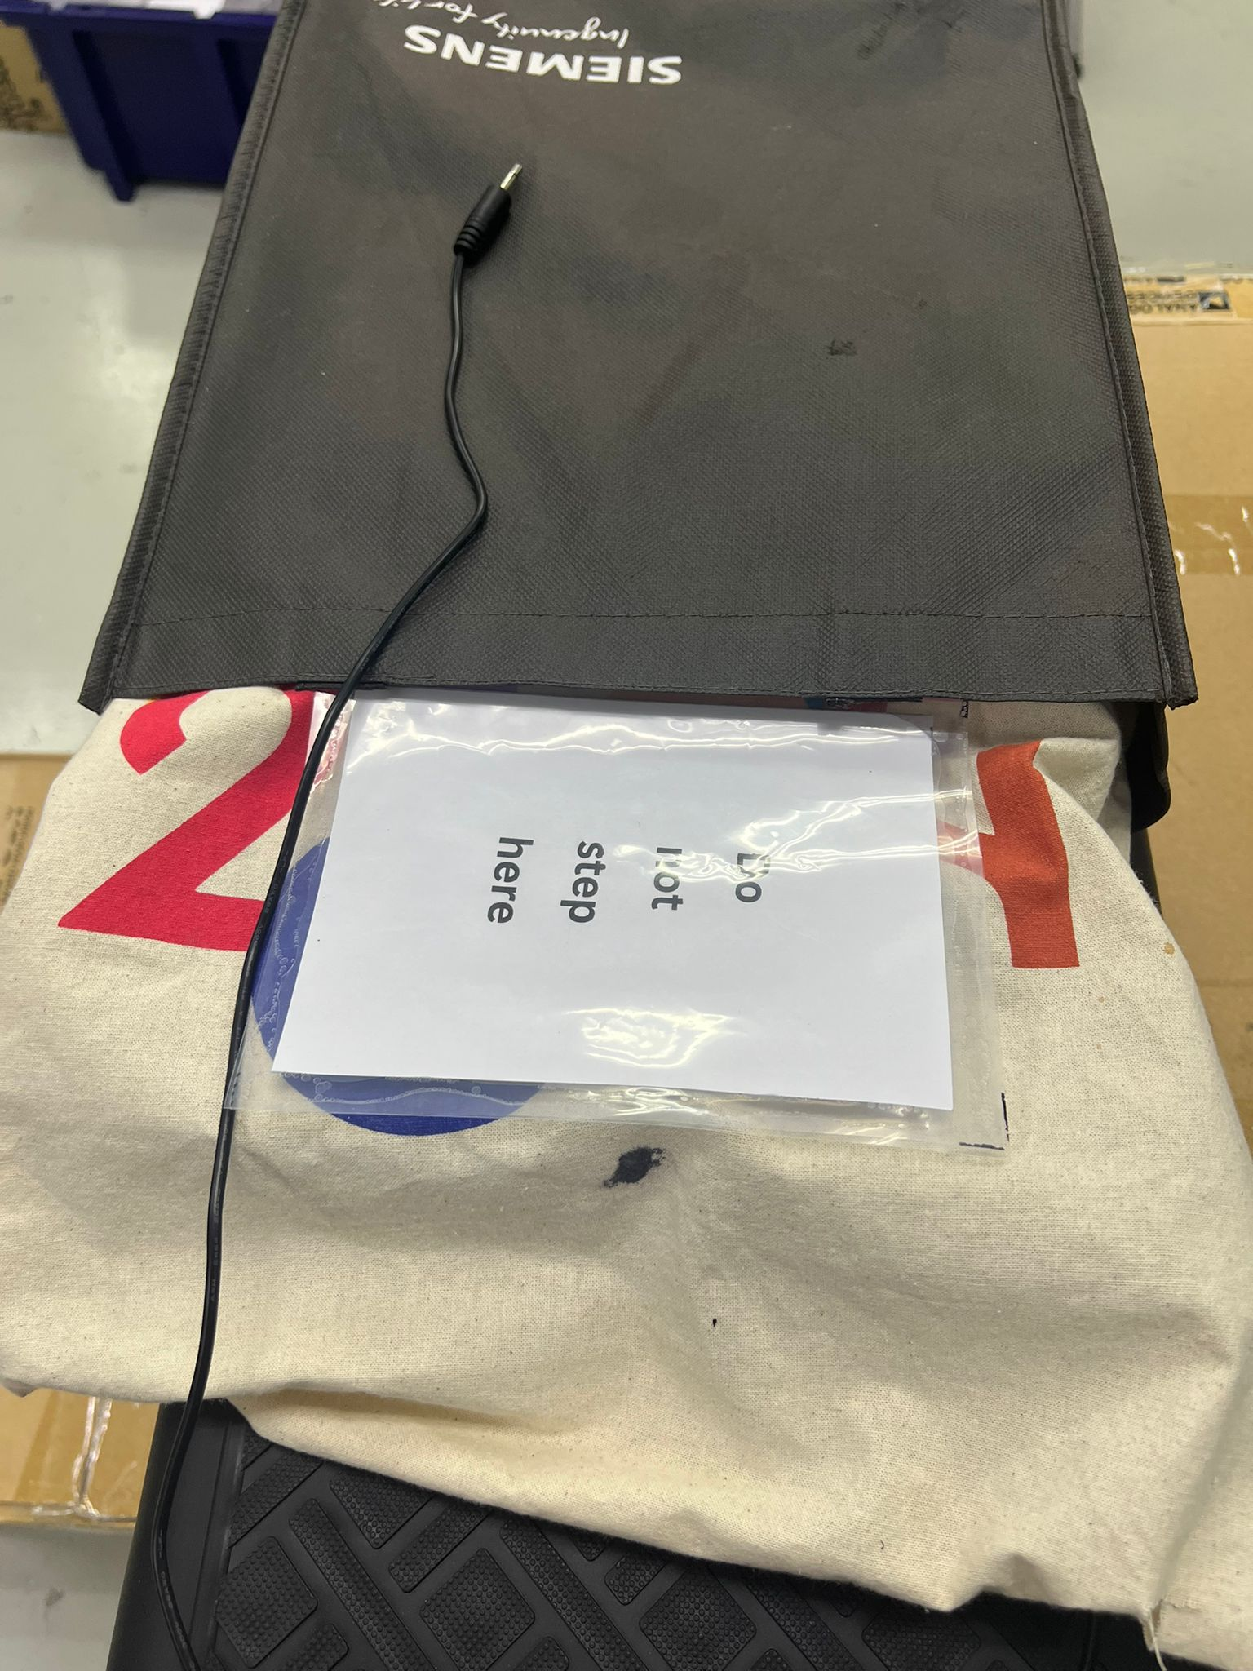
You can choose or not to connect the audio jack to a toy, the audio you recorded will playback anyway. Then, step on the dark part of the step switch. | 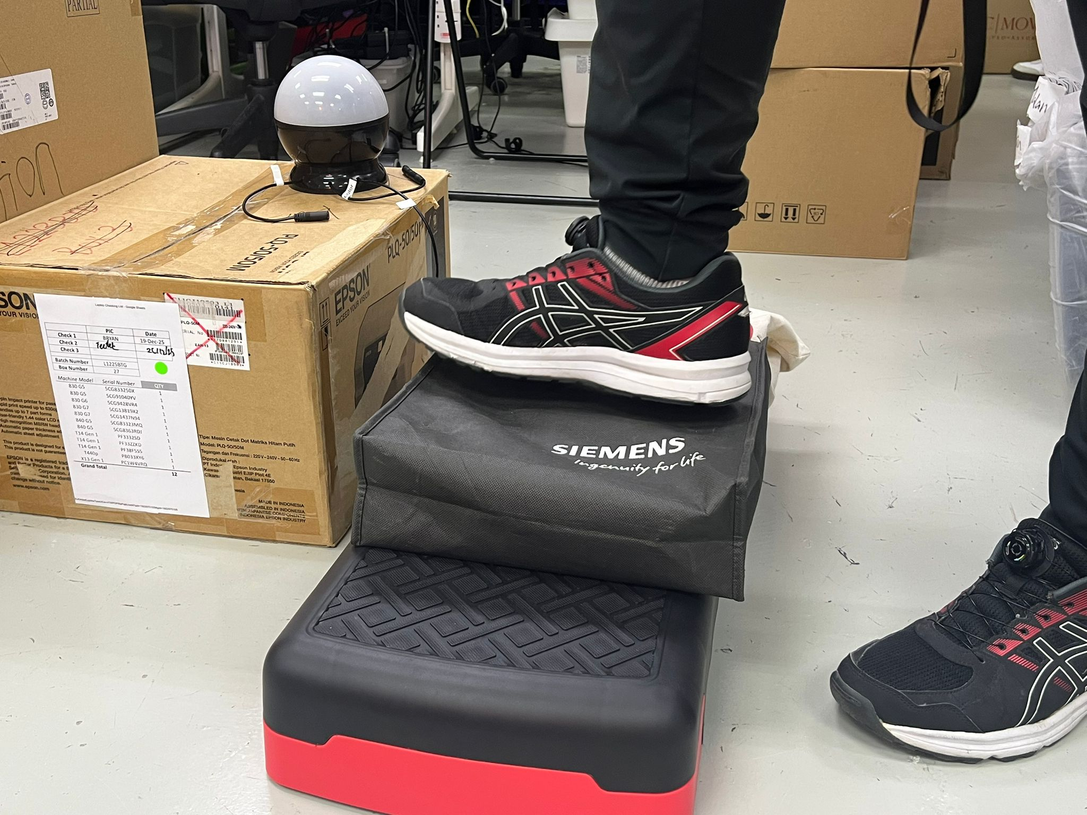
It should play the audio you recorded and turn on the connected toy. | 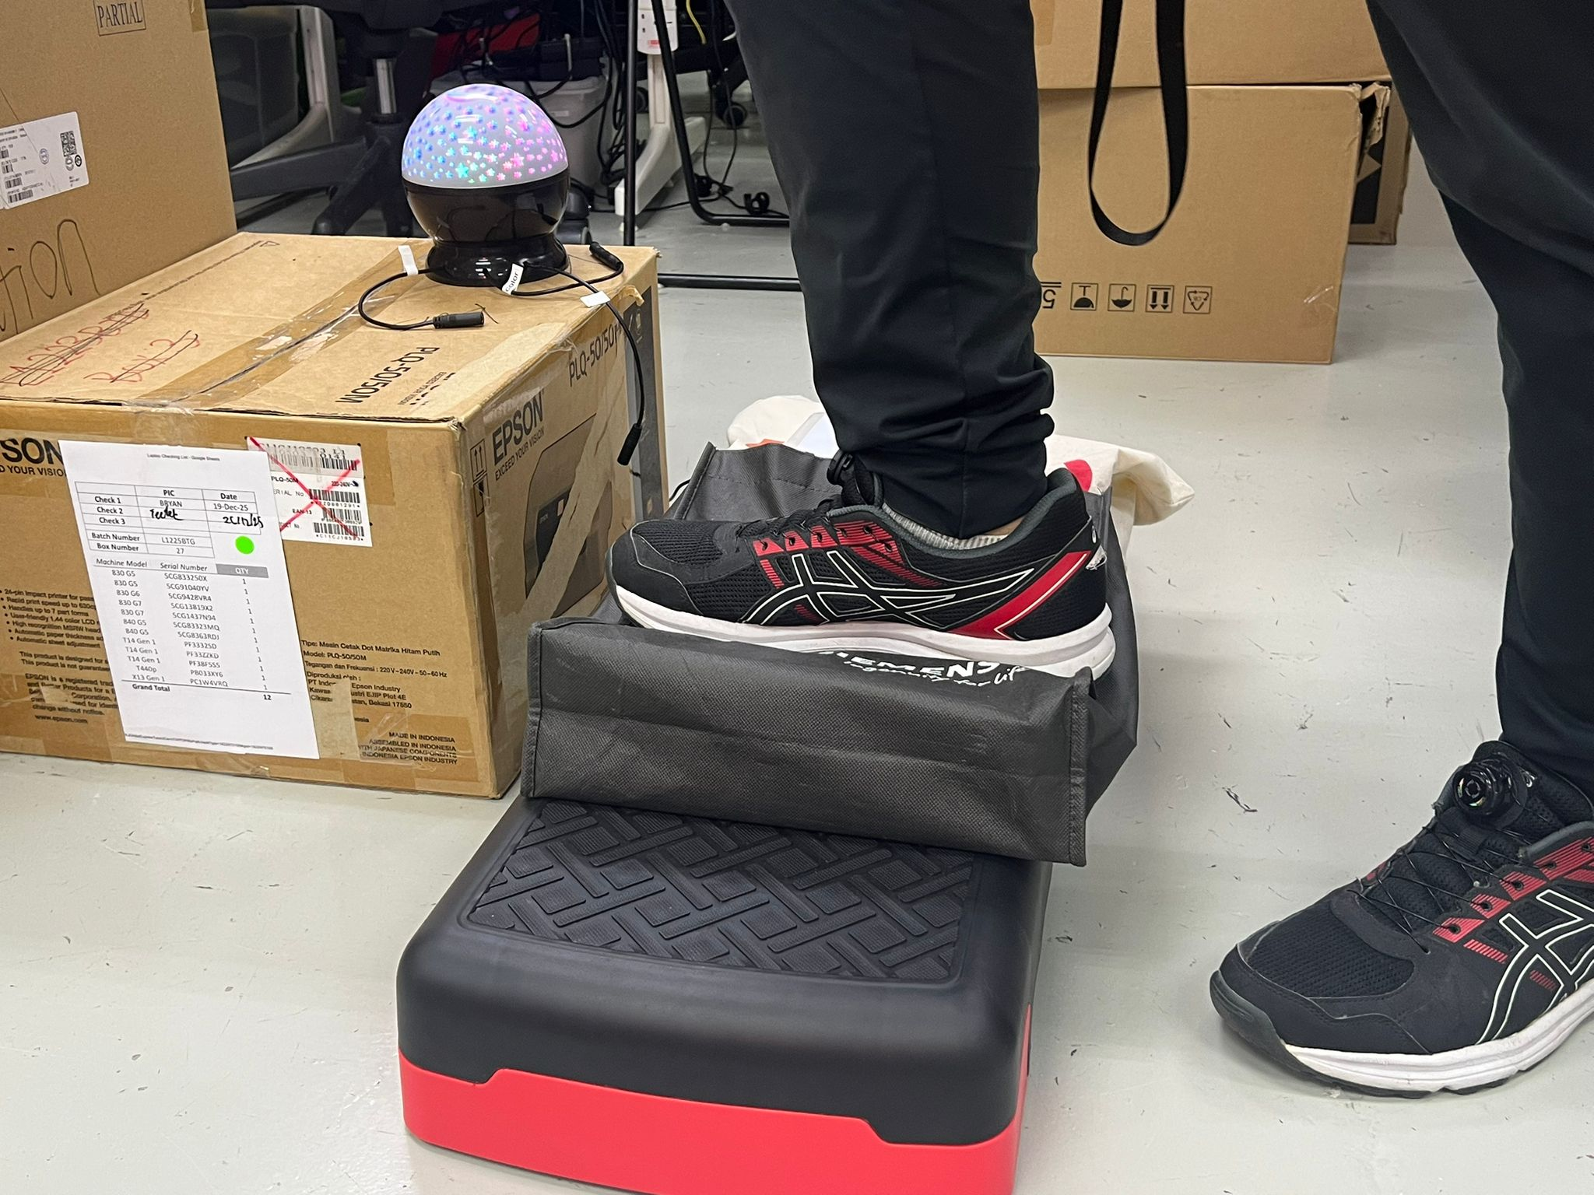

2.2 Maintenance

1. Routine Inspection
- Check if the step switch activates properly when stepped on
- Ensure the outer cloth cover is not torn
- Check that the wires are not frayed, loose, or exposed
- Confirm the step surface is still firm and not sinking

2. Cleaning
- Wipe the outer surface with a dry or slightly damp cloth
- Avoid water entering the internal circuits

3. Electrical Check
- Test if the switch still completes the circuit when pressed
- Check that solder joints are secure

4. Mechanical Check
- Make sure the spring/foam mechanism still rebounds after pressing
- Ensure the switch is aligned properly and not stuck

5. Replacement of Parts
- Replace worn foam
- Re-solder loose wires if needed

6. Testing After Maintenance
- Step on the switch multiple times to ensure consistent activation
- Confirm the connected device turns on/off correctly

2.3 Troubleshooting

Problem | Possible Cause | What You Can Try
Step switch not working | Battery drain | Change the battery to see if it works
 | Battery spoilt because of leakage | Change the battery to see if it works
 | Step switch is malfunctioning because battery leakage has caused the contact points to corrode | Check how bad the corrosion is?  1. If is is very bad that is leaks to the PCB, please replace the step switch,  2. If not try to clean up and replace the battery
Step switch plays back sound but toy is not triggering | Toy issues | 1. Plug switch into a known working toy. If the switch is able to activate the working toy, the issue may lie with the original toy.  2. Check the toy’s product manual for troubleshooting.
Step switch does not activate | Solder broken inside the switch | Resolder the wires inside the switch and try again
 | Top and bottom layer fabric does not contact each other | Check whether the holes in the foam are aligned with the mini peaks at the bottom cloth
Step switch internals circuits are exposed | Check whether the outer cloth layer is torn and exposed | Replace the outer layer with a new tote bag

3. Maker Guide: Assembly Instructions
image

3.1 Assembly Guide

Steps | Images
Cut the foam for form rectangular holes | 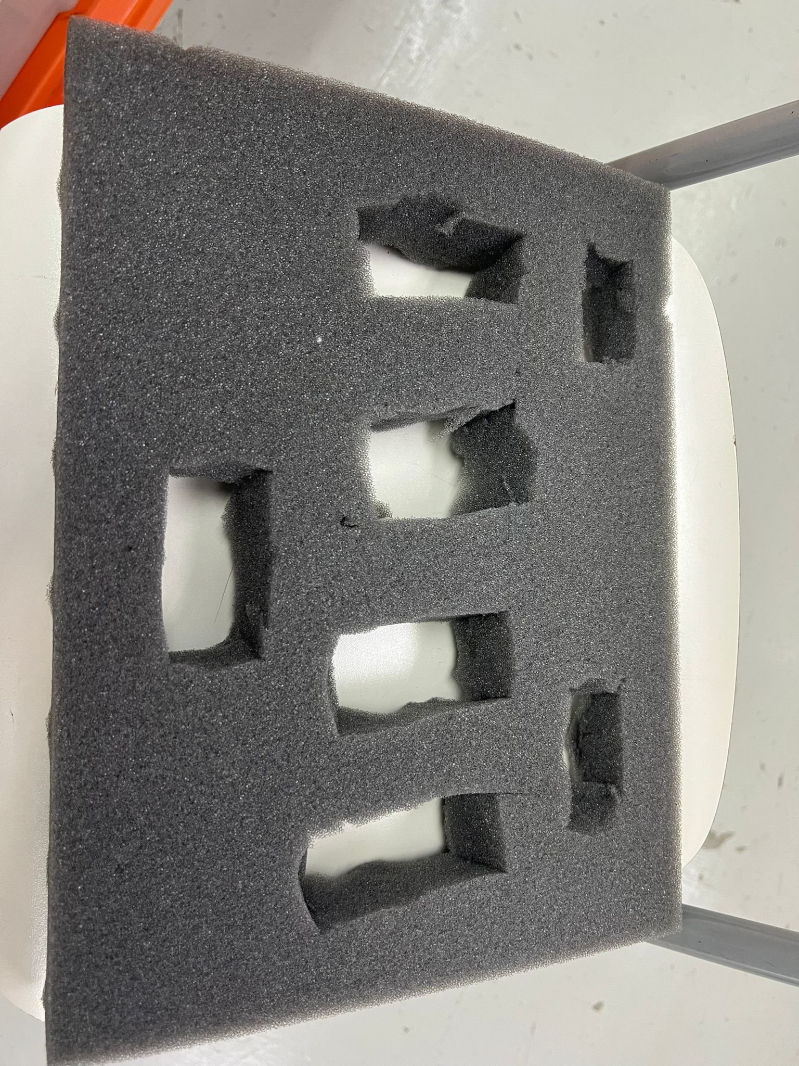
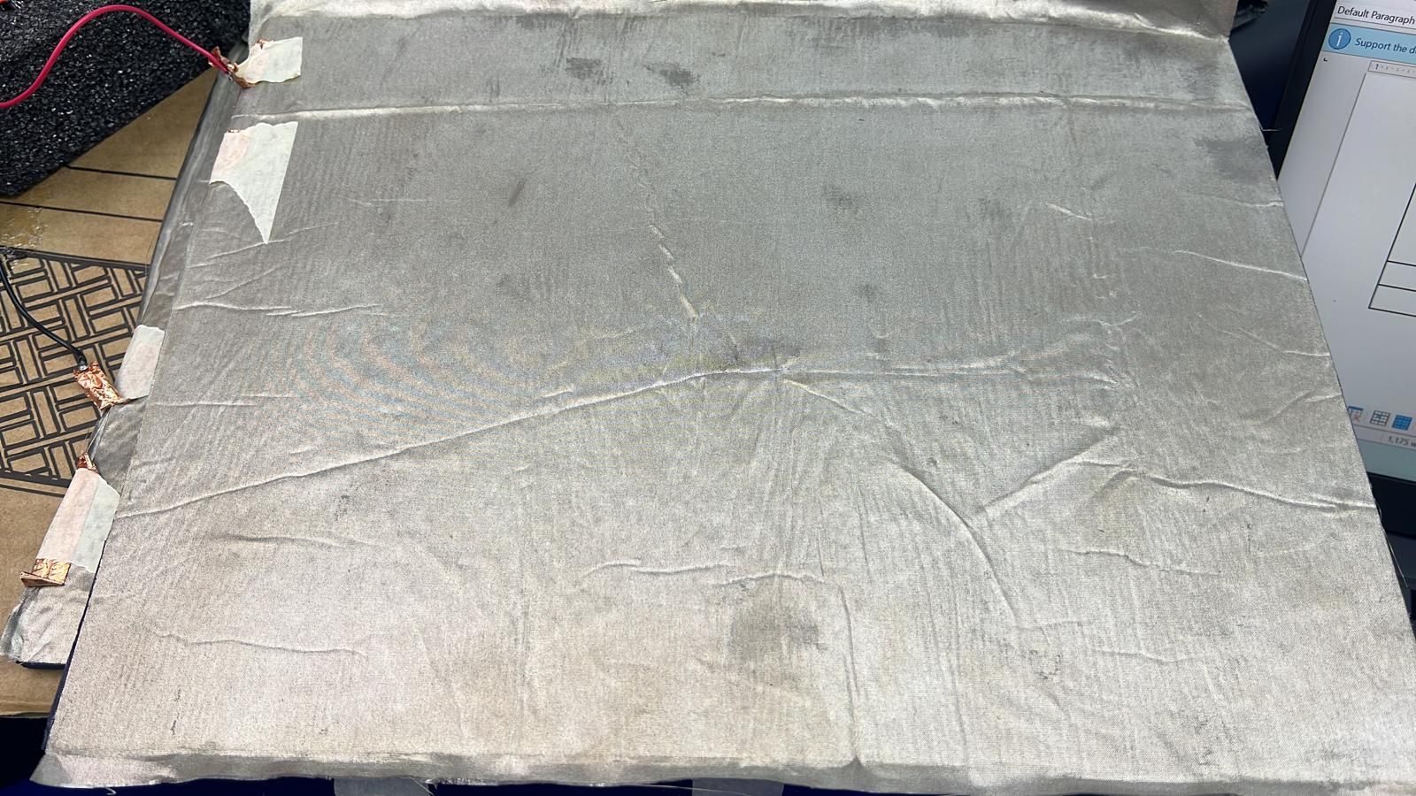  Glue the faraday fabric on the yogamat. Make 2 sets of each, top and bottom. | 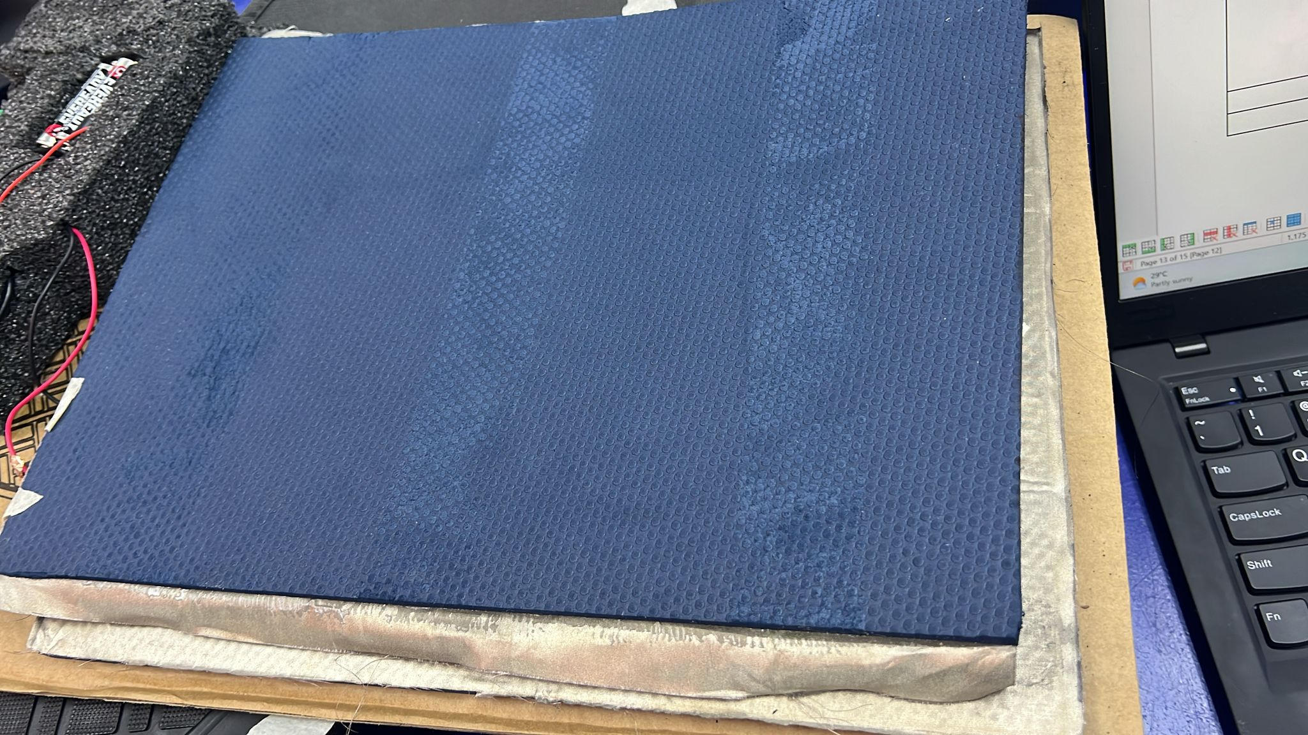
Cut out more of the fabric to make mini “peaks” for the bottom layer.  In the mini peaks, insert mini cardboards.  Then tape it up with masking tape. | 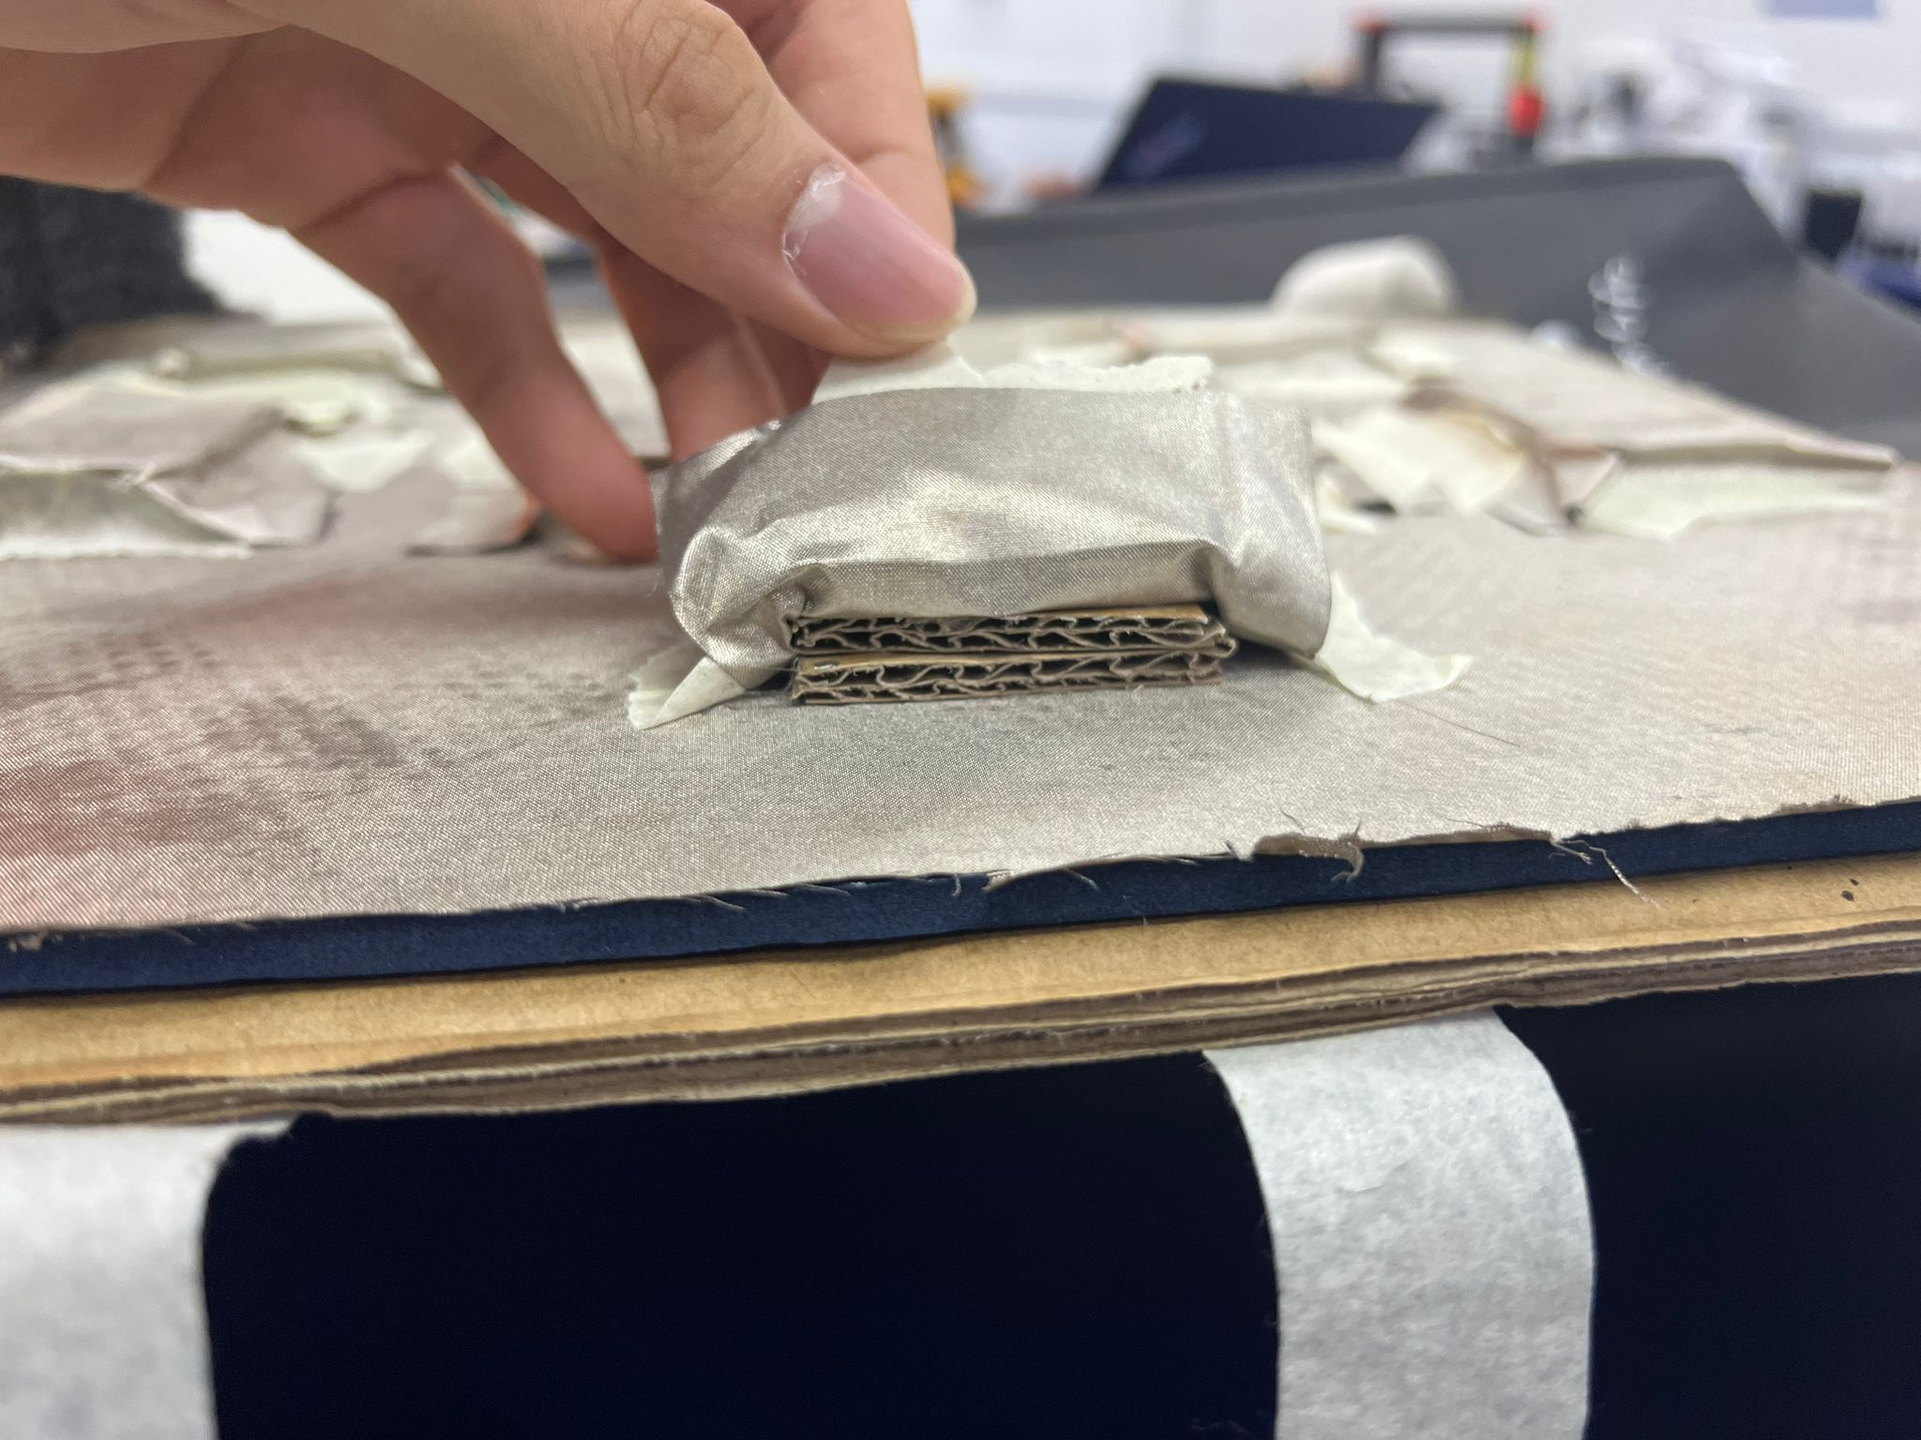  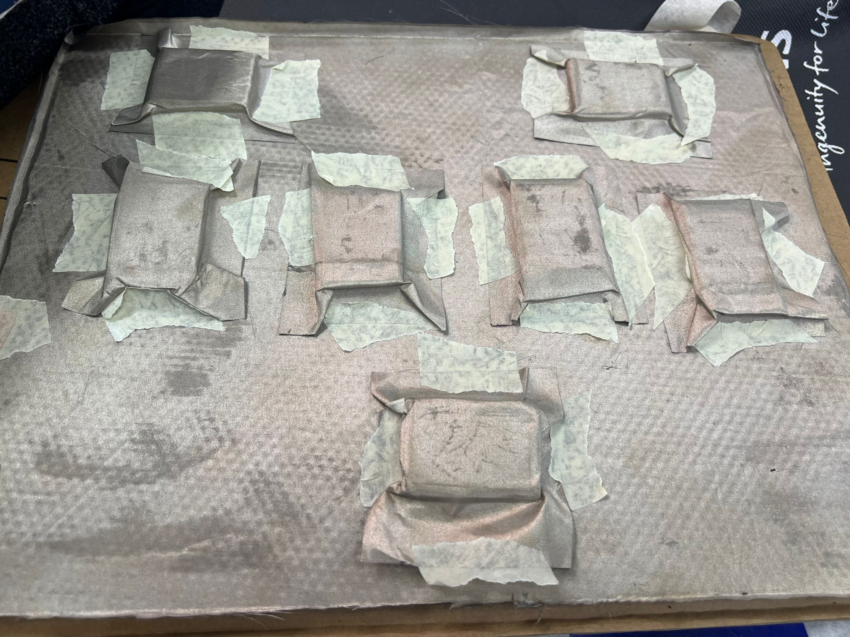
Take out the PCB board from the pet button, then solder in the 3.5mm mono jack audio and the battery holder into the PCB board. | 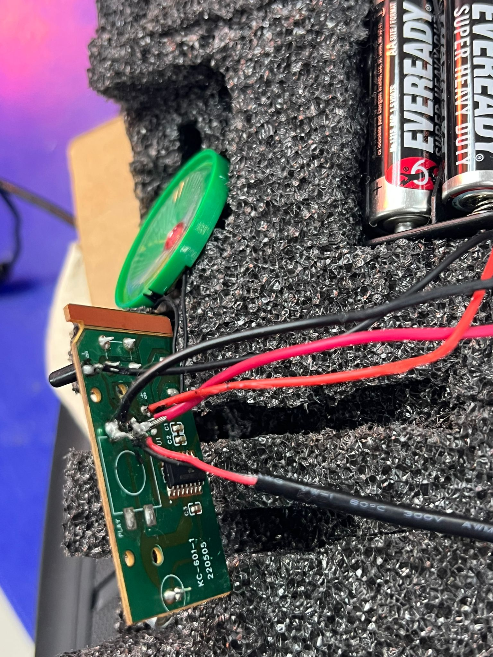  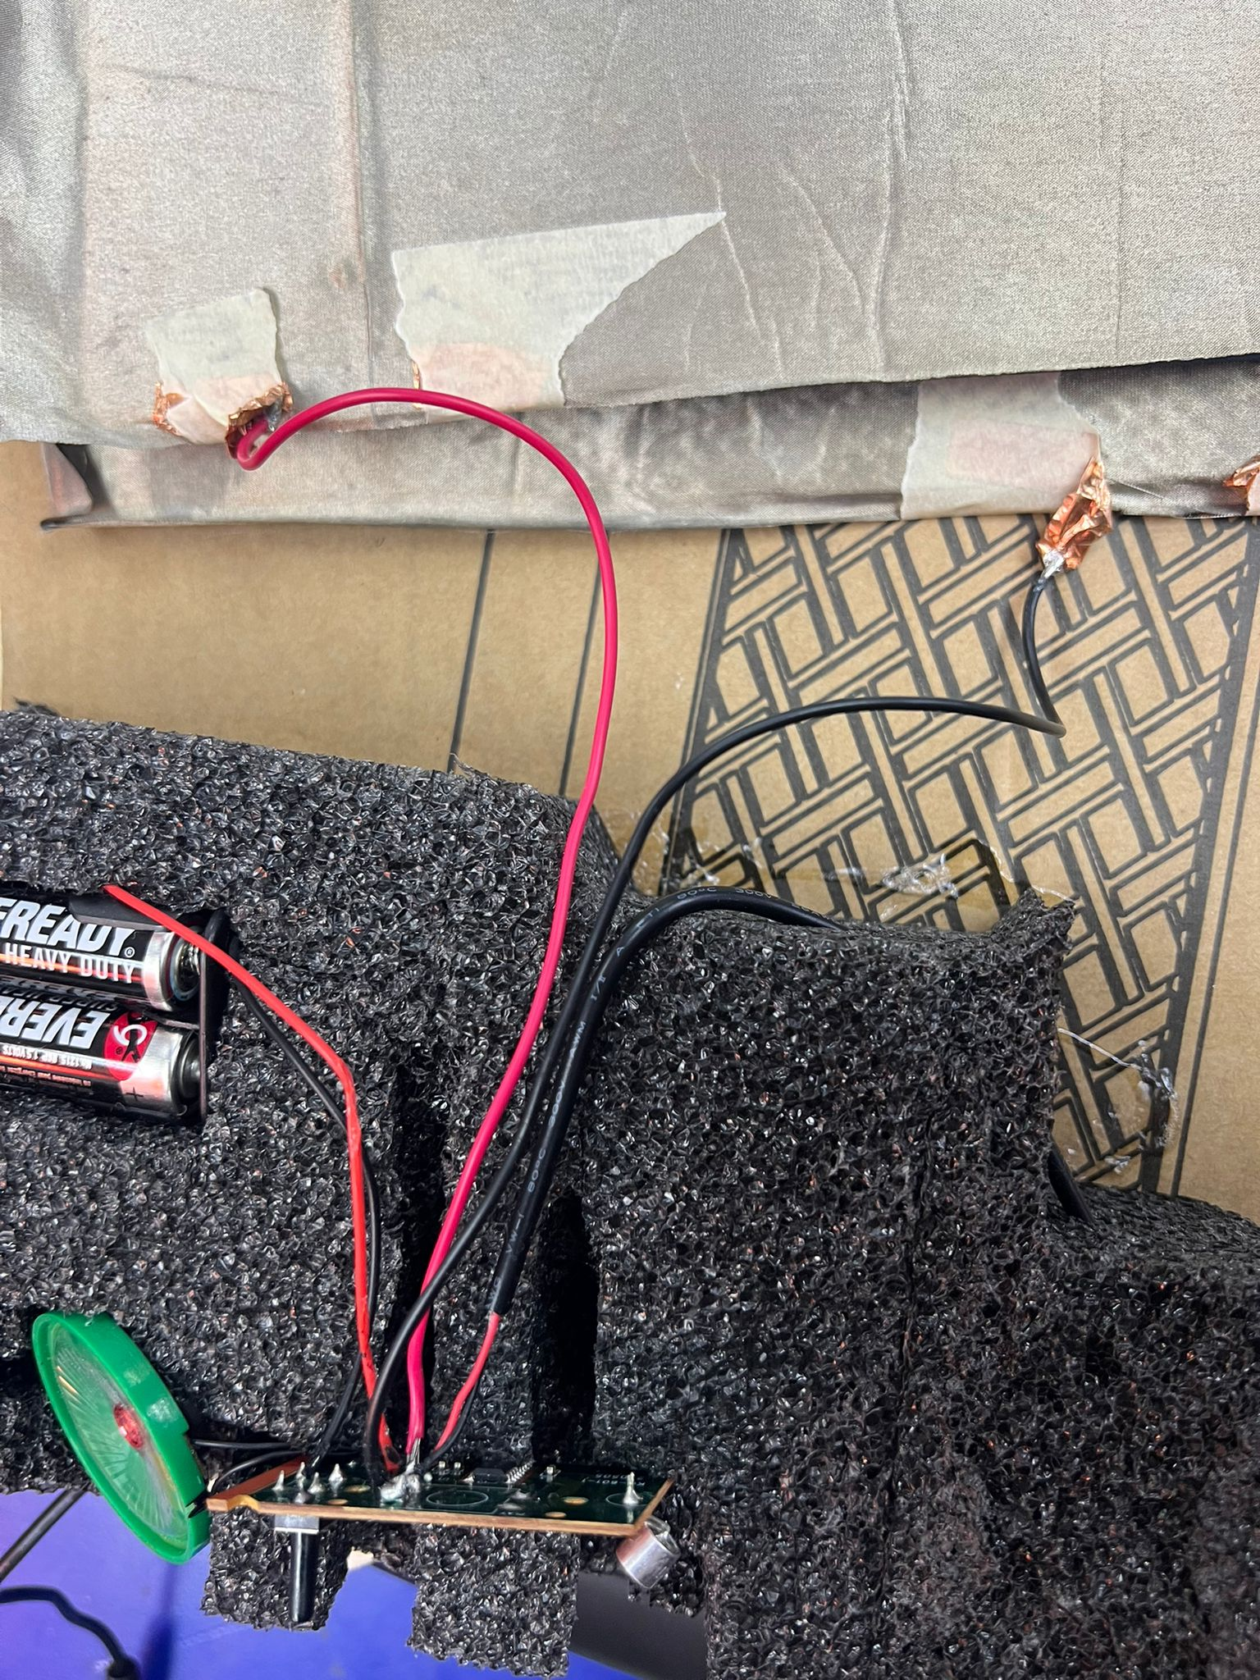  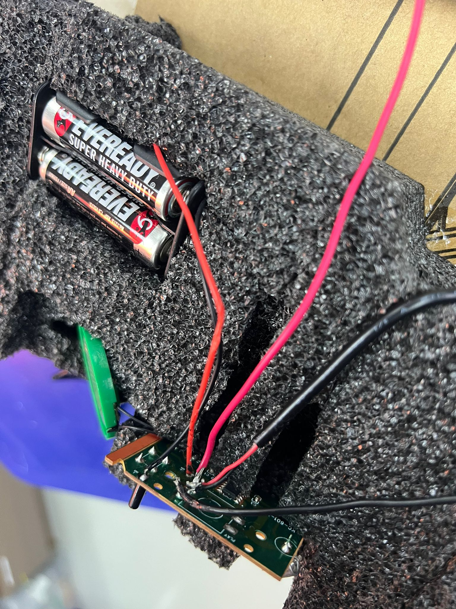
The two wires of the mono audio jack, each of them solder to the copper tape. For a more secured wire, you can tape the wire tip to the faraday fabric. | 
Cut out the EPE foam to store the PCB board, microphone, recorder switch, the speaker and battery holder | 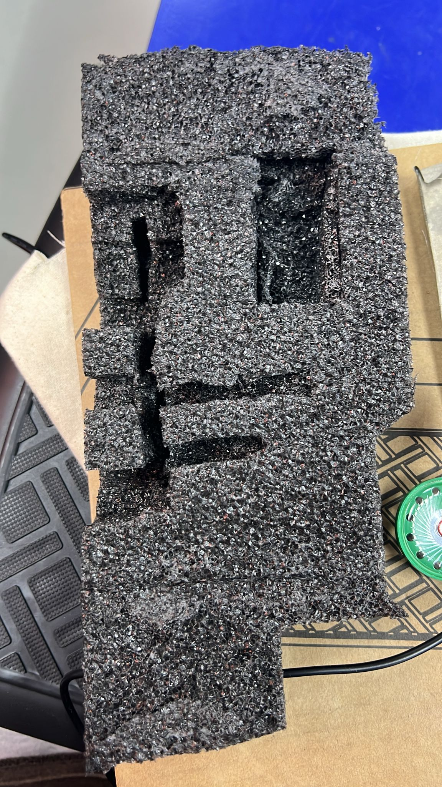
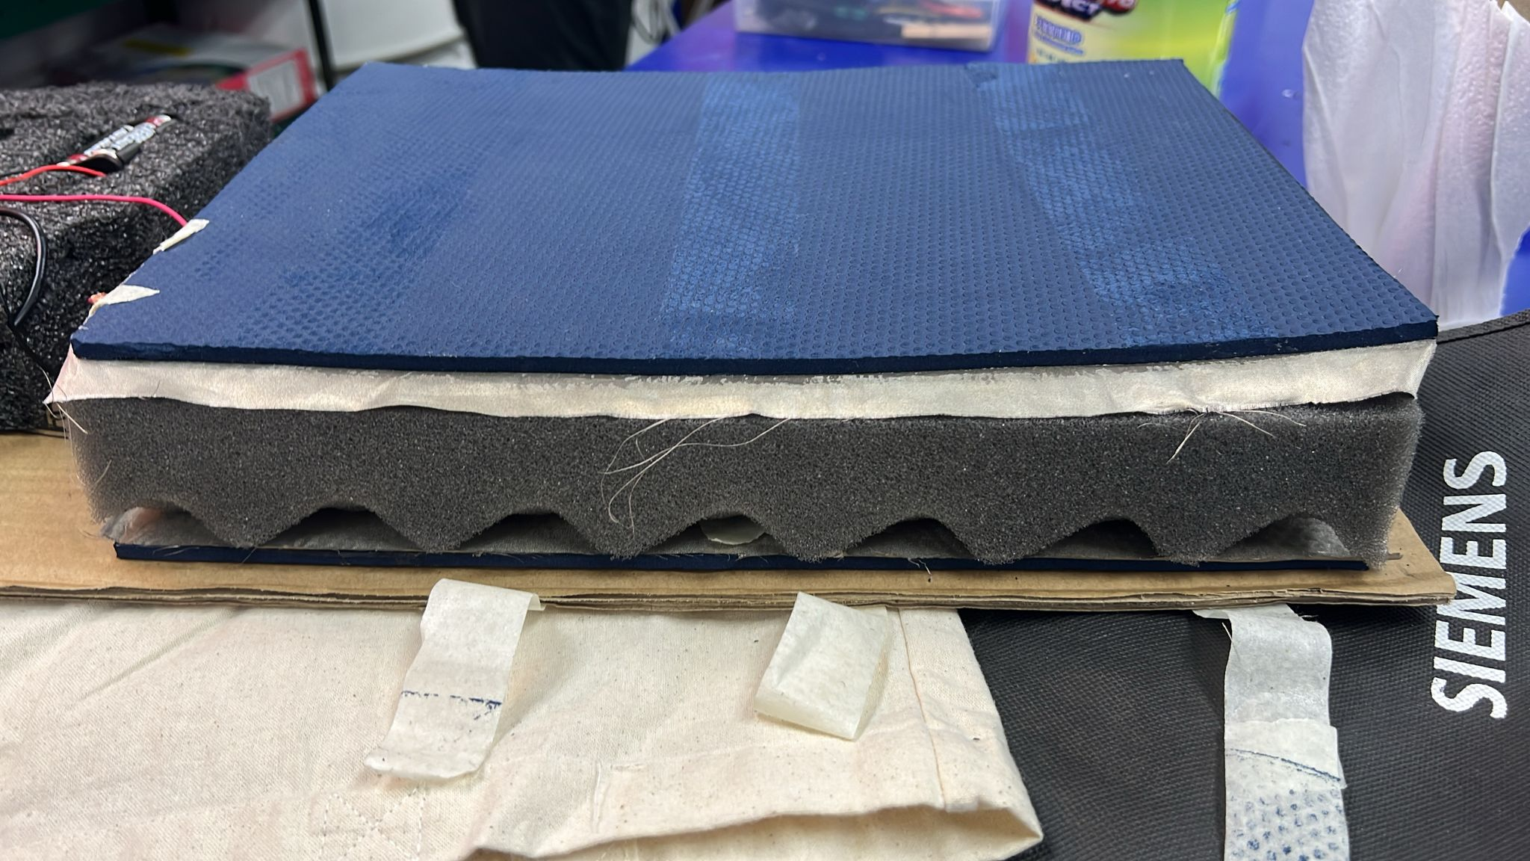  Align the “mini peaks” of the faraday fabric to the foam you have cut. | 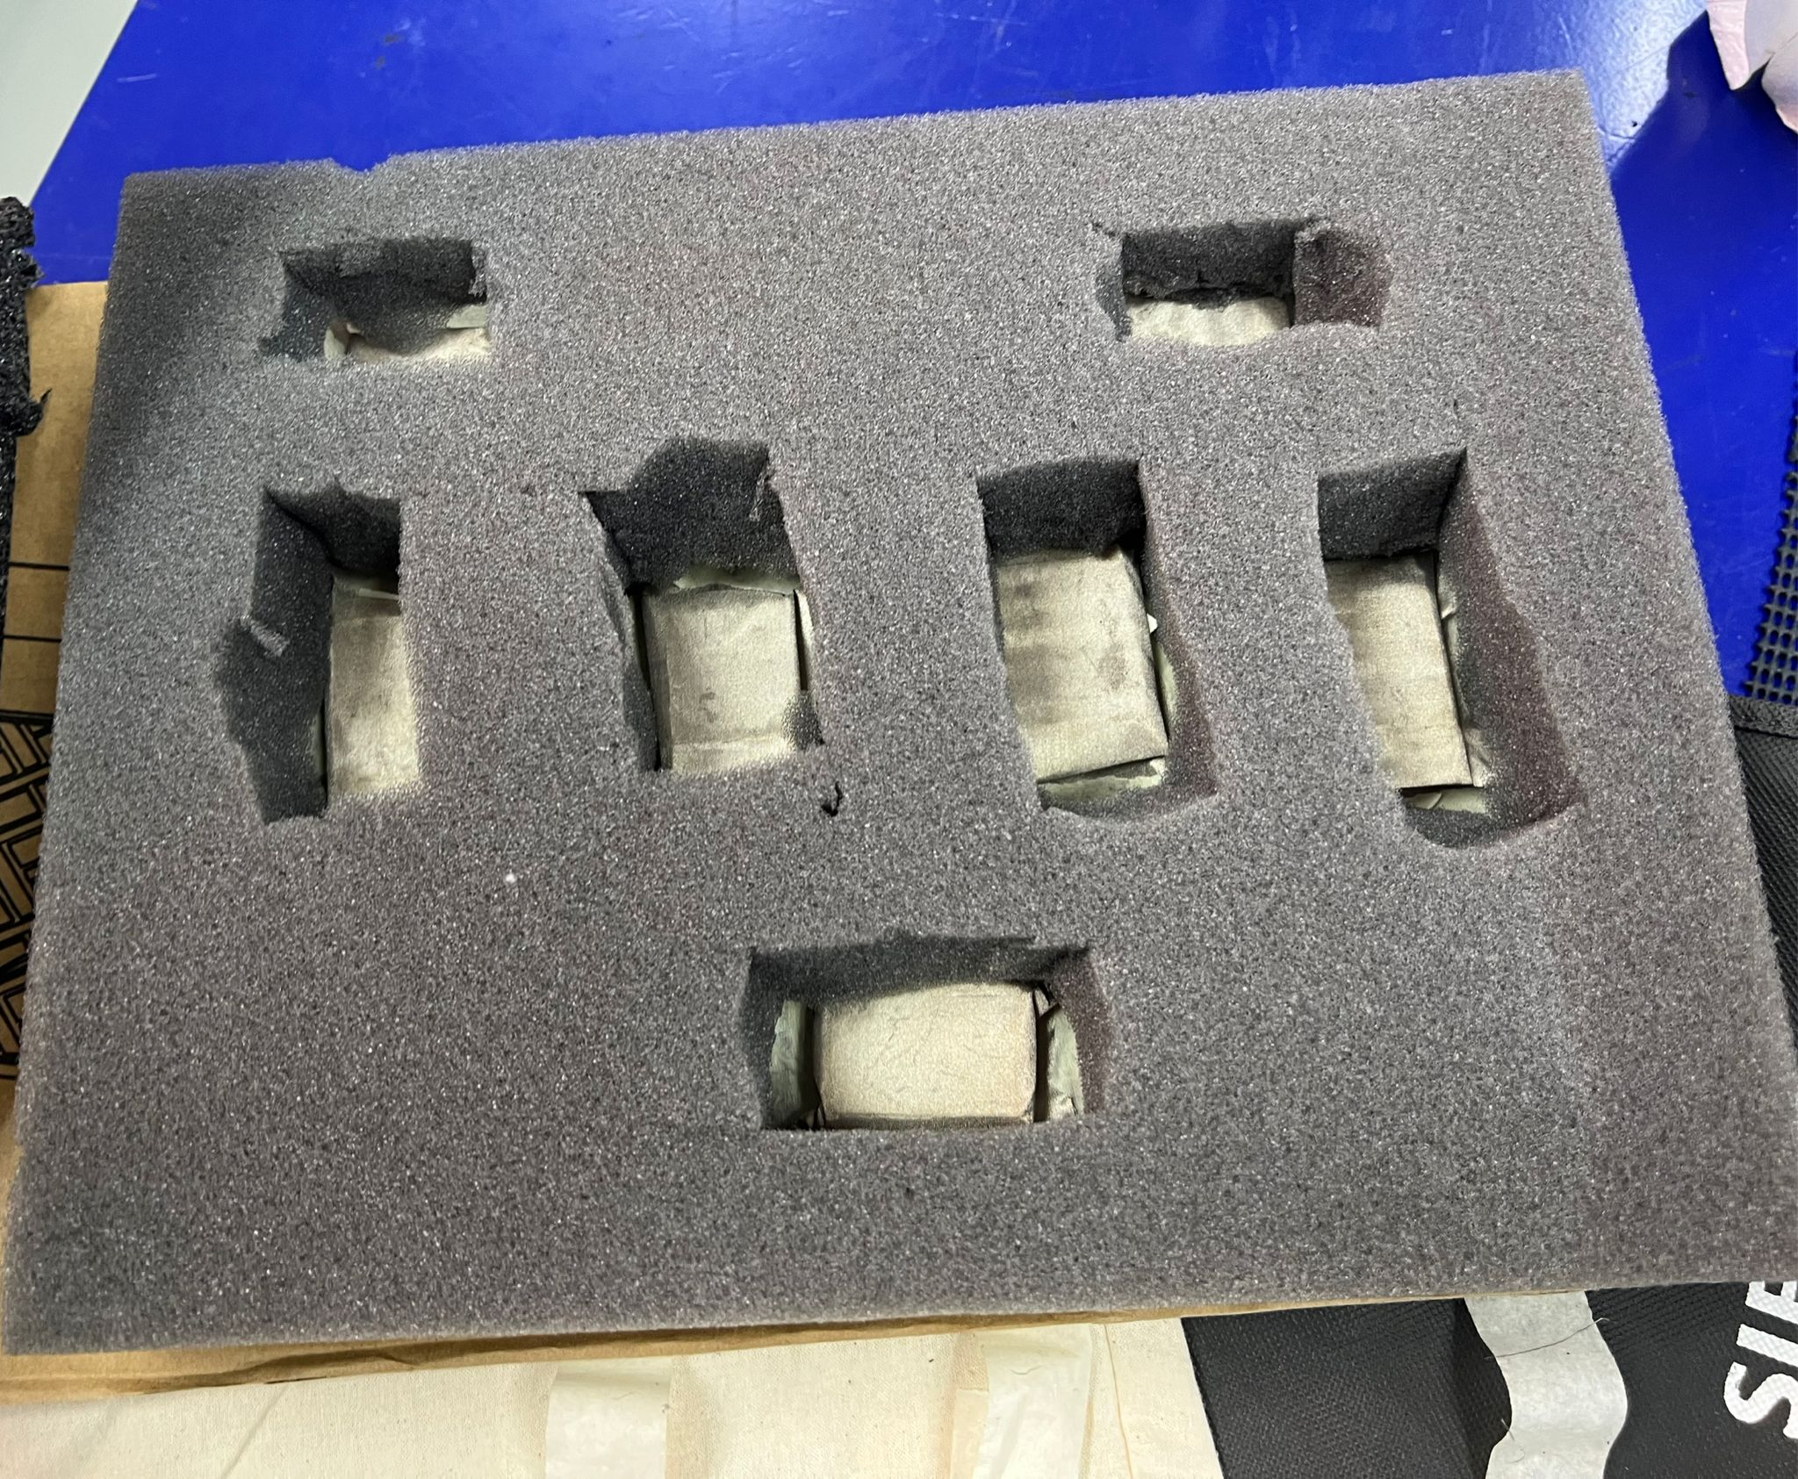
Cover up the foam with the top layer of the
faraday fabric you glued.
Cut out the straps of the tote bags and place Velcro strips on top and bottom | Top:  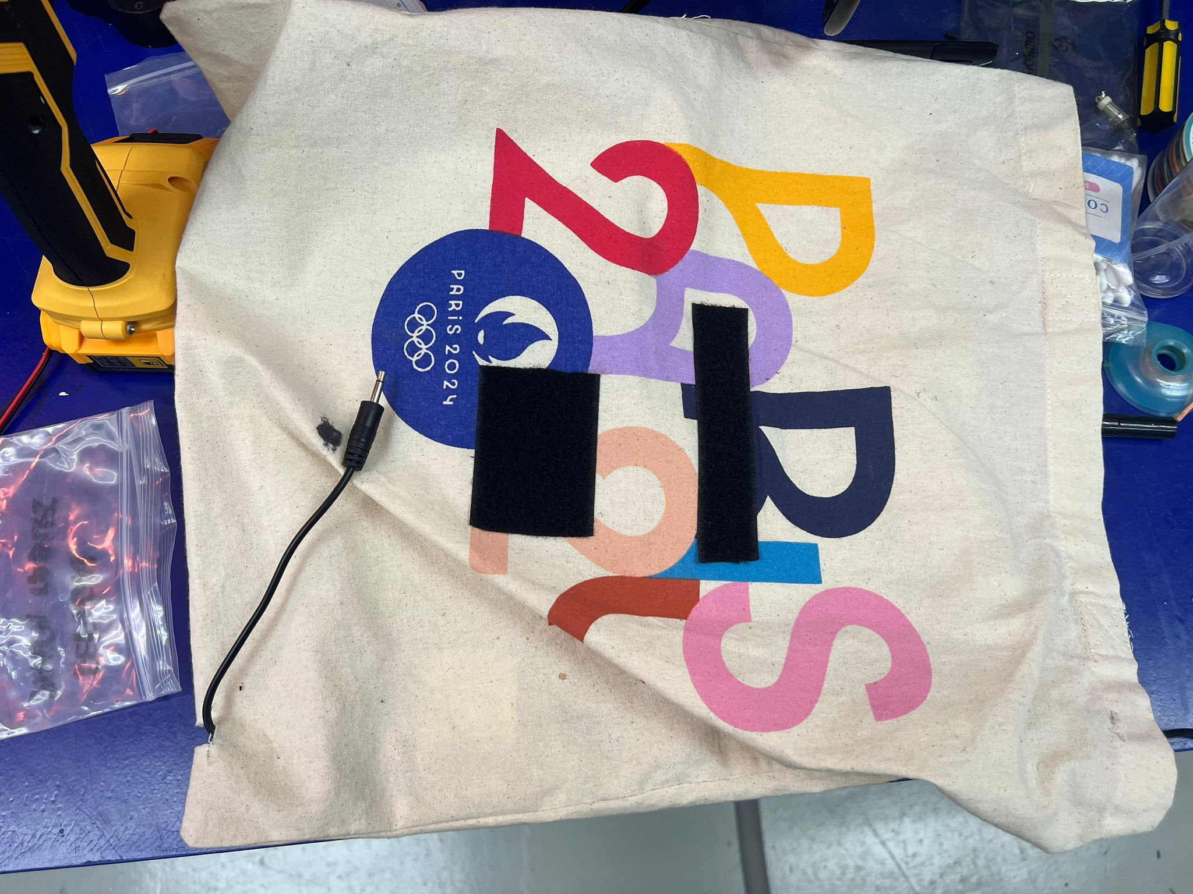  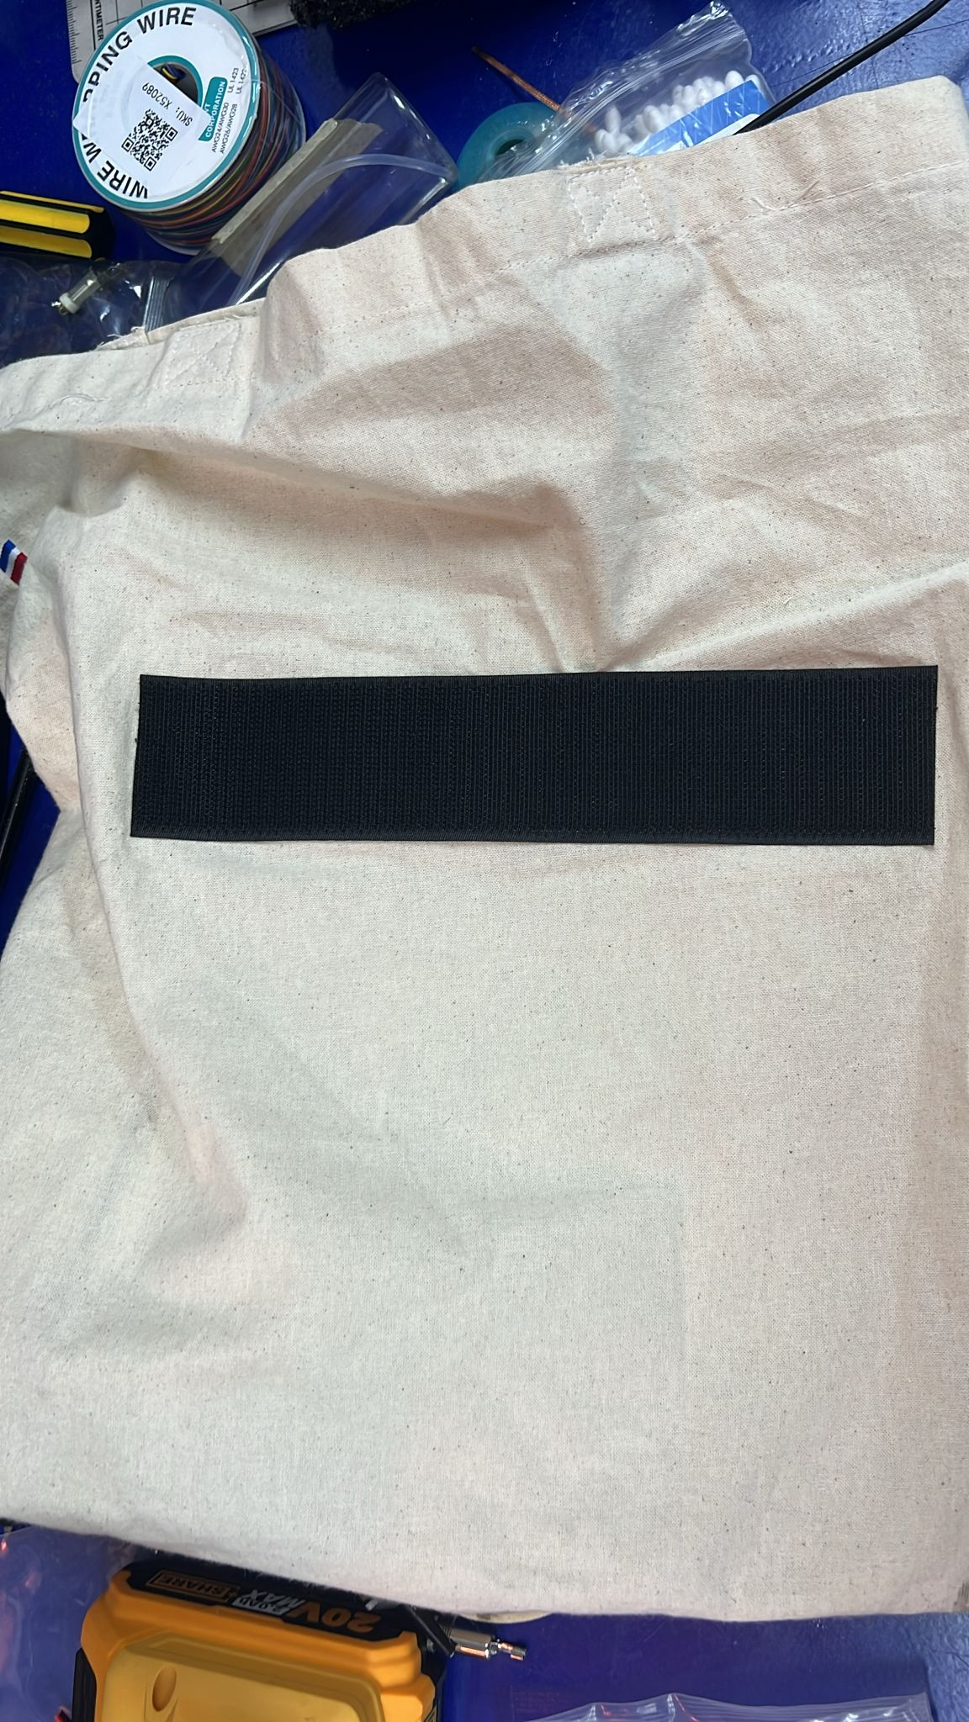  Bottom:  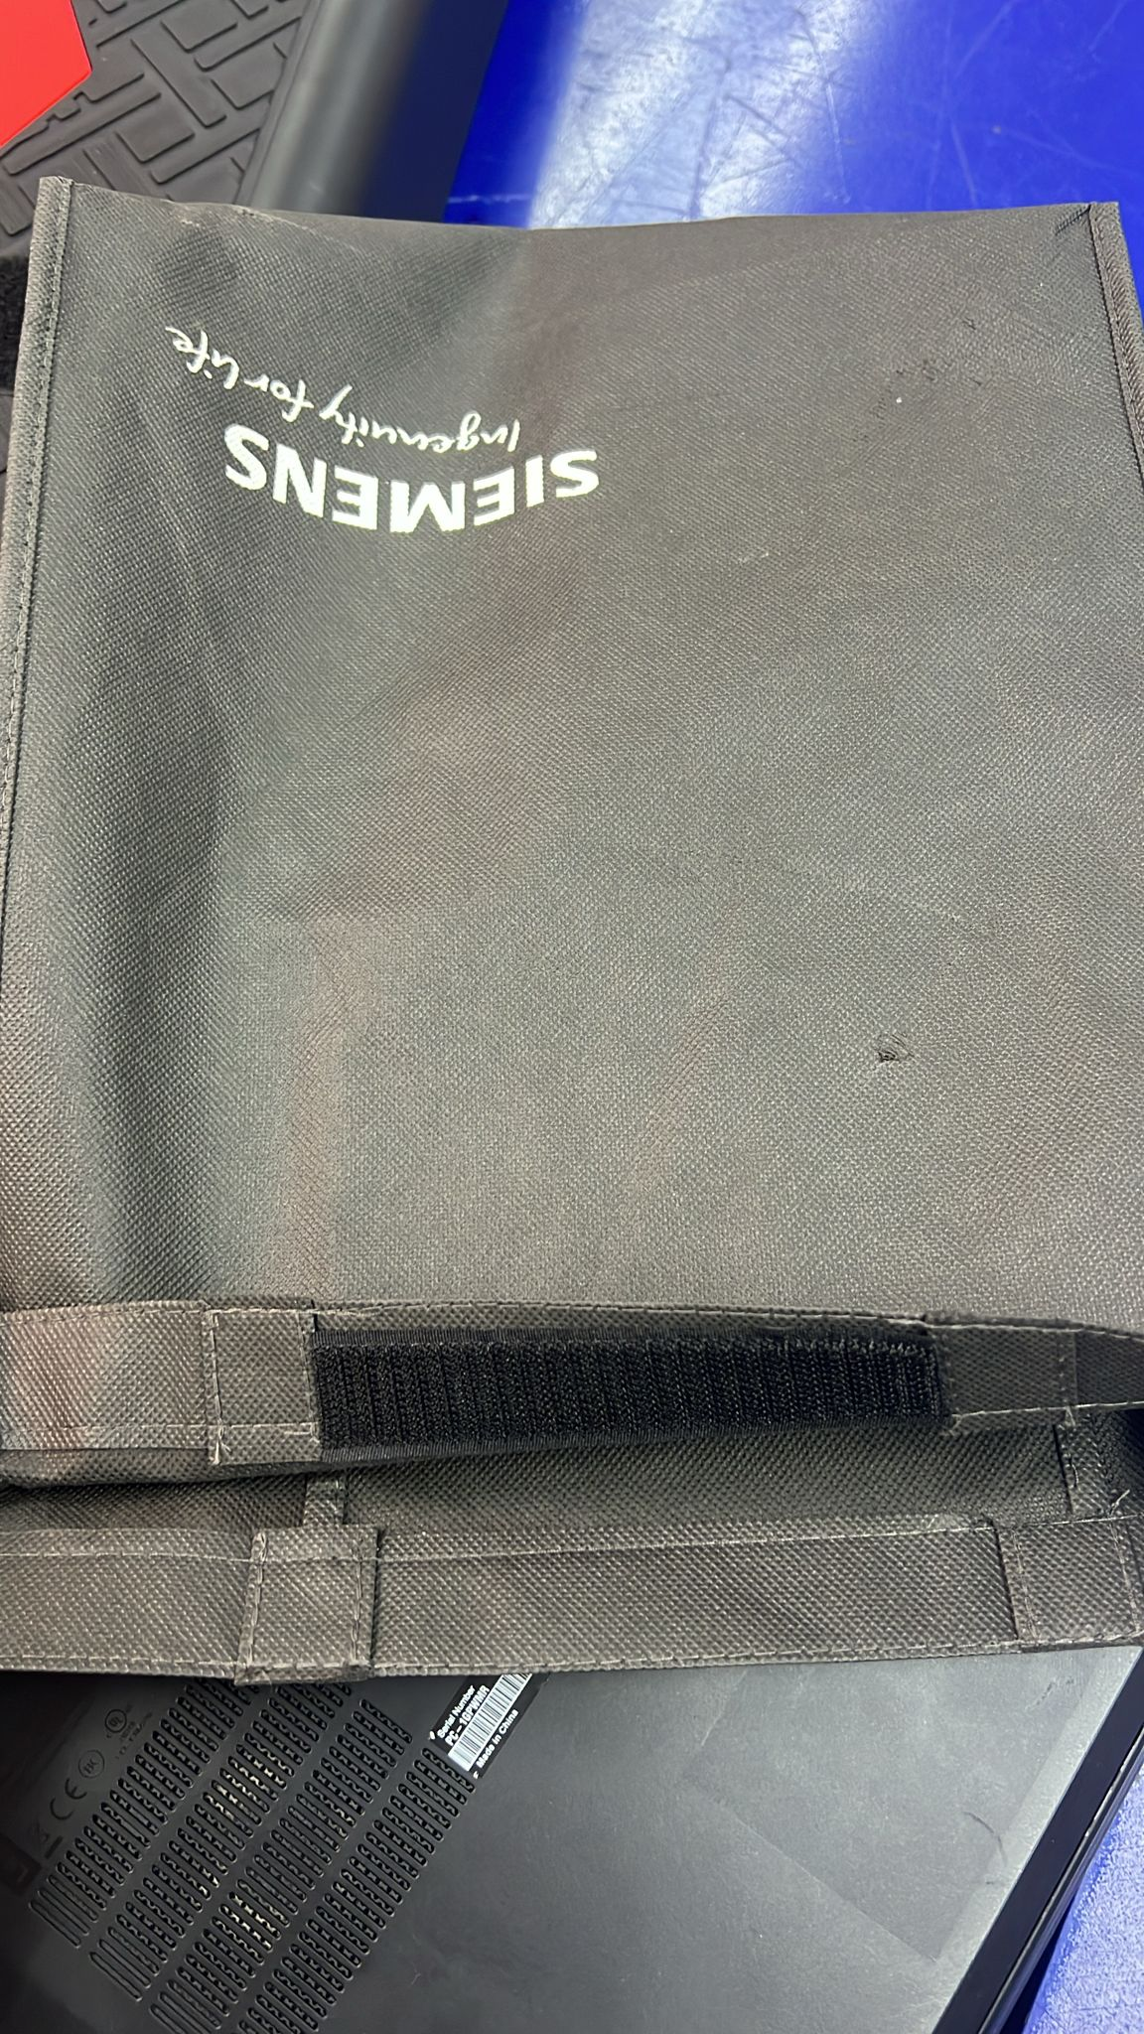  Inside:  Bottom:  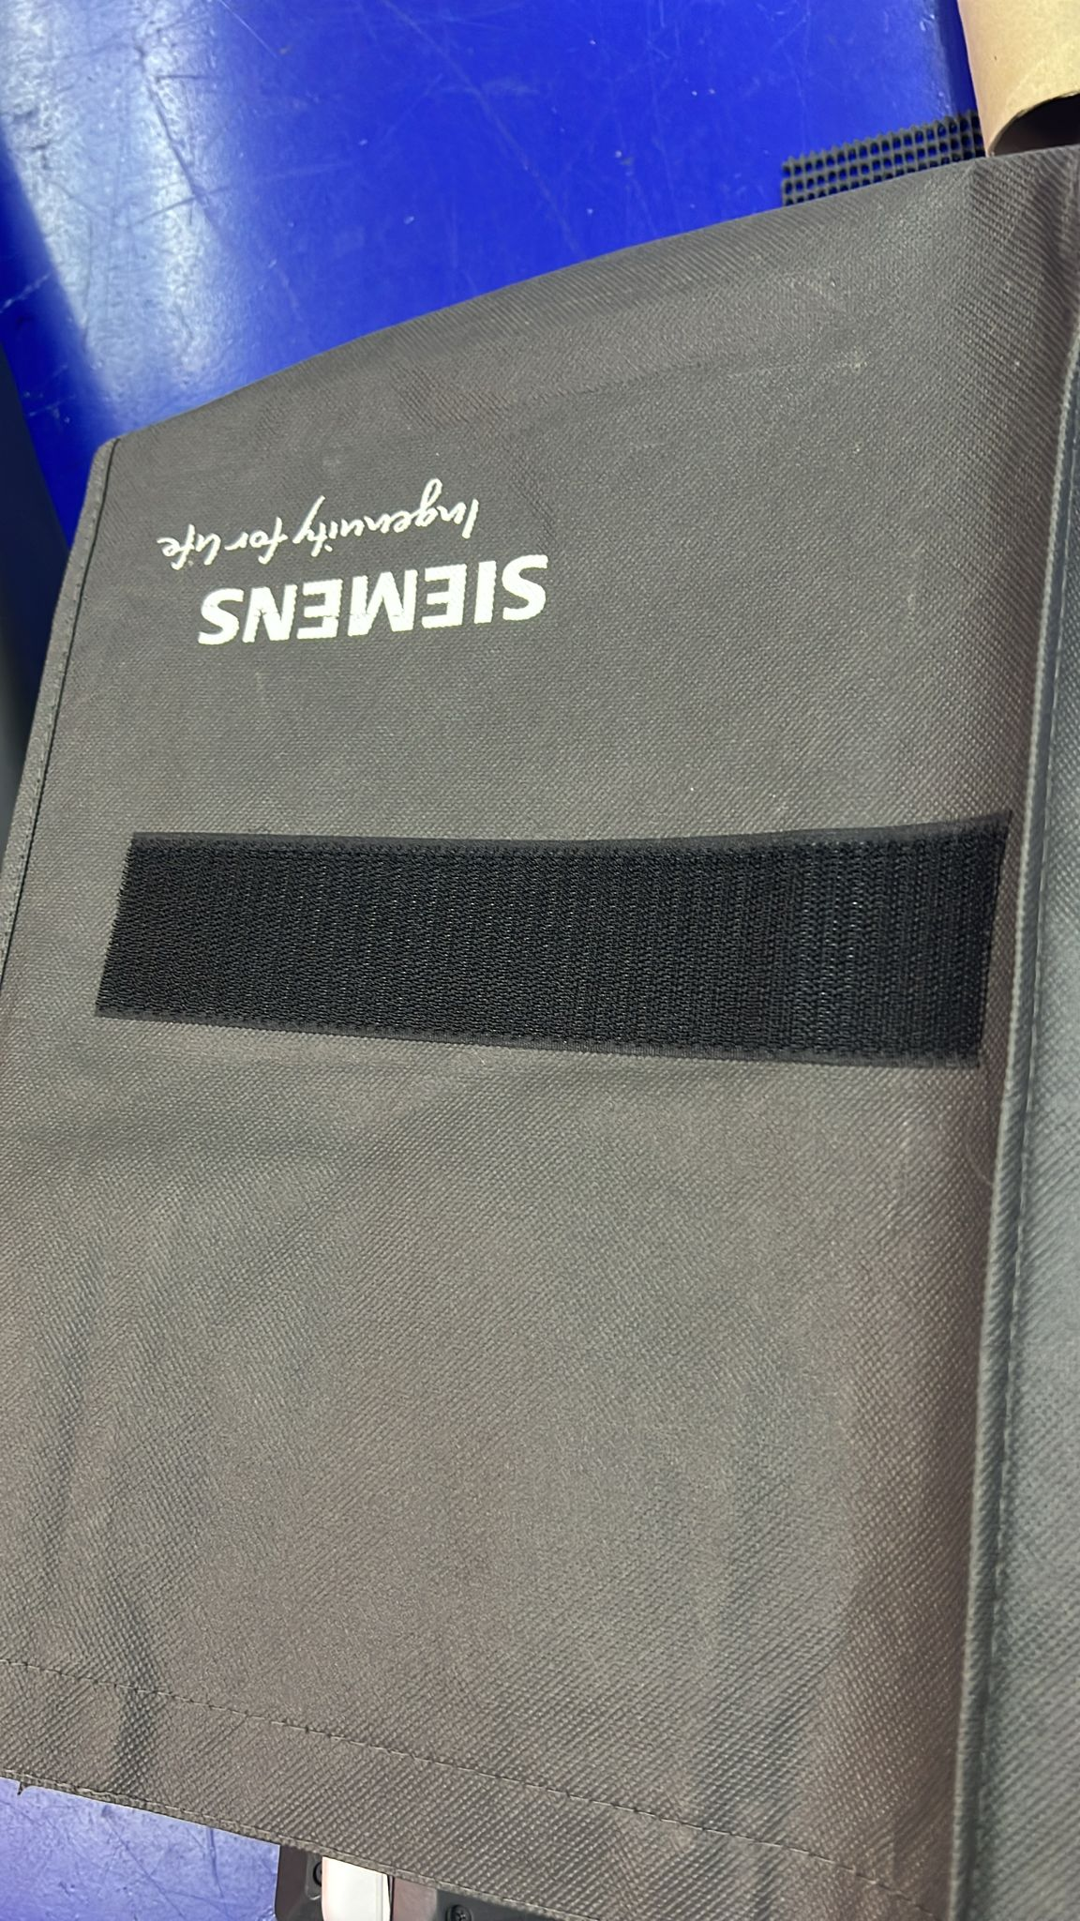
Make a printed paper “Do not step here”  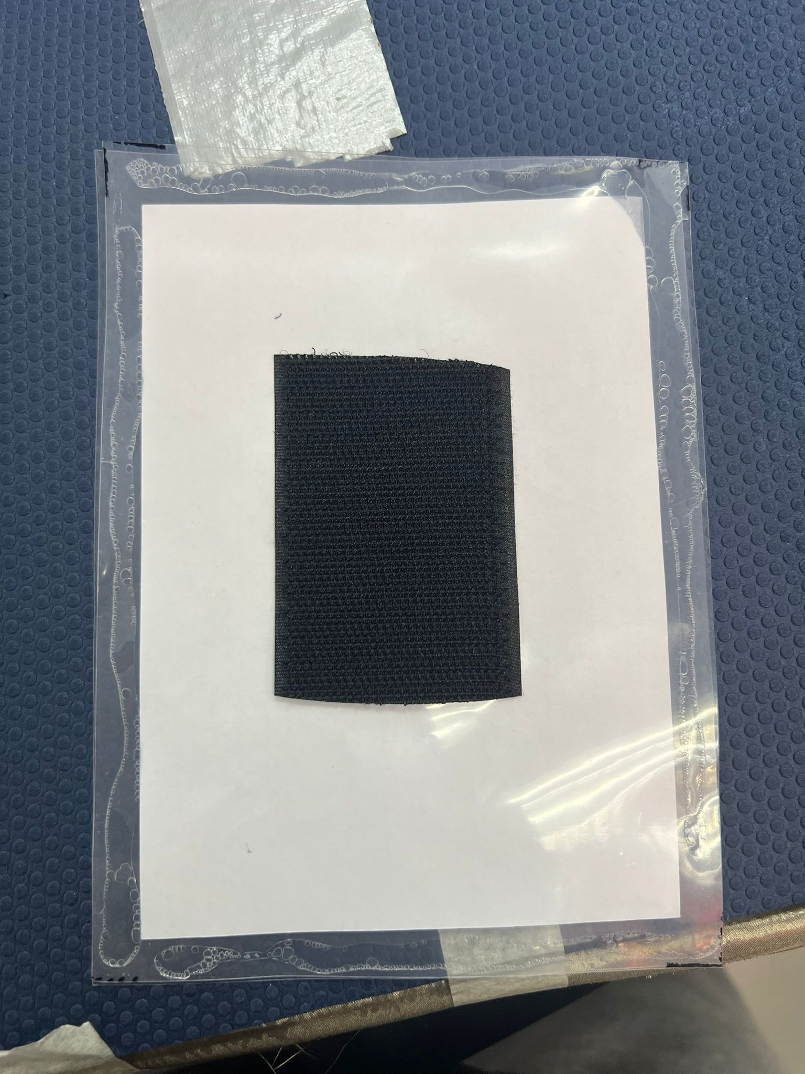    and put 2 plastic sheets together and glue them together. Add Velcro strips to the sheet. Place the other side of the Velcro strip to the tote bag | 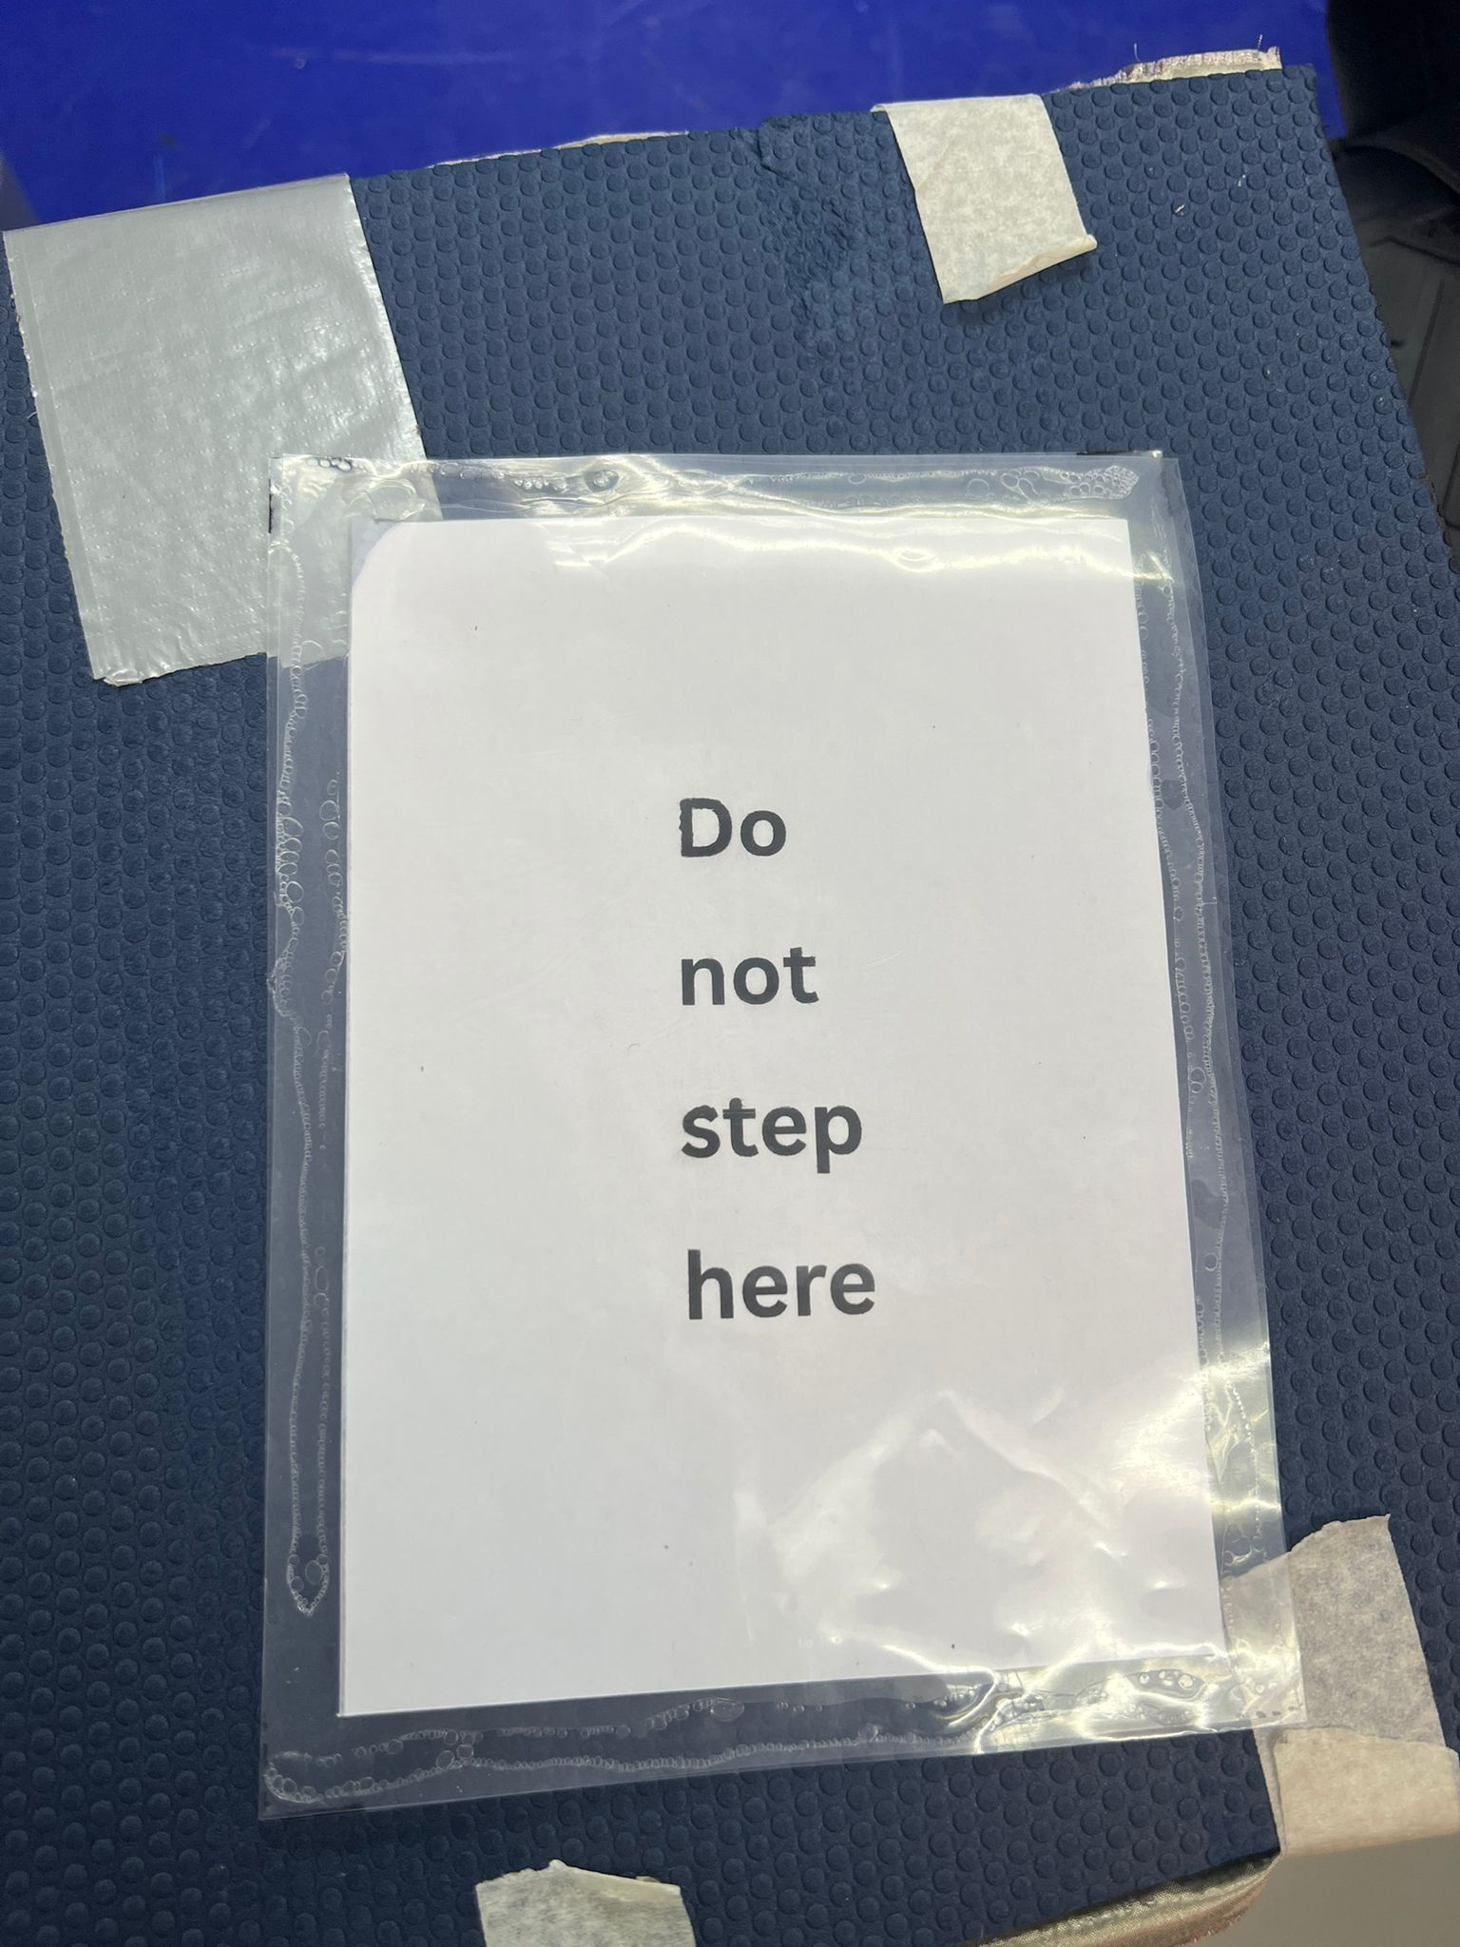
From the 3.5mm mono audio jack, remember to cut a small in the tote bag to let out the audio jack. | 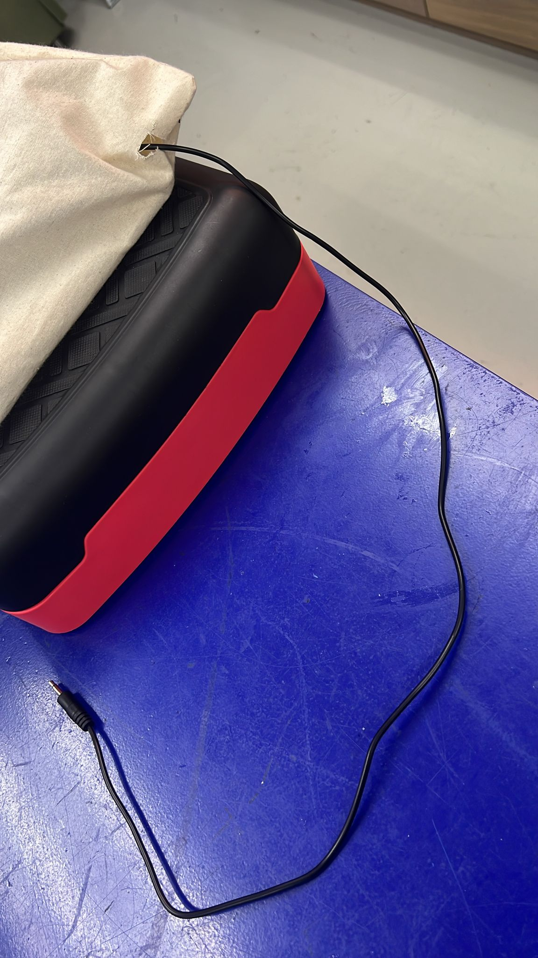
Check that you have Velcro strips on the stepper as well. | 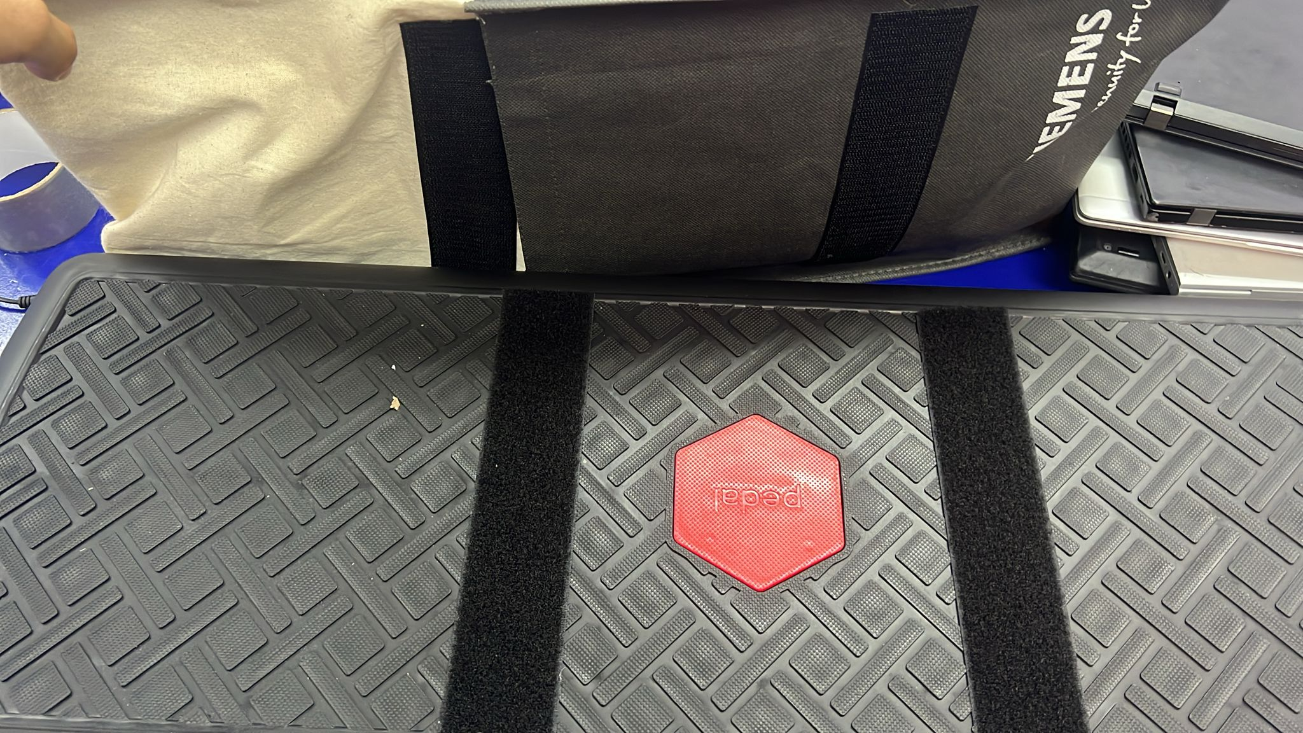
Finished! | 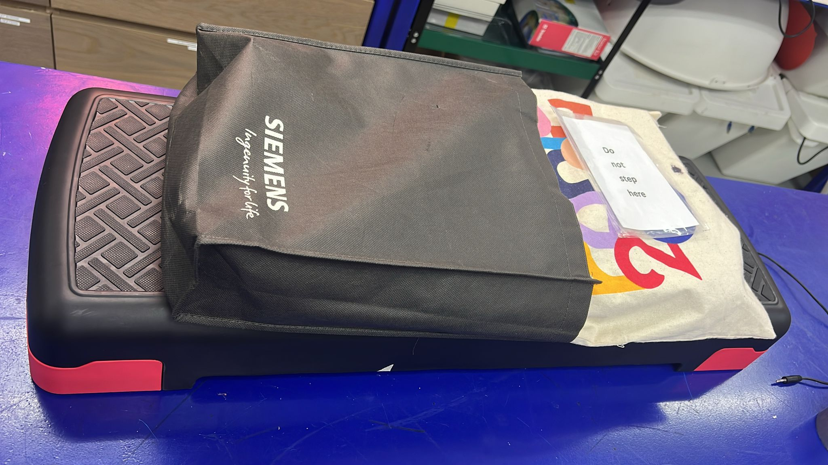

4. Credit and Open Hardware Licence
This section provides the required legal notices and attribution for the open hardware design used to create this product.

4.2. License Statement and Source Availability

The hardware design used in this product is licensed under the CERN Open Hardware Licence Version 2 – Weakly Reciprocal (CERN-OHL-W 2.0) or later.
By distributing this product, we are obligated to make the complete design source available to you.
- Complete Source Availability: The complete design files (Source), including schematics, assembly instructions, and any modifications made by Engineering Good, are available free of charge at a permanent online location: github url
- Modification Notice: This version of the product name design was modified by Engineering Good to include the 3.5mm mono audio jack functionality for triggering other toys. The full, modified source is available at the URL listed above.
- Full License Text: The complete legal text of the CERN Open Hardware Licence Version 2 – Weakly Reciprocal** follows this section.

4.3 CERN Open Hardware Licence Version 2

The full text of the license is available here: CERN-OHL-W 2.0 Full Text

