Remoteness-Data-EDA

#################################################################################  
# SCRIPT OVERVIEW  
# Exploratory data analysis (incl. data quality review of remoteness data)  
#################################################################################  
  
library(tidyverse)  
library(raustats)  
library(ggplot2)  
#library(hrbrthemes)  
  
load("data/master_data.RData")  
master <- master_social_good  
glimpse(master)  
summary(master)  
  
u_r <- master %>%  
 select(date, unemployed, population, territory_sa4, remoteness_index) %>%  
 mutate(unemploy_rate = unemployed / population)  
glimpse(u_r)  
  
summary(u_r)  
#date unemployed population territory_sa4 remoteness_index  
#Min. :2006-01-01 Min. : 570 Min. : 27801 Length:15390 Min. :1.000   
#1st Qu.:2009-07-01 1st Qu.: 3989 1st Qu.:127171 Class :character 1st Qu.:1.008   
#Median :2013-02-01 Median : 6060 Median :182056 Mode :character Median :1.161   
#Mean :2013-01-30 Mean : 7280 Mean :210216 Mean :1.785   
#3rd Qu.:2016-09-01 3rd Qu.: 9319 3rd Qu.:262458 3rd Qu.:2.318   
#Max. :2020-03-01 Max. :37202 Max. :699356 Max. :4.548   
#unemploy_rate   
#Min. :0.01017   
#1st Qu.:0.02726   
#Median :0.03365   
#Mean :0.03413   
#3rd Qu.:0.04008   
#Max. :0.10060   
  
scatter <- ggplot(data = u_r) +   
 geom_point(mapping = aes(x = remoteness_index, y = unemploy_rate))  
print(scatter + labs(caption = "Suggests no linear relationship or one obscured by larger variation in unemployment over time", y = "Unemployment Rate", x = "Remoteness Rank"))

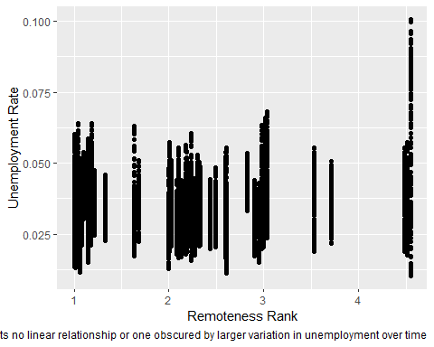

ggsave("RemoteEDA 1 Unemp+Remote Scatter All.pdf")  
  
# Unemployment by remoteness area at peak (Aug 2007 12.7%) and trough (2020 4.6%)  
# of unemployment (by colour)  
u_r_200708_202001 <- u_r %>%  
 filter(date == "2007-08-01" | date == "2020-01-01")  
glimpse(u_r_200708_202001)  
scatter <- ggplot(data = u_r_200708_202001) +   
 geom_point(mapping = aes(x = remoteness_index, y = unemploy_rate, colour = date))  
print(scatter + ggtitle("Aug 2007 (12.1%) and Jan 2020 (4.6%)") + labs(caption = "Superficial glance suggests no linear relationship", y = "Unemployment Rate", x = "Remoteness Rank"))

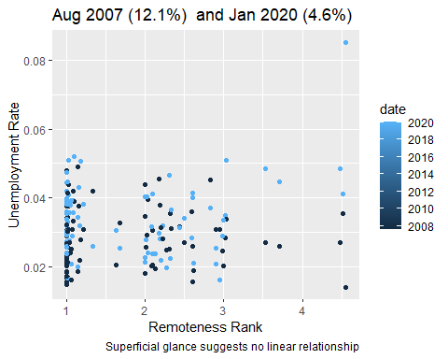

ggsave("RemoteEDA 4 Unemp+Remote Scatter 2007008+20200101 Colour.pdf")  
ggsave("RemoteEDA 4 Unemp+Remote Scatter 2007008+20200101 Colour.png")  
  
# Unemployment by remoteness area at peak (Aug 2007 12.7%) and trough (2020 4.6%)  
# of unemployment (by facet)  
scatter_peakTrough <- ggplot(data = u_r_200708_202001) +   
 geom_point(mapping = aes(x = remoteness_index, y = unemploy_rate)) +   
 facet_wrap(~date, nrow = 1)  
print(scatter_peakTrough + ggtitle("Aug 2007 (12.1%) and Jan 2020 (4.6%)") + labs(caption = "Superficial glance suggests no linear relationship", y = "Unemployment Rate", x = "Remoteness Rank"))

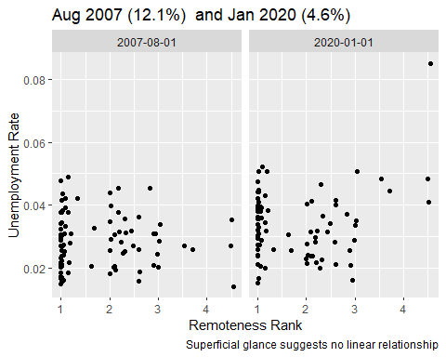

ggsave("RemoteEDA 5 Unemp+Remote Scatter 2007008+20200101 Facet.pdf")  
  
# Group into bins and chart the resulting boxplots  
u_r_bins <- u_r %>%  
 mutate( bin=cut_width(remoteness_index, width=1.0, boundary=0.5))  
glimpse(u_r_bins)  
  
box_r_bins <- ggplot(u_r_bins, aes(x=bin, y=unemploy_rate)) +   
 geom_boxplot()  
print(box_r_bins)

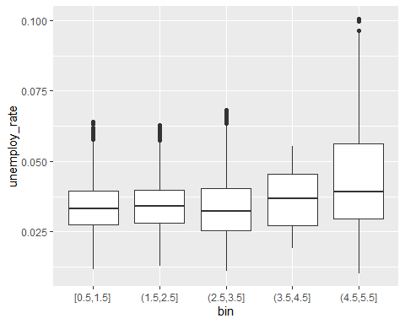

ggsave("RemoteEDA 11 Unemp+Remote Boxplot.pdf")  
ggsave("RemoteEDA 11 Unemp+Remote Boxplot.png")  
  
bin1_sa4_count <- u_r_bins %>%  
 filter(bin == "[0.5,1.5]") %>%  
 distinct(territory_sa4)  
print(bin1_sa4_count)   
# 49  
  
bin2_sa4_count <- u_r_bins %>%  
 filter(bin == "(1.5,2.5]") %>%  
 distinct(territory_sa4)  
print(bin2_sa4_count)   
# 22  
  
bin3_sa4_count <- u_r_bins %>%  
 filter(bin == "(2.5,3.5]") %>%  
 distinct(territory_sa4)  
print(bin3_sa4_count)   
# 12  
  
bin4_sa4_count <- u_r_bins %>%  
 filter(bin == "(3.5,4.5]") %>%  
 distinct(territory_sa4)  
print(bin4_sa4_count)   
# 2  
  
bin5_sa4_count <- u_r_bins %>%  
 filter(bin == "(4.5,5.5]") %>%  
 distinct(territory_sa4)  
print(bin5_sa4_count)   
# 2  
  
# simple boxplot for Unemployment on it's own  
ggplot(data = u_r, mapping = aes(y = unemploy_rate)) +   
 geom_boxplot()

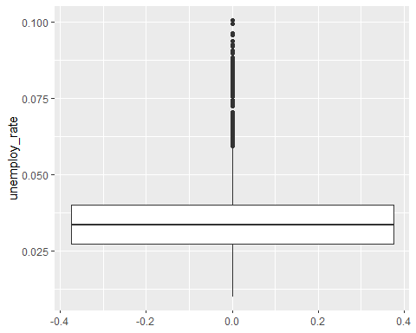

ggsave("RemoteEDA 3 Unemp+Remote Boxplot.pdf")  
  
summary(u_r$unemploy_rate)  
#Min. 1st Qu. Median Mean 3rd Qu. Max.   
#0.01017 0.02726 0.03365 0.03413 0.04008 0.10060  
  
u_r_outliers <- u_r %>%  
 filter(unemploy_rate > 1.5 * 0.03413)  
glimpse(u_r_outliers)  
#Observations: 620  
  
n_distinct(u_r_outliers$territory_sa4)  
#[1] 28  
u_r_outliers_sa4 <- u_r_outliers %>%  
 group_by(territory_sa4) %>%  
 summarise(mean(unemploy_rate), mean(remoteness_index))  
u_r_outliers_sa4  
print(u_r_outliers_sa4, n = "inf")  
# A tibble: 28 x 3  
#territory_sa4 `mean(unemploy_rate)` `mean(remoteness_index)`  
#<chr> <dbl> <dbl>  
# 1 Adelaide - North 0.0529 1.02  
#2 Ballarat 0.0552 2.00  
#3 Cairns 0.0565 3.02  
#4 Central Queensland 0.0524 2.30  
#5 Coffs Harbour - Grafton 0.0527 2.18  
#6 Hunter Valley exc Newcastle 0.0584 1.63  
#7 Ipswich 0.0553 1.18  
#8 Logan - Beaudesert 0.0524 1.10  
#9 Mackay - Isaac - Whitsunday 0.0540 2.61  
#10 Mandurah 0.0578 1.04  
#11 Melbourne - North West 0.0515 1.08  
#12 Melbourne - West 0.0545 1.01  
#13 Mid North Coast 0.0544 2.18  
#14 Moreton Bay - North 0.0546 1.15  
#15 Murray 0.0564 2.23  
#16 New England and North West 0.0520 2.59  
#17 Northern Territory - Outback 0.0549 4.51  
#18 Perth - North East 0.0516 1.05  
#19 Queensland - Outback 0.0758 4.55  
#20 Southern Highlands and Shoalhaven 0.0523 2.00  
#21 Sydney - Blacktown 0.0550 1   
#22 Sydney - Outer South West 0.0538 1.14  
#23 Sydney - South West 0.0551 1.00  
#24 Tasmania - South East 0.0554 2.98  
#25 Tasmania - West and North West 0.0523 2.82  
#26 Townsville 0.0574 3.04  
#27 Western Australia - Outback (North and South) 0.0531 4.01  
#28 Wide Bay 0.0536 2.10  
  
#########################################################################  
#Problem solving to try to resolve joining problems and getting to territory rollup  
  
sa1_4 <- read_csv("data/SA1_2016_AUST.csv")  
glimpse(sa1_4) #Observations: 57,523  
glimpse(u_r) #Observations: 15,390  
  
#This left_join didn't work - 9 million rows?  
sa1_4 <- read_csv("data/SA1_2016_AUST.csv")  
u_r_r <- left_join(u_r, sa1_4, by = c("territory_sa4" = "SA4_NAME_2016"))  
glimpse(u_r_r) # Observations: 9,368,406 ###9 million rows?###  
  
#This inner_join didn't fix it  
sa1_4 <- read_csv("data/SA1_2016_AUST.csv")  
u_r_r <- inner_join(u_r, sa1_4, by = c("territory_sa4" = "SA4_NAME_2016"))  
glimpse(u_r_r) # Observations: 9,366,867 ###9 million rows?###  
  
#This semi_join didn't fix it  
sa1_4 <- read_csv("data/SA1_2016_AUST.csv")  
u_r_r <- semi_join(u_r, sa1_4, by = c("territory_sa4" = "SA4_NAME_2016"))  
glimpse(u_r_r) # Observations: 13,851 ###13,851 rows?###  
  
# Neither of these 3 X attempts to group the orginal data acted to reduce the rows in the original file   
sa1_4 <- read_csv("data/SA1_2016_AUST.csv")  
sa1_4_group <- sa1_4 %>%  
 select(SA4_NAME_2016, GCCSA_NAME_2016, STATE_NAME_2016)%>%  
 group_by(SA4_NAME_2016)  
glimpse(sa1_4_group)  
# Observations: 57,523  
  
sa1_4 <- read_csv("data/SA1_2016_AUST.csv")  
sa1_4 <- sa1_4 %>%  
 select(SA4_NAME_2016, GCCSA_NAME_2016, STATE_NAME_2016) %>%  
 group_by("SA4_NAME_2016")  
# Observations: 57,523  
  
sa1_4 <- read_csv("data/SA1_2016_AUST.csv")  
sa1_4 <- sa1_4 %>%  
 group_by(SA4_NAME_2016) %>%  
 summarise(territory_gccsa = mean("GCCSA_NAME_2016"), territory_state = mean("STATE_NAME_2016"))  
#warnings()  
  
#These 2 X efforts to group_by didn't work  
sa1_4 <- read_csv("data/SA1_2016_AUST.csv")  
sa1_4_group <- sa1_4 %>%  
 group_by(SA4_NAME_2016) # same result with "SA4_NAME_2016"  
u_r_r <- left_join(u_r, sa1_4_group, by = c("territory_sa4" = "SA4_NAME_2016"))  
glimpse(sa1_4_group) # Observations: 57,523  
glimpse(u_r_r)# Observations: 9,366,867 ###9 million rows?###  
  
sa1_4 <- read_csv("data/SA1_2016_AUST.csv")  
sa1_4_group <- sa1_4 %>%  
 select(SA4_NAME_2016, GCCSA_NAME_2016, STATE_NAME_2016) %>%  
 group_by(SA4_NAME_2016)  
glimpse(sa1_4_group) # Observations: 57,523  
u_r_r <- left_join(u_r, sa1_4_group, by = c("territory_sa4" = "SA4_NAME_2016"))  
glimpse(u_r_r) # Observations: 9,368,406 ###9 million rows?###  
  
#Build on Irfan's solution to create a 1-2-1 like territory rollup table  
sa4_rollup <- sa1_4 %>%  
 add_column(territory_nation = "Australia") %>%  
 select(territory_nation, territory_sa4 = SA4_NAME_2016, territory_gccsa = GCCSA_NAME_2016, territory_state =STATE_NAME_2016) %>%  
 distinct(territory_sa4, territory_gccsa, territory_state, territory_nation)   
glimpse(sa4_rollup)# Observations: 107 - interim SUCCESS!!!  
count(distinct(sa4_rollup, territory_sa4)) #1 107  
print(distinct(sa4_rollup, territory_sa4), n = "inf") # A tibble: 107 x 1  
print(distinct(sa4_rollup, territory_gccsa), n = "inf") # A tibble: 34 x 1  
print(distinct(sa4_rollup, territory_state), n = "inf") # A tibble: 9 x 1  
print(distinct(sa4_rollup, territory_nation), n = "inf") # A tibble: 1 x 1  
  
  
# Extend Irfan's solution'  
u_r_rollup <- left_join(u_r, sa4_rollup)  
glimpse(u_r) #Observations: 15,390  
glimpse(u_r_rollup) #Observations: 15,390  
select(u_r_rollup, territory_state, territory_gccsa, territory_sa4, date, unemployed, population, unemploy_rate)  
  
#End of Problem solving to try to resolve joining problems and getting to territory rollup  
#Solution below using Irfan's tips  
#########################################################################  
#Resuming remoteness EDA  
  
#Load ABS sa1 -> sa4 -> gccsa -> state rollup hierarchies   
sa1_4 <- read_csv("data/SA1_2016_AUST.csv")  
glimpse(sa1_4) #Observations: 57,523  
glimpse(u_r) #Observations: 15,390  
  
#Create a 1-2-1 like territory rollup table  
sa4_rollup <- sa1_4 %>%  
 add_column(territory_nation = "Australia") %>%  
 select(territory_nation, territory_sa4 = SA4_NAME_2016, territory_gccsa = GCCSA_NAME_2016, territory_state =STATE_NAME_2016) %>%  
 distinct(territory_sa4, territory_gccsa, territory_state, territory_nation)   
glimpse(sa4_rollup)# Observations: 107 - interim SUCCESS!!!  
count(distinct(sa4_rollup, territory_sa4)) #1 107  
print(distinct(sa4_rollup, territory_sa4), n = "inf") # A tibble: 107 x 1  
print(distinct(sa4_rollup, territory_gccsa), n = "inf") # A tibble: 34 x 1  
print(distinct(sa4_rollup, territory_state), n = "inf") # A tibble: 9 x 1  
print(distinct(sa4_rollup, territory_nation), n = "inf") # A tibble: 1 x 1  
  
# Join unemployment data to territory rollups  
u_r_rollup <- left_join(u_r, sa4_rollup) %>%  
 select(territory_nation, territory_state, territory_gccsa, territory_sa4, remoteness_index, date, unemployed, population, unemploy_rate)  
  
glimpse(u_r) #Observations: 15,390  
glimpse(u_r_rollup) #Observations: 15,390  
  
#############################################################################  
# Truncated exploration of unusual territories  
# filter(sa4_rollup, territory_state == "Other Territories") # A tibble: 9 x 1  
#############################################################################  
#Resuming remoteness EDA  
  
#Build a table for charting unemployment for the whole of Australia  
u_aust <- u_r_rollup %>%  
 select(territory_nation, date, unemployed, population) %>%  
 group_by(territory_nation, date) %>%  
 summarize(unemployed = sum(unemployed), population = sum(population)) %>%  
 mutate(unemploy_rate = unemployed / population)  
  
#Build a table for charting unemployment for the whole of Australia  
u_aust_tline <- ggplot(data = u_aust) +   
 geom_smooth(mapping = aes(x = date, y = unemploy_rate), se = FALSE)  
print(u_aust_tline +   
 ggtitle("Unemployment Rates Australia")  
 + labs(y="Unemployment Rate", x = "Jan 2006 - Mar 2020"))

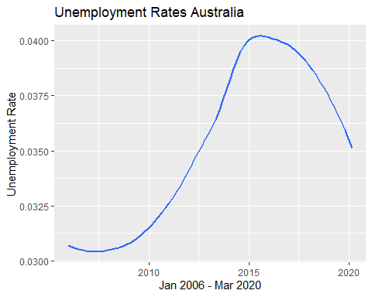

ggsave("RemoteEDA 6 Aust TLine.pdf")  
ggsave("RemoteEDA 6 Aust TLine.png")  
  
#Build a table to show unemployment variation in the ACT and NT  
u_states <- u_r_rollup %>%  
 select(territory_state, date, unemployed, population) %>%  
 group_by(territory_state, date) %>%  
 filter(territory_state == "Australian Capital Territory" | territory_state == "Northern Territory") %>%  
 summarize(unemployed = sum(unemployed), population = sum(population)) %>%  
 mutate(unemploy_rate = unemployed / population)  
glimpse(u_states)  
  
#Build a table for charting unemployment in the ACT and NT  
u_states_tline <- ggplot(data = u_states) +   
 geom_smooth(mapping = aes(x = date, y = unemploy_rate, linetype = territory_state), se = FALSE)  
print(u_states_tline +   
 ggtitle("Unemployment Rates ACT and NT")  
 + labs(y="Unemployment Rate", x = "Jan 2006 - Mar 2020"))

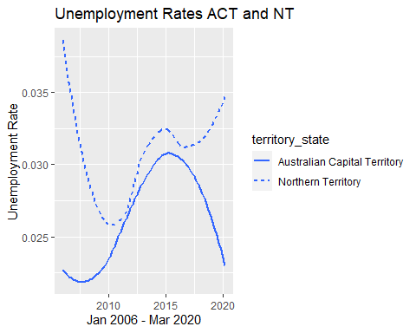

ggsave("RemoteEDA 7 AustStates TLine ACTNT.pdf")  
  
#Build a table to show unemployment variation in NSW and WA  
u_states <- u_r_rollup %>%  
 select(territory_state, date, unemployed, population) %>%  
 group_by(territory_state, date) %>%  
 filter(territory_state == "Western Australia" | territory_state == "New South Wales") %>%   
 summarize(unemployed = sum(unemployed), population = sum(population)) %>%  
 mutate(unemploy_rate = unemployed / population)  
glimpse(u_states)  
  
#Build a table for charting unemployment in NSW and WA  
u_states_tline <- ggplot(data = u_states) +   
 geom_smooth(mapping = aes(x = date, y = unemploy_rate, linetype = territory_state), se = FALSE)  
print(u_states_tline +   
 ggtitle("Unemployment Rates NSW and WA")  
 + labs(y="Unemployment Rate", x = "Jan 2006 - Mar 2020"))

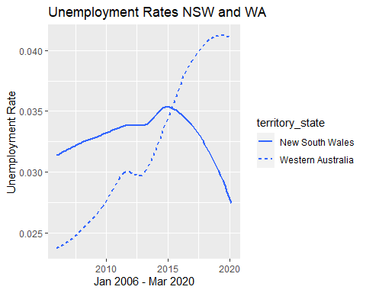

ggsave("RemoteEDA 8 AustStates TLine NSWWA.pdf")  
ggsave("RemoteEDA 8 AustStates TLine NSWWA.png")  
  
#Build a table to show unemployment variation in Greater Sydney and the Rest of NSW  
u_gccsa <- u_r_rollup %>%  
 select(territory_gccsa, date, unemployed, population) %>%  
 group_by(territory_gccsa, date) %>%  
 filter(territory_gccsa == "Greater Sydney" | territory_gccsa == "Rest of NSW") %>%   
 summarize(unemployed = sum(unemployed), population = sum(population)) %>%  
 mutate(unemploy_rate = unemployed / population)  
glimpse(u_gccsa)  
  
#Build a table for charting unemployment in Greater Sydney and the Rest of NSW  
u_gccsa_tline <- ggplot(data = u_gccsa) +   
 geom_smooth(mapping = aes(x = date, y = unemploy_rate, linetype = territory_gccsa), se = FALSE)  
print(u_gccsa_tline +   
 ggtitle("Unemployment Rates Greater Sydney and Rest of NSW")  
 + labs(y="Unemployment Rate", x = "Jan 2006 - Mar 2020"))

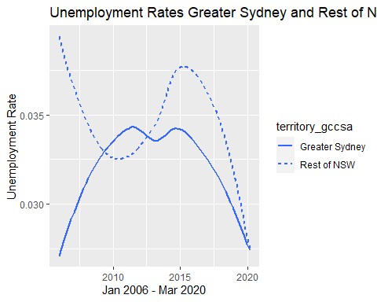

ggsave("RemoteEDA 9 AustGCCSA TLine GSydNSW.pdf")  
ggsave("RemoteEDA 9 AustGCCSA TLine GSydNSW.png")  
  
#Build a table to show unemployment variation within Sydney  
u_sa4 <- u_r_rollup %>%  
 select(territory_sa4, date, unemployed, population) %>%  
 group_by(territory_sa4, date) %>%  
 filter(territory_sa4 == "Sydney - Eastern Suburbs" | territory_sa4 == "Sydney - South West") %>%   
 summarize(unemployed = sum(unemployed), population = sum(population)) %>%  
 mutate(unemploy_rate = unemployed / population)  
glimpse(u_sa4)  
  
#Build a table for charting unemployment in Greater Sydney and the Rest of NSW  
u_sa4_tline <- ggplot(data = u_sa4) +   
 geom_smooth(mapping = aes(x = date, y = unemploy_rate, linetype = territory_sa4), se = FALSE)  
print(u_sa4_tline +   
 ggtitle("Unemployment Rates Sydney Eastern Suburbs and South West")  
 + labs(y="Unemployment Rate", x = "Jan 2006 - Mar 2020"))

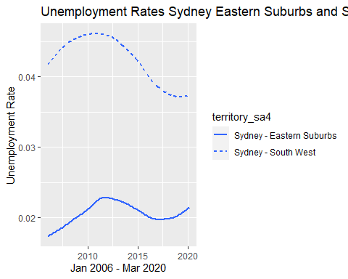

ggsave("RemoteEDA 10 Austsa4 TLine SydEastAndSouthWest.pdf")  
ggsave("RemoteEDA 10 Austsa4 TLine SydEastAndSouthWest.png")  
  
#Build a table to show unemployment variation within Sydney  
u_sa4 <- u_r_rollup %>%  
 select(territory_sa4, date, unemployed, population) %>%  
 group_by(territory_sa4, date) %>%  
 filter(territory_sa4 == "Sydney - Eastern Suburbs" | territory_sa4 == "Sydney - South West") %>%   
 summarize(unemployed = sum(unemployed), population = sum(population)) %>%  
 mutate(unemploy_rate = unemployed / population)  
glimpse(u_sa4)  
  
#Build a table for charting unemployment variation within Sydney  
u_sa4_tline <- ggplot(data = u_sa4) +   
 geom_smooth(mapping = aes(x = date, y = unemploy_rate, linetype = territory_sa4), se = FALSE)  
print(u_sa4_tline +   
 ggtitle("Unemployment Rates Sydney Eastern Suburbs and South West")  
 + labs(y="Unemployment Rate", x = "Jan 2006 - Mar 2020"))



ggsave("RemoteEDA 10 Austsa4 TLine SydEastAndSouthWest.pdf")