AL-AQSA UNIVERSITY
Faculty of Computing and Information Technology
Final Project Report
University Campus Network Using Cisco Packet Tracer

Student: Khattab Jouda
Course: Computer Networks - Practical
Instructor: Haneen Tabasi
Semester: Second Semester 2026
Gaza, Palestine

1. Introduction
This project is a simulation of a complete university campus network using Cisco Packet Tracer. The network connects five university buildings and allows the devices in different buildings to communicate with each other. It also provides important services such as DHCP, DNS, Web, Email, and LMS services.
The main goal was to build a clear network design, give each part a suitable IP address, connect the routers, configure the required services, and test the communication between the devices.

2. Project Requirements
- Connect five university buildings: Administration, Library, Engineering and Technology, Business and Economics, and Health Sciences.
- Use Mesh topology between the five main building routers.
- Use Star topology inside each building.
- Provide wired computers and wireless laptops.
- Use static routing between the buildings.
- Configure DHCP, DNS, Web, Email, and LMS services in the Administration Building.
- Add basic router security using enable secret and console password.
- Test communication between different networks and services.

3. Network Topology
The design contains five main routers in the center of the network. Each router represents one university building. The main routers are connected to each other using a Mesh topology. This gives more than one possible path between the buildings.
Inside each building, a Star topology is used. The building router connects to a switch for wired devices and to a wireless router or access point for laptops. The Administration Building is different because its first floor contains the server room.
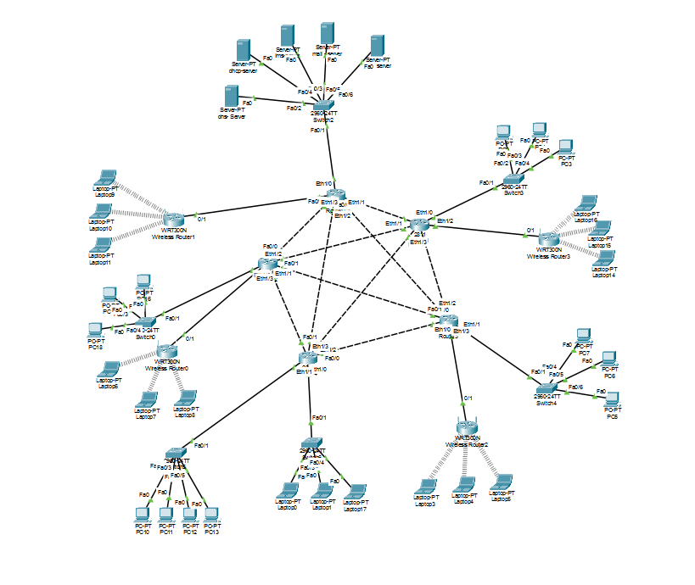
Figure 1. Complete campus network topology in Cisco Packet Tracer

4. Router Names and Basic Security
The routers were renamed to make the network easier to understand and manage.
Building | Router Name
Administration Building | admin-rtr
Library Building | lib-rtr
Engineering and Technology Building | eng-rtr
Business and Economics Building | bus-rtr
Health Sciences Building | health-rtr
Basic security settings:
- An enable secret password was added to protect privileged mode.
- A console password was added with login enabled.

5. IP Addressing and Routing
Different networks were used for the buildings and for the links between routers. Local networks mainly use /24 addressing, while the router-to-router links use /30 addressing because each link needs only two usable IP addresses.
The server network in the Administration Building uses 192.168.10.0/24. The default gateway for this network is 192.168.10.1.
Static routing was configured on the five main routers. Each router has routes to the remote networks through the correct next-hop address. This makes it possible for devices in one building to reach devices and servers in the other buildings.

6. Server Room and Services
The server room is located on the first floor of the Administration Building. Five servers were configured, and each server has one main job.
Server | IP Address | Service | Name / Role
Web Server | 192.168.10.10 | HTTP | www.aqsa.edu.ps
Mail Server | 192.168.10.11 | SMTP / POP3 | mail.aqsa.edu.ps
LMS Server | 192.168.10.12 | HTTP | lms.aqsa.edu.ps
DHCP Server | 192.168.10.13 | DHCP | Automatic IP distribution
DNS Server | 192.168.10.14 | DNS | Name resolution
DNS records used in the project:
- www.aqsa.edu.ps -> 192.168.10.10
- mail.aqsa.edu.ps -> 192.168.10.11
- lms.aqsa.edu.ps -> 192.168.10.12
The DHCP server was used to give IP addresses automatically to client devices. The DNS server was used to convert the service names into IP addresses. This made the network easier to use because users can open the services by name instead of typing the IP address.

7. Wired and Wireless Networks
The wired floors use switches to connect desktop computers. The wireless floors use wireless routers or access points to connect laptops. Wireless security was added using WPA2 settings according to the project requirements.
All client devices were configured with a correct IP address, subnet mask, default gateway, and DNS server. Some addresses were entered manually, while other addresses were received from the DHCP server.

8. Testing the Network
After finishing the configuration, several tests were used to check the network:
- Ping between devices in the same building.
- Ping between devices in different buildings.
- Ping from client devices to the servers in the Administration Building.
- Open the university website using www.aqsa.edu.ps.
- Open the LMS website using lms.aqsa.edu.ps.
- Check that client devices can receive IP addresses from DHCP.
- Check that DNS converts the domain names to the correct server addresses.
The tests showed that the routers, client networks, and server services were working together. When a problem appeared, the IP address, subnet mask, gateway, interface status, and static routes were checked.

9. Problems and Simple Solutions
Problem | Solution
Ping did not work between two networks. | Checked the interface IP addresses, subnet masks, gateways, and static routes.
A device did not receive an IP address. | Checked the DHCP pool, start address, gateway, DNS address, and network connection.
A website name did not open. | Checked the DNS service and the DNS record for the server.
A router interface was down. | Used no shutdown and checked the cable and connected port.
Wireless laptop could not connect. | Checked the wireless name, password, security type, and IP settings.

10. Conclusion
In this project, I designed a campus network for five university buildings using Cisco Packet Tracer. The project included Mesh and Star topologies, wired and wireless devices, static routing, router security, and central server services.
The project helped me understand how to connect different networks, organize IP addresses, configure routers and servers, and find simple solutions when communication problems happen. It was a useful practical project for learning the main ideas of computer networks.

