Docker & Docker Compose
DevOps Internship — Week 4 Report
Submitted by: Kosgei Kipngetich
Program: Davine Technologies — DevOps Internship
Week: Week 4
Topic: Docker & Docker Compose
Report Date: 18/08/2026
GitHub Repository: https://github.com/Engkipngetich/week4-docker.git

Week 4 Report — Docker & Docker Compose
Davine Technologies DevOps Internship

1. What is Docker?
Docker is an open-source containerization platform that packages an application together with everything it needs to run — code, runtime, system libraries, and configuration — into a single, portable unit called a container. Because the container includes its own environment, it runs the same way regardless of where it is deployed: a developer's laptop, a test server, or a production cloud environment. This solves the classic "it works on my machine" problem and makes applications easier to build, ship, and run consistently.

2. Docker Architecture
Docker uses a client-server architecture made up of the following core components:
- Docker Client: The command-line tool (docker) used to issue commands such as build, run, and pull.
- Docker Daemon (dockerd): The background service that builds, runs, and manages containers, images, networks, and volumes.
- Docker Images: Read-only templates used to create containers.
- Docker Containers: Running instances of images.
- Docker Registry (e.g. Docker Hub): A remote repository for storing and distributing images.
The client communicates with the daemon (locally or remotely) via a REST API, and the daemon carries out the requested actions on the host system.

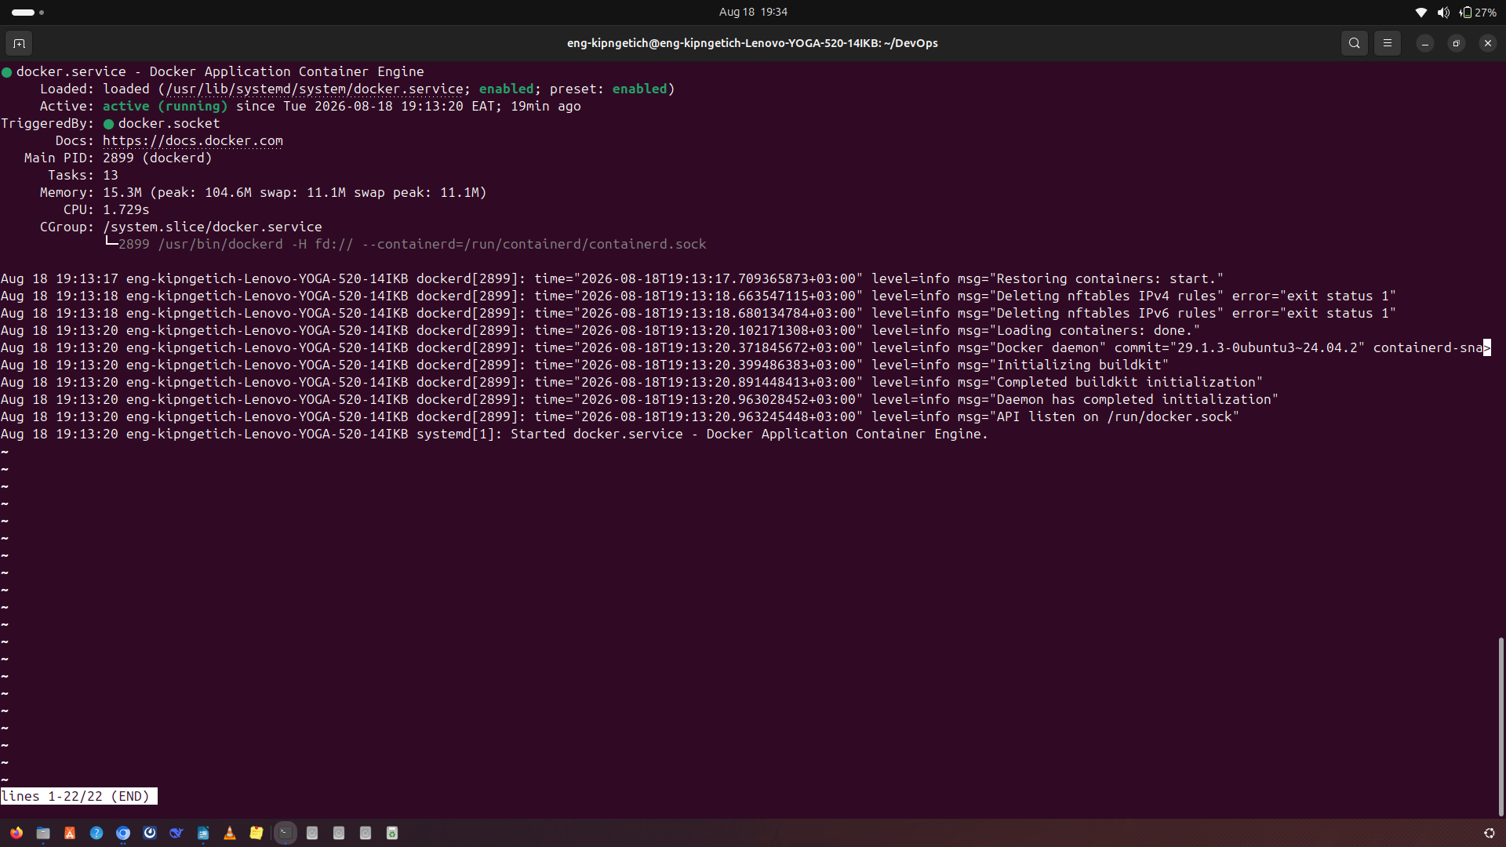

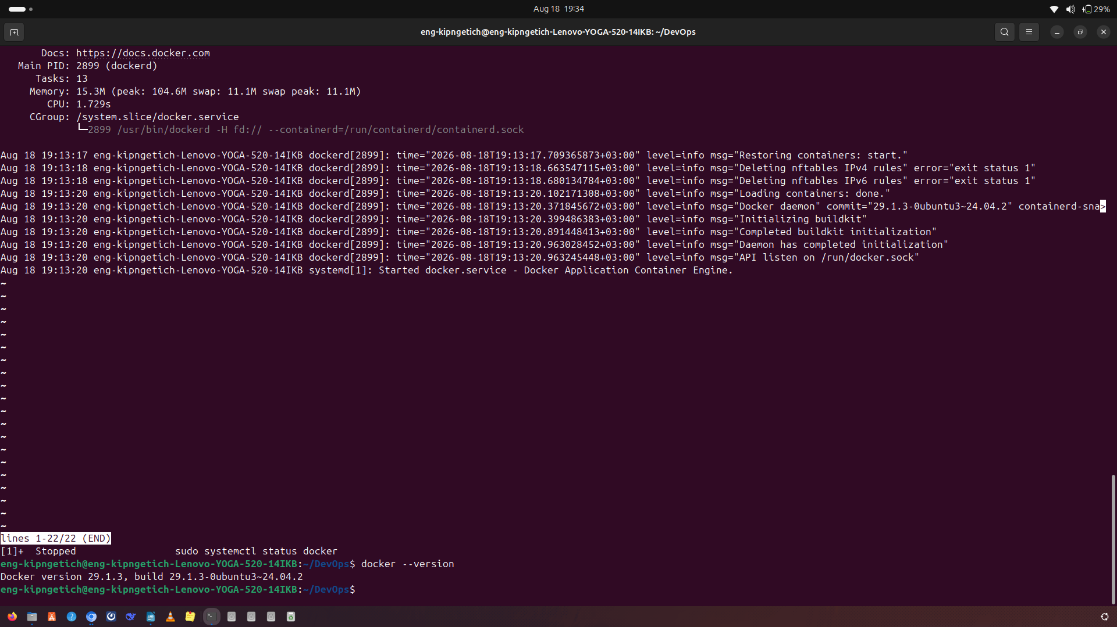
Docker Installation — output of docker --version / docker info

3. Images vs Containers
Docker Image | Docker Container
A static, read-only blueprint/template | A running (or stopped) instance of an image
Built once, reused many times | Created fresh from an image each time it is run
Stored in a registry (e.g. Docker Hub) | Exists on the host machine while running
Does not consume runtime resources | Consumes CPU, memory, and storage while active

In short: an image is the recipe, and a container is the dish made from that recipe.

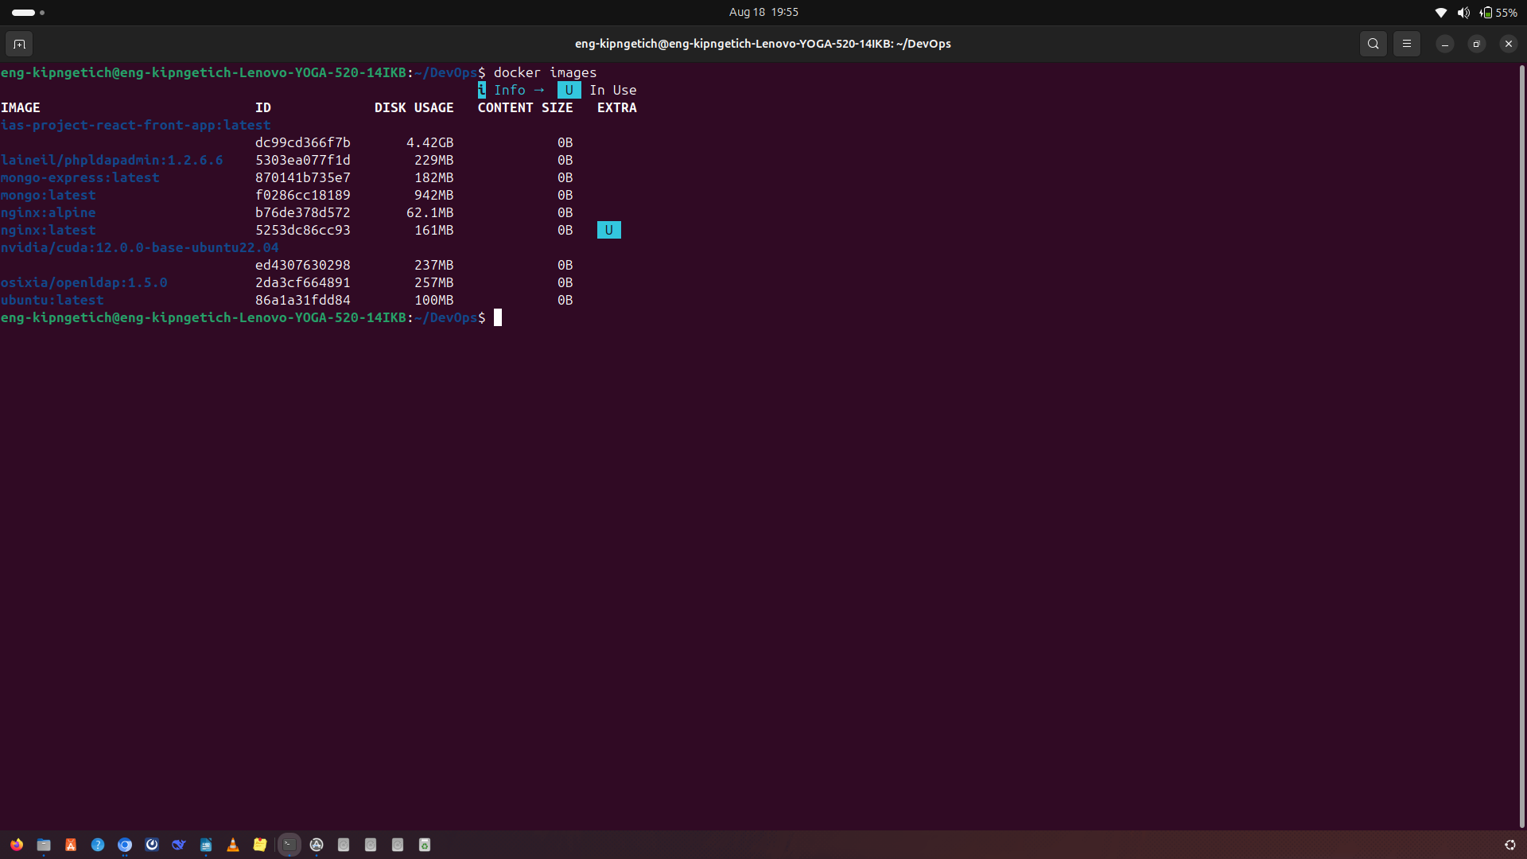
Docker Images — output of docker images

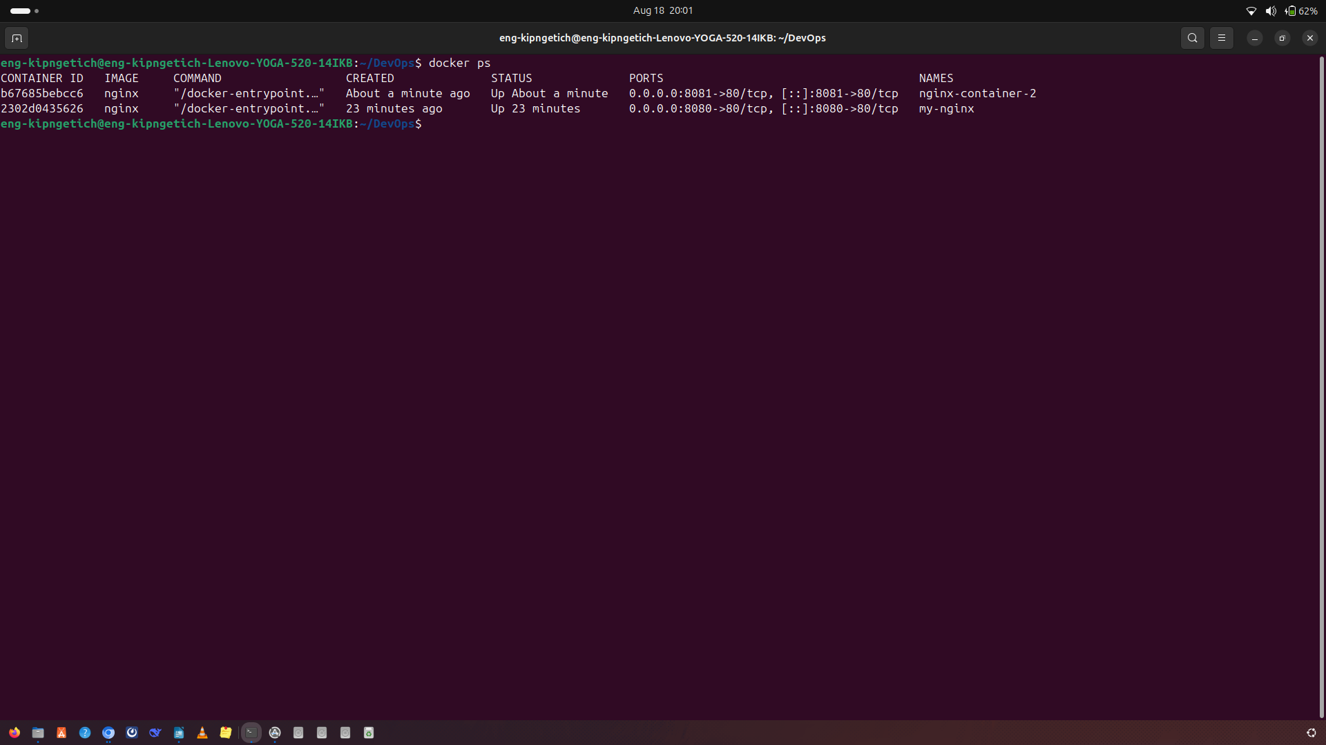
Running Containers — output of docker ps

4. Dockerfile
A Dockerfile is a plain-text script containing step-by-step instructions for building a Docker image automatically. Common instructions include:
- FROM — specifies the base image
- WORKDIR — sets the working directory inside the container
- COPY — copies files from the host into the image
- RUN — executes a command during the build (e.g. installing dependencies)
- EXPOSE — documents the port the container listens on
- CMD / ENTRYPOINT — defines the command that runs when the container starts
Example Dockerfile for a simple Node.js application:
FROM node:20-alpine
WORKDIR /app
COPY package*.json ./
RUN npm install
COPY . .
EXPOSE 3000
CMD ["node", "server.js"]

5. Docker Volumes
Containers are ephemeral by default — data inside them is lost when the container is removed. Docker Volumes solve this by providing a persistent storage mechanism that exists independently of the container's lifecycle. Volumes are managed by Docker and can be shared across multiple containers, making them the recommended way to persist data such as database files.
# Create a named volume
docker volume create app_data

# Mount it into a container
docker run -d -v app_data:/var/lib/data my-image

6. Docker Networks
Docker Networks allow containers to communicate with each other and with the outside world in a controlled way. Docker provides several network drivers:
- bridge — the default network for standalone containers on a single host
- host — removes network isolation between the container and the host
- none — disables networking entirely
- custom bridge networks — allow containers to resolve each other by name, ideal for multi-container applications
# Create a custom network
docker network create app-network

# Attach a container to it
docker run -d --network app-network --name backend my-backend-image

7. Environment Variables & Port Mapping
Environment variables allow configuration (e.g. database credentials, API URLs) to be injected into a container at runtime without hardcoding them into the image. Port mapping exposes a container's internal port to the host machine so external traffic can reach the application.
docker run -d \
-e DB_HOST=database \
-e DB_PASSWORD=secret \
-p 8080:3000 \
my-app-image

8. Docker Compose
Docker Compose is a tool for defining and running multi-container Docker applications using a single YAML configuration file (docker-compose.yml). Instead of starting each container manually, Compose lets you define all services, networks, and volumes in one place and bring the entire stack up or down with a single command.
version: "3.9"
services:
frontend:
build: ./frontend
ports:
- "3000:3000"
depends_on:
- backend
networks:
- app-network

backend:
build: ./backend
ports:
- "5000:5000"
environment:
- DB_HOST=database
- DB_PASSWORD=secret
depends_on:
- database
networks:
- app-network

database:
image: postgres:16
environment:
- POSTGRES_PASSWORD=secret
volumes:
- db_data:/var/lib/postgresql/data
networks:
- app-network

volumes:
db_data:

networks:
app-network:

# Bring the whole stack up
docker compose up -d --build

# Bring it down
docker compose down

9. Docker Hub
Docker Hub is Docker's default cloud registry for storing and sharing container images. It allows images to be pushed, pulled, and version-tagged, making it easy to distribute a built image to any machine with Docker installed.
# Tag and push an image
docker tag my-app-image myusername/my-app-image:v1
docker push myusername/my-app-image:v1

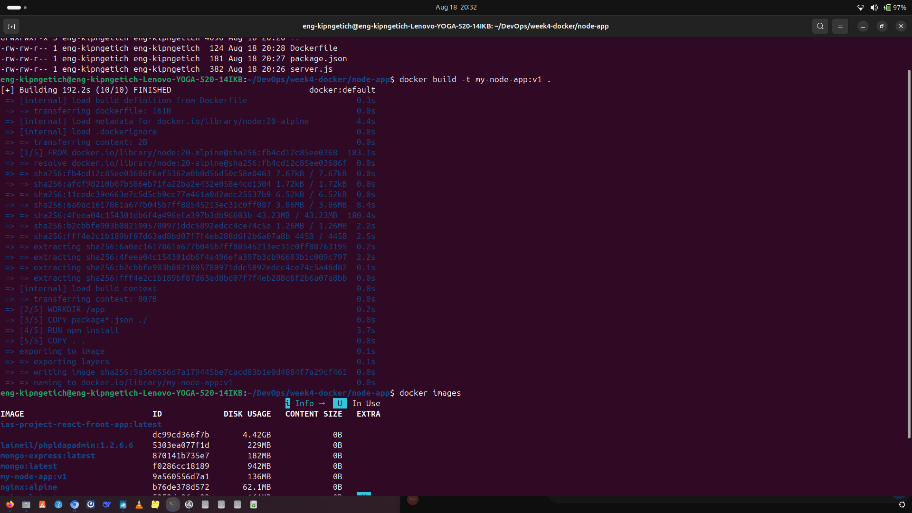
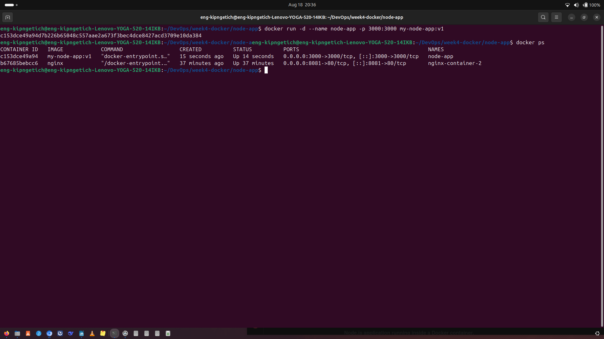
Docker Hub Repository — pushed image visible in Docker Hub

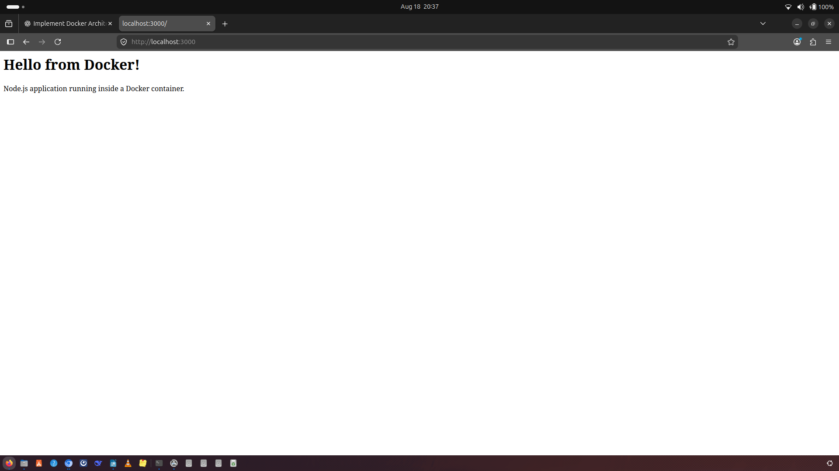
Running Application — application accessible in browser after deployment

10. Multi-Container Application Summary
For the hands-on activity, a multi-container application was deployed consisting of a frontend, backend, and database, connected via a custom Docker network and using a Docker volume for persistent database storage. All services were orchestrated using a single docker-compose.yml file and verified to communicate successfully.

11. Docker Best Practices Applied
- Used lightweight, minimal base images (e.g. alpine variants) to reduce image size.
- Added a .dockerignore file to exclude unnecessary files (e.g. node_modules, .git) from the build context.
- Used named volumes for persistent data instead of writing to the container's writable layer.
- Used a custom bridge network so containers could resolve each other by service name.
- Kept environment-specific configuration (credentials, hosts) in environment variables rather than hardcoding them.
- Verified AI-generated Dockerfile and Compose configurations by testing them directly in the Docker environment before relying on them.
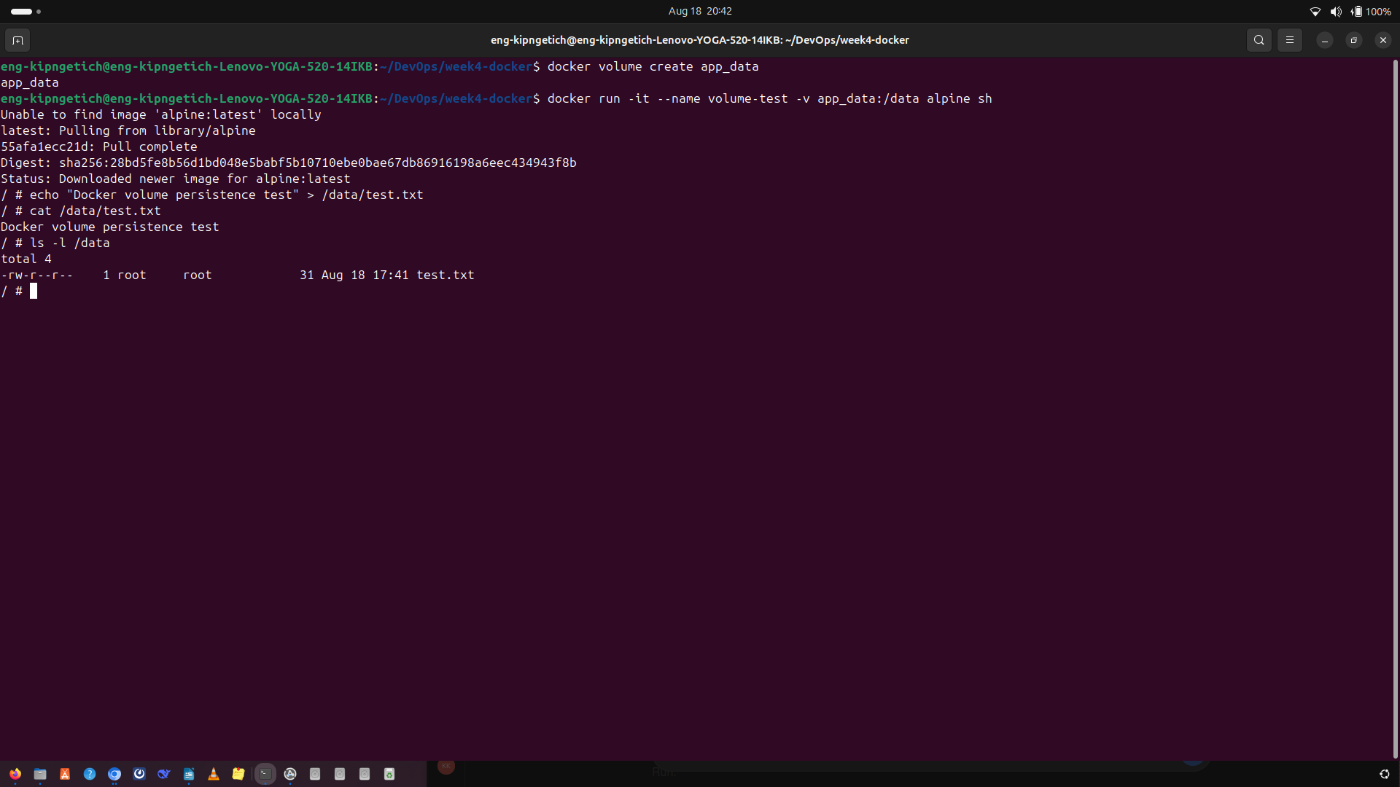
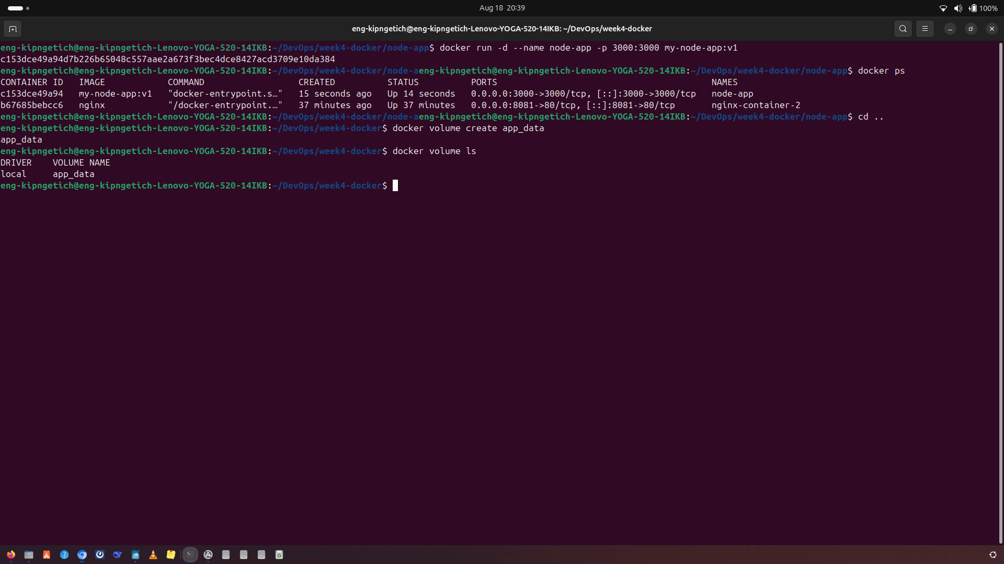

12. Implementation Summary
The project involved containerizing a Node.js application using Docker, with the application configured to listen on port 3000 and accept connections through 0.0.0.0. The Dockerfile was structured using the Node.js 20 Alpine base image, installed the required dependencies, copied the application files, exposed port 3000, and started the application with server.js. During implementation, a port conflict was encountered because another container was already using port 3000; this was resolved by stopping the conflicting container before starting the Node.js container. The container was successfully built and started, and the application was verified through the browser at http://localhost:3000, confirming successful container execution and network communication.

 | Status
Dockerfile | Done
Docker Compose File | Done
Screenshot — Docker Installation | Done
Screenshot — Running Containers | Done
Screenshot — Docker Images | Done
Screenshot — Docker Hub Repository | https://app.docker.com/accounts/engkipngetich

Prepared as part of the Davine Technologies DevOps Internship — Week 4: Docker & Docker Compose.

