

ITAM1.1 Subscriptions -   
User Guide

September 2018

DRAFT

Table of Contents

Revision History c

Overview 1

Preparation 1

Step 1: Open the DXC DD Self-Subscription application 2

Step 2: Begin Subscription Definition – Name & Type 2

HR Fieldglass Data Source 3

Step 2: Name & Type 3

Step 3: File & Transport 4

Step 4: Source 7

Step 5: Fields 7

Step 5a: Specify Field filters 8

Step 5b: Specify Formats 9

Step 5c: Save and move to the next section 9

Step 6: Scheduler 9

Step 7: Members 10

Step 8: Summary & Submit 13

HR Workday Data Source 15

Step 2: Name & Type 15

Step 3: File & Transport 16

Step 4: Source 19

Step 5: Fields 19

Step 6: Members 20

Step 7: Summary 21

Supply Chain Purchase Order Data 23

Step 2: Name & Type 23

Step 3: File & Transport 23

Step 4: Source 24

Step 5: Fields 24

Step 5a: Specify Field Filters 26

Step 5b: Save and move to the next section 29

Step 6: Scheduler 29

Step 7: Members 29

Step 8: Summary & Submit 29

Appendix A: Glossary 1

Appendix B: Fieldglass Field List 1

Appendix C: Workday Field List 1

Appendix D: Purchase Order Field List 2

# Revision History

|  |  |  |  |
| --- | --- | --- | --- |
| Date | Version | Name | Description |
| 27 Sep 2018 | 0.1 | Karen Cook | Initial Draft |
|  |  |  |  |

# Overview

This document outlines how to create subscriptions, and fields and values needed for integration compatibility with the ITAM1.1 solution. It requires two types of data from DXC Data Distribution Self-Service (DXC DDSS):

1. HR Source Data: Automates creation and update of employee and contingent workforce (CWF) user records with HR source data in PDXC ServiceNow (PDXC SN); and
2. Purchase Order (PO): Enables the Asset Receipt process in Enterprise IT Asset Management (EITAM).

Each of these data objects will be described in the following sections.

Although there is a lot of information on how to use DXC Data Distribution Self-Service (DXC DDSS) to assist the ITAM user in using the tool. This is NOT intended to be a user guide for the application.

Steps 1 and 2 below are the same regardless of the subscription’s related data object.

Each “Step X” section contains a description of the actions, screen shot, and list/table of data that is to be entered during that step.

## Preparation

Prior to accessing DXC DDSS, the user is required to complete certification on the “Respecting Privacy – Employee Data Protection” course. If you do not have the certification, you will receive a notice similar to the one below when you try to access the tool. If you receive the notice, you MUST complete the class before you will be allowed access to the tool.

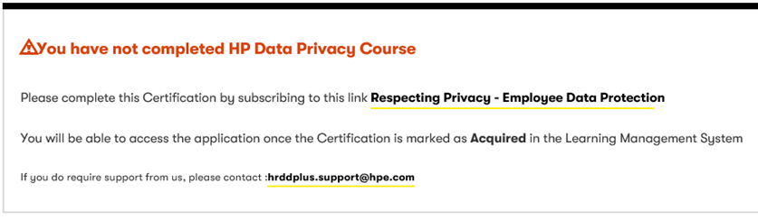

The notice includes a link to enroll for the class on DXC University. Allow for ~1 hour to complete the course. After you complete the course, you need to allow time for the certification to be registered and made available to DXC DD SS.

In addition, EVERY subscription created goes through a two level approval process. The first level is your direct manager, approving your need to subscribe to the data. The second level is the data owner, approving your use of their data.

Once both approvals are received, the subscription will be enabled and begin running based on the related schedule.

**Any user that will either create, update or be added as Administrators or Members of a subscription must complete this training. They cannot be added until their certification can be validated by the tool.**

## Step 1: Open the DXC DD Self-Subscription application

This step is the same for all self-service subscriptions regardless of the data source.

The following URLs access the DXC DD Self-subscription:

|  |  |  |
| --- | --- | --- |
| Environment | Component | URL/Link |
| DXC DD Production | Self-Subscription | https://dxcddss-prd.itcs.houston.dxccorp.net/ |
| DXC DD Integration | Self-Subscription | https://dxcddss-itg.itcs.houston.dxccorp.net/ |

Assuming you have completed the required certification, you will be taken directly to your DXC DD SS[1] Dashboard.

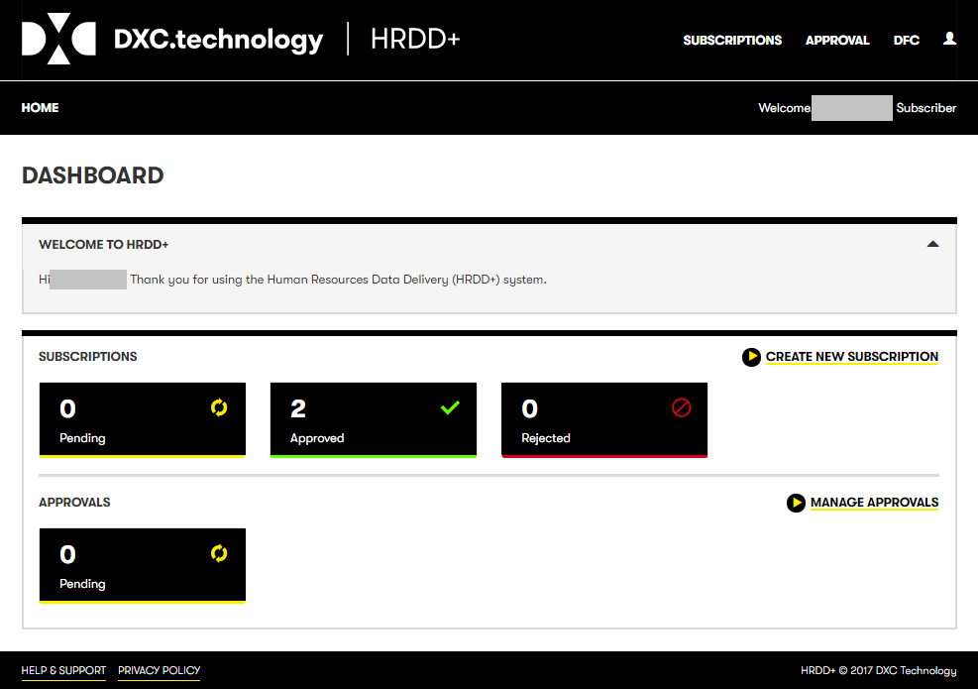

From the dashboard, selectto begin a new subscription.

## Step 2: Begin Subscription Definition – Name & Type

To start the subscription, you need to provide some basic information enabling the subscription to be logged and tracked. This information will be passed through the approval process, and needs to be as accurate as possible. The information in the subscription is the only information by which they can determine whether to allow their data to be used in the subscription.

It is important to provide an accurate EPRID for the system that will consume the data. This provides the data owner additional clues to the end use of the data and if it can be appropriately secured.

The following screen will be the first screen for ANY subscription. Details related to each specific subscription is found in each individual subscription section.

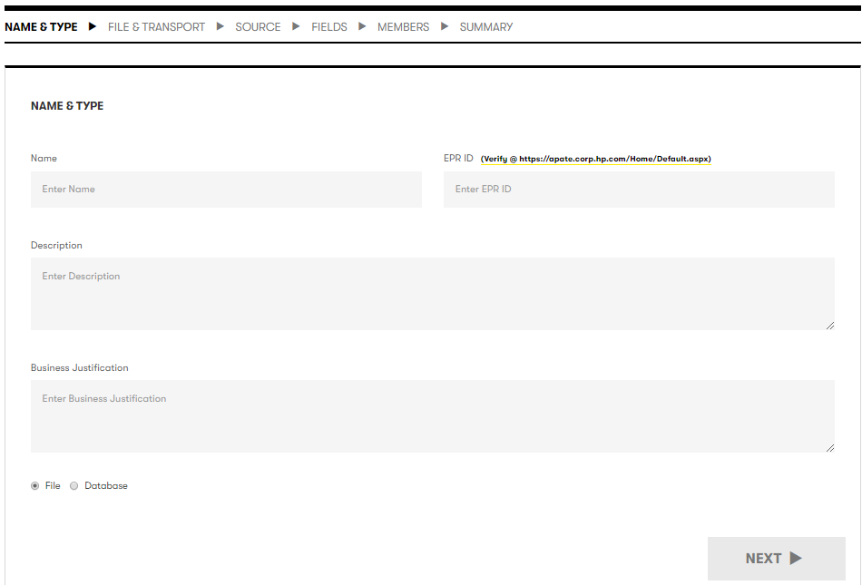

# HR Fieldglass Data Source

This section describes the Fieldglass subscription definition. Fieldglass data represents DXC Contingent workforce (CWF) / contractors. The majority of CWF employees are represented in this file, though there are a few Statement of Work (SOW) contractors that have not been included. These include (but are not limited to) DXC’ wholly owned subsidiary FDS and some agency/SOW contractors hired by CSC.

Fieldglass subscription data is sourced from the Data Lake Hive database. The steps outlined below can also be applied to subscriptions for any other data sourced from a database.

The first step in any subscription is the Name & type.

## Step 2: Name & Type

As mentioned above, this information is important to the approvers so they can verify your need for the data. Be as accurate and complete as possible to let them know the reason the data is needed and how it will be used.

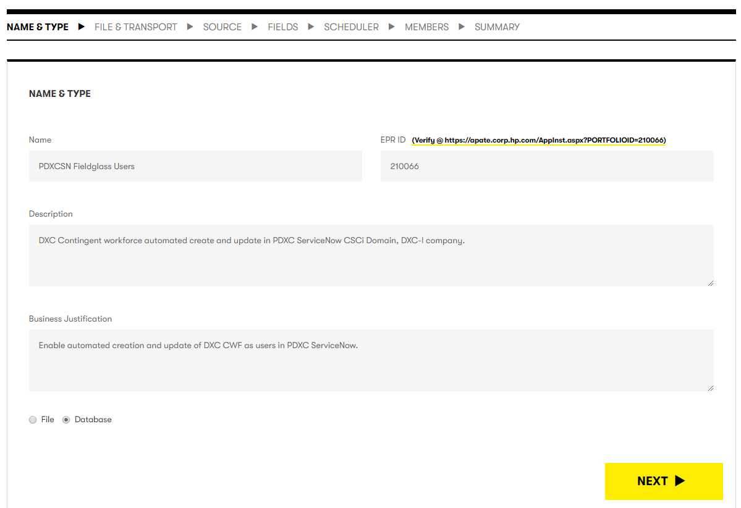

The following are the values that should be provided for each field on the screen.

| Field | Value |
| --- | --- |
| Name | PDXCSN Fieldglass Users |
| EPRID | 210066[2] |
| Description | DXC Contingent workforce automated create and update in PDXC ServiceNow CSCi domain, and both CSCI and DXCI Companies in the domain. |
| Business Justification | Enable automated creation and update of DXC CWF as users in PDXC ServiceNow. |
| File | Unselected |
| Database | 1. Selected |

Once you’ve entered all the data, select  to specify the File & Transport.

## Step 3: File & Transport

This step specifies the file characteristics and method of transport to the end data consumer.

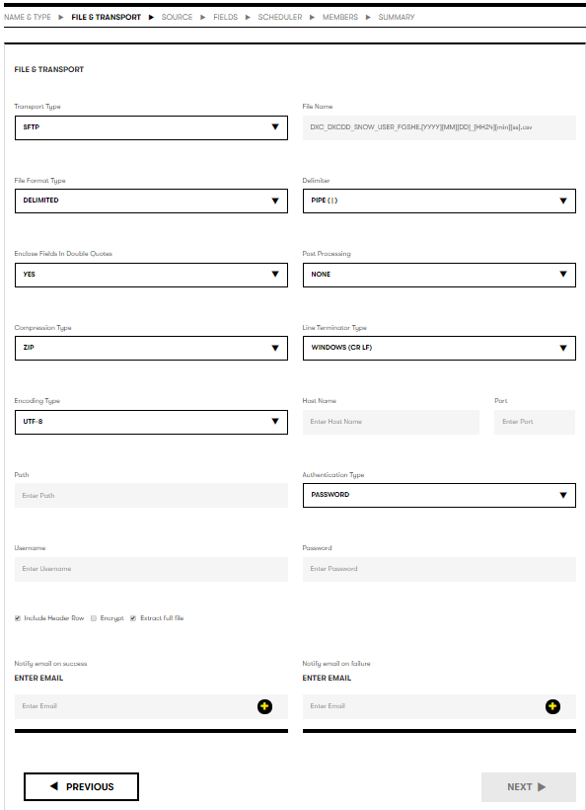

The following are the values that should be selected for each field on the screen.

| Field | Value |
| --- | --- |
| Transport Type | SFTP |
| File Name | DXC_DXCDD_SNOW_USER_FGSHE.[YYYY][MM][DD]_[HH24][min][ss].csv |
| File Format Type | Delimited |
| Delimiter | Pipe (|) |
| Enclose Fields in Double Quotes | YES |
| Post Processing | NONE |
| Compression Type | ZIP |
| Line Terminator Type | WINDOWS (CR, LF) |
| Encoding Type | UTF-8 |
| Include Header Row | ✓ |
| Encrypt | Unchecked.  **DO NOT Encrypt the data**. PDXC ServiceNow **cannot** consume encrypted data at this time. |
| Extract Full File | ✓ |

SFTP configuration is needed to complete the transport definition. Below are values for both ITG (aka. QA, Pre-Prod) and Production.

| Attribute | ITG Fieldglass | Production Fieldglass |
| --- | --- | --- |
| Hostname | CSCMIDNDCP001.CSCMWS.CSCMWS.COM | CSCMIDNDCP001.CSCMWS.CSCMWS.COM |
| Port | 22 | 22 |
| Path | D:\dxcddpplqa\fieldglass\MIDServer\data_files\in | d:\dxcddpplprod\fieldglass\midserver\MidServer\data_files\in |
| Authentication Type | Password | Password |
| Username | <enter ITG Username> | <enter Prod Username> |
| Password | <enter ITG Password> | <enter Prod Password> |

**IMPORTANT: You will need to obtain the user id and password (for each environment) from support or other person knowledgeable on this integration.**

The last section of this page is related to notifications on whether the subscription ran successfully or encountered a failure. It is recommended to specify at least one person (or distribution list) to be notified in the event of a failure.

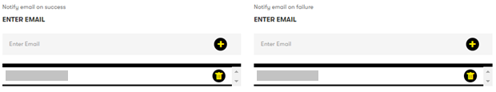

The steps to add email addresses to either notification are:

1. Enter the desired email address in the appropriate grey box.
2. Click  to add the name to the list below the box.
3. Repeat the previous steps for each email address in each list.

There is no validation on these email addresses. If you make a mistake, you can click the next to the incorrect entry to remove it from the list.

Once you’ve entered all the data, select  to specify the data source.

## Step 4: Source

This step defines where to pull the data for the subscription.

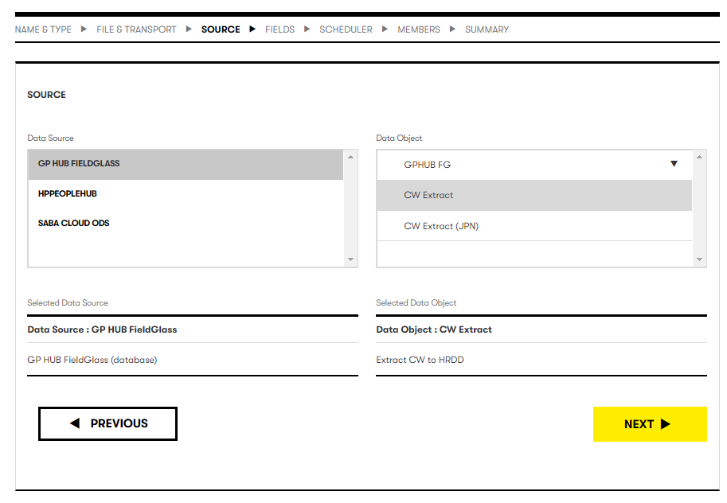

The following are the values that should be selected for each field on the screen.

| Field | Value |
| --- | --- |
| Data Source | GP HUB Fieldglass |
| Data Object | CW Extract |

Once you’ve entered all the data, select  to specify the fields to include from the data source.

## Step 5: Fields

This step defines the content of the subscription provided to the consumer or subscriber. The order the fields appear in the field list is the order they will appear in the file when it is generated. The value in the “NAME” column will be the value in the Header Row if that is checked on the File and Transport definition.

The fields to be selected for the subscription are shown in the screen shot below, as well as in Appendix B: Fieldglass Field List section. These 13 fields should be selected by clicking the “SELECT” box resulting in a ‘✓’. You will need to scroll through the complete list of fields to find them. Fields are not in any particular order.

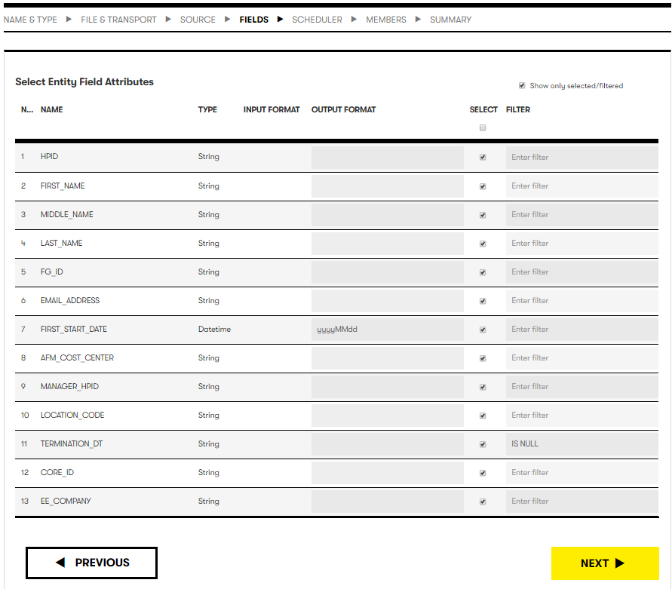

Once the fields are selected, verify the selections by selecting the “Show only selected/filtered” in the upper left area of the screen. This will display ONLY those fields that were checked. You should have 13, and they should align to the screen above.

### Step 5a: Specify Field filters

This section explains how to add filters without values.

|  |  |  |
| --- | --- | --- |
| Field | Filter | Value(s) |
| TERMINATION_DT | is null | n/a |

The steps can be applied to any filter that does not have a value (e.g. null, not null).

1. Click in the “No filter” area next to the field, a drop down should appear.
2. This will display a field filters screen
3. Select “null” from the drop down.

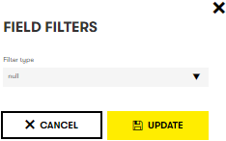

1. Select  to save the filter.

### Step 5b: Specify Formats

DXC DD SS provides the ability to specify special formatting for certain types of fields. This is necessary to make the field format compatible with the format expected by the interface that processes the file.

An “OUTPUT FORMAT” must be specified for the “FIRST_START_DATE” field. The correct format string is “yyyyMMdd”. **Please note** the format string is case sensitive!

The steps can be applied to any OUTPUT.

1. Click in the box next to the field and under the “OUTPUT FORMAT” header.
2. Enter the format string: yyyyMMdd (without double quotes)

**IMPORTANT: ONLY the fields specified above should be included in the extract. Any changes to this list requires development work to be done to recognize new fields (or omit deleted fields). Adding or deleting fields may change the order of fields in the interface resulting in errors and incorrect data entry on the PDXC ServiceNow side.**

### Step 5c: Save and move to the next section

Once you’ve entered all the data, select  to specify the schedule for the interface.

## Step 6: Scheduler

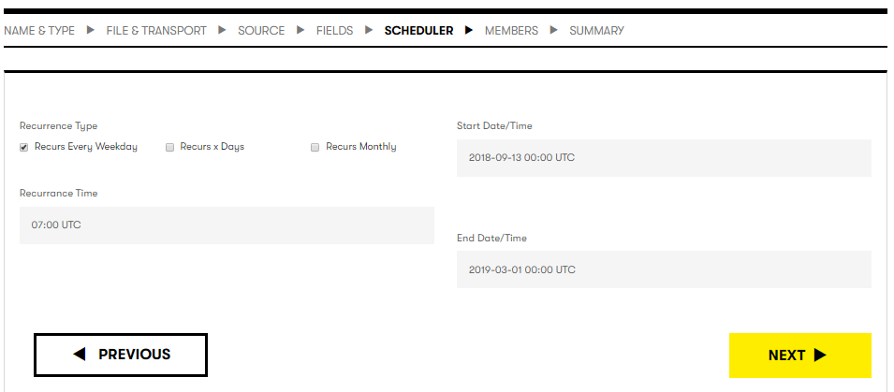

Database type extracts can be scheduled to run at specific times. The current schedule runs on every weekday (Monday – Friday), at 07:00 UTC (01:00 CDT). This can be varied as desired, though care should be taken when changing schedules. It could have downstream impact depending on how the schedule is changed.

There are three recurrence types. The following field values assume the “Recurs Every Weekday” type.

| Field | Value |
| --- | --- |
| Recurrence Type | Select the appropriate timeframe for the file to be created.   1. ✓ Recurs Every Weekday. Every day Monday through Friday. 2. Recurs x Days. This is an absolute every X days from the Start Date/Time 3. Recurs Monthly. This will run on the day of the month specified (e.g. 1-31). Suggest using care with dates beyond 28, as number of days in months differ. |
| Start Date/Time | Specify the date to start the subscription. This is the first date the subscription will run |
| Recurrence Time | UTC time the subscription will kick off each scheduled day |
| End Date/Time | Specify the date to end the subscription. This is a required field, and needs to be provided.  **Note:** Be sure to include tasks in the support model to extend it when it nears the end date. |

**IMPORTANT: All Times are entered in UTC, 24 hour clock. If you are unsure of the appropriate UTC time to enter, use a translator or other mechanism to determine the correct UTC time.**

Once you’ve specified the subscription schedule, select  to configure members with visibility to the subscription.

## Step 7: Members

Each subscription requires at least one administrator in addition to the person that is creating the subscription. They cannot be the same person.

These are the same steps regardless of the data source (file or database) and can be used as reference for other data objects.

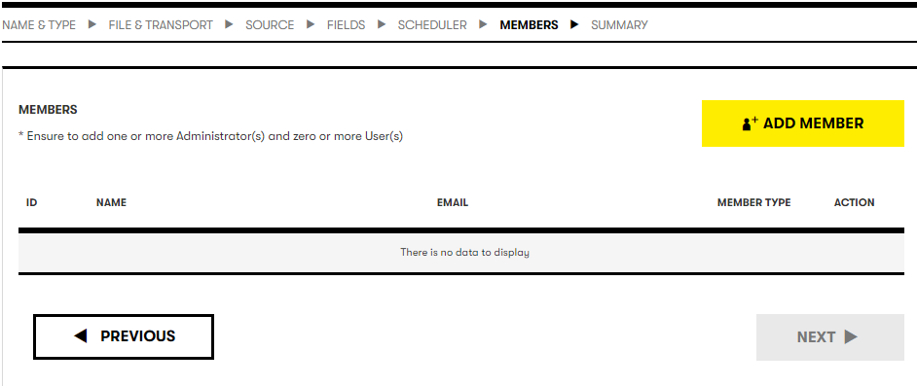

To add members, select  to look up members and add them to the subscription.

You can look up members by ID, name or email. Email is probably the easiest to search.

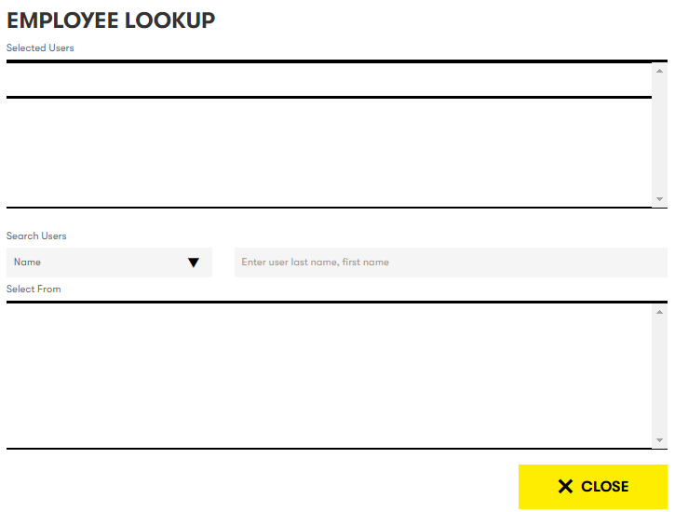

The steps to lookup employees are:

1. Select the desired search criteria from the “Search Users” drop down.
2. Enter the user value in the box to the right of the drop down.
3. Hit “Enter” to initiate the search.
4. Wait for results to be displayed.
   1. NOTE: Be patient after hitting “Enter”. The lookup can take longer than expected.
   2. Matches are displayed in the “bottom Select From” section. Grey box
5. Select the correct user by clicking .
6. The user’s information will be moved to the top “Selected Users” section.
7. Repeat steps 1-5 for all users that will have visibility to the subscription.

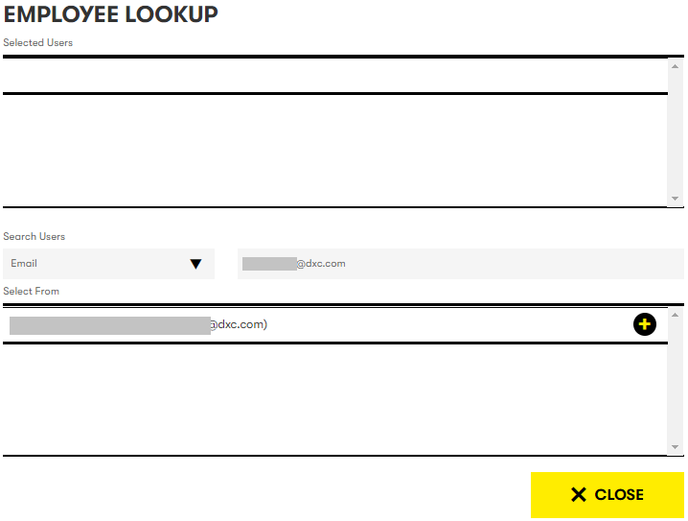

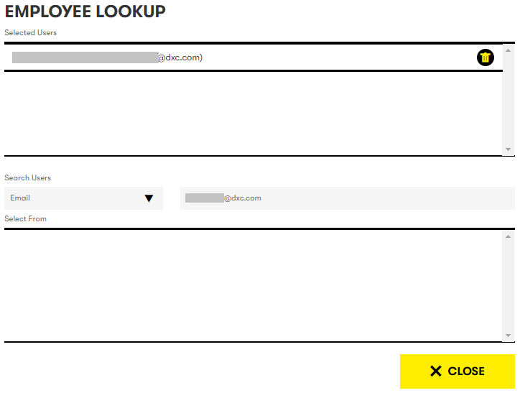

Once all users are added to the “Selected Users” section, click  to close the window and return to the Members screen.

When you return to the Members screen, each of the users added will appear in the list.

Each user must be assigned a “Member Type”, and by default each is assigned “Admin”. You are considered the subscription owner and are required to have add least 1 Admin member. If you want the user added as a User of the subscription instead of an Admin, it can be changed using the “Member Type” drop down for their entry.

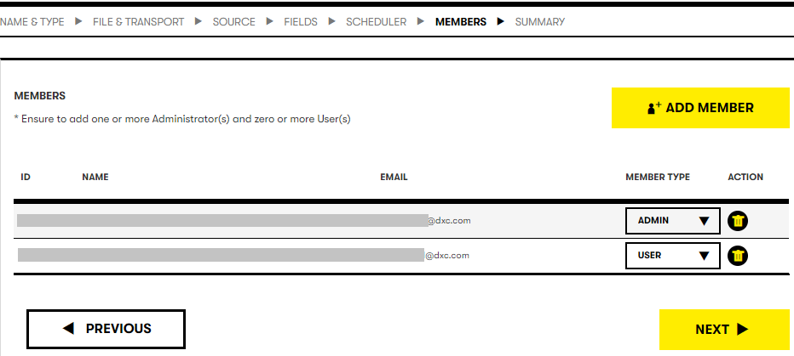

Once all users are added to the “Selected Users” section, click  to move to the Summary screen.

## Step 8: Summary & Submit

The Summary screen displays all information related to the subscription. This information should match the information entered in steps 2-7.

The final step in subscription creation is to save the subscription. This will submit the subscription to the self-service application and initiate the two level approval process. The 1st level is your manager and the 2nd is the data source/concept owner.

**IMPORTANT: It is highly recommended to carefully review the content and verify the subscription is accurate before saving it. Once it is saved, no changes can be made until the approval process is completed.**

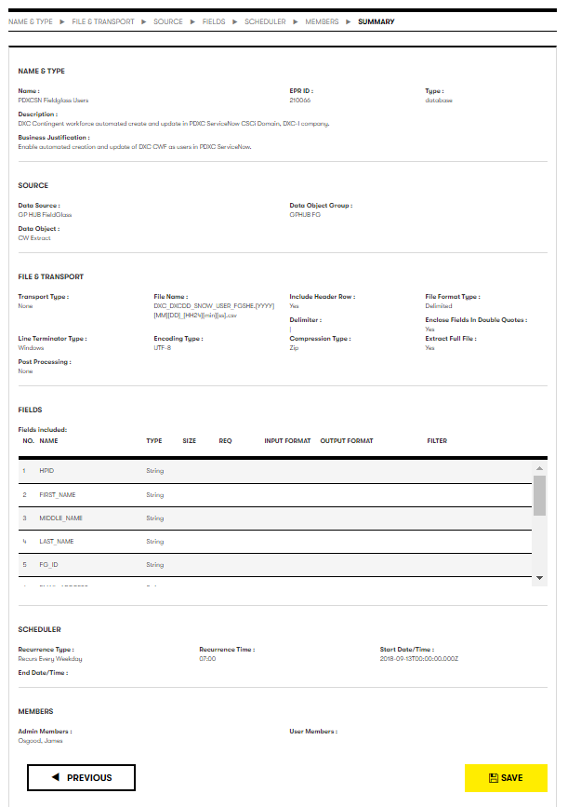

To save the subscription and initiate the approval process, click. You will be taken to the subscription page and you should see the newly added subscription.

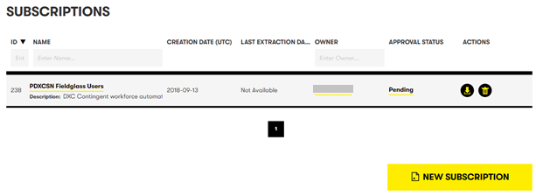

You will notice the “Approval Status” is “Pending”. That indicates it is in the approval process. When the process is complete and both levels approve, it will change to “Approved”.

You (the subscription owner) and the Members on the subscription will receive email updates as the subscription moves through the approval process.

This screen can also be used to see when the subscriptoin was last run – “Last Extraction Da…”.

Subscriptions can be manually downloaded using the , and can be removed using the .

# HR Workday Data Source

This section describes the Workday subscription definition. Workday data represents DXC direct employees.

Workday subscription data is a file based data object. The steps outlined below can also be applied to subscriptions for any other file based data objects.

The first step in any subscription is the Name & type.

## Step 2: Name & Type

As mentioned in the Step 2: Begin Subscription Definition – Name & Type section, this information is important to the approvers so they can verify your need for the data. Be as accurate and complete as possible to let them know the reason the data is needed and how it will be used.

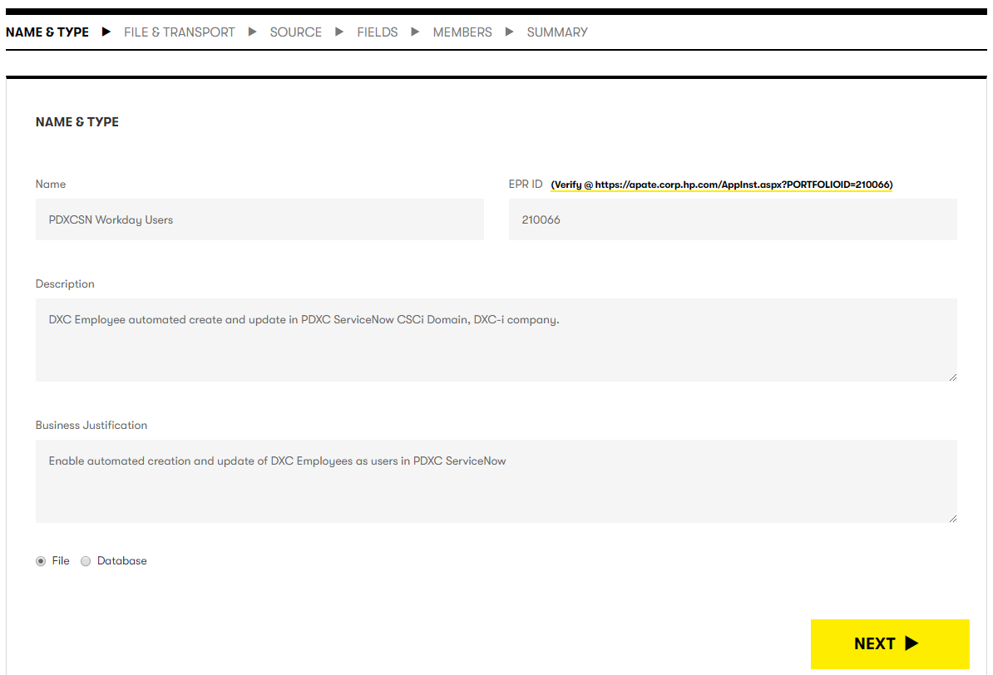

The following are the values that should be provided for each field on the screen.

| Field | Value |
| --- | --- |
| Name | PDXCSN Workday Users |
| EPRID | 210066[3] |
| Description | DXC Employee automated create and update in PDXC ServiceNow CSCi domain, and both CSCI and DXCI Companies in the domain. |
| Business Justification | Enable automated creation and update of DXC Employees as users in PDXC ServiceNow. |
| File | 1. Selected |
| Database | Unselected |

Once you’ve entered all the data, select  to specify the File & Transport.

## Step 3: File & Transport

This step specifies the file characteristics and method of transport to the end data consumer.

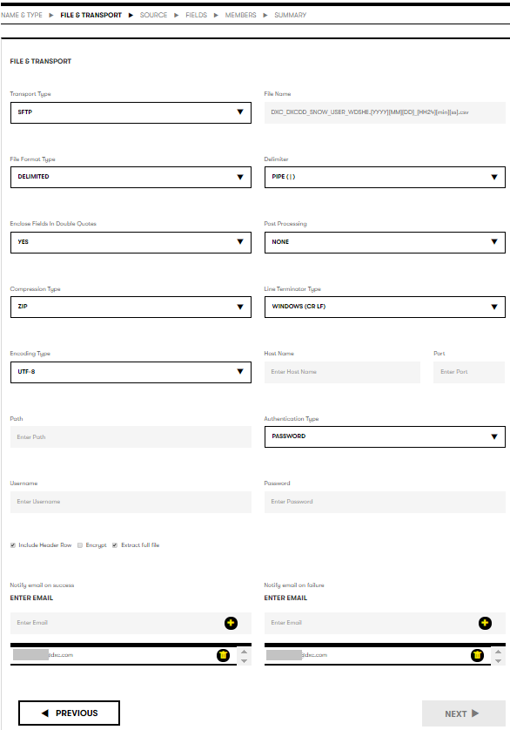

The following are the values that should be selected for each field on the screen.

| Field | Value |
| --- | --- |
| Transport Type | SFTP |
| File Name | DXC_DXCDD_SNOW_USER_FGSHE.[YYYY][MM][DD]_[HH24][min][ss].csv |
| File Format Type | Delimited |
| Delimiter | Pipe (|) |
| Enclose Fields in Double Quotes | YES |
| Post Processing | NONE |
| Compression Type | ZIP |
| Line Terminator Type | WINDOWS (CR, LF) |
| Encoding Type | UTF-8 |
| Include Header Row | ✓ |
| Encrypt | Unchecked.  **DO NOT Encrypt the data**. PDXC ServiceNow **cannot** consume encrypted data at this time. |
| Extract Full File | ✓ |

SFTP configuration is needed to complete the transport definition. Below are values for both ITG (aka. QA, Pre-Prod) and Production.

|  |  |  |
| --- | --- | --- |
| Hostname | CSCMIDNDCP001.CSCMWS.CSCMWS.COM | CSCMIDNDCP001.CSCMWS.CSCMWS.COM |
| Port | 22 | 22 |
| Path | D:\dxcddpplqa\workday\MIDServer\data_files\in | d:\dxcddpplprod\workday\midserver\MidServer\data_files\in |
| Authentication Type | Password | Password |
| Username | <ITG user name> | <PROD user name> |
| Password | <password> | <password> |

**IMPORTANT: You will need to obtain the user id and password (for each environment) from support or other person knowledgeable on this integration.**

The last section of this page is related to notifications on whether the subscription ran successfully or encountered a failure. It is recommended to specify at least one person (or distribution list) to be notified in the event of a failure.



The steps to add email addresses to either notification are:

1. Enter the desired email address in the appropriate grey box.
2. Click  to add the name to the list below the box.
3. Repeat the previous steps for each email address in each list.

There is no validation on these email addresses. If you make a mistake, you can click the next to the incorrect entry to remove it from the list.

Once you’ve entered all the data, select  to specify the data source.

## Step 4: Source

This step defines where to pull the data for the subscription.

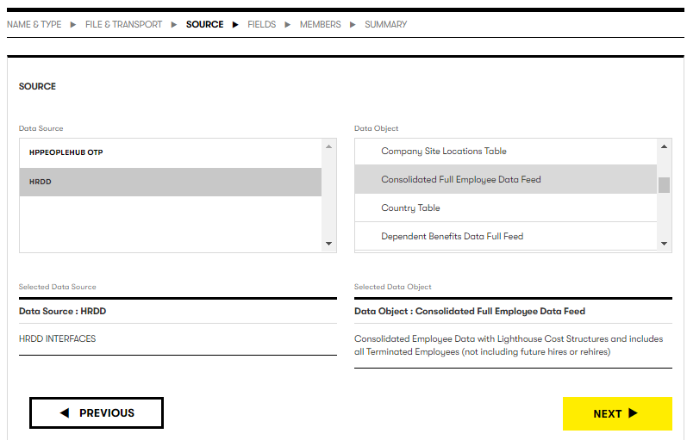

The following are the values that should be selected for each field on the screen.

| Field | Value |
| --- | --- |
| Data Source | HRDD |
| Data Object | Consolidated Full Employee Data Feed |

Once you’ve entered all the data, select  to specify the fields to include from the data source.

## Step 5: Fields

This step defines the content of the subscription provided to the consumer or subscriber. The order the fields appear in the field list is the order they will appear in the file when it is generated. The value in the “NAME” column will be the value in the Header Row if that is checked on the File and Transport definition.

The fields to be selected for the subscription are shown in the screen shot below as well as in Appendix C: Workday Field List section. These 17 fields should be selected by clicking the “SELECT” box resulting in a ‘✓’. You will need to scroll through the complete list of fields to find them. Fields are not in any particular order.

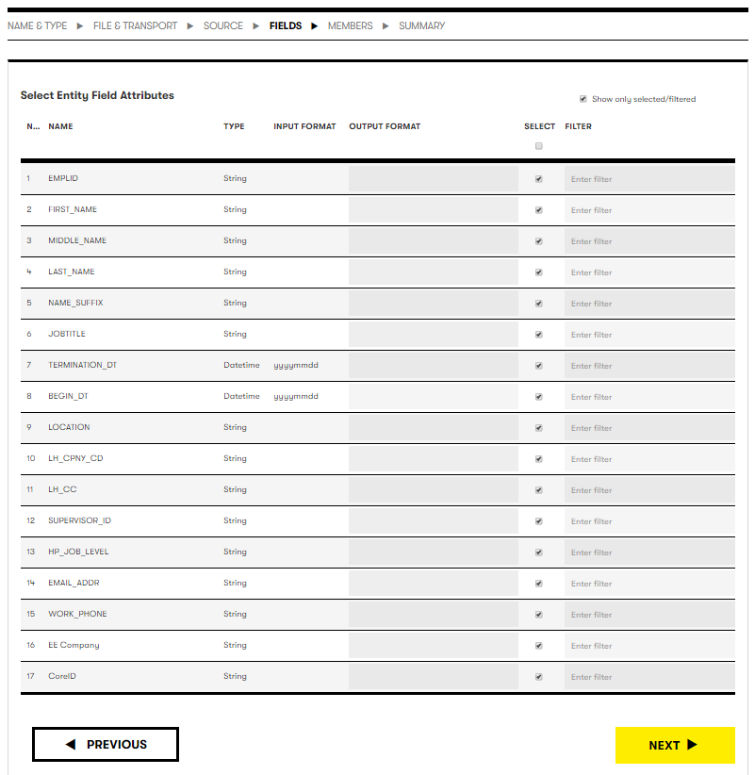

Once the fields are selected, verify the selections by selecting the “Show only selected/filtered” in the upper left area of the screen. This will display ONLY those fields that were checked. You should have 13, and they should align to the screen above.

**IMPORTANT: ONLY the fields specified above should be included in the extract. Any changes to this list requires development work to be done to recognize new fields (or omit deleted fields). Adding or deleting fields may change the order of fields in the interface resulting in errors and incorrect data entry on the PDXC ServiceNow side.**

Once you’ve entered all the data, select  to specify the schedule for the interface.

## Step 6: Members

Reference the Fieldglass Step 7: Members for steps to add members to the subscription.

Once all users are added to the “Selected Users” section, click  to move to the Summary screen.

## Step 7: Summary

The Summary screen displays all information related to the subscription. This information should match the information entered in steps 2-7.

The final step in subscription creation is to save the subscription. This will submit the subscription to the self-service application and initiate the two level approval process. The 1st level is your manager and the 2nd is the data source/concept owner.

**IMPORTANT: It is highly recommended to carefully review the content and verify the subscription is accurate before saving it. Once it is saved, no changes can be made until the approval process is completed.**

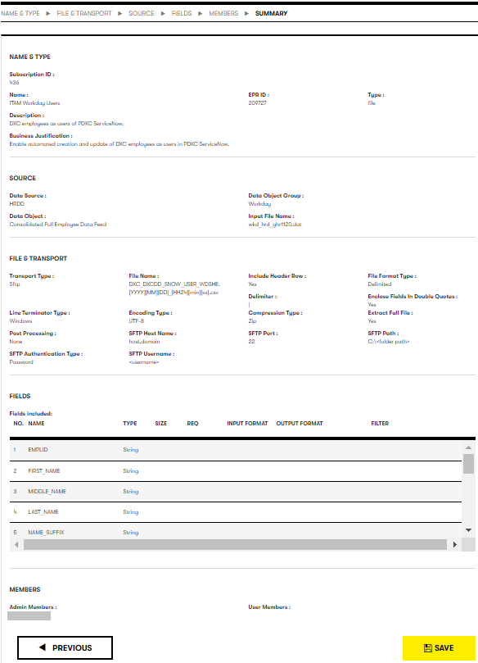

To save the subscription and initiate the approval process, click. You will be taken to the subscription page and you should see the newly added subscription.

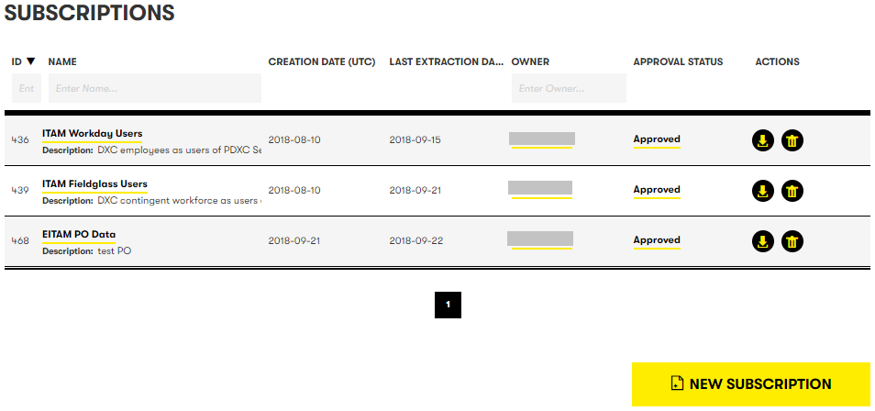

You will notice the “Approval Status” is “Pending”. That indicates it is in the approval process. When the process is complete and both levels approve, it will change to “Approved”.

You (the subscription owner) and the Members on the subscription will receive email updates as the subscription moves through the approval process.

This screen can also be used to see when the subscriptoin was last run – “Last Extraction Da…”.

Subscriptions can be manually downloaded using the , and can be removed using the .

# Supply Chain Purchase Order Data

Creating a subscription for PO data is very similar to creating the Fieldglass subscription – both are database sourced subscriptions.

Each section below will only provide the data content for each screen. If you need to step-by-step instructions, reference the HR Fieldglass Data Source section.

## Step 2: Name & Type

As mentioned in the Step 2: Begin Subscription Definition – Name & Type section, this information is important to the approvers so they can verify your need for the data. Be as accurate and complete as possible to let them know the reason the data is needed and how it will be used.

| Field | Value |
| --- | --- |
| Name | EITAM PO Data |
| EPRID | 209727 |
| Description | Purchase Order data to support DXC IT Asset Management |
| Business Justification | PO data provides the basis for asset receipt and other asset management processes. |
| File | Unselected |
| Database | 1. Selected |

## Step 3: File & Transport

The following are the values that should be selected for each field on the screen.

| Field | Value |
| --- | --- |
| Transport Type | NONE |
| File Name | DXC_DXCDD_SNOW_USER_FGSHE.[YYYY][MM][DD]_[HH24][min][ss].csv |
| File Format Type | Delimited |
| Delimiter | Pipe (|) |
| Enclose Fields in Double Quotes | YES |
| Post Processing | NONE |
| Compression Type | ZIP |
| Line Terminator Type | WINDOWS (CR, LF) |
| Encoding Type | UTF-8 |
| Include Header Row | ✓ |
| Encrypt | Unchecked.  **DO NOT Encrypt the data**. PDXC ServiceNow **cannot** consume encrypted data at this time. |
| Extract Full File | ✓ |

Once you’ve entered all the data, select  to specify the data source.

## Step 4: Source

This step defines where to pull the data for the subscription.

| Field | Value |
| --- | --- |
| Data Source | Data Lake |
| Data Object Group | Supply Chain |
| Data Object | Purchase Orders |

Once you’ve entered all the data, select  to specify the fields to include from the data source.

## Step 5: Fields

This step defines the content of the subscription provided to the consumer or subscriber. The order the fields appear in the field list is the order they will appear in the file when it is generated. The value in the “NAME” column will be the value in the Header Row if that is checked on the File and Transport definition.

The fields to be selected for the subscription are shown in the screen shot below as well as in the Appendix D: Purchase Order Field List section. These 26 fields should be selected by clicking the “SELECT” box resulting in a ‘✓’. You will need to scroll through the complete list of fields to find them. Fields are not in any particular order.

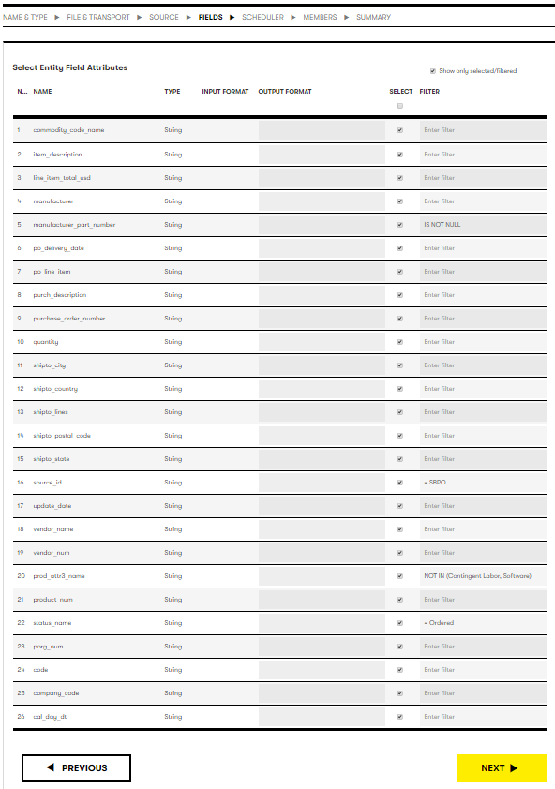

Once the fields are selected, verify the selections by selecting the “Show only selected/filtered” in the upper left area of the screen. This will display ONLY those fields that were checked. You should have 26, and they should align to the screen above.

**IMPORTANT: ONLY the fields specified above should be included in the extract. Any changes to this list requires development work to be done to recognize new fields (or omit deleted fields). Adding or deleting fields may change the order of fields in the interface resulting in errors and incorrect data entry on the PDXC ServiceNow side.**

### Step 5a: Specify Field Filters

Three fields require filters to make sure the appropriate data is provided in the subscription. They are:

1. manufacturer_part_number = not null
2. status_name = Ordered
3. prod_attr3_name not in (Contingent Labor, Software)
4. source_id. - SBPO

To set filters, click in the “Enter filter” and a blank “Field Filters” screen should appear.

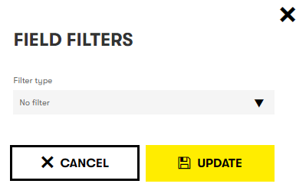

#### manufacturer_part_number

This section explains how to add filters without values.

|  |  |  |
| --- | --- | --- |
| Field | Filter | Value(s) |
| manufacturer_part_number | Not null | n/a |

The steps can be applied to any filter that does not have a value (e.g. null, not null).

1. Click in the “No filter” area next to the field, a drop down should appear.
2. This will display a field filters screen
3. Select “not null” from the drop down.

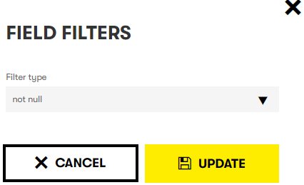

1. Select  to save the filter.

#### status_name

This section explains how to add single value filters.

|  |  |  |
| --- | --- | --- |
| Field | Filter | Value(s) |
| status_name | equals | Ordered |

The steps can be applied to any filter that has a single value. **Please note** the format strings are case sensitive!

1. Click in the “No filter” area next to the field, a drop down should appear.
2. This will display a field filters screen
3. Select “equals” from the drop down.

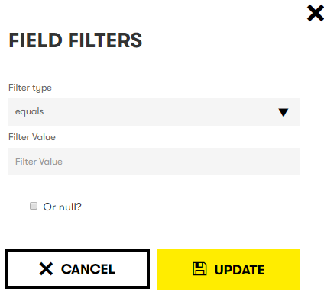

1. In the “Filter value” enter “Ordered” (do not include the double quotes)

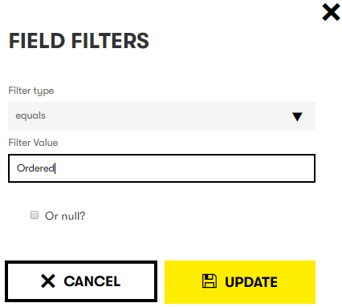

1. Select  to save the filter.

#### prod_attr3_name

This section explains how to add multi-value filters.

|  |  |  |
| --- | --- | --- |
| Field | Filter | Value(s) |
| prod_attr3_name | not in | Contingent Labor Software |

The steps can be applied to any filter that has a single value. **Please note** the format strings are case sensitive!

1. Click in the “No filter” area next to the field, a drop down should appear.
2. This will display a field filters screen
3. Select “not in” from the drop down.
4. In the “Filter value” enter “Contingent Labor” (do not include the double quotes)
5. Click  to add the entry.
6. Repeat the previous 2 steps for each of the remaining values: Software.

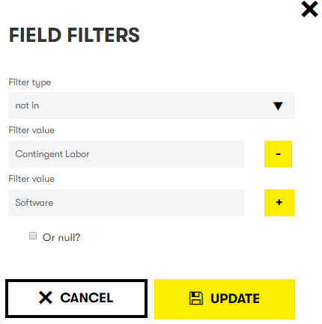

1. Once all filter values have been entered, select  to save them.

#### Source_id

The filter for “source_id” is a single value filter. Reference manufacturer_part_number section for specific steps. **Please note** the format strings are case sensitive!

|  |  |  |
| --- | --- | --- |
| Field | Filter | Value(s) |
| source_id | equals | SBPO |

### Step 5b: Save and move to the next section

Once you’ve entered all the data and filters, select  to specify the schedule for the interface.

## Step 6: Scheduler

Database type extracts can be scheduled to run at specific times. The current schedule runs on every weekday (Monday – Friday), at 07:00 UTC (01:00 CDT). This can be varied as desired, though care should be taken when changing schedules. It could have downstream impact depending on how the schedule is changed.

There are three recurrence types. The following field values assume the “Recurs Every Weekday” type.

| Field | Value |
| --- | --- |
| Recurrence Type | Select the appropriate timeframe for the file to be created.   1. ✓ Recurs Every Weekday. Every day Monday through Friday. 2. Recurs x Days. This is an absolute every X days from the Start Date/Time 3. Recurs Monthly. This will run on the day of the month specified (e.g. 1-31). Suggest using care with dates beyond 28, as number of days in months differ. |
| Start Date/Time | Specify the date to start the subscription. This is the first date the subscription will run |
| Recurrence Time | UTC time the subscription will kick off each scheduled day |
| End Date/Time | Specify the date to end the subscription. This is a required field, and needs to be provided.  **Note:** Be sure to include tasks in the support model to extend it when it nears the end date. |

**IMPORTANT: All Times are entered in UTC, 24 hour clock. If you are unsure of the appropriate UTC time to enter, use a translator or other mechanism to determine the correct UTC time.**

Once you’ve specified the subscription schedule, select  to configure members with visibility to the subscription.

## Step 7: Members

Each subscription requires at least one administrator in addition to the person that is creating the subscription. They cannot be the same person.

Once all users are added to the “Selected Users” section, click  to move to the Summary screen.

## Step 8: Summary & Submit

The Summary screen displays all information related to the subscription. This information should match the information entered in steps 2-7.

The final step in subscription creation is to save the subscription. This will submit the subscription to the self-service application and initiate the two level approval process. The 1st level is your manager and the 2nd is the data source/concept owner.

**IMPORTANT: It is highly recommended to carefully review the content and verify the subscription is accurate before saving it. Once it is saved, no changes can be made until the approval process is completed.**

To save the subscription and initiate the approval process, click. You will be taken to the subscription page and you should see the newly added subscription.

# Appendix A: Glossary

|  |  |
| --- | --- |
| Term | Description |
| PDXC SN | Platform ServiceNow |
| EITAM | Enterprise IT Asset Management |
| DXC DD | DXC Data Distribution |
| DXC DD SS | DXC Data Distribution Self-Service |
| PO | Purchase Order |
| CWF | Contingent Workforce |

# Appendix B: Fieldglass Field List

The following is the list of files that should be selected for the Fieldglass subscription. It also includes any special instructions that must be applied for each field.

| Field Name | Special Instructions |
| --- | --- |
| HPID | N/A |
| FIRST_NAME | N/A |
| MIDDLE_NAME | N/A |
| LAST_NAME | N/A |
| FG_ID | N/A |
| EMAIL_ADDRESS | N/A |
| FIRST_START_DATE | **Output Format:** yyyyMMdd |
| AFM_COST_CENTER | N/A |
| MANAGER_HPID | N/A |
| LOCATION_CODE | N/A |
| TERMINATION_DT | **Filter:** (is) null |
| CORE_ID | N/A |
| EE_COMPANY | N/A |

# Appendix C: Workday Field List

The following is the list of files that should be selected for the Workday subscription. It also includes any special instructions that must be applied for each field.

| Field Name | Special Instructions |
| --- | --- |
| EMPLID | N/A |
| FIRST_NAME | N/A |
| MIDDLE_NAME | N/A |
| LAST_NAME | N/A |
| NAME_SUFFIX | N/A |
| JOBTITLE | N/A |
| TERMINATION_DT | N/A |
| BEGIN_DT | N/A |
| LOCATION | N/A |
| LH_CPNY_CD | N/A |
| LH_CC | N/A |
| SUPERVISOR_ID | N/A |
| HP_JOB_LEVEL | N/A |
| EMAIL_ADDR | N/A |
| WORK_PHONE | N/A |
| EE Company | N/A |
| CoreID | N/A |

# Appendix D: Purchase Order Field List

The following is the list of files that should be selected for the Purchase Order subscription. It also includes any special instructions that must be applied for each field.

| Field Name | Special Instructions |
| --- | --- |
| po_delivery_date | N/A |
| manufacturer | N/A |
| manufacturer_part_number | **Filter:** not null |
| commodity_code_name | N/A |
| manufacturer_part_number | N/A |
| cal_day_dt | N/A |
| purch_description | N/A |
| item_description | N/A |
| company_code | N/A |
| code | N/A |
| prod_attr3_name | **Filter:** not in (Contingent Labor, Software) |
| po_line_item | N/A |
| purchase_order_number | N/A |
| line_item_total_usd | N/A |
| porg_num | N/A |
| quantity | N/A |
| shipto_lines | N/A |
| shipto_city | N/A |
| shipto_country | N/A |
| shipto_state | N/A |
| shipto_postal_code | N/A |
| vendor_name | N/A |
| vendor_num | N/A |
| update_date | N/A |
| status_name | **Filter:** equals Ordered |
| source_id | **Filter:** equals SBPO |

1. The actual name of the tool is DXC DD Self-Service. The screen is still branded as HRDD+. That will be updated in a future release.
2. This is the EPRID for PDXC ServiceNow.
3. This is the EPRID for PDXC ServiceNow.