**DXC Digital Explorer**

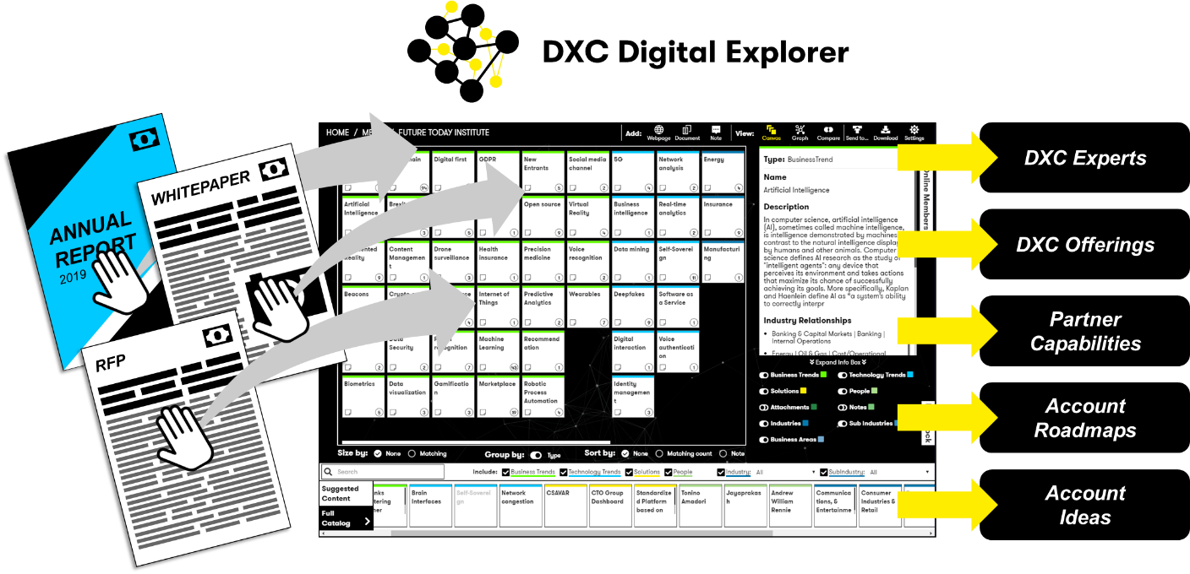

The [DXC Digital Explorer](https://digitalexplorer.dxc.com) platform has come of age during the past 12 months; be it through the integration within the new London Innovation Centre, proving its value at external events or gaining ground with our solutioning and sales teams, [DXC Digital Explorer](https://digitalexplorer.dxc.com/) is **THE** platform every customer facing employee has to try.  
  
Understanding the potential of emerging technologies and how these directly relate to our clients’ line of business and strategic goals used to take hours or days to analyse; with DXC Digital Explorer you can do this in less than a minute. DXC Digital Explorer doesn’t stop there; once the core information is captured you can then compare against the DXC portfolio, our partner capabilities and publish your own eBook to share with the client via the Digital Explorer Playbooks feature.

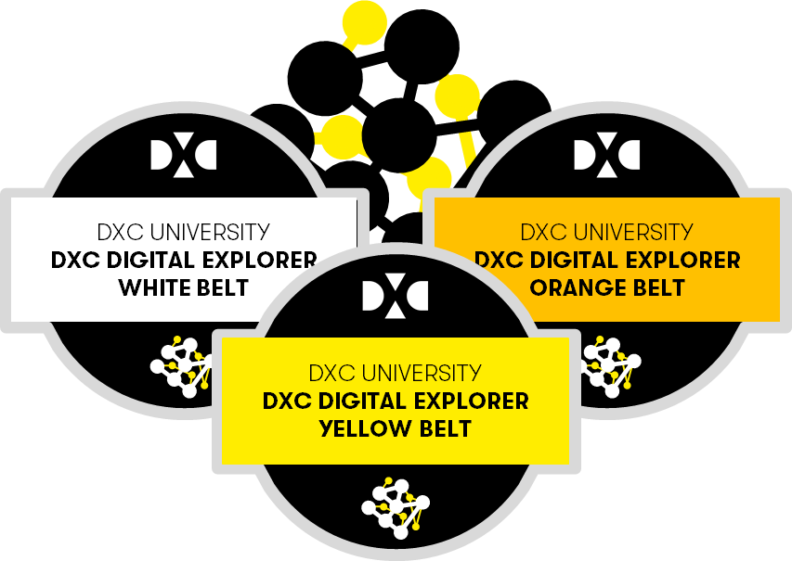A new set of courses are available on DXC University to give you the skills to unlock your next set of client opportunities.

* White belt: High-level overview and awareness training
* Yellow Belt: Analyse client requirements within the Workspaces Module and create your first Playbook
* Orange Belt: Build out an Innovation Agenda or Digital Roadmap and outline ideas to discuss with your client

**Call to action**

1. Search for “Digital Explorer” in DXC university to access the courses.
2. Analyse your current clients investor or similar documents in a [Digital Explore](https://digitalexplorer.dxc.com)r Workspace and see where you might want to take the client next.
3. Join the [Digital Explorer workplace group](https://dxc.workplace.com/groups/1944577162473453/) to stay informed on the latest releases

**Contact**

David Stevens, Product Owner, Distinguished Architect  
Kimberly Gennusa, Product Champion, Integration Assurance