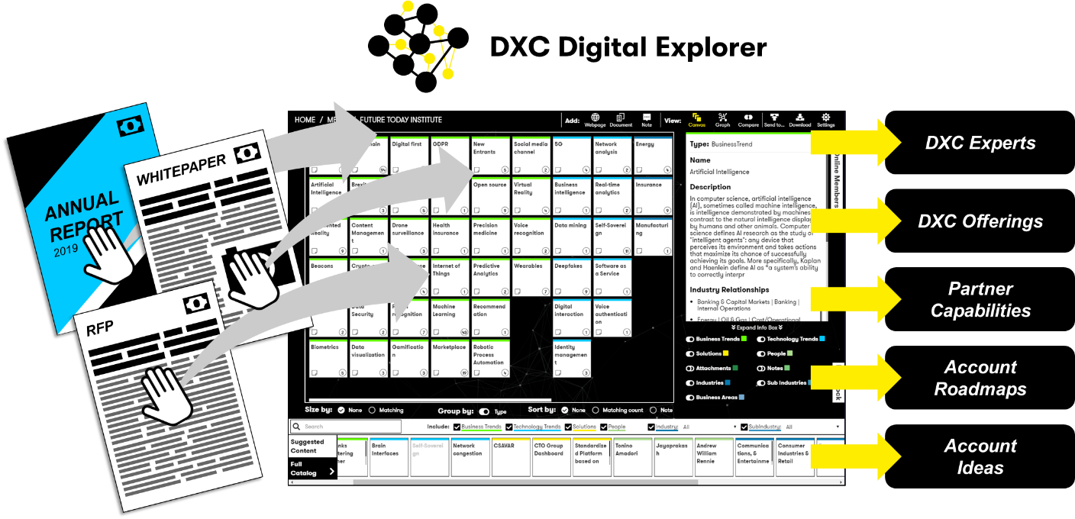

The [DXC Digital Explorer](https://digitalexplorer.dxc.com) platform has come of age during the past 12 months; be it through the integration within the new London Innovation Centre, proving its value at external events or gaining ground with our solutioning and sales teams, [DXC Digital Explorer](https://digitalexplorer.dxc.com/) is **THE** platform every customer facing employee has to try.  
  
Understanding the potential of emerging technologies and how these directly relate to our clients’ line of business and strategic goals used to take hours or days to analyse; with DXC Digital Explorer you can do this in less than a minute. DXC Digital Explorer doesn’t stop there; once the core information is captured you can then compare against the DXC portfolio, our partner capabilities and publish your own eBook to share with the client via the Digital Explorer Playbooks feature.

“One day, we’ll all look back and wonder how we ever managed to engage with clients without Digital Explorer”   
  
Andrew Broadhurst  
Sales Enablement Leader, UKIIMEA Sales

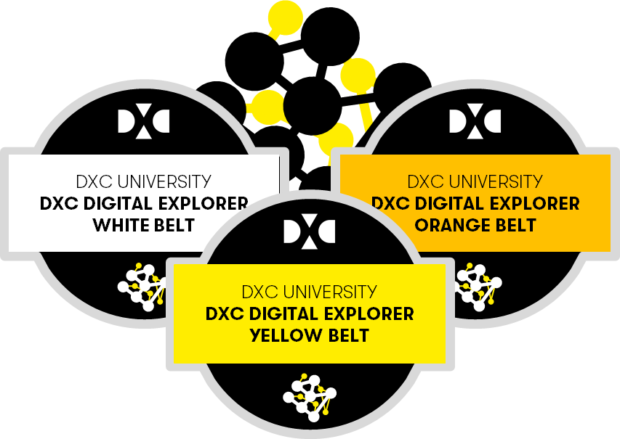

A new set of courses are available on DXC University to give you the skills to unlock your next set of client opportunities:

* [**White belt**](https://dxc.sabacloud.com/Saba/Web_spf/NA2PRD0005/app/shared;spf-url=common%2Flearningeventdetail%2Fcurra000000000004384): High-level overview and awareness training
* [**Yellow belt**](https://dxc.sabacloud.com/Saba/Web_spf/NA2PRD0005/app/shared;spf-url=common%2Flearningeventdetail%2Fcurra000000000004500): Analyse client requirements within the Workspaces Module and create your first Playbook
* [**Orange belt**](https://dxc.sabacloud.com/Saba/Web_spf/NA2PRD0005/app/shared;spf-url=common%2Flearningeventdetail%2Fcurra000000000004560): Build out an Innovation Agenda or Digital Roadmap and outline ideas to discuss with your client

**Published Content**DXC Teams are already publishing their insights directly within the Digital Explorer platform; the [European Automotive Industry Analyst](https://digitalexplorer.dxc.com/pb/playbook/765453) and [Insurance Market Overview](https://digitalexplorer.dxc.com/pb/playbook/769034) are two excellent examples; bringing together the analyse completed within the Digital Explorer Workspaces, Roadmap and Solutions modules into a single playbook.

**Supporting DXC Open Source approach**DXC Digital Explorer is one of DXC’s sponsored open source projects; all the documentation, specifications and backlog is available publicly on GitHub under the [DXC Organisation](https://github.com/dxc-technology/dxc-digitalexplorer).

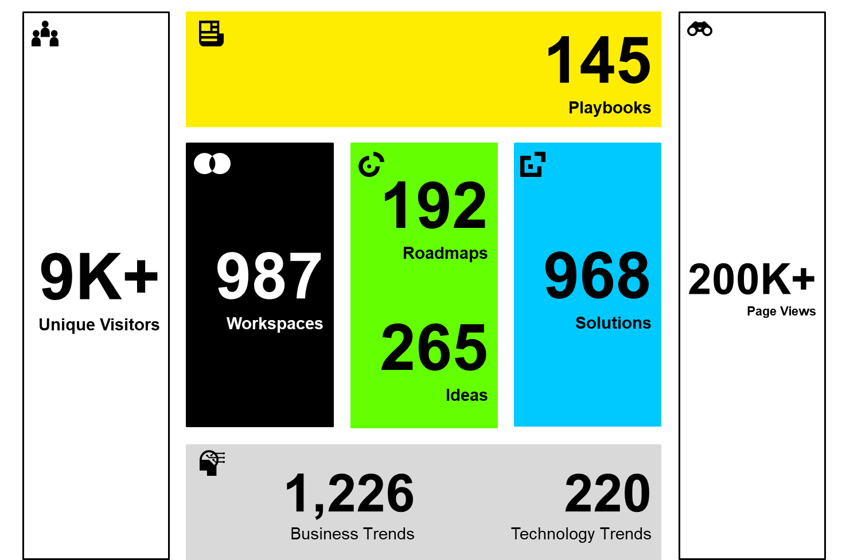**Digital Explorer: Stats**

**Call to action**

“A hugely positive impact on our presence at the exhibition.  
The ability to readily articulate a client’s business need in front of them and to explore the impact that this might have on their plans and strategy hit the mark with a number of the MoD clients. Whilst we weren’t looking to sell DE to the MoD, its existence and features were a positive surprise to them.”

Paul O’Hanlon UKIIMEA Defence CT

1. Search for “Digital Explorer” in DXC university to access the courses.
2. Analyse your current clients investor and strategic documents in a [Digital Explorer Workspace](https://digitalexplorer.dxc.com) and see where you might want to take your client next.
3. Join the [Digital Explorer workplace group](https://dxc.workplace.com/groups/1944577162473453/) to stay informed on the latest releases

**Contacts**

[David Stevens](mailto:davidstevens@dxc.com?subject=Digital%20explorer%20mydxc%20-%20), Product Owner, Distinguished Architect  
[Kimberly Gennusa](mailto:kgennusa@dxc.com?subject=Digital%20explorer%20mydxc%20-%20), Product Champion, Integration Assurance