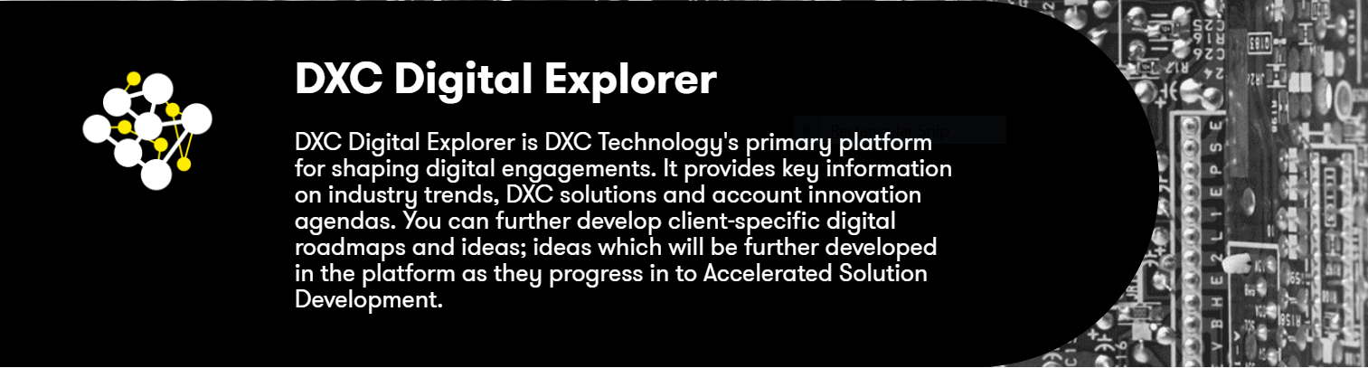

**DXC Digital Explorer: Shaping our customers’ Digital Roadmaps**

*“One day, we’ll all look back and wonder how we ever managed to engage with customers without Digital Explorer.”*Andrew Broadhurst  
Sales Enablement Leader UKIIMEA Sales

Need to know which industry trends are disrupting your customer’s business or how emerging technologies are shaping their strategic goals? Capturing and analyzing this information used to take hours or days. With [DXC Digital Explorer](https://digitalexplorer.dxc.com), it takes less than a minute. DXC Digital Explorer doesn’t stop there. Once the core information is captured, you can compare it against our DXC portfolio and partner capabilities, create and publish your own Roadmaps and eBooks. Giving you the ability to shape your customer’s Digital Roadmap and share leading examples of DXC Technology solutions with them.

**Coming of age**

*“Digital Explorer had a hugely positive impact on our presence at the exhibition. The ability to readily articulate a customer’s business need in front of them and to explore the impact that this might have on their plans and strategy hit the mark.”*

Paul O’Hanlon

UKIIMEA Defense

Chief Technologist

[DXC Digital Explorer](https://digitalexplorer.dxc.com) is an interactive, internal knowledge platform that has come of age during the past 12 months. The brainchild of Dave Stevens, Product Owner and Distinguished Architect within the DXC Technology Office, and his team, DXC Digital Explorer was [launched](https://my.dxc.com/news/2017/november/new-internal-platform-helps-employees-grasp-industry-and-it-tren.html) in 2017.

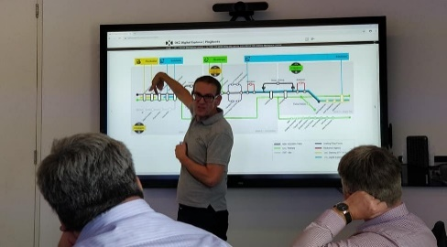The platform has matured as more solutioning and sales colleagues have contributed content, providing value at external events and internal planning sessions with customers. At the London Innovation Center, for example, DXC teams are using DXC Digital Explorer as a way to interact with customers, creating workspaces live on the site’s innovation board and creating playbooks for customers to share with their colleagues.

*Dave Stevens at the London Innovation Center*

**Sharing insights**

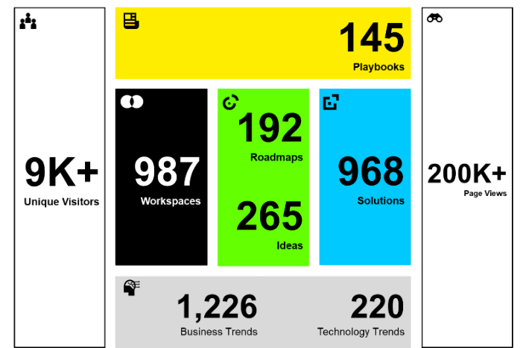As usage builds, [DXC Digital Explorer](https://digitalexplorer.dxc.com/) is becoming **THE** platform every customer-facing employee has to try. DXC teams are publishing their insights directly within the Digital Explorer platform. [Industry Analyst](https://digitalexplorer.dxc.com/pb/playbook/765453): Automotive and [Insurance Market Overview](https://digitalexplorer.dxc.com/pb/playbook/769034) are two excellent examples, bringing analyses completed within the DXC Digital Explorer Workspaces, Roadmap and Solutions modules together into a single playbook.

DXC Digital Explorer is one of DXC’s sponsored open source projects. All the documentation, specifications and backlog are available on GitHub under [DXC Organization](https://github.com/dxc-technology/dxc-digitalexplorer).

*Digital Explorer usage*

**DXC Digital Explorer and What We Sell**

DXC Digital Explorer uses [What We Sell’s](https://whatwesell.dxc.com/dxc/) API to pull gold-source offering content. DXC Digital Explorer combines trusted content from What We Sell with user-provided content and industry trends for deal shaping. What We Sell is the single, trusted source for everything a salesperson needs to sell a DXC-approved offering/solution, and Digital Explorer is a collaborative space to dig deeper and work on solutions.

**New training available**

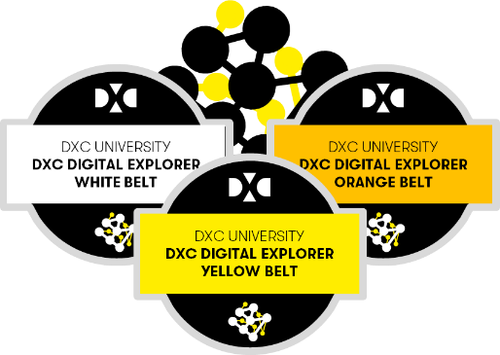A new set of DXC Digital Explorer courses are available on DXC University to give you the skills to unlock your next set of customer opportunities:

* [**White belt**](https://dxc.sabacloud.com/Saba/Web_spf/NA2PRD0005/app/shared;spf-url=common%2Flearningeventdetail%2Fcurra000000000004384): High-level overview and awareness training.
* [**Yellow belt**](https://dxc.sabacloud.com/Saba/Web_spf/NA2PRD0005/app/shared;spf-url=common%2Flearningeventdetail%2Fcurra000000000004500): Analyze customer requirements within the Workspaces Module and create your first playbook.
* [**Orange belt**](https://dxc.sabacloud.com/Saba/Web_spf/NA2PRD0005/app/shared;spf-url=common%2Flearningeventdetail%2Fcurra000000000004560): Build out an Innovation Agenda or Digital Roadmap and outline ideas to discuss with your customer.

**Call to action**

1. Search for “Digital Explorer” in [DXC University](https://dxc.sabacloud.com/Saba/Web_spf/NA2PRD0005/app/dashboard) to access the courses.
2. Analyze your current customers’ investor and strategic documents in a [Digital Explorer Workspace](https://digitalexplorer.dxc.com) and see where you might want to take your customere next.
3. Join the [Digital Explorer Workplace group](https://dxc.workplace.com/groups/1944577162473453/) to stay informed of the latest releases.

**Reference**

[DXC Digital Explorer Platform Overview](https://digitalexplorer.dxc.com/pb/playbook/643254)

[DXC Digital Explorer TV](https://digitalexplorer.dxc.com/explorer-tv)

**Contacts**

[David Stevens](mailto:davidstevens@dxc.com?subject=Digital%20explorer%20mydxc%20-%20), Product Owner, Distinguished Architect  
[Kimberly Gennusa](mailto:kgennusa@dxc.com?subject=Digital%20explorer%20mydxc%20-%20), Product Champion, Integration Assurance