

Survey Control networks: re-establishment & integration

Official Project Proposal



October 26, 2018

Team asg surveys: Adele castillo-ayala; soroosh sadeghi; george barnhardt

University of Calgary geomatics department

ENGO 500 F2018/W2019

**Table of Contents**

Executive Summary 3

Section 1. Project Overview 4

1.1 Project Description 4

1.2 Impact if Not Done 5

1.3 Proponent Profile 5

1.4 Collaborator Profile 6

1.5 Client/User Profile 6

Section 2. Project Performance Framework 7

2.1 Objectives, Outputs, Outcomes and Criteria 7

2.2 Project Performance Measurement Plan 8

2.3 Sustainability 10

2.3.1 Network Maintenance 10

2.3.2 Exercise Area Future 10

Section 3. Project Issues and Risks 11

3.1 Issue Identification 11

3.1.1 Policy and Standard Issues 11

3.1.2 Data and Technical Issues 11

3.1.3 Stakeholder Issues 12

3.2 Feasibility and Risk 12

Section 4. Project Plan 16

4.1 Project Team and Resources 16

4.2 Project Management and Control 17

4.3 Project Implementation Plan 20

4.4 Budget Summary 24

4.5 Communication Plan and Accessibility of Project Results 24

Section 5. Benefits 25

# Executive Summary

The University of Calgary’s Geomatics Department maintains multiple networks used for various courses offered by the Geomatics Engineering Undergraduate Degree, collectively known as the University Campus Geodetic Network. Renovations to the engineering building, construction of the TITL building, landscaping, and general deformations of these networks over time has degraded the internal consistency (between networks) and external consistency (ASCM network). Courses that use these networks include, but are not limited to: ENGO 343, 443, 401, 579, and 581. One network is located in the ICT/MacEwan Hall courtyard. The second network runs along Collegiate Blvd NW and Collegiate Rd NW down to 24th Ave NW. The third network is located on the East side of the Ronald McDonald House on 24th Ave NW.

The goal of this project is to re-establish the internal and external consistency of these networks. This is expected to be accomplished by performing an integrated survey using both conventional and contemporary methods. Primary objectives would include the retracement of all networks to re-establish internal consistency of the established control; re-integration of existing local UCG network control to ASCM geodetic control, and; establishment of new network control to current geodetic standards.

This project will be completed by Team ASG Surveys; A team of Geomatics Undergraduates at the University of Calgary. This project stands to directly benefit the current and future students/ professors associated with the aforementioned courses. Establishment of new control is also expected to aid future development of the University of Calgary Campus as they continue to expand, adding additional facilities and buildings. In general, establishing a high precision control will strengthen the local survey fabric in the vicinity of the University of Calgary which may include Varsity, Brentwood, and the in development Research Park Community.

# Project Overview

## Project Description

The University of Calgary’s current control network is used by the Department of Geomatics Engineering for several compulsory undergraduate courses requiring field work and for research purposes as necessary. The network has approximately 100 points on record, of varying order and condition, spread over a large area around campus as seen in Figure 1.

Another key observation is the growth of the Geomatics Undergraduate Program at the University of Calgary. The 2015 networks were mainly designed to accommodate up to 10 groups for certain lab exercises and practical projects. In the coming years, expected quotas may mean that there is a need to double current key areas to appease the approaching hordes of young geomatics professionals.

This project proposes to resurvey the existing network, integrate additional controls, and establish new local networks. As a result, the geomatics program survey labs, tutorials and block week courses may operate seamlessly directly on campus. Figure 1 below is the existing network. Green points may be reused in the new network.

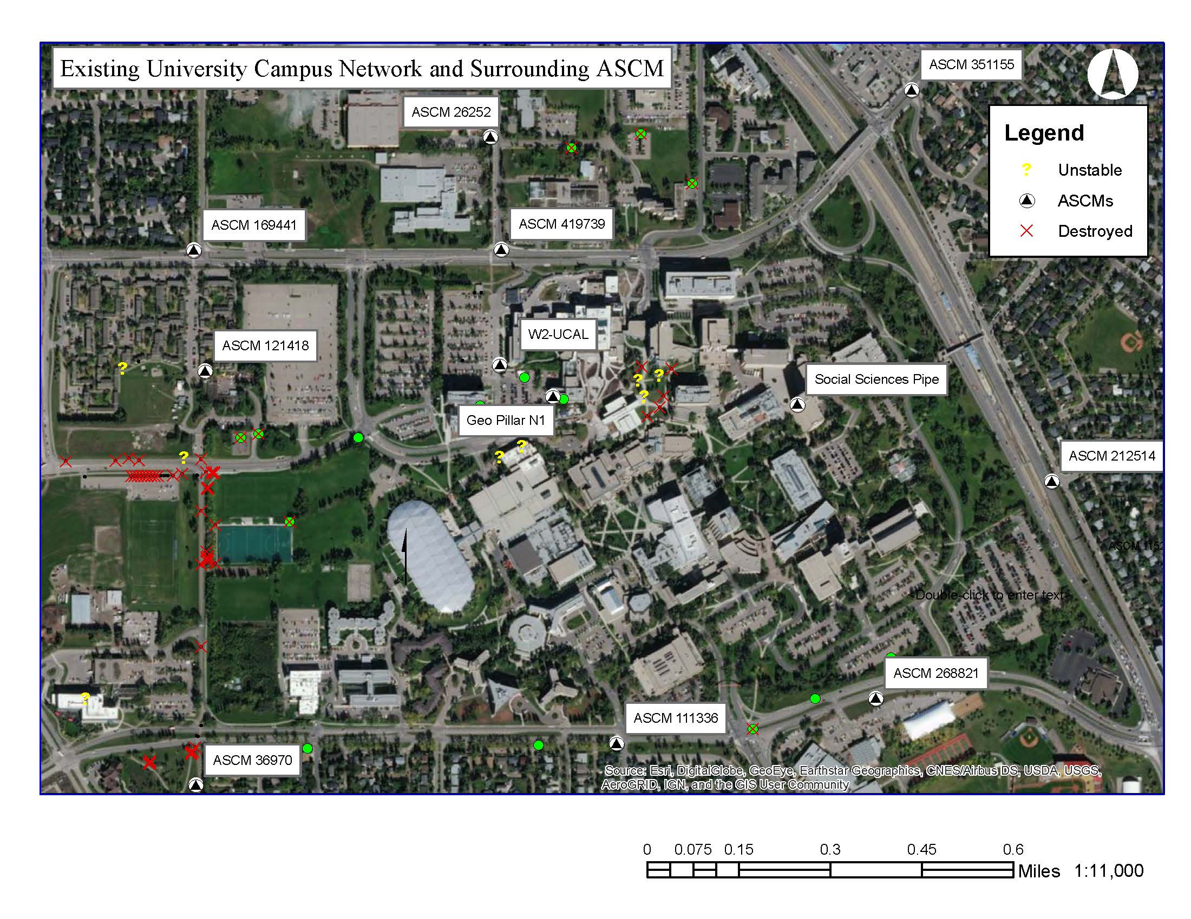

Figure 1: Existing UCG Network Locations.

## Impact if Not Done

Courses that utilize this network include ENGO 343, 401, 443, 579, and 581, which is inclusive of the entire Cadastral Concentration offered as part of the undergraduate program. In order to validate the results of the Exercises, the network needs to be easily accessible and the position of the control must be well established. About 20 points have been disturbed or destroyed since the last large amendment to the network in 2015 due to the construction of the TITL building, the renovation and construction of the ENGG building, and the ongoing march of time. Another 30 points may fall into an unknown or unstable category due to ongoing large construction projects. Especially vulnerable is the west part of the control network bordering the West Campus Development (West of Collegiate Road) as outlined below in Figure 1. The expected amount of disturbance in this portion of the Campus Network alone will significantly affect the entire Network. If this project is not completed, only approximately 40% or less of the control may be usable.

As described above, if not done, issues arising from poor precision, network geometry degradation, and loss of integral sightlines will cause future difficulty of a resurvey of which will progressively increase in difficulty every year. Furthermore, due to the expected growth of Department size, without an expansion of the network, temporary accommodation measures may induce patchwork solutions that will compound the problem and degrade the network integrity. These problems can be expected to result in both student and professor underperformance and frustration.

## Proponent Profile

ASG Surveys was founded by Adele Castillo-Ayala, Soroosh Sadeghi, and George Barnhardt. While all currently students in the Department of Geomatics Engineering, all come from variety of backgrounds. Adele has gained valuable expertise in GIS app development, sales, and public relations. Soroosh and George have both been in the survey industry for several years. The experience and skills of the team will be covered in greater detail in Section 4.1 of this proposal.

Team ASG Surveys strives to operate ethically to benefit clients and the community. ASG Surveys vows to provide quality surveying services to our clients where and when they need them. The Team understands that client success is their success.

Current services include both office and field expertise in the areas of network design, management and implementation. Additional services offered include working with clients to implement regular network maintenance protocols and procedures; modernizing existing network management systems; provide short turn-over times; and turn-key solutions to network remediation. Field services include local and geodetic order surveys including both contemporary GNSS and conventional Terrestrial Positioning Systems (TPS).

The Team strives to protect the health and safety of its employees, client personnel, and others that may be directly or indirectly involved in project activities. The ASG organization ensures to meet or exceed health and safety standards set by clients and regulatory bodies. An accident free workplace is the main goal, and ASG expects everyone’s commitment to good safety practices. To monitor adherence to good safety practice, monthly safety meetings are held to monitor progress and address any shortcomings.

The members of ASG Surveys have spent a long time using the current Campus Network in various practical projects. ASG is very excited to be involved in a project which will have direct benefits to the Geomatics Department at The University of Calgary and its future students. The Team at ASG Surveys is whole-heartedly confident in delivering exceptional results that will be dependable for years to come.

## Collaborator Profile

Our collaborating organization is Element Land Surveys Inc. The company provides residential and commercial surveying services both in legal and construction fields. The company is committed to delivering quality land survey services to clients using the best technologies and methods currently available.

James Durant is our industry advisor. James is an Alberta Land Surveyor (ALS) and the Owner of Element Land Surveys Inc. James, a University of Calgary graduate with a B.Sc in Earth Science, received his commission number 920 as an ALS in August 2013. Currently, he is the principle ALS, project manager, and president at Element Land Surveys Inc. His broad experience ranges from extensive field experience with both GPS and conventional surveys in areas of municipal legal survey, construction, high rise, topographic, and oil and gas. In addition, James has several years of office experience as a CST and PM. Some of his major projects include: “The Bow”, Keynote Building, Fish Creek Park Storm Pond Upgrade, Calgary Science Centre, Saddle Ridge Tri Services and Cochrane Medical Centre.

## Client/User Profile

The Department of Geomatics Engineering at the University of Calgary is one of the leading Geomatics departments in the world, proud to offer an exceptional education to its undergraduate students.  As part of the University’s accreditation, both CBEPS (Canadian Board of Examiners for Professional Surveyors) and CEAB (Canadian Engineering Accreditation Board) require the program to maintain certain levels of technical field work, survey project design and management, and team work that are to be taught as part of the degree requirements.

The team is excited to work with client representative, Dr. Elena Rangelova Ph.D, P.Eng. She has been a member of the University of Calgary Geomatics Department since January 2015, currently serving as the instructor for various surveying courses, and Schulich chair in innovative teaching. She is responsible for key surveying courses that utilize the existing network including Geodetic and Engineering Surveys, Block Week Surveys, and Fundamentals of Surveying. She has been an instructor and a mentor to everyone on the team for at least 3 years now.

The results of this project will directly affect the students and instructional staff of the Department by providing the framework for learning surveying fundamentals necessary to this degree.

# Project Performance Framework

1. Objectives, Outputs, Outcomes and Criteria

Below is the summary table of the objectives, outputs, outcomes and measurement criteria of this project. Project outcomes have been classified into short, medium and long term impacts. The goal of this project is to re-establish the internal and external consistency of the existing networks. This is expected to be accomplished by integrated surveys using both conventional and contemporary methods.

Primary objectives would include: (1) establishing integrated high order control, a skeleton network that additional networks and exercise areas may be constructed around, and; (2) design and establishment of new exercise networks to be used for the various courses offered at The University of Calgary. Outputs for this project will ultimately be ground monuments and accompanying grid coordinates; moreover, inclusive of that will be a modern network software protocol that can be used to perform network maintenance in the future. Outcomes of this project should reduce current efforts of the instructors using the network; reduce network errors for the exercises performed for courses; allow for less cumbersome network maintenance documents with the inclusion of a procedural manual for the maintenance and upkeep of the network for future reference. A success factor of the project is for it to reduce the amount of time and effort put in by instructors, teaching assistants, and students during laboratory exercises and assignments so that they may focus on the learning taking place. These objectives are summarized below in Table 1.

|  |  |  |  |
| --- | --- | --- | --- |
| **Table 1: Project Objectives, Outputs and Outcomes.** | | | |
| **#** | **Objectives** | **Outputs** | **Outcomes** |
| **1** | Geodetic network integration. | Framework control established. | Provide the framework for UCG network. Allow for the ability to amend the network as necessary for future generations. |
| **2** | Establish exercise networks. | Exercise areas optimized for surveying fundamentals. | Highly modular, and scalable areas to perform exercises; ease of use for Users. |

Measurement criteria has been created to measure the performance of each of these as the project progresses. They are outlined in the following section.

1. Project Performance Measurement Plan

Performance Management Plans are necessary in ensuring that a project is completed on time and in good form. It is also a way to continuously improve the procedures that help deliver our clients the best product. Following are the Performance Measurement Plans for each objective outlined in Section 2.1 above.

|  |  |
| --- | --- |
| **Table 2.1: Performance Measurement Plan for Objective 1: Geodetic network integration** | |
| **Description:** | The main control network will be developed by GNSS static observations using a cyclic observation procedure otherwise known as ‘leap-frogging’. This objective includes three phases. Phase (1) the installation of monuments, (2) data acquisition, and (3) data processing. |
| **Metrics:** | Variables within the procedure include (i) the number of monuments to install, (ii) the number of observations required for each point, (iii) the required precisions of each control, and (iv) a turnover of adjusted results. |
| **Objective Lead:** | Soroosh is project lead on this portion of the project. Each member of the team will be necessary to complete phase 1.1 and 1.2 of this project. |
| **Success Criteria (metric addressed):** | Sufficient control points are installed to meet the continuing needs of the department (i). Each point meets the precision requirements to the 95% CI (ii),(iii),(iv). Field work is performed safely, and in a timely manner (iv). |
| **Timeline:** | An estimated 5 hours per point for all phases. See Section 4.3 for detailed a WBS. |

|  |  |
| --- | --- |
| **Table 2.2: Performance Measurement Plan for Objective 2: Establish exercise networks** | |
| **Description:** | A full list of the different exercise networks required may be found in the WBS (Section 4.3). Ultimately, each of these networks will be used to perform surveying fundamentals including resections, traversing, baseline calibrations, and more for a total of 6 different areas. Due to the natural conditions of the areas, each area will require different procedures including (1) a design, (2) establishment, and (3) test phase. |
| **Metrics:** | The (i) number of monuments to install, (ii) the required number of observations for each point, (iii) the required precisions of each control, (iv) a turnover of adjusted results. Additionally through the test phase (v) usability will be measured. |
| **Objective Lead:** | George is project lead for this portion of the project. Ultimately, each member of the team will be necessary to complete all phases of this project. |
| **Success Criteria (metric addressed):** | These areas need to be adaptable to varying class sizes which insinuates scalability and modularity are crucial (i), (v). These may be evaluated in the design phase. Regarding course exercises, students need to complete them within short and strict time lines, and sometimes through poor weather conditions. This means usability and accessibility will also be key considerations. This criteria will be evaluated during the test phase. Additionally, some of these areas need immediate attention (ii)(iv). |
| **Timeline:** | Each area is expected to take 5-6 days with major variation on the design phase. See Section 4.3 for a detailed WBS. |

1. Sustainability

### 2.3.1 Network Maintenance

Network maintenance needs to be done regularly even if it does not look like it. The control network is planned out to thus ensure inter-visibility with major controls. The intended redundancy in the network implies that a complete re-survey should not have to be done regularly; however, pieces of the network may be observed in regular intervals to update coordinates.

The organization that will be responsible for maintaining this project through its lifecycle will be the Geomatics Department at the University of Calgary. With the continuing construction of the West Campus Development, this is presumptively critical.

### 2.3.2 Exercise Area Future

Students observe these points every year. Notwithstanding gross errors, all this data may be collected and re-purposed to increase redundancy and create a perpetual observation protocol. A stretch goal of this project would be to develop a system where the data captured by these students would be injectable into the network.

For example, the calibration baseline will be observed every year, thus generating enough data to detect potential blunders in one group’s work. Another example may be the levelling network, where each group may level between two different controls. Through this type of modular and scalable design of these areas, it is the hope of our team that these networks are able to be partially self-sustaining.

# Project Issues and Risks

1. Issue Identification

Below is a breakdown of issues relating to the project. These have been broken down into Policy and Standard Issues; Data and Technical Issues, and; Client and Stakeholder Issues.

### 3.1.1 Policy and Standard Issues

Policy and Standard Issues include approvals from client and governing bodies. Installation of points is also subject to Ground Disturbance and other utility protection and construction protocols (REF). This has been mitigated by the industry sponsor who has graciously offered his certification to oversee any work done in line with these policies.

### 3.1.2 Data and Technical Issues

These arise during the data acquisition and processing phases of this project. They are a function of data management, and the technical limitations of equipment used. Technical issues during the data acquisition phase include the limitations of the different software and equipment to be used during this project. There are multiple different types of equipment used throughout this project such as the Leica TS30 (conventional observations), Trimble R10 (GNSS observations), Trimble V10 (Photogrammetric observations), and Leica Sprinter (levelling). Observations using each of these is subject to various systematic and random technical errors as outlined in Table 3 below.

|  |  |
| --- | --- |
| **Table 3.1: Issue Identification and Corresponding Actions Taken.** | |
| **Potential Issue** | **Actions Taken** |
| **Conventional survey errors** | A calibration and applicable error determinations are done at the beginning of the project and throughout as necessary. Observational procedures are set up to reduce all systematic errors. Traversals are designed to minimize random errors present. |
| **GNSS errors** | Double differencing and PPP processing services provided by NRCan, ensures the best possible results. Network design is done to ensure points are placed in optimal locations to minimize multipath. |
| **Photogrammetric errors** | Conventional survey is done to verify coordinates. |
| **Levelling errors** | Calibration is completed prior to observations. Geodetic spirit levelling procedures are followed to reduce random and systematic errors. |

Data synthesis is another important concern as data will be synthesized from the aforementioned methods and then integrated through multiple 3rd party software once collected. This includes Trimble Business Centre (TBC), MicroSurvey CAD (MSCAD), Cyclone, and ArcGIS and/or other ESRI software. Database integrity will be monitored and a streamlined onboarding process should be implemented. This will ensure data is entered free of gross errors and in compatible formats. Version control is necessary to monitor progress and ensure cohesive collaboration. Care should be taken at each step to ensure data is uploaded in the correct location and format (including geospatial information such as the projected coordinate system), and that the next task may be triggered from the completion of its dependent. To facilitate all of this, GitHub and ZenHub will be utilized.

### 3.1.3 Stakeholder Issues

Listed on the following page in Table 3.2 are the identified stakeholders for this project, their concerns, and their impact to the project. A separate Stakeholder Management Plan has also been added to assess the effect each may have on the project, and how the team plans to manage them. Stakeholders are also included in the RACI chart (see Section 4.2) for additional accountability. Stakeholders will continue to be identified and assessed throughout the completion of the project. Client concerns will be dealt with directly on a day to day, week to week, or any other frequency basis as needed.

1. Feasibility and Risk

The feasibility of this project is high. Geodetic surveys are completed everyday under various conditions, all over the world. However, no project is without risks. Examples of risks include: commitment risks, organization risks, contracting risks, technical risks, financial risks, and human resources risks (such as the availability of qualified personnel or experienced personnel). Risks also include project dependencies and/or policy issues related to data access (i.e. licensing, intellectual property, copyright, security, privacy, etc.). Table 3.2 is a Risk Assessment table which aids in the visualization of the severity of specified risks. The risks are represented below by their severity and probability. Table 3.3 outlines the Risk Analysis and Management Plan. Lastly, Table 3.4 outlines the stakeholders and their impact on the project.

|  |  |  |  |
| --- | --- | --- | --- |
| **Table 3.2: Risk Assessment.** | | | |
| **High** |  |  | Construction West of Campus; |
| **Medium** | Observation station disturbed; weather; Licensing issues; | Safety; Scope Creep |  |
| **Low** | Losing personnel; | GNSS precisions; equipment availability | Project Approval; |
| **Probability/ Severity** | **Low** | **Medium** | **High** |

|  |  |  |  |  |
| --- | --- | --- | --- | --- |
| **Table 3.3: Risk Analysis and Management Plan.** | | | | |
| **No** | **Risk Description** | **Severity (H/M/L)** | **Probability (H/M/L)** | **Mitigation Strategies** |
| **1** | Construction Nearby | H | H | The construction of the University District poses huge implications to the potential areas for the UCG networks. Coordination with these projects will be paramount to executing a lasting project. |
| **2** | Safety | H | L | Have someone in charge of enforcing the known safety practices. Examples include: (1) wearing safety vests, (2) looking both ways when crossing the street, (3) using safety cones, and (4) carrying a first aid kit just in case of any accidents. Please refer to OH&S best practices for a full list. |
| **3** | Losing personnel | H | L | Three people is already little man power to do such a large-scale project. If The Team lost one person, it would really affect the efficiency of the project. Examples of mitigation include: (1) Making sure everyone is in a good state of mind. (2) Ensuring proper communication between team members. (3) Keeping records of everything everybody does with details on how they did it so that others can properly take over if there were any accidents. (4) Making people sign contracts to give notice of absence. |
| **4** | Disturbed monument | M | L | If uncaught, this would introduce error into the network. Contemporary network analysis should catch any blunder. Time loss to correct is unavoidable. |
| **5** | Scope Creep | M | M | The severity of this risk depends on the stakeholder. For example: If a stakeholder such as The University decided Team ASG Surveys is not to follow through with the project, the project scope would change entirely. To mitigate this, Team ASG Surveys has been in clear communication with all the stakeholders capable of discussing the project details. A Stakeholder Management Plan has been created to discuss this. Refer to Table 3.4 below. |
| **6** | Weather | L | L | Could cause large environmental effects and errors in networks’ observations. |
| **Table 3.3 continued: Risk Analysis and Management Plan.** | | | | |
| **No** | **Risk Description** | **Severity (H/M/L)** | **Probability (H/M/L)** | **Mitigation Strategies** |
| **7** | Damaged equipment | M | L | This would delay the project if we had to get a new total station. This would also throw the survey off. Team ASG Surveys will (1) set every station up with care, away from possible hazards such as heavy traffic. (2) Make sure there are cones around each instrument station where the public may come across them. (3) Treat survey equipment with care and take responsibility. (4) Make sure all data is being stored and copies of observation records are recorded elsewhere in case the total station or GNSS receivers undergo a malfunction/get damaged. |
| **8** | Licensing Issues | L | L | Software used during this project include Trimble Business Centre, MicroSurvey CAD, Microsurvey StarNet, and ArcGIS. |
| **9** | GNSS precision | L | M | Multipath errors introduced by large buildings and reflective surfaces may require additional observations. Care will be taken in pre-planning to avoid less than ideal stations. If problems remain, redundant observations may be taken from different station locations. Conventional observations will take place if GNSS problems persist. |
| **10** | Equipment availability | M | L | The Department of Geomatics Engineering has limited equipment that must be shared between multiple parties including undergraduate and graduate students. We are mandated to use just one robotic total station for the whole project. If it was in use somewhere else, we would be unable to survey that day. Scheduling and booking of the equipment is required well in advance.  For the GNSS component, the proposed working plan requires eight different receivers in its current conception. They may not be available in the survey stores at all times. Reserving the equipment far enough in advance should resolve this issue. |

|  |  |  |
| --- | --- | --- |
| **Table 3.4: Stakeholder Identification.** | | |
| **Stakeholder** | **Concerns** | **Impact** |
| **Geomatics Students** | To get a good grade, learn all geomatics concepts and not struggle with network problems. | Possibility of protest. High traffic areas can cause disturbance to the project. |
| **University of Calgary Students / Public at large** | Exercises need to be strategically placed as not to impede normal foot traffic present at the University during use. Care taken not to create tripping hazards. | Productivity loss in high-traffic areas; chance they might disturb station and or monument. Safety concern. |
| **Maintenance Staff** | Monuments placed may damage equipment (lawnmowers, snow blowers); monuments may frost heave; ground disturbance may cause ground settlement. | Disturbed or obliterated monuments lessens the integrity of the network created. |
| **CEAB / CBEPS** | Engineering undergraduates are gaining valuable experience in technical processes. | Will assess functionality of technical skills of the exercises. |
| **Wildlife** | Food, shelter, and general survival. | Disturbing monuments lessens the integrity of the network created. Wildlife can impose safety concerns on team members which is loss in personnel. |
| **West Campus Development** | Construction timeline of 10 years creates possibility of disrupting the network created. Construction zones impose safety risks to team members and students performing surveys. | May obliterate monuments. May cause entire plan to be re-evaluated. |
| **Research Park Businesses** | Trespass concerns. | If networks are established on their land without their permission, it may cause entire plan to be re-evaluated. |
| **Utility Companies** | Hitting their assets during installation of points. Putting monuments in ROW that needs maintenance. | Obliterated monuments causes the entire plan to be re-evaluated. Damage to utilities can result in legal action. Safety concern to team members may cause a loss in personnel. |

# Project Plan

1. Project Team and Resources

Below is a summary on Team ASG Surveys, their individual member roles, responsibilities and key skills. Please refer back to Sections 1.3, 1.4, and 1.5 for similar information, as well as supplemental organizations such as the industry sponsor and project advisor, whose mentorship, advice, and support are indispensable.

|  |  |  |  |
| --- | --- | --- | --- |
| **Table 4.1: Team ASG Surveys Members, Roles and Qualifications.** | | | |
| **Name** | Adele Castillo-Ayala | Soroosh Sadeghi | George Barnhardt |
| **Organization** | Team ASG Surveys | Team ASG Surveys | Team ASG Surveys |
| **Role** | Data Processing and Rendering | Project Manager | Data Collection and Network Analyst |
| **Responsibilities** | Processing data into database; data integrity; data representation in ArcGIS; | Control work activities to reach a desired result on time, within budget, and according to the project specifications. | Field Operations; Observation procedures; Network design and implementation; testing procedures. |
| **Key Skills** | Several years of experience processing data in University courses. Extensive Data Analysis knowledge. Worked as a GIS Analyst on internship. Has had to process field data during internship. | Several years of surveying experience (mostly field surveys) in AB and BC. Currently pursuing the Cadastral concentration specialization in the Department of Geomatics Engineering. | Several years of experience in a project coordinator and management role for municipal development in varying EPC roles. Two years direct survey experience. Currently pursuing the Cadastral concentration specialization in the Department of Geomatics Engineering. |

1. Project Management and Control

The project management procedures of this project will follow the typical Project Development and Execution Plan set out in industry. Included in this is a RACI chart. This is a project management tool used to identify the relationships between the project managers, teams, advisors, and sponsors. It supports communication in the project by directly identifying who is Responsible for each task, Action by whom, with whom to Consult, and who to Inform. It is a supplement to the Work Breakdown Structure (refer to Section 4.3). Below in Table 4.2 is the RACI chart outlining the milestone timeline of this project.

|  |  |  |  |  |  |  |
| --- | --- | --- | --- | --- | --- | --- |
| **Table 4.2: RACI Chart.** | | | | | | |
| **Task** | **Project Manager** | **Field Operations** | **Data Processing** | **Client** | **Sponsor** | **Coordinator** |
| **Phase 1: Project Execution** | | | | | | |
| Proposal Completion | A | A | A | C | C | I |
| Proposal Presentation | A | A | A |  |  |  |
| Project Execution Plan | R | A | A | C | C |  |
| Integrated WBS | R | A | A | C | C |  |
| **Phase 2: GNSS Control** | | | | | | |
| Network Design | C/A | R/A | I/A | C/I | C |  |
| Monument Installation | A | R/A | A | I | C |  |
| Monument Observation | A | R/A | I | I | C |  |
| Data processing | I | I | R | C | C |  |
| Levelling | A | R/A | A | I |  |  |
| Processing | I | C | R/A | I | C |  |
| **Phase 3: Exercise Networks (iterative per network)** | | | | | | |
| Reconnaissance | A | R/A | A | C | C |  |
| Network Design | C/A | R/A | I/A | C/I | C |  |
| Monument Installation | A | R/A | A | I | C/A |  |
| Monument Observation | A | R/A | I | I | C |  |
| Data Processing | I | C | R | I | C |  |
| Data Rendering | C | C | R/A | C | C |  |
| Data Publishing | A | A | R/A | I | C |  |
| **Project 4: Project Closeout** | | | | | | |
| Final Report | R/A | A | A | C/I | C | I |
| Final Presentation | R/A | A | A | C/I | C | I |
| Lessons Learned | R/A | R/A | R/A | C | C |  |
| Benchmark Reporting | R/A | R/A | R/A | C | C |  |

Team members must effectively communicate their own personal schedules and plan to collaborate accordingly. Goals and objectives are to be understood and clearly communicated between group members and every party involved with the project from start to finish. Each member is to help maintain a constructive, goal-oriented culture throughout the completion of the project. Trusting that each member can and will hold up to their respective responsibilities in a timely manner is crucial to project success. This is monitored with bi-monthly reported minutes and a RACI chart (refer to Table 4.2 above).

This project will follow a 5 step Project Development and Execution Plan (PDEP):

1. Identify & Assess Opportunities:
   * Clearly state the goal of the project
     1. Refer to Section 2: Project Overview.
   * Check for team competence
     1. Appoint one member as PM and delegate roles upon each member based on individual strengths and technical competence to make the work more efficient. Each role will be responsible for an x number of tasks which can be visualized with the RACI chart in Table 4.2.
   * Discuss overall plan
     1. This can be visualized with an Integrated WBS (refer to Section 4.2).
2. Discuss and Select an Alternative:
   * Brainstorm alternate solutions/ ideas
   * Discuss the plan for each alternative
     1. Visualized with sketches and maps. An example of this is Figure 1.
   * Decide which alternative to move forward with
     1. Discussion between group members and advice from the Industry advisor and Supervisor is considered.
   * Discuss Risks and Stakeholders for each alternative
     1. All possible risks are brainstormed, and a Risk Register is completed (Refer to Section 3.2 Feasibility and Risks).
     2. All stakeholders are thought out and put into a Stakeholder Identification Table (refer to Section 3.2).
3. Progress the Preferred Alternative:
   * Fully define the scope of the project and discuss with all parties involved
     1. A clearly defined scope is issued to the Client, Project Supervisor/ Industry Sponsor and Capstone Coordinator, and understood between Team Members. There is a clearly stated purpose and well-thought out plan, as explained in this proposal.
   * Develop a plan of execution
     1. The exact networks to re-survey and the method of survey is finalized and mapped out.
     2. Weather will be checked to decide on which day(s) are most ideal to go survey. Days with (close to) ideal weather conditions will be preserved for data collection.
     3. All equipment will be booked well in advance for the scheduled survey dates.
   * Develop a timeline of estimated milestone and task completion dates
     1. Set completion dates to minor and large-scale milestones in order to stay on schedule as the project progresses. Keep each milestone/task in a sequence. This is visualized with a RACI chart (Table 4.2) and Integrated WBS (Section 4.3).
   * Develop an estimated budget
     1. Refer to Section 4.4: Budget Summary.
4. Execute:
   * Implement the execution plan
     1. Gather all equipment and complete the field work (Refer to Section 4.3 and see WBS).
   * Finalize the operating plan
     1. Organize the data collected and do post-processing to obtain the results.
5. Operate and Evaluate:
   * Monitor and Evaluate Performance
     1. From analysis performed in previous step, come up with a conclusion with the obtained results.
     2. Plan on how to display and explain the outcome of the project. Was the project successful (goals were achieved)? If yes, explain. If not, what went wrong? What was the desired result? What could’ve been done differently to prevent failure?
6. Project Implementation Plan

The project execution plan is divided into three main tasks of (1) calibrating the total station for local network observations, (2) GNSS observations, and (3) local network observations. Contingency was added in the case where reservations may be required.

|  |  |  |  |  |  |  |  |
| --- | --- | --- | --- | --- | --- | --- | --- |
| **Table 4.3: Work Breakdown Structure**. | | | | | | | |
| **WBS** | **Task & Work Breakdown** | **Duration (Days)** | **Organization** | **Team Members Name** | **Outputs** | **Start Date** | **Delivery Date** |
| **1** | **Instrument Calibration** | 2 | AGS Surveys | GB, SS, AC | Ensure the total station is performing according to the manufacturer specifications. | Sep 26, 2018 | Sep 27, 2018 |
| **1.1** | **Acquire equipment** | 1 | AGS Surveys | GB, SS, AC | Required equipment obtained. | Sep 26, 2018 | Sep 26, 2018 |
| **1.2** | **Baseline calibration** | 1 | AGS Surveys | GB, SS, AC | Perform the baseline calibration at Springbank baseline. | Sep 27, 2018 | Sep 27, 2018 |
| **2** | **GNSS Observations** | 46 | AGS Surveys | GB, SS, AC | Produce control points around the campus. | Oct 01, 2018 | Dec 02, 2018 |
| **2.1** | **Network design** | 23 | AGS Surveys | GB, SS, AC | Provide skeleton of UCG network. | Oct 01, 2018 | Oct 31,  2018 |
| **2.1.1** | Existing control network inspection | 11 | AGS Surveys | GB, SS, AC | Required number of control points to be placed and surveyed. | Oct 01, 2018 | Oct 15, 2018 |
| **2.1.2** | Locations of new control points | 7 | AGS Surveys | GB, SS, AC | Location of control points in U of C. | Oct 16, 2018 | Oct 24, 2018 |
| **2.1.3** | Types of monuments | 7 | AGS Surveys | GB, SS, AC | Determine optimal monuments to be used. | Oct 16, 2018 | Oct 24, 2018 |
| **2.1.4** | Pre-analysis | 5 | AGS Surveys | GB, SS, AC | Determine the optimal observation methods to achieve the desired precisions. | Oct 25, 2018 | Oct 31, 2018 |
| **2.2** | **Installation** | 5 | AGS Surveys | GB, SS, AC | Place the monuments in ground. | Nov 01, 2018 | Nov 07, 2018 |
| **2.2.0** | Acquire required equipment | 1 | AGS Surveys | GB, SS, AC | Required equipment obtained. | Nov 01, 2018 | Nov 01, 2018 |
| **2.3** | **Network observations** | 18 | AGS Surveys | GB, SS, AC | Gather GNSS data on the control points. | Nov 08, 2018 | Dec 02,  2018 |
| **2.3.1** | Book equipment | 1 | AGS Surveys | GB, SS, AC | Ensure availability of equipment. | Nov 08, 2018 | Nov 08, 2018 |
| **2.3.2** | Observation sequence | 6 | AGS Surveys | GB, SS, AC | Optimal equipment use, maximize time efficiency. | Nov 09, 2018 | Nov 16, 2018 |
| **1st milestone** | 1st progress report | 17 | AGS Surveys | GB, SS, AC | Present the client, collaborator, instructor, and the class with our progress. | Oct 26, 2018 | Nov 19, 2018 |
| **2.3.3** | Leveling | 7 | AGS Surveys | GB, SS, AC | Ensure high precision vertical positioning. | Nov 17, 2018 | Nov 25, 2018 |
| **2.3.4** | Post- processing | 12 | AGS Surveys | GB, SS, AC | A main step in obtaining resulting coordinates. | Nov 17, 2018 | Dec 02, 2018 |
| **2.3.5** | Error detection and analysis | 12 | AGS Surveys | GB, SS, AC | Reduce errors in obtained coordinates. | Nov 17, 2018 | Dec 02, 2018 |
| **2.3.6** | NRCan processing | 12 | AGS Surveys | GB, SS, AC | Obtain final coordinates from the static data. | Nov 17, 2018 | Dec 02, 2018 |
| **2.3.7** | Network adjustment | 12 | AGS Surveys | GB, SS, AC | Produces final coordinates (in a commercial software such as TBC). | Nov 17, 2018 | Dec 02, 2018 |
| **3** | **Local network observations** | 32 | AGS Surveys | GB, SS, AC | Produce working stations from control points. | Jan 10, 2019 | Feb 22, 2019 |
| **3.1** | **Local network designs** | 11 | AGS Surveys | GB, SS, AC | Provide skeleton of the local networks at each station. | Jan 10, 2019 | Jan 24, 2018 |
| **3.1** | Area 1: ENGO 343 (ICT) Network | | | | | | |
| **3.1** | Area 2: ENGO 401 Network | | | | | | |
| **3.1** | Area 3: ENGO 443 Traverse | | | | | | |
| **3.1** | Area 4: ENGO 581 Topo Area | | | | | | |
| **3.1** | Area 5: 24th Ave Control | | | | | | |
| **3.1** | Area 6: ENGG Courtyard | | | | | | |
| **3.1.1** | Existing local network inspection at each station | 6 | AGS Surveys | GB, SS, AC | Required number of control points to be placed and surveyed. | Jan 10, 2019 | Jan 17, 2019 |
| **3.1.2** | Locations of new points | 6 | AGS Surveys | GB, SS, AC | Optimal locations for visibility, and maximum number of setups. | Jan 10, 2019 | Jan 17, 2019 |
| **3.1.3** | Types of monuments and targets | 6 | AGS Surveys | GB, SS, AC | Select the appropriate monuments at each station. | Jan 10, 2019 | Jan 17, 2019 |
| **3.1.4** | Pre-analysis | 5 | AGS Surveys | GB, SS, AC | Determine the optimal observation methods to achieve the desired precisions. | Jan 18, 2019 | Jan 24, 2019 |
| **3.2** | **Installation** | 6 | AGS Surveys | GB, SS, AC | Place the monuments in ground. | Jan 25, 2019 | Feb 01, 2019 |
| **3.2.1** | Acquire required equipment | 1 | AGS Surveys | GB, SS, AC | Required equipment obtained. | Jan 25, 2019 | Jan 25, 2019 |
| **3.3** | **Network observation** | 16 | AGS Surveys | GB, SS, AC | Conventional survey (total station observations). | Feb 02, 2019 | Feb 08, 2019 |
| **3.3.1** | Book equipment | 1 | AGS Surveys | GB, SS, AC | Ensure availability of equipment. | Feb 04, 2019 | Feb 04, 2019 |
| **3.3.2** | Observations | 6 | AGS Surveys | GB, SS, AC | Ensure each point is observed at least twice. | Feb 02, 2019 | Feb 08, 2019 |
| **2nd milestone** | 2nd progress report | 60 | AGS Surveys | GB, SS, AC | Present the client, collaborator, instructor, and the class with our progress. | Nov 19, 2019 | Feb 11, 2019 (tentative) |
| **3.3.3** | Processing | 11 | AGS Surveys | GB, SS, AC GB, SS, AC | A main step in obtaining resulting coordinates. | Feb 09, 2019 | Feb 22, 2019 |
| **3.3.4** | Error detection and analysis | 11 | AGS Surveys | GB, SS, AC | Reduce errors in obtained coordinates. | Feb 09, 2019 | Feb 22, 2019 |
| **3.3.5** | Network adjustment | 11 | AGS Surveys | GB, SS, AC | To refine the coordinates (done in commercial software such as MicroSurvey). | Feb 09, 2019 | Feb 22, 2019 |
| **4** | **Contingency** | 9 | AGS Surveys | GB, SS, AC | Possible circumstance that would require re-measurements in the field. | Feb 23, 2019 | Mar 06, 2019 |
| **Final milestone** | Final Report | 36 | AGS Surveys | GB, SS, AC | Final deliverable to the client that included the control and working station coordinates and survey plans. | Feb 12, 2019 | April 12, 2019 |

The Gantt Chart shown below helps visualize the Work Breakdown Structure. It should be noted that the WBS and the Gantt chart tasks, subtasks, and timelines are subject to change as more is discovered with project progression.

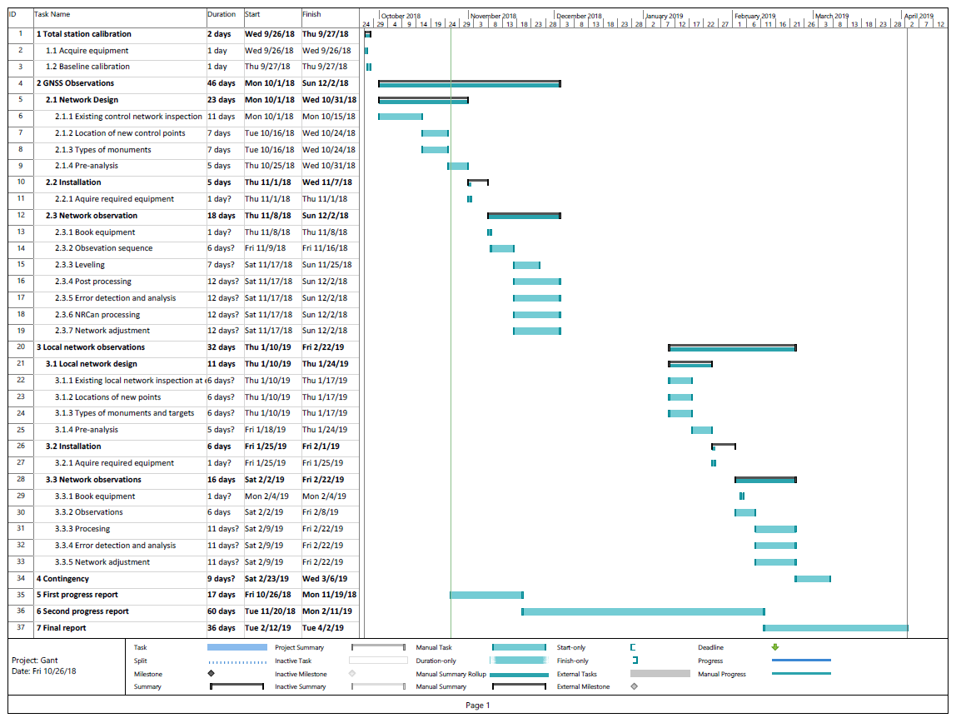

*Figure 2: Gantt Chart.*

1. Budget Summary

Due to the availability of survey equipment and software by the Department. Monument installation tools are being provided by the industry sponsor. The only expense is expected to be the monument material. This is expected to be covered under the project client’s budget for the project. Below is the cost breakdown for this project:

|  |  |  |
| --- | --- | --- |
| **Table 4.4: Budget Summary.** | | |
| **Item Description** | **Related Portions of WBS** | **Cost** |
| 5/8” rebar | Control monument installation | ~$4 /m. A 0.5m monument would cost $2. |
| Brass Caps | Control monument installation | ~$2 per cap. |

1. Communication Plan and Accessibility of Project Results

The resulting network established after completion of the project will be visualized with ArcGIS generated maps. The old network will be compared to the new re-established and integrated Campus Network, with the differences clearly explained by a PowerPoint presentation. This presentation will be presented to the Client, Project Sponsor, and Capstone Coordinator. All budget used up, resources exploited, and time/efforts put in by each Team Member during the completion of the project will be summarized and presented to the aforementioned involved parties. Team ASG Surveys will be representing the Geomatics Department with their project results at the University of Calgary Capstone Fair in 2019.

# Benefits

**University Faculties:**

Faculty members such as the Project Client will not have to travel to Springbank Baseline anymore, and all networks on campus will be connected/ updated for their convenience. The courses taught by the Project Client will conveniently have their labs performed on campus.

**Department of Geomatics Engineering:**

The Department will face less liability issues as this projects grants professors the option to not take students to the Springbank Baseline. Rather, the calibrations can be performed directly on campus.

**University Students (undergrad and post grad):**

Geomatics students will benefit from the Baseline established by ASG Surveys on 24th Ave, and the 3 Campus networks re-stablished/ integrated. Students will be able to perform all survey labs on campus, and utilize the newly designed calibration baseline. Any post graduate students wanting to conduct research, calibrate equipment along a baseline, or use the networks for any other reason, will be able to conveniently perform their surveys on campus.