Name: ENG Piseth
ID: e20240972

Lecturer: VANN VISAL

Group 1: Python Basic Data Types
a. Primitive/Built-in Data Types (int, float, bool, str)
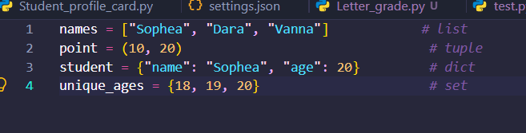
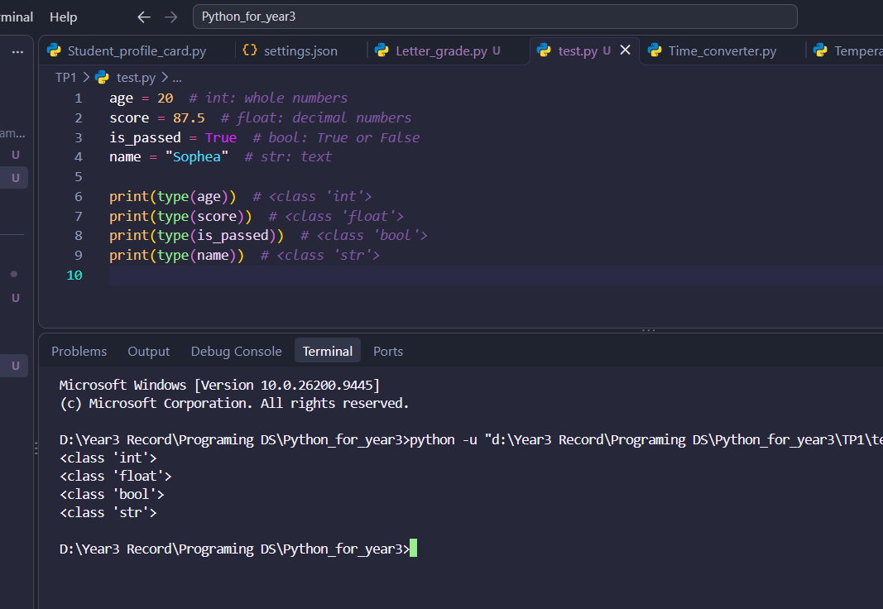
- These are the basic building blocks of data in Python.
b. Collection and Reference Types (list, tuple, dict, set, objects)
These hold multiple values.
Type | Ordered? |  |  | Notes
  Mutable?
  Duplicates?
List | Yes | Yes | Yes | Indexed with []
Tuple | Yes | No | Yes | Fixed once created
Dict | Yes (insertion order) | Yes | Unique keys | Key-value pairs
Set | No | Yes | No | Fast membership tests

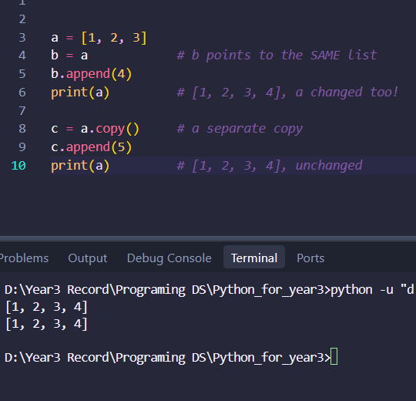
- Objects and references: In Python, everything is an object. Variables hold references to objects rather than the data itself.
- Mutable types (list, dict, set) can change in place. Immutable types (int, float, bool, str, tuple) cannot.
c. Literals in Python (numeric, string, Boolean, None, collection literals)
Practical example: storing student names, ages, scores, and student records.
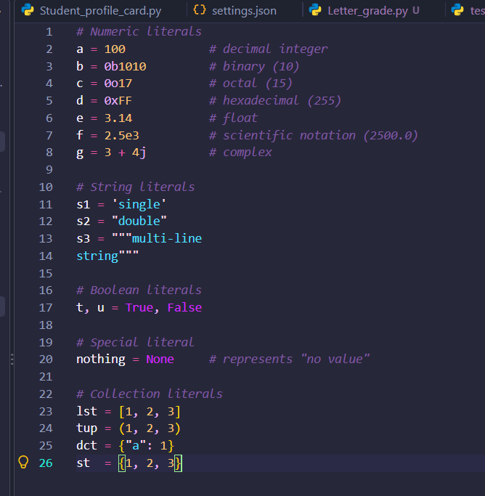
- A literal is a fixed value written directly in the code.

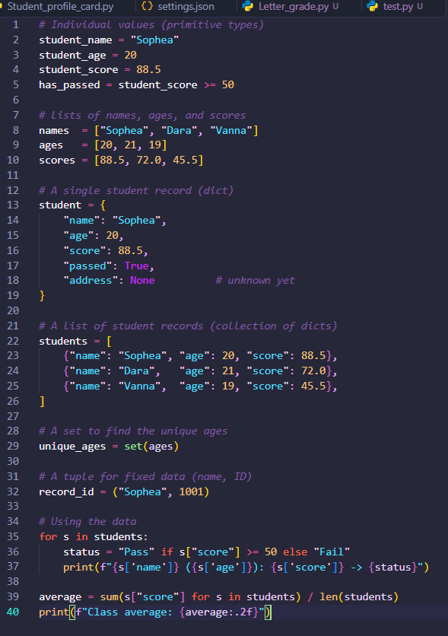
Example of student records:

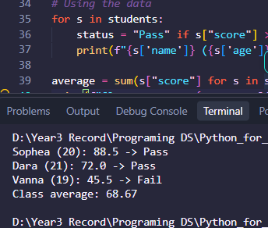
Output:

Key points:
- Use primitives for single values, and collections to group them.
- Choose list for ordered, changeable data, tuple for fixed data, dict for labeled data, and set for unique values.
- Remember that mutable objects share references when assigned

Group 2: Python Variables and Attributes
a. Local Variables
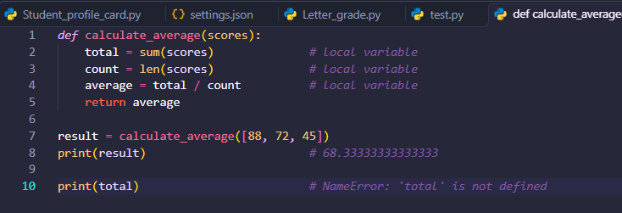
- A local variable is created inside a function and exists only while that function runs. It cannot be accessed from outside.
Key points:
- Each function call gets its own fresh set of local variables.
- Parameters (like scores) are also local variables.
- A local variable can shadow a global one with the same name, without changing it.
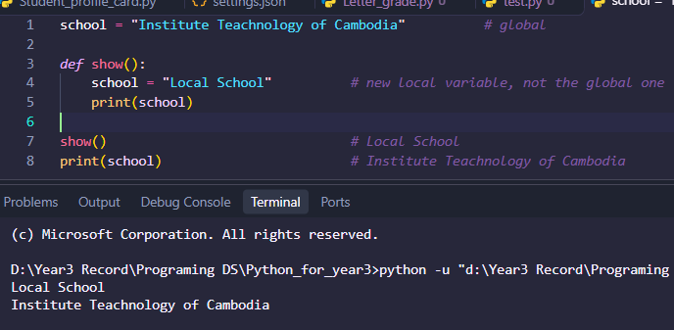

b. Instance Attributes
- An instance attribute belongs to one specific object. It is usually created in __init__ using self, so every object stores its own values.

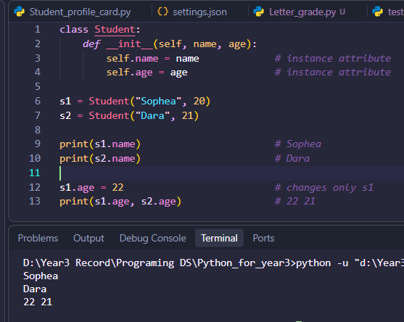
Key points:
- self refers to the specific object being created or used.
- Changing one object’s attribute does not affect other objects.
- Each instance stores its attributes in its own __dict__.

c. Class Attributes (shared by all instances)
- A class attribute is defined directly in the class body, outside any method. All instances share the same value.

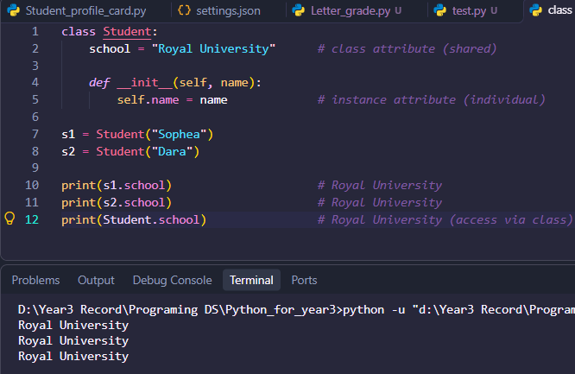
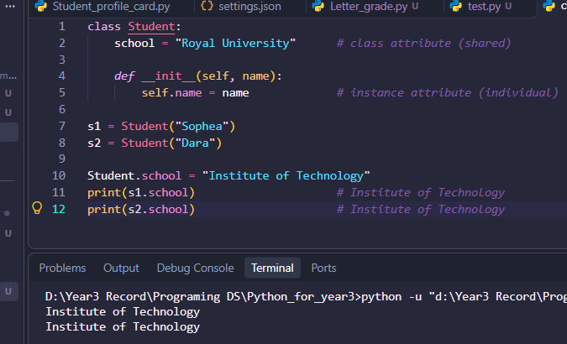
Changing a shared value: Change it through the class, and every instance sees the update.

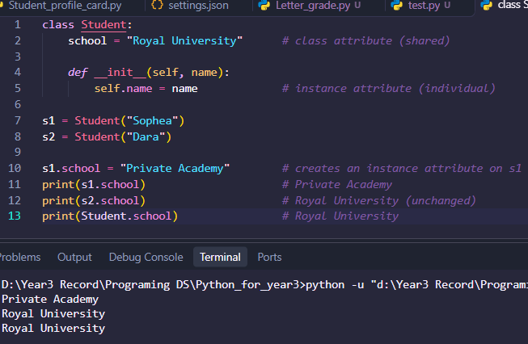
Common pitfall: Assigning through an instance creates a new instance attribute that hides the class attribute for that object only.

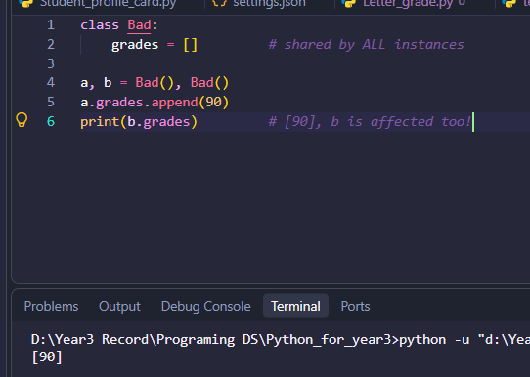
Another pitfall: Avoid mutable class attributes (like lists) unless you want them shared.
Comparison:

Feature | Local Variable | Instance Attribute | Class Attribute
Defined in | Function body | __init__ / methods via self | Class body
Belongs to | One function call | One object | The class (shared)
Lifetime | Until function ends | Until object is deleted | Until class is deleted
Access | Inside function only |  | Class.attr or object.attr
  object.attr
Unique per object? | N/A | Yes | No, shared

- Practical Example: Student Class
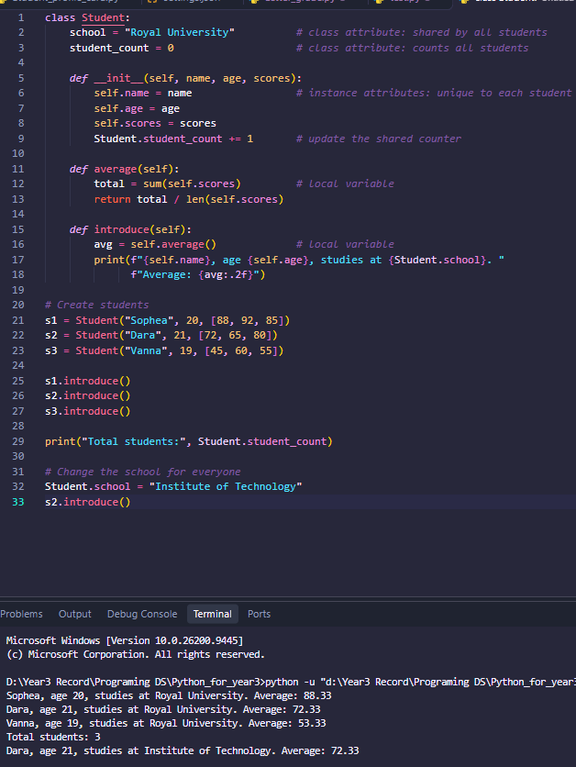

- Output:

Key Takeaways
- Local variables are temporary and private to a function call.
- Instance attributes (self.x) store data unique to each object.
- Class attributes store data shared by all objects, and are best changed through the class name (Student.school = ...).
- Python looks up an attribute on the instance first, then on the class.

Group 3: Python Modifiers and Access Control — Part 1
a. Public, Non-Public, and Private Naming Conventions
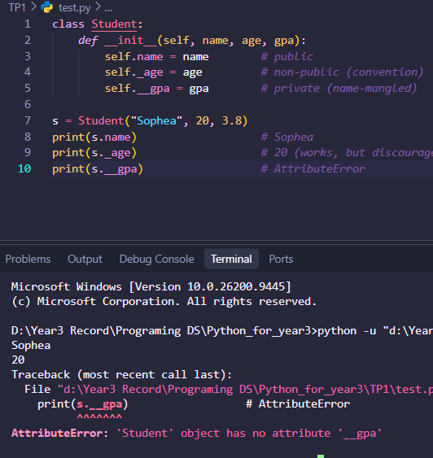
- Python has no public or private keywords. Instead, the name itself signals how an attribute or method should be used.
Style | Example | Meaning
Public | name | Part of the official interface; free to use anywhere
Non-public (protected) | _name | Internal use; “please don’t touch from outside”
Private | __name | Name-mangled to reduce accidental access and clashes
Special (dunder) | __init__ | Python’s own hooks; not private, not mangled
b. Access Control by Convention and Name Mangling
- By convention: A single underscore is a message to other programmers. Python does not enforce it.
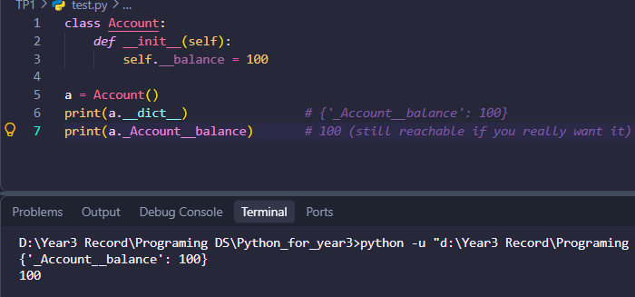
- By name mangling: Inside a class, __balance is rewritten to _ClassName__balance. This stops accidental access and prevents subclasses from accidentally overriding the attribute.

Key points:
- Mangling is not security. It is protection against mistakes, not against determined users.
- Names that end with two underscores (like __init__) are not mangled.
- Python’s philosophy: “We are all consenting adults here.” Offer a clear public interface and trust users to respect it.
c. The @staticmethod Decorator
- A static method belongs to the class’s namespace but receives neither self nor cls. It behaves like a regular function that is grouped inside the class because it is logically related.
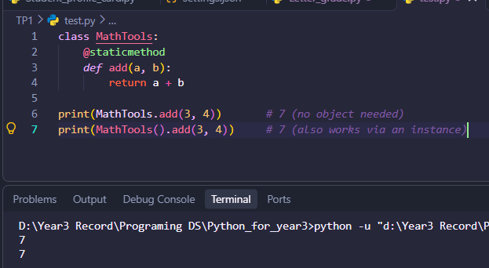
- Use it when the method does not need any object or class data, such as validation or utility helpers.
d. The @classmethod Decorator
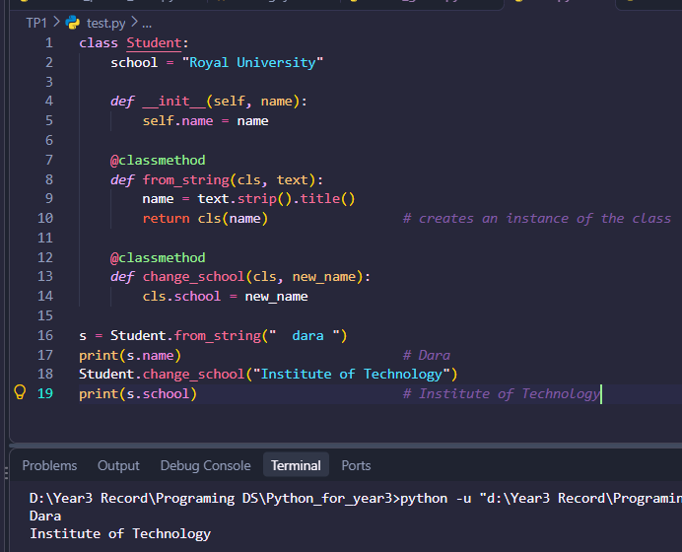
- A class method receives the class itself as its first argument (cls). It can read or modify class attributes and is commonly used for alternative constructors.
- Why cls instead of the class name? If a subclass calls the method, cls is the subclass, so inheritance works correctly.

Comparison of Method Types:

Feature | Instance Method | @classmethod | @staticmethod
First parameter | self | cls | none
Access instance data | Yes | No | No
Access class data | Yes (via self/class) | Yes | Only by naming the class
Typical use | Behavior of one object | Alternative constructors, class-wide changes | Utility/helper functions
> Practical example: controlling access to a BankAccount class and defining class-level methods.
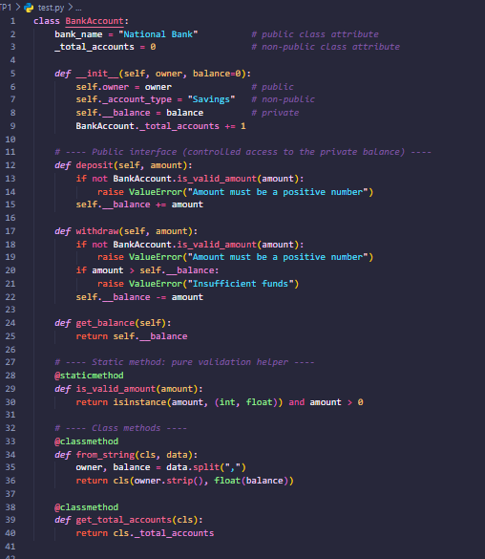
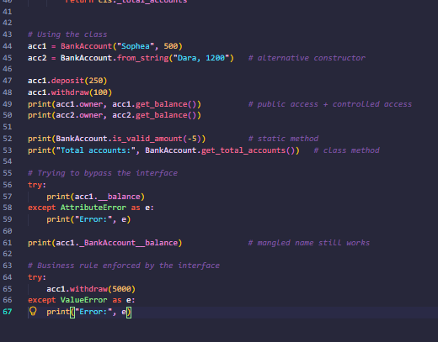

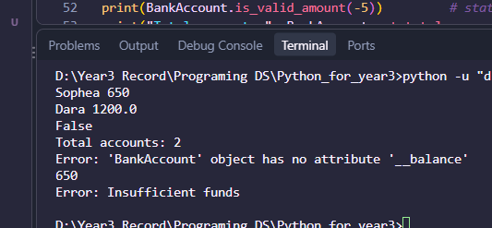
- Output:

Key Takeaways
- name is public, _name is a convention for internal use, and __name is name-mangled to _ClassName__name.
- Python relies on convention and trust, not strict enforcement.
- Keep sensitive data (like a balance) private and expose it through methods that enforce rules.
- Use @staticmethod for helpers that need no class or instance data.
- Use @classmethod when you need the class itself, especially for alternative constructors and class-wide data.

Group 4: Python Modifiers and OOP Features — Part 2
e. Abstract Classes and Methods (abc, @abstractmethod)
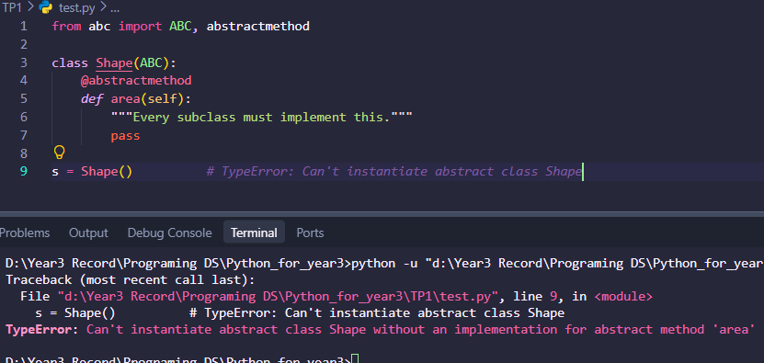
- An abstract class defines a common interface that subclasses must follow. It cannot be instantiated directly. Python provides this through the abc module (Abstract Base Classes).

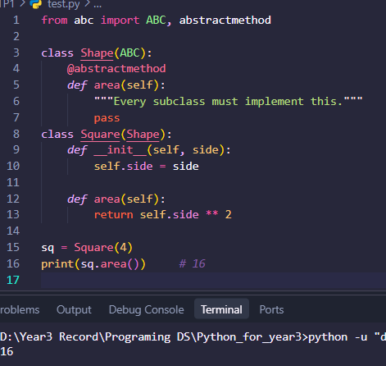
- A subclass must override all abstract methods, otherwise it is also abstract and cannot be instantiated
Key points:
- Inherit from ABC (or use metaclass=ABCMeta).
- An abstract class can also contain normal (concrete) methods and attributes that subclasses inherit.
- Abstract properties are possible by stacking @property on top of @abstractmethod.
- Abstract classes enforce a contract: “any Shape must be able to compute its area.”
f. Access Control and Encapsulation
Encapsulation means bundling data with the methods that work on it, and controlling how that data is accessed. In Python this is done by:
- Using naming conventions (_name, __name) to mark internal data.
- Exposing a clean public interface (methods or properties).
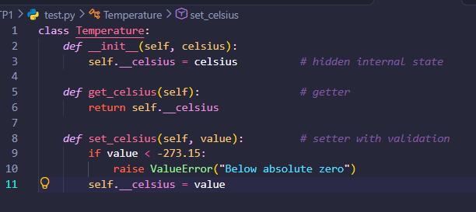
- Validating data before it is stored.

- Benefits: data stays valid, internal details can change without breaking outside code, and the class stays easy to use. The @property decorator (next section) makes this approach more Pythonic.

g. Other OOP Features: @property, @final, and typing.final
@property
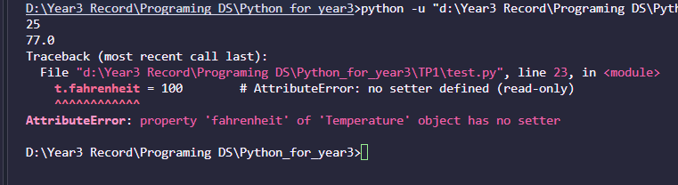
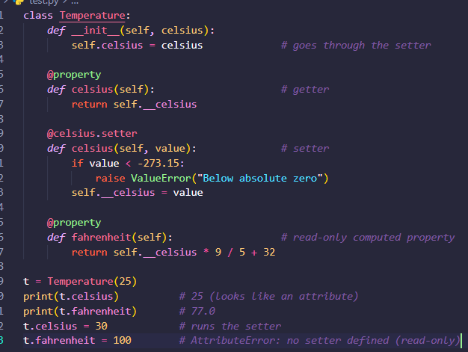
- @property lets you access a method like an attribute, while still running validation or computation.

- Why use it? You can start with a plain attribute and add validation later without changing the calling code.

@final and typing.final
- Python has no built-in final keyword like Java. Since Python 3.8, typing.final marks that something should not be overridden or subclassed. It is mainly a signal for type checkers (such as mypy) and, since Python 3.11, it also sets a __final__ attribute. It is not enforced at runtime.
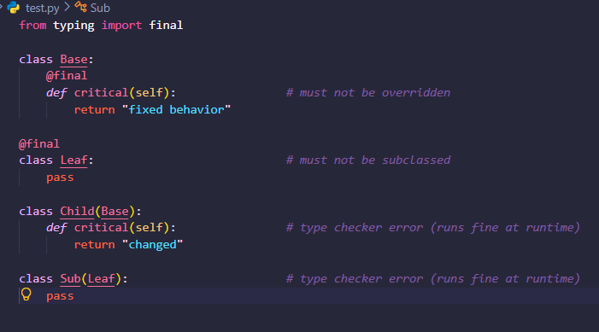
- There is also typing.Final (capital F) for constants that should not be reassigned:
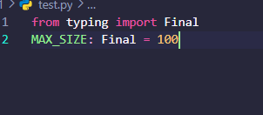

Comparison:
Feature | Purpose | Enforced at runtime?
ABC + @abstractmethod | Force subclasses to implement methods | Yes (on instantiation)
_name / __name | Signal or mangle internal data | Convention / mangling only
@property | Controlled attribute-style access | Yes
@final / Final | Prevent overriding, subclassing, or reassignment | No (type checkers only)

Practical example: an abstract Shape class with Circle and Rectangle subclasses.
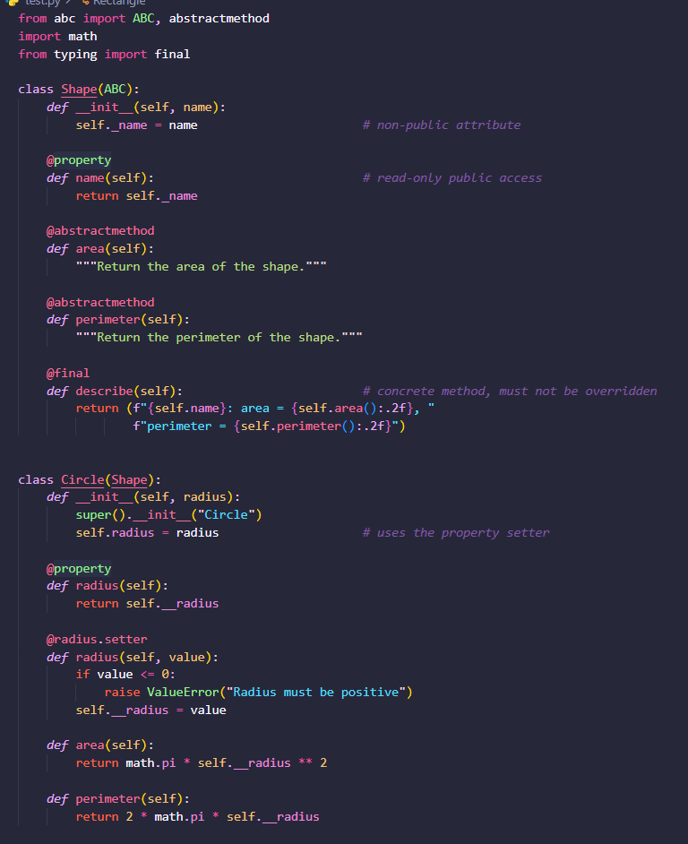

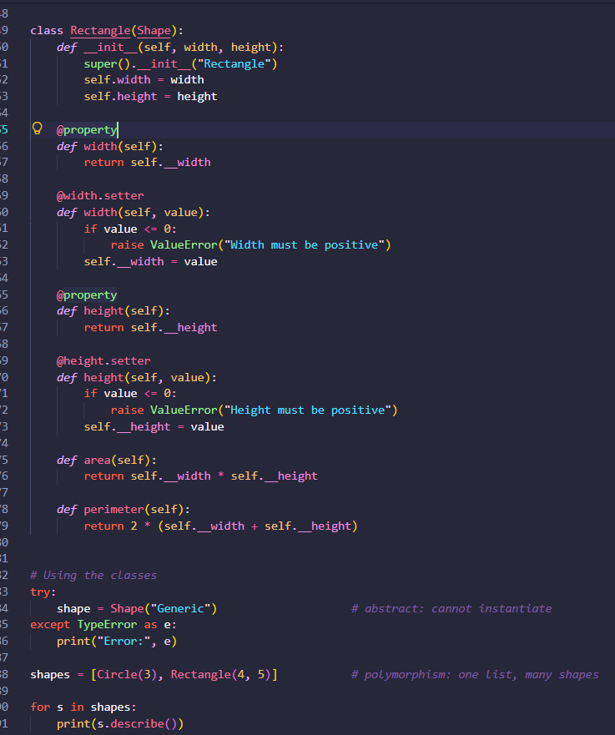

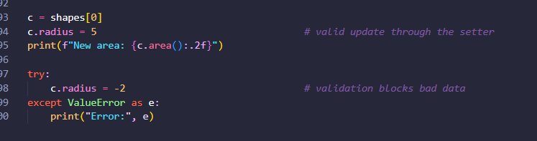
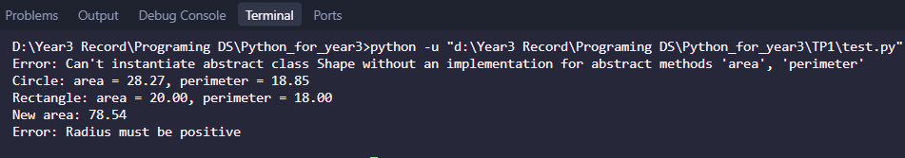
- Output:

Key Takeaways
- Abstract classes (ABC + @abstractmethod) define a contract that every subclass must fulfill, and cannot be instantiated themselves.
- Encapsulation hides internal data (_x, __x) and exposes a controlled public interface.
- @property gives attribute-style access with validation, and a property without a setter is read-only.
- @final documents and type-checks that a method or class should not be overridden or extended, but Python itself does not enforce it.
- Polymorphism: code like s.describe() works for any Shape subclass without knowing which one it is.
Group 5: Python Operators — Part 1
a. Arithmetic Operators (+, -, *, /, //, %, **)
Operator | Name | Example | Result
+ | Addition | 7 + 3 | 10
- | Subtraction | 7 - 3 | 4
* | Multiplication | 7 * 3 | 21
/ | True division (always float) | 7 / 2 | 3.5
// | Floor division | 7 // 2 | 3
% | Modulus (remainder) | 7 % 2 | 1
** | Exponent (power) | 2 ** 5 | 32

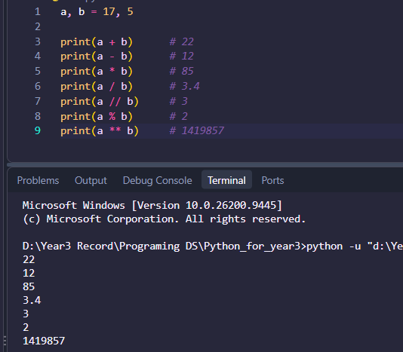
Example:
Key points:
- / always returns a float, even for 10 / 2 (which gives 5.0).
- // rounds down (toward negative infinity), so -7 // 2 is -4, not -3.
- % takes the sign of the divisor: -7 % 3 is 2.
- divmod(a, b) returns both results at once: divmod(17, 5) gives (3, 2).
- Precedence: ** first, then * / // %, then + -. Use parentheses to be clear.
- + and * also work on strings and lists: "ab" * 3 gives "ababab".
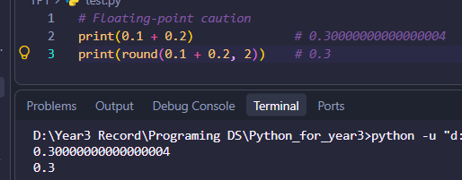
Augmented assignment: x += 5, x -= 2, x *= 3, x //= 2, x %= 4, x **= 2.

b. Comparison Operators (==, !=, >, <, >=, <=)

- They compare two values and return bool.
Operator | Meaning | Example | Result
== | Equal to | 5 == 5 | True
!= | Not equal to | 5 != 3 | True
> | Greater than | 5 > 3 | True
< | Less than | 5 < 3 | False
>= | Greater than or equal | 5 >= 5 | True
<= | Less than or equal | 4 <= 3 | False

Example:
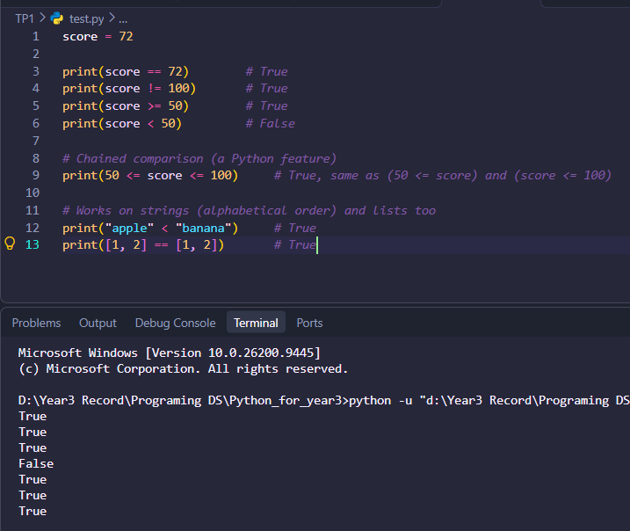
Common mistake: = assigns a value, == compares values.
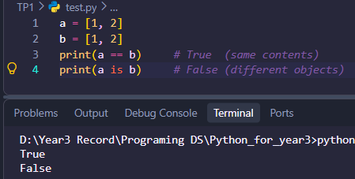
Also remember: == checks equal values, while is checks the same object.

c. Bitwise Operators (&, |, ^, ~, <<, >>)
- These work on the binary digits of integers.

Operator | Name | Rule | Example (a=12, b=10)
& | AND | 1 if both bits are 1 | 12 & 10 gives 8
| | OR | 1 if either bit is 1 | 12 | 10 gives 14
^ | XOR | 1 if bits differ | 12 ^ 10 gives 6
~ | NOT | Flips all bits: ~x = -x – 1 | ~12 gives -13
<< | Left shift | Multiply by 2 per shift | 12 << 2 gives 48
>> | Right shift | Floor-divide by 2 per shift | 12 >> 2 gives 3

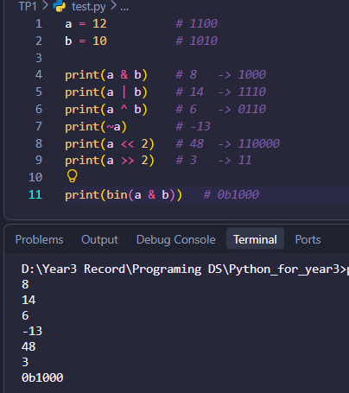
Example:
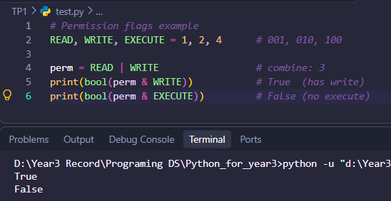
Typical uses: permission flags, masks, low-level data, and fast multiplication or division by powers of 2.

Note: Bitwise &, | are different from logical and, or.
d. Logical Operators (and, or, not)
Operate | Meaning | Example | Result
and | True only if both are true | True and False | False
or | True if at least one is true | True or False | True
not | Reverses the value | not True | False
Truth table:
A | B | A and B | A or B | not A
True | True | True | True | False
True | False | False | True | False
False | True | False | True | True
False | False | False | False | True

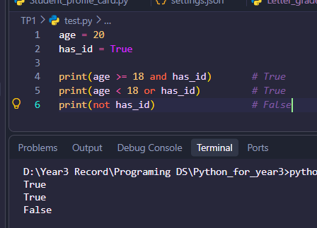

Short-circuit evaluation:
- and stops at the first falsy value.
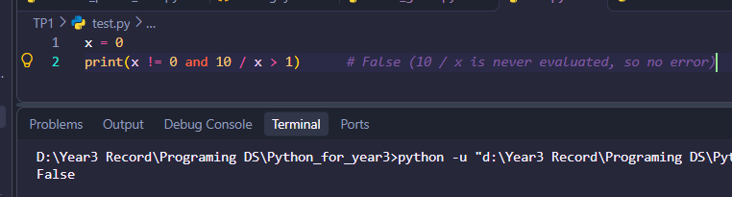
- or stops at the first truthy value.

Logical operators return actual values, not just True/False:

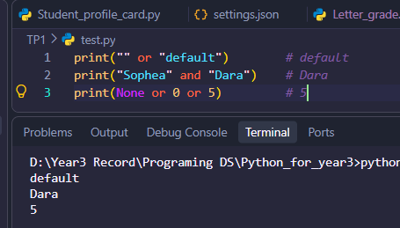
Falsy values: False, None, 0, 0.0, "", [], (), {}, set().
Precedence: not first, then and, then or.

- Practical example: calculating student grades and checking eligibility.
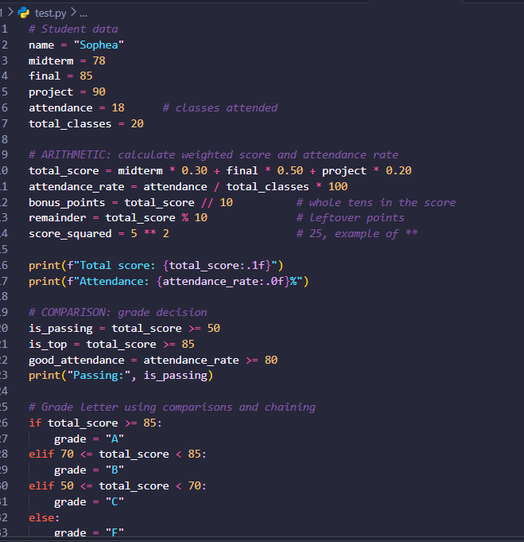

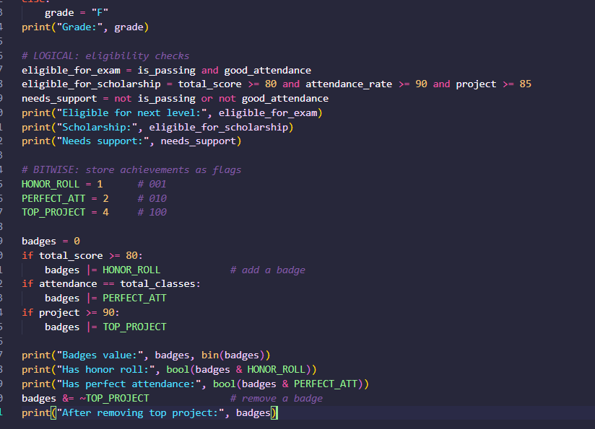

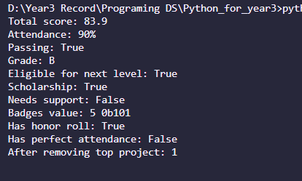
Output:

Key Takeaways
- Arithmetic: / gives a float, // floors, % gives the remainder, ** is power.
- Comparison operators return bool and can be chained (50 <= x <= 100).
- Bitwise operators work on binary digits and are useful for flags and masks.
- Logical operators (and, or, not) short-circuit and return actual operand values.
- Do not confuse = with ==, is with ==, or &/| with and/or.
Group 6: Python Operators — Part 2
e. Assignment Operators (=, +=, -=, *=, etc.)
- The basic = binds a name to a value. Augmented assignment operators combine an operation with assignment.

Operator | Equivalent to | Example (x = 10) | Result
= | Assign | x = 10 | 10
+= | x = x + n | x += 5 | 15
-= | x = x - n | x -= 5 | 7
/= | x = x / n | x /= 4 | 2.5
//= | x = x // n | x //= 3 | 3
%= | x = x % n | x %= 3 | 1
**= | x = x ** n | x **= 2 | 100
&=, |=, ^= | bitwise + assign | x &= 6 | 2
*= | x = x * n | x *= 2 | 20
<<=, >>= | Shift + assgin | x <<= 1 | 20
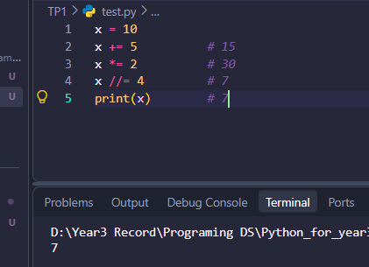
Example:
f. Special Operators: Identity (is, is not), Membership (in, not in), and Conditional Expressions (x if condition else y)
- Identity: is, is not
- These check whether two names refer to the same object (same memory identity), not just equal values.

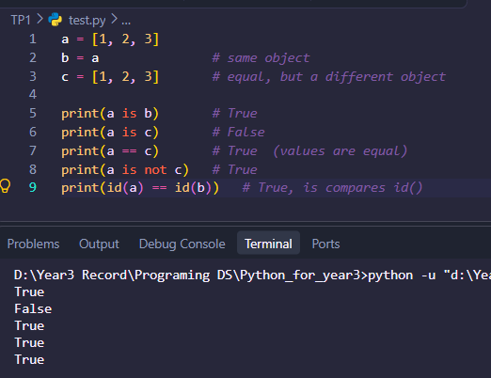
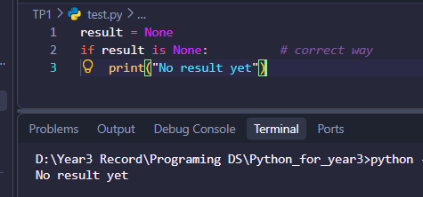
- Best practice: use is for None (and True/False singletons), and == for comparing values.

- Caution: do not use is to compare numbers or strings. Small ints and some strings may be cached, so the outcome can vary and should not be relied on.

- Membership: in, not in
- These test whether a value exists inside a sequence or collection.
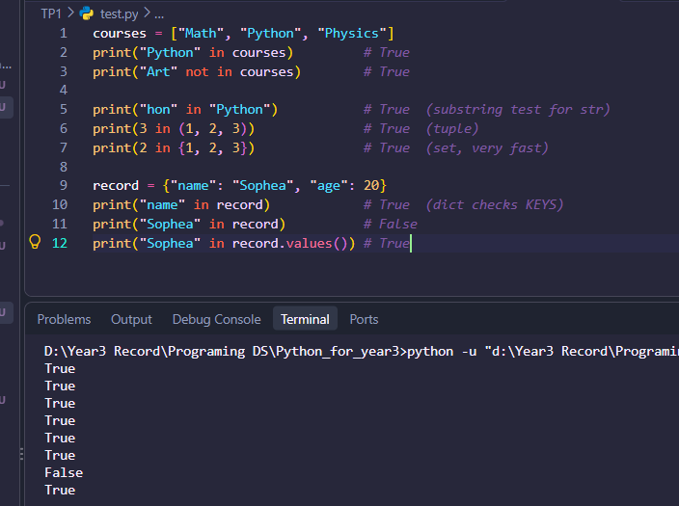

Performance tip: membership in a set or dict is very fast (about constant time), while a list or tuple is scanned item by item.
Conditional Expression: x if condition else y
A one-line version of if/else that produces a value (also called the ternary operator).
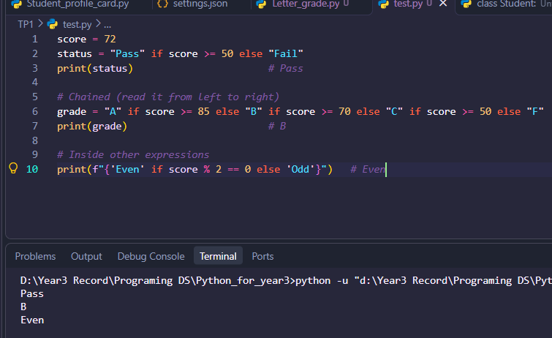
Use it for simple choices between two values. For complex logic, a regular if/elif/else is easier to read.

g. Operator Precedence and Associativity
- Precedence decides which operator is evaluated first. Associativity decides the order when operators have the same precedence.

Precedence table (highest to lowest)

Level | Operators | Associativity
1 | ( ) parentheses | n/a
2 | x[i], x.attr, f() | left to right
3 | ** | right to left
4 | +x, -x, ~x (unary) | right to left
5 | *, /, //, %, @ | left to right
6 | +, - | left to right
7 | <<, >> | left to right
8 | & | left to right
9 | ^ | left to right
10 | | | left to right
11 | ==, !=, <, >, <=, >=, is, is not, in, not in | chained
12 | not | right to left
13 | and | left to right
14 | or | left to right
15 | x if c else y | right to left
16 | Lambda | n/a
17 | := | n/a

Assignment (=, +=, ...) is a statement, not an operator, and it evaluates the right side first.

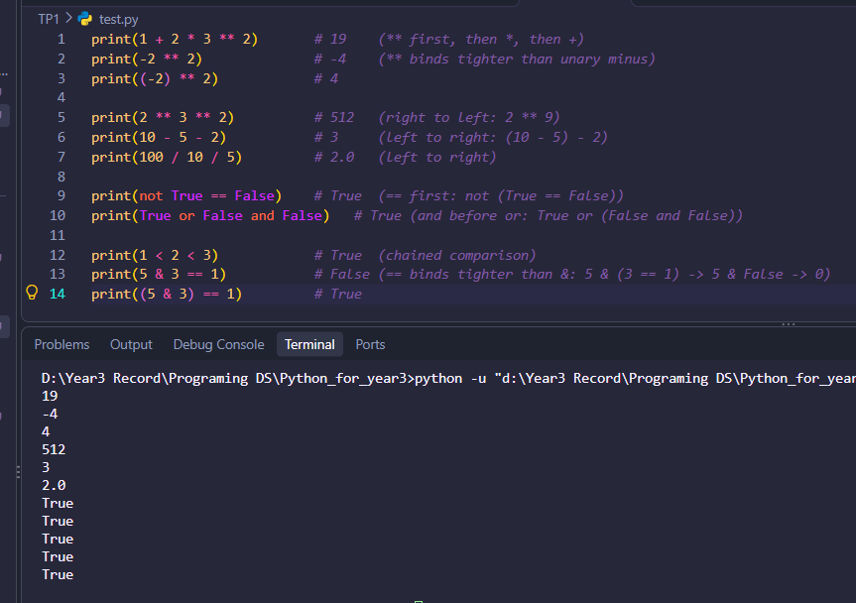
Example:
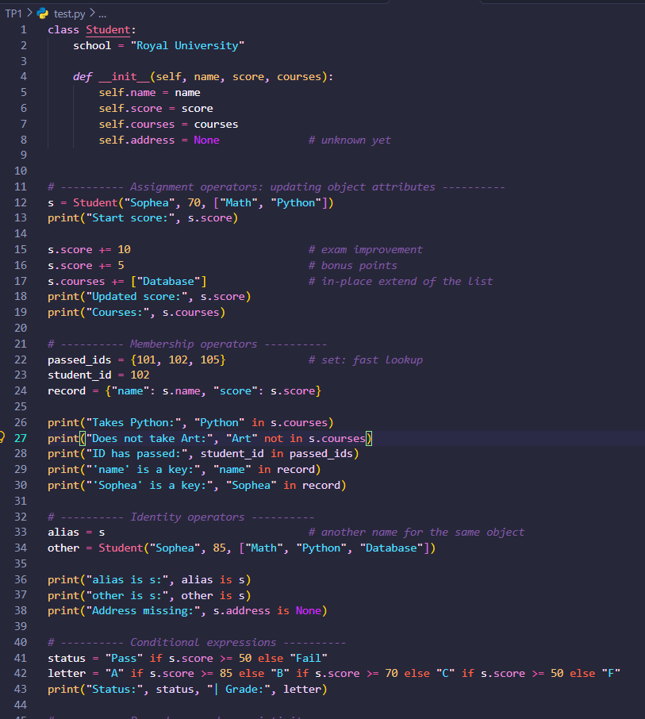
Practical example: updating object attributes, checking membership in collections, and evaluating expressions.

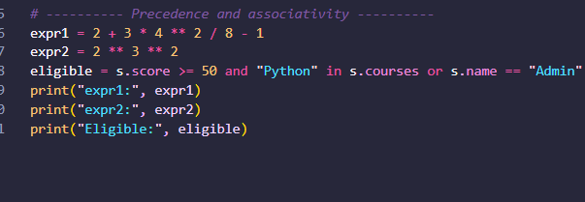
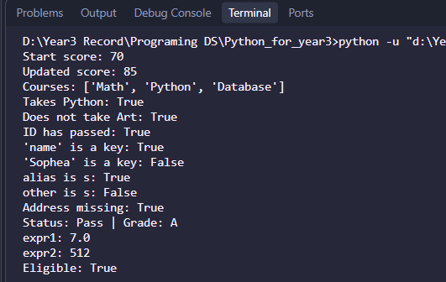
Output:

Key Takeaways
- Augmented assignment (+=, *=, ...) is shorthand, but on mutable objects such as lists it modifies the object in place.
- is compares object identity (use it for None), while == compares values.
- in / not in test membership, and for dictionaries they check the keys. Use sets for fast lookups.
- x if condition else y gives a compact one-line choice between two values.
- Precedence: ** is highest among arithmetic, then * / // %, then + -, then comparisons, then not, and, or. ** is right-associative, and most others are left-associative.
- Use parentheses whenever an expression could be misread.

Group 7: Python Decision-Making Statements

Decision-making statements let a program choose which block of code to run, depending on whether a condition is True or False.
Important rules:
- A condition ends with a colon :.
- The block under it must be indented (4 spaces is the standard).
- Any value can act as a condition: zero, empty collections, None, and "" count as False, while most other values count as True.
a. The if Statement
- Runs a block only when the condition is true. Otherwise, nothing happens.

Syntax:

if condition:
# runs only if condition is True

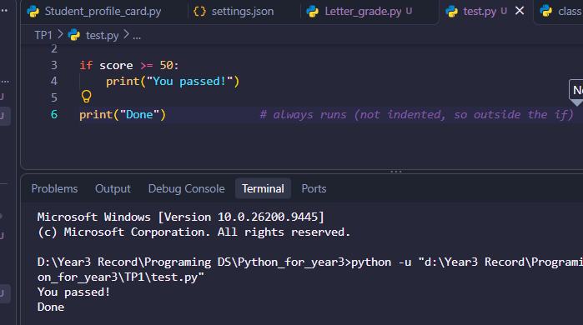
Example:

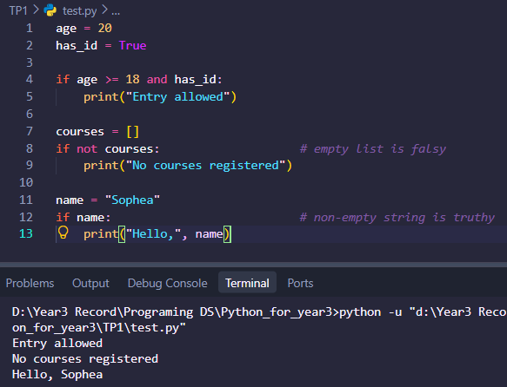
Combining conditions and truthiness:
Nested if (an if inside another if):
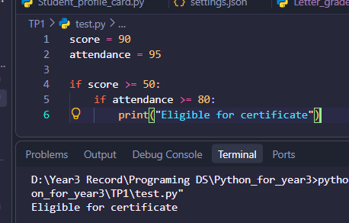

This is the same as if score >= 50 and attendance >= 80:, which is usually cleaner.
b. The if-else Statement
- Chooses between two paths. Exactly one block runs.
Syntax:
if condition:
# runs if True
else:
# runs if False

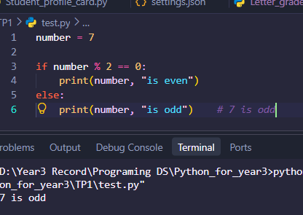
Example:
One-line alternative (conditional expression from Group 6):

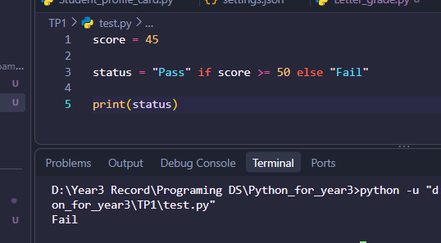

c. The if-elif-else Statement
- Chooses among many paths. Python checks the conditions from top to bottom and runs the first block whose condition is true, then skips the rest.
Syntax:
if condition1:
# block 1
elif condition2:
# block 2
elif condition3:
# block 3
else:
# runs if none of the above were true

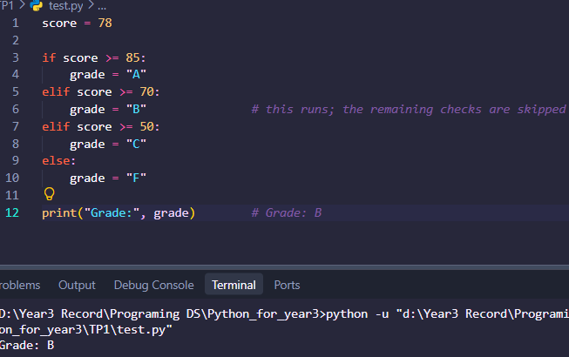
Example:
Key points:
- elif means “else if”. You can have as many as you need.
- else is optional and must come last.
- Only one block in the whole chain runs.
- Separate if statements (instead of elif) are each checked independently.

Comparison

Statement | Number of paths | Runs when
if | 1 (or nothing) | Condition is true
if – else | 2 | if block when true, else block otherwise
if – elif - else | 3 or more | The first true condition, or else if none are ture
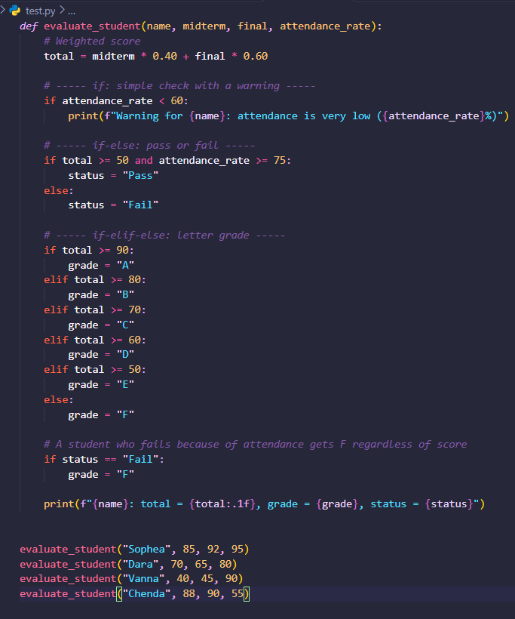
Practical example: determining student pass/fail status and assigning letter grades.
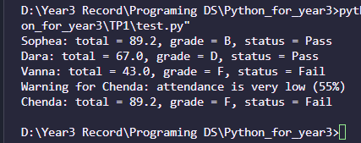
Output:

Key Takeaways
- if runs a block only when a condition is true.
- if-else chooses between two paths, and exactly one runs.
- if-elif-else chooses among many paths, and only the first matching block runs.
- Indentation defines the blocks, and each condition line ends with :.
- Order your elif conditions carefully, and use and, or, not, and in to build clear conditions.
- For two simple outcomes, a conditional expression (x if c else y) can replace a short if-else.

Group 8: Python Decision-Making — Part 2
d. Nested if Statements
- A nested if is an if placed inside another if, elif, or else block. The inner condition is only checked when the outer one allows it.
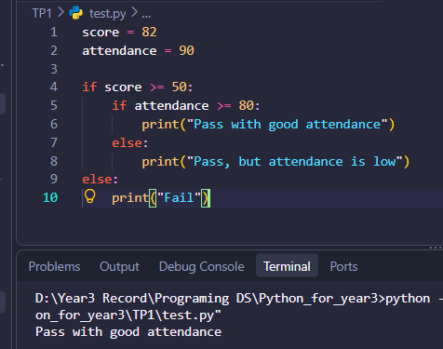
Example:

Reducing nesting. Deep nesting is hard to read. Two common fixes:

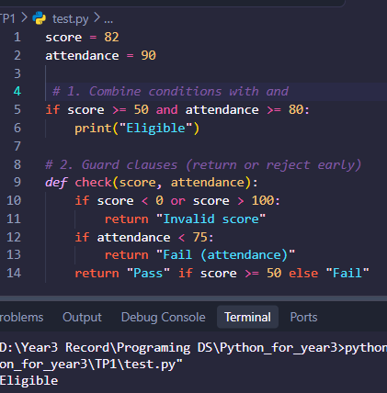
Example:
A good rule: if you go deeper than about 3 levels, restructure the code.
e. Multiple-Branch Selection Using match-case (Python 3.10+) or if-elif-else
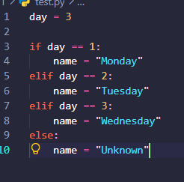
- if-elif-else (works in every Python version)
- match-case (Python 3.10+)
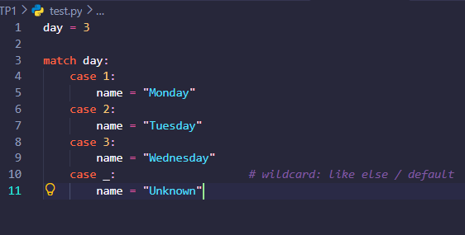
match compares one value against several patterns from top to bottom and runs the first one that matches.

- Differences from Java’s switch:
- No break needed. Only the first matching case runs, with no fall-through.
- case _ is the default.
- It is more powerful than switch because it matches structures, not just values.
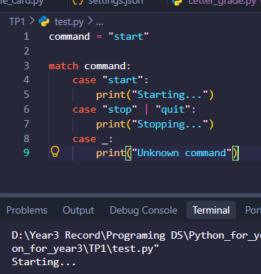
Pattern types:
- Which to choose?
Situation | Use
Ranges (score >= 85) | if-elif-else
Many fixed values (menu choices, commands) | match-case
Python older than 3.10 | if-elif-else
Matching shapes of data (lists, dicts, objects) | match-case

f. Conditional Expressions
Java and C use the ternary operator:
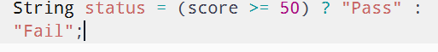
Python puts the condition in the middle:
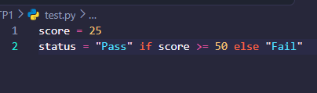
The pattern is value_if_true if condition else value_if_false.

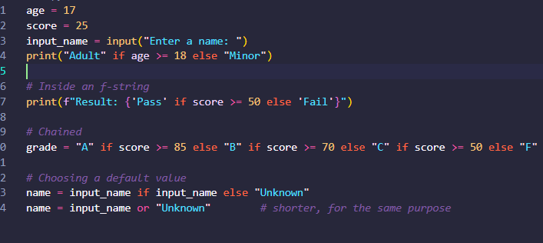
Java | Python
c ? a : b | a if c else b
switch (x) { case 1: ... } | match x: case 1: ...
else if | elif

Use it only for simple value choices. Do not use it to run statements. For anything complex, use a normal if-else.

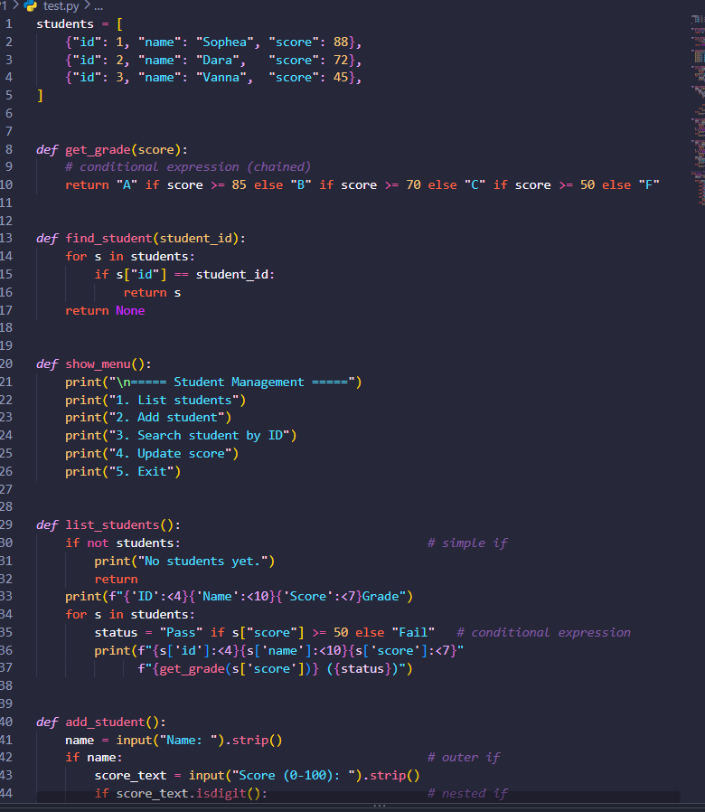
Practical example: a menu-driven student management system.

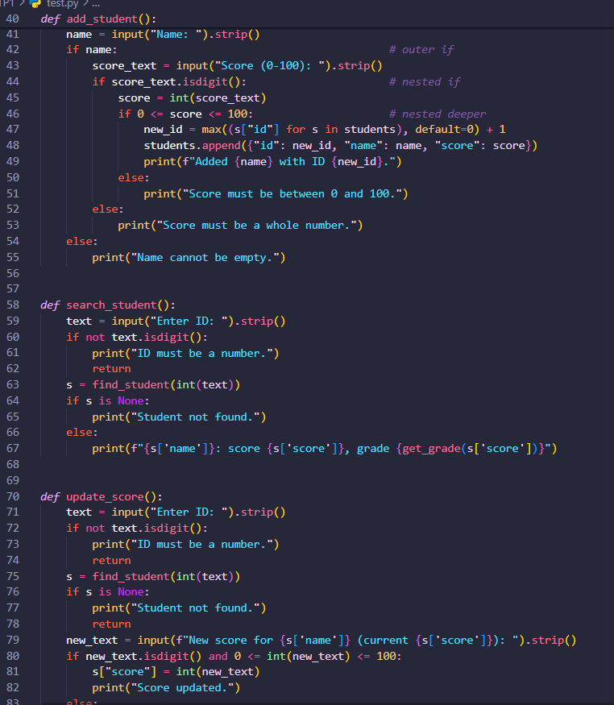

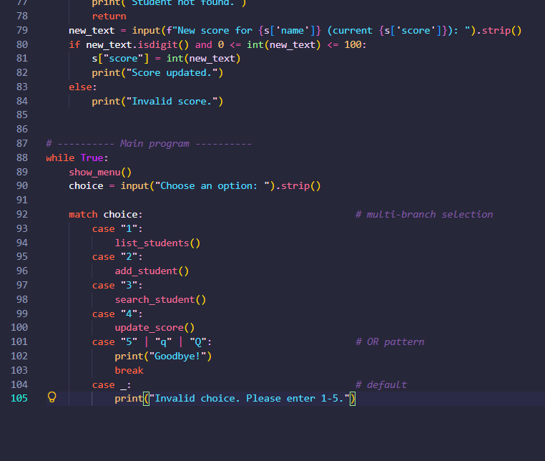
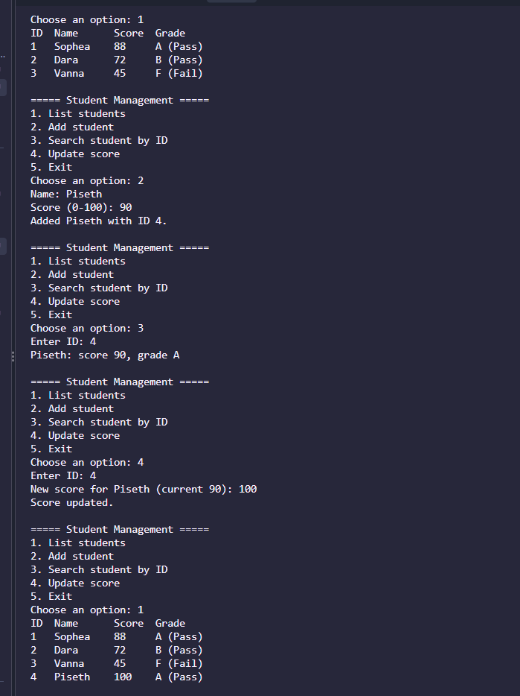
Output:
Key Takeaways
- Nested if checks a second condition only when the first is satisfied. Keep nesting shallow by using and or early returns.
- match-case (Python 3.10+) selects among many branches with no break or fall-through, and case _ is the default. It also supports |, guards (if), and structure patterns.
- Use if-elif-else for ranges and for Python versions before 3.10, and match-case for fixed values like menu options.
- A bare name in a case captures a value instead of comparing to it.
- Conditional expression: Java’s c ? a : b becomes a

Group 9: Python Loops and Loop Control
- A loop repeats a block of code. Python has two loops, while and for. As with if, the block is defined by a colon and indentation.
a. The while Loop
- Repeats as long as the condition is true. Use it when you do not know in advance how many repetitions you need.
Syntax:
while condition:
# runs again and again while condition is True
Example:
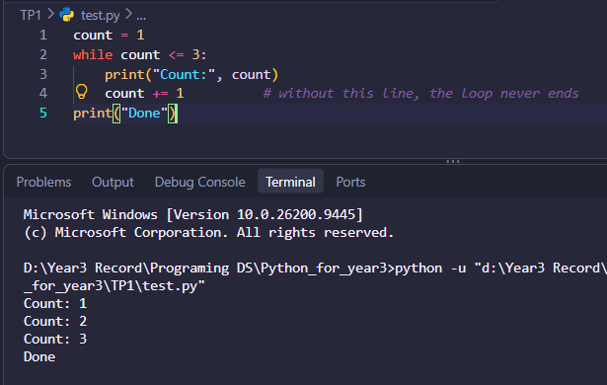
Key points:
- The condition is checked before each repetition, so the body may run zero times.
- Something inside the loop must eventually make the condition false, otherwise you get an infinite loop.
- Any value works as a condition (while items: runs while a list is not empty).
b. The for Loop
- Goes through the items of any iterable (list, tuple, string, dict, set, range, and so on). Use it when you have a collection or a known number of repetitions.
Syntax:
for item in iterable:
# runs once per item
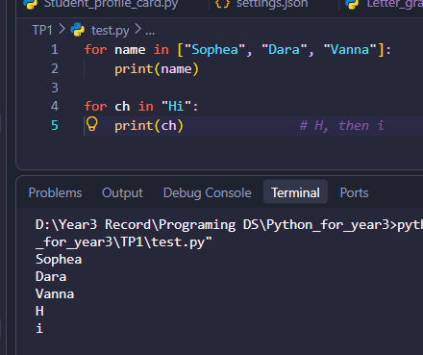
Example:
range() generates numbers:
Call | Produces
range(5) | 0,1,2,3,4
range(1, 6) | 1,2,3,4,5
range(0, 10, 2) | 0,2,4,6,8
range(5, 0, -1) | 5,4,3,2,1
The end value is never included.
Useful helpers:
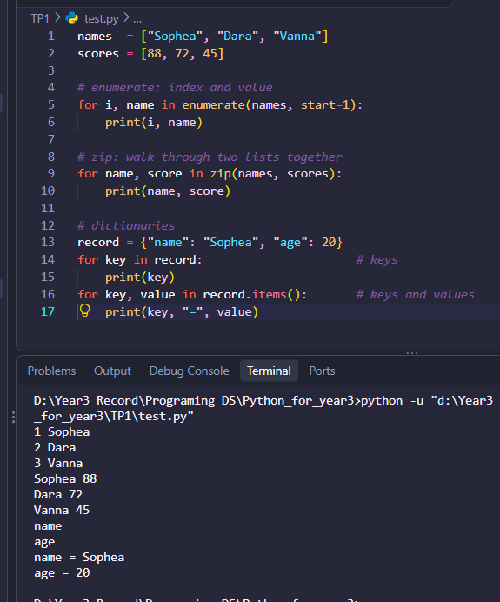

Output:

Cautions:
- Do not add or remove items from a list while looping over it. Loop over a copy (for x in items[:]:) or build a new list.
- The loop variable still exists after the loop ends.

c. Repetition with for and while (Python has no native do-while loop)

Use for when... | Use while when...
You have a collection to go through | You repeat until a condition changes
You know the number of repetitions | The number of repetitions is unknown
Example: print every student | Example: keep asking until the input is valid

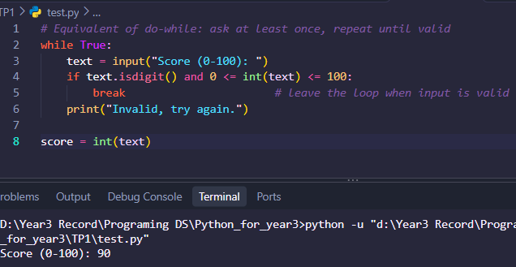
- Java’s do { ... } while (cond); runs the body at least once. Python has no such loop, so the standard replacement is while True with a break:

- Another way is to run the body once before a normal while, but that duplicates code, so while True + break is preferred.
d. Loop Control Statements: break, continue, and pass

Statement | Effect
break | Leaves the loop immediately
continue | Skips the rest of this repetition and goes to the next one
pass | Does nothing; a placeholder where a statement is required

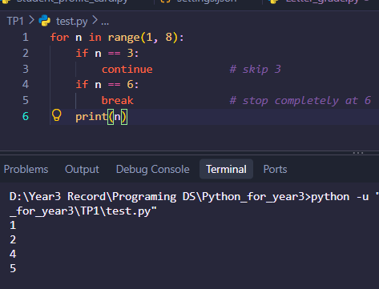
Example:
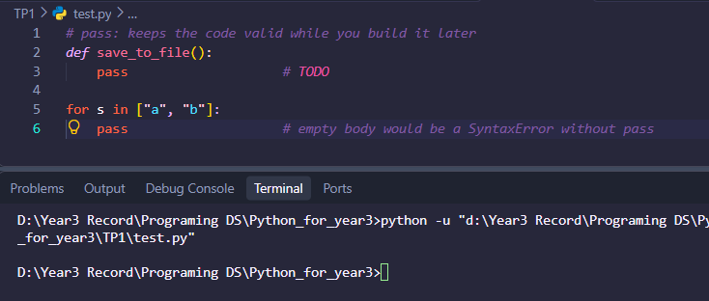

e. The break Statement
- break ends the innermost loop right away, and execution continues after the loop. It is mostly used for searching and for stopping when a goal is reached.
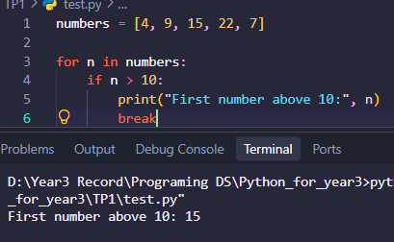
Example:

- Loop else (a Python feature): the else block of a loop runs only if the loop finished without hitting break. It is perfect for “not found” cases.
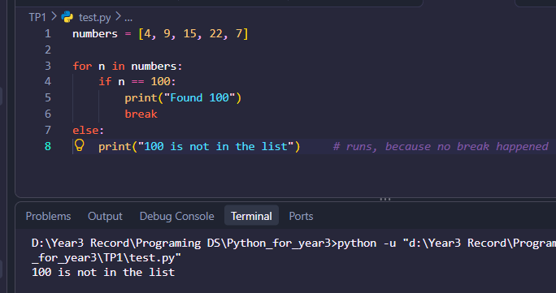
Example:

Note: break and continue affect only the innermost loop. Python has no labeled break like Java.
Practical example: iterating through student objects, calculating averages, and searching for a student.
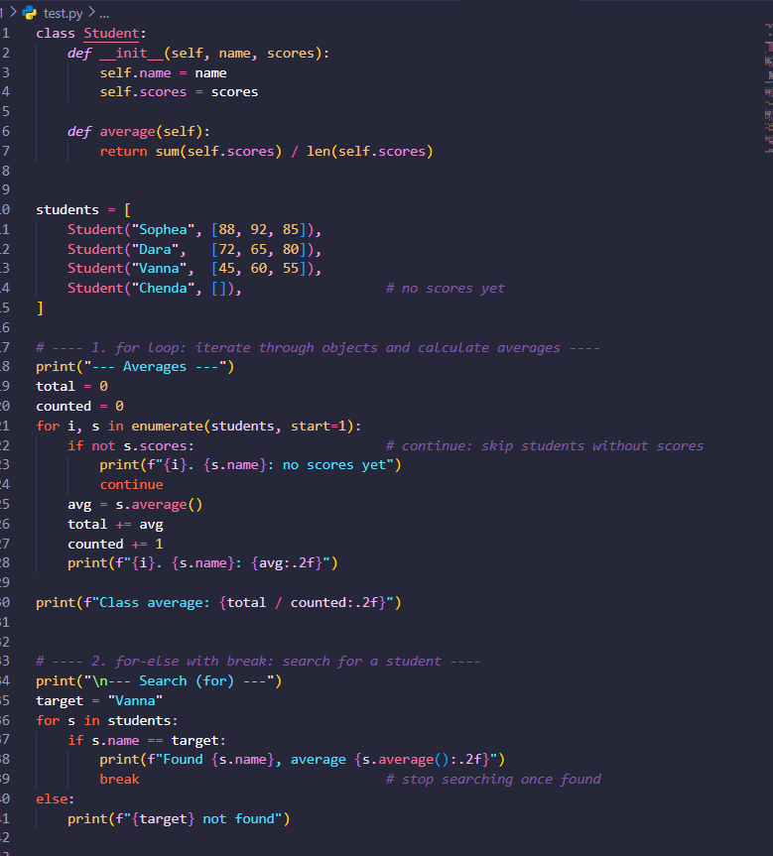

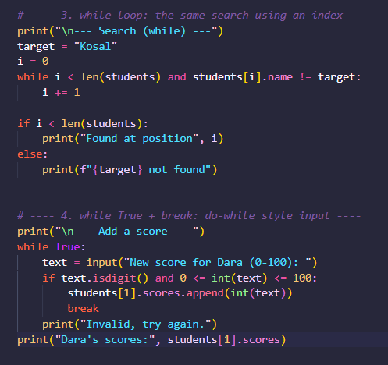
Output:
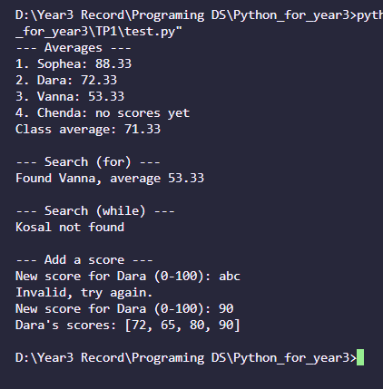

- Important Differences Between Java and Python

Topic | Java | Python
Blocks | { } braces | Colon and indentation
Condition | Needs parentheses: while (x < 5) | No parentheses needed: while x < 5:
Counting loop | for (int i = 0; i < 5; i++) | for i in range(5):
For-each | for (String s : list) | for s in list:
Increment | i++, ++i | Not available; use i += 1
Condition type | Must be boolean | Any value (truthy or falsy)
do-while | Built in | Not available; use while True + break
Loop else | Not available | Runs if the loop ended without break
Labeled break/continue | Supported | Not supported
Empty block | { } | Needs pass
Loop variable after loop | Out of scope if declared in the for | Still accessible
Iterating with an index | Usual style | Use enumerate() instead of range(len(...))
Booleans | true, false | True, False (capitalized)

Example:
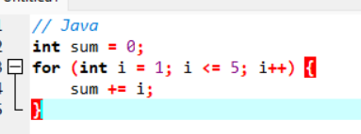
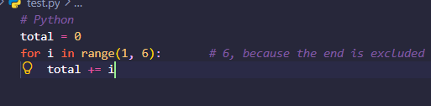

Common Mistakes
Mistake | Problem | Fix
Forgetting to update the variable in while | Infinite loop | Change the loop variable inside the body
range(1, 5) expecting 5 | Stops at 4 | Use range(1, 6)
Missing : after for/while | SyntaxError | Add the colon
Modifying a list while looping over it | Items get skipped | Loop over a copy or build a new list
Using i++ | SyntaxError | Use i += 1
Dividing by len(...) of an empty list | ZeroDivisionError | Check if not scores: first
Key Takeaways
- Use for to go through a collection or a known range, and while to repeat until a condition changes.
- do-while does not exist, so use while True with break.
- break leaves the loop, continue skips to the next repetition, and pass does nothing.
- A loop else runs only when no break happened, which is ideal for “not found” messages.
- Prefer enumerate() and zip() over manual index handling.
- Compared with Java, Python uses indentation, range(), no ++, and any truthy value as a condition.

Conclusion
These nine topics form the foundation of Python programming. Data types and variables store information, operators combine and compare it, decision statements choose a path, and loops repeat work. Object-oriented features such as classes, properties, and abstract methods organize all of this into reusable, well-protected designs.
The practical examples built up from simple values to a complete menu-driven student management system, showing how each concept fits into a real program. With these fundamentals in place, natural next steps are functions and modules, exception handling, file input and output, and comprehension syntax.
Thank you for your attention. Questions are welcome.

