SCREW SYSTEM
Desktop Application Guide
Python BLE Controller Application
ScrewSystem.py
Installation, Usage, and Technical Reference
Document Date: February 2026

1. Introduction
ScrewSystem.py is a comprehensive Python desktop application that provides a graphical user interface (GUI) for controlling and monitoring the Screw System STM32WB15CC BLE device (referred to as 'BOLT'). The application leverages Bluetooth Low Energy (BLE) technology to establish wireless communication with the device, enabling real-time sensor data acquisition, device control, and firmware management.

1.1 Key Features
The application provides the following core functionalities:
- BLE Device Management: Connect, disconnect, and monitor connection quality with the BOLT device
- LED Control: Toggle the onboard LED on/off for visual feedback
- Sensor Control: Independent start/stop control for IMU, Temperature, and Strain Gauge sensors
- Real-Time Data Display: Receive and visualize sensor data with timestamped logging
- Connection Monitoring: Track RSSI (signal strength), latency, and MTU size
- Firmware Management: Query firmware version and perform Over-The-Air (OTA) updates
- Resizable Interface: Adjustable paned window layout for optimal viewing

1.2 Application Screenshot
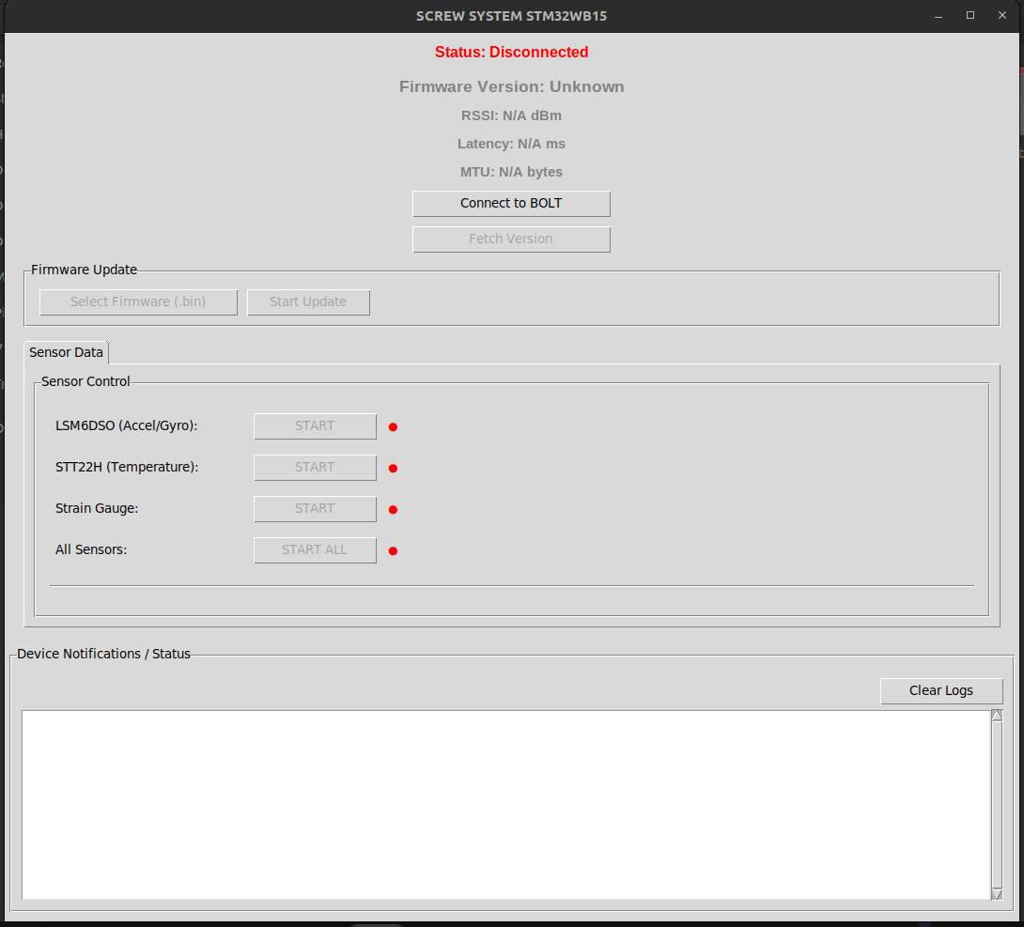
Figure 1.1: Screw System Desktop Application Main Interface

2. System Requirements

2.1 Hardware Requirements
- Computer with Bluetooth 4.0+ (BLE) capability
- Built-in Bluetooth adapter or USB Bluetooth dongle
- BOLT device (STM32WB15CC) powered on and advertising

2.2 Software Requirements
Requirement | Details
Operating System | Windows 10/11 (64-bit recommended), Linux, macOS
Python Version | Python 3.8 or higher
Bluetooth Driver | Windows native Bluetooth stack (no additional drivers needed)

2.3 Python Dependencies
The application requires the following Python packages:
Package | Purpose
tkinter | GUI framework (included with standard Python installation)
bleak | Cross-platform BLE communication library (must be installed)
asyncio | Asynchronous I/O for non-blocking BLE operations (built-in)
struct | Binary data parsing for sensor values (built-in)
threading | Run async loop in separate thread for responsive UI (built-in)
datetime | Timestamp generation for logging (built-in)

3. Installation on Windows

3.1 Install Python
- Download Python from https://www.python.org/downloads/
- Run the installer
- IMPORTANT: Check 'Add Python to PATH' checkbox during installation
- Click 'Install Now'
- Verify installation by opening Command Prompt and typing:
python --version

3.2 Install Required Packages
Open Command Prompt (cmd) or PowerShell and run:
pip install bleak
Or if you have multiple Python versions installed:
python -m pip install bleak
Note: tkinter is included with Python on Windows. If you encounter a tkinter error, reinstall Python and ensure 'tcl/tk and IDLE' is checked in the optional features.

3.3 Download the Application
- Save the ScrewSystem.py file to a folder (e.g., C:\ScrewSystem\)
- Keep firmware .bin files in the same folder for convenient OTA updates

4. Running the Application

4.1 Start the Application
Method 1: Command Line (Recommended)
- Open Command Prompt
- Navigate to the folder containing ScrewSystem.py:
cd C:\ScrewSystem
- Run the script:
python ScrewSystem.py
Method 2: Double-Click
- If Python is properly associated with .py files, you can double-click ScrewSystem.py to run it
- Right-click the file and select 'Open with' then choose Python if needed

4.2 Connecting to BOLT Device
- Ensure the BOLT device is powered on and advertising (BLE enabled)
- Verify your computer's Bluetooth is turned ON
- Click the 'Connect to BOLT' button in the application
- The application will scan for 8 seconds looking for a device named 'BOLT'
- Upon successful connection, the status indicator turns green and control buttons become enabled

5. User Interface Components
The application features a resizable window (1080×1500 pixels default) with a paned interface that allows you to adjust the view proportions between the control tabs and the notification log.

5.1 Status Area (Top Section)
Element | Description
Status Label | Shows connection state: Disconnected (red), Connected (green), Scanning (orange)
Firmware Version | Displays firmware version (e.g., 2.0.0) fetched from device
RSSI | Signal strength in dBm (fetched on demand via 'Fetch RSSI' button). Color-coded: black (>-70), orange (-70 to -90), red (<-90)
Latency | Round-trip time for version request/response in milliseconds (measured during 'Fetch Version')
MTU | Maximum Transmission Unit size in bytes (affects max packet size). Queried automatically on connection.

5.2 Connection Control Buttons
- Connect to BOLT: Scans for and connects to the BOLT device. Changes to 'Disconnect from BOLT' when connected.
- Fetch Version: Sends version request command (0x30) and displays the firmware version response. Also measures latency.
- Fetch RSSI: Sends RSSI request command (0x40) to retrieve current signal strength from the device.

5.3 Firmware Update Section
- Select Firmware (.bin): Opens file dialog to choose a firmware binary file (.bin format)
- Start Update: Initiates the OTA (Over-The-Air) firmware update process. Enabled only after a firmware file is selected.

5.4 Tabbed Interface
The application features a tabbed notebook interface with two main tabs:

5.4.1 LED Control Tab
Provides simple on/off control for the BOLT device's onboard LED:
- LED ON: Sends command [0x01] to turn LED on
- LED OFF: Sends command [0x00] to turn LED off
- Device responds with [0xAA, 0x01] for ON or [0xAA, 0x00] for OFF

5.4.2 Sensor Control Tab
Each sensor has an independent START/STOP button and a status indicator (green = active, red = inactive):
Sensor | Description
LSM6DSO (IMU) | 6-axis inertial measurement unit - provides accelerometer (3-axis) and gyroscope (3-axis) data
STT22H (Temperature) | Temperature sensor reading in degrees Celsius
Strain Gauge | Raw ADC value from strain measurement sensor (16-bit unsigned)
All Sensors | Start/stop all sensors simultaneously. Individual sensor buttons are disabled when this is active.

5.5 Device Notifications / Status Log
The scrollable text area at the bottom displays timestamped events and data:
- All BLE communication events with millisecond timestamps
- Sent commands indicated by (→)
- Received notifications indicated by (←)
- Parsed sensor data (logs every 10th sample to reduce spam)
- Error messages (✗) and success confirmations (✓)
- Clear Logs button: Clears the entire log area

6. BLE Communication Protocol

6.1 GATT Service UUIDs
The application uses standard ST P2P server UUIDs for communication:
Purpose | UUID
Write (Commands) | 0000fe41-8e22-4541-9d4c-21edae82ed19
Notify (Data) | 0000fe42-8e22-4541-9d4c-21edae82ed19
OTA Reboot | 0000fe11-8e22-4541-9d4c-21edae82ed19

6.2 Command Protocol

6.2.1 LED Control Commands
LED commands are sent as single-byte payloads:
- [0x01] → Turn LED ON
- [0x00] → Turn LED OFF
Device response format:
- [0xAA, 0x01] → LED is ON
- [0xAA, 0x00] → LED is OFF

6.2.2 Sensor Control Commands
Sensor commands are sent as 3-byte payloads to the Write characteristic:
Format: [Device_Selection, Sensor_ID, Action]
Device_Selection:
- 0x10 = Sensor commands prefix
Sensor_ID values:
- 0x01 = LSM6DSO (IMU - accelerometer + gyroscope)
- 0x02 = STT22H (Temperature sensor)
- 0x03 = Strain Gauge (ADC input)
- 0x04 = All Sensors
Action values:
- 0x01 = Start streaming
- 0x00 = Stop streaming
Command Examples:
- [0x10, 0x01, 0x01] → Start IMU sensor
- [0x10, 0x02, 0x00] → Stop Temperature sensor
- [0x10, 0x03, 0x01] → Start Strain Gauge
- [0x10, 0x04, 0x01] → Start All Sensors

6.2.3 Device Information Commands
- [0x30] → Request Firmware Version
- [0x40] → Request RSSI (signal strength)

6.3 Notification Data Formats
The device sends notifications via the Notify characteristic with the following byte formats:

6.3.1 Sensor Status Confirmation (0x21)
Format: [0x21, Sensor_ID, Status]
Sent by the device to confirm a sensor was started or stopped successfully.

6.3.2 IMU Data (LSM6DSO) - 14 bytes
[0x20, 0x01, AccX_H, AccX_L, AccY_H, AccY_L, AccZ_H, AccZ_L, GyroX_H, GyroX_L, GyroY_H, GyroY_L, GyroZ_H, GyroZ_L]
- Message type: 0x20 (sensor data)
- Sensor ID: 0x01 (LSM6DSO)
- Accelerometer values: 16-bit signed integers (big-endian) for X, Y, Z axes
- Gyroscope values: 16-bit signed integers (big-endian) for X, Y, Z axes
- Parsed using struct.unpack('>h', bytes) for each axis

6.3.3 Temperature Data (STT22H) - 4 bytes
[0x20, 0x02, Temp_H, Temp_L]
- Message type: 0x20 (sensor data)
- Sensor ID: 0x02 (STT22H)
- Temperature: 16-bit signed integer (big-endian) in degrees Celsius

6.3.4 Strain Gauge Data - 4 bytes
[0x20, 0x03, Raw_H, Raw_L]
- Message type: 0x20 (sensor data)
- Sensor ID: 0x03 (Strain Gauge)
- Raw value: 16-bit unsigned integer (big-endian) ADC reading
- Parsed using struct.unpack('>H', bytes)

6.3.5 Version Response - 4 bytes
[0x30, MAJOR, MINOR, PATCH]
Example: [0x30, 0x02, 0x00, 0x00] = Version 2.0.0

6.3.6 RSSI Response - 2 bytes
[0x40, RSSI_VALUE]
- Message type: 0x40 (RSSI response)
- RSSI_VALUE: Signed byte (-128 to 127) representing signal strength in dBm
- Typical values: -30 to -90 dBm (closer to 0 = stronger signal)

7. How Sensor Data is Received and Processed

7.1 Notification Handler
The application uses the _notification_handler() callback method to process incoming BLE notifications. This function is automatically called by the Bleak library whenever the device sends data over the Notify characteristic.
def _notification_handler(self, sender, data: bytes):
# data[0] = message type
# data[1] = sensor ID (for sensor data messages)
# data[2:] = payload bytes

if data[0] == 0x20: # NOTIF_SENSOR_DATA
sensor_id = data[1]

if sensor_id == 0x01: # LSM6DSO
accel_x = struct.unpack('>h', data[2:4])[0]
accel_y = struct.unpack('>h', data[4:6])[0]
# ... parse remaining accelerometer and gyroscope

7.2 Data Flow Architecture
Sensor data flows through the system in the following sequence:
┌──────────────────────────────────────────────────────┐
│ BOLT Device (STM32WB15) │
│ │
│ Sensors → main.c → Variables → BLE Stack → Notify │
└──────────────────────┬───────────────────────────────┘
│
BLE Radio (2.4GHz)
│
▼
┌──────────────────────────────────────────────────────┐
│ ScrewSystem.py (Desktop Application) │
│ │
│ BleakClient → _notification_handler → Parse → UI │
└──────────────────────────────────────────────────────┘

7.3 Asynchronous Threading Architecture
The application uses a dual-thread architecture to keep the UI responsive while handling BLE operations:
- Main Thread: Runs the tkinter GUI event loop (handles button clicks, updates display)
- Async Thread: Runs the asyncio event loop for non-blocking BLE operations
- Thread Communication: Uses asyncio.run_coroutine_threadsafe() to schedule async tasks and root.after() to update UI from async callbacks

8. OTA Firmware Update Process
The application supports Over-The-Air (OTA) firmware updates using ST's BLE_Ota bootloader application.

8.1 OTA Process Steps
- Read firmware file: Load the selected .bin file into memory
- Calculate sectors: Determine which flash sectors need to be erased
- Send reboot command: Device reboots into OTA bootloader mode
- Reconnect in OTA mode: Scan for and connect to the BLE_Ota application
- Send START_USER_APP: Initialize transfer at the application base address (0x08007000)
- Stream firmware data: Send firmware in 100-byte chunks over BLE
- Send FILE_FINISHED: Signal completion, device validates and reboots
- Reconnect to new firmware: Verify update was successful

8.2 OTA Configuration Constants
Constant | Value / Description
FLASH_BASE_ADDR | 0x08000000 (STM32 flash start)
APP_BASE_ADDR | 0x08007000 (User app base)
FLASH_PAGE_SIZE | 2048 bytes (2KB per flash page)
OTA_CHUNK_SIZE | 100 bytes per BLE write

8.3 OTA Service UUIDs
Purpose | UUID
OTA Service | 0000fe20-cc7a-482a-984a-7f2ed5b3e58f
Base Address | 0000fe22-8e22-4541-9d4c-21edae82ed19
Reboot Confirm | 0000fe23-8e22-4541-9d4c-21edae82ed19
Data Transfer | 0000fe24-8e22-4541-9d4c-21edae82ed19

9. Troubleshooting

9.1 Common Issues and Solutions
Problem | Solution
"BOLT not found" | Ensure device is powered on, Bluetooth is enabled on computer, move closer to device, check device is advertising
"No module named bleak" | Run: pip install bleak
"Connection failed" | Restart Bluetooth service on computer, power cycle the BOLT device, try connecting again
No sensor data received | Check notification characteristic is subscribed (happens automatically on connect), verify firmware version supports sensors, try restarting sensor
MTU shows 23 bytes | Windows Bluetooth limitation - this is normal. Functionality works correctly with standard MTU size.
OTA update fails | Ensure BLE_Ota bootloader is flashed on device, verify .bin file is valid and for correct device, check file path is correct
Tkinter import error | Reinstall Python and ensure 'tcl/tk and IDLE' option is selected during installation

9.2 Windows Bluetooth Tips
- Use Windows Settings → Bluetooth & devices to verify your Bluetooth adapter is working
- Do NOT pair the BOLT device in Windows Settings - let the application handle the connection
- If issues persist, try: Device Manager → Bluetooth → Disable then Enable your adapter
- Some USB Bluetooth dongles may work better than built-in laptop adapters
- Ensure no other application is connected to the BOLT device simultaneously
- Keep the BOLT device within 10 meters (30 feet) of the computer for best results

9.3 Performance Optimization
- The application logs every 10th sensor sample to reduce UI overhead and improve responsiveness
- All sensor data is still processed in the background; only logging frequency is reduced
- If experiencing UI lag, try using 'Clear Logs' button periodically
- Running multiple sensors simultaneously may increase BLE traffic and latency

10. Technical Reference

10.1 Application Constants
Constant | Value
SENSOR_CMD_PREFIX | 0x10
SENSOR_LSM6DSO | 0x01
SENSOR_STTSH22H | 0x02
SENSOR_STRAIN_GAUGE | 0x03
SENSOR_ALL | 0x04
SENSOR_START | 0x01
SENSOR_STOP | 0x00
NOTIF_SENSOR_DATA | 0x20
NOTIF_SENSOR_STATUS | 0x21
VERSION_REQUEST_PREFIX | 0x30
RSSI_REQUEST_PREFIX | 0x40

10.2 Window Specifications
- Default Size: 1080 × 1500 pixels
- Resizable: Yes (both width and height)
- Layout: Vertical paned window with draggable divider
- Minimum Tab Height: 150 pixels

10.3 Data Sampling and Logging
- All sensor data is processed in real-time via the notification handler
- Only every 10th sample is logged to the UI to reduce visual clutter
- Each sensor maintains an independent sample counter
- Timestamps are displayed with millisecond precision (HH:MM:SS.mmm)
--- End of Document ---

