STM32CubeMX
IOC Configuration Guide
Screw System Project
STM32WB15CC BLE Configuration
Visual Step-by-Step Guide with Screenshots
Document Date: February 2026

1. Introduction
This document provides a comprehensive visual guide to the STM32CubeMX configuration for the Screw System project. The .ioc file (screw_system.ioc) contains all peripheral configurations, clock settings, and middleware setup for the STM32WB15CC microcontroller.
STM32CubeMX is a graphical tool that allows easy configuration of STM32 microcontrollers and generates initialization C code. The .ioc file stores all these configurations and can be reopened at any time to modify settings.

1.1 How to Open the .ioc File
- Launch STM32CubeMX application
- Go to File → Load Project (or click on the project in Recent Projects)
- Navigate to the screw_system folder and select screw_system.ioc
- The project will load showing all configured peripherals
Figure 1.1: STM32CubeMX Home Screen - shows recent projects including screw_system.ioc
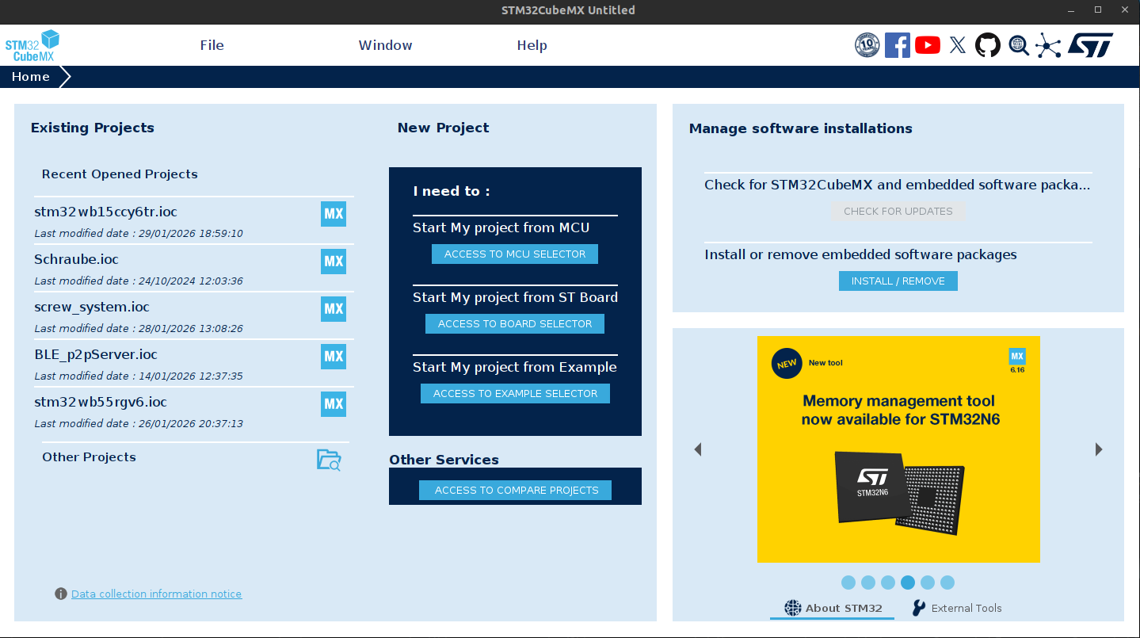
Key Elements: The home screen displays Existing Projects (left panel) where you can see recent .ioc files. The screw_system.ioc file is visible in the list. You can also start new projects from MCU, Board, or Example selectors.

2. System Core Peripherals
The System Core category contains essential peripherals for the STM32WB dual-core operation. These include GPIO, hardware semaphores (HSEM), inter-processor communication (IPCC), interrupt controller (NVIC), clock control (RCC), and system configuration (SYS).

2.1 GPIO Configuration
GPIO (General Purpose Input/Output) configuration shows all pin assignments. The right panel displays the chip pinout view (WLCSP49 package - Top view).
Figure 2.1: GPIO Mode and Configuration
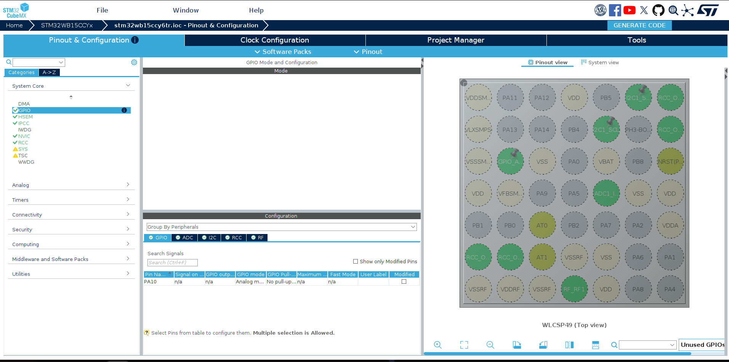
Configuration Details: PA10 is configured as Analog mode (no pull-up/pull-down). The Configuration panel at bottom shows pins grouped by peripherals: GPIO, ADC, I2C, RCC, RF. Green pins on the chip view indicate configured/active pins.

2.2 HSEM (Hardware Semaphore)
HSEM provides hardware semaphores for synchronization between CPU1 (Cortex-M4) and CPU2 (Cortex-M0+). This is essential for the dual-core STM32WB architecture.
Figure 2.2: HSEM Mode and Configuration
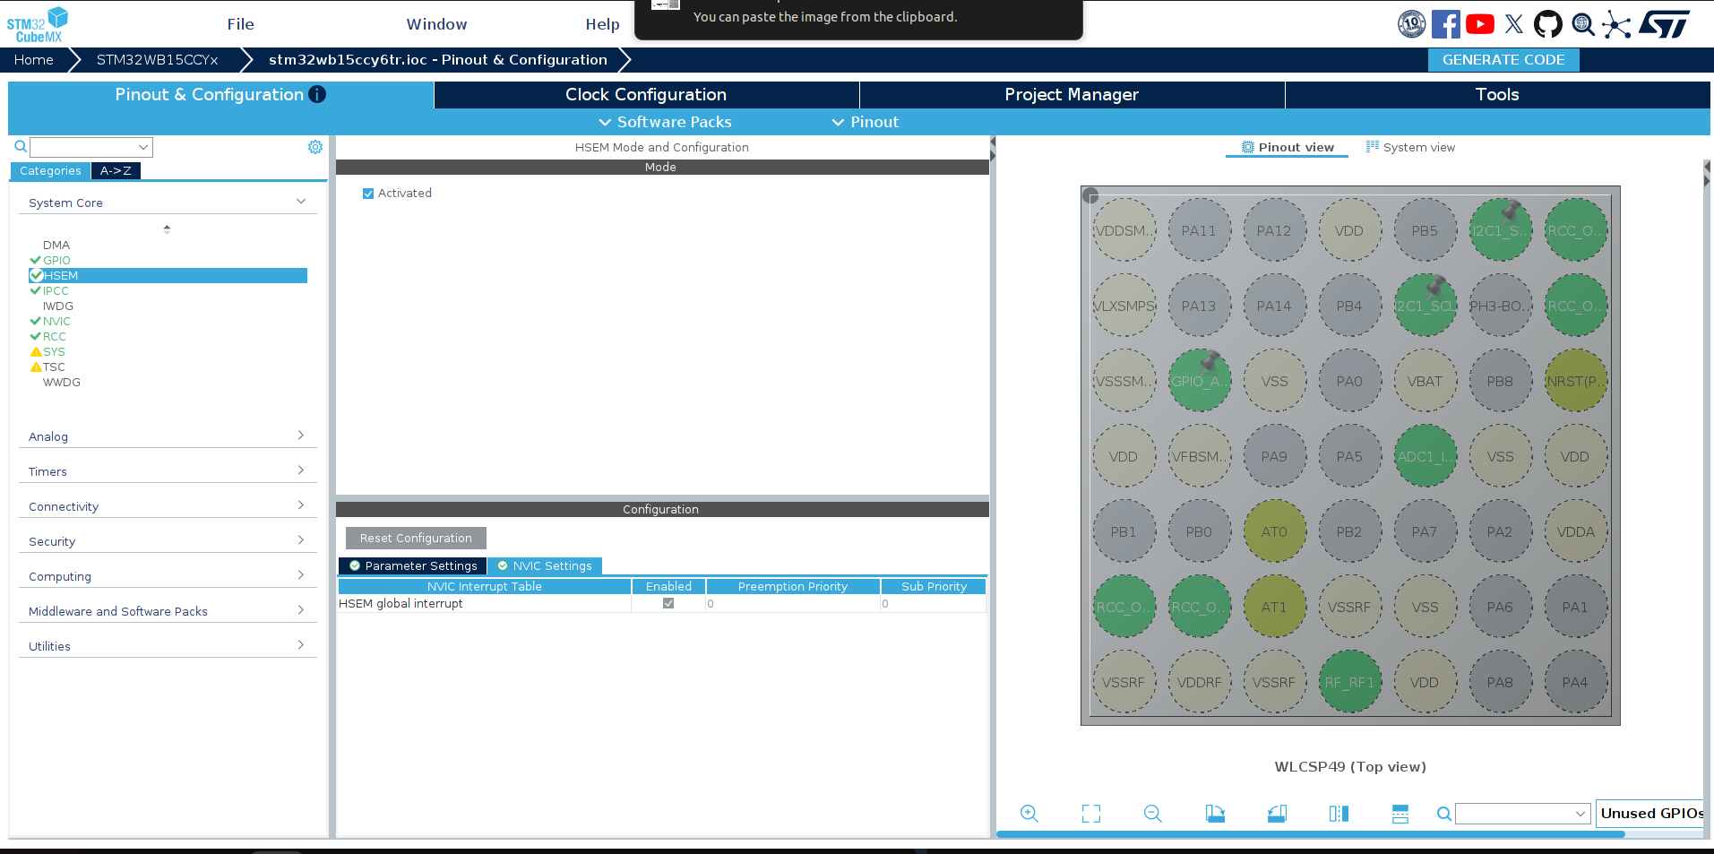
Configuration Details: HSEM is Activated (checkbox checked). The NVIC Settings tab shows HSEM global interrupt is enabled. Semaphores are used for flash access protection, RCC synchronization, and BLE stack communication between the two cores.

2.3 IPCC (Inter-Processor Communication Controller)
IPCC enables communication between CPU1 and CPU2. It uses a mailbox mechanism with channels for different types of communication (BLE commands, system commands, etc.).
Figure 2.3: IPCC Mode and Configuration
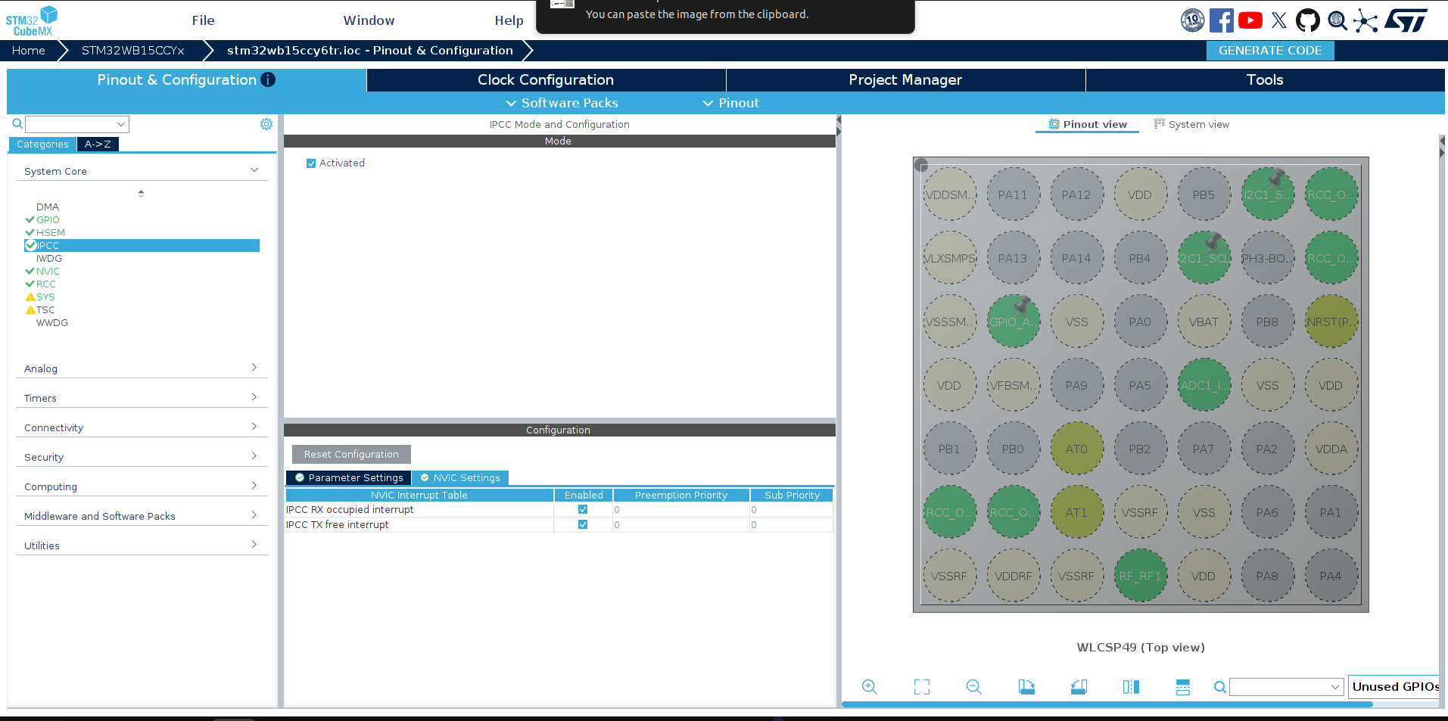
Configuration Details: IPCC is Activated. Two interrupts are enabled in NVIC Settings: IPCC RX occupied interrupt (for receiving data from CPU2) and IPCC TX free interrupt (for notification when transmit buffer is available). Both have priority 0.

2.4 NVIC (Nested Vector Interrupt Controller)
NVIC manages all system interrupts and their priorities. This is where you configure which interrupts are enabled and their preemption/sub-priority levels.
Figure 2.4: NVIC Mode and Configuration
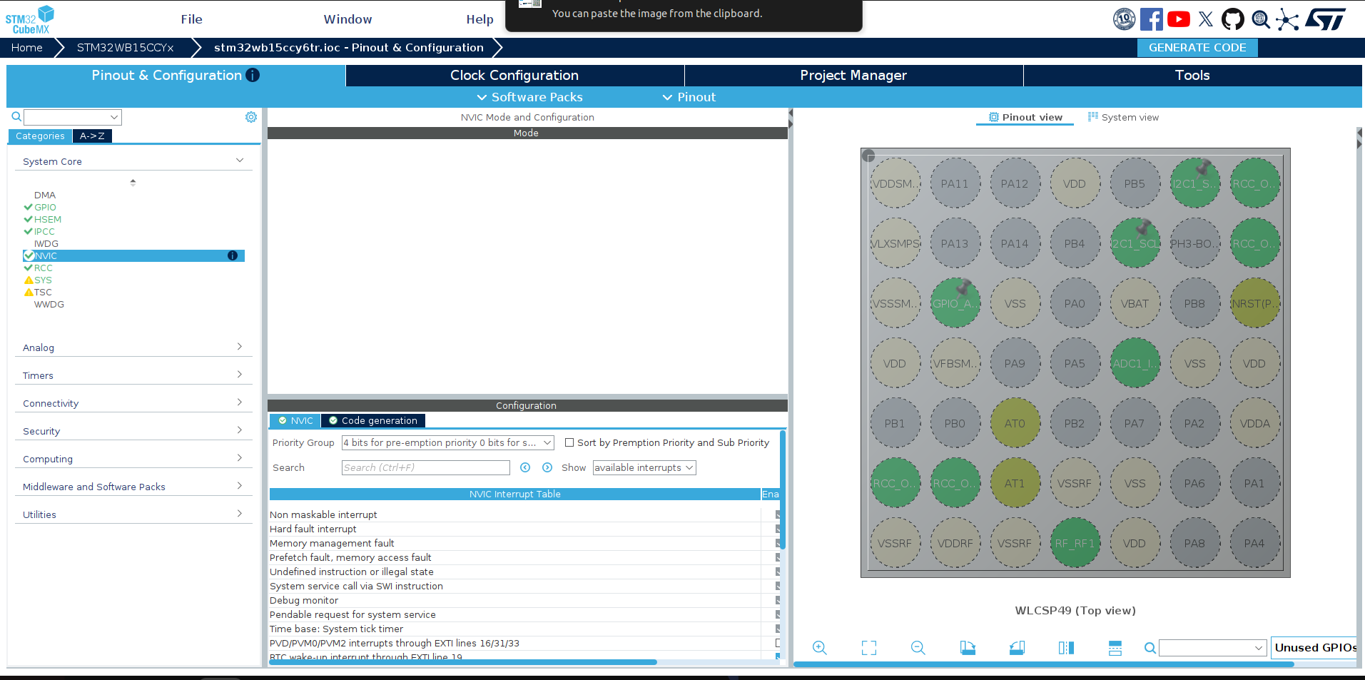
Configuration Details: The NVIC Interrupt Table shows all available interrupts including: Non-maskable interrupt, Hard fault, Memory management fault, System tick timer, PVD/PVM interrupts, and RTC wake-up. Priority Group is set to 4 bits for preemption priority. Code generation tab allows customizing generated interrupt handlers.

2.5 RCC (Reset and Clock Control)
RCC configures the clock sources for the microcontroller. For BLE operation, both HSE (High Speed External) and LSE (Low Speed External) crystal oscillators are required.
Figure 2.5: RCC Mode and Configuration
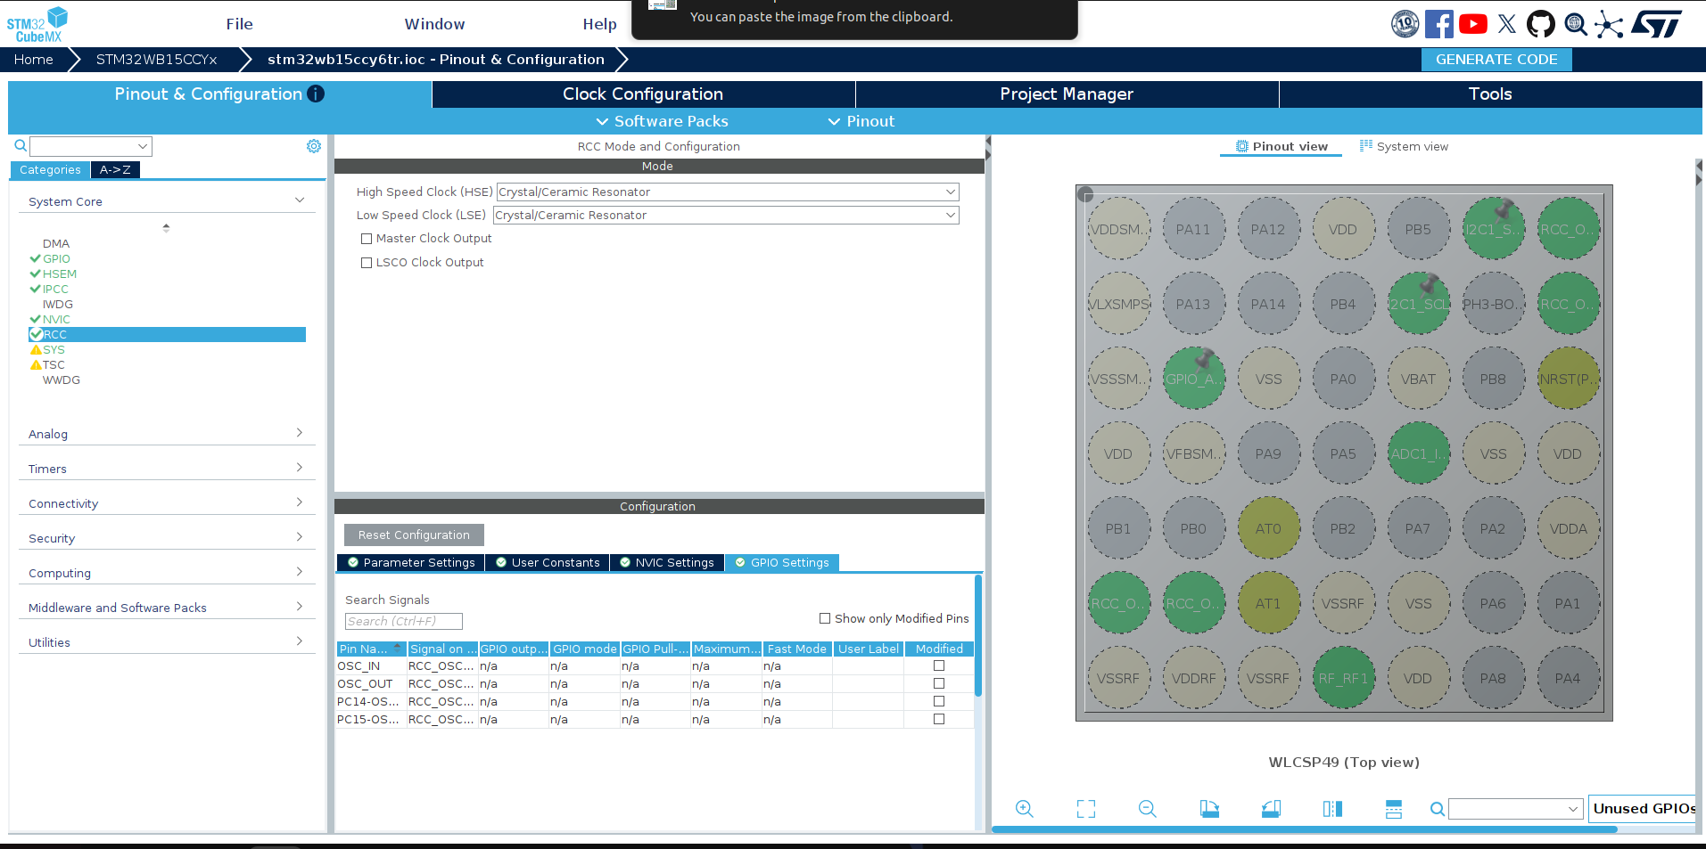
Configuration Details: High Speed Clock (HSE) is set to Crystal/Ceramic Resonator (32 MHz for BLE). Low Speed Clock (LSE) is also Crystal/Ceramic Resonator (32.768 kHz for RTC). GPIO Settings tab shows oscillator pins: OSC_IN, OSC_OUT, PC14-OSC32_IN, PC15-OSC32_OUT.

2.6 SYS (System Configuration)
SYS configures system-level settings including debug interface, timebase source, and power voltage detection.
Figure 2.6: SYS Mode and Configuration
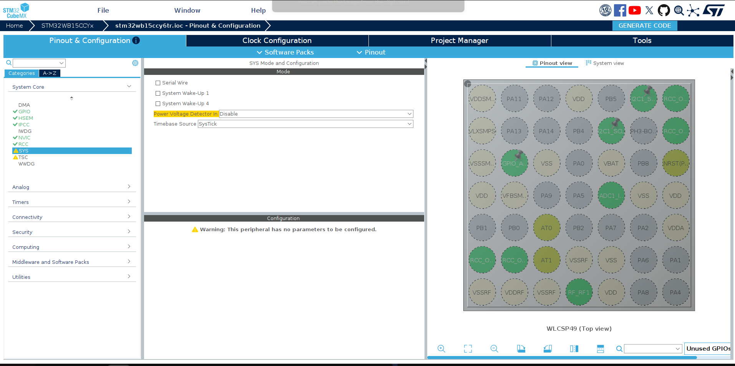
Configuration Details: Serial Wire debug is not enabled (unchecked) to save pins. System Wake-Up options 1 and 4 are not used. Power Voltage Detector is Disabled. Timebase Source is set to SysTick (default). Note: "This peripheral has no parameters to be configured" warning is normal.

3. Analog Peripherals

3.1 ADC1 Configuration
ADC1 is configured to read the strain gauge sensor connected to PA3 (Channel IN8). The ADC provides 12-bit resolution analog-to-digital conversion.
Figure 3.1: ADC1 Mode and Configuration
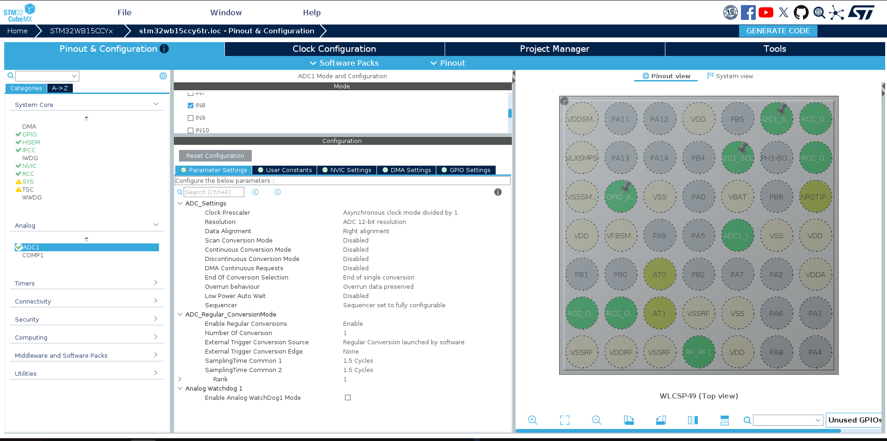
Mode Settings: IN8 channel is enabled (checkbox checked) - this corresponds to PA3 pin for the strain gauge.
Parameter | Value
Clock Prescaler | Asynchronous clock mode divided by 1
Resolution | ADC 12-bit resolution
Data Alignment | Right alignment
Scan Conversion Mode | Disabled (single channel)
Continuous Conversion Mode | Disabled
External Trigger | Regular Conversion launched by software
Number Of Conversion | 1
Sampling Time | 1.5 Cycles

4. Timer Peripherals

4.1 RTC (Real Time Clock)
RTC provides timekeeping functionality and is used by the BLE stack for timing. It also serves as the timer server base for hardware timers used in sensor data transmission.
Figure 4.1: RTC Mode and Configuration
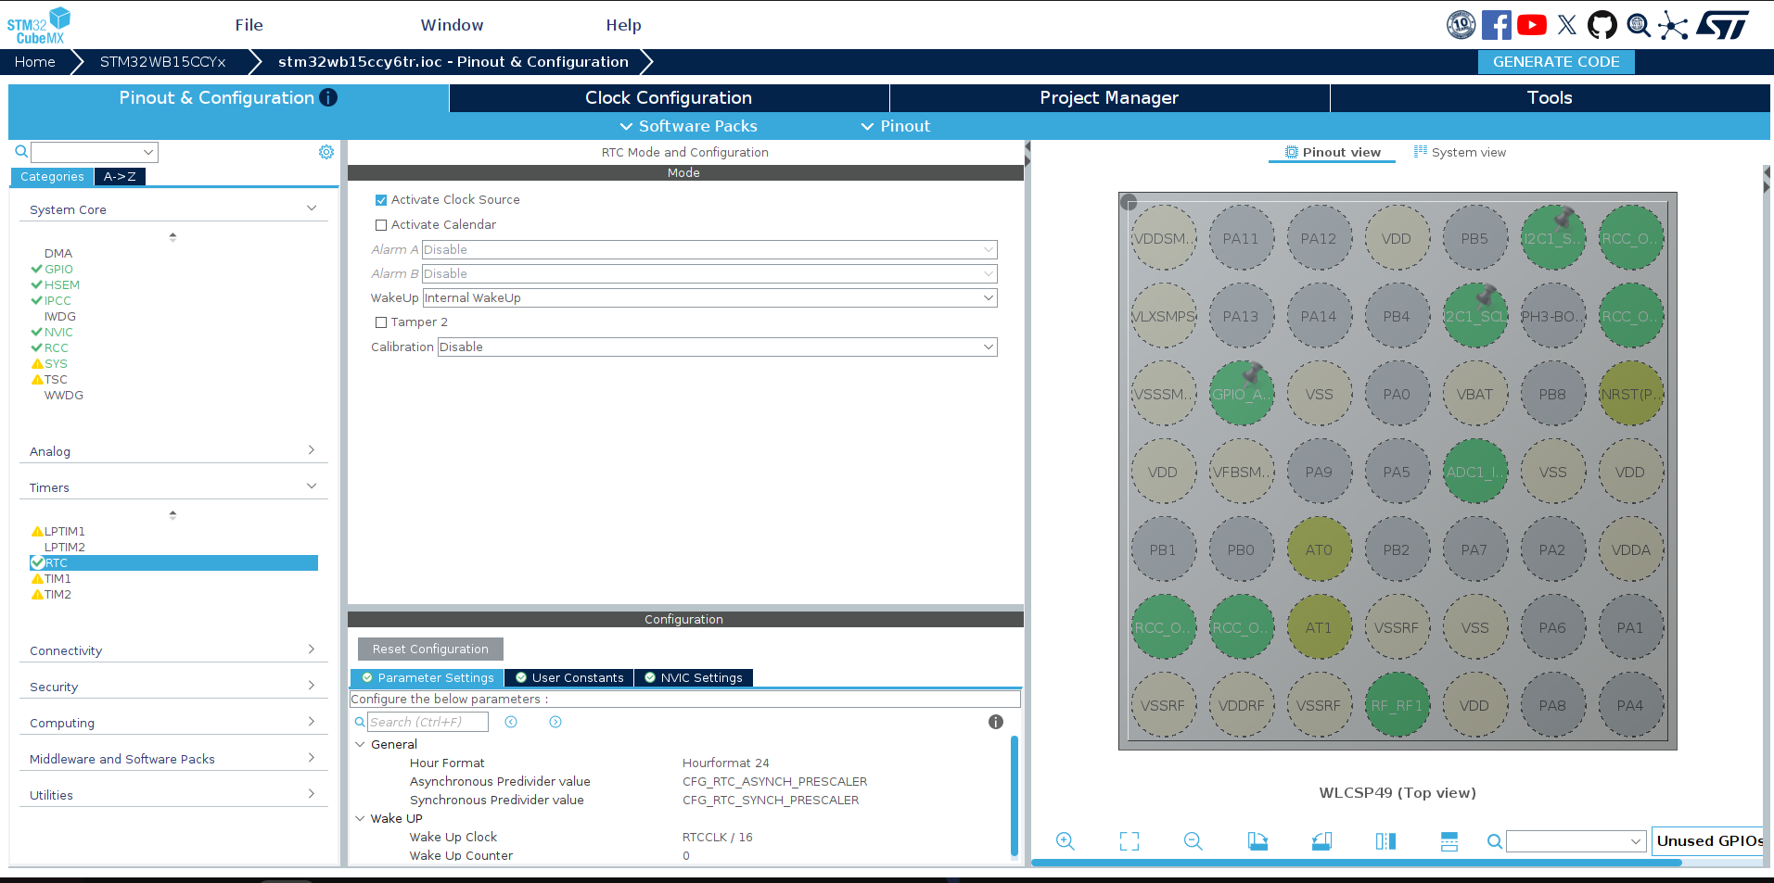
Configuration Details: Activate Clock Source is enabled. WakeUp is set to Internal WakeUp - this is used by the BLE stack and timer server for scheduling. Hour Format is 24-hour. The Wake Up Clock is RTCCLK/16, which provides the timebase for hardware timers used to send sensor data at 10Hz.

5. Connectivity Peripherals

5.1 I2C1 Configuration
I2C1 is configured to communicate with the LSM6DSL (IMU) and STTS22H (temperature) sensors. Both sensors share the same I2C bus.
Figure 5.1: I2C1 Mode and Configuration
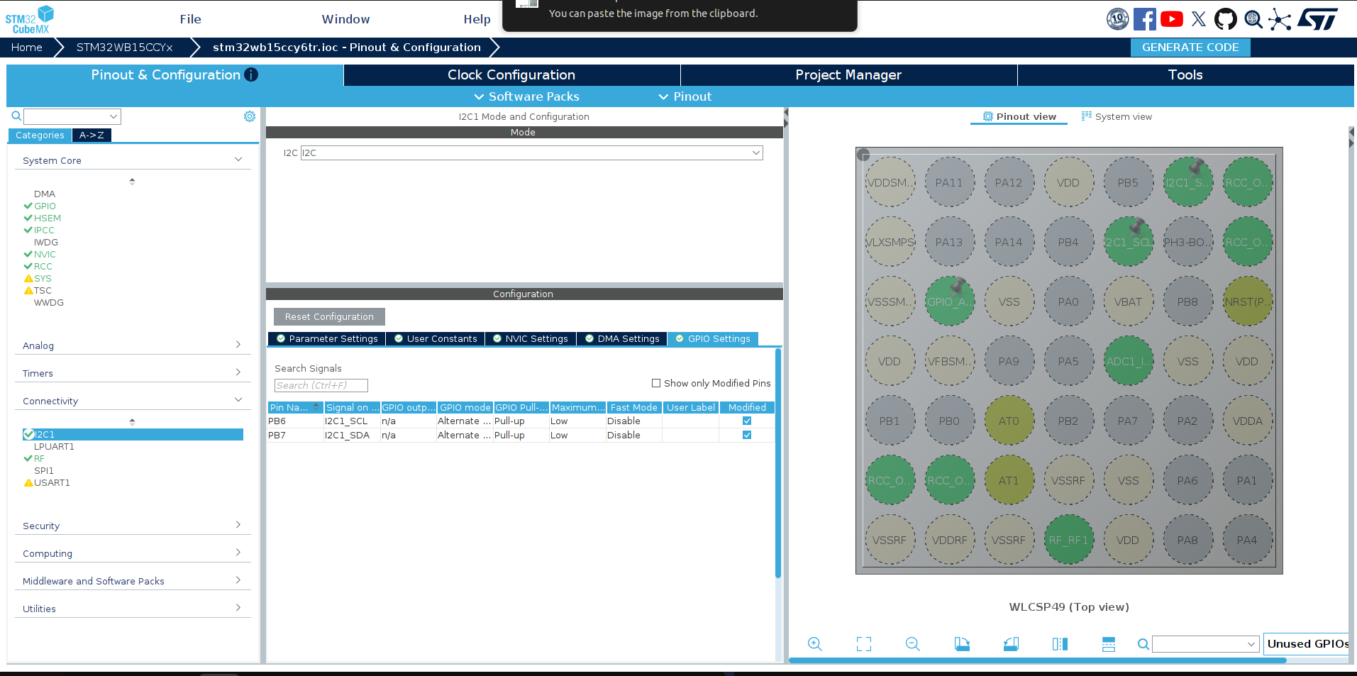
Configuration Details: I2C mode is set to I2C (standard mode). GPIO Settings shows the pin assignments:
Pin | Signal | GPIO Mode | Pull
PB6 | I2C1_SCL | Alternate Function Open Drain | Pull-up
PB7 | I2C1_SDA | Alternate Function Open Drain | Pull-up

5.2 RF (Radio Frequency)
RF peripheral controls the 2.4 GHz radio used for Bluetooth Low Energy communication. This is managed by CPU2.
Figure 5.2: RF Mode and Configuration
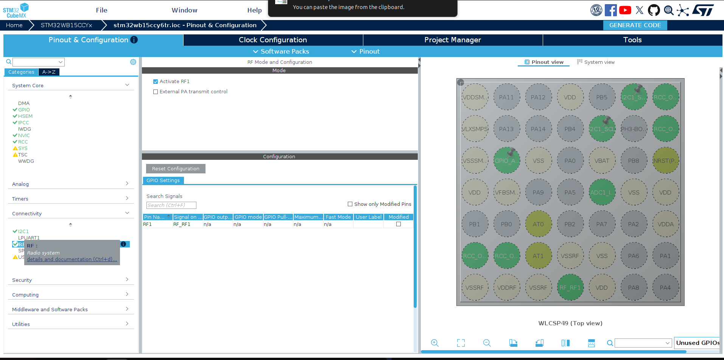
Configuration Details: Activate RF1 is enabled. External PA transmit control is not used. The RF1 pin is shown in GPIO Settings. The tooltip shows "RF: Radio system - details and documentation" indicating this enables the BLE radio hardware.

6. Security Peripherals

6.1 RNG (Random Number Generator)
RNG provides true random numbers required for BLE security features like encryption key generation and address randomization.
Figure 6.1: RNG Mode and Configuration
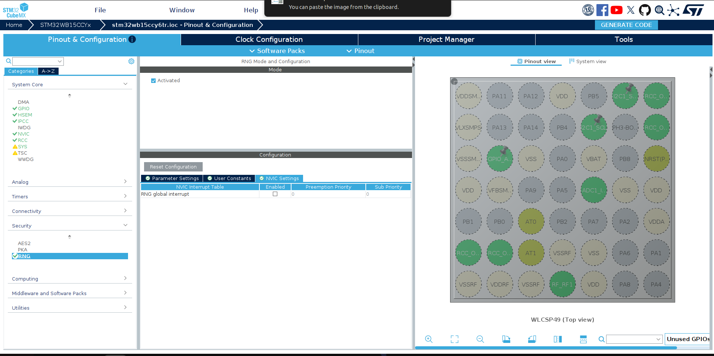
Configuration Details: RNG is Activated. NVIC Settings shows RNG global interrupt is available (can be enabled if needed). The RNG is essential for BLE security - it's used to generate random addresses, encryption keys, and other security-related random values.

7. Middleware - STM32_WPAN (BLE Stack)
STM32_WPAN is the wireless middleware that provides the BLE protocol stack. This is the most important configuration for BLE functionality.

7.1 BLE Applications and Services
This tab configures the BLE application type and services.
Figure 7.1: STM32_WPAN BLE Applications and Services Configuration
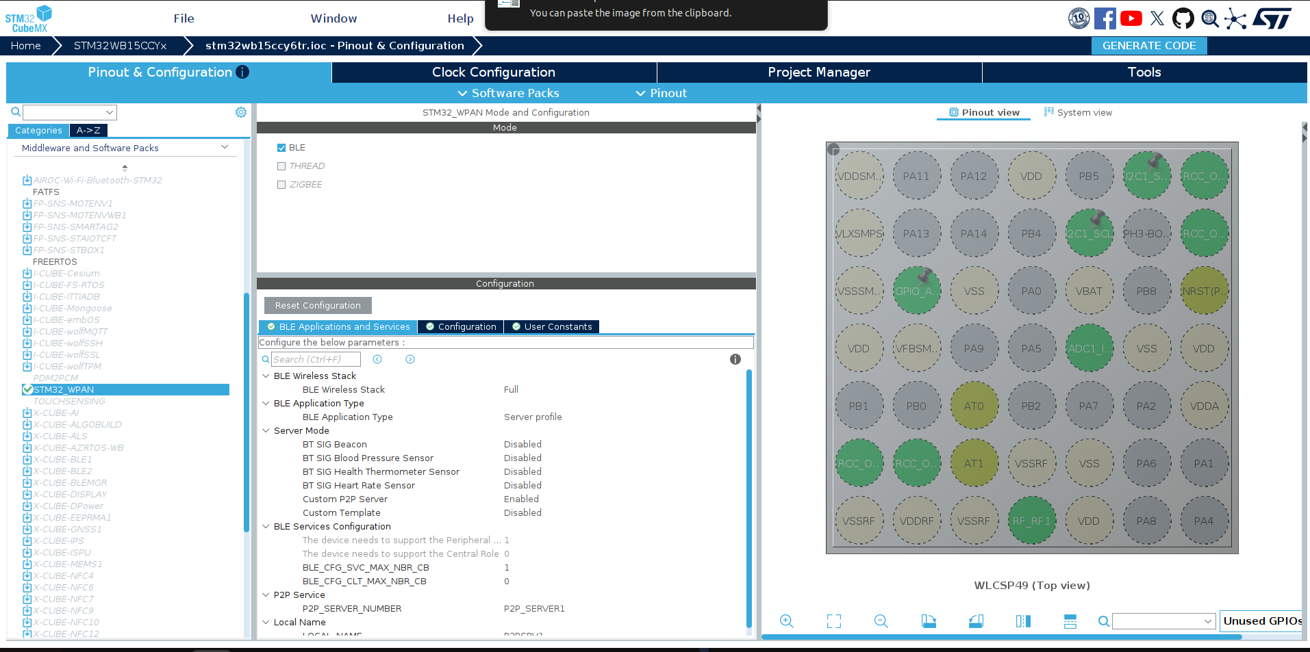
Key Configuration Settings:
Parameter | Value
BLE Wireless Stack | Full
BLE Application Type | Server profile
Custom P2P Server | Enabled
P2P_SERVER_NUMBER | P2P_SERVER1
Peripheral Role Support | 1 (enabled)
Central Role Support | 0 (disabled)
BLE_CFG_SVC_MAX_NBR_CB | 1

7.2 BLE Configuration Parameters
The Configuration tab contains hardware timer server settings and other low-level BLE parameters.
Figure 7.2: STM32_WPAN Configuration Tab
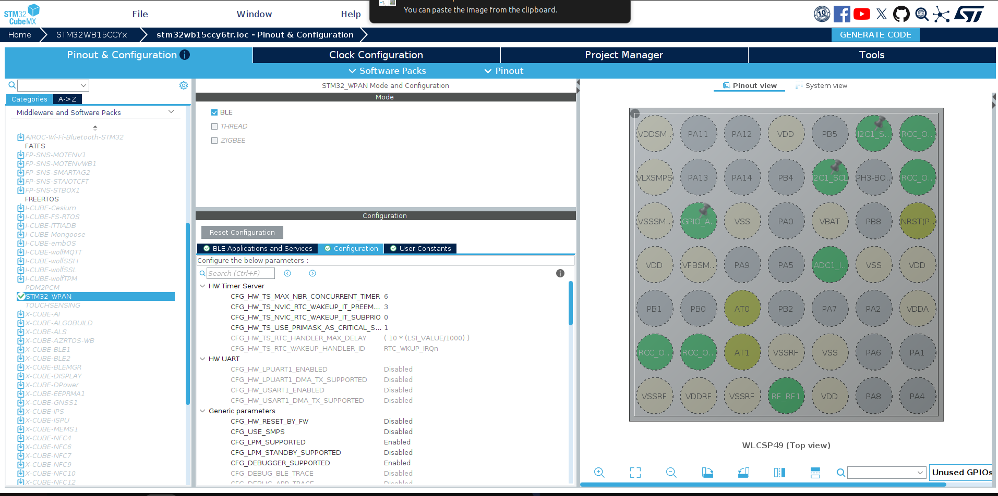
Important Parameters:
- CFG_HW_TS_MAX_NBR_CONCURRENT_TIMER: 6 - Maximum number of concurrent hardware timers (used for sensor data transmission)
- CFG_LPM_SUPPORTED: Enabled - Low Power Mode support for battery-efficient operation
- CFG_DEBUGGER_SUPPORTED: Enabled - Allows debugging during development
- HW UART: Disabled - LPUART1 and USART1 are not used

8. Clock Configuration
The Clock Configuration tab provides a visual clock tree showing all clock sources, multiplexers, prescalers, and output frequencies. This is critical for proper BLE operation.
Figure 8.1: Complete Clock Configuration Tree
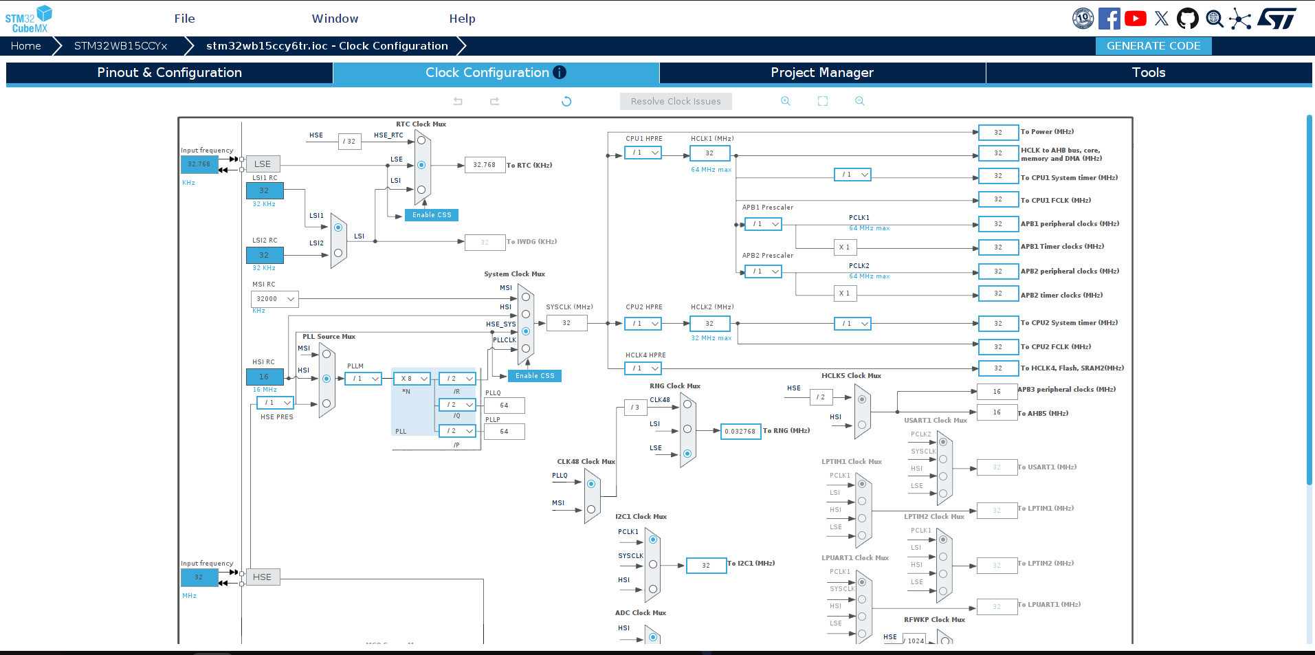
Clock Sources and Key Frequencies:
Clock Source | Frequency | Purpose
LSE (External) | 32.768 kHz | RTC, BLE timing
HSE (External) | 32 MHz | BLE RF, System clock
HSI | 16 MHz | PLL source, ADC
SYSCLK | 32 MHz | CPU1, CPU2
HCLK1, HCLK2 | 32 MHz | AHB bus, DMA
PCLK1, PCLK2 | 32 MHz | APB peripherals
I2C1 Clock | 32 MHz | I2C1 (sensors)

9. Project Manager
The Project Manager tab contains settings for project generation, code generator options, and advanced configuration.

9.1 Project Settings
Figure 9.1: Project Manager - Project Settings
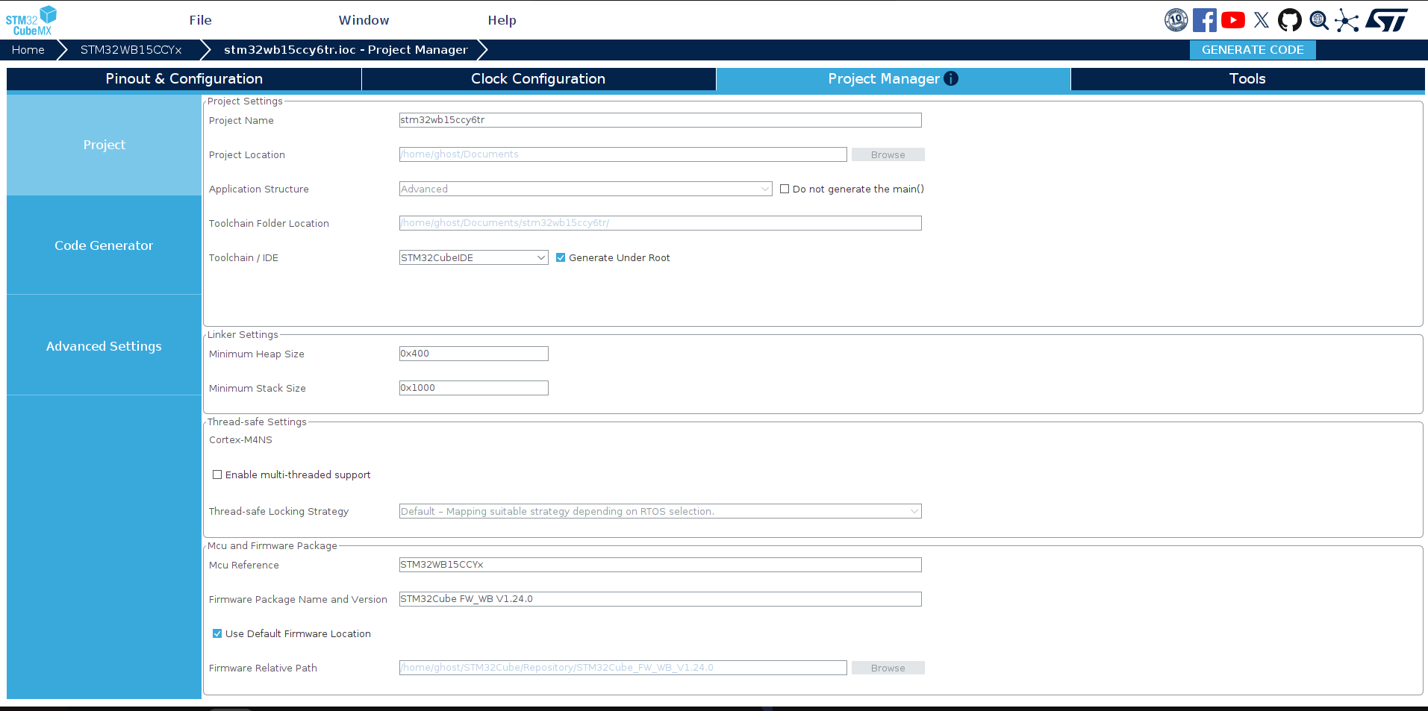
Project Settings:
Setting | Value
Project Name | stm32wb15ccy6tr
Application Structure | Advanced
Toolchain / IDE | STM32CubeIDE
Minimum Heap Size | 0x400
Minimum Stack Size | 0x1000
MCU Reference | STM32WB15CCYx
Firmware Package | STM32Cube FW_WB V1.24.0

9.2 Code Generator Settings
Figure 9.2: Project Manager - Code Generator
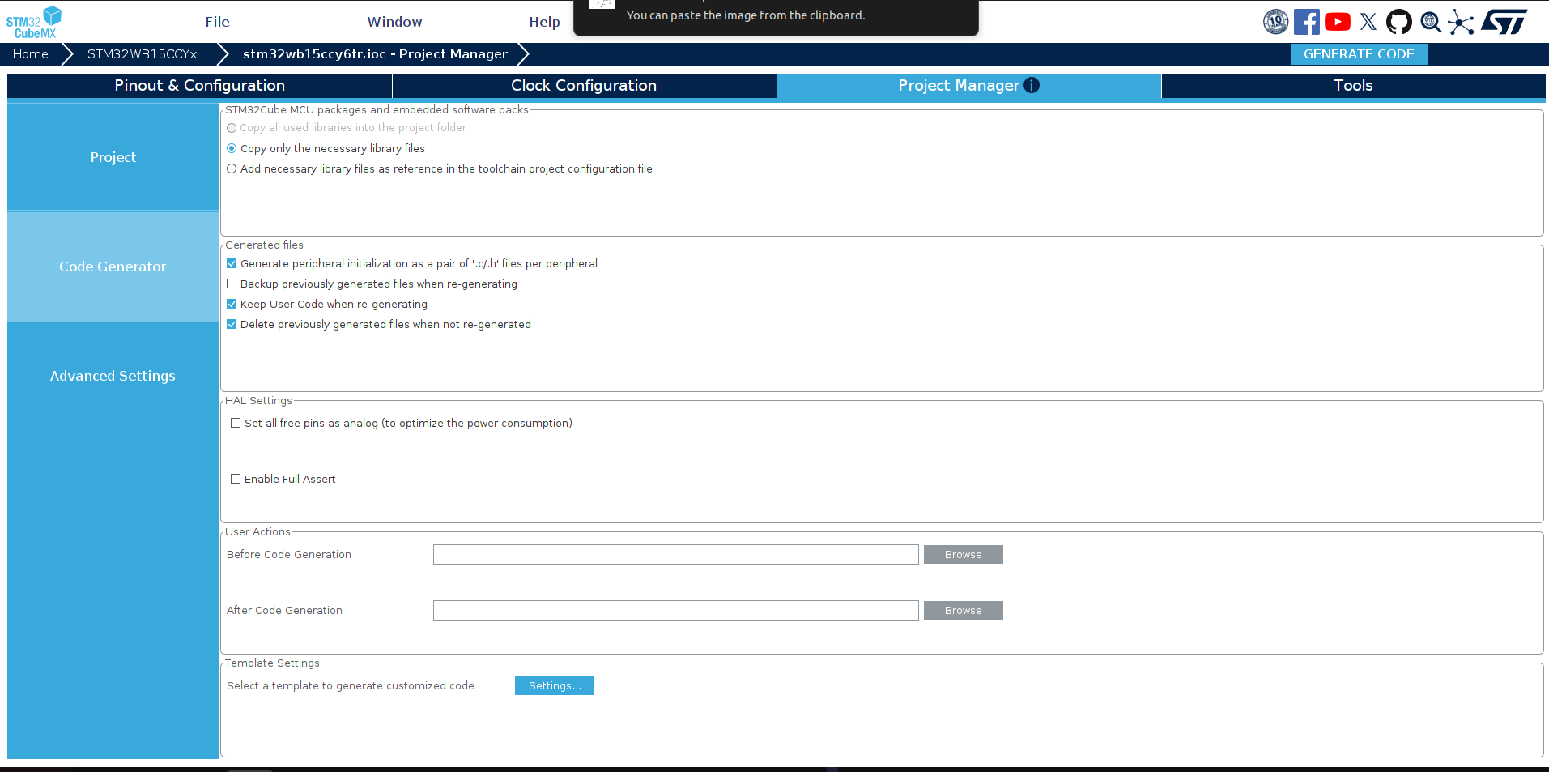
Code Generator Options:
- Copy only the necessary library files - Reduces project size by not copying unused HAL drivers
- Generate peripheral initialization as pair of .c/.h files - Creates separate files for each peripheral (adc.c, i2c.c, etc.)
- Keep User Code when re-generating - Preserves custom code between USER CODE BEGIN/END comments
- Delete previously generated files when not re-generated - Cleans up old files

9.3 Advanced Settings
Figure 9.3: Project Manager - Advanced Settings
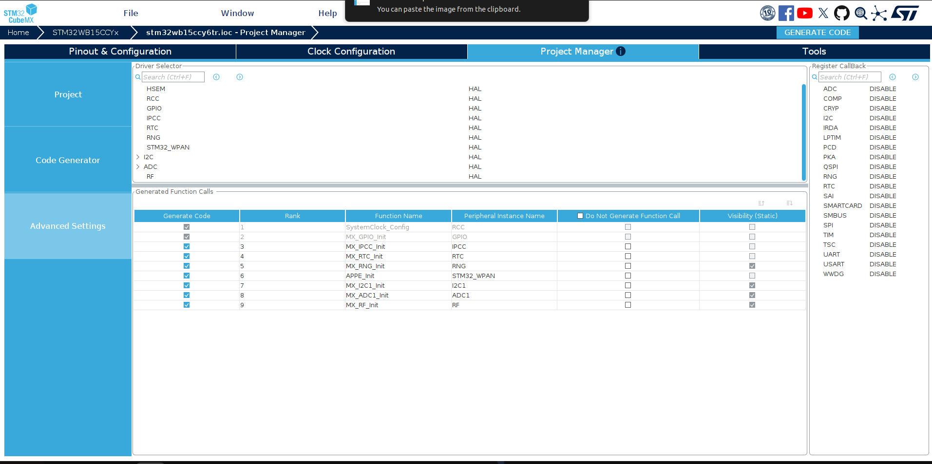
Generated Function Calls: This table shows the order in which initialization functions are called in main.c:
Rank | Function Name | Peripheral
1 | SystemClock_Config | RCC
2 | MX_GPIO_Init | GPIO
3 | MX_IPCC_Init | IPCC
4 | MX_RTC_Init | RTC
5 | MX_RNG_Init | RNG
6 | APPE_Init | STM32_WPAN
7 | MX_I2C1_Init | I2C1
8 | MX_ADC1_Init | ADC1
9 | MX_RF_Init | RF
Driver Selector: Shows all peripherals use HAL (Hardware Abstraction Layer) drivers. The Register Callback panel on the right shows all callbacks are disabled (callbacks would use more RAM).

10. Generating Code
After making configuration changes, you need to regenerate the code to apply them.

10.1 Steps to Generate Code
- Make your desired configuration changes in any tab
- Click the "GENERATE CODE" button (blue button in top-right corner)
- Wait for code generation to complete
- Click "Open Project" to open in STM32CubeIDE, or close the dialog

10.2 Important Notes
- User Code Preservation: Always place custom code between /* USER CODE BEGIN */ and /* USER CODE END */ comments to prevent it from being overwritten during regeneration.
- Backup: Consider backing up your project before regenerating if you've made significant manual changes.
- BLE Stack: Remember that the wireless BLE stack binary must be separately flashed to CPU2 using STM32CubeProgrammer.
— End of Document —

