STM32WB15 Device Bring-Up Guide
(FUS + Wireless Stack + BLE_OTA + Application)
One-time provisioning flow using STM32CubeProgrammer

Target | STM32WB15 (STM32WB1x family)
Tool | STM32CubeProgrammer (ST-LINK / SWD)
One-time steps | Flash FUS -> power cycle -> flash Wireless Stack -> Start Wireless Stack -> power cycle -> verify -> flash BLE_OTA
App address (this project) | 0x08007000 (program from CubeIDE or CubeProgrammer)

1. Purpose and scope
This guide describes the one-time device bring-up (provisioning) procedure for an STM32WB15 target before normal application development. The bring-up includes:
• Updating the FUS (Firmware Upgrade Services) firmware
• Updating the Wireless Stack and starting it
• Verifying FUS and stack versions
• Programming BLE_OTA.bin once at address 0x08000000
After the one-time steps, you can program your user application normally.

2. Prerequisites
Hardware
• STM32WB15 target board (or NUCLEO / custom board)
• ST-LINK (or on-board ST-LINK)
• Reliable USB cable / power source
Software
• STM32CubeProgrammer installed
• (Optional) STM32CubeIDE for application development
Required binary files
• FUS firmware binary (example name: stm32wb1x_FUS_fw.bin)
• Wireless Stack binary (example name: stm32wb1x_BLE_Stack_full_fw.bin)
• BLE_OTA.bin
• Your application binary (or .elf for CubeIDE)
Note: The exact file names and versions depend on your STM32CubeWB package and your project.

3. One-time device bring-up (recommended flow)
Important: This section is a one-time process per device (or only repeated if you intentionally upgrade FUS/stack again).

3.1 Connect to the target
1) Connect the ST-LINK to the board and power the target.
2) Open STM32CubeProgrammer.
3) Select the ST-LINK interface and click Connect.
4) Confirm the status shows Connected.

Screenshot: Connected device view (example).
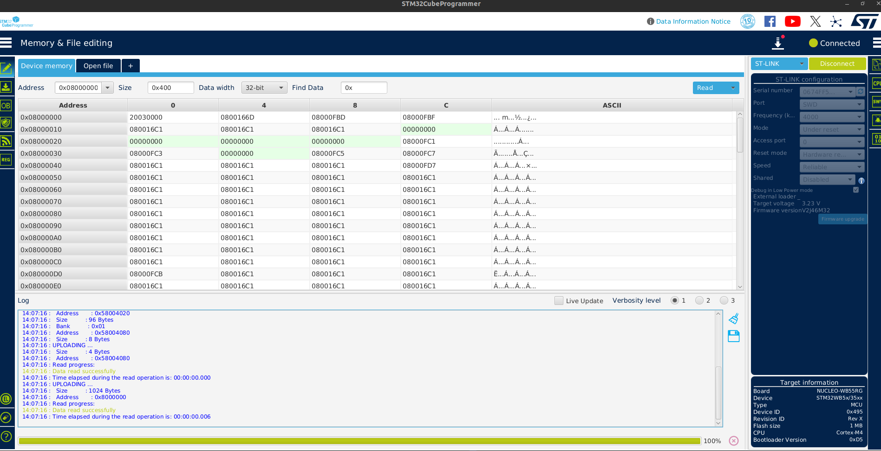
STM32CubeProgrammer connected and reading device flash memory (example view).

3.2 Step A - Flash the FUS firmware
The FUS (Firmware Upgrade Services) firmware is required to manage and upgrade the Wireless Stack.
Typical flow:
1) Open Firmware Upgrade Services (FUS) in STM32CubeProgrammer.
2) Select the FUS firmware binary.
3) Use Start address automatic determination (recommended).
4) Start the firmware upgrade.
5) Power cycle the board.
A1) Select the FUS binary file (example).
Example file selection for FUS firmware binary (stm32wb1x_FUS_fw.bin).
A2) Confirm the install address from the binary table (example shown).
Binary table showing the install address for the FUS firmware (example: 0x08040000).
Put this address in the start address and disable the uncheck the automatic start address selection.
A3) Use Firmware Upgrade Services to perform the upgrade (example UI).
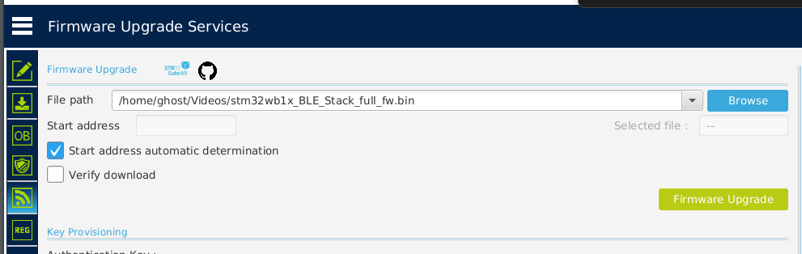
Firmware Upgrade Services page used to select a binary and run Firmware Upgrade (UI is the same for FUS and Stack).
A4) Power cycle the target (remove power / reset) after the FUS upgrade completes.
- This is required so the newly programmed FUS becomes active.

3.3 Step B - Flash the Wireless Stack and start it
After FUS is updated and the device is power-cycled, program the Wireless Stack:
1) In Firmware Upgrade Services, select the Wireless Stack binary.
2) Keep Start address automatic determination enabled.
3) Start Firmware Upgrade.
4) Go to the FUS information page and click Start Wireless Stack.
5) Power cycle the target again.
B1) Select the Wireless Stack binary file (example).
Example file selection for Wireless Stack binary (stm32wb1x_BLE_Stack_full_fw.bin).
B2) Confirm the Wireless Stack install address from the binary table (example shown).
Binary table showing the install address for the Wireless Stack (example: 0x08022800).
B3) Read FUS infos and start the Wireless Stack (WB Commands).
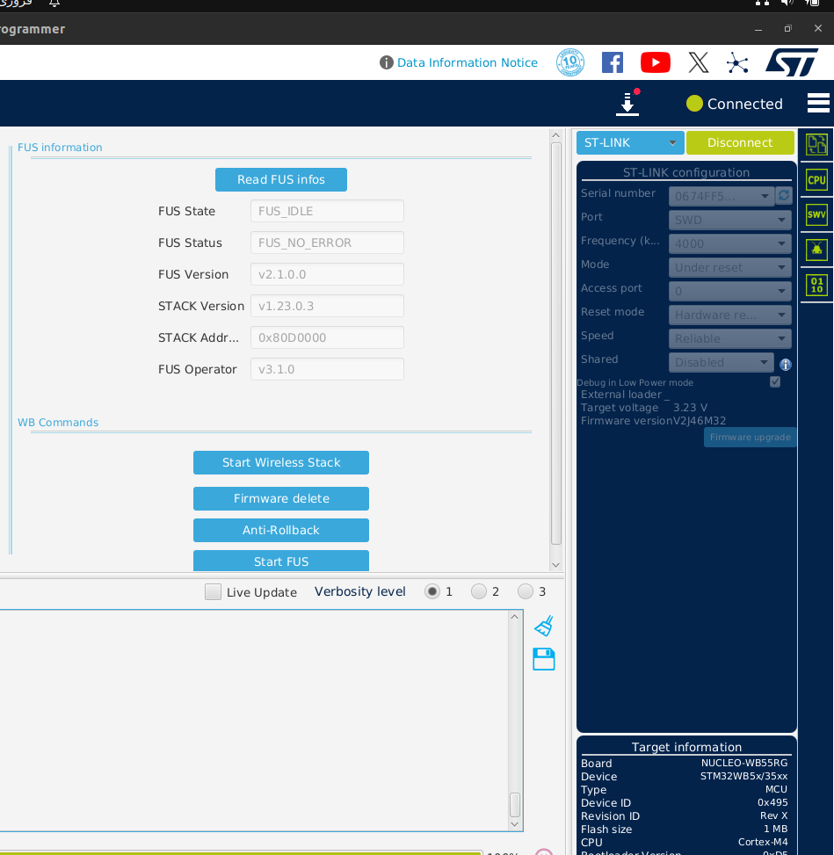
FUS information page (Read FUS infos) and WB Commands (Start Wireless Stack).
Zoom: Start Wireless Stack button.
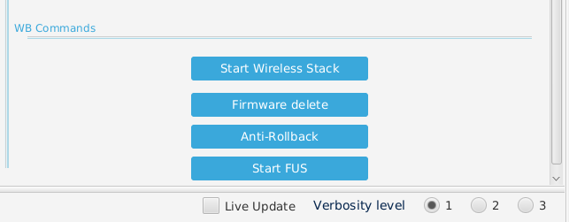
WB Commands buttons (Start Wireless Stack, Firmware delete, Anti-Rollback, Start FUS).
B4) Power cycle the target after clicking Start Wireless Stack.
- This ensures the wireless coprocessor (stack) starts cleanly with the updated image.

3.4 Step C - Verify FUS and Wireless Stack versions
1) Open the FUS information page.
2) Click Read FUS infos.
3) Check that:
• FUS State is idle (not in an error state)
• FUS Status indicates no error
• FUS Version matches the expected version
• STACK Version matches the expected version
If the versions are correct and there are no errors, the FUS and Wireless Stack update is successful.

3.5 Step D - Program BLE_OTA.bin once at 0x08000000
BLE_OTA.bin is programmed once as part of bring-up.
1) Open Erasing & Programming.
2) Browse and select BLE_OTA.bin.
3) Set Start address to 0x08000000.
4) Click Start Programming.
5) Optionally verify programming if your workflow requires it.
D1) Open Erasing & Programming from the left menu.
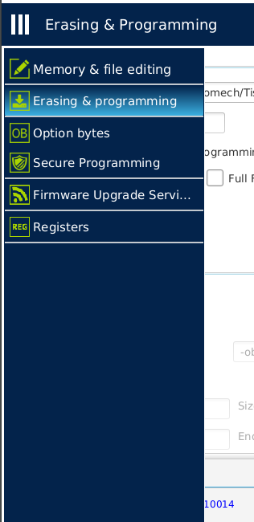
STM32CubeProgrammer left menu: open the Erasing & Programming page for manual flashing.
D2) Select BLE_OTA.bin and program it at start address 0x08000000.
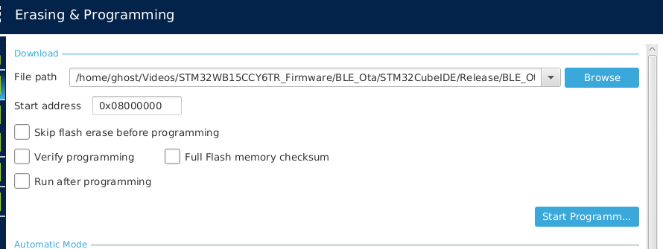
Erasing & Programming page: flashing BLE_OTA.bin at start address 0x08000000.
After this step, the one-time bring-up is complete. In normal development, you typically do not re-flash FUS/Wireless Stack/BLE_OTA unless you are performing an upgrade.

4. Programming your user application (after bring-up)
Your application is programmed after the one-time steps. In this project the application start address is:
• 0x08007000
Choose one of the following methods.

4.1 Option A - Program from STM32CubeIDE
1) Open your project in STM32CubeIDE.
2) Build the project.
3) Debug or Run as usual.
CubeIDE typically uses the linker settings from your project to place the application at the correct address (so you do not manually enter 0x08007000 in most cases).

4.2 Option B - Program from STM32CubeProgrammer (manual address)
1) Open Erasing & Programming.
2) Browse and select your application .bin file.
3) Set Start address to 0x08007000.
4) Click Start Programming.
Tip: Keep Verify programming enabled for initial validation.

5. Troubleshooting notes
• If Connect fails: try a different USB cable, lower SWD frequency, or use 'Under reset' connect mode.
• If FUS infos show an error state: power cycle and re-read; if still failing, re-flash the expected FUS image.
• If Wireless Stack does not start: ensure you clicked Start Wireless Stack, then power cycle, then re-check versions.
• Always double-check the Start address when programming manual binaries (BLE_OTA at 0x08000000, App at 0x08007000).

Document version: 1.0

