SCREW SYSTEM
Desktop Application Guide
Python BLE Controller Application
ScrewSystem.py
Installation, Usage, and Technical Reference
Document Date: February 2026

1. Introduction
ScrewSystem.py is a Python desktop application that provides a graphical user interface (GUI) for controlling and monitoring the Screw System STM32WB15 BLE device. The application communicates with the "BOLT" device over Bluetooth Low Energy (BLE) to perform the following functions:
- Connect and disconnect from the BOLT device
- Start and stop individual sensors (IMU, Temperature, Strain Gauge)
- Receive and display real-time sensor data
- Monitor connection quality (RSSI, latency, MTU)
- Perform Over-The-Air (OTA) firmware updates
- Fetch and display firmware version

1.1 Application Screenshot
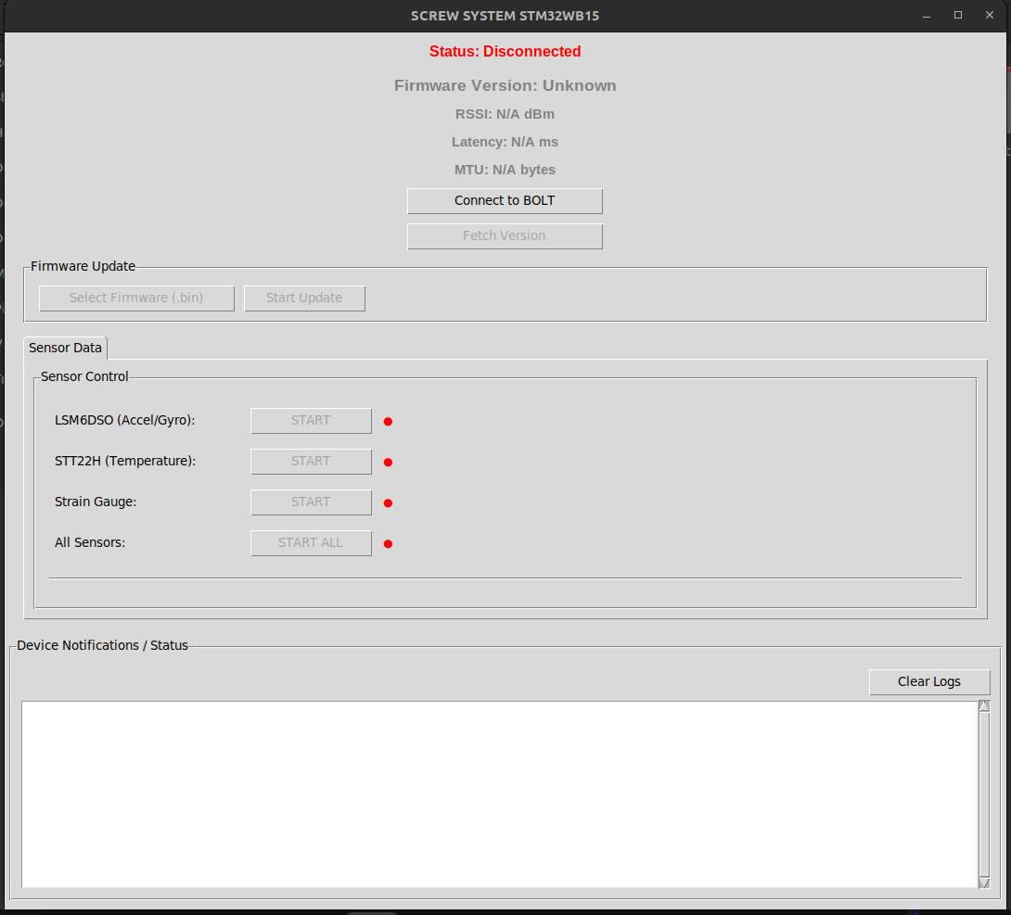
Figure 1.1: Screw System Desktop Application Main Interface

2. System Requirements

2.1 Hardware Requirements
- Computer with Bluetooth 4.0+ (BLE) support
- Built-in Bluetooth adapter or USB Bluetooth dongle
- BOLT device (STM32WB15CC) powered and advertising

2.2 Software Requirements
Requirement | Details
Operating System | Windows 10/11 (64-bit recommended)
Python Version | Python 3.8 or higher
Bluetooth Driver | Windows native Bluetooth stack

2.3 Python Dependencies
The application requires the following Python packages:
Package | Purpose
tkinter | GUI framework (included with Python)
bleak | BLE communication library (cross-platform)
asyncio | Async I/O for non-blocking BLE operations (built-in)
struct | Binary data parsing for sensor values (built-in)
threading | Run async loop in separate thread (built-in)

3. Installation on Windows

3.1 Install Python
- Download Python from https://www.python.org/downloads/
- Run the installer
- IMPORTANT: Check "Add Python to PATH" checkbox during installation
- Click "Install Now"
- Verify installation by opening Command Prompt and typing:
python --version

3.2 Install Required Packages
Open Command Prompt (cmd) or PowerShell and run:
pip install bleak
Or if you have multiple Python versions:
python -m pip install bleak
Note: tkinter is included with Python on Windows. If you get a tkinter error, reinstall Python and ensure "tcl/tk and IDLE" is checked in the optional features.

3.3 Download the Application
- Save the ScrewSystem.py file to a folder (e.g., C:\ScrewSystem\)
- Keep the firmware .bin files in the same folder for easy OTA updates

4. Running the Application

4.1 Start the Application
Method 1: Command Line (Recommended)
- Open Command Prompt
- Navigate to the folder containing ScrewSystem.py:
cd C:\ScrewSystem
- Run the script:
python ScrewSystem.py
Method 2: Double-Click
- If Python is properly associated with .py files, you can double-click ScrewSystem.py to run it
- Right-click the file and select "Open with" then choose Python if needed

4.2 Connecting to BOLT Device
- Ensure the BOLT device is powered on and advertising (BLE enabled)
- Ensure your computer's Bluetooth is turned ON
- Click the "Connect to BOLT" button in the application
- The application will scan for 8 seconds looking for a device named "BOLT"
- Upon successful connection, the status turns green and control buttons become enabled

5. User Interface Components

5.1 Status Area (Top Section)
Element | Description
Status Label | Shows connection state: Disconnected (red), Connected (green), Scanning (orange)
Firmware Version | Displays firmware version (e.g., 2.0.0) fetched from device
RSSI | Signal strength in dBm (updated every 2 seconds when connected)
Latency | Round-trip time for version request/response in milliseconds
MTU | Maximum Transmission Unit size in bytes (affects max packet size)

5.2 Connection Buttons
- Connect to BOLT - Scans for and connects to the BOLT device
- Fetch Version - Sends version request command (0x30) and displays response

5.3 Firmware Update Section
- Select Firmware (.bin) - Opens file dialog to choose firmware binary file
- Start Update - Initiates OTA firmware update process

5.4 Sensor Control Tab
Each sensor has a START/STOP button and a status indicator (green = active, red = inactive):
Sensor | Description
LSM6DSO (Accel/Gyro) | 6-axis IMU - accelerometer and gyroscope data
STT22H (Temperature) | Temperature sensor reading in degrees Celsius
Strain Gauge | Raw ADC value from strain measurement
All Sensors | Start/stop all sensors simultaneously

5.5 Device Notifications / Status Log
The scrollable text area at the bottom displays:
- Timestamped log entries for all BLE communication
- Sent commands indicated by (→)
- Received notifications indicated by (←)
- Parsed sensor data (logs every 10th sample to reduce spam)
- Error messages (✗) and success confirmations (✓)
- Clear Logs button clears the entire log area

6. BLE Communication Protocol

6.1 GATT Service UUIDs
Purpose | UUID
Write (Commands) | 0000fe41-8e22-4541-9d4c-21edae82ed19
Notify (Data) | 0000fe42-8e22-4541-9d4c-21edae82ed19
OTA Reboot | 0000fe11-8e22-4541-9d4c-21edae82ed19

6.2 Sensor Command Protocol
Commands are sent as 3-byte payloads to the Write characteristic:
Format: [0x10, SENSOR_ID, ACTION]

SENSOR_ID values:
0x01 = LSM6DSO (IMU - accelerometer + gyroscope)
0x02 = STT22H (Temperature sensor)
0x03 = Strain Gauge (ADC input)
0x04 = All Sensors

ACTION values:
0x01 = Start streaming
0x00 = Stop streaming
Command Examples:
[0x10, 0x01, 0x01] --> Start IMU sensor
[0x10, 0x02, 0x00] --> Stop Temperature sensor
[0x10, 0x04, 0x01] --> Start All Sensors
[0x30] --> Request Firmware Version

6.3 Notification Data Formats
The device sends notifications with the following byte formats:
IMU Data (14 bytes):
[0x20, 0x01, AccX_H, AccX_L, AccY_H, AccY_L, AccZ_H, AccZ_L,
GyroX_H, GyroX_L, GyroY_H, GyroY_L, GyroZ_H, GyroZ_L]
Temperature Data (4 bytes):
[0x20, 0x02, Temp_H, Temp_L]
Strain Gauge Data (4 bytes):
[0x20, 0x03, Raw_H, Raw_L]
Version Response (4 bytes):
[0x30, MAJOR, MINOR, PATCH]
Example: [0x30, 0x02, 0x00, 0x00] = Version 2.0.0

7. How Sensor Data is Received and Processed

7.1 Notification Handler
The application uses the _notification_handler() callback method to process incoming BLE notifications. This function is automatically called by the Bleak library whenever the device sends data.
def _notification_handler(self, sender, data: bytes):
# data[0] = message type (0x20=sensor data, 0x21=status, 0x30=version)
# data[1] = sensor ID (for sensor data messages)
# data[2:] = payload bytes

if data[0] == 0x20: # NOTIF_SENSOR_DATA
sensor_id = data[1]
if sensor_id == 0x01: # LSM6DSO
accel_x = struct.unpack('>h', data[2:4])[0]
accel_y = struct.unpack('>h', data[4:6])[0]
# ... parse remaining accelerometer and gyroscope values
elif sensor_id == 0x02: # Temperature
temp_raw = struct.unpack('>h', data[2:4])[0]
# Convert to Celsius if needed

7.2 Data Flow Architecture
Sensor data flows through the system in the following sequence:
+---------------------------------------------------------------+
| BOLT Device (STM32WB15) |
| |
| Sensors --> main.c loop --> Global Variables --> p2p_server |
| | |
| BLE Notification (10Hz) |
+-------------------------------+-------------------------------+
|
BLE Radio (2.4GHz)
|
+-------------------------------v-------------------------------+
| ScrewSystem.py (Desktop App) |
| |
| BleakClient --> _notification_handler --> Parse --> Log/UI |
+---------------------------------------------------------------+

7.3 Asynchronous Threading Architecture
The application uses a dual-thread architecture to keep the UI responsive while handling BLE operations:
- Main Thread: Runs the tkinter GUI event loop (handles button clicks, updates display)
- Async Thread: Runs the asyncio event loop for non-blocking BLE operations
- Thread Communication: Uses asyncio.run_coroutine_threadsafe() to schedule async tasks and root.after() to update UI from async callbacks
# Thread setup in __init__:
self.loop = asyncio.new_event_loop()
self.async_thread = threading.Thread(
target=self._run_async_loop,
daemon=True # Thread dies when main app closes
)
self.async_thread.start()

8. OTA Firmware Update Process
The application supports Over-The-Air (OTA) firmware updates using ST's BLE_Ota bootloader application.

8.1 OTA Process Steps
- Read firmware file - Load the selected .bin file into memory
- Calculate sectors - Determine which flash sectors need to be erased
- Send reboot command - Device reboots into OTA bootloader mode
- Reconnect in OTA mode - Scan and connect to the BLE_Ota application
- Send START_USER_APP - Initialize transfer at the application base address
- Stream firmware data - Send firmware in 100-byte chunks over BLE
- Send FILE_FINISHED - Signal completion, device validates and reboots
- Reconnect to new firmware - Verify update was successful

8.2 OTA Configuration Constants
FLASH_BASE_ADDR = 0x08000000 # STM32 flash memory start address
APP_BASE_ADDR = 0x08007000 # User application base address
FLASH_PAGE_SIZE = 4096 # 4KB per flash page
OTA_CHUNK_SIZE = 100 # Bytes per BLE write operation

9. Troubleshooting

9.1 Common Issues and Solutions
Problem | Solution
"BOLT not found" | Ensure device is powered on, Bluetooth is enabled, move closer to device
"No module named bleak" | Run: pip install bleak
"Connection failed" | Restart Bluetooth service, reboot device, try again
No sensor data received | Check notification characteristic is subscribed, verify firmware version
MTU shows 23 bytes | Windows Bluetooth limitation - functionality still works normally
OTA update fails | Ensure BLE_Ota app is flashed on device, verify .bin file is valid

9.2 Windows Bluetooth Tips
- Use Windows Settings → Bluetooth & devices to verify your adapter is working
- Do NOT pair the BOLT device in Windows Settings - let the application handle the connection
- If issues persist, try: Device Manager → Bluetooth → Disable then Enable your adapter
- Some USB Bluetooth dongles may work better than built-in laptop adapters
- Ensure no other application is connected to the BOLT device simultaneously
— End of Document —

