P0-U01 Supplementary Concept Note
Understanding AUROC and Related Classification Metrics
Phase 0 — Researcher Mindset & Scientific Workflow
Purpose: This note fills a prerequisite exposed by the P0-U01 guided lab. To reason correctly about an AUROC change across hospitals, a researcher must understand what AUROC measures, what it does not measure, how it differs from other classification metrics, and which kinds of changes can plausibly affect it.

Learning objectives
- Explain AUROC using both the ROC curve and a ranking interpretation.
- Distinguish AUROC from accuracy, calibration, sensitivity, specificity, PPV, NPV, and AUPRC.
- Explain why changing a single decision threshold does not change AUROC.
- Distinguish pure prevalence change from case-mix change.
- Identify plausible mechanisms for cross-hospital AUROC degradation.
- State what a high AUROC does and does not establish about clinical reliability.

1. Start with model scores, not hard decisions
A binary chest X-ray classifier commonly produces a continuous score for the positive class. A higher score indicates that the model ranks the image as more compatible with the positive class.
Patient | True label | Model score
A | Pneumonia | 0.92
B | No pneumonia | 0.81
C | Pneumonia | 0.75
D | No pneumonia | 0.40
E | Pneumonia | 0.32
F | No pneumonia | 0.10
To convert scores into positive/negative decisions, we choose a decision threshold. Changing that threshold changes the resulting confusion matrix and therefore many threshold-dependent metrics.

2. Sensitivity, specificity, and false-positive rate
At a chosen threshold:
Sensitivity (True Positive Rate, TPR) = TP / (TP + FN)
Specificity = TN / (TN + FP)
False Positive Rate (FPR) = FP / (FP + TN) = 1 − Specificity
Sensitivity asks: among truly positive patients, how many were detected? Specificity asks: among truly negative patients, how many were correctly rejected?

3. What is the ROC curve?
The Receiver Operating Characteristic (ROC) curve evaluates the classifier over many possible decision thresholds. For each threshold, it plots the True Positive Rate (sensitivity) against the False Positive Rate (1 − specificity). A classifier with stronger discrimination tends to produce a curve closer to the upper-left region.
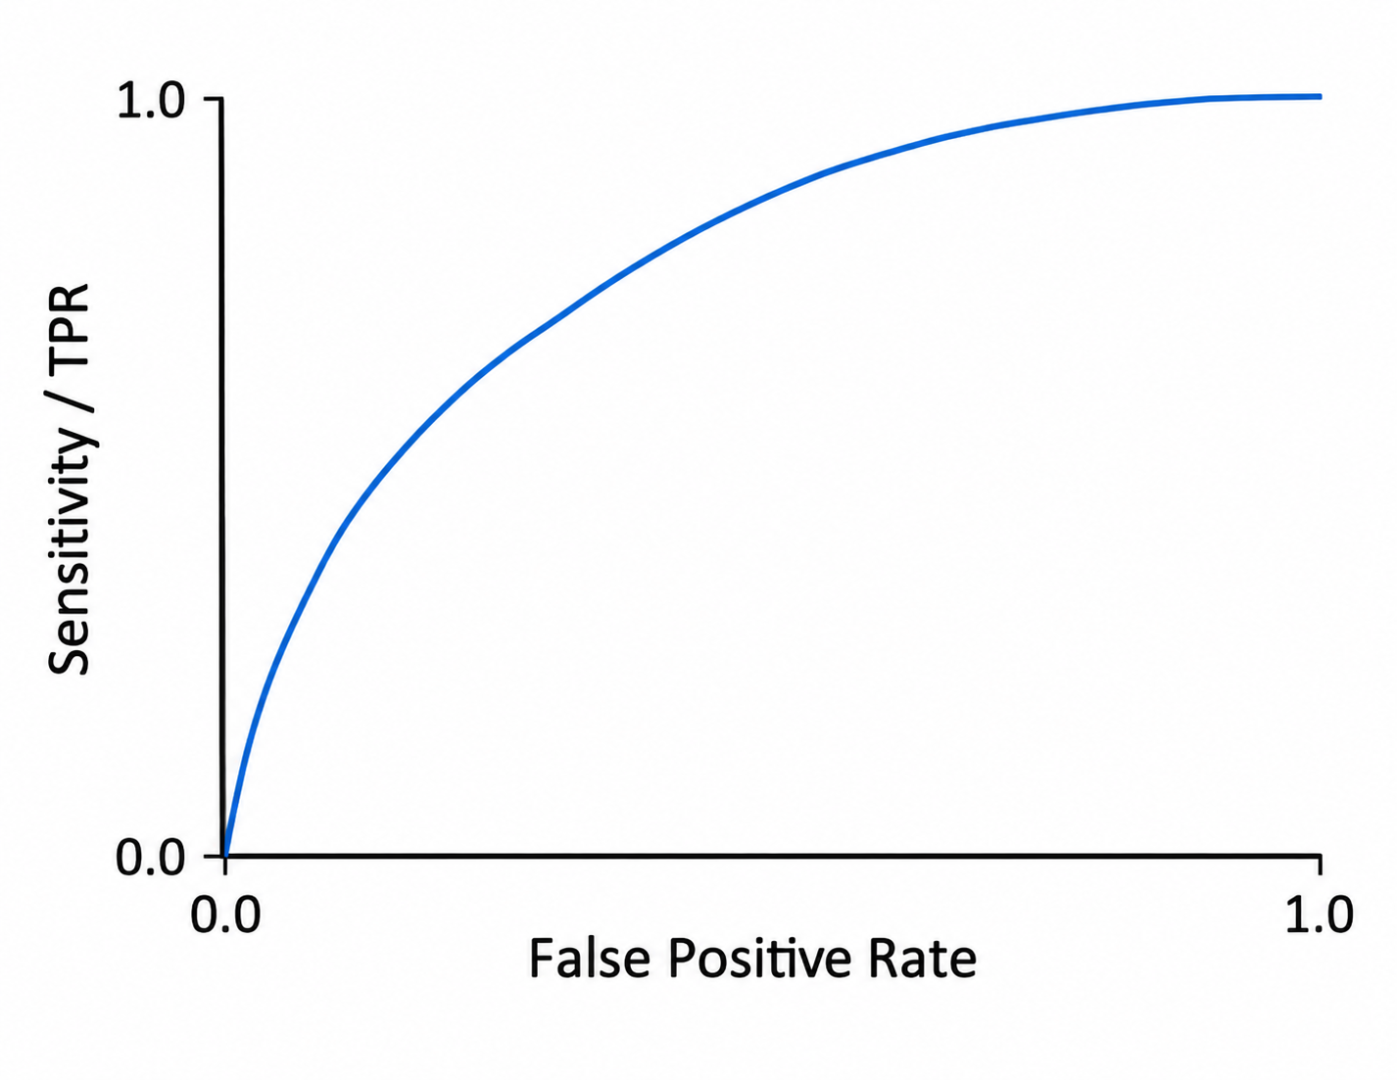

4. What exactly is AUROC?
AUROC means Area Under the Receiver Operating Characteristic Curve. The most useful mental model is that AUROC measures how well the model ranks positive examples above negative examples.
Ranking interpretation: If one positive example and one negative example are sampled, AUROC can be interpreted as the probability that the classifier assigns the positive example a higher score than the negative example, with standard handling of ties.
- AUROC = 0.50: approximately random discrimination.
- AUROC = 1.00: perfect discrimination.
- AUROC = 0.94: very strong ranking/discrimination on that evaluated dataset.

5. Interpreting the P0-U01 lab result
Hospital A internal test set: AUROC = 0.94
Hospital B external test set: AUROC = 0.73
Directly supported observation: The model demonstrates substantially lower discrimination/ranking performance on the Hospital B external dataset than on the Hospital A internal test dataset.
The AUROC values alone do not establish why this happened. Scanner differences, preprocessing mismatch, population/case-mix changes, label differences, shortcut reliance, and other mechanisms remain hypotheses until investigated.

6. AUROC is not accuracy
Accuracy = (TP + TN) / (TP + TN + FP + FN)
Accuracy evaluates hard decisions at a particular threshold. AUROC evaluates discrimination across thresholds. Therefore AUROC and accuracy are not interchangeable. When you see AUROC, train yourself to think 'discrimination/ranking', not simply 'accuracy'.

7. AUROC is not calibration
Calibration asks whether predicted probabilities correspond to observed frequencies. For example, among cases assigned approximately 0.80 probability, does the event occur approximately 80% of the time?
A model can rank positives above negatives very well (high discrimination) while its probability estimates are poorly calibrated. Thus good AUROC does not imply good calibration.

8. Why changing one classification threshold does not change AUROC
Sensitivity, specificity, accuracy, PPV, and NPV at an operating point can change when the threshold changes. AUROC, however, summarizes the ranking performance over the range of thresholds. Simply using threshold 0.5 at one hospital and 0.7 at another does not explain an AUROC difference when AUROC is correctly computed from the underlying continuous scores.
Research implication: A threshold mismatch is important for threshold-dependent clinical decisions, but it is not a first-order explanation for a cross-site AUROC drop.

9. AUROC and disease prevalence
A pure change in the proportion of positive and negative cases does not, by itself, inherently change AUROC if the underlying conditional score distributions and ranking difficulty remain the same. This differs from metrics such as PPV and NPV, which are strongly prevalence-dependent.

10. Prevalence is not the same as case mix
Case mix concerns the kinds and difficulty of positive and negative examples, not merely their proportions. For example, Hospital A might contain obvious severe pneumonia versus healthy controls, while Hospital B contains subtle pneumonia versus other lung diseases that look similar on X-ray. The discrimination task at Hospital B is harder, so AUROC can change even if the model itself is frozen.

11. Plausible reasons AUROC may change across hospitals
Population / case-mix shift: Disease severity, age, comorbidities, clinical setting, disease presentation, or negative-case composition may differ.
Acquisition shift: Scanner manufacturer, portable versus fixed radiography, positioning, resolution, or acquisition protocols may alter image appearance.
Preprocessing mismatch: Resizing, normalization, cropping, orientation, intensity handling, or image encoding may differ from development conditions.
Label differences: Hospitals may operationalize or annotate the target differently, changing what counts as a positive or negative example.
Shortcut / spurious-feature reliance: The model may rank cases using hospital-specific markers or contextual features whose label relationship does not transfer.
Sampling uncertainty: AUROC is estimated from finite samples; sample size, confidence intervals, and composition matter when comparing estimates.

12. AUROC versus clinically important operating-point metrics
A hospital ultimately deploys a model at an operating point, not at an entire ROC curve. A high AUROC therefore does not guarantee that sensitivity and specificity at the chosen threshold are clinically acceptable.
Metric | Main question
AUROC | How well does the model rank/discriminate positives from negatives across thresholds?
Sensitivity / Recall | Of the truly positive patients, how many did we detect?
Specificity | Of the truly negative patients, how many did we correctly reject?
PPV / Precision | Of those predicted positive, how many are actually positive?
NPV | Of those predicted negative, how many are actually negative?
Accuracy | What fraction of hard decisions are correct at the selected threshold?
Calibration | Do predicted probabilities correspond to observed event frequencies?
AUPRC | How does precision trade against recall across thresholds?

13. PPV, NPV, and prevalence
PPV = TP / (TP + FP)
NPV = TN / (TN + FN)
PPV and NPV depend strongly on disease prevalence. A model evaluated in a high-prevalence research dataset can have different predictive values when used in a lower-prevalence screening population, even if its underlying discrimination is similar.

14. AUROC versus AUPRC
AUPRC is the Area Under the Precision-Recall Curve. It summarizes the trade-off between precision (PPV) and recall (sensitivity). It can be particularly informative when positive cases are rare, but its baseline and magnitude depend on prevalence. Avoid the simplistic rule 'AUROC is bad and AUPRC is good for imbalance.' Instead ask which metric answers the scientific or clinical question.

15. What AUROC does not tell you
- whether the model is clinically safe;
- whether predicted probabilities are calibrated;
- whether sensitivity or specificity at the deployed threshold is acceptable;
- whether PPV or NPV will be acceptable in the target population;
- whether performance is equitable across patient subgroups;
- whether the model will generalize to another hospital;
- whether the model learned clinically meaningful features;
- whether shortcut learning is absent;
- whether the model learned causal relationships;
- whether deployment will improve patient outcomes.

16. Researcher workflow for a cross-hospital AUROC drop
1. Observation — External discrimination is substantially lower.
2. Question — Why did the model's ability to rank positive versus negative cases deteriorate?
3. Competing mechanisms — Consider population/case mix, acquisition, preprocessing, labels, shortcut features, sampling uncertainty, and other relevant shifts.
4. Diagnostics — Determine which mechanisms have evidence.
5. Intervention — Decide what to change only after the problem has been characterized.
6. Evaluation — Test whether the intervention addresses the hypothesized mechanism and whether the conclusion is supported beyond one result.

17. Core sentence to remember
AUROC tells me how well the model discriminates/ranks positive versus negative examples across thresholds. It does not tell me why that performance occurred, whether the probabilities are calibrated, or whether the model is clinically useful at a particular operating point.

18. Return-to-lab exercise
Without copying a replacement answer from the mentor, return to your P0-U01 lab and reconsider:
- Part 1: whether your observation uses the correct metric terminology;
- H3: whether you have separated pure prevalence from case-mix effects;
- H6: whether the proposed mechanism can genuinely change AUROC;
- Part 4: whether your diagnostic ranking still makes sense after understanding AUROC;
- Part 9: whether your conclusion stays within the evidence.

Recommended follow-up reading
For now, focus on the conceptual distinctions in this note. Later phases will formally cover confusion matrices, ROC/PR curves, threshold selection, calibration, uncertainty/confidence intervals, subgroup evaluation, and clinically appropriate model evaluation.
Supplement ID: P0-U01-S01 | Version 1.0

